***Advancing into Analytics*: Getting Started in Python**

1. **Download Anaconda’s distribution of Python**

* Go to [anaconda.com](https://www.anaconda.com) > Products > Individual Edition  
  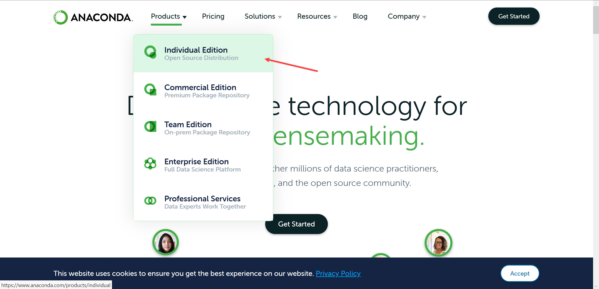
* Click on “Download”   
  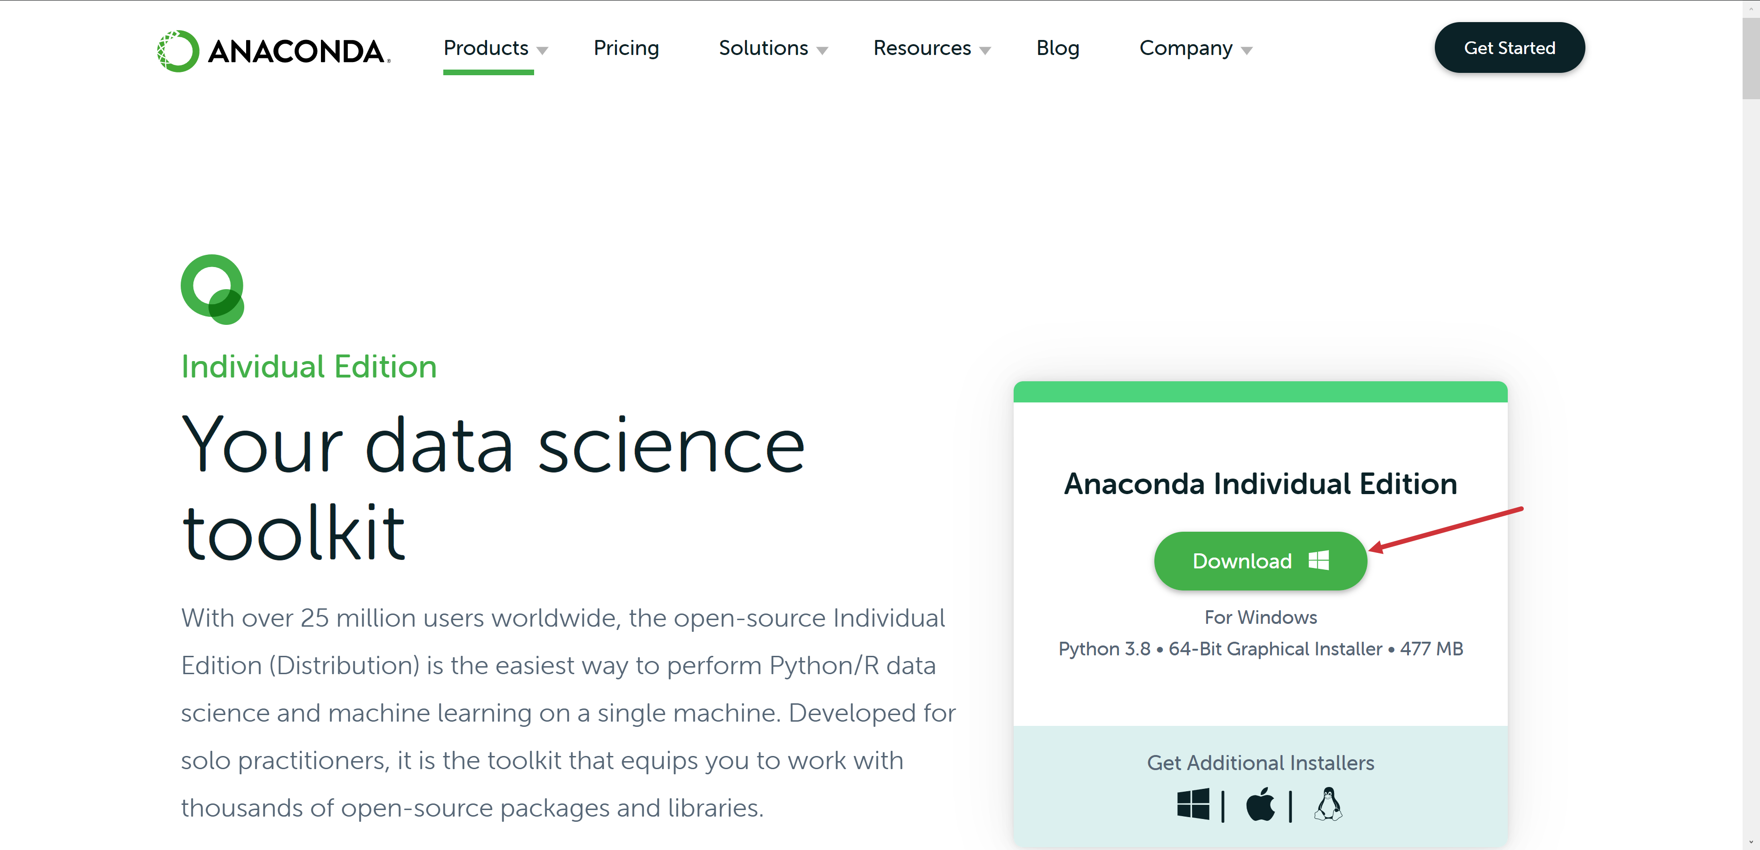
* Complete installation
* Search for “Jupyter Notebook” on PC