***Advancing into Analytics*  Foundations: Demo notes**

Is there a difference in sales between legacy and prototype stores?

1. Make a copy of the workbook. We want to keep the raw data intact for the next lessons.
2. Create a PivotTable containing *trans_id* in the rows, *airco* in the Columns and *Sum of sales_amt* in the Values.
   1. Design > Grand Totals > Off for Rows and Columns
3. Download the Data Analysis ToolPak:
   1. File > Options > Add-ins > Go > Analysis ToolPak
4. Run the descriptives for each category using the Analysis ToolPak:
   1. Data > Data Analysis > Descriptive Statistics
   2. Select the data range, making sure you check on “Labels in first row”
   3. Specify that you want summary statistics and select the output range.   
      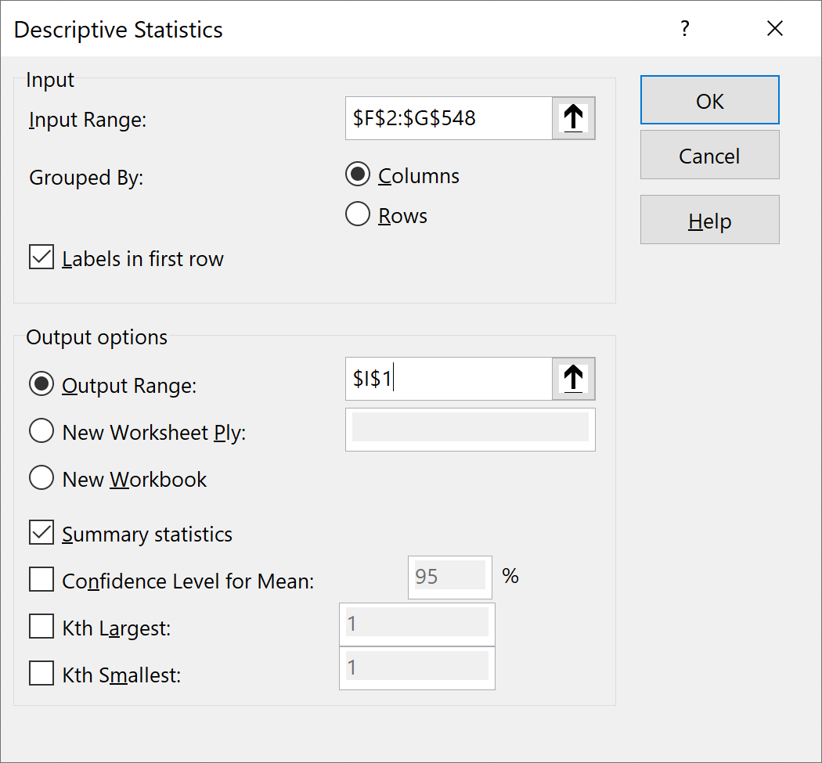
5. It appears the prototype stores are pulling in a $20 increase over legacy. But is this likely to hold up across all stores?   
   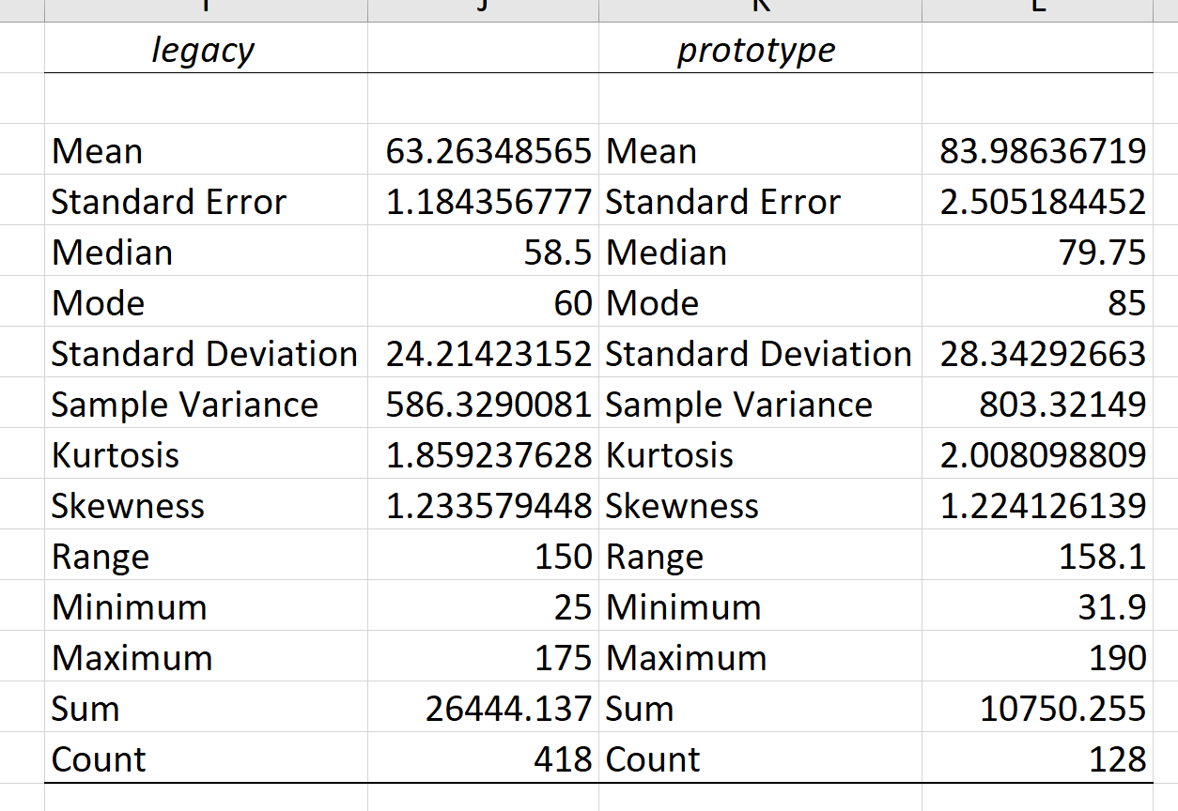

We’ll check one more thing before answering: let’s visualize the data.

**Plot a histogram for two categories**

1. Create another PivotTable (copy-paste the old one)
2. Place the two categories along the Columns, the continuous variable of interest down the Rows, and the Count of the ID variable in the Values.
3. Right-click the Rows area and select Group.   
     
   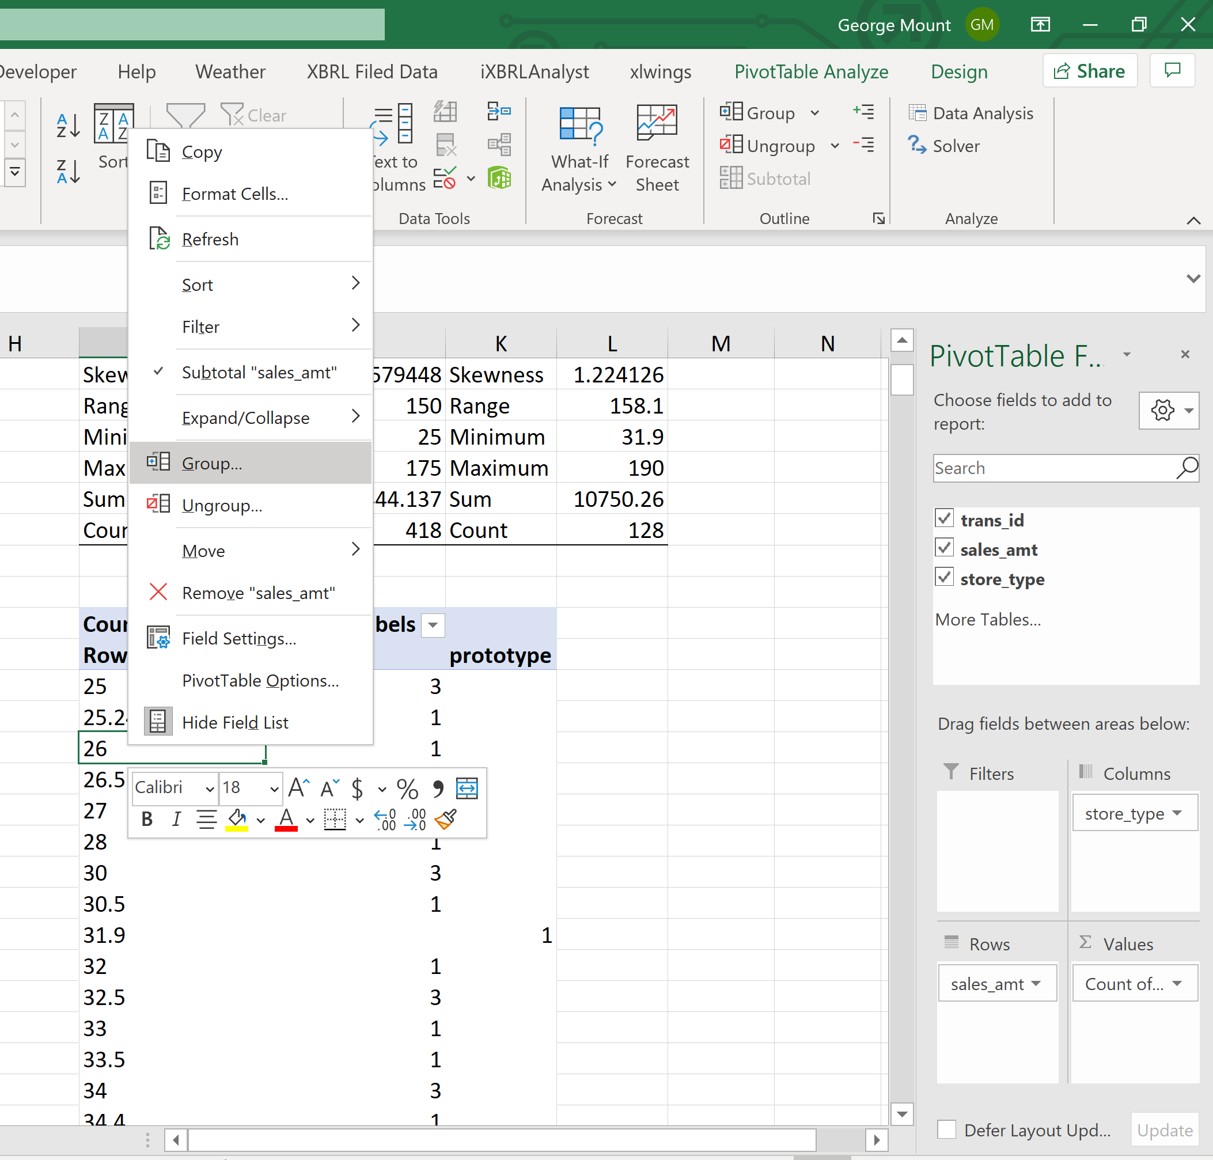
4. Go to Insert on the home ribbon and select a 2-D Column chart.

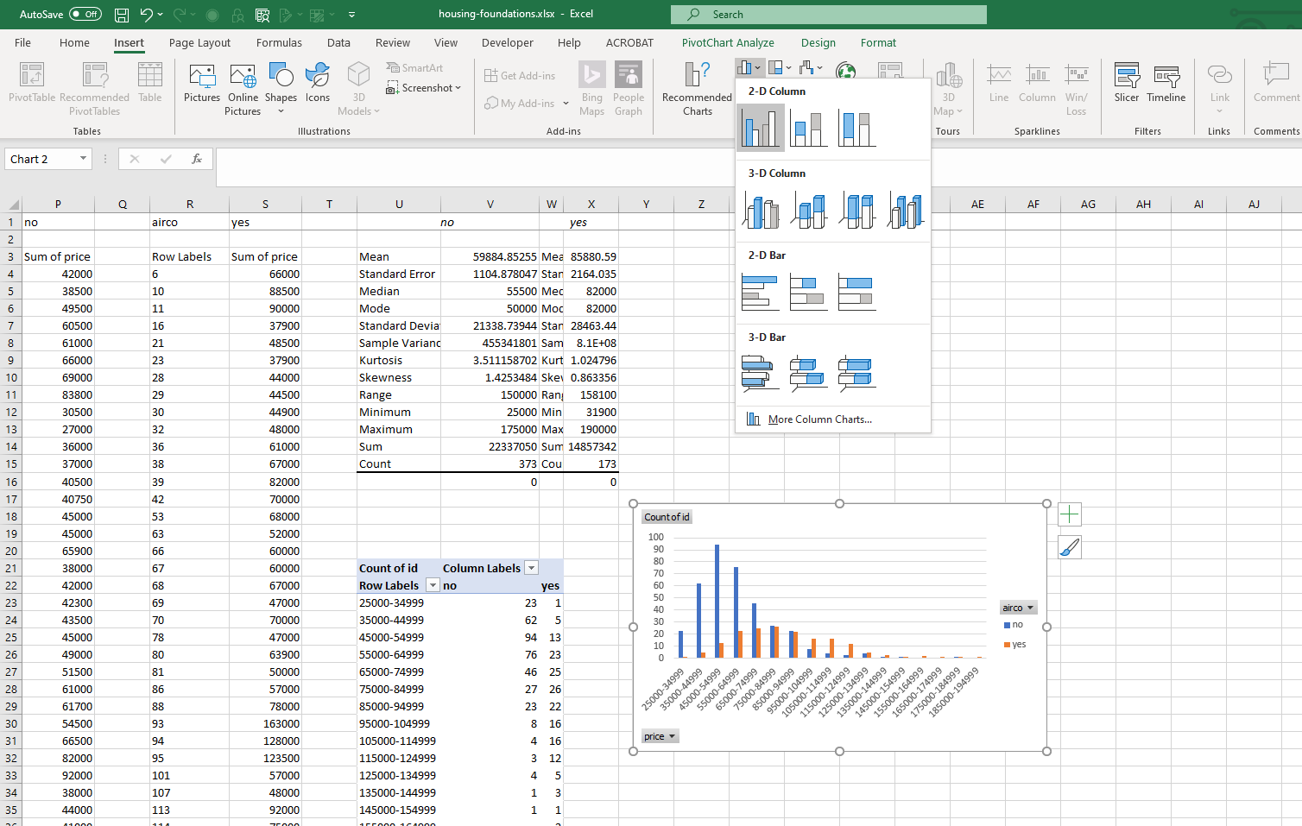

1. Right-click on any of the bars in the resulting bar chart. Select Format Data Series.  
   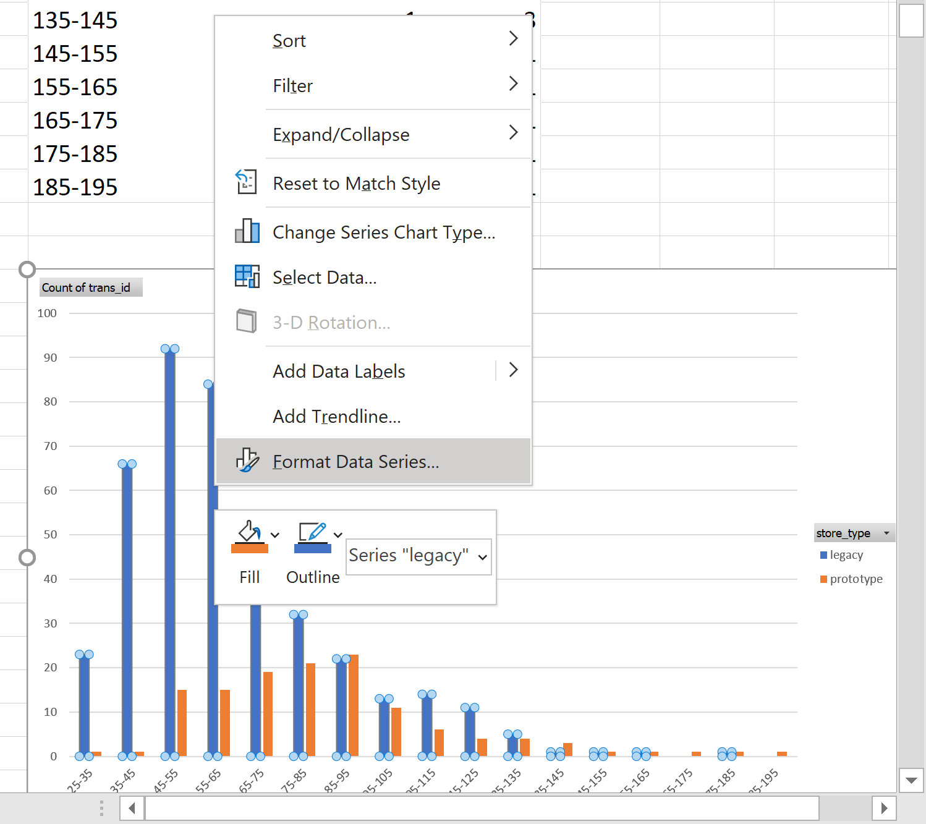
2. Adjust the Series Overlap to 100% and the Gap Width to 0%.

