Dynamic arrays

UNIQUE() – This should probably really say “distinct,” but it will remove duplicates in the data.
- UNIQUE(computers) will give the number of unique rows
- Do ROWS(UNIQUE(computers)) = ROWS(computers)? Why?

FILTER() – We can filter to get resulting records.

- We only want the premium computers?
  - FILTER(computers, computers[premium] = "yes")
- Add the headers to the results: computers[#Headers]
- AND criteria with *
  - FILTER(computers,(computers[premium]="yes")*computers[speed]>30)
- OR criteria with +
  - FILTER(computers,(computers[premium]="yes+computers[speed]>30

SORTBY() – This function lets you sort by multiple columns and you can return whichever arrays you want. Operates a lot like SUMIFS().
- Sort by price, descending: =SORTBY(computers, computers[price], -1)
- Sort by speed descending and premium ascending: =SORTBY(computers, computers[speed], -1, computers[premium], 1)
- Sort by price, descending but only return the index column: =SORTBY(computers[Index], computers[price], -1)

XLOOKUP()

- Let’s get the name of the location added to the employee table
  - This would be difficult with VLOOKUP() because of “looking to the left”
  - We can easily do it with XLOOKUP: =XLOOKUP([@locno], locations[locno], locations[cty])
- Let’s get the name of the department added to the employee table
  - With VLOOKUP() we would get a matching error and have to do something like IFERROR()
  - With XLOOKUP() we simply add another argument to the function: =XLOOKUP([@deptno],departments[deptno], departments[dept_title], "OTHER")

Dynamic visualizations with dynamic arrays

Worksheet: iris
- Dynamic arrays can be a bunch of different sizes, so it’s very possible their results will “spill” into a pre-populated area.
- For example, let’s try SEQUENCE(5) but put some text directly beneath it. What happens? We get a spill error
- If we want to refer to the dynamic array range as a whole we can do so with the spill operator, #
  - For example, we can reprint the array in A1 with =A1# or we could even operate on it as a whole with =SUM(A1#)

- Let’s create a dynamic scatterplot that you can filter and see the data for each group of iris.
- First thing we are going to do is create a dropdown that lists the three species:
  - Let’s create a helper worksheet iris_helper and use the UNIQUE() function to list the unique species: =UNIQUE(iris[species])
- We can dynamically tie the dropdown to this array result with the spill operator:
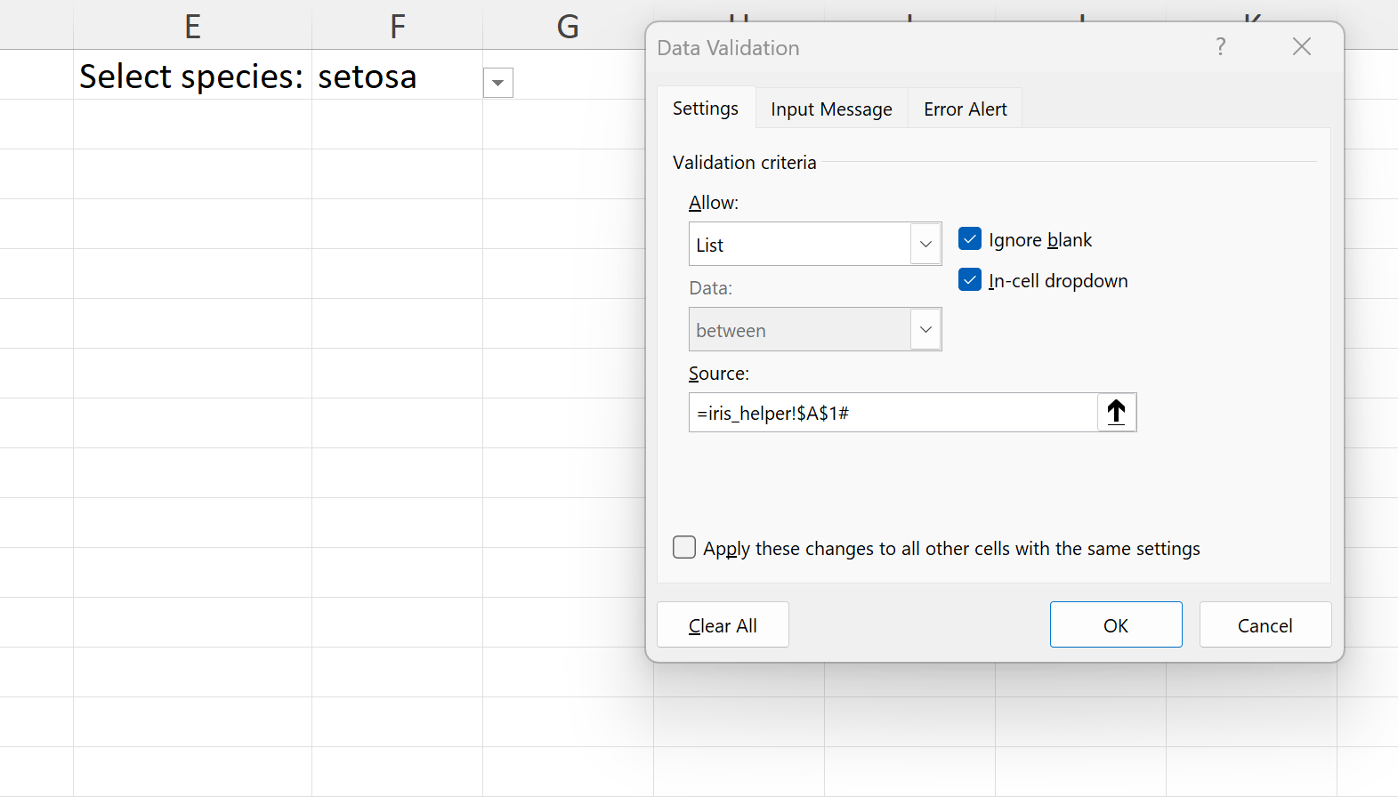
- Now we can use the FILTER() function to get the resulting sepal length and widths for each:
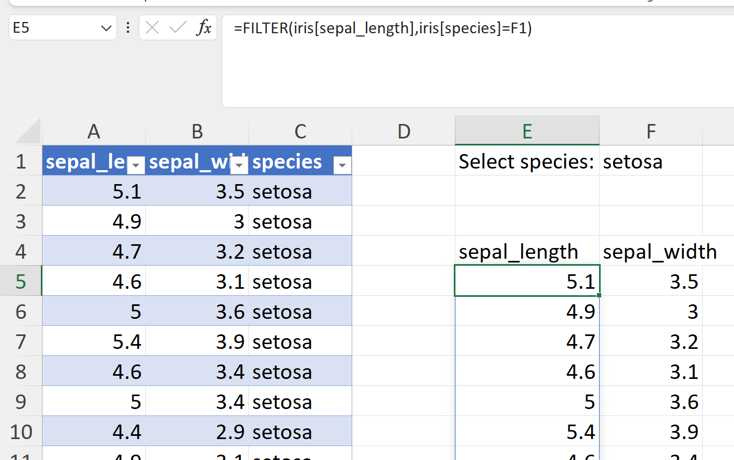
- Now, select the resulting sepal length vs width dataset and insert a scatterplot
- Go to Formulas > Name Manager > New
  - We will create a sepal_length named range using the spill operator
- Right-click the resulting scatterplot > Edit > Select Data
- Specify the series X and Y values so that they refer to dynamic arrays with the spill operator # :
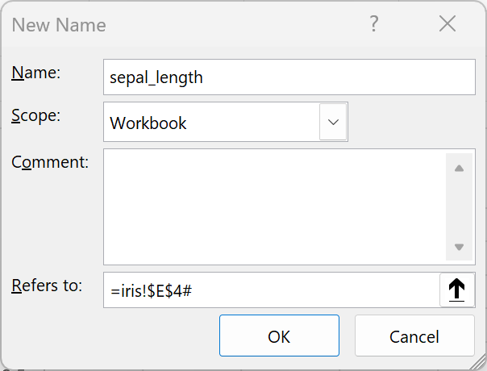
- Right-click on the current scatterplot > Select Data > Edit
  - Keep the iris! worksheet preface in there but change the numbered ranges to your NAMED ranges
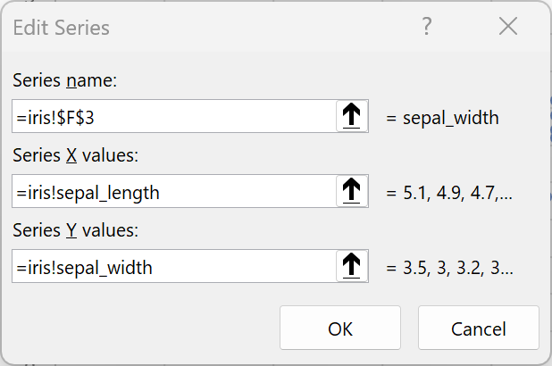
  - You should now have a fully dynamic, interactive visualization right from Excel!

