**Downloading R**

* Go to <https://www.r-project.org>
* Click on “download R”   
  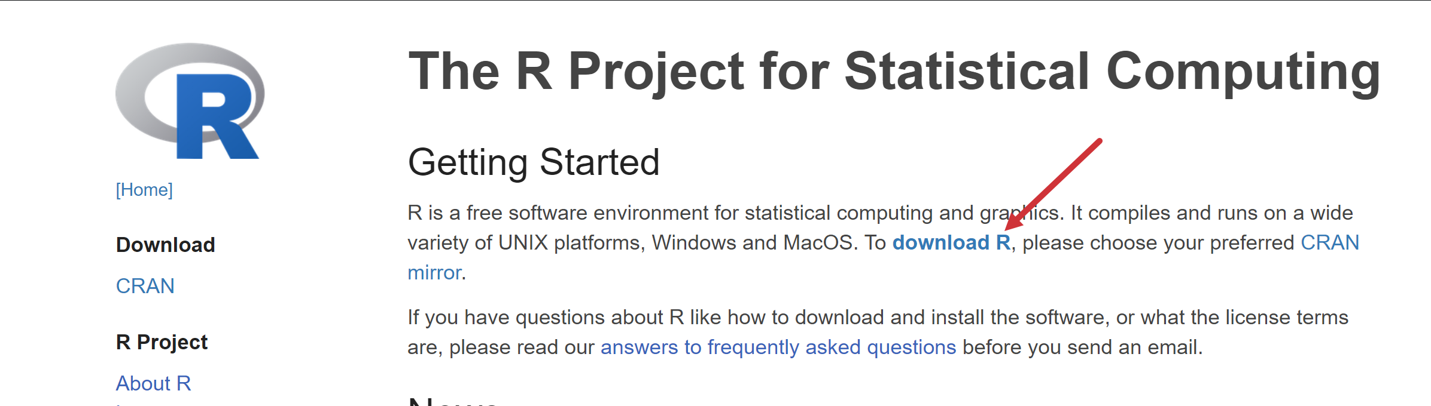
* Choose a location near you from the list of mirrors; I will choose [Case Western Reserve University](https://cran.case.edu).
* Click “Download R for Windows”   
  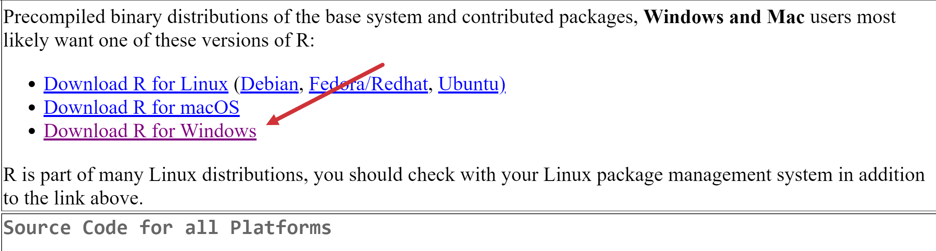
* Click “base” or “install R for the first time” (same link)  
  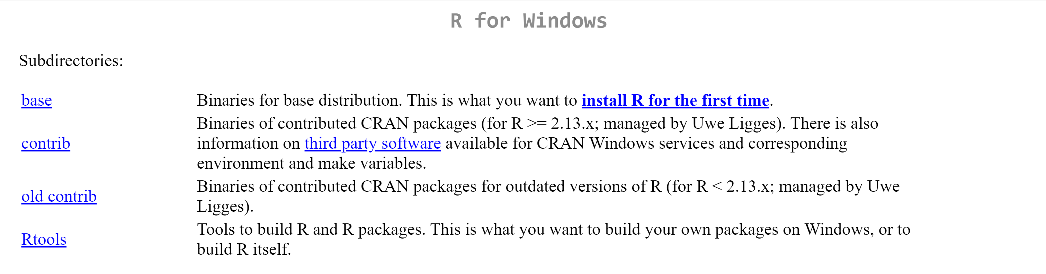
* Click “Download R for Windows” (version number will vary based on when you do this)
* Complete the installation

**Downloading RStudio**

* Go to <https://www.rstudio.com>
* Click “Download”  
  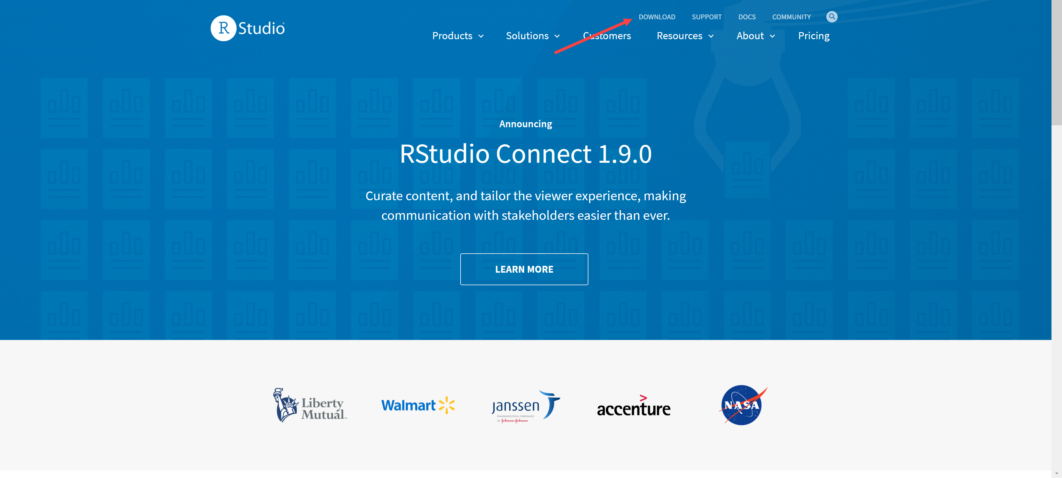
* Click “Download” on RStudio Desktop  
  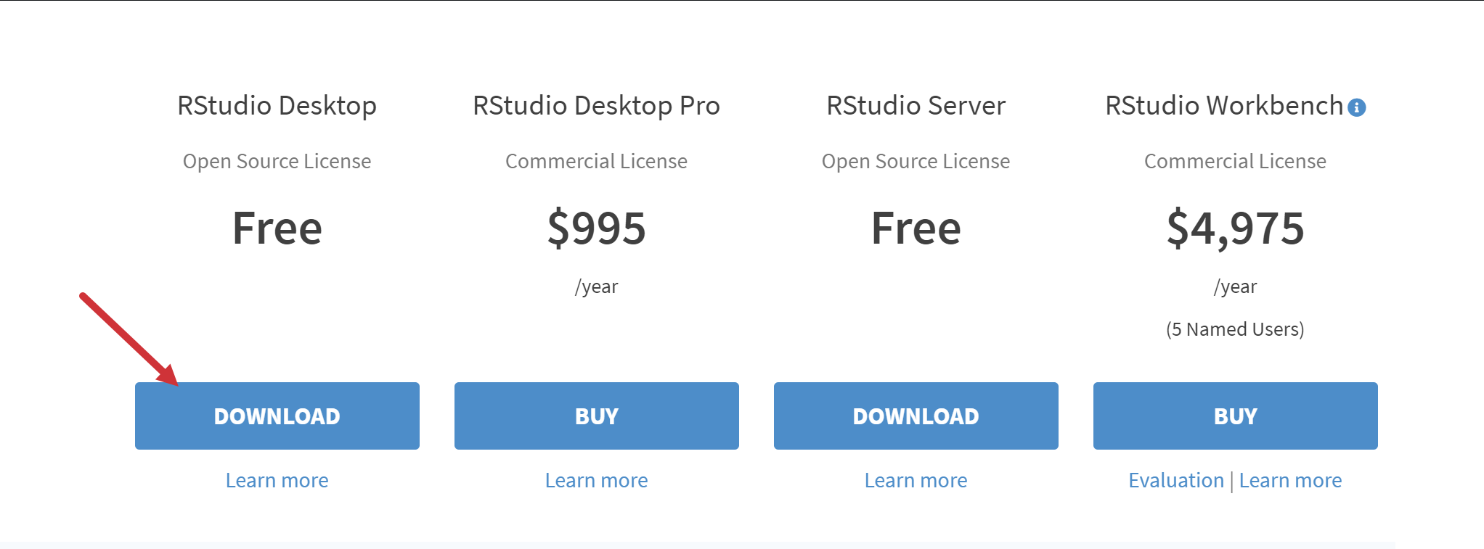
* Click “Download RStudio for Windows”

Complete installation

**Connecting R to Power BI**

1. Go to File > Options and settings > Options > R scripting > Detected R home directories.
   1. Your R home directory should be default be listed under “Detected R home directories,” but if it is not or you need to change it select “Other” from the dropdown.
   2. You can now browse your computer to locate the path of your R installation.

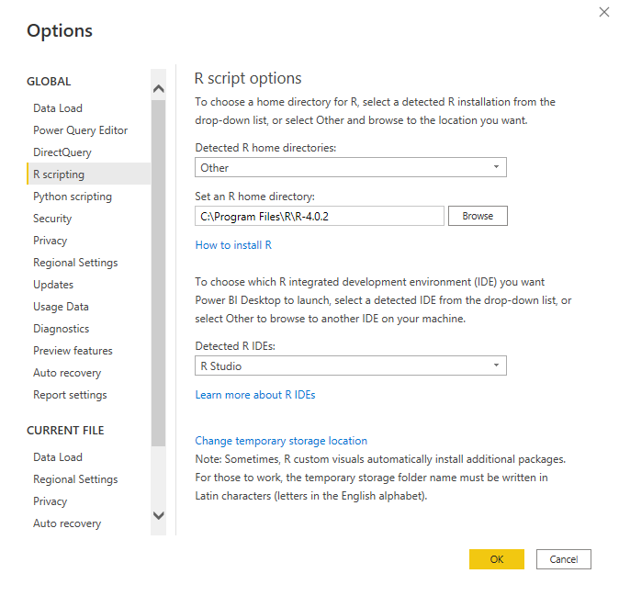

1. To locate your R installation, open RStudio and from the menu select Tools > Global Options
   1. The path to your R installation will be available under “R version.” Plug this path into Power BI.

