**How R talks with Power BI**

There are three places to integrate R with Power BI; let’s walk through them here:

1. Data import.

You can insert a script to load data in as a query:

* Go to Data > Get data > More > R Script
  + For example, we can read in this [CSV file from the web](https://raw.githubusercontent.com/mwaskom/seaborn-data/master/tips.csv) using this code:

- 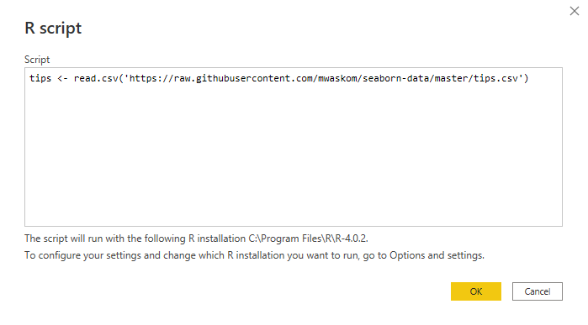

* From here, you’ll be able to load this query in as a table called tips and use it as any other data source.

1. Insert a step in the Power Query editor  
     
   This lets you run an R script as part of the Applied Steps in Power Query.
   * Transform > Run R script  
     Graphical user interface, text

     Description automatically generated
   * By default, your table is stored as a data frame called *dataset*. You can create a new data frame and operate on it like so:

* When you are done, the new dataset will appear in the Editor.
* Click on the gearwheel under Applied Steps where the R script was run to review what code was used.
  + You can click on Table to re-expand the data frame.   
    Graphical user interface, application

    Description automatically generated

1. Insert a data visualization

This lets you insert an R visualization as part of the report.

* Select the fields you’d like to include as part of the visualization.
* Click on the R visualization icon.
* This will launch a script at the bottom of the report.
  + Again, the default data frame loaded will be called *dataset*
  + You can run a plot function in the script, then click the play button at top of script editor to render the plot in the report.   
      
    