## Load the datasets into Power BI

1. Get Data > More > R Script:

housing_pred <- readRDS("C:/Users/User/Documents/GitHub/edna-r-pbi-exploration/housing_pred.rds")

housing_pred_grid <- readRDS("C:/Users/User/Documents/GitHub/edna-r-pbi-exploration/housing_pred_grid.rds")

Note that you can insert an R script into Power Query, but reading from an RDS file is usually preferred.

## Create the what-if parameter for predicted values

We want to create a single-value slider to get a predicted price for a given lot size.

1. Create a parameter: Modeling > New Parameter
   1. 1650 to 16150 in increments of 500
2. Define the relationship between your prediction grid and the what if grid datasets

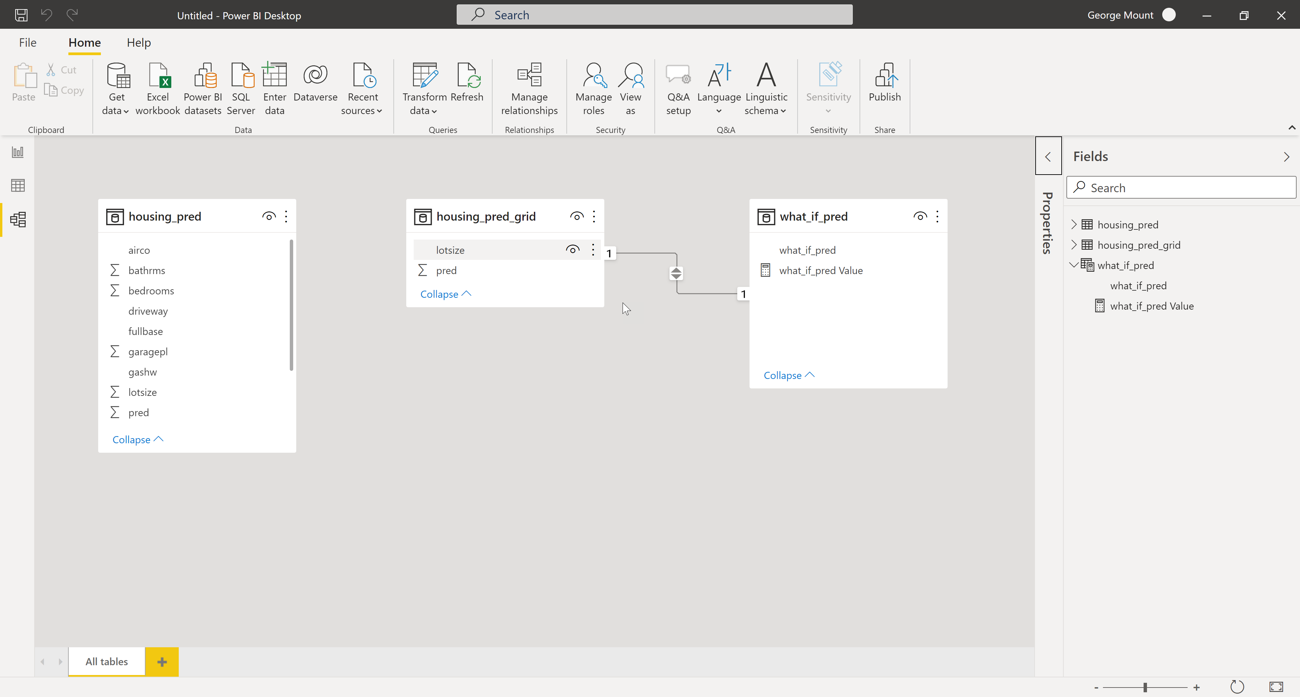

1. Format the pred column from housing_pred_grid and what_if_pred from the parameter table. Rename the pred column in housing_pred_grid to “Predicted price”
2. Add to the report
3. Add a Card visual with Predicted price.

## Add data visualization

1. Insert the R visual into the report
2. Drag lotsize, prefarea and price into Values

Run the following code:  
  
# The following code to create a dataframe and remove duplicated rows is always executed and acts as a preamble for your script:

# dataset <- data.frame(lotsize, prefarea, price)

# dataset <- unique(dataset)

# Paste or type your script code here:

library(ggplot2)

ggplot(data = dataset, aes(y=price, x=lotsize, color=prefarea)) +

geom_point() +

geom_smooth(method='lm')