Five tips for virtual Excel instruction

1. **Draw attention to the spreadsheet**

Make the screenshare BIG!

1. Use Ctrl + Spinwheel up to increase size of cells. This can also be done with the Zoom wheel on lower-right of workbook:  
   
2. This does *not* affect size of the font in the formula bar. To do that, go to File > Options > General > Font size.   
   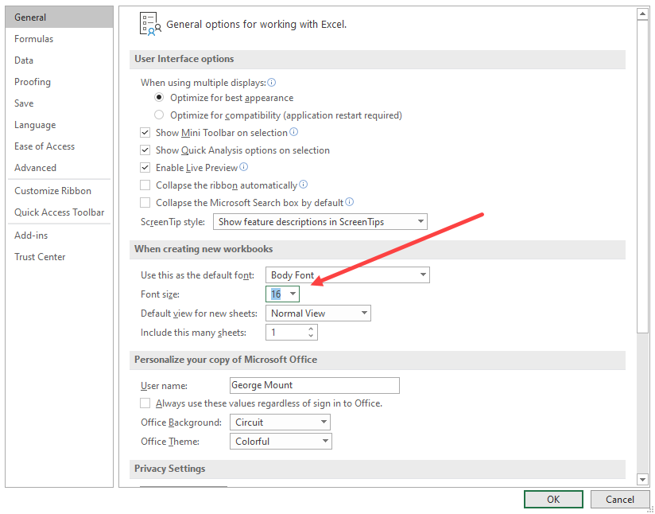
   * Restart Excel for changes to take effect.
3. Use the Logitech Spotlight to highlight parts of the screen and more. [Learn more here](https://www.logitech.com/en-us/products/presenters/spotlight-presentation-remote.910-004654.html). I do not earn a commission from endorsing this product.
4. **Get help with your functions**You can open a visual menu to walk through a function and describe each argument by going to the ribbon: Formulas > Insert Function. You can search for a function by name, or view a list by category. (This is a great way to learn about different functions!)

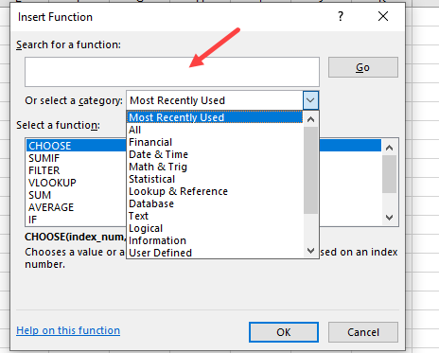

In this demo, we will use this feature first to generate random qualitative data with the CHOOSE() function, then count how many of one choice are in the resulting range with the COUNTIF() function.

1. The CHOOSE() function can be used to return a specific value given an index number. We will randomly choose an index number with RANDBETWEEN(), which will then choose one of the resulting values:   
   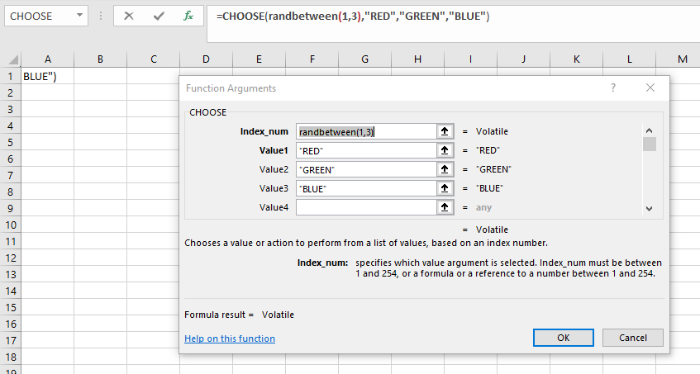
2. Fill your resulting function down for a few rows. We now want to count how many times the value RED is found in the range. Search for and use COUNTIF() to do this. Note that the formula even evaluates for you before even entering it:  
   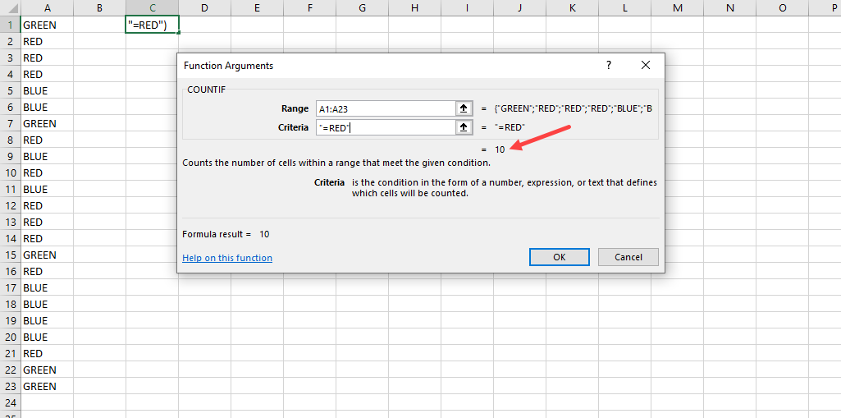

1. **Show off your formulas**
   1. Use the FORMULATEXT() function to display the formula contents of a given cell:  
      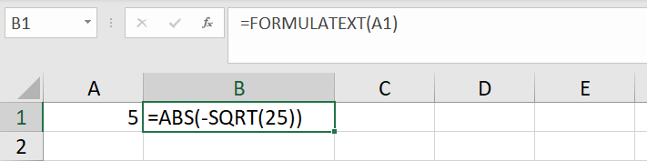
   2. FORMULATEXT() will evaluate to #N/A if referring to an empty cell. To avoid this until you’ve written to that cell, pass it into IFERROR():  
      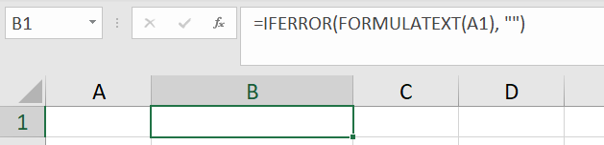
2. **Display your keystrokes**
   1. [Download Carnac here (Windows only).](http://code52.org/carnac/)
   2. Once downloaded, move the files to a folder like C:\Carnac:  
      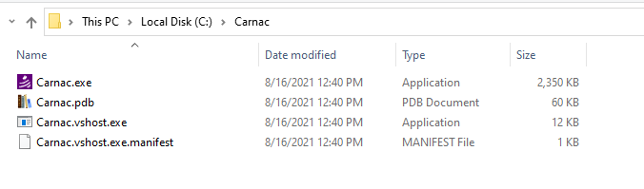
   3. Search for and run carnac.exe in the Windows search bar
   4. Change options like the screen positioning or keystroke size with the open window:  
      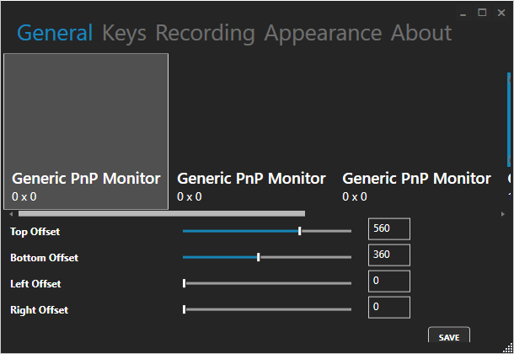
   5. Click on Carnac in system tray (small icons by clock) and select “Exit” to end sharing keystrokes.
3. **Embed workbooks**

This feature works on an Office Business account but is much easier to demonstrate on n Personal account.

* 1. Navigate to the workbook you want to embed in your OneDrive Online and select “Embed”  
     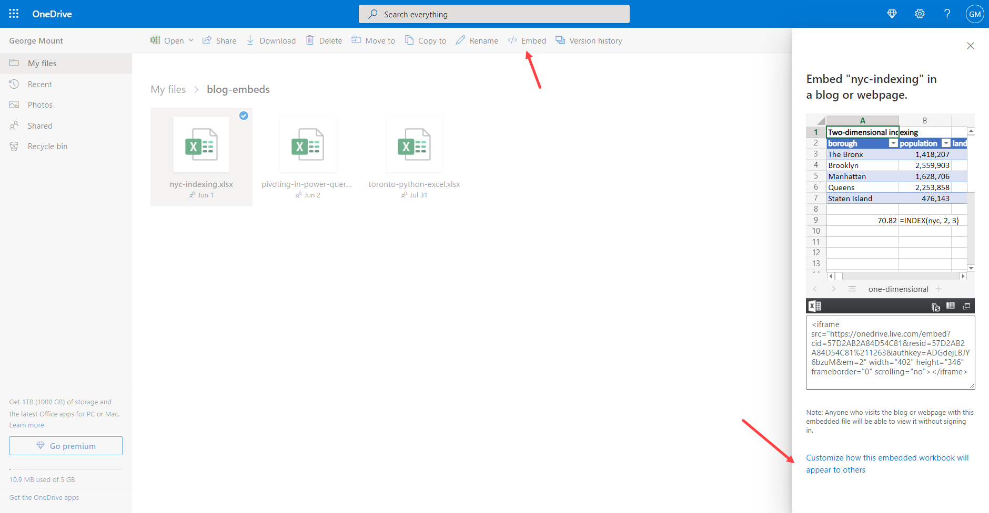
     1. Click “Customize how this embedded workbook…” on lower-right
  2. Here you can specify what ranges in workbook to display, the dimensions of the embed and so forth  
       
     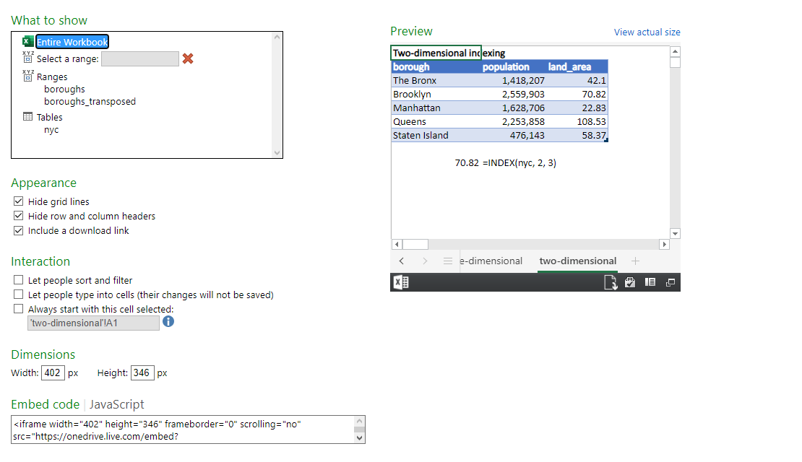
  3. Embed the IFrame code in your website or CMS (like WordPress)