**TRANSFORMING COLUMNS IN POWER QUERY I – DEMO NOTES**

**Demo: dvdrentals.xlsx**

1. Create the query from the source table.
2. Convert Title and Artist Name to proper case by right-clicking the column and selecting Transform -> Capitalize Each Word.
3. There are no spaces after commas or colons. Add them by right-clicking on the headers and selecting Replace Values. Replace commas, then colons with each character followed by a space.

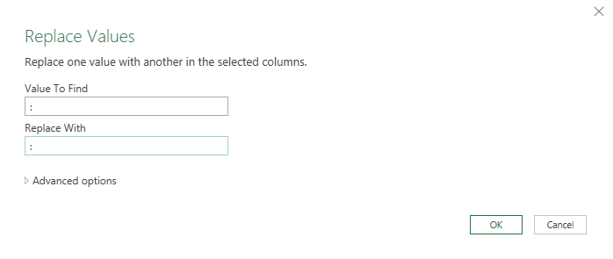

1. Split Item # into two columns based on the space delimiter by right-clicking on the column and selecting Split Column -> By Delimiter -> Space.
2. The UPC and ISBN 13 columns are probably better classified as strings than numbers. Change their types by clicking on the number icons to the left of their column headers and changing to text.
3. We don’t need the BTKey column. Simply select it and hit Delete on your keyboard
4. Now, change the Retail column from Decimal to Currency.
5. Finally, convert the Release Date column into three columns, Year, Month and Day:
   1. Right-click the column label and select Duplicate column. Do this twice so there are three Release Date columns in total.
   2. Right-click the first one, and select Transform -> Year -> Year.
   3. Do the same for the remaining columns, but for Month and Day.
   4. Now, rename these columns as Year, Month and Day

**Drill: orders.xlsx**

1. Convert the Date column to a month data type.
2. Convert the Account column to proper case.
3. Split the Opportunity column into three columns:
   1. Vendor
   2. Status
   3. Order Type