**TRANSFORMING COLUMNS IN POWER QUERY II – DEMO NOTES**

**Demo: population-densities.xlsx**

1. Load into Power Query
2. First, create a concatenated field in the format: Name (Abbreviation)
   1. Add Column on the ribbon, then Custom Column.
   2. Name this column state-full. Use ampersands to concatenate strings:

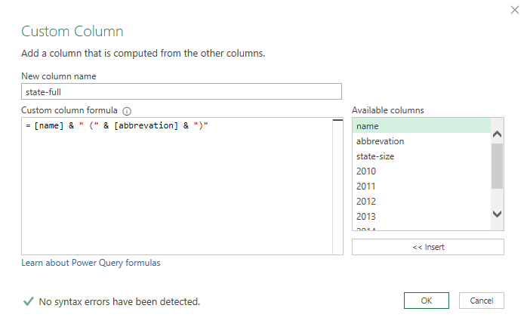

* 1. Click link at the bottom of this menu to “Learn about Power Query formulas”: – this is M code.
  2. Our new column is added to Applied Steps. We can view the formula using the gear box.

1. Move the column to the front of this dataset by holding down Control and dragging it to the front.
2. Delete the two columns we had referred to in our formula. We can delete them and not break our calculated column.
3. We want to calculate population density. Rather than calculate the density for each year, we can “tidy” this dataset to get one, “population” variable, then calculate the density for each year in one fell swoop.
4. To create a “Year” column, select all but the 2010-2016 columns, then right-click and select Unpivot Other Columns.

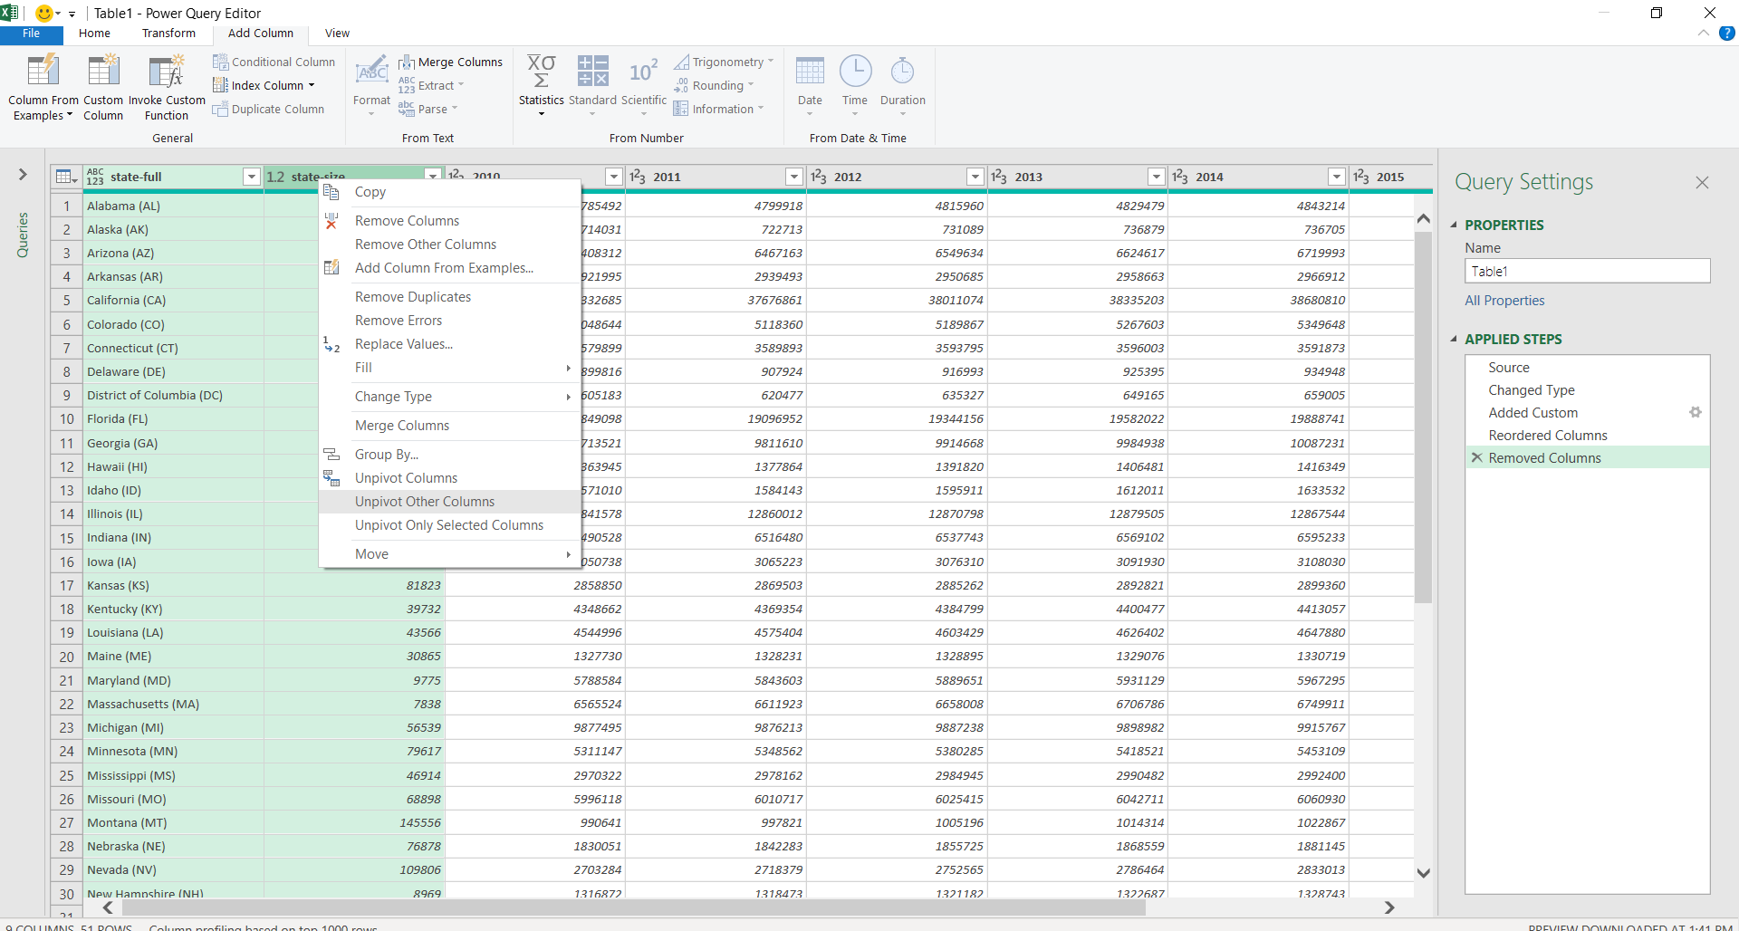

1. We can re-name the Attribute and Value columns to Year and Population, respectively.
2. Now we can create another custom column formula, Density, which is Population/state-size.

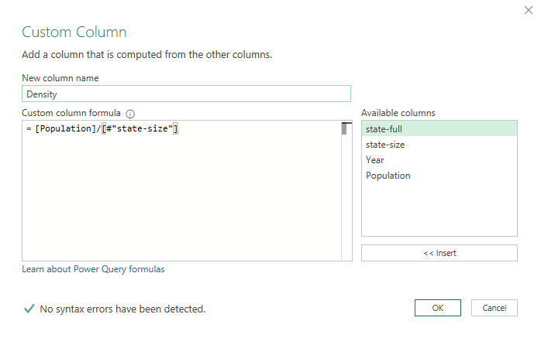

1. Finished! Close & load.

**Drill: wholesale-customers.xlsx**

1. Remember this data from the beginning of the lesson? Tidy it!
2. Create a field calculating 10% of the sales called Tax.