**JOIN BEYOND THE BASICS – DEMO NOTES**

**Demo: championships.xlsx**

We would like to find what cities can claim *only* a baseball or football championship.

1. Preface: This data has been wrangled using Column From Examples. This is a powerful way to add a conditionally-formatted column to a table.
   1. To do this, open the football query, select WINNER field and head to the query editor and Add Column > Column From Examples > From Selection.
   2. What we want to do is start typing the name of the team in the new column. Power Query will start to use conditional logic to begin to complete the field for us.
   3. This is an iterative process. Power Query might get things right at first and then not later. Eventually it should get to “the truth” as determined by you. You can then click OK and use the column in your query.

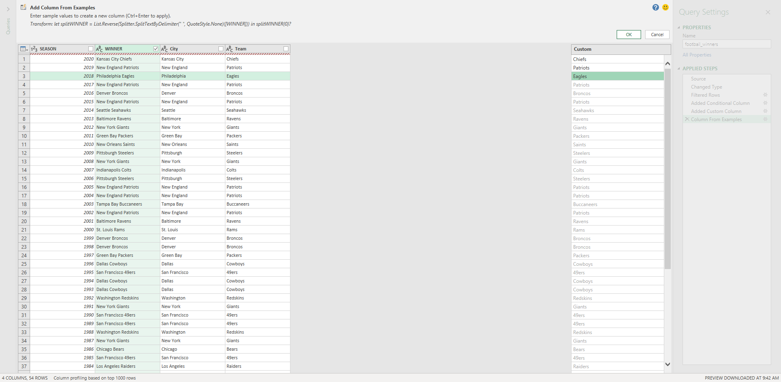

1. Back to the task at hand: We want to find what teams have a baseball championship and not a football championship.
2. Open up the baseball query in the editor and go to Home > Merge Queries > Merge Queries as New.
   1. This way we don’t write over this current query, we make a new query.
   2. This will be a left anti join, to get the cities that have a baseball and not a football win.

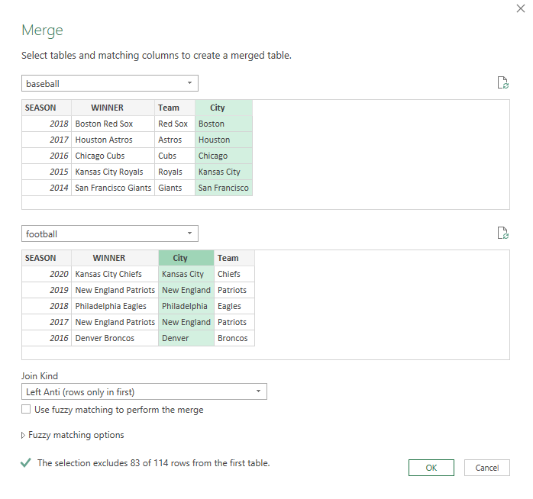

1. Click OK. You are going to see a new column “football” in our query which we can expand, however since we are only keeping the baseball records, this is going to be all blank.
   1. Since it’s a blank field, let’s delete it.

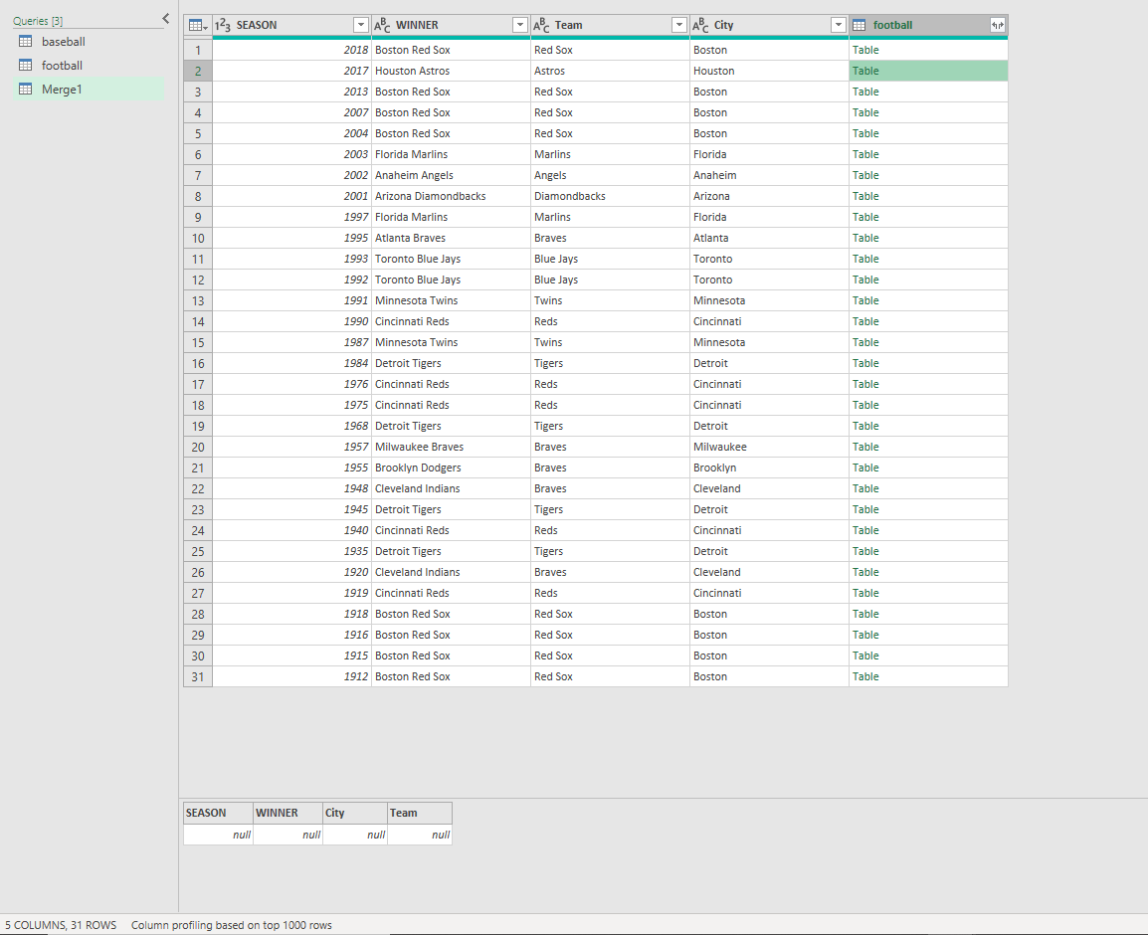

1. Here we can see all the cities that have a baseball win but not a football win. We could clean this up further if we wanted by removing the other fields and then going to Home > Remove Rows > Remove Duplicates.
2. Let’s rename this query as baseball_only.
   1. One quick thing to notice about our data – we see for example that “Florida” is listed as a city because that is the name of the team. Currently, the Florida Marlins are the Miami Marlins – and the Miami *Dolphins* have won a Super Bowl, so we could dispute whether this one should be on the list.
      1. There are lots of other ways to nitpick our results, what else can you think of?

Let’s now find cities that have a football but not a baseball win.

1. Go back to the baseball query and select Home > Merge Queries > Merge Queries as New.
2. This time we will want a right anti-join, to get only the cities with just a football championship.

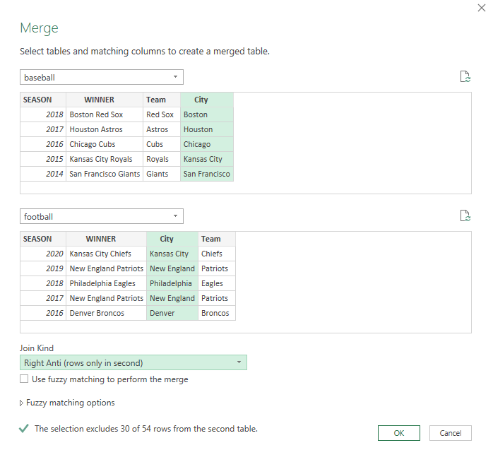

1. This time it looks like we didn’t get any data, however that’s because all of it is “hidden” in that “football” field. Go ahead and click on it to expand. We can then get rid of the null baseball records.
   1. We now have a list of cities who have a football but no baseball championship.
   2. Let’s name this query football_only.

Drill: championships-2.xlsx

Which cities can claim *only* a hockey or basketball championship?

(Just fill out the city name, you don’t need to create a team name column.)

**Demo: office-employees.xlsx**

Worksheet:get-to-know-you

HR wants to set up a get-to-know-you activity for the sales team. You need to set up a table so that each salesperson can fill out their favorite color, food, sport to play and sport to watch.

We can do this with a cross join in Power Query:

1. We’ve already loaded each of these tables in as queries. Click into the names query to edit.
2. Copy and paste the names query and rename it get_to_know_you.
3. We want to add a custom column (Add Column > Custom Column). We will name this column favorite_things.
   1. The formula for our column will be favorite_things. This is another query that shows up in the Intellisense.

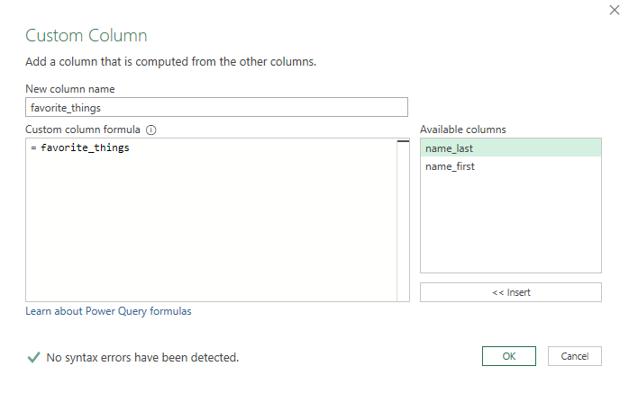

1. Click OK. Now if you click on any of the favorite_things cells, you can get a preview of the resulting data at the bottom of your screen:

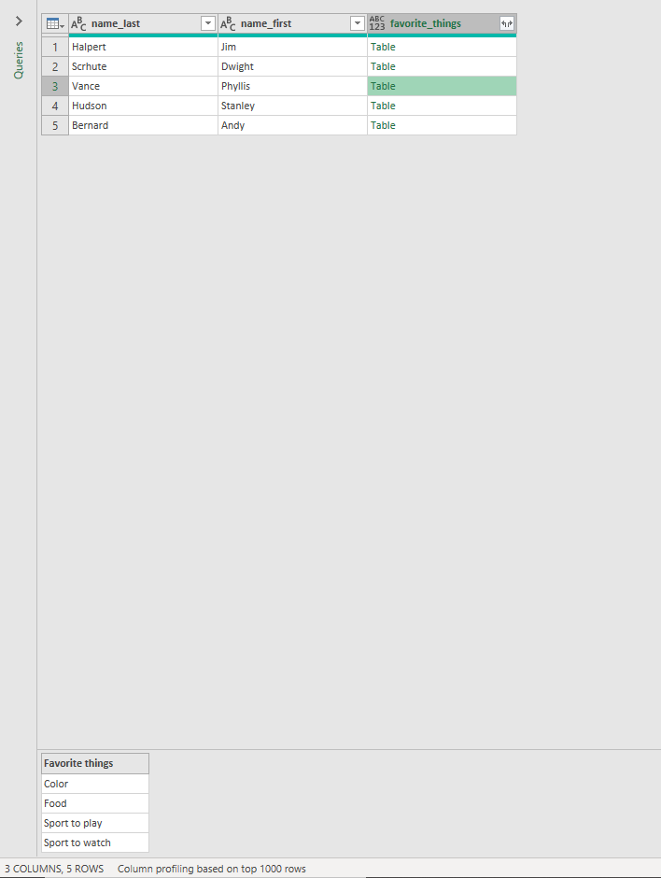

1. Go ahead and expand the data now. We will get this in a tabular form now.
2. To pivot this table to make a checklist, we first need a “values” column to pivot on. This is blank for now so we can insert a blank or null field:

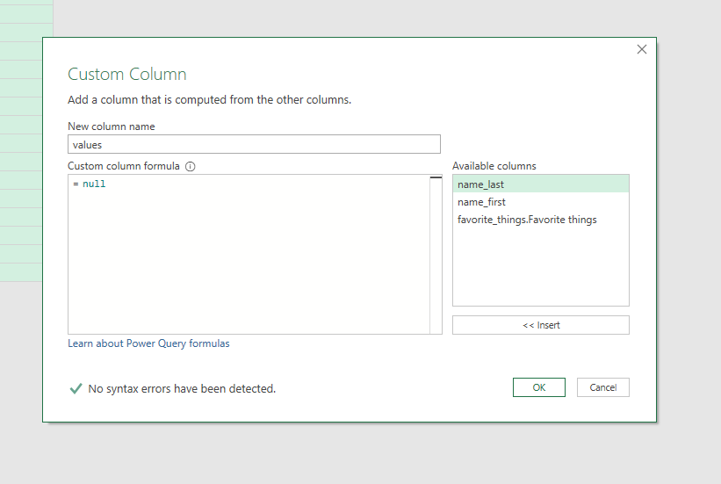

1. Now we need to “pivot” on top of favorite_things, based on the values column.
   1. Select the favorite_things column and go to Transform > Pivot Column.
   2. Select values as the column to pivot on, then select Advanced Options and choose “Don’t Aggregate” as your aggregate value function.

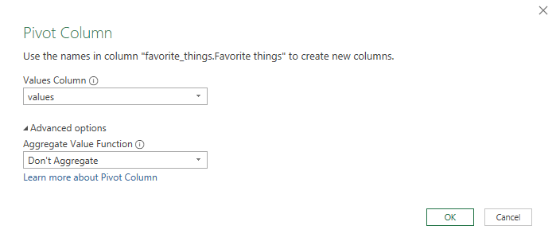

1. We now have a “checklist” table that we can load into Excel.

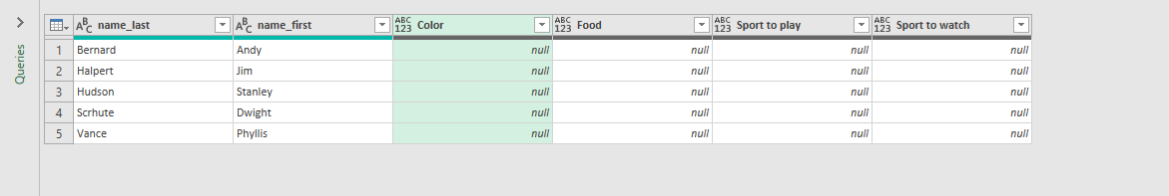

1. Currently the names query is loading to a connection only. If we want to change that we can right-click on the query and select Load To.

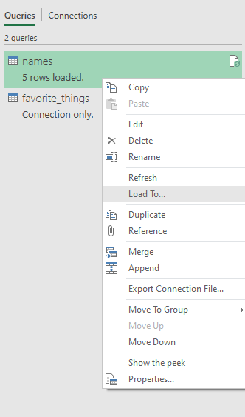

Drill: states.xlsx

Create a table to record each state’s bird, flower and capital.

Demo note: Note that we can add a new property to our table, and refresh it and get that added, for example we can add the state song to the worksheet.

