**POWER QUERY AS EXCEL’S ETL – DEMO NOTES**

* I want to “pivot” on the file wholesale_customers.xlsx. What is the problem? .
  + There is no “sales” field to “pivot” on. I have several fields representing one attribute, category.

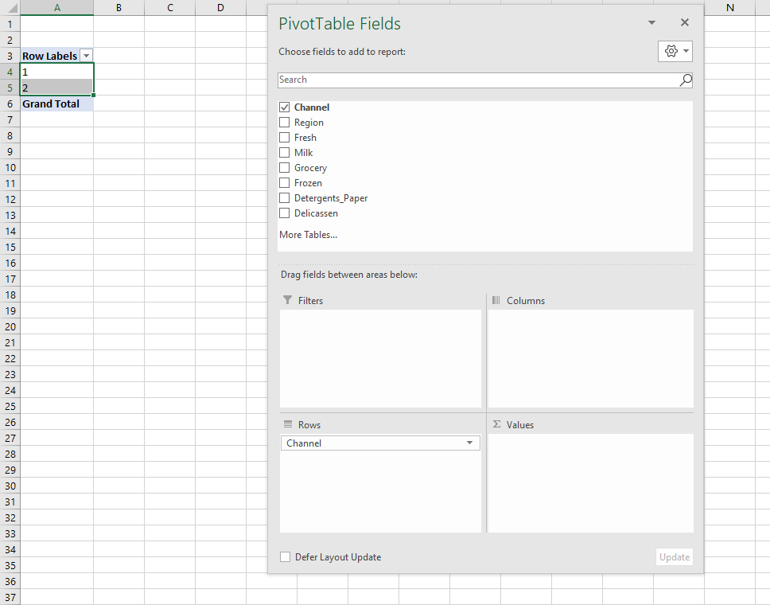

* *How would we have fixed this in Excel without Power Query*
* *What does this example tell us about how data should be shaped?*