**FIRST STEPS IN POWER QUERY – DEMO NOTES**

**Import a Table into Power Query**

Demo: star.xlsx

1. Leave cursor anywhere inside the range you want to select
2. On the ribbon, select Data -> From Table/Range

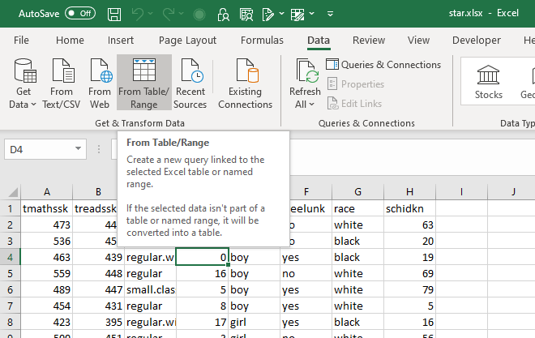

1. This will convert the range to a Table.

* Ok, I think we are ready to explore Power Query, let’s do so on a relatively clean dataset so we can get a nice lay of the land here and how to use the interface because it’s honestly kind of disorienting and intimidating at first.

1. You will now see the Power Query Editor (source: <https://people.highline.edu/mgirvin/AllClasses/348/MSPTDA/Content/PowerQuery/003-MSPTDA-IntroToPowerQuery.pdf>)

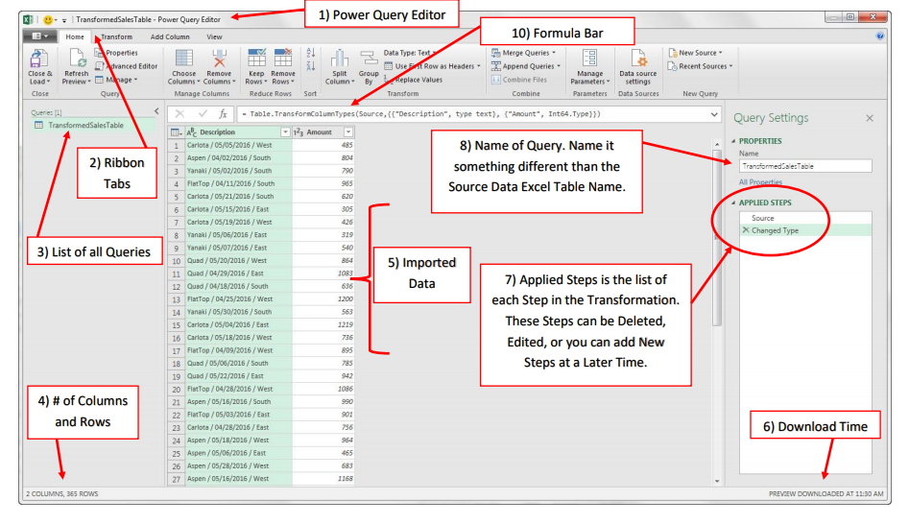

* 1. A Home ribbon is at the top, just like in Excel. The first three tabs are going to have data cleaning functionality.
  2. The imported data is in the middle of the screen. We can click on rows and cells and see their values at the bottom of the screen.
  3. There is a small table icon in the “corner” of the dataset. Click on that and there are some shortcuts to working with this data.

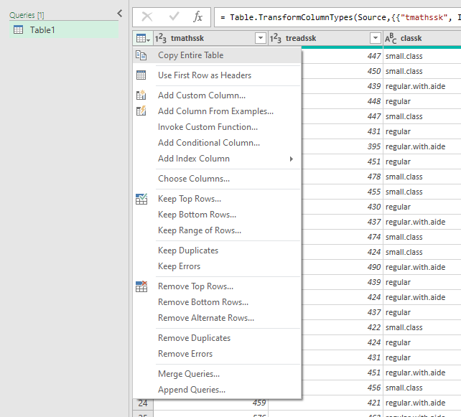

* 1. Click on any column drop-down and you’ll see you can filter it just like in native Excel.

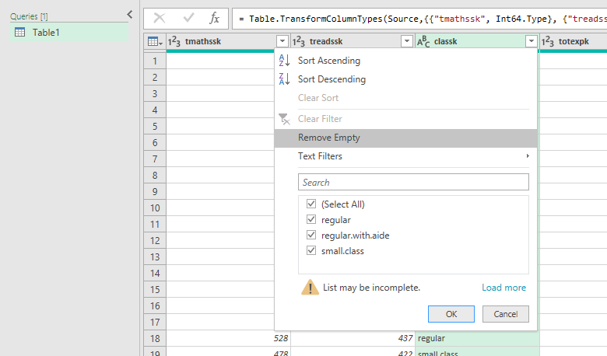

* 1. You’ll also see a symbol to the left of the column. This indicates the column’s type. You can click on that to change the data type.

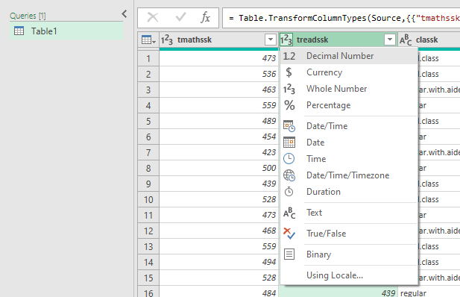

* 1. You can also right-click on a column to operate on it. Hold down Ctrl and click multiple columns to operate on multiple columns.

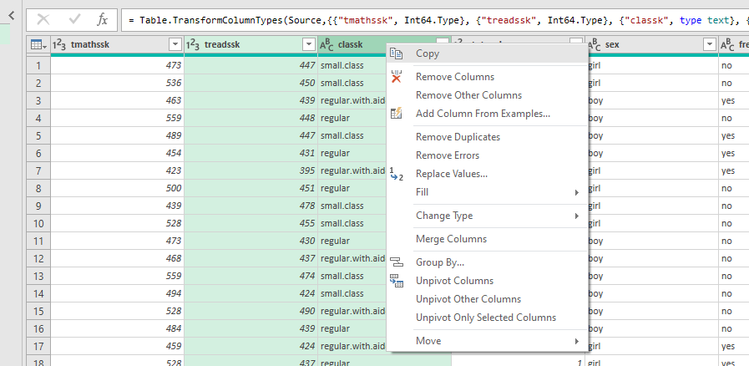

* 1. Now, go to the View tab on the home ribbon.
     1. Initially, what you are seeing in the Power Query editor is based on the first 1,000 rows.
     2. To include all data in the Data Preview, click the message at the bottom which says Column profiling based on top 1000 rows. Change to Column profiling based on entire data set.

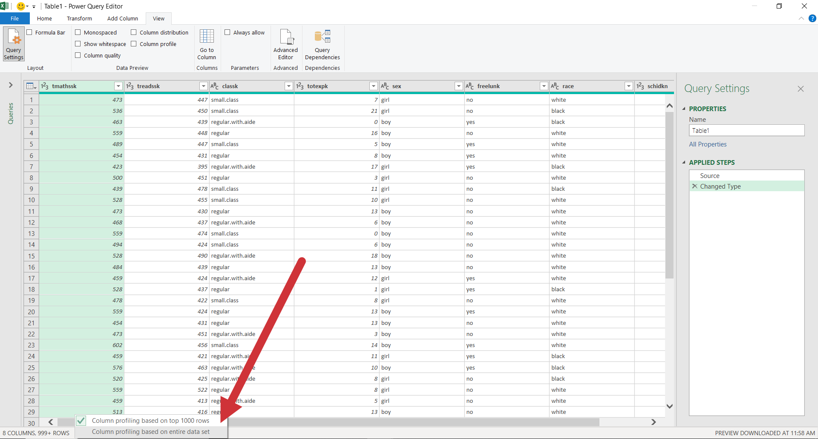

* 1. You can now change column appearance and add some statistics about each column using the Data Preview group of the View tab.

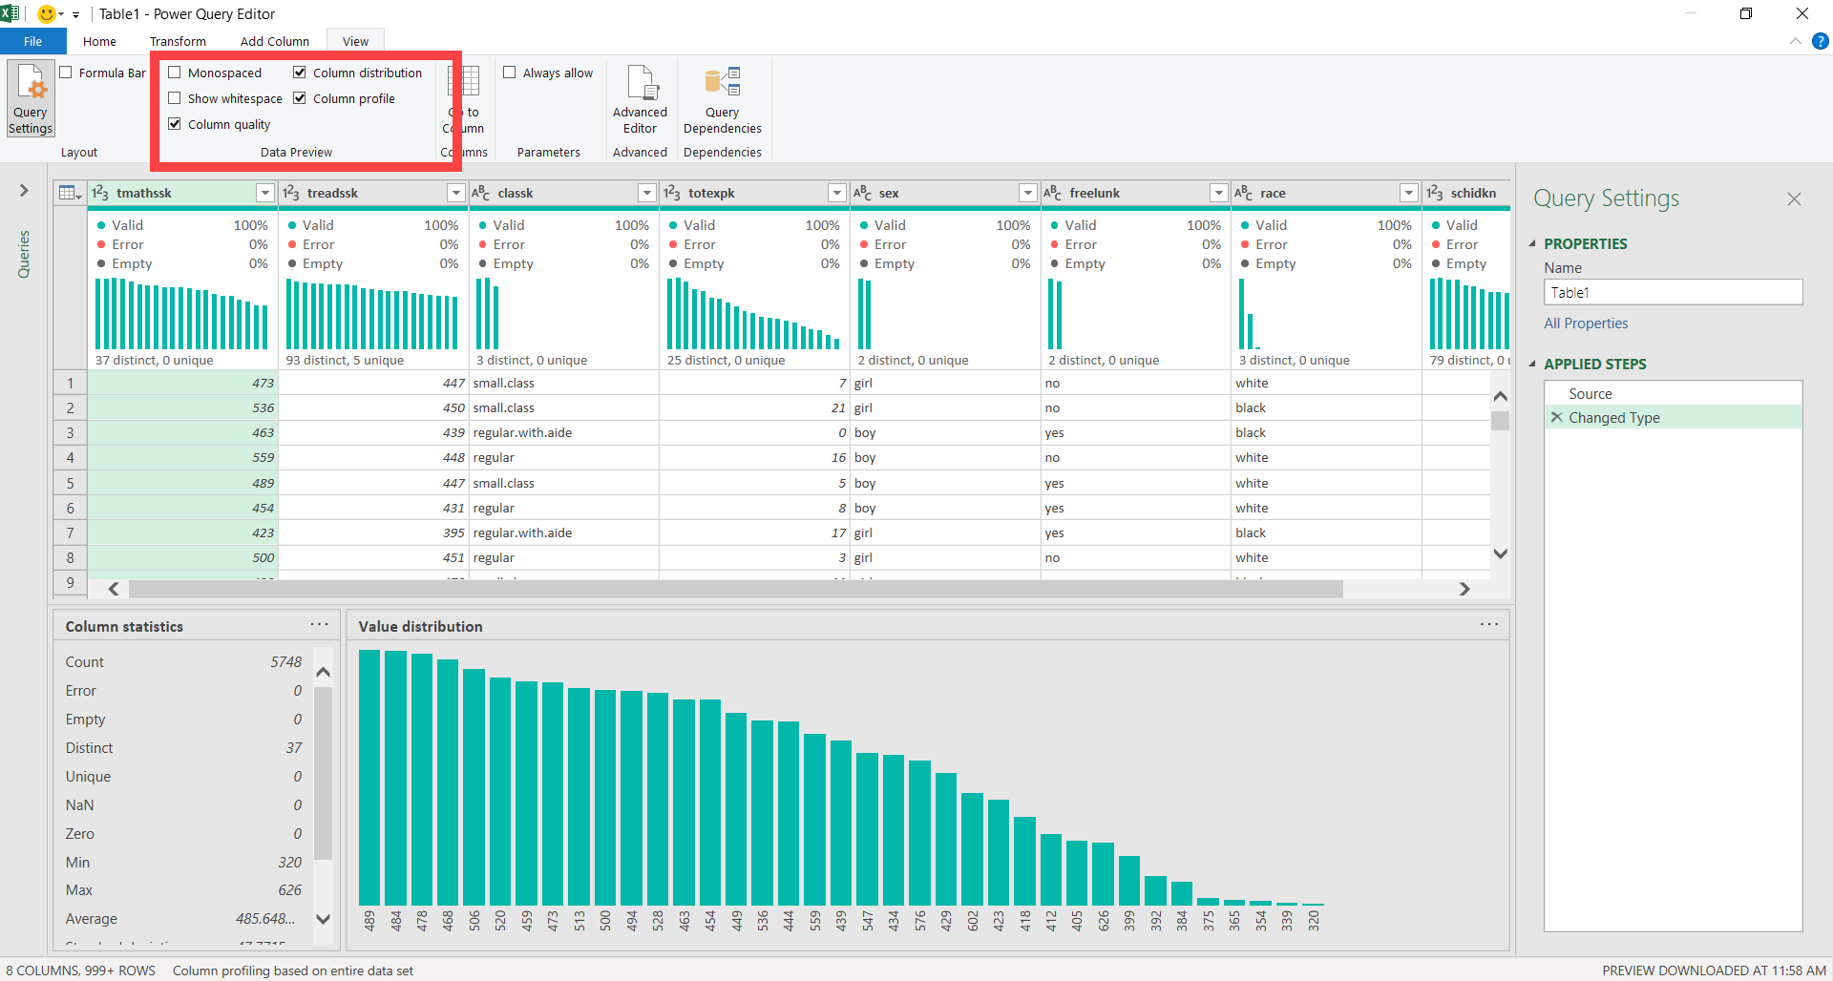

* 1. To exit the Power Query editor, hit the X on the upper-right. You can discard your changes for now.
     1. This will return you to “classic” Excel.

