**APPENDING TABLES IN POWER QUERY – DEMO NOTES**

**Demo: oscars_yes.csv, oscars_no.csv**

1. Start with a blank workbook.
2. This time we will connect to a csv file. Still go to Data -> Get & Transform Data and select From Text/CSV.
   1. Connect to oscars_yes.csv
      1. Note: If we have the [direct URL to the file](https://raw.githubusercontent.com/summerofgeorge/olt-intro-to-excel-power-query/master/6-transforming-columns-ii/6-b-appending-tables/oscars_yes.csv), we can connect to the CSV file that way.
   2. An import menu will appear previewing the data. If we wanted to re-shape this data, we could select Transform Data at the bottom; however Excel seems to have done a good job with the import, so let’s go ahead and load it to a table.

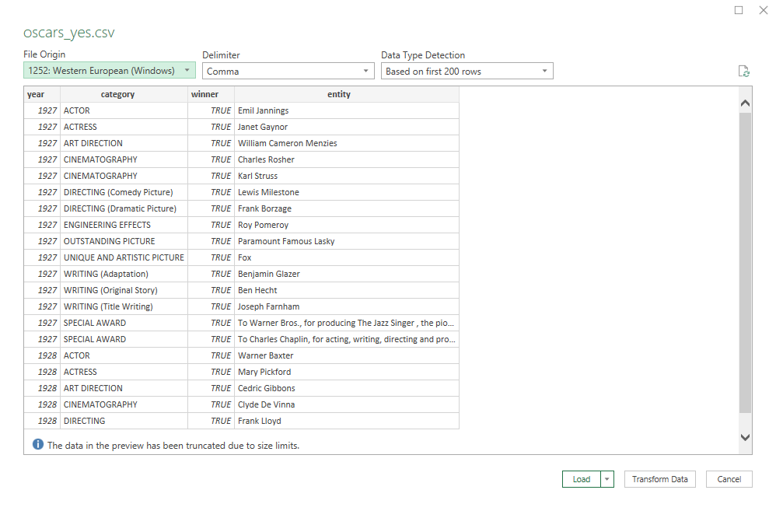

1. Do the same thing to export oscars_no.csv into this workbook.
2. There are now two queries in the Queries & Connections menu.
3. Right-click on the oscars_yes query and select Append.

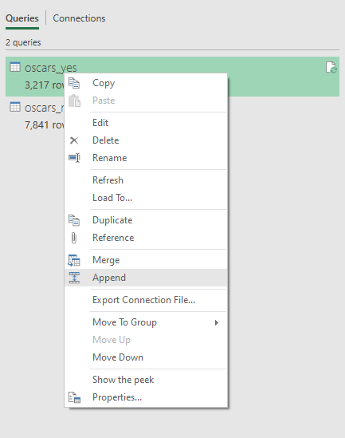

1. Now we can append oscars_no to oscars_yes.

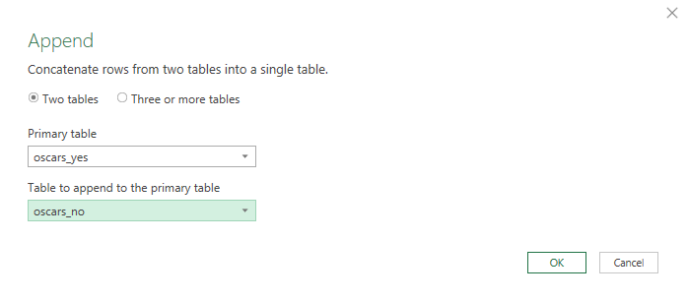

1. This will make a *new* query, named by default Append1. Rename it to oscars_append.
2. To get a visual look at how our workbook’s queries are related, go to the View tab on the ribbon and select Query Dependencies.

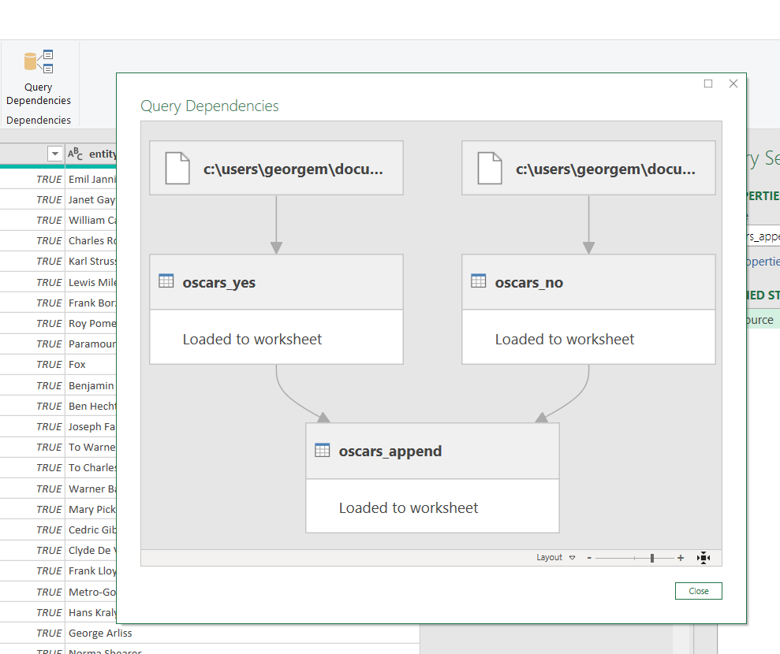

**Drill: hof_inducted.csv, hof_not_inducted.csv**

1. Append these tables.

**Demo: state-populations folder**

This time we want to append the results of several files that are located in a folder. Instead of importing these in one at a time, we can read in the whole *folder* and append the data.

1. Open a blank Excel workbook and go to Data > Get Data > From File > From Folder
   1. Locate your state-populations folder. You are now going to see all of your files listed in this folder. That is pretty nifty already! We are going to take it a step further by appending these files together.
      1. To do that, select Combine > Combine & Transform Data

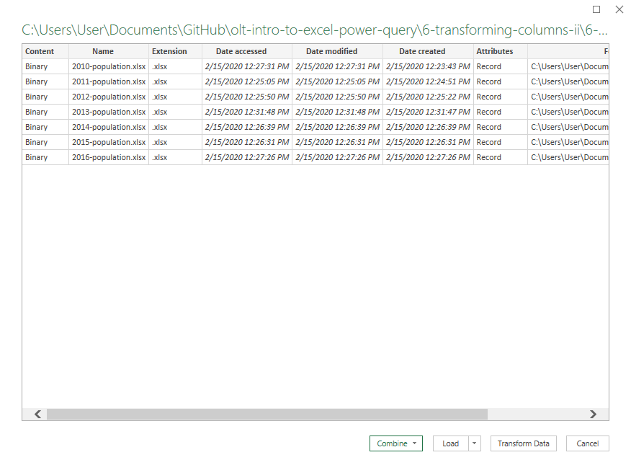

1. We now need to select what we should be extracting from each file. We only have one worksheet each named the same thing, so this is pretty easy. We will select “Combine & Transform Data.”

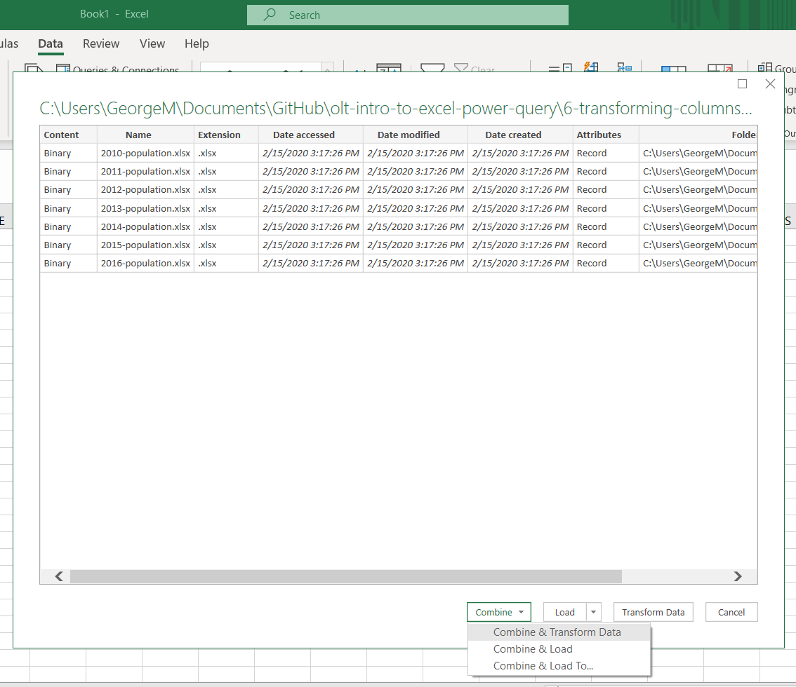

1. Click on the “state-population-worksheet” as the object that we want to extract from our files. This is the same across *all* files which will make this a lot easier for us.
2. Now you are going to see all these files have been appended together, we have a separate column for the file name, we can get rid of that if we want.
   1. Check out how we have a whole series of different queries to get to our result this time.

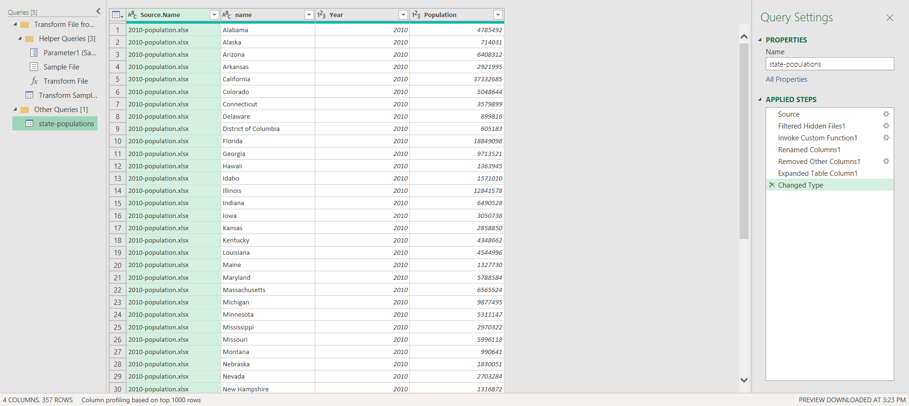

**Drill:** baseball folder

This is a download of the csv version of the [Lahman baseball database](http://www.seanlahman.com/baseball-archive/statistics).

1. See if you can get a table of *all* files in this folder using Power Query.
   1. In this case we *do not* want to transform the data, just load a table of the file metadata.