**VLOOKUP(), MEET JOIN – DEMO NOTES**

**Demo: flights-and-planes.xlsx**

1. We have a table of flights and tables of planes. The “lookup value” is tailnum but there is not a “match” for all of them (See Found in planes? column to confirm.)
   1. So, when we “look up” this plane information into our flights table, do we want to keep the information about the records without a match? Essentially we are asking, when we join flights on planes do we want to use a left outer join or an inner join?
2. Load both tables in Power Query and create only a connection for each.
3. In the Queries & Connections menu, right-click on flights and select Merge.

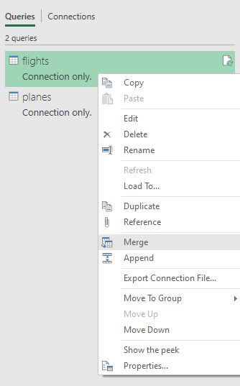

1. We will now create a merged table. We will merge flights on planes. Leave the Join Kind as Left Outer, but check out all the options available on the drop-down.

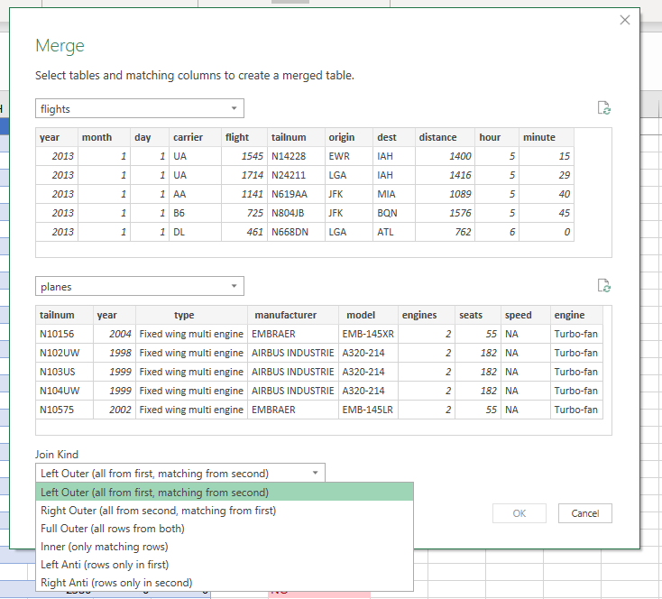

1. We can’t hit OK until we specify *what* we want to join on. In VLOOKUP()-ese, this would be our “lookup value” which in this case is tailnum.
2. We’ll get a green check-mark saying it’s matched X out of Y rows from the first table. We knew there were going to be some non-matches, so this number makes sense.
3. Hit OK, we get a new query, now we have an accordion-style menu here where we can select any of the returned fields into our merged table. We already have tailnum included in the table since that’s what we joined on, so probably we don’t need that one.

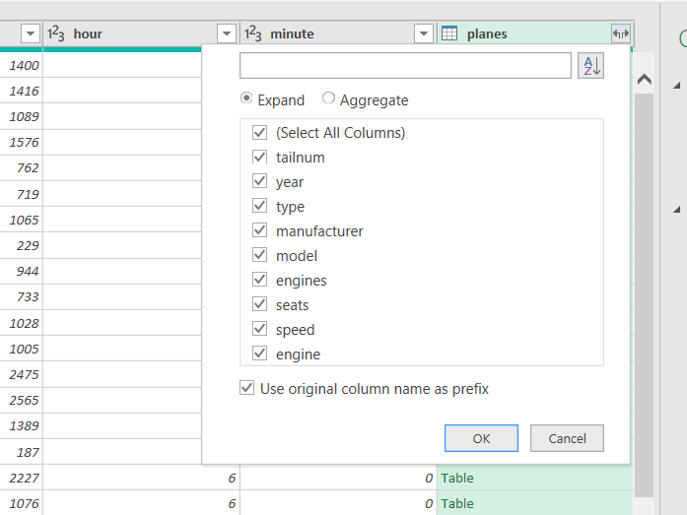

1. You’ll see that each of these are named planes.field name. Undo our Expanded step to see why: Hit the accordion again. You’ll see the option to “Use original column name as prefix” is checked on.
   1. This is not a terrible idea, for example there is a year field for the planes data and a year field for the flights field (one for when the plane was built, one for when the flight took place). So this way we easily know which is which.
2. Scroll down the resulting table and we can see there are rows of null’s where there was no match for the planes data:

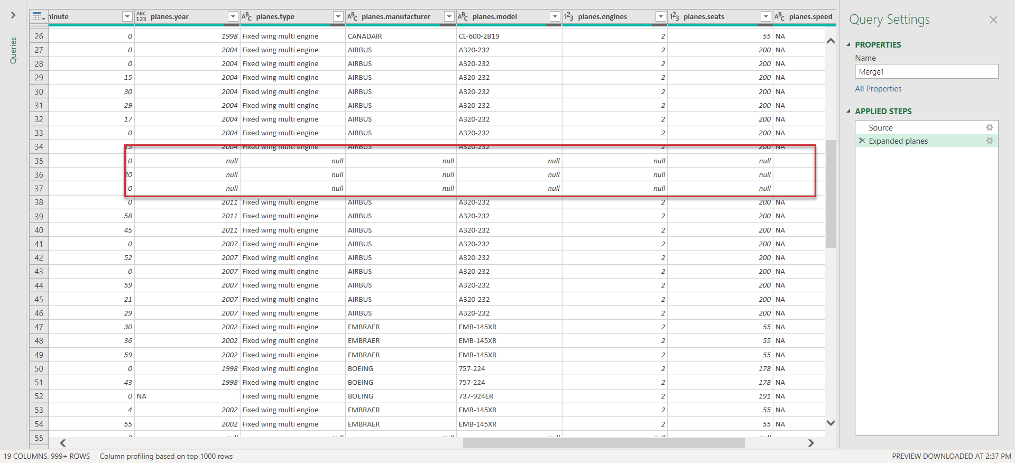

1. Now we can close and load the table and I am going to name it left_join.
2. Take the same steps except this time we will do an inner join of flights on planes.

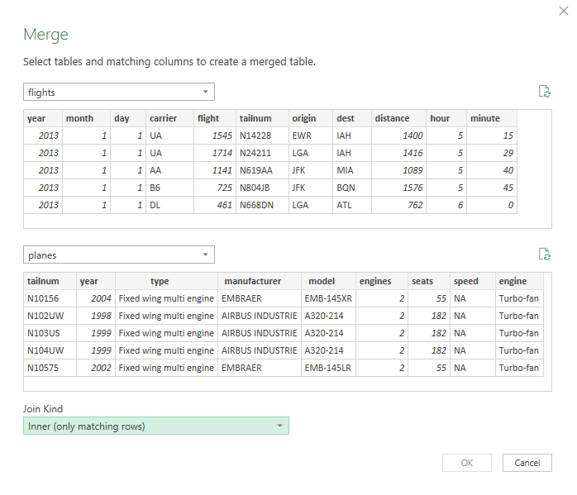

1. Another green light.
2. Same steps, expand the resulting columns and load the table.
3. Check it out, this time there are only 284K rows loaded. Why? Well we can take a look here, there are no more NULL’s for the plane info, those have been removed from the join. So it stands to reason there would be fewer rows this time.
4. Name the query inner_join.

**Drill: hof.csv, people-a-thru-m.csv**

1. What is the result of a left outer join of hof on people-a-thru-m?
2. What about an inner join?