**Downloading Anaconda**

* Go to [anaconda.com](https://www.anaconda.com) > Products > Individual Edition  
  
* Click on “Download”   
  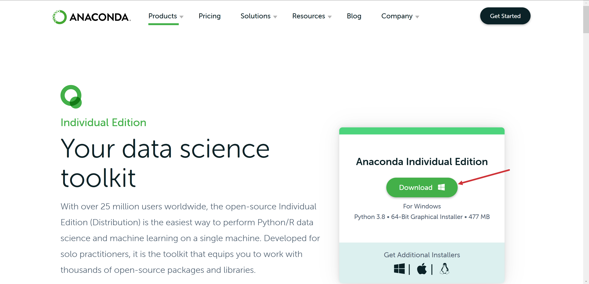
* Complete installation
* Hit Windows key, search for and open Jupyter Notebook (**don’t close the terminal window**)
  + Choose a browser to open with and click OK
* Navigate to where your workshop files are
* Select New > Python 3

