**Remote <> Origin via GitHub Desktop**

**Cloning a repo to GitHub Desktop**

1. From the repo of interest, go to Code > Open with GitHub Desktop  
   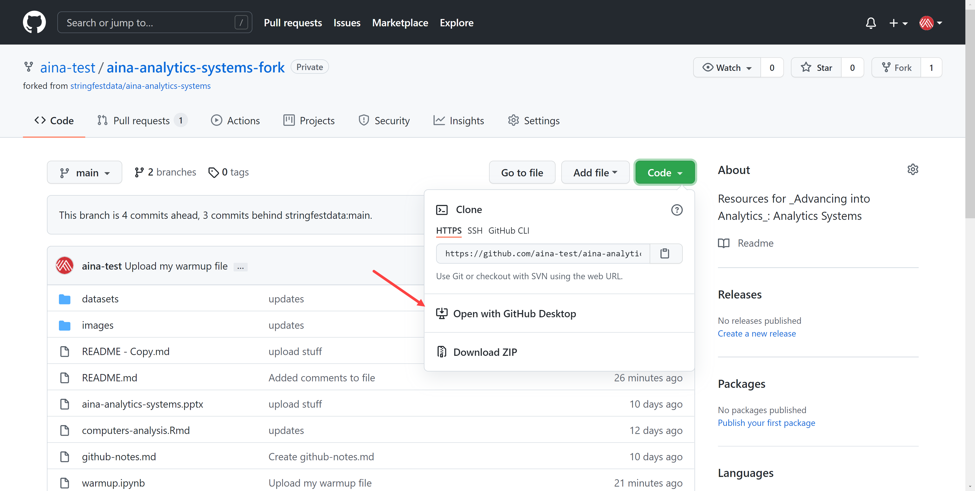
2. This dialog box will then open GH Desktop. Select what folder to clone this repo into.   
   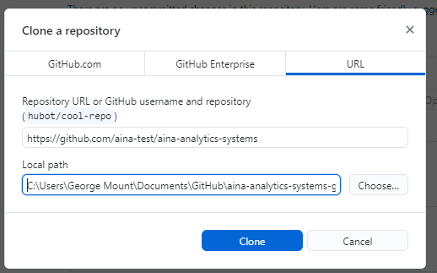
3. If you are forking a repo, it will ask you whether you’re using it to contribute to parent or for your own purposes. Choose the second.
4. You now have a copy of this repo *cloned* to your computer. It is *not* the source of truth – what lives on GitHub is the source of truth. To practice working on the so-called “origin,” or your local copy, let’s create a new repo.

**Creating a new repo**

So far we’ve been working with a *forked* repo; you could continue to do so using GitHub Desktop. But let’s create a brand-new repo instead.

1. Go back go to GitHub.com and select “New”   
   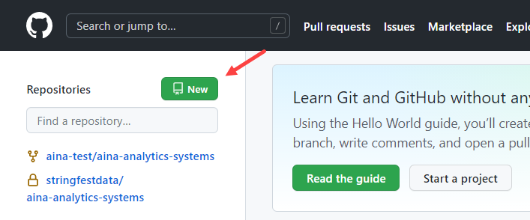
2. Create the repo:
   1. Give the repo a name and say something about it.
   2. You can set it to private or public, your choice
   3. Add a readme file
   4. Select “Create repository”  
      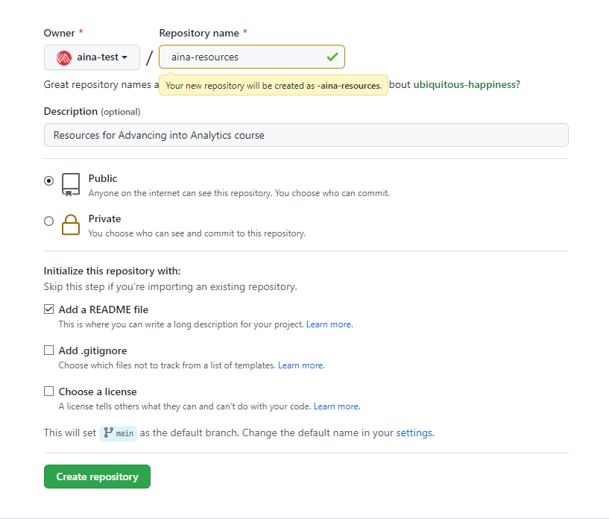
3. You can now clone the repo to your computer: Code > Open with GitHub Desktop
   1. Select where on your computer to store the repo
4. You’ve got a few options for how to access this repository’s data. You should see this in the middle of your Desktop session:   
   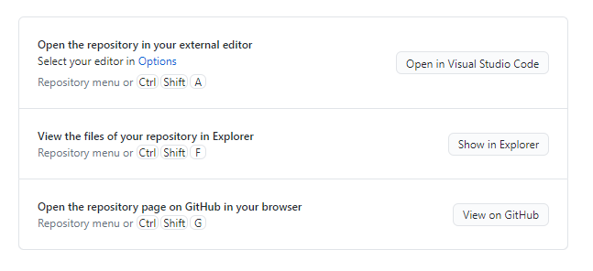
5. Choose the second option to have a File Explorer session open up to the folder where this repo is located.
6. If your first option does not say “Open in Visual Studio Code,” go to File > Options > Integrations and select “Visual Studio Code” under External editor  
   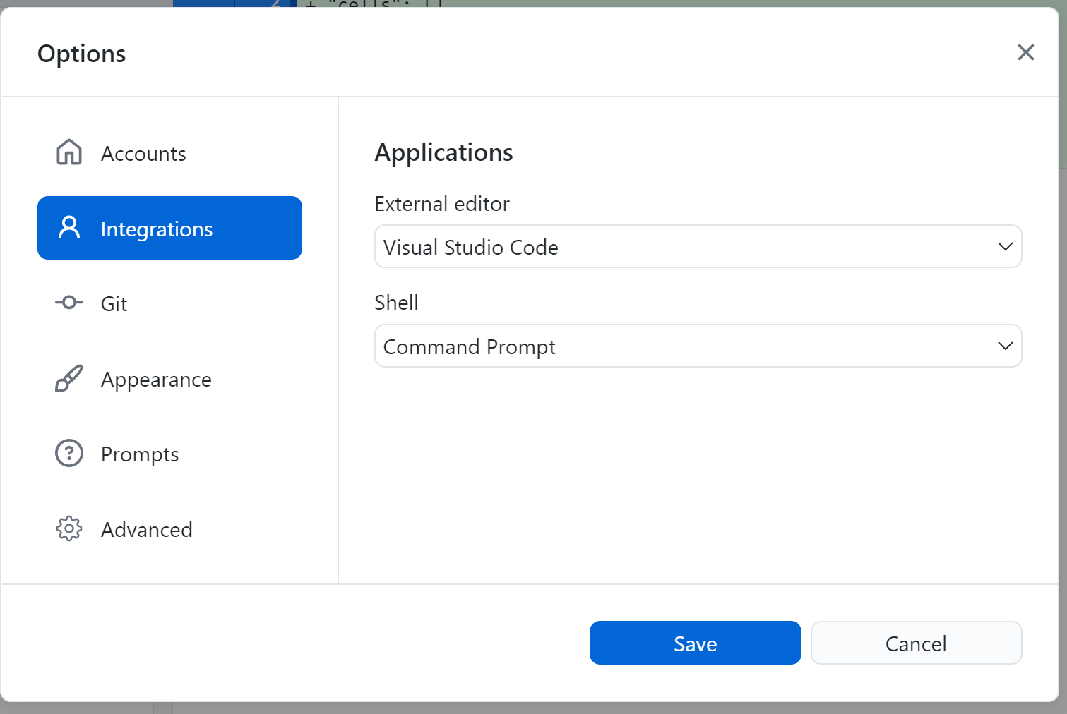
7. Click the option to “Navigate in Visual Studio Code.”
   1. Navigate the files toward the side to work with your files. VS Code can work with many files types, including Jupyter Notebooks.
      1. If you’d like to preview the Markdown inside of VS Code, Use Ctrl + K + V.
   2. Save your changes to the file, then head back to GitHub Desktop.   
      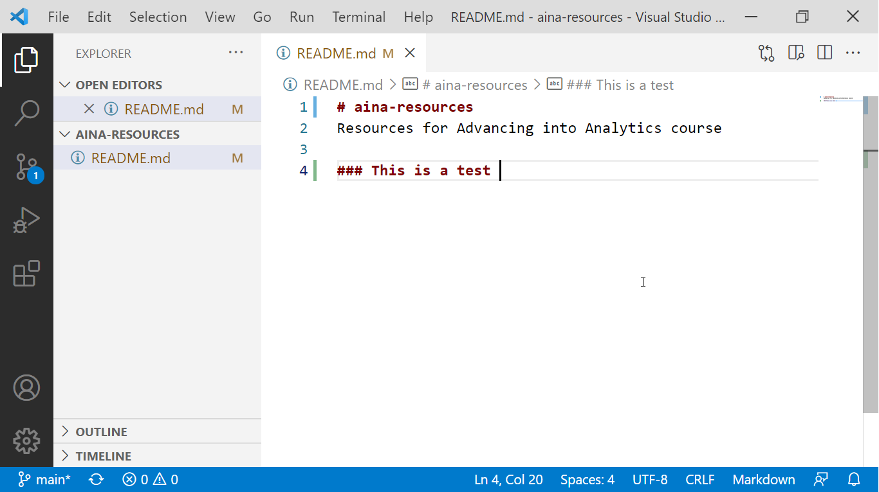
8. You will see a list of changed files on the left, along with the contents of what’s changed to the right.
   1. Add a commit message and summary to the lower-left, then select “Commit to main.”  
      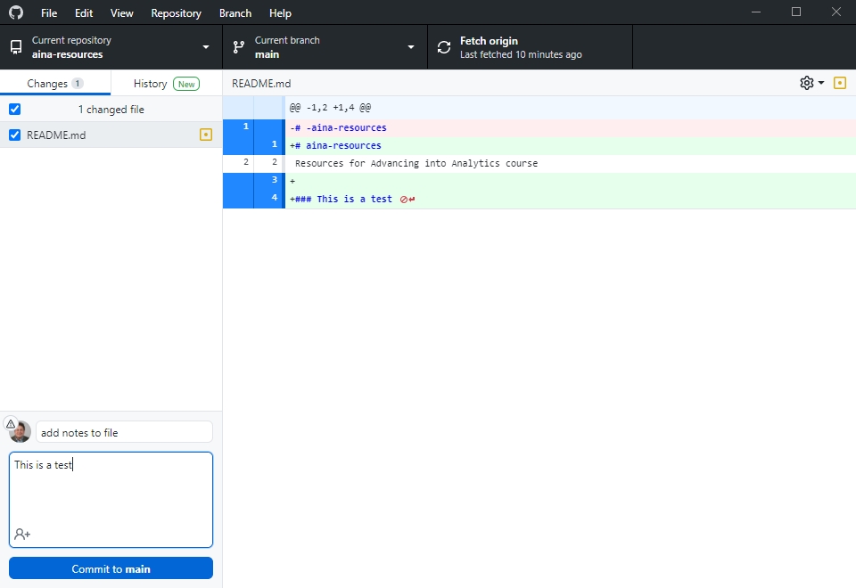
9. You’ve committed or staged your changes to the main branch. You could continue committing locally if you’d like, but let’s go ahead and push this to origin.:  
   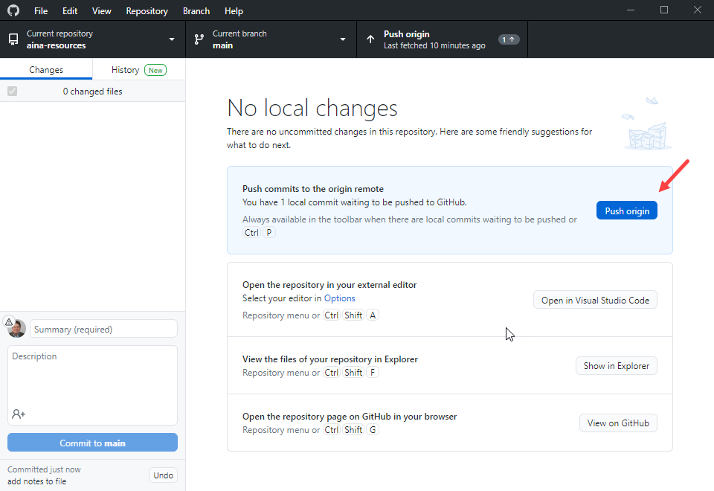
10. Click on “View on GitHub” or otherwise get back to your repo to see the changes:   
    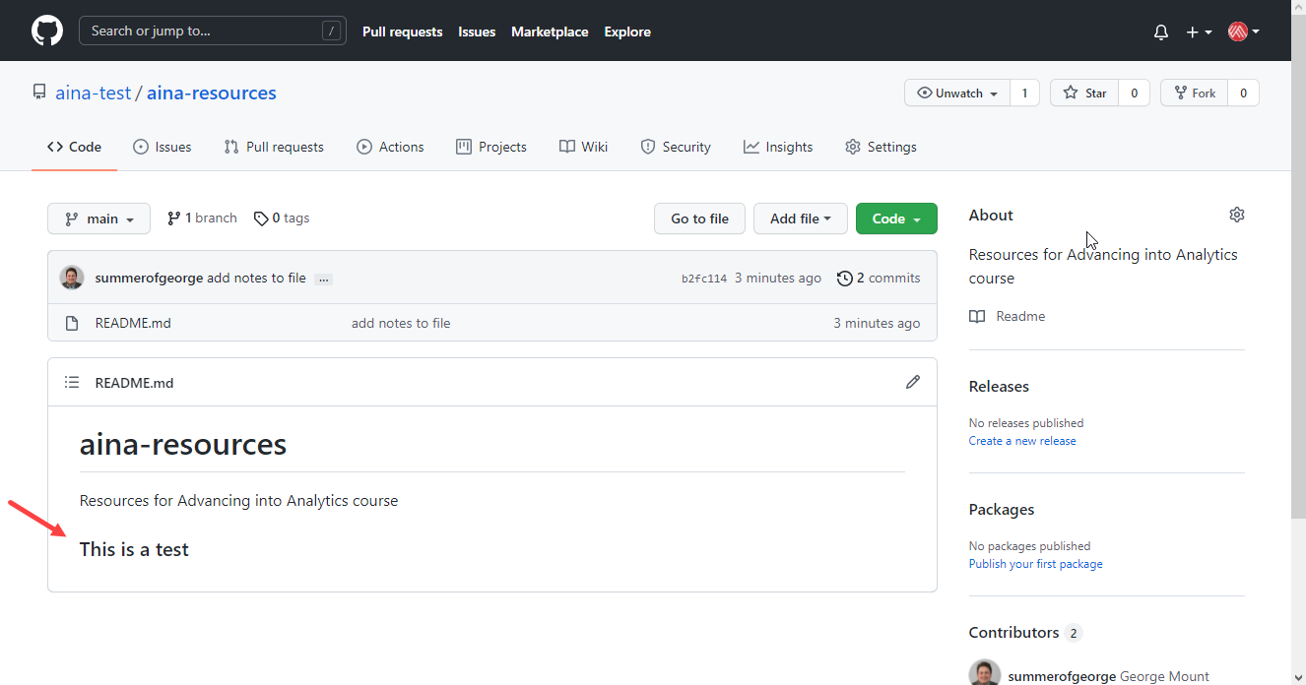
11. Now let’s try this in reverse: make a change on GitHub.com and have it reflect on your computer. Go ahead and make some tweak to your readme file:  
    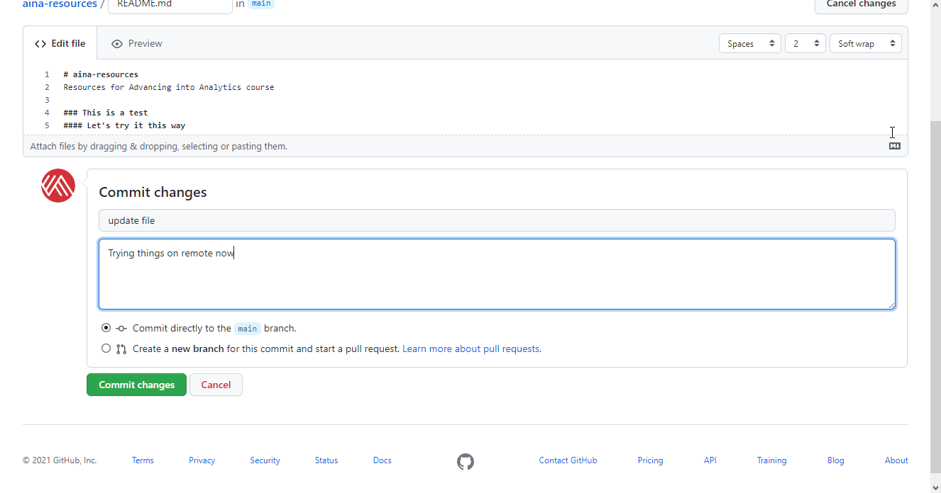
12. Go back to your GitHub and select “Fetch origin” to check for any changes on GitHub.com (In this case, that’s the origin; you’re the remote!)  
    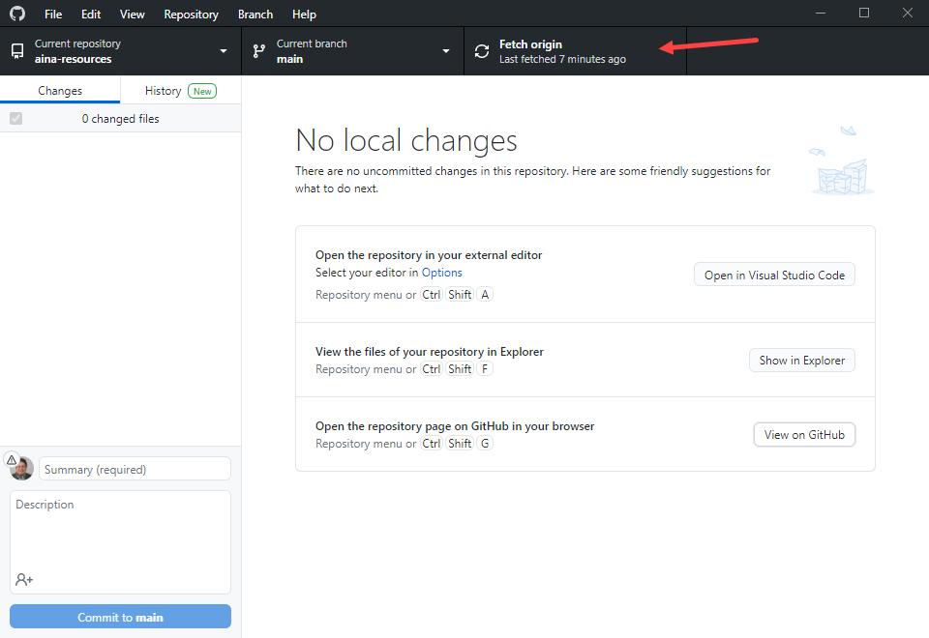
13. Now click on “Pull Origin” (sound familiar)?  
    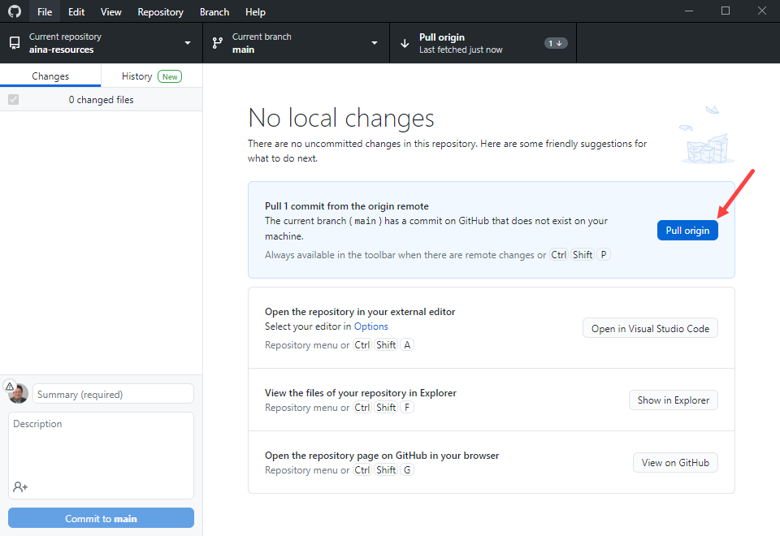
14. You can now view these changes locally.

**Working with branches**

You can work with branches locally via GitHub Desktop similar to on GitHub.com.

1. Click Current branch > New branch  
   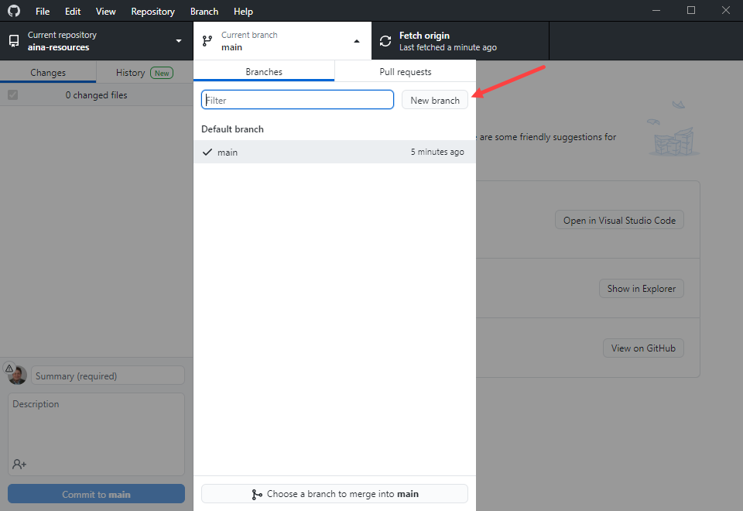
2. Give the branch a name > Create new branch > Create branch
3. If you click “Publish branch,” it will be made available on GitHub.com
4. Make any changes on the branch using VS Code, etc.
   1. You will commit and push your changes like before, then go to GitHub to open and manage pull requests.
5. After you’ve made the changes GitHub Desktop will ask if you want to Create Pull Request. Go ahead and click it:  
   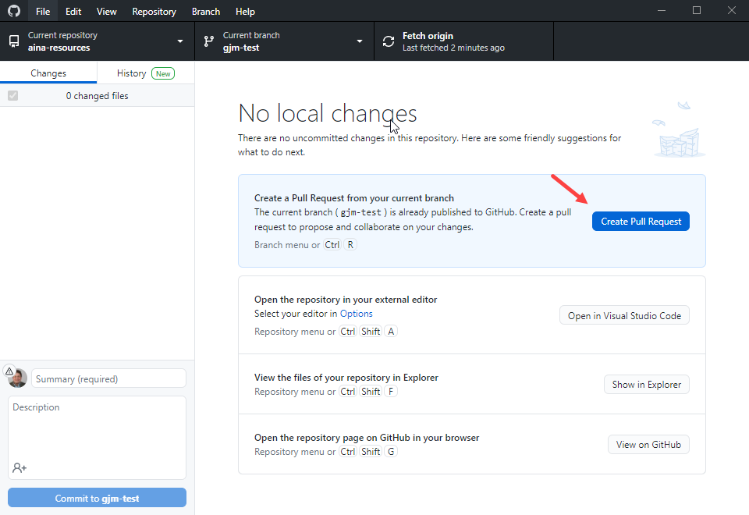
6. This will bring you back to GitHub.com where you’ll walk through the PR steps again.