Unlike a classic PivotTable, there is no way in Power Pivot to create a PivotTable “field.” So how could we calculate something like profit margin? Let’s try calculated columns.

From Power Pivot Data View, add a profit_margin field:

Load this into Excel as a PivotTable. Let’s take a look at sales, profit and profit margin by region. Clearly this isn’t right:

In classic PivotTables, we could create a field by taking the sum of sales and the sum of profit. In Power Pivot, this process is more powerful but more locked down. Let’s explore what’s meant there.

While dragging/dropping fields into the Values section of a PivotTable to aggregate them is familiar to PivotTable users, this is NOT the way to create measures in Power Pivot! Let’s see why.

Head to Power Pivot > Manage Data Model. Then under Advanced > Show Implicit Measures:

Implicit Measures are to be avoided:

* Lack of transparency
* Limited flexibility and customization
* Cannot be used to create more advanced measures

Go ahead and delete from the Data Model.

We are going to create three explicit measures to properly derive profit margin.

Back out of the Power Pivot menu and back in Excel, go to Power Pivot > Measures > New Measure

Build the following measures:

* Total sales
* Total profit
* Profit margin 🡪 This should build on the above 2

Now the profit margins are mathematically correct:

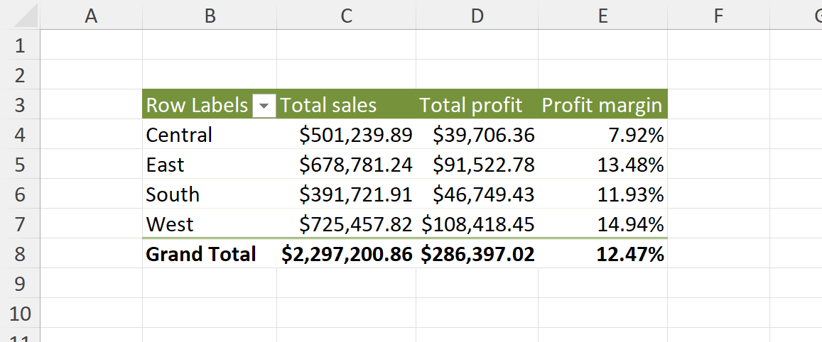

So, when would you actually use a calculated column in Power Pivot?

Mainly to create a dimension, not a measure – something that is *not* going to get aggregated. For example, we can bin and recode categories with the SWITCH() function:

What gets even more complicated is that this could have *also* been a calculated field in Power Query!

Remember, every value in a data model table must be of the same type, so because we are including an "Unknown" as a string we must also make the other values like 1 and 2 strings.