Lab 1: Creating Relational Models in Power Pivot
- Load the tables into Power Pivot via Power Query and establish relationships in the Power Pivot Data Model.
The new step here will be to make sure that under Close & Load To you select “Add this data to the Data Model” for each table/query. I’d also suggest loading to Connection Only since our view is to use these datasets together in Power Pivot rather than in isolation.
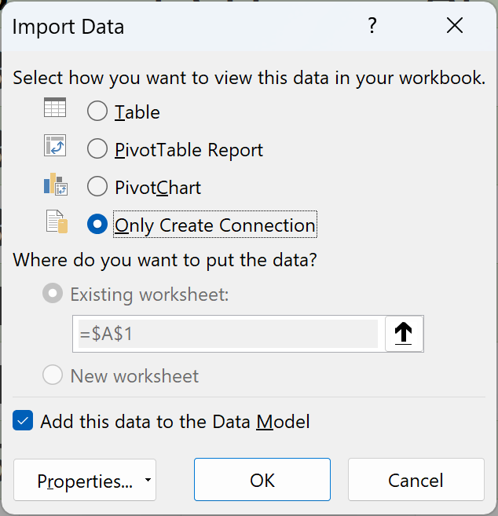
If you miss this step for any of the queries, you can change the settings by going to Data > Queries & Connections in the ribbon and selecting Load To
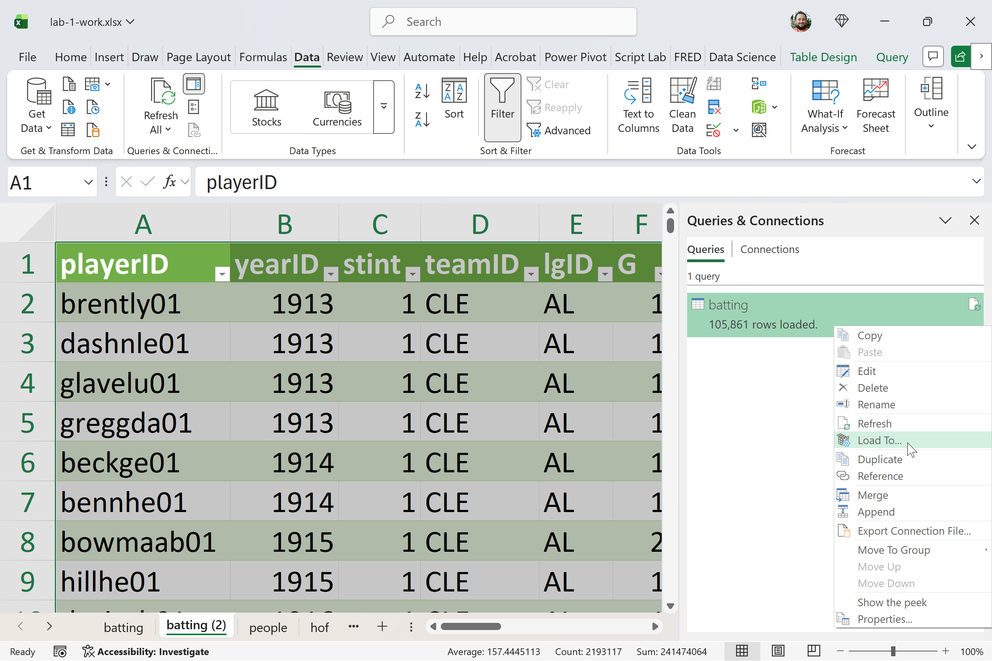
Next, switch to Power Pivot → Diagram View so you can see how the tables connect.
Create the relationships by doing the following:
- Drag playerID from the batting table to playerID in the people table
- Drag playerID from the hof table to playerID in the people table
Once the relationships are created, place the people table in the center of the diagram, with batting and hof on either side.
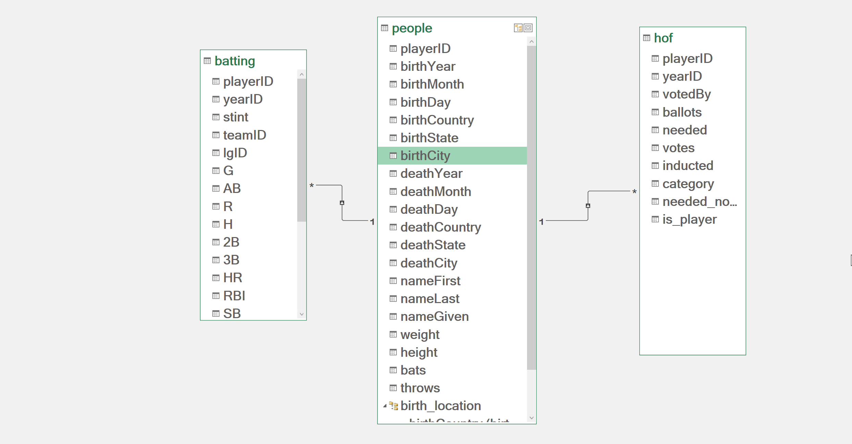
We organize the model this way because player details only need to be stored once, while player activity happens many times. The people table contains one row per player with descriptive information like name and birthplace. The batting and hof tables store repeated events—season statistics and Hall of Fame voting—that include numbers we want to analyze and summarize. Connecting the tables this way avoids duplicated data, keeps player information consistent, and makes the model easier to analyze.
- Create a hierarchy among the birthCountry, birthState, and birthCity fields in the people table.
Right-click birthCountry and select Create Hierarchy
From there, drag-and-drop birthState and birthCity underneath as lower levels of the hierarchy.
Right-click on Hierarchy1 to rename.
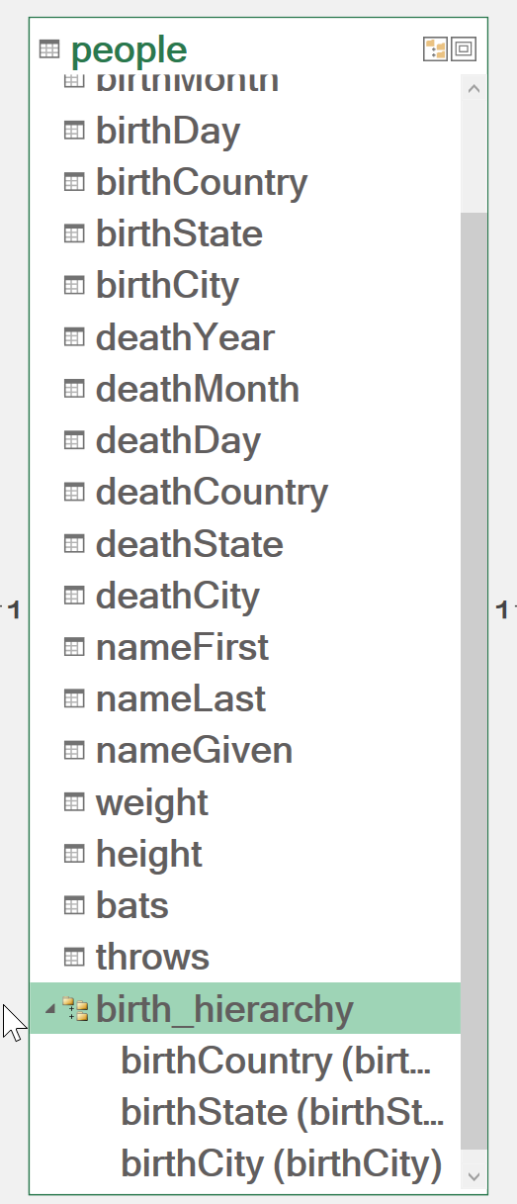
- Load the Data Model results into an Excel PivotTable. Count the number of players. You can do this by totaling the number of playerIDs that have Yes in the is_player column
Go to Home > Insert > PivotTable to add a PivotTable to the workbook
Create a PivotTable that looks like this:

