Lab 2: Creating Measures and KPIs in Power Pivot
- Create a PivotTable to present the total number of home runs (HR) by birth state (birthState) using an implicit measure.
This is done just as a regular PivotTable. Use “Sum of hr” to aggregate.
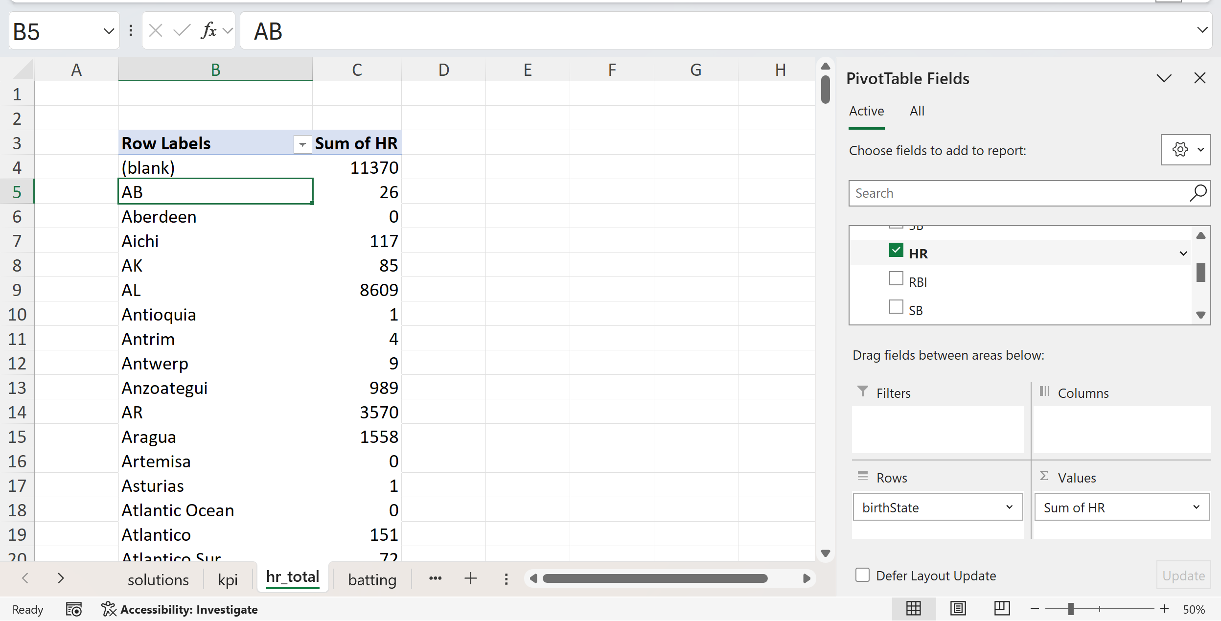
- Remove the implicit measure created in step 1 and establish a new explicit measure named hr_total that computes the sum of home runs, formatted as a whole number in thousands. Add this measure to the PivotTable.
We can delete implicit measures by doing to Power Pivot > Manage Data Model
Under Diagram View > Advanced > Turn on Show Implicit Measures
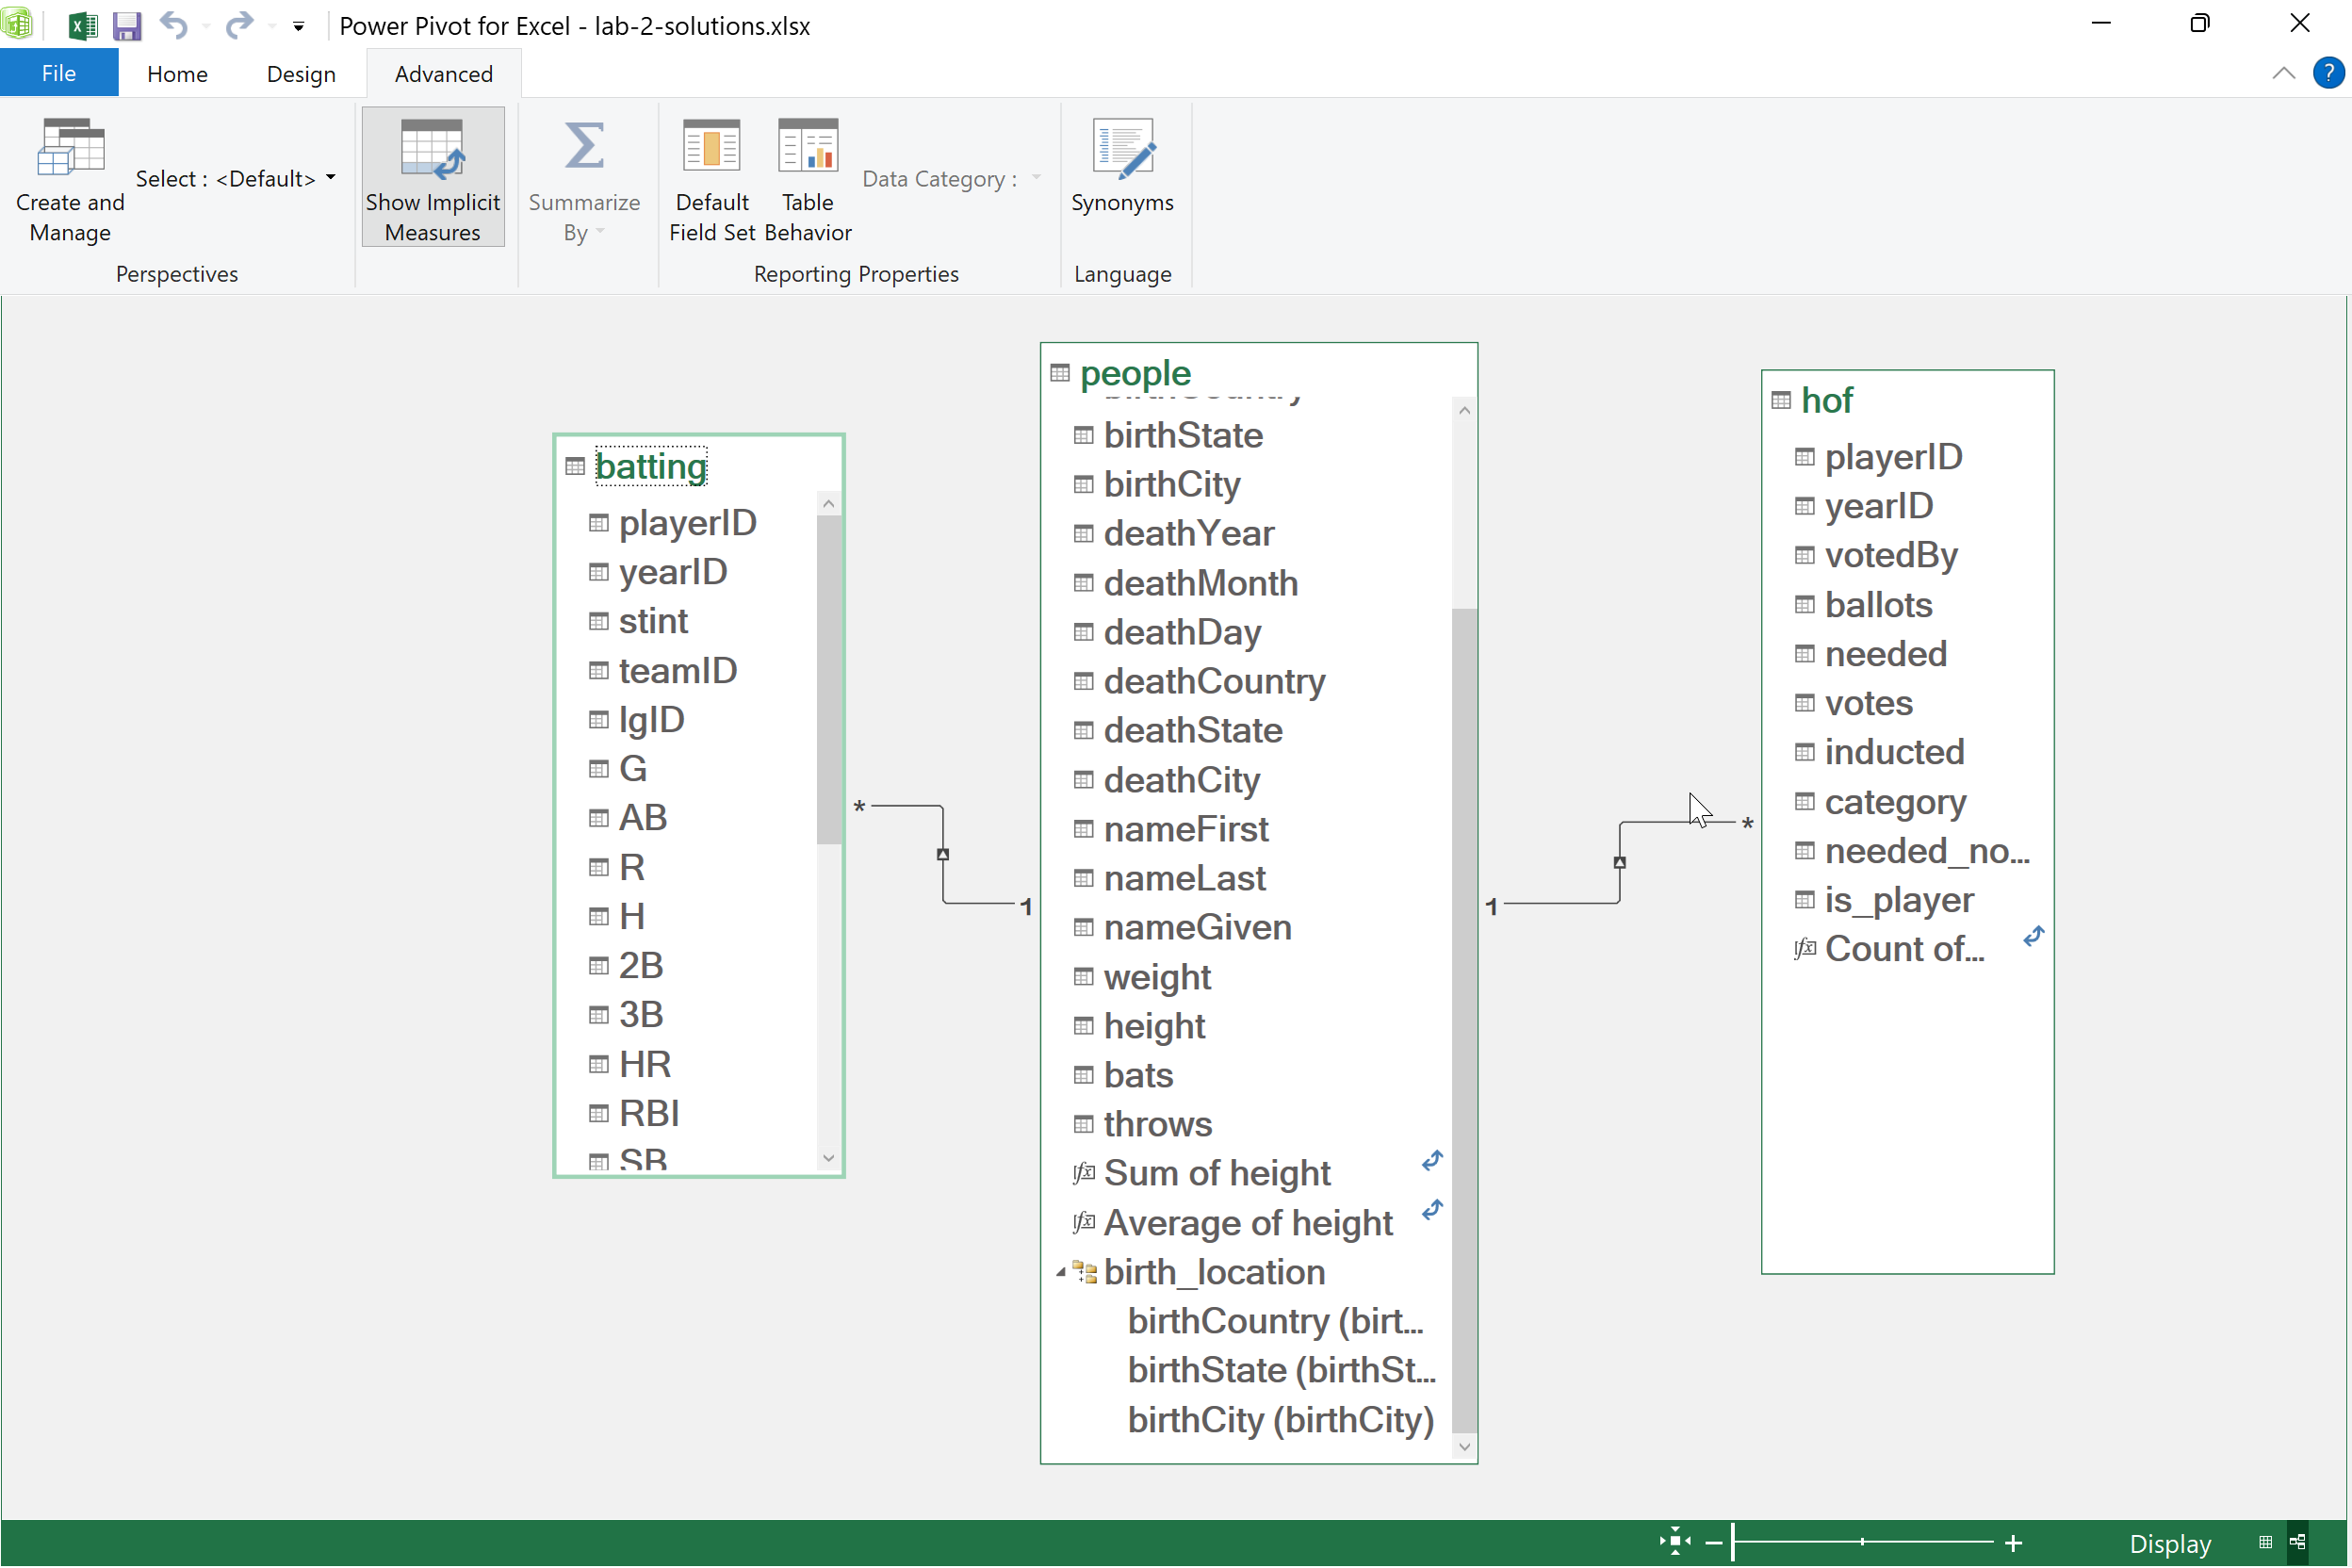
Right-click to Delete them
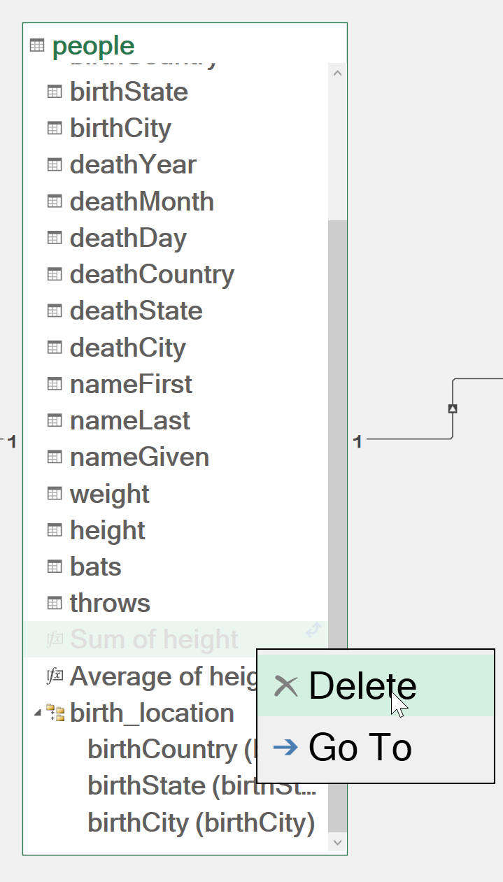
Go to Power Pivot > Measures > New Measure
Create the new measure. Call it something like hr_total.
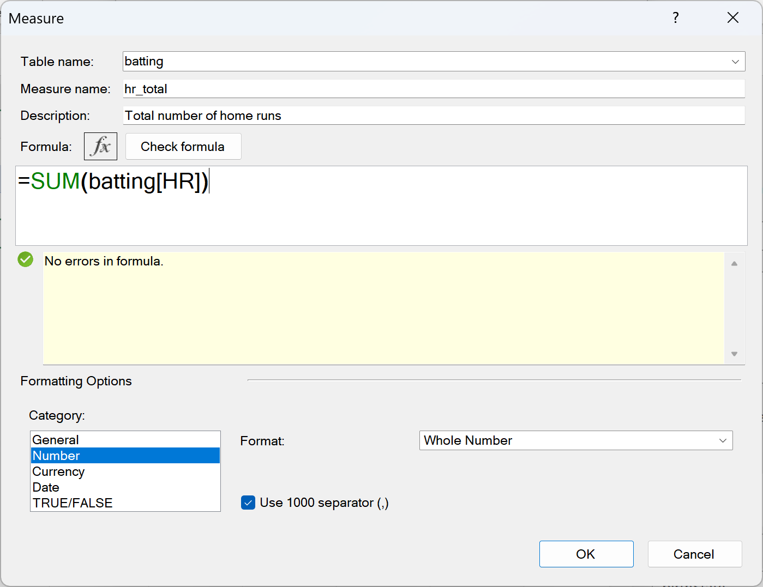
You also have the option to set the formatting of the measure and check for formula errors. Hit OK when done.
Now in the PivotTable you want to use the metric with the Fx icon next to it:
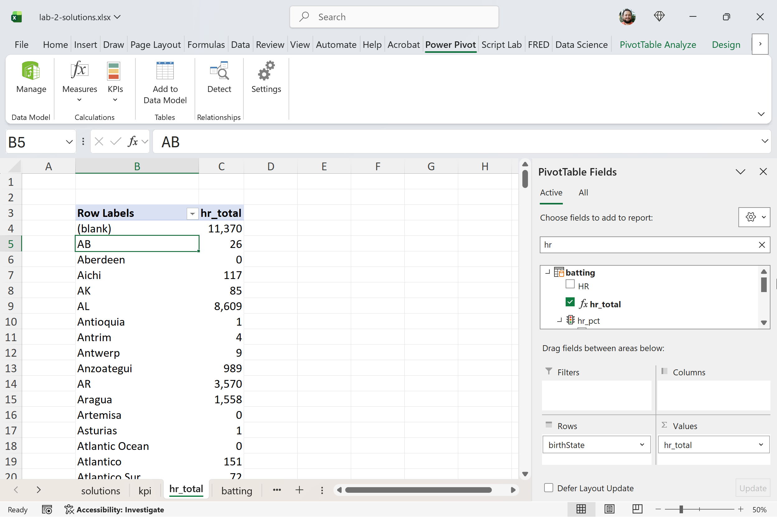
- Generate another explicit measure named hr_pct that calculates the percentage of total home runs (HR) out of total at bats (AB) from the batting table. Format the result as a percentage. Feel free to create an additional total at bats measure to assist with this.
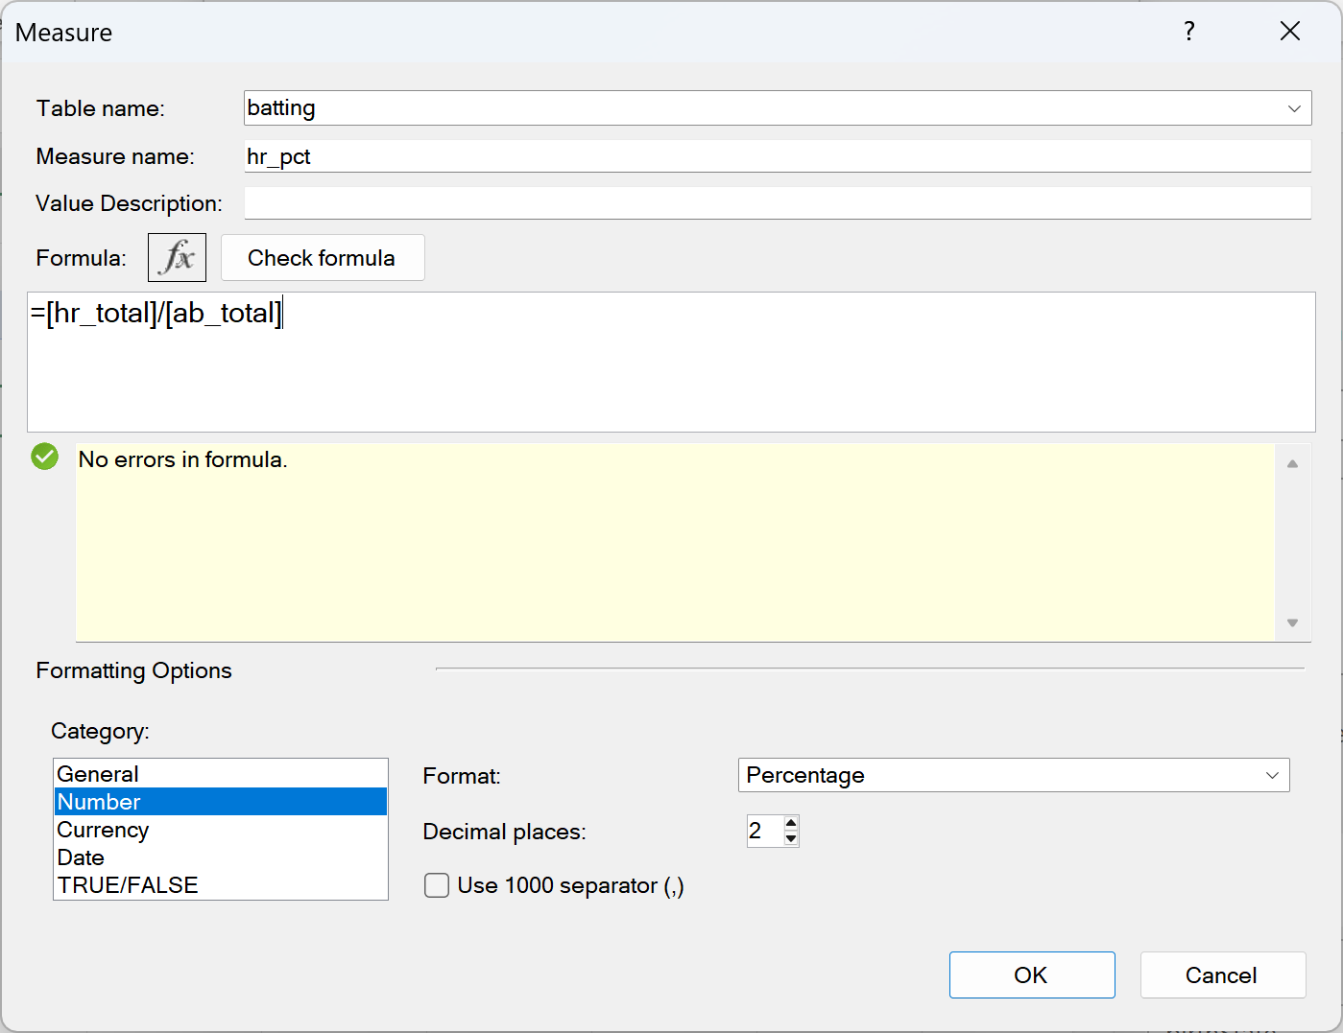
- Develop a KPI based on the metric hr_pct aiming for a target absolute value of 1. Use the following status thresholds:
  - Less than 2%: Red status
  - Between 2% and 3%: Yellow status
  - Greater than 3%: Green status
To do this go to Power Pivot > KPIs and New KPI. Name the KPI something like hr_pct
Set the KPI relative to the Absolute value of 1.
Define the status thresholds of 2% and 3% by dragging or typing into the threshold keys (can be tricky!)
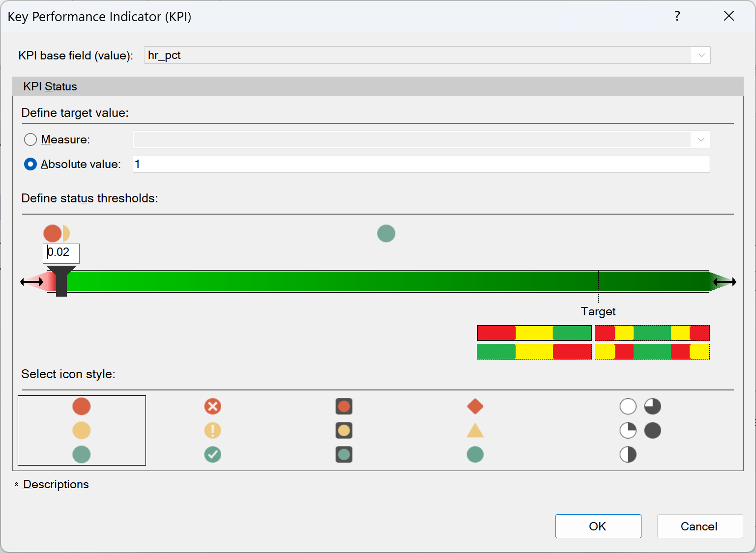

- Apply the KPI to a PivotTable that displays teamID along the Rows and yearID along the Columns.
Use the hr_pct and hr_pct Status to show the metric next to the KPI inside the PivotTable:

