Lab 1: First steps in Excel Power Query
- Load the data into Power Query as a table. Name the query computers.
- Add an index column starting from 1 to the data.
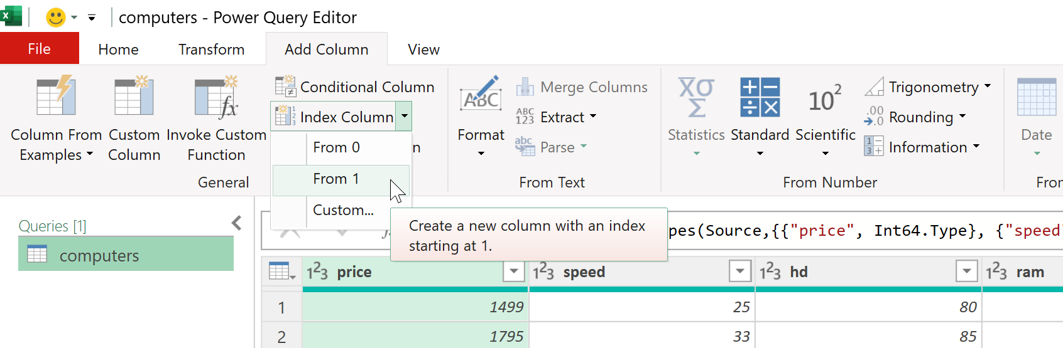
- Rename the previous step in the Applied Steps list as “Added unique identifier.” \
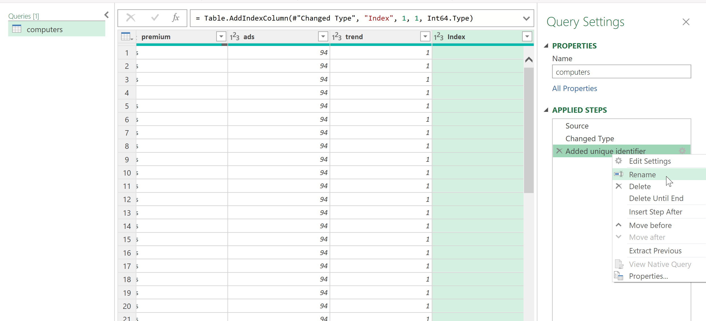
- Drag-and-drop the Index column so that it is the first column in the dataset.
- Use Power Query’s data profiling features to address the following questions. Be sure to adjust column profiling to work on the entire dataset.
  - What is the range of prices for the computers in the dataset?
The range goes from $949 to $5,399

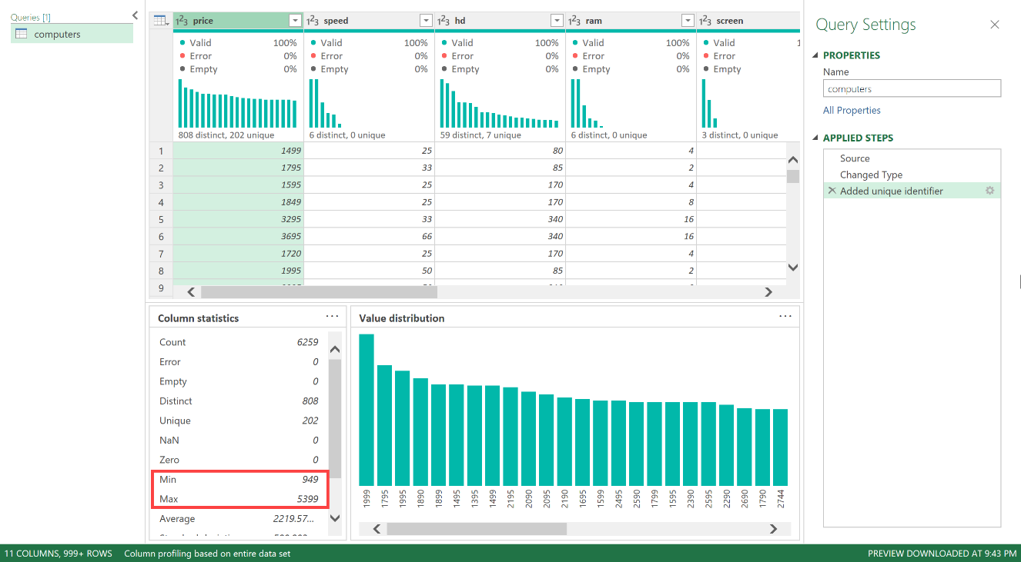
  - What is the average amount of RAM in the dataset?
The average amount of RAM is 8.29
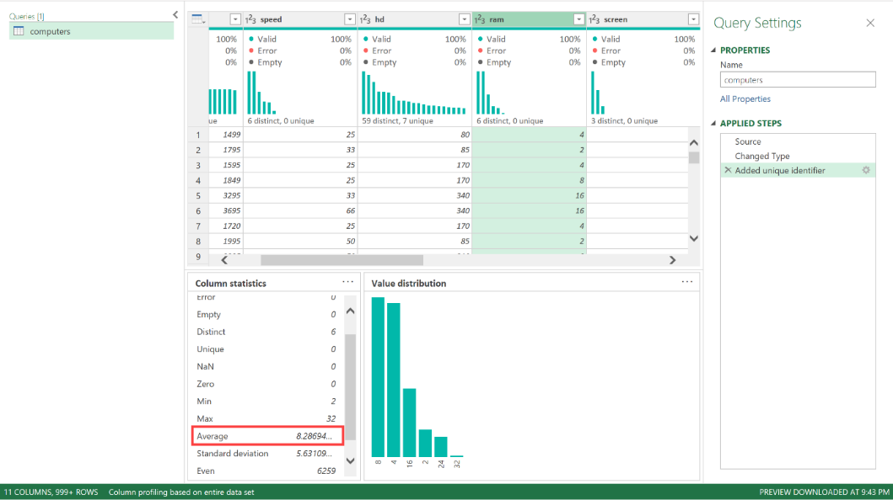
  - Are there any missing values in this dataset? If so, where? \
Based on Column quality, there are no missing values in any columns of the dataset.
However, it's still worth thoroughly profiling the data to check for any incorrectly-coded missing values!

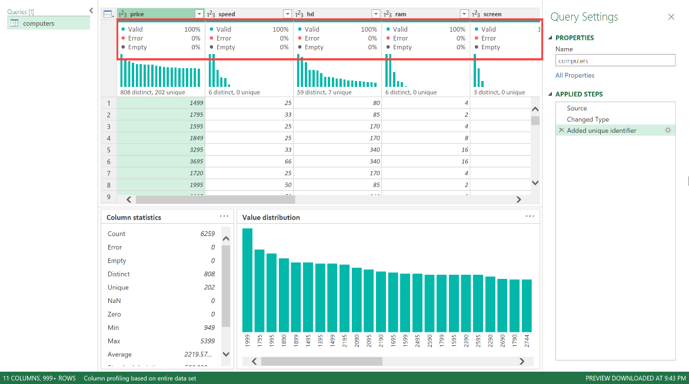
- Load the query results into an Excel PivotTable.
  - Close & Load > Close & Load To > PivotTable

