Lab 2: Transforming rows in Power Query Exercises
On the states worksheet:
- Remove the United States row from the data (Filter it out)
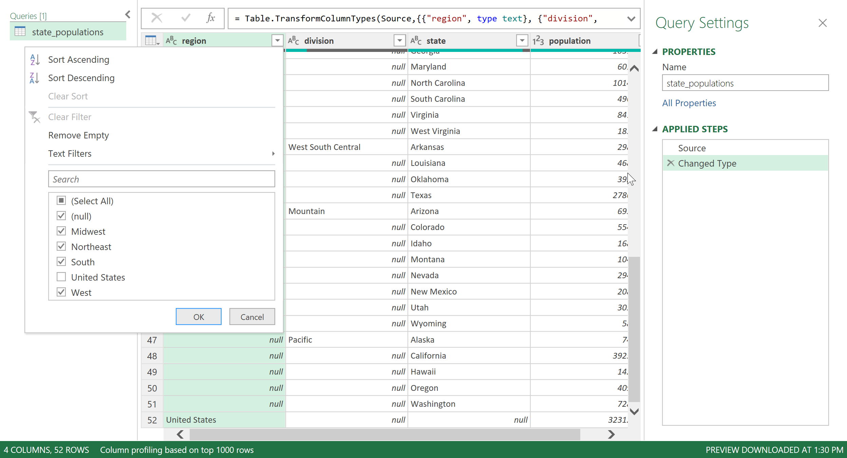
- Fill down blanks on the region and division columns.
Hold down Control > Select both columns > Fill > Fill Down
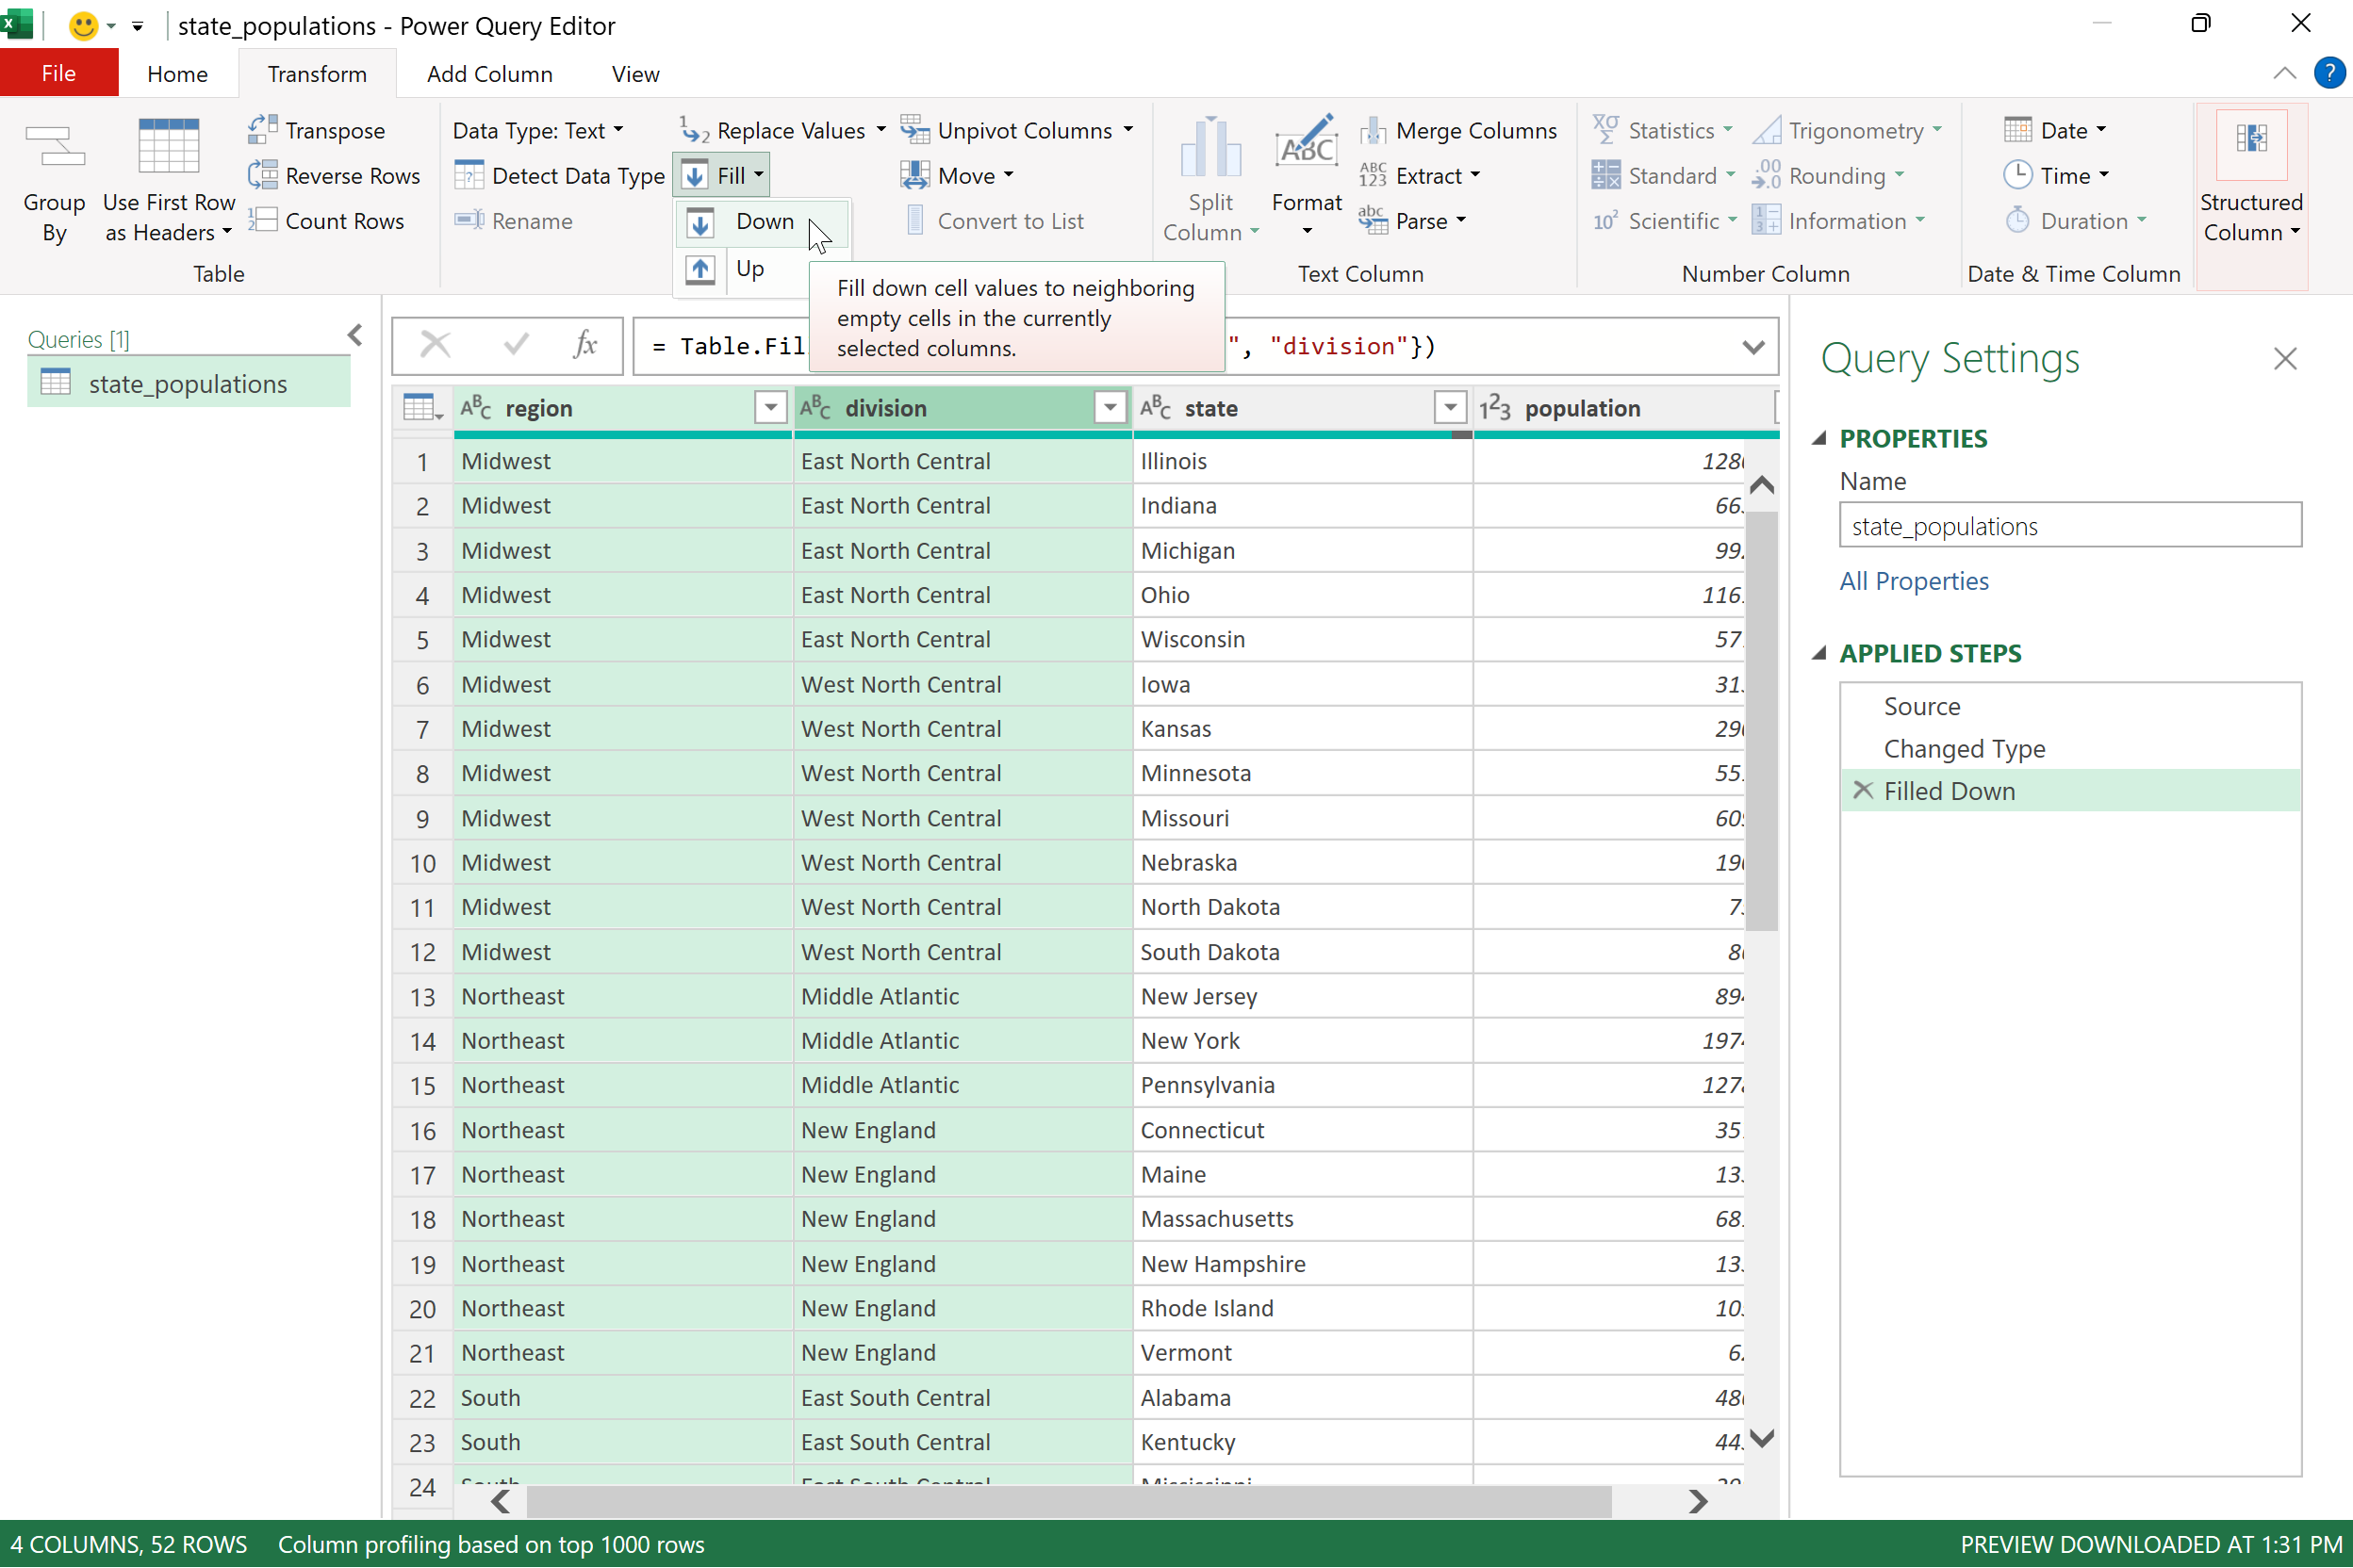
- Sort by population from high to low.
Select dropdown button next to population > Sort Descending

On the midwest_cities worksheet:
- Load this data into a table where each city is in its own row
This one will take a few steps.
Make sure when the data is imported that the first row gets promoted to headers:
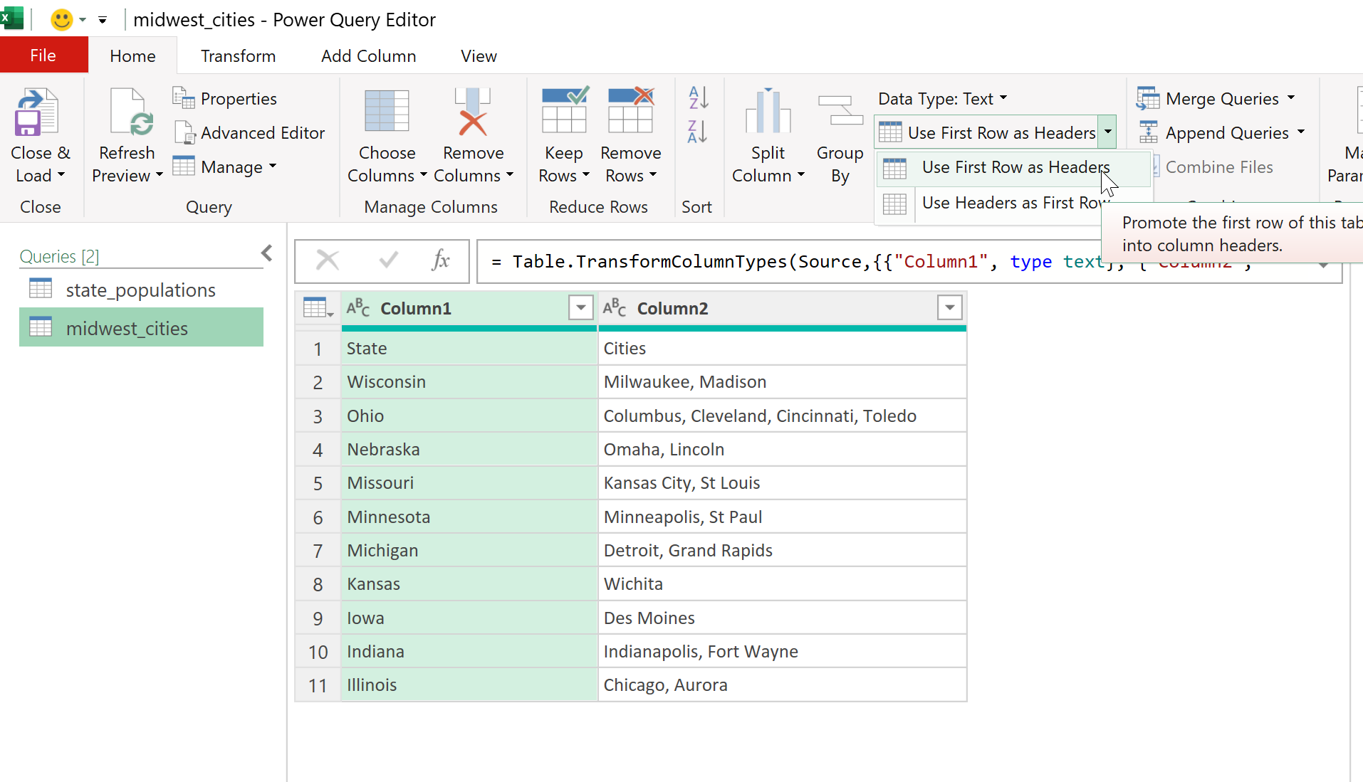
Now select the Cities column > right-click > Split Column > By Delimiter
Split by comma, then space, then under Advanced Options hit the dropdown and select Rows (NOT Columns!)
