-Lab 3: Transforming columns in Power Query
- Transform the date column to a month number, such as changing 1/1/2023 to January.
Right-click > Transform > Name of Month
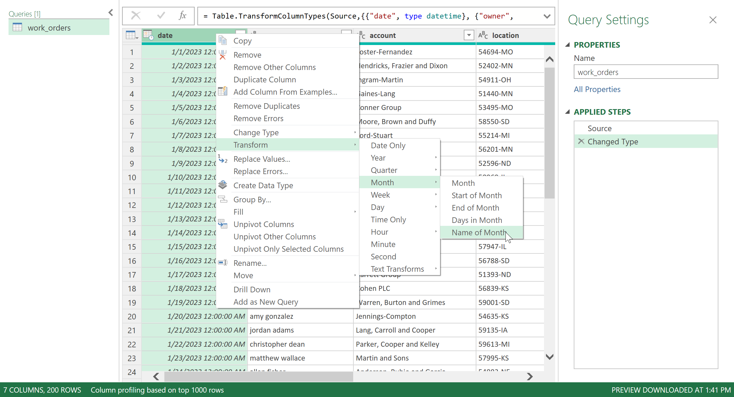

- Transform the owner column to proper case.
Right-click > Transform > Capitalize Each Word
- Split the location column into two separate columns: zip and state.
Right-click > Split column > By delimiter > use the dash

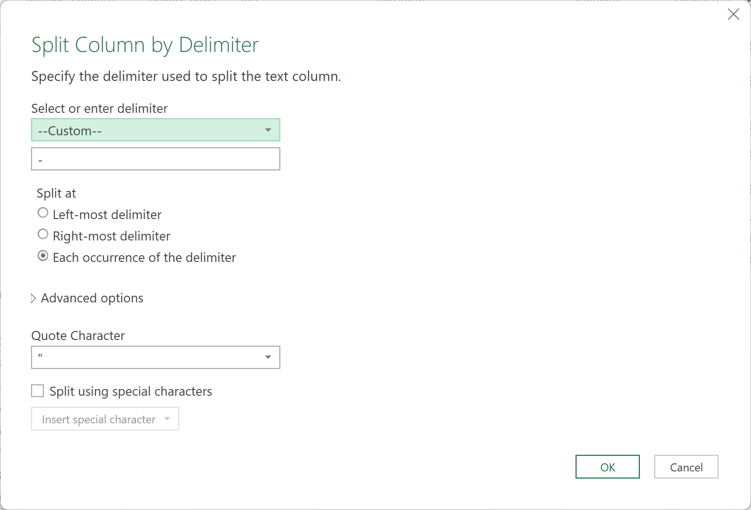
Double-click on column labels and hit Enter to rename
- Reshape the dataset so that subscription_cost, support_cost, and services_cost are consolidated into two columns: category and cost.
Hold down Control to select the three columns
Right-click > Unpivot Columns
Rename the two resulting columns

