1. Data > Get Data > From File > From Excel Workbook
2. Load the orders table > Transform Data
3. Right click Order Date > Duplicate Column
4. Right click Order Date – Copy > Transform > Year
   1. Filter the data by this Year so you *only* have 2017 data
5. Remove this column – note that we are *still* filtering by it *even though* we have removed the filter column.
6. Close & Load > Close & Load To > Connection Only, but also add to the Data Model
7. Repeat the same with the People table
   1. Make sure to select “Use First Row as Headers” in the PQ Editor
   2. Close & Load to Connection + add to Data Model
8. Do the same with the Returns table

The data has been loaded! Now let’s create the Data Model.

1. Power Pivot > Manage > Diagram View
2. Create relationships between orders.Order ID/returns.Order ID and orders/Region people/Region
   1. You can do this by dragging and dropping in Diagram View a la Access
3. Add a Date Table to this diagram by going to Design > Date Table > New
   1. Drag and drop this one to be related to orders.Order Date   
      Your diagram should look something like this:

1. Let’s load this into Excel! Home > PivotTable > PivotChart

Visualizing Average Order Sale by Segment

1. Get a placeholder going here > Sum of Orders in Values, Segment in Axis.
2. Right-click on chart > Change Chart Type > Bar
3. I am also going to remove the field buttons and gridlines from this chart
4. This is looking much better! But I want Average Order Sales here and not Total Quantity. This is going to require adding a measure.
5. Power Pivot > Measures > New Measure. Use Excel table notation to calculate total sales divided by total quantity and format the result as currency with two decimals. Your measure should look something like this:

1. Keep cleaning up the bar chart until you get something like this:   
     
   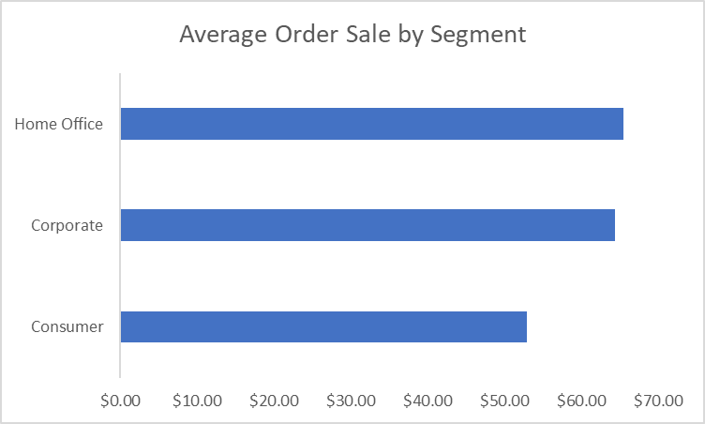
2. It’s not a bad idea to create a temporary PivotTable containing these numbers just to spot-check they are correct
   1. Go back to Power Pivot > Manage > then under Home > PivotTable > PivotTable > Existing Worksheet
   2. Try and hand-calculate these profit margins. They seem to be functioning as expected!

Creating a map chart of profit margin by state <https://www.simonsezit.com/article/excel-map-chart/>

1. First thing to do will be create a Profit Margin measure:  
     
   Graphical user interface, application

   Description automatically generated
2. Next, insert another PivotTable from the Data Model, but this time do it in a new worksheet. We will need this one as a “helper” worksheet
3. Fill the PivotTable with State in Rows and Profit margin in Values
   1. Turn off the Grand Total: Click on PivotTable then Design > Grand Totals > Off for Rows and Columns
4. Copy-paste values this data immediately to the right of the PivotTable, you will see why this is necessary soon 😊
5. Insert the pasted data, then go to Insert > Charts > Maps > Filled Map
6. You should now have a map of profit margin by state!
   1. Right-click inside it > Select Data > change the Chart data range to the PivotTable data source.
7. Cut-paste this map chart over to your dashboard to the right of the AOS chart.
   1. You can use the chart size options to make these charts the same size
   2. You can also align these charts by selecting multiple with shift and manipulating Shape Format > Align:   
      Graphical user interface

      Description automatically generated with medium confidence
8. At this point this is starting to look like a real dashboard! I am going to do a few more things to jazz it up, then we’ll add one more asset beneath these charts.
   1. Turn off gridlines: View > check off Gridlines
   2. Hide the extra columns to the right of Column P or so: Ctrl + Shift + Right to select them all > right-click > Hide
   3. Add a header that sales something like Superstore Sales Dashboard
   4. I also want to indicate when this data was last updated. To do this, I am going to copy-paste the PivotTable in the helper worksheet, find Max of Order Date using the PivotTable and then feed this to the dashboard worksheet.
      1. Be sure to format this as a date in the PivotTable!  
           
         You should be seeing something like this:   
         A picture containing chart

         Description automatically generated

YTD Sales by Category/Subcategory

1. Now we are going to create a KPI table consisting of month-to-date figures by category and subcategory. Go ahead and insert another PivotTable from the Data Model below our two charts
2. We are going to create a few measures here that will let us get TY YTD sales, LY YTD sales, then compare the two. They should look like these:   
   Graphical user interface, text, application, email

   Description automatically generated  
     
   Graphical user interface, text, application, email

   Description automatically generated  
   Graphical user interface, text, application, email

   Description automatically generated  
   Graphical user interface, text, application, email

   Description automatically generated
3. Now drag these into ____________.
4. We can also create a KPI chart !