1. **Getting the most of PivotTable**

* **Why PivotTables?**
* **Anatomy of a PivotTable** 
  + **The PivotTable 2-step**
* **The three types of things we can do with PivotTables** 
  + **Slice and dice**
  + **Roll-up/drill-down**
  + **Pivoting**
* Slicers and timelines
* Always be refreshing!
  + Different refresh options
* Design options
  + Totals, display and all that stuff
  + Repeat field item labels
  + Styles and themes!
* Display options – changing aggregation, double-counting all that stuff and setting to % totals etc.
* Tables and PivotTables go together like they should
* Conditional formatting with PivotTable - <https://www.excelcampus.com/pivot-tables/pivot-table-conditional-formatting/>

1. PivotCharts and visualizations

* PivotCharts can do some cool stuff
  + Histogram
  + Slicing and dicing charts?
* Map charts!

1. Power Pivot and relational modeling

Power Pivot!

* Create hierarchies
* DAX and all that nonsense!
* Importing to Power BI

1. Introduction to Excel dashboards

Excel Dashboards!

* Basic stuff about what is a dashboard and why do it in Excel I guess…
* Sparklines?

## Introduction to PivotTables

https://github.com/Thinkful-Ed/data-analytics-bootcamp/blob/master/library/excel_pivot_tables/content.md

* Create a PivotTable: Insert > PivotTable > Select data > OK
* The primary “Canvas” of the PivotTable is the Field menu. We will drag-and-drop to get data configurations
* Drag Name to Rows, then move over to Columns
  + This is a nice shorthand way to remove duplicates!
* Generally you use PivotTables not just to list categories but to *measure* something by those categories, that’s where the Values come in
  + Drag Sales Qty to Values
  + We can do the same with Sales $. We might also want to format the results

## PivotCharts and visualizations

Let’s first “hack” a PivotChart to make overlapping histograms:

* Drag price to Axis, cd to Legend and Count of Index to Value

* It’s going to look pretty bad right now, let’s fix that:
  + Right-click on the price along the Axis > Group > OK
  + Right-click any of the resulting bars on the PivotChart
    - Set Series Overlap to 100%
    - Set Gap Width to 0%
* Probably still need to adjust the groups in the PivotChart, go ahead and do that.

Your completed analysis should look something like this:

Right-click one of the labels and select “Hide all Field Buttons on Chart.” Also, click on any of the horizontal jailbars and press Delete on keyboard. We don’t need this chartjunk!

We should however have a chart title, so click on the plus sign on upper-right of chart, select Chart Title and give the chart a name:

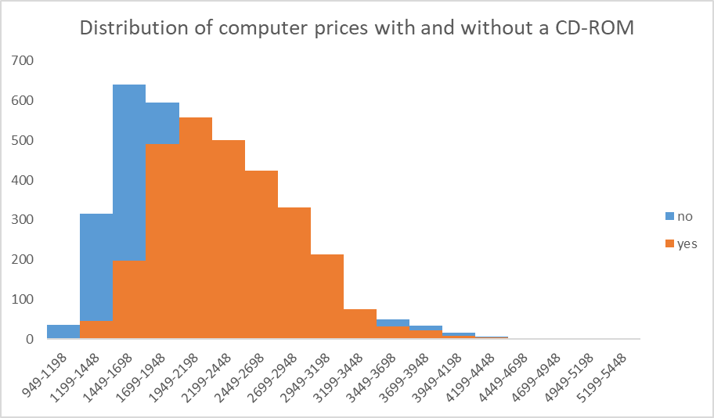

Now let’s try a couple of PivotCharts using time series data.

* Insert a PivotChart based on the housing starts data.
  + Place Date on the Row Labels and Sum of starts on the Values
* By default this will roll up the data by Year.
  + We can “drill down” by right-clicking on the Date field and selecting Expand/Collapse > Expand Entire Field:  
    Graphical user interface, application, Excel

    Description automatically generated
  + You can also change the groupings by right-clicking and selecting Group. For example, this will aggregate the data by quarter only, regardless of year:   
    Graphical user interface

    Description automatically generated
* Go ahead and clear some of the chartjunk off this thing! Add a good chart title too.
* Now let’s create something to compare the percentage of total housing starts by quarter for each year.
  + Move Years to the Rows, Quarters to Columns (get rid of Dates) and Sum of starts to Values
  + Right-click any of the Values > Show Values As > % of Column Total
  + Insert > Recommended Charts > 100% Stacked Column:  
    Graphical user interface, application, table

    Description automatically generated
  + Clean up the chartjunk!
  + What happens if you right-click on the data > Select Data > Switch Row/Column?

PivotChart exercises

* When you create the bar chart of bills by day, you may notice that the days aren’t in a great order:

* There are a couple of ways to fix this:
  + First, you can type directly over the entries to put them in the desired order
  + The more elegant way will be to create a custom list:
    - Go to File > Options > Advanced > Edit Custom Lists (way toward the bottom)   
      Graphical user interface, text, application, email

      Description automatically generated
    - Go to NEW LIST > Add > then add your entries and click OK   
      Graphical user interface, application

      Description automatically generated
    - Now when you create the PivotTable it should automatically display the values in that order.

**Power Pivot PDQ! Demo notes**

Before doing anything else, make sure you see a Power Pivot tab on your home ribbon!

If you do not, you need to load it. [Follow these instructions to do so](https://support.microsoft.com/en-us/office/start-the-power-pivot-add-in-for-excel-a891a66d-36e3-43fc-81e8-fc4798f39ea8).

**Loading to Power Pivot**

We’ve got three workbooks in the data folder:

* orders.xlsx
* people.xlsx
* returns.xlsx

We want to load each of these into Power Pivot, via Power Query.

* Data > Get Data > From File > From Excel Workbook
* Navigate to the first file > Click OK
* We are *not* going to transform this in Power Query right now, so click Load > Load to:  
  A screenshot of a computer

  Description automatically generated with medium confidence
* Select Only Create Connection > Add this data to the Data Model > OK  
  Graphical user interface, text, application

  Description automatically generated
* Do the same for the other two tables.

**Viewing the data in Power Pivot**

* Go back to the Power Pivot tab and click Manage under Data Model
* We are now in the Power Pivot Editor. Let’s look around a bit.
  + First thing you will notice is that, like Power Query, while you can click around and see your data, you can’t just type over it.
  + Unlike Power Query, you should generally be making *minimal changes* to your tables in Power Pivot.
    - One difference is formatting the data. It’s nice to do it in Power Pivot because the PivotTables will then match that formatting.
    - For example, we can format
    - To learn the difference between formatting data in Power Pivot versus defining data types in Power Query, [check out this post](https://excelguru.ca/do-data-types-matter-in-power-query/)

Now we’ll go to Diagram View, this will show a *schema* of the database. Drag the relationships between these variables to create them.

Fact vs dimension tables. The dimension tables are kind of like lookup tables.

Still in Diagram View, let’s click on PivotTable up at the top:

We have a Power PivotTable!

It’s going to look very similar to a regular PivotTable, here are some big differences:

* We can use data from multiple tables on the same Pivot! For example, drag Person and Sum of Sales onto the PivotTable. Notice that Sales is even pre-formatted for you, nice!   
    
  Graphical user interface

  Description automatically generated
* One particular measure that is NOT available in a regular PivotTable but is in the Power PivotTable is the Distinct Count. To understand the difference let’s drag Count of Order ID vs Distinct Count of Order ID to the PivotTable. Distinct Count is down at the bottom. What is the difference?  
    
  Graphical user interface, application

  Description automatically generated

**Implicit vs Explicit Measures**

While using the PivotTable to change aggregation types is very familiar, you do NOT want to do this in Power Pivot. Instead, we are going to do this “explicitly” writing our own explicit measures. And this is where DAX comes in.

Go back to the Power Pivot editor and click Calculation Area on/off a couple of times. This area at the bottom is actually like a workbook that you can write formulas in!  
  
To see this in action, let’s go back to the Sales column in orders. We will go to the cells below this column and use the AutoSum feature for right now. Let’s take the Average of Sales:

We can go over to Quantity and take the Sum as well.

This is like the “Macro Recorder” way of creating these measures. It’s easy, but not always scalable and extensible. For example, it’s considered a better practice to *explicitly* state the name of the table where a column is coming from in the formula, with AutoSum does not do.

Let’s fix that. You will see this notation is identical to Excel tables.   
  
**Creating calculated measures**

Close out of the Power Pivot editor and head back to your PivotTable. You should now see these explicit measures in your Power PivotTable. You could format Quantity to thousands if you’d like:

You can learn more about these measures by going to the Power Pivot tab of the ribbon > Measures > Manage Measures. Click New:

Let’s create a Profit margin measure:

You should be starting to see something like this:

**Time intelligence**

This is all great to know, but to really dig into most business insights we want to be able to compare across time periods. Power Pivot makes this relatively easy.

Let’s go back to Diagram View in the editor, then go to the Design tab of the ribbon. Click on Date Table > New:

We will now create a relationship between Order Date in orders and Date in Calendar. Your schema should now look like this:

Go back to your Power PivotTable. We are now going to create some different date measures to analyze this data. To make best use of time and date functionality in Power Pivot, you should have a date table.

Go back to the Create Measures area and create a Total Sales measure first:

We will now create a MTD Sales column:   
  
Clear out your existing PivotTable; let’s add Date Hierarchy on the Rows and Total Sales MTD in the Values:

Expand the years out to see sales each month, day and so forth.   
  
Let’s create a YTD now:

We can also get a measure to compare the current month or year to the previous month or year:

Drag those into the PivotTable and you should see something like this:­­­­­

