Demo notes
Thank you for coming to today’s event. Please keep in mind that I am an independent professional and can only continue with these free events with your testimonials and referrals.
Before doing anything else, make sure you see a Power Pivot tab on your home ribbon!

If you do not, you need to load it. Follow these instructions to do so.
Loading to Power Pivot
We’ve got three workbooks in the data folder:
- orders.xlsx
- people.xlsx
- returns.xlsx

We want to load each of these into Power Pivot, via Power Query.
- Data > Get Data > From File > From Excel Workbook
- Navigate to the first file > Click OK
- We are not going to transform this in Power Query right now, so click Load > Load to:
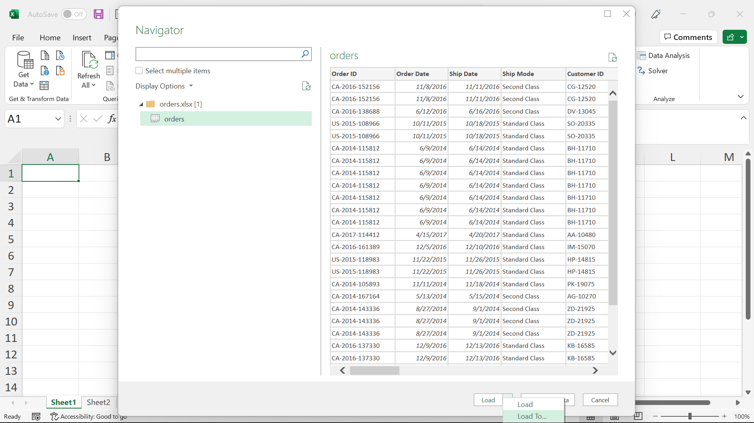
- Select Only Create Connection > Add this data to the Data Model > OK
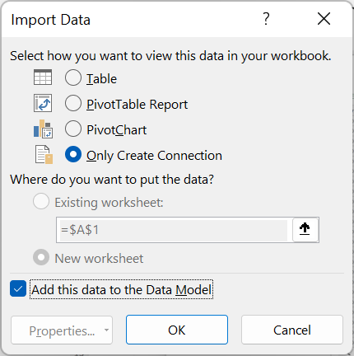
- Do the same for the other two tables.

Viewing the data in Power Pivot
- Go back to the Power Pivot tab and click Manage under Data Model
- We are now in the Power Pivot Editor. Let’s look around a bit.
  - First thing you will notice is that, like Power Query, while you can click around and see your data, you can’t just type over it.
  - Unlike Power Query, you should generally be making minimal changes to your tables in Power Pivot.
    - One difference is formatting the data. It’s nice to do it in Power Pivot because the PivotTables will then match that formatting.
    - For example, we can format
    - To learn the difference between formatting data in Power Pivot versus defining data types in Power Query, check out this post

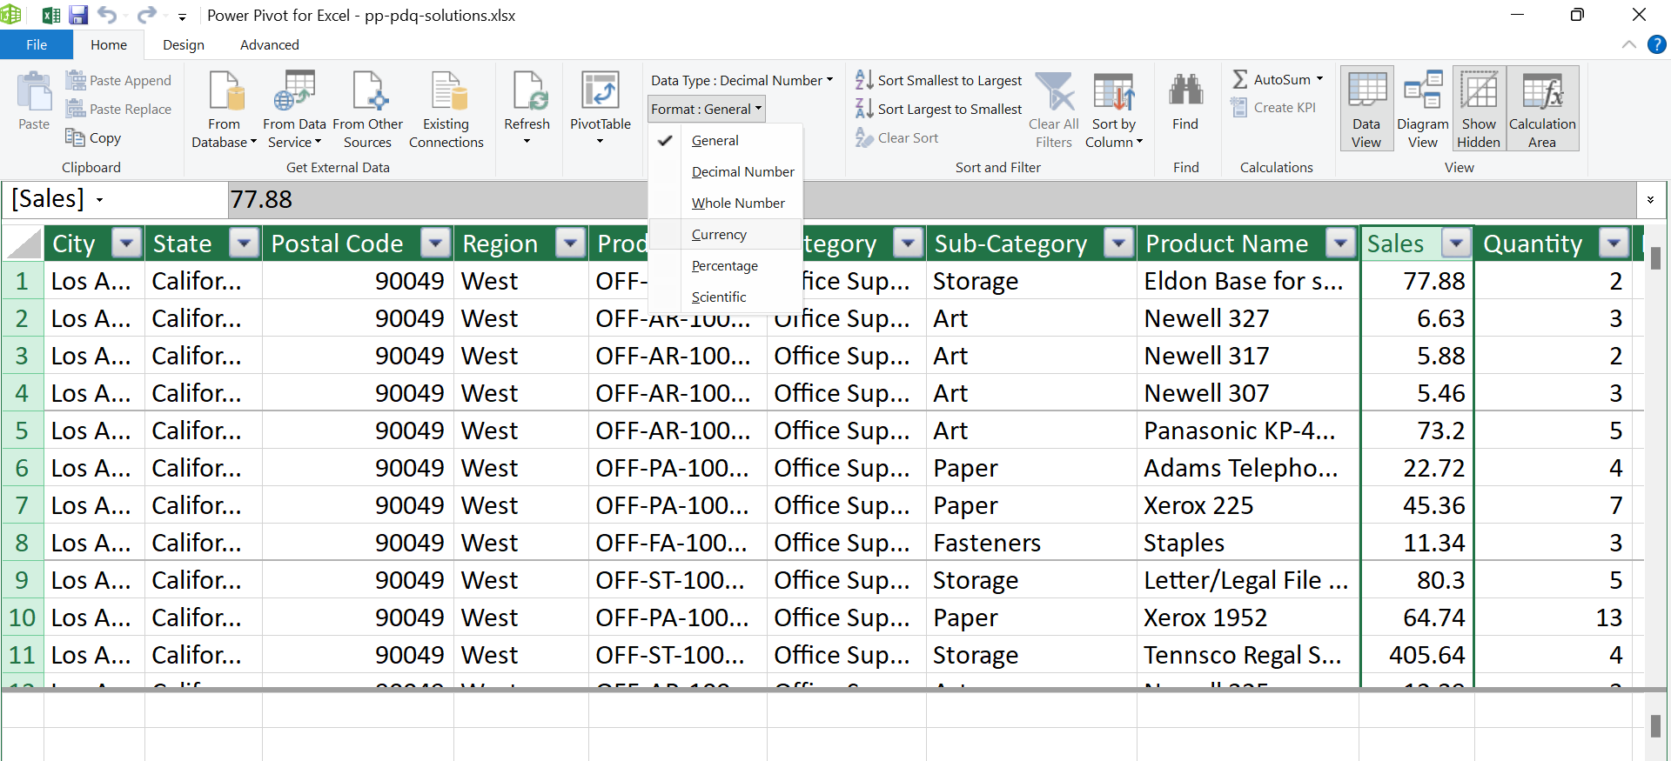

Now we’ll go to Diagram View, this will show a schema of the database. Drag the relationships between these variables to create them.
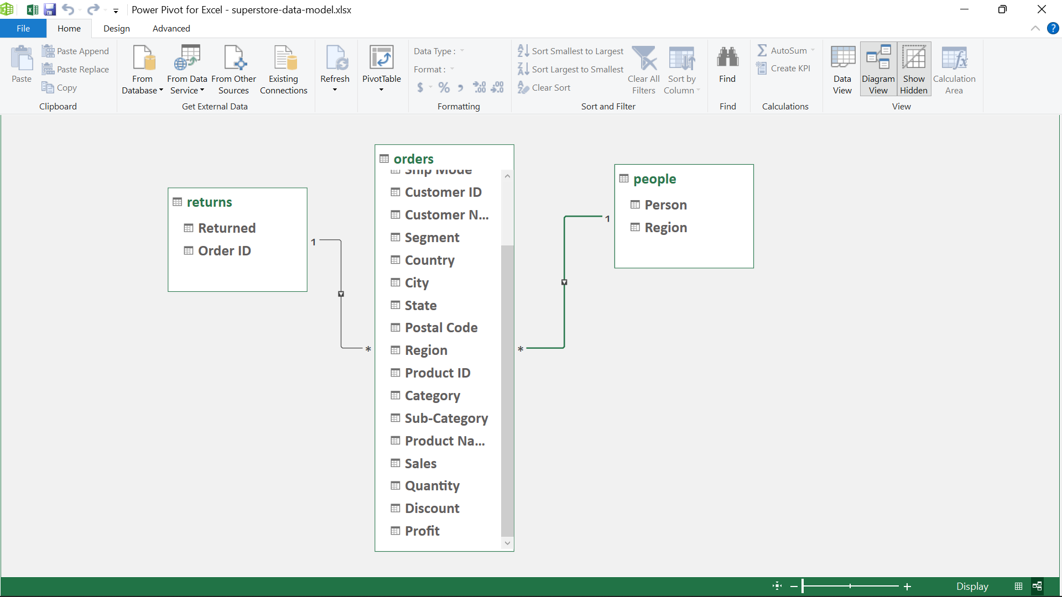
Fact vs dimension tables. The dimension tables are kind of like lookup tables.

Still in Diagram View, let’s click on PivotTable up at the top:
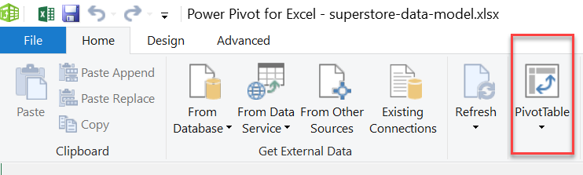
We have a Power PivotTable!
It’s going to look very similar to a regular PivotTable, here are some big differences:
- We can use data from multiple tables on the same Pivot! For example, drag Person and Sum of Sales onto the PivotTable. Notice that Sales is even pre-formatted for you, nice!
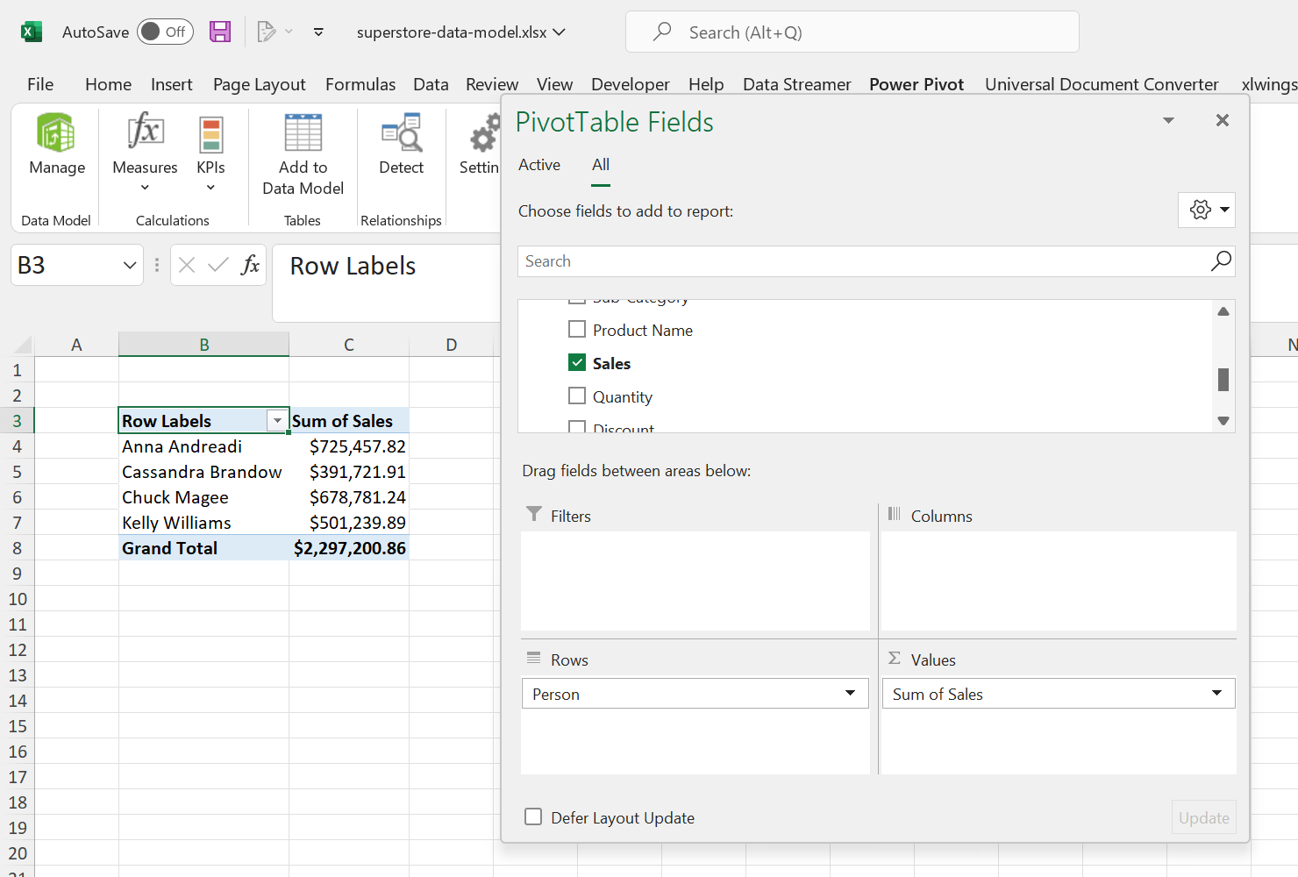

- One particular measure that is NOT available in a regular PivotTable but is in the Power PivotTable is the Distinct Count. To understand the difference let’s drag Count of Order ID vs Distinct Count of Order ID to the PivotTable. Distinct Count is down at the bottom. What is the difference?
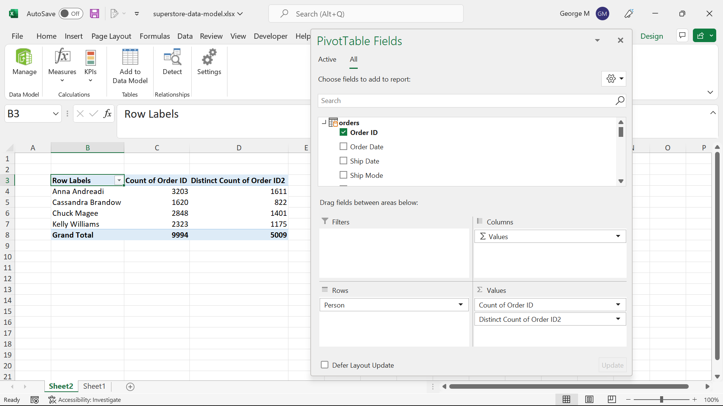

Implicit vs Explicit Measures
While using the PivotTable to change aggregation types is very familiar, you do NOT want to do this in Power Pivot. Instead, we are going to do this “explicitly” writing our own explicit measures. And this is where DAX comes in.
Go back to the Power Pivot editor and click Calculation Area on/off a couple of times. This area at the bottom is actually like a workbook that you can write formulas in!
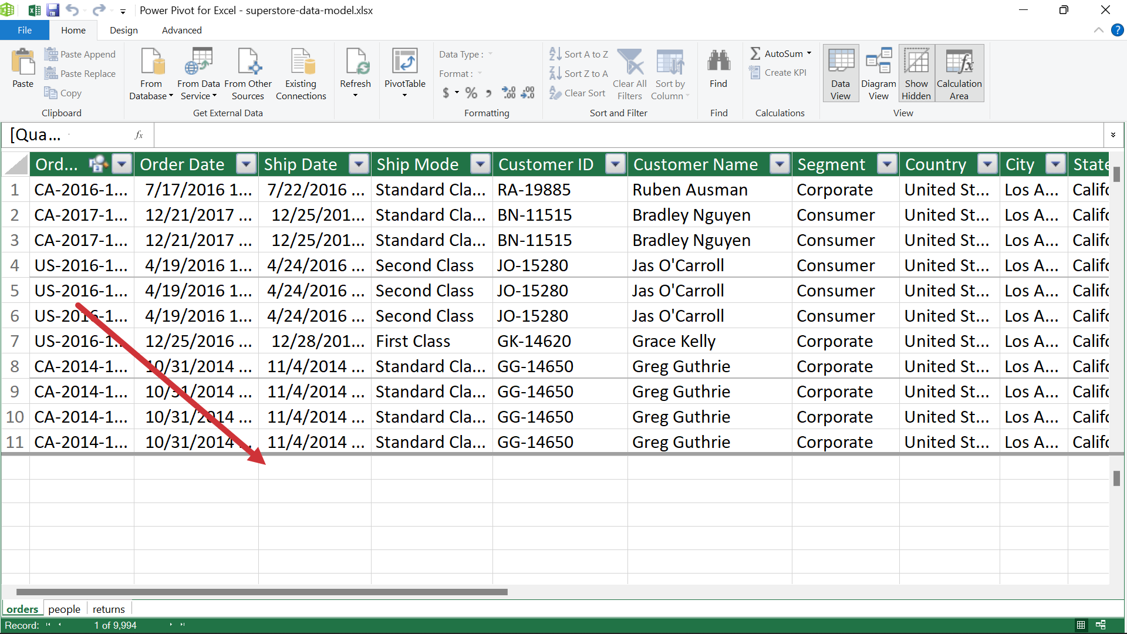

To see this in action, let’s go back to the Sales column in orders. We will go to the cells below this column and use the AutoSum feature for right now. Let’s take the Average of Sales:
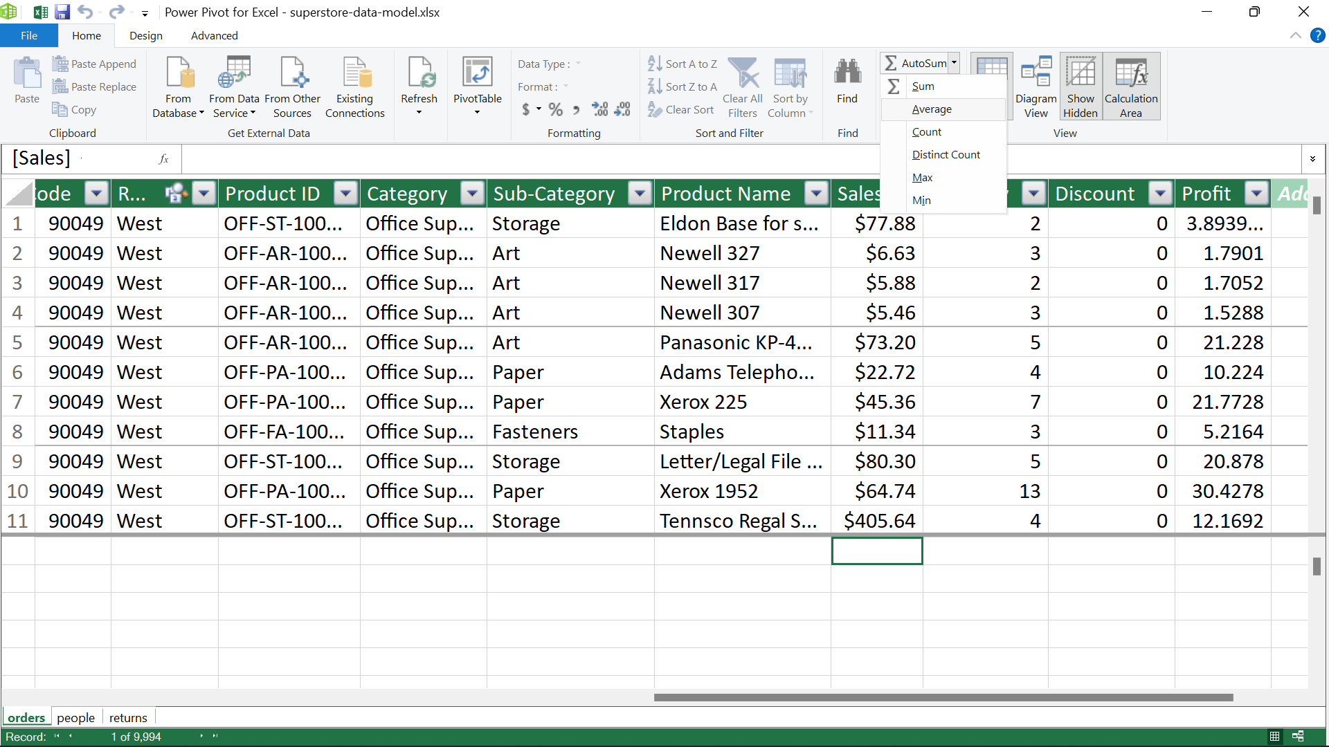

We can go over to Quantity and take the Sum as well.
This is like the “Macro Recorder” way of creating these measures. It’s easy, but not always scalable and extensible. For example, it’s considered a better practice to explicitly state the name of the table where a column is coming from in the formula, with AutoSum does not do.
Let’s fix that. You will see this notation is identical to Excel tables.
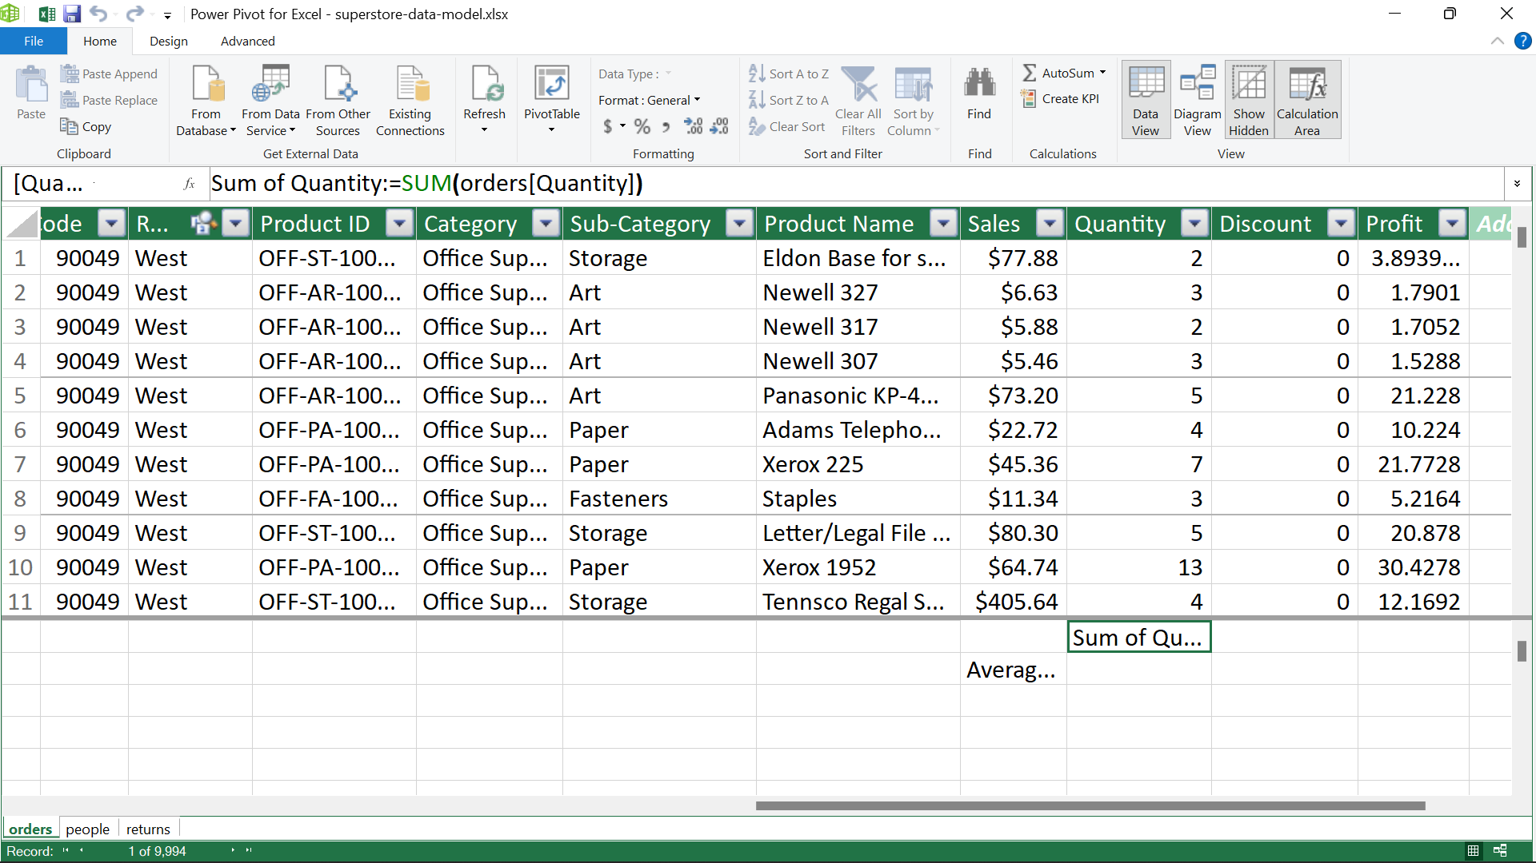

Creating calculated measures

Close out of the Power Pivot editor and head back to your PivotTable. You should now see these explicit measures in your Power PivotTable. You could format Quantity to thousands if you’d like:

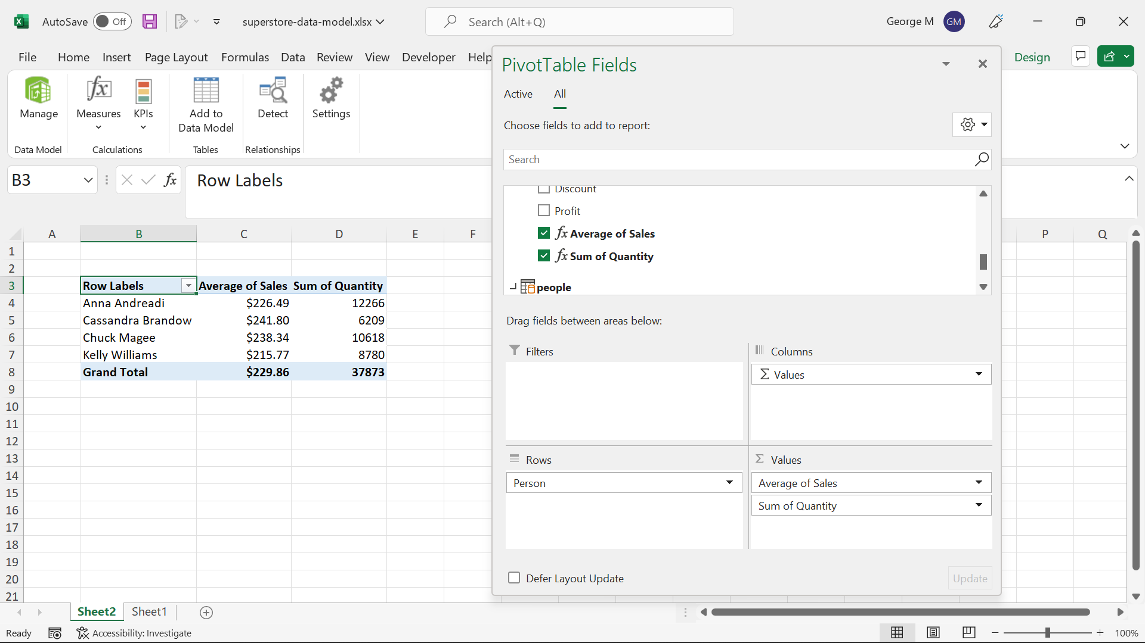

You can learn more about these measures by going to the Power Pivot tab of the ribbon > Measures > Manage Measures. Click New:

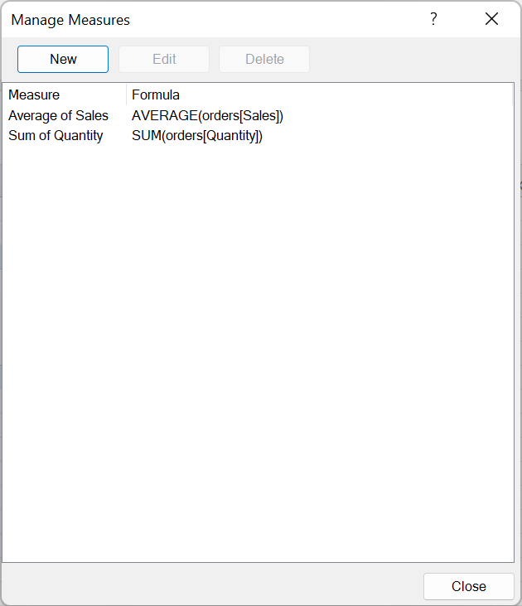
Let’s create a Profit margin measure:

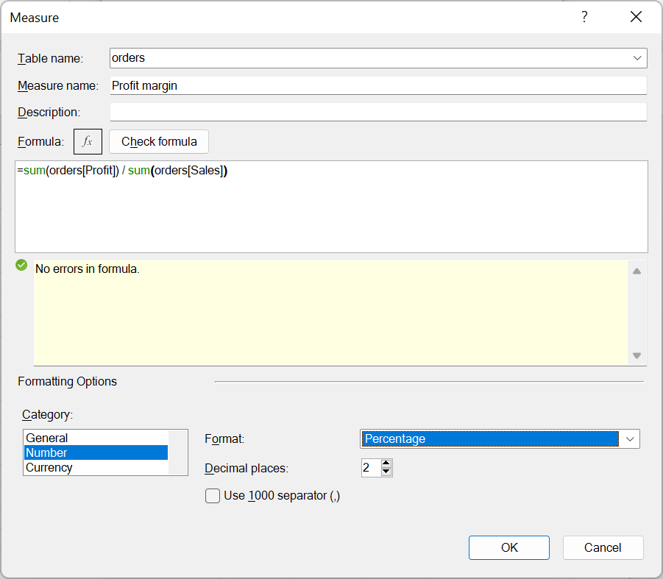

You should be starting to see something like this:

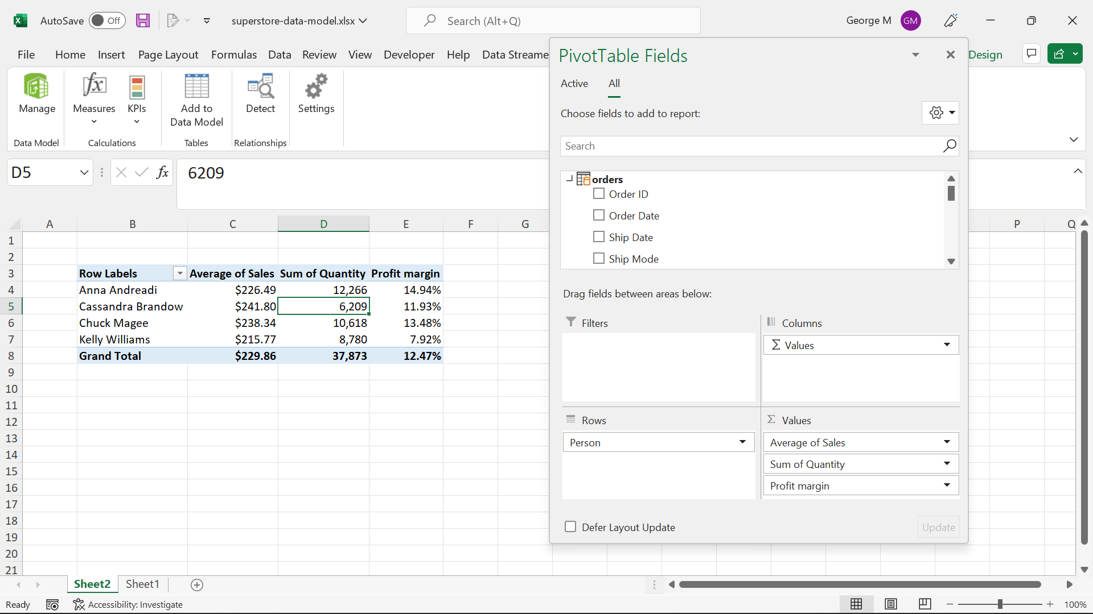

Time intelligence

This is all great to know, but to really dig into most business insights we want to be able to compare across time periods. Power Pivot makes this relatively easy.

Let’s go back to Diagram View in the editor, then go to the Design tab of the ribbon. Click on Date Table > New:

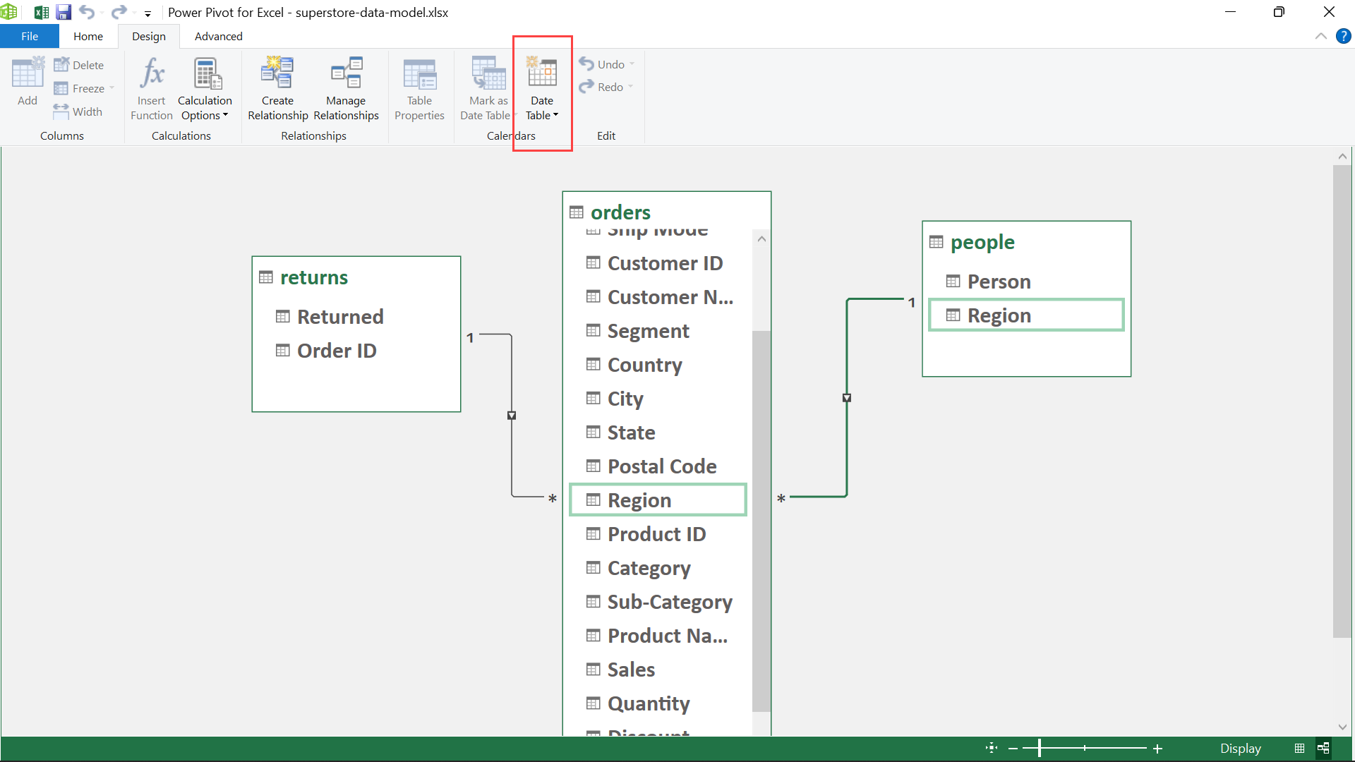

We will now create a relationship between Order Date in orders and Date in Calendar. Your schema should now look like this:

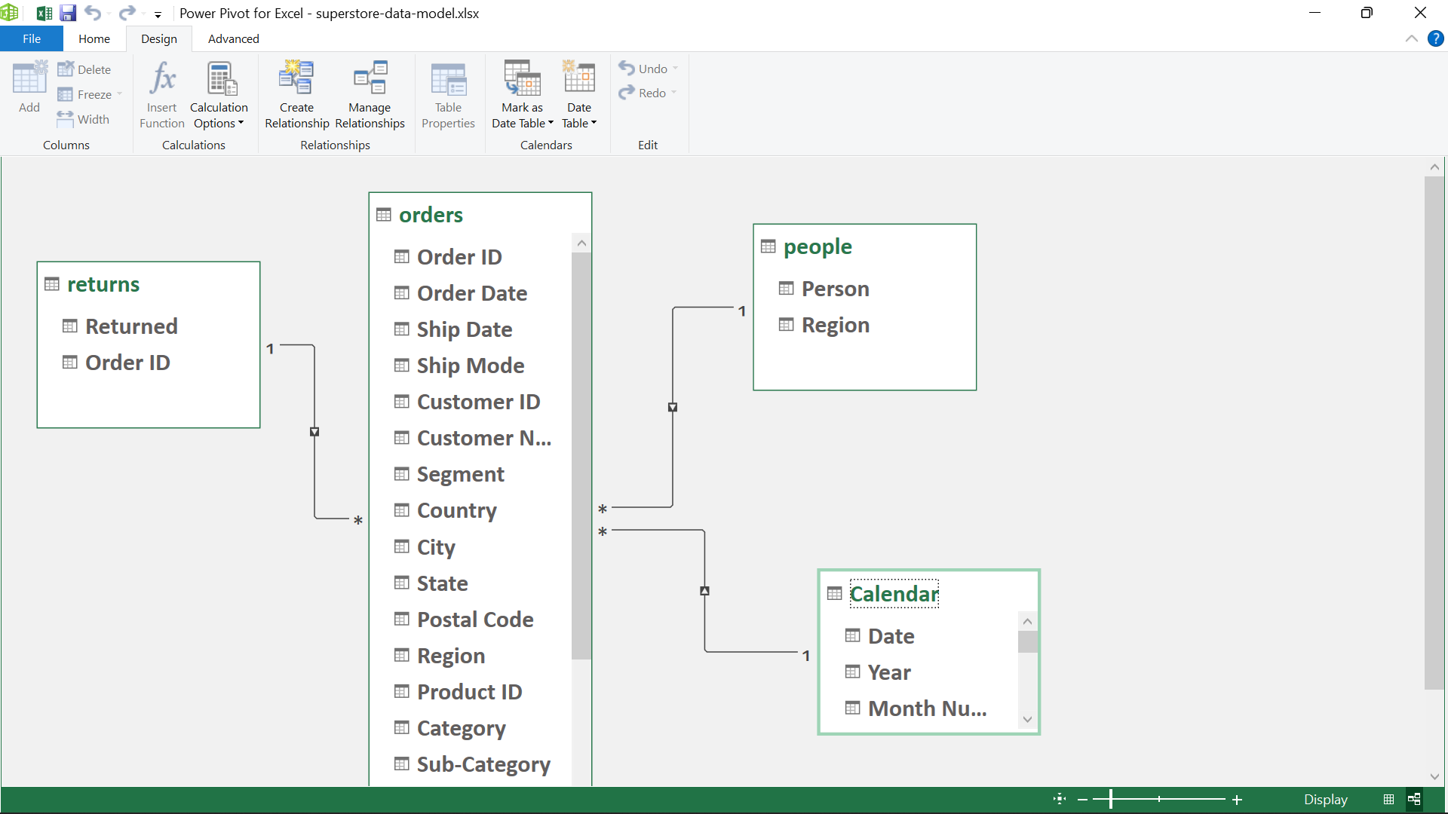
Go back to your Power PivotTable. We are now going to create some different date measures to analyze this data. To make best use of time and date functionality in Power Pivot, you should have a date table.

Go back to the Create Measures area and create a Total Sales measure first:

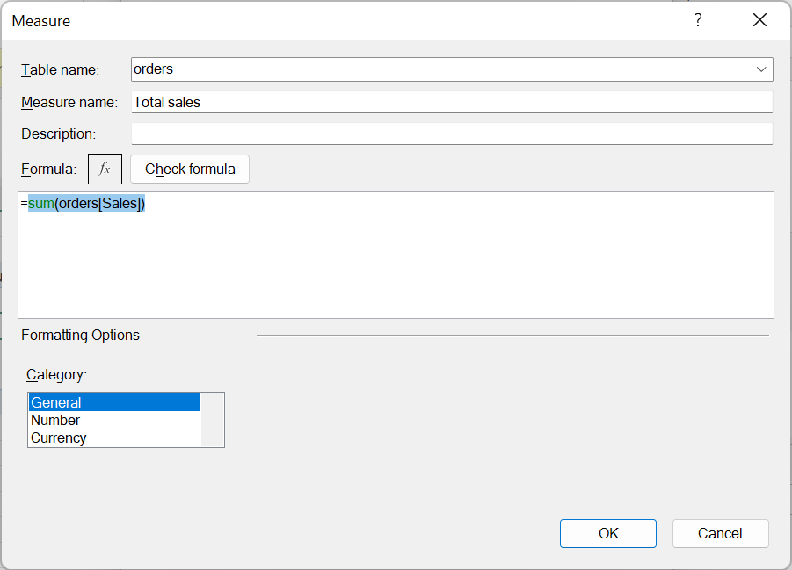

We will now create a MTD Sales column:
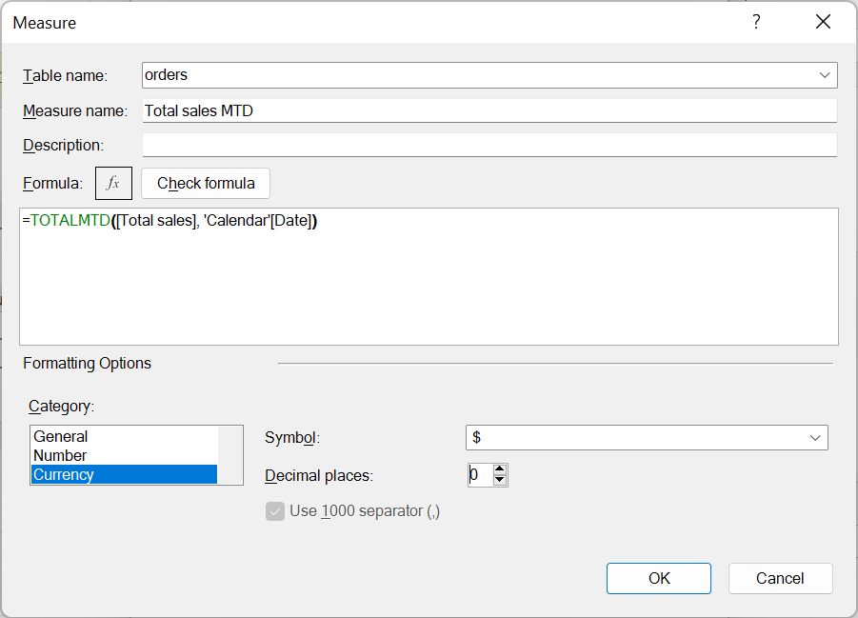

Clear out your existing PivotTable; let’s add Date Hierarchy on the Rows and Total Sales MTD in the Values:

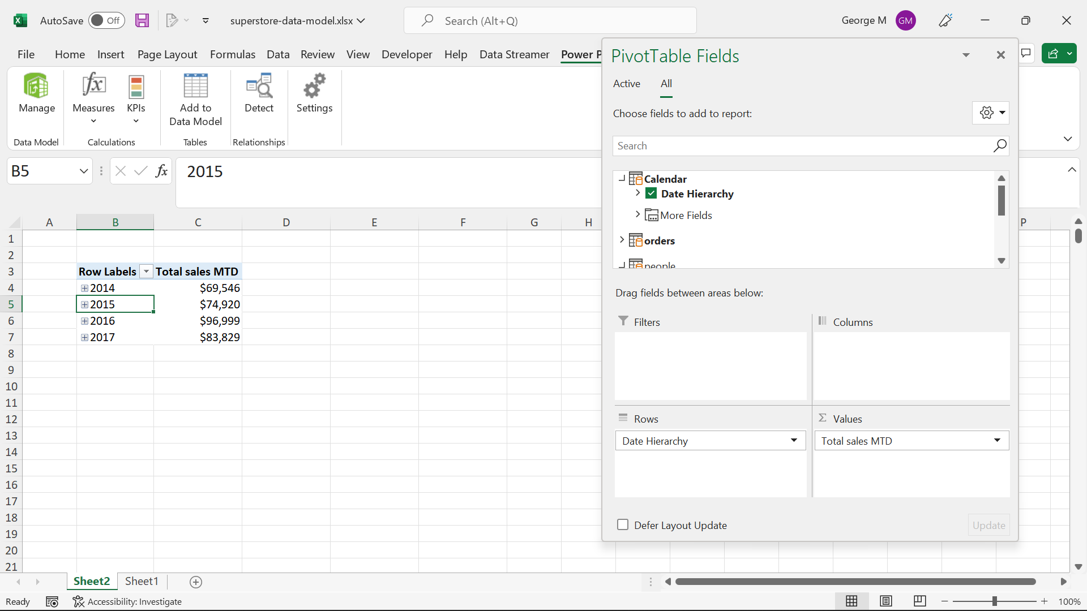

Expand the years out to see sales each month, day and so forth.
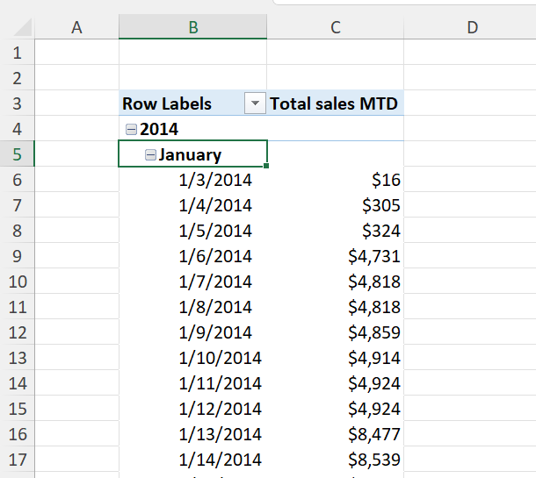

Let’s create a YTD now:

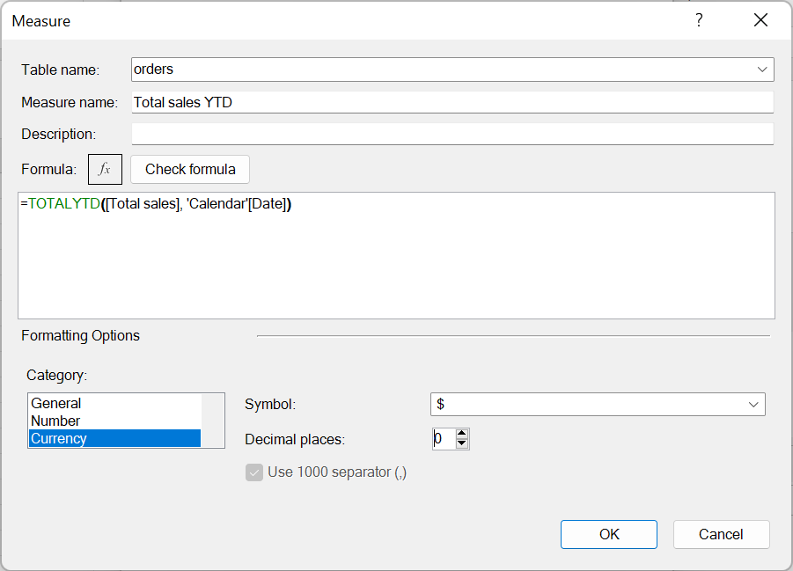

We can also get a measure to compare the current month or year to the previous month or year:

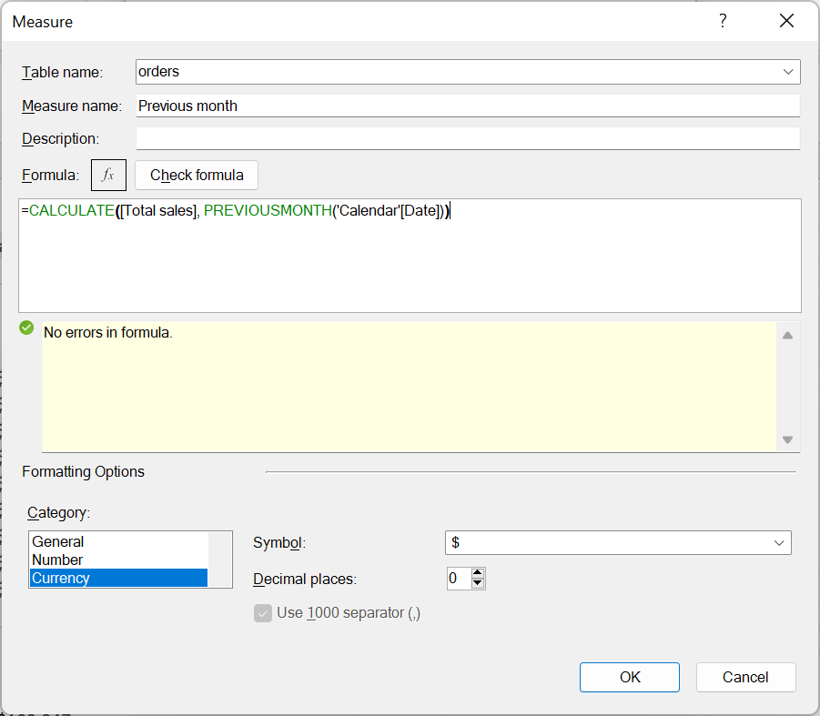

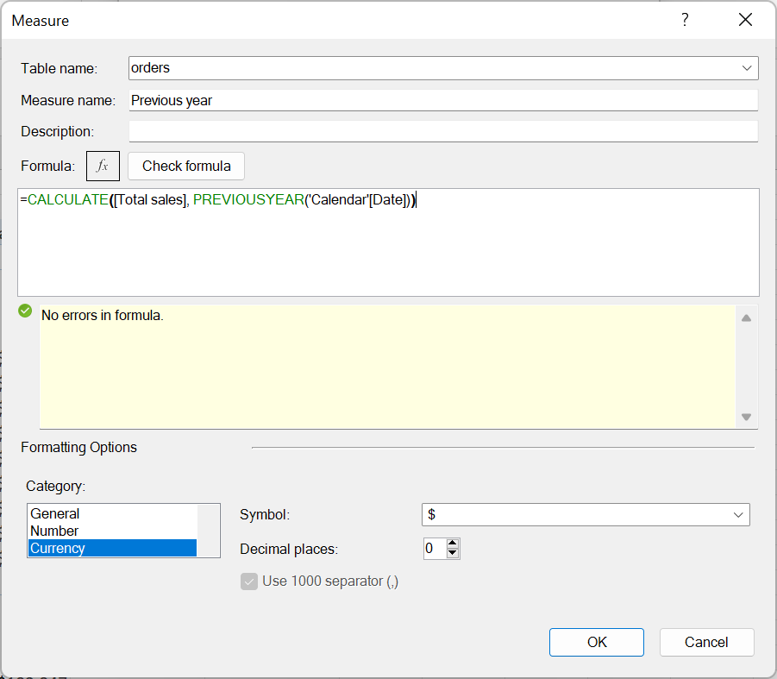
Drag those into the PivotTable and you should see something like this:

