**R-driven Power BI: Demo notes**

## Importing data

## 

From an R Script:

* Get Data > More > R Script.
* A script box will appear. Set up the script. You need to assign to an object name. You need to specify the full thing.

library(tidyverse)

personal_info <- read_csv('https://raw.githubusercontent.com/stringfestdata/satrday-r-power-bi/main/data/personal_info.csv')

perosnal_info

* From here you can check on the data frame you want and load it in.  
  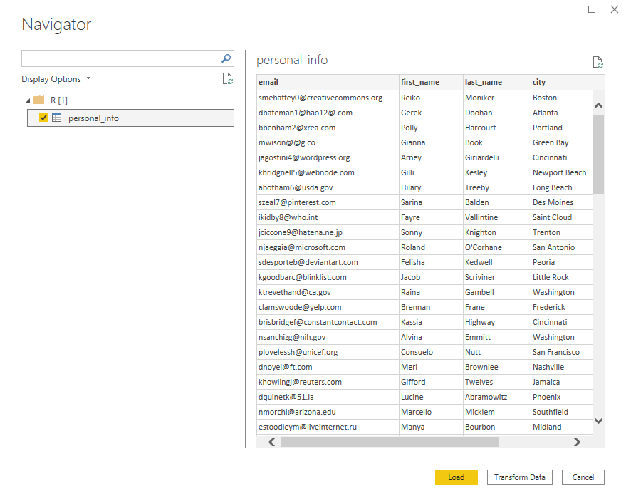

## Defining relationships

This is something special to Power BI.

* Modeling > Manage relationships. You can set the cardinality by clicking on the arrow and