Annex A (normative):
Measurement channels

A.1 General

A.1.1 Throughput definition
The throughput values defined in the measurement channels specified in Annex A, are calculated and are valid per codeword. For multi-codeword transmissions, the throughput referenced in the minimum requirements is the sum of throughputs of all codewords.

A.1.2 TDD UL-DL configurations for FR1
TDD UL-DL configurations for performance requirements are provided in Tables A.1.2-1, A.1.2-2, and A.1.2-3.
Table A.1.2-1: TDD UL-DL configuration for SCS 15 kHz
Parameter |  | Unit | UL-DL pattern
 |  | Unit | FR1.15-1
TDD Slot Configuration pattern (Note 1) |  |  | DDDSU
Special Slot Configuration (Note 2) |  |  | 10D+2G+2U
referenceSubcarrierSpacing |  | kHz | 15
pattern1 | dl-UL-TransmissionPeriodicity | ms | 5
pattern1 | nrofDownlinkSlots |  | 3
pattern1 | nrofDownlinkSymbols |  | 10
pattern1 | nrofUplinkSlot |  | 1
pattern1 | nrofUplinkSymbols |  | 2
The number of slots between PDSCH and corresponding HARQ-ACK information (Note 3) |  |  | 4 if mod(i,5) = 0  3 if mod(i,5) = 1  2 if mod(i,5) = 2  6 if mod(i,5) = 3
Note 1: D denotes a slot with all DL symbols; S denotes a slot with a mix of DL, UL and guard symbols; U denotes a slot with all UL symbols. The field is for information.
Note 2: D, G, U denote DL, guard and UL symbols, respectively. The field is for information.
Note 3: i is the slot index per frame; i = {0,…,9}.

Table A.1.2-2: TDD UL-DL configuration for SCS 30 kHz
Parameter |  | Unit | UL-DL pattern
 |  | Unit | FR1.30-1 | FR1.30-2 | FR1.30-3 | FR1.30-4 | FR1.30-5 | FR1.30-6
TDD Slot Configuration pattern (Note 1) |  |  | 7DS2U | DDDSU | DDDSUDDSUU | DDDSUUDDDD | DSUU | DS₁S₂U
Special Slot Configuration (Note 2) |  |  | 6D+4G+4U | 10D+2G+2U | 10D+2G+2U | 6D+4G+4U | 12D+2G | S1: 10D+2G+2U  S2: 12D+2G+0U
referenceSubcarrierSpacing |  | kHz | 30 | 30 | 30 | 30 | 30 | 30
pattern1
pattern1 | dl-UL-TransmissionPeriodicity | ms | 5 | 2.5 | 2.5 | 3 | 2 | 1
pattern1 | nrofDownlinkSlots |  | 7 | 3 | 3 | 3 | 1 | 1
pattern1 | nrofDownlinkSymbols |  | 6 | 10 | 10 | 6 | 12 | 10
pattern1 | nrofUplinkSlot |  | 2 | 1 | 1 | 2 | 2 | 0
pattern1 | nrofUplinkSymbols |  | 4 | 2 | 2 | 4 | 0 | 2
pattern2
pattern2 | dl-UL-TransmissionPeriodicity | ms | N/A | N/A | 2.5 | 2 | N/A | 1
pattern2 | nrofDownlinkSlots |  | N/A | N/A | 2 | 4 | N/A | 0
pattern2 | nrofDownlinkSymbols |  | N/A | N/A | 10 | 0 | N/A | 12
pattern2 | nrofUplinkSlot |  | N/A | N/A | 2 | 0 | N/A | 1
pattern2 | nrofUplinkSymbols |  | N/A | N/A | 2 | 0 | N/A | 0
The number of slots between PDSCH and corresponding HARQ-ACK information (Note 3) |  |  | 8 if mod(i,10) = 0  7 if mod(i,10) = 1  6 if mod(i,10) = 2  5 if mod(i,10) = 3  5 if mod(i,10) = 4  4 if mod(i,10) = 5  3 if mod(i,10) = 6  2 if mod(i,10) = 7 | 4 if mod(i,5) = 0  3 if mod(i,5) = 1  2 if mod(i,5) = 2  6 if mod(i,5) = 3 | 4 if mod(i,10) = 0  3 if mod(i,10) = 1  2 if mod(i,10) = 2  5 if mod(i,10) = 3  3 if mod(i,10) = 5  3 if mod(i,10) = 6  2 if mod(i,10) = 7 | 5 if mod(i,10) = 0  4 if mod(i,10) = 1  3 if mod(i,10) = 2  2 if mod(i,10) = 3  8 if mod(i,10) = 6  7 if mod(i,10) = 7  6 if mod(i,10) = 8  5 if mod(i,10) = 9 | 3 if mod(i,4) = 0  2 if mod(i,4) = 1 | 3 if mod(i,4) = 0  2 if mod(i,4) = 1  3 if mod(i,4) = 2
Note 1: D denotes a slot with all DL symbols; S denotes a slot with a mix of DL, UL and guard symbols; U denotes a slot with all UL symbols. The field is for information.
Note 2: D, G, U denote DL, guard and UL symbols, respectively. The field is for information.
Note 3: i is the slot index per frame; i = {0,…,19}

Table A.1.2-2a: TDD UL-DL configuration for SCS 30 kHz for DCI-based dynamic UL/DL detection
Parameter |  | Unit | UL-DL pattern
 |  | Unit | FR1.30-1A
TDD Slot Configuration pattern (Note 1) |  |  | 7DS2U
Special Slot Configuration (Note 2) |  |  | 6D+4G+4U
referenceSubcarrierSpacing |  | kHz | N/A
pattern1 (Note 4)
pattern1 (Note 4) | dl-UL-TransmissionPeriodicity | ms | N/A
pattern1 (Note 4) | nrofDownlinkSlots |  | N/A
pattern1 (Note 4) | nrofDownlinkSymbols |  | N/A
pattern1 (Note 4) | nrofUplinkSlot |  | N/A
pattern1 (Note 4) | nrofUplinkSymbols |  | N/A
PDCCH DCI Configuration | DCI Format |  | 1-1 for slot indices with mod(i,10) = 0,1,2,3,4,5,6,7
PDCCH DCI Configuration | Scheduled Grant |  | Symbol 2-13 for slot indices with mod(i,10) = 0,1,2,3,4,5,6 and Symbol 2-5 for slot indices with mod(i,10) = 7
The number of slots between PDSCH and corresponding HARQ-ACK information (Note 3)  (PDSCH-to-HARQ-timing-indicator) |  |  | 8 if mod(i,10) = 0  7 if mod(i,10) = 1  6 if mod(i,10) = 2  5 if mod(i,10) = 3  5 if mod(i,10) = 4  4 if mod(i,10) = 5  3 if mod(i,10) = 6  2 if mod(i,10) = 7
Note 1: D denotes a slot with all DL symbols; S denotes a slot with a mix of DL, UL and guard symbols; U denotes a slot with all UL symbols. The field is for information.
Note 2: D, G and U denote DL, guard and UL symbols, respectively. The field is for information.
Note 3: i is the slot index per frame; i = {0,…,19}
Note 4: Do not configure tdd-UL-DL-ConfigurationCommon using RRC configuration

Table A.1.2-2b: TDD UL-DL configuration for SCS 30 kHz for PDSCH on band with shared spectrum access
Parameter |  | Unit | UL-DL pattern
 |  | Unit | FR1.30-7
TDD Slot Configuration pattern (Note 1) |  |  | 7DS2U
Special Slot Configuration (Note 2) |  |  | 6D+4G+4U
referenceSubcarrierSpacing |  | kHz | 30
Pattern 1 | dl-UL-TransmissionPeriodicity | ms | 5
Pattern 1 | nrofDownlinkSlots | slot | 7
Pattern 1 | nrofDownlinkSymbols | symbol | 6
Pattern 1 | nrofUplinkSlot | slot | 2
Pattern 1 | nrofUplinkSymbols | symbol | 4
Pattern 2 | dl-UL-TransmissionPeriodicity | ms | N/A
Pattern 2 | nrofDownlinkSlots |  | N/A
Pattern 2 | nrofDownlinkSymbols |  | N/A
Pattern 2 | nrofUplinkSlot |  | N/A
Pattern 2 | nrofUplinkSymbols |  | N/A
The number of slots between PDSCH and corresponding HARQ-ACK information (Note 3) |  |  | 8 if mod(i,10) = 0  7 if mod(i,10) = 1  6 if mod(i,10) = 2  5 if mod(i,10) = 3  4 if mod(i,10) = 4  3 if mod(i,10) = 5  2 if mod(i,10) = 6
Note 1: D denotes a slot with all DL symbols; S denotes a slot with a mix of DL, UL and guard symbols; U denotes a slot with all UL symbols. The field is for information.
Note 2: D, G, U denote DL, guard and UL symbols, respectively. The field is for information.
Note 3: i is the slot index of all slots in every 5ms i = {0,…,9}Note 4: The slot i, mod (i,10)=9 is idle slot with no UL transmission.

Table A.1.2-2c: TDD UL-DL configuration for SCS 30 kHz for ATG
Parameter |  | Unit | UL-DL pattern
 |  | Unit | FR1.30-8
TDD Slot Configuration pattern (Note 1) |  |  | 30D4S6U
Special Slot Configuration (Note 2) |  |  | 14G
referenceSubcarrierSpacing |  | kHz | 30
Pattern 1 | dl-UL-TransmissionPeriodicity | ms | 10
Pattern 1 | nrofDownlinkSlots | slot | 20
Pattern 1 | nrofDownlinkSymbols | symbol | 0
Pattern 1 | nrofUplinkSlot | slot | 0
Pattern 1 | nrofUplinkSymbols | symbol | 0
Pattern 2 | dl-UL-TransmissionPeriodicity | ms | 10
Pattern 2 | nrofDownlinkSlots |  | 10
Pattern 2 | nrofDownlinkSymbols |  | 0
Pattern 2 | nrofUplinkSlot |  | 6
Pattern 2 | nrofUplinkSymbols |  | 0
The number of slots between PDSCH and corresponding HARQ-ACK information for UE supporting outOfOrderOperationDL-r16 (Note 3) |  |  | 34 if mod(i,40) = 0, 1, 2, 3, 4, 5  28 if mod(i,40) = 6, 7, 8, 9, 10, 11  22 if mod(i,40) = 12, 13, 14, 15, 16, 17  16 if mod(i,40) = 18, 19, 20, 21, 22, 23  10 if mod(i,40) = 24, 25, 26, 27, 28, 29
The number of slots between PDSCH and corresponding HARQ-ACK information for UE not supporting outOfOrderOperationDL-r16 (Note 3) |  |  | 33 if mod(i,40) = 1  30 if mod(i,40) = 4, 5  26 if mod(i,40) = 9,10  22 if mod(i,40) = 14,15  18 if mod(i,40) = 19,20  14 if mod(i,40) = 24,25  11 if mod(i,40) = 28  10 if mod(i,40) = 29
Note 1: D denotes a slot with all DL symbols; S denotes a slot with a mix of DL, UL and guard symbols; U denotes a slot with all UL symbols. The field is for information.
Note 2: D, G, U denote DL, guard and UL symbols, respectively. The field is for information.
Note 3: i is the slot index of all slots in every 20ms, i = {0,…,39}

A.1.3 TDD UL-DL configurations for FR2
TDD UL-DL patterns configurations for performance requirements are provided in Tables A.1.3-1, A.1.3-2.
Table A.1.3-1: TDD UL-DL pattern for SCS 60 kHz
Parameter |  | Unit | UL-DL pattern
 |  | Unit | FR2.60-1
TDD Slot Configuration pattern (Note 1) |  |  | DDSU
Special Slot Configuration (Note 2) |  |  | 11D+3G+0U
referenceSubcarrierSpacing |  | kHz | 60
pattern1 | dl-UL-TransmissionPeriodicity | ms | 1
pattern1 | nrofDownlinkSlots |  | 2
pattern1 | nrofDownlinkSymbols |  | 11
pattern1 | nrofUplinkSlot |  | 1
pattern1 | nrofUplinkSymbols |  | 0
The number of slots between PDSCH and corresponding HARQ-ACK information (Note 3) |  |  | 3 if mod(i,4) = 0  2 if mod(i,4) = 1  5 if mod(i,4) = 2
Note 1: D denotes a slot with all DL symbols; S denotes a slot with a mix of DL, UL and guard symbols; U denotes a slot with all UL symbols. The field is for information.
Note 2: D, G, U denote DL, guard and UL symbols, respectively. The field is for information.
Note 3: i is the slot index per frame; i = {0,…,39}

Table A.1.3-2: TDD UL-DL configuration for SCS 120 kHz
Parameter |  | Unit | UL-DL pattern
 |  | Unit | FR2.120-1 | FR2.120-2
TDD Slot Configuration pattern (Note 1) |  |  | DDDSU | DDSU
Special Slot Configuration (Note 2) |  |  | 10D+2G+2U | 11D+3G+0U
referenceSubcarrierSpacing |  | kHz | 120 | 120
pattern1 | dl-UL-TransmissionPeriodicity | ms | 0.625 | 0.5
pattern1 | nrofDownlinkSlots |  | 3 | 2
pattern1 | nrofDownlinkSymbols |  | 10 | 11
pattern1 | nrofUplinkSlot |  | 1 | 1
pattern1 | nrofUplinkSymbols |  | 2 | 0
The number of slots between PDSCH and corresponding HARQ-ACK information(Note 3) |  |  | 4 if mod(i,5) = 0  3 if mod(i,5) = 1  2 if mod(i,5) = 2  6 if mod(i,5) = 3 | 3 if mod(i,4) = 0  2 if mod(i,4) = 1  5 if mod(i,4) = 2
Note 1: D denotes a slot with all DL symbols; S denotes a slot with a mix of DL, UL and guard symbols; U denotes a slot with all UL symbols. The field is for information.
Note 2: D, G, U denote DL, guard and UL symbols, respectively. The field is for information.
Note 3: i is the slot index per frame; i = {0,…,79}

Table A.1.3-2a: TDD UL-DL configuration for SCS 120 kHz for DCI-based dynamic UL/DL detection
Parameter |  | Unit | UL-DL pattern
 |  | Unit | FR2.120-1A
TDD Slot Configuration pattern (Note 1) |  |  | DDDSU
Special Slot Configuration (Note 2) |  |  | 10D+2G+2U
referenceSubcarrierSpacing |  | kHz | N/A
pattern1 (Note 4) | dl-UL-TransmissionPeriodicity | ms | N/A
pattern1 (Note 4) | nrofDownlinkSlots |  | N/A
pattern1 (Note 4) | nrofDownlinkSymbols |  | N/A
pattern1 (Note 4) | nrofUplinkSlot |  | N/A
pattern1 (Note 4) | nrofUplinkSymbols |  | N/A
PDCCH DCI Configuration | DCI Format |  | 1-1 for slot indices with mod(i,5) = 0,1,2,3
PDCCH DCI Configuration | Scheduled Grant |  | Symbol 1-13 for slot indices with mod(i,5) = 0,1,2 and Symbol 1-9 for slot indices with mod(i,5) = 3
The number of slots between PDSCH and corresponding HARQ-ACK information(Note 3) |  |  | 4 if mod(i,5) = 0  3 if mod(i,5) = 1  2 if mod(i,5) = 2  6 if mod(i,5) = 3
Note 1: D denotes a slot with all DL symbols; S denotes a slot with a mix of DL, UL and guard symbols; U denotes a slot with all UL symbols. The field is for information.
Note 2: D, G and U denote DL, guard and UL symbols, respectively. The field is for information.
Note 3: i is the slot index per frame; i = {0,…,79}
Note 4: Do not configure tdd-UL-DL-ConfigurationCommon using RRC configuration.

Table A.1.3-3: TDD UL-DL configuration for SCS 480 kHz
Parameter |  | Unit | UL-DL pattern
 |  | Unit | FR2.480-1
TDD Slot Configuration pattern (Note 1) |  |  | DDDDDDDDDDDDDDS1S2UUUU
Special Slot Configuration (Note 2) |  |  | S1:12D+2G+0U  S2: 0D+6G+8U
referenceSubcarrierSpacing |  | kHz | 480
pattern1 | dl-UL-TransmissionPeriodicity | ms | 0.625
pattern1 | nrofDownlinkSlots |  | 14
pattern1 | nrofDownlinkSymbols |  | 12
pattern1 | nrofUplinkSlot |  | 4
pattern1 | nrofUplinkSymbols |  | 8
The number of slots between PDSCH and corresponding HARQ-ACK information(Note 3) |  |  | 19-mod(i,40) if mod(i,40) =0,1,…,11  39-mod(i,40) if mod(i,40) =12,13,14,20,21,…, 31
Note 1: D denotes a slot with all DL symbols; S denotes a slot with a mix of DL, UL and guard symbols; U denotes a slot with all UL symbols. The field is for information.
Note 2: D, G, U denote DL, guard and UL symbols, respectively. The field is for information.
Note 3: i is the slot index per frame; i = {0,…,319}

A.2 Void
<Editor's note: Clause A.2 is a placeholder for UL Measurement channels>

A.3 DL reference measurement channels

A.3.1 General
The transport block size (TBS) determination procedure is described in clause 5.1.3.2 of TS 38.214 [12].
Unless otherwise stated, no user data is scheduled on slot #0 within 20 ms in order to avoid SSB and PDSCH transmissions in one slot and simplify test configuration.
Unless otherwise stated, SIB1 transmission shall only be scheduled during call setup to avoid SIB1 and PDSCH transmissions in the same slot.

A.3.2 Reference measurement channels for PDSCH performance requirements
For PDSCH reference channels if more than one Code Block is present, an additional CRC sequence of L = 24 Bits is attached to each Code Block (otherwise L = 0 Bit).

A.3.2.1 FDD

A.3.2.1.1 Reference measurement channels for SCS 15 kHz FR1
Table A.3.2.1.1-1: PDSCH Reference Channel for FDD (QPSK)
Parameter | Unit | Value
Reference channel |  | R.PDSCH.1-1.1 FDD | R.PDSCH.1-1.2 FDD | R.PDSCH.1-1.3 FDD | R.PDSCH.1-1.4 FDD | R.PDSCH.1-1.5 FDD
Channel bandwidth | MHz | 10 | 10 | 10 | 10 | 10
Subcarrier spacing | kHz | 15 | 15 | 15 | 15 | 15
Number of allocated resource blocks | PRBs | 52 | 6 | 52 | 52 | 25
Number of consecutive PDSCH symbols |  | 12 | 12 | 7 | 12 | 12
Allocated slots per 2 frames | Slots | 19 | 19 | 19 | 19 | 19
MCS table |  | 64QAM | 64QAM | 64QAM | 64QAMLowSE | 64QAM
MCS index |  | 4 | 4 | 4 | 14 | 4
Modulation |  | QPSK | QPSK | QPSK | QPSK | QPSK
Target Coding Rate |  | 0.30 | 0.30 | 0.30 | 0.59 | 0.30
Number of MIMO layers |  | 1 | 1 | 1 | 1 | 1
Number of DMRS REs |  | 18 | 12 | 12 | 12 | 18
Overhead for TBS determination |  | 0 | 0 | 0 | 0 | 0
Information Bit Payload per Slot
For Slot i = 0 | Bits | N/A | N/A | N/A | N/A | N/A
For Slots i = 1,…, 19 | Bits | 3904 | 480 | 2280 | 8064 | 1928
Transport block CRC per Slot
For Slot i = 0 | Bits | N/A | N/A | N/A | N/A | N/A
For Slots i = 1,…, 19 | Bits | 24 | 16 | 16 | 24 | 16
Number of Code Blocks per Slot
For Slot i = 0 | CBs | N/A | N/A | N/A | N/A | N/A
For Slots i = 1,…, 19 | CBs | 1 | 1 | 1 | 1 | 1
Binary Channel Bits Per Slot
For Slot i = 0 | Bits | N/A | N/A | N/A | N/A | N/A
For Slots i = 10, 11 | Bits | 12480 | 1512 | 6864 | 13104 | 6000
For Slots i =1,…, 9, 12, …, 19 | Bits | 13104 | 1584 | 7488 | 13728 | 6300
Max. Throughput averaged over 2 frames | Mbps | 3.709 | 0.456 | 2.166 | 7.661 | 1.832
Note 1: SS/PBCH block is transmitted in slot #0 with periodicity 20 ms
Note 2: Slot i is slot index per 2 frames

Table A.3.2.1.1-2: PDSCH Reference Channel for FDD (16QAM)
Parameter | Unit | Value
Reference channel |  | R.PDSCH.1-2.1 FDD | R.PDSCH.1-2.2 FDD | R.PDSCH.1-2.3 FDD | R.PDSCH.1-2.4 FDD | R.PDSCH.1-2.5 FDD | R.PDSCH.1-2.6 FDD
Channel bandwidth | MHz | 10 | 10 | 10 | 10 | 10 | 10
Subcarrier spacing | kHz | 15 | 15 | 15 | 15 | 15 | 15
Number of allocated resource blocks | PRBs | 52 | 52 | 52 | 52 | 52 | 52
Number of consecutive PDSCH symbols |  | 12 | 12 | 12 | 12 | 12 | 12
Allocated slots per 2 frames | Slots | 19 | 19 | 19 | 19 | 19 | 19
MCS table |  | 64QAM | 64QAM | 64QAM | 64QAM | 64QAMLowSE | 64QAM
MCS index |  | 13 | 13 | 13 | 13 | 19 | 16
Modulation |  | 16QAM | 16QAM | 16QAM | 16QAM | 16QAM | 16QAM
Target Coding Rate |  | 0.48 | 0.48 | 0.48 | 0.48 | 0.54 | 0.64
Number of MIMO layers |  | 1 | 2 | 3 | 4 | 2 | 1
Number of DMRS REs |  | 12 | 12 | 24 | 24 | 12 | 12
Overhead for TBS determination |  | 0 | 0 | 0 | 0 | 0 | 0
Information Bit Payload per Slot
For Slot i = 0 | Bits | N/A | N/A | N/A | N/A | N/A | N/A
For Slots i = 1,…, 19 | Bits | 13064 | 26120 | 35856 | 48168 | 29704 | 17424
Transport block CRC per Slot
For Slot i = 0 | Bits | N/A | N/A | N/A | N/A | N/A | N/A
For Slots i = 1,…, 19 | Bits | 24 | 24 | 24 | 24 | 24 | 24
Number of Code Blocks per Slot
For Slot i = 0 | CBs | N/A | N/A | N/A | N/A | N/A | N/A
For Slots i = 1,…, 19 | CBs | 2 | 4 | 5 | 6 | 4 | 3
Binary Channel Bits Per Slot
For Slot i = 0 | Bits | N/A | N/A | N/A | N/A | N/A | N/A
For Slots i = 10, 11 | Bits | 26208 | 52416 | 71136 | 94848 | 49920 | 26208
For Slots i = 1,…, 9, 12, …, 19 | Bits | 27456 | 54912 | 74880 | 99840 | 54912 | 27456
Max. Throughput averaged over 2 frames | Mbps | 12.411 | 24.814 | 34.063 | 45.760 | 28.219 | 16.553
Note 1: SS/PBCH block is transmitted in slot #0 with periodicity 20 ms
Note 2: Slot i is slot index per 2 frames

Table A.3.2.1.1-3: PDSCH Reference Channel for FDD (64QAM)
Parameter | Unit | Value
Reference channel |  | R.PDSCH.1-3.1 FDD | R.PDSCH.1-3.2 FDD | R.PDSCH.1-3.3 FDD | R.PDSCH.1-3.4 FDD | R.PDSCH.1-3.5 FDD | R.PDSCH.1-3.6 FDD | R.PDSCH.1-3.7 FDD | R.PDSCH.1-3.8 FDD (Note 5)
Channel bandwidth | MHz | 10 | 10 | 10 | 10 | 10 | 10 | 10 | 10
Subcarrier spacing | kHz | 15 | 15 | 15 | 15 | 15 | 15 | 15 | 15
Number of allocated resource blocks | PRBs | 52 | 52 | 26 (Note 3) | 26 (Note 4) | 52 | 52 | 52 | 52
Number of consecutive PDSCH symbols |  | 12 | 12 | 12 | 12 | 12 | 12 | 12 | 12
Allocated slots per 2 frames | Slots | 19 | 19 | 19 | 19 | 19 | 19 | 19 | 19
MCS table |  | 64QAM | 64QAM | 64QAM | 64QAM | 64QAM | 64QAM | 64QAM | 64QAM
MCS index |  | 19 | 19 | 19 | 19 | 19 | 22 | 17 | 17
Modulation |  | 64QAM | 64QAM | 64QAM | 64QAM | 64QAM | 64QAM | 64QAM | 64QAM
Target Coding Rate |  | 0.51 | 0.51 | 0.51 | 0.51 | 0.51 | 0.65 | 0.43 | 0.43
Number of MIMO layers |  | 2 | 2 | 2 | 2 | 1 | 1 | 4 | 4
Number of DMRS REs |  | 12 | 24 | 24 | 24 | 12 | 12 | 24 | 48
Overhead for TBS determination |  | 0 | 0 | 0 | 0 | 0 | 0 | 0 | 0
Information Bit Payload per Slot
For Slot i = 0 | Bits | N/A | N/A | N/A | N/A | N/A | N/A | N/A | N/A
For Slots i = 1,…, 19 | Bits | 42016 | 37896 | 18960 | 18960 | 21000 | 26632 | 64552 | 51216
Transport block CRC per Slot
For Slot i = 0 | Bits | N/A | N/A | N/A | N/A | N/A |  | N/A | N/A
For Slots i = 1,…, 19 | Bits | 24 | 24 | 24 | 24 | 24 | 24 | 24 | 24
Number of Code Blocks per Slot
For Slot i = 0 | CBs | N/A | N/A | N/A | N/A | N/A |  | N/A | N/A
For Slots i = 1,…, 19 | CBs | 5 | 5 | 3 | 3 | 3 | 4 | 8 | 7
Binary Channel Bits Per Slot
For Slot i = 0 | Bits | N/A | N/A | N/A | N/A | N/A |  | N/A | N/A
For Slots i = 10, 11 | Bits | 78624 | 67392 | 33696 | 33696 | 39312 | 39312 | 142272 | 112320
For Slots i = 1,…, 9, 12, …, 19 | Bits | 82368 | 74880 | 37440 | 37440 | 41184 | 41184 | 149760 | 119808
Max. Throughput averaged over 2 frames | Mbps | 39.915 | 36.001 | 18.012 | 18.012 | 19.950 | 25.300 | 61.32 | 48.66
Note 1: SS/PBCH block is transmitted in slot #0 with periodicity 20 ms
Note 2: Slot i is slot index per 2 frames
Note 3: PDSCH is scheduled in PRB numbers from 0 to 25.
Note 4: PDSCH is scheduled in PRB numbers from 26 to 51.
Note 5: Two codewords and given per codeword

Table A.3.2.1.1-4: PDSCH Reference Channel for FDD (256QAM)
Parameter | Unit | Value
Reference channel |  | R.PDSCH.1-4.1 FDD | R.PDSCH.1-4.2 FDD
Channel bandwidth | MHz | 10 | 10
Subcarrier spacing | kHz | 15 | 15
Number of allocated resource blocks | PRBs | 52 | 52
Number of consecutive PDSCH symbols |  | 12 | 12
Allocated slots per 2 frames | Slots | 19 | 19
MCS table |  | 256QAM | 256QAM
MCS index |  | 24 | 20
Modulation |  | 256QAM | 256QAM
Target Coding Rate |  | 0.82 | 0.67
Number of MIMO layers |  | 1 | 1
Number of DMRS REs |  | 12 | 12
Overhead for TBS determination |  | 0 | 0
Information Bit Payload per Slot
For Slot i = 0 | Bits | N/A | N/A
For Slots i = 1,…, 19 | Bits | 45096 | 36896
Transport block CRC per Slot
For Slot i = 0 | Bits | N/A | N/A
For Slots i = 1,…, 19 | Bits | 24 | 24
Number of Code Blocks per Slot
For Slot i = 0 | CBs | N/A | N/A
For Slots i = 1,…, 19 | CBs | 6 | 5
Binary Channel Bits Per Slot
For Slot i = 0 | Bits | N/A | N/A
For Slots i = 10, 11 | Bits | 52416 | 52416
For Slots i = 1,…, 9, 12, …, 19 | Bits | 54912 | 54912
Max. Throughput averaged over 2 frames | Mbps | 42.841 | 35.051
Note 1: SS/PBCH block is transmitted in slot #0 with periodicity 20 ms
Note 2: Slot i is slot index per 2 frames

Table A.3.2.1.1-5: PDSCH Reference Channel for FDD and CSI-RS overlapped with PDSCH
Parameter | Unit | Value
Reference channel |  | R.PDSCH.1-5.1 FDD
Channel bandwidth | MHz | 10
Subcarrier spacing | kHz | 15
Number of allocated resource blocks | PRBs | 52
Number of consecutive PDSCH symbols |  | 12
Allocated slots per 2 frames | Slots | 19
MCS table |  | 64QAM
MCS index |  | 13
Modulation |  | 16QAM
Target Coding Rate |  | 0.48
Number of MIMO layers |  | 2
Number of DMRS REs |  | 12
Overhead for TBS determination |  | 0
Information Bit Payload per Slot
For Slot i = 0 | Bits | N/A
For Slots i = 1,…, 19 | Bits | 26120
Transport block CRC per Slot
For Slot i = 0 | Bits | N/A
For Slots i = 1,…, 19 | Bits | 24
Number of Code Blocks per Slot
For Slot i = 0 | CBs | N/A
For Slots i = 1,…, 19 | CBs | 4
Binary Channel Bits Per Slot
For Slot i = 0 | Bits | N/A
For Slots i = 5, 15 | Bits | 50752
For Slots i = 10 | Bits | 48256
For Slots i = 11 | Bits | 52416
For Slots i = 1,…,4,6,…, 9,12,…14,16,…,19 | Bits | 54912
Max. Throughput averaged over 2 frames | Mbps | 24.814
Note 1: SS/PBCH block is transmitted in slot #0 with periodicity 20 ms
Note 2: Slot i is slot index per 2 frames

Table A.3.2.1.1-6: PDSCH Reference Channel for FDD PMI reporting requirements
Parameter | Unit | Value
Reference channel |  | R.PDSCH.1-6.1 FDD | R.PDSCH.1-6.2 FDD | R.PDSCH.1-6.3 FDD | R.PDSCH.1-6.4 FDD | R.PDSCH.1-6.5 FDD
Channel bandwidth | MHz | 10 | 10 | 10 | 10 | 10
Subcarrier spacing | kHz | 15 | 15 | 15 | 15 | 15
Number of allocated resource blocks | PRBs | 52 | 52 | 52 | 52 | 25
Number of consecutive PDSCH symbols |  | 12 | 12 | 12 | 12 | 12
Allocated slots per 2 frames | Slots | 15 | 15 | 15 | 15 | 15
MCS table |  | 64QAM | 64QAM | 64QAM | 64QAM | 64QAM
MCS index |  | 13 | 13 | 20 | 13 | 13
Modulation |  | 16QAM | 16QAM | 64QAM | 16QAM | 16QAM
Target Coding Rate |  | 0.48 | 0.48 | 0.55 | 0.48 | 0.48
Number of MIMO layer |  | 1 | 2 | 2 | 2 | 1
Number of DMRS REs (Note 3) |  | 24 | 24 | 24 | 24 | 24
Overhead for TBS determination |  | 0 | 0 | 0 | 0 | 0
Information Bit Payload per Slot
For Slot i = 0 | Bits | N/A | N/A | N/A | N/A | N/A
For CSI Slots i, if mod (i,5) =1, i={0,…,19} |  | N/A | N/A | N/A | N/A | N/A
For Non CSI-RS Slot i, if mod (i,5) ={0,2,3,4}, i={1,..19} | Bits | 12040 | 24072 | 40976 | 24072 | 5760
Transport block CRC per Slot
For Slot i = 0 | Bits | N/A | N/A | N/A | N/A | N/A
For CSI Slots i, if mod (i,5) =1, i={0,…,19} |  | N/A | N/A | N/A | N/A | N/A
For Non CSI-RS Slot i, if mod (i,5) ={0,2,3,4}, i={1,..19} | Bits | 24 | 24 | 24 | 24 | 24
Number of Code Blocks per Slot
For Slot i = 0 | CBs | N/A | N/A | N/A | N/A | N/A
For CSI Slots i, if mod (i,5) =1, i={0,…,19} |  | N/A | N/A | N/A | N/A | N/A
For Non CSI-RS Slot i, if mod (i,5) ={0,2,3,4}, i={1,..,19} | CBs | 2 | 3 | 5 | 3 | 1
Binary Channel Bits Per Slot
For Slot i = 0 | Bits | N/A | N/A | N/A | N/A | N/A
For CSI Slots i, if mod (i,5) =1, i={0,…,19} |  | N/A | N/A | N/A | N/A | N/A
For Slots i = 10 | Bits | 23712 | 47424 | 71136 | 44928 | 11400
For Non CSI-RS Slot i, if mod (i,5) ={0,2,3,4}, i={1,..9,11,…,19} | Bits | 24960 | 49920 | 74880 | 49920 | 12000
Max. Throughput averaged over 2 frames | Mbps | 9.030 | 18.054 | 30.732 | 18.054 | 4.320
Note 1: SS/PBCH block is transmitted in slot #0 with periodicity 20 ms
Note 2: Slot i is slot index per 2 frames
Note 3: Number of DMRS REs includes the overhead of the DM-RS CDM groups without data
Note 4: PDSCH is not scheduled on slots containing CSI-RS for CSI acquisition. No change to PDSCH scheduling for other type of CSI-RS slots.

Table A.3.2.1.1-7: PDSCH Reference Channel for FDD LTE-NR coexistence scenario
Parameter | Unit | Value
Reference channel |  | R.PDSCH.1-7.1 FDD | R.PDSCH.1-7.2 FDD | R.PDSCH.1-7.3 FDD
Channel bandwidth | MHz | 10 | 10 | 10
Subcarrier spacing | kHz | 15 | 15 | 15
Number of allocated resource blocks | PRBs | 52 | 52 | 52
Number of consecutive PDSCH symbols |  | 9 | 11 | 9
Allocated slots per 2 frames | Slots | 16 | 16 | 16
MCS table |  | 64QAM | 64QAM | 64QAM
MCS index |  | 4 | 4 | 13
Modulation |  | QPSK | QPSK | 16QAM
Target Coding Rate |  | 0.30 | 0.30 | 0.48
Number of MIMO layers |  | 1 | 1 | 1
Number of DMRS REs |  | 12 | 12 | 12
Overhead for TBS determination |  | 18 | 18 | 12
Information Bit Payload per Slot
For Slots i = 0,5,10,15 | Bits | N/A | N/A | N/A
For Slots i, if mod(i, 5) = {1,2,3,4} for i from {0,…,19} | Bits | 2472 | 3240 | 8456
Transport block CRC per Slot
For Slots i = 0,5,10,15 | Bits | N/A | N/A | N/A
For Slots i, if mod(i, 5) = {1,2,3,4} for i from {0,…,19} | Bits | 16 | 16 | 24
Number of Code Blocks per Slot
For Slots i = 0,5,10,15 | CBs | N/A | N/A | N/A
For Slots i, if mod(i, 5) = {1,2,3,4} for i from {0,…,19} | CBs | 1 | 1 | 2
Binary Channel Bits Per Slot
For Slots i = 0,5,10,15 | Bits | N/A | N/A | N/A
For Slots i = 11 | Bits | 7760 | 10256 | 16224
For Slots i, if mod(i, 5) = {1,2,3,4} for i from {1,…, 9, 12, …, 19} | Bits | 8384 | 10880 | 17472
Max. Throughput averaged over 2 frames | Mbps | 1.978 | 2.592 | 6.764
Note 1: SS/PBCH block is transmitted in slot #0 with periodicity 20 ms
Note 2: Slot i is slot index per 2 frames
Note 3: No user data is scheduled on slots with LTE PBCH/PSS/SSS

Table A.3.2.1.1-8: PDSCH Reference Channel for FDD HST scenario
Parameter | Unit | Value
Reference channel |  | R.PDSCH.1-8.1 FDD | R.PDSCH.1-8.2 FDD | R.PDSCH.1-8.3 FDD | R.PDSCH.1-8.4 FDD | R.PDSCH.1-8.5 FDD
Channel bandwidth | MHz | 10 | 10 | 10 | 10 | 10
Subcarrier spacing | kHz | 15 | 15 | 15 | 15 | 15
Number of allocated resource blocks | PRBs | 52 | 52 | 52 | 52 | 52
Number of consecutive PDSCH symbols |  | 12 | 12 | 12 | 12 | 12
Allocated slots per 2 frames | Slots | 19 | 19 | 19 | 19 | 19
MCS table |  | 64QAM | 64QAM | 64QAM | 64QAM | 64QAM
MCS index |  | 13 | 17 | 13 | 17 | 13
Modulation |  | 16QAM | 64QAM | 16QAM | 64QAM | 16QAM
Target Coding Rate |  | 0.48 | 0.43 | 0.48 | 0.43 | 0.48
Number of MIMO layers |  | 1 | 1 | 2 | 2 | 2
Number of DMRS REs |  | 18 | 18 | 18 | 18 | 18
Overhead for TBS determination |  | 0 | 0 | 0 | 0 | 0
Information Bit Payload per Slot
For Slot i = 0 | Bits | N/A | N/A | N/A | N/A | N/A
For Slots i = 1,…, 19 | Bits | 12552 | 16896 | 25104 | 33816 | 25104
Transport block CRC per Slot
For Slot i = 0 | Bits | N/A | N/A | N/A | N/A | N/A
For Slots i = 1,…, 19 | Bits | 24 | 24 | 24 | 24 | 24
Number of Code Blocks per Slot
For Slot i = 0 | CBs | N/A | N/A | N/A | N/A | N/A
For Slots i = 1,…, 19 | CBs | 2 | 3 | 3 | 5 | 5
Binary Channel Bits Per Slot
For Slot i = 0 | Bits | N/A | N/A | N/A | N/A | N/A
For Slots i = 1,2,11,12 | Bits | 24960 | 37440 | 49920 | 74880 | 47424
For Slots i = 3,…, 10, 13, …, 19 | Bits | 26208 | 39312 | 52416 | 78624 | 52416
Max. Throughput averaged over 2 frames | Mbps | 11.924 | 16.0512 | 23.8488 | 32.1252 | 23.8488
Note 1: SS/PBCH block is transmitted in slot #0 with periodicity 20 ms
Note 2: Slot i is slot index per 2 frames

Table A.3.2.1.1-9: PDSCH Reference Channel for FDD CC and CA scenario
Parameter | Unit | Value
Reference channel |  | R.PDSCH.1-9.1 FDD | R.PDSCH.1-9.2 FDD | R.PDSCH.1-9.3 FDD | R.PDSCH.1-9.4 FDD | R.PDSCH.1-9.5 FDD
Channel bandwidth | MHz | 5 | 15 | 20 | 25 | 30
Subcarrier spacing | kHz | 15 | 15 | 15 | 15 | 15
Number of allocated resource blocks | PRBs | 25 | 79 | 106 | 133 | 160
Number of consecutive PDSCH symbols |  | 12 | 12 | 12 | 12 | 12
Allocated slots per 2 frames | Slots | 19 | 19 | 19 | 19 | 19
MCS table |  | 64QAM | 64QAM | 64QAM | 64QAM | 64QAM
MCS index |  | 13 | 13 | 13 | 13 | 13
Modulation |  | 16QAM | 16QAM | 16QAM | 16QAM | 16QAM
Target Coding Rate |  | 0.48 | 0.48 | 0.48 | 0.48 | 0.48
Number of MIMO layers |  | 2 | 2 | 2 | 2 | 2
Number of DMRS REs |  | 12 | 12 | 12 | 12 | 12
Overhead for TBS determination |  | 0 | 0 | 0 | 0 | 0
Information Bit Payload per Slot
For Slot i = 0 | Bits | N/A | N/A | N/A | N/A | N/A
For Slots i = 1,…, 19 | Bits | 12552 | 39936 | 53288 | 67584 | 79896
Transport block CRC per Slot
For Slot i = 0 | Bits | N/A | N/A | N/A | N/A | N/A
For Slots i = 1,…, 19 | Bits | 24 | 24 | 24 | 24 | 24
Number of Code Blocks per Slot
For Slot i = 0 | CBs | N/A | N/A | N/A | N/A | N/A
For Slots i = 1,…, 19 | CBs | 2 | 5 | 7 | 9 | 10
Binary Channel Bits Per Slot
For Slot i = 0 | Bits | N/A | N/A | N/A | N/A | N/A
For Slots i = 10, 11 | Bits | 25200 | 79632 | 106848 | 134064 | 161280
For Slots i =1,…, 9, 12, …, 19 | Bits | 26400 | 83424 | 111936 | 140448 | 168960
Max. Throughput averaged over 2 frames | Mbps | 11.924 | 37.939 | 50.624 | 64.205 | 75.901
Note 1: SS/PBCH block is transmitted in slot #0 with periodicity 20 ms
Note 2: Slot i is slot index per 2 frames

Table A.3.2.1.1-10: PDSCH Reference Channel for FDD CC and CA scenario
Parameter | Unit | Value
Reference channel |  | R.PDSCH.1-10.1 FDD | R.PDSCH.1-10.2 FDD | R.PDSCH.1-10.3 FDD | R.PDSCH.1-10.4 FDD
Channel bandwidth | MHz | 40 | 50 | 35 | 45
Subcarrier spacing | kHz | 15 | 15 | 15 | 15
Number of allocated resource blocks | PRBs | 216 | 270 | 188 | 242
Number of consecutive PDSCH symbols |  | 12 | 12 | 12 | 12
Allocated slots per 2 frames | Slots | 19 | 19 | 19 | 19
MCS table |  | 64QAM | 64QAM | 64QAM | 64QAM
MCS index |  | 13 | 13 | 13 | 13
Modulation |  | 16QAM | 16QAM | 16QAM | 16QAM
Target Coding Rate |  | 0.48 | 0.48 | 0.48 | 0.48
Number of MIMO layers |  | 2 | 2 | 2 | 2
Number of DMRS REs |  | 12 | 12 | 12 | 12
Overhead for TBS determination |  | 0 | 0 | 0 | 0
Information Bit Payload per Slot
For Slot i = 0 | Bits | N/A | N/A | N/A | N/A
For Slots i = 1,…, 19 | Bits | 108552 | 135296 | 94248 | 122976
Transport block CRC per Slot
For Slot i = 0 | Bits | N/A | N/A | N/A | N/A
For Slots i = 1,…, 19 | Bits | 24 | 24 | 24 | 24
Number of Code Blocks per Slot
For Slot i = 0 | CBs | N/A | N/A | N/A | N/A
For Slots i = 1,…, 19 | CBs | 13 | 17 | 12 | 15
Binary Channel Bits Per Slot
For Slot i = 0 | Bits | N/A | N/A | N/A | N/A
For Slots i = 10, 11 | Bits | 217728 | 272160 | 189504 | 243936
For Slots i =1,…, 9, 12, …, 19 | Bits | 228096 | 285120 | 198528 | 255552
Max. Throughput averaged over 2 frames | Mbps | 103.124 | 128.531 | 89.536 | 116.827
Note 1: SS/PBCH block is transmitted in slot #0 with periodicity 20 ms
Note 2: Slot i is slot index per 2 frames

Table A.3.2.1.1-11: PDSCH Reference Channel for FDD
Parameter | Unit | Value
Reference channel |  | R.PDSCH.1-11.1 FDD | R.PDSCH.1-11.2 FDD
Channel bandwidth | MHz | 10 | 10
Subcarrier spacing | kHz | 15 | 15
Number of allocated resource blocks | PRBs | 52 | 52
Number of consecutive PDSCH symbols |  | 12 | 12
Allocated slots per 2 frames | Slots | 18 | 18
MCS table |  | 64QAMLowSE | 64QAMLowSE
MCS index |  | 19 | 19
Modulation |  | 16QAM | 16QAM
Target Coding Rate |  | 0.54 | 0.54
Number of MIMO layers |  | 1 | 1
Number of DMRS REs |  | 12 | 12
Overhead for TBS determination |  | 0 | 0
Information Bit Payload per Slot
For Slot i = 0,1 | Bits | N/A | N/A
For Slots i = 2,…, 19 | Bits | 14856 | 14856
Transport block CRC per Slot
For Slot i = 0,1 | Bits | N/A | N/A
For Slots i = 2,…, 19 | Bits | 24 | 24
Number of Code Blocks per Slot
For Slot i = 0,1 | CBs | N/A | N/A
For Slots i = 2,…, 19 | CBs | 2 | 2
Binary Channel Bits Per Slot
For Slot i = 0,1 | Bits | N/A | N/A
For Slots i = 10, 11 | Bits | 26208 | 24960
For Slots i =2,…, 9, 12, …, 19 | Bits | 27456 | 27456
Max. Throughput averaged over 2 frames | Mbps | 6.685  (NOTE 3) | 6.685  (NOTE 4)
Note 1: SS/PBCH block is transmitted in slot #0 with periodicity 20 ms
Note 2: Slot i is slot index per 2 frames
Note 3: Throughput is calculated under assumption of aggregation factor 2.
Note 4: Throughput is calculated under assumption of repetition number 2

Table A.3.2.1.1-12: PDSCH Reference Channel for FDD
Parameter | Unit | Value
Reference channel |  | R.PDSCH.1-12.1 FDD | R.PDSCH.1-12.2 FDD | R.PDSCH.1-12.3 FDD | R.PDSCH.1-12.4 FDD | R.PDSCH.1-12.5 FDD
Channel bandwidth | MHz | 10 | 10 | 10 | 10 | 10
Subcarrier spacing | kHz | 15 | 15 | 15 | 15 | 15
Number of allocated resource blocks | PRBs | 52 | 52 | 40 | 25 | 12
Number of consecutive PDSCH symbols |  | 2 | 12 | 12 | 12 | 12
Allocated slots per 2 frames | Slots | 19 | 19 | 19 | 19 | 19
MCS table |  | 64QAM | 64QAM | 64QAM | 64QAM | 64QAM
MCS index |  | 4 | 13 | 13 | 19 | 19
Modulation |  | QPSK | 16QAM | 16QAM | 64QAM | 64QAM
Target Coding Rate |  | 0.3 | 0.48 | 0.48 | 0.51 | 0.51
Number of MIMO layers |  | 1 | 4 | 1 | 1 | 2
Number of DMRS REs |  | 6 | 12 | 12 | 12 | 12
Overhead for TBS determination |  | 0 | 0 | 0 | 0 | 0
Information Bit Payload per Slot |  |  |  |  |  | R4
For Slot i = 0 | Bits | N/A | N/A | N/A | N/A | N/A
For Slots i = 1,…, 19 | Bits | 576 | 52224 | 9992 | 9992 | 9480
Transport block CRC per Slot
For Slot i = 0 | Bits | N/A | N/A | N/A | N/A | N/A
For Slots i = 1,…, 19 | Bits | 16 | 24 | 24 | 24 | 24
Number of Code Blocks per Slot
For Slot i = 0 | CBs | N/A | N/A | N/A | N/A | N/A
For Slots i = 1,…, 19 | CBs | 1 | 7 | 2 | 2 | 2
Binary Channel Bits Per Slot
For Slot i = 0 | Bits | N/A | N/A | N/A | N/A | N/A
For Slots i = 10, 11 | Bits | 1872 | 104832 | 20160 | 18900 | 18144
For Slots i =1,…, 9, 12, …, 19 | Bits | 1872 | 109824 | 21120 | 19800 | 19008
Max. Throughput averaged over 2 frames | Mbps | 0.547 | 49.613 | 9.492 | 9.492 | 9.006
Note 1: SS/PBCH block is transmitted in slot #0 with periodicity 20 ms
Note 2: Slot i is slot index per 2 frames

Table A.3.2.1.1-13: PDSCH Reference Channel for FDD HST-SFN with CA scenario
Parameter | Unit | Values
Reference channel |  | R.PDSCH.1-13.1 FDD | R.PDSCH.1-13.2 FDD | R.PDSCH.1-13.3 FDD | R.PDSCH.1-13.4 FDD | R.PDSCH.1-13.5 FDD
Channel bandwidth | MHz | 5 | 15 | 20 | 25 | 30
Subcarrier spacing | kHz | 15 | 15 | 15 | 15 | 15
Number of allocated resource blocks | PRBs | 25 | 79 | 106 | 133 | 160
Number of consecutive PDSCH symbols |  | 12 | 12 | 12 | 12 | 12
Allocated slots per 2 frames | Slots | 19 | 19 | 19 | 19 | 19
MCS table |  | 64QAM | 64QAM | 64QAM | 64QAM | 64QAM
MCS index |  | 13 | 13 | 13 | 13 | 13
Modulation |  | 16QAM | 16QAM | 16QAM | 16QAM | 16QAM
Target Coding Rate |  | 0.48 | 0.48 | 0.48 | 0.48 | 0.48
Number of MIMO layers |  | 2 | 2 | 2 | 2 | 2
Number of DMRS REs |  | 18 | 18 | 18 | 18 | 18
Overhead for TBS determination |  | 0 | 0 | 0 | 0 | 0
Information Bit Payload per Slot
For Slot i = 0 | Bits | N/A | N/A | N/A | N/A | N/A
For Slots i = 1,…, 19 | Bits | 12040 | 37896 | 51216 | 64552 | 77896
Transport block CRC per Slot
For Slot i = 0 | Bits | N/A | N/A | N/A | N/A | N/A
For Slots i = 1,…, 19 | Bits | 24 | 24 | 24 | 24 | 24
Number of Code Blocks per Slot
For Slot i = 0 | CBs | N/A | N/A | N/A | N/A | N/A
For Slots i = 1,…, 19 | CBs | 2 | 5 | 7 | 8 | 10
Binary Channel Bits Per Slot
For Slot i = 0 | Bits | N/A | N/A | N/A | N/A | N/A
For Slots i = 1,2,11,12 (Note 3) | Bits | 24000 | 77136 | 104352 | 131568 | 158784
For Slots i = 3,…, 10, 13, …, 19 | Bits | 25200 | 79632 | 106848 | 134064 | 161280
Max. Throughput averaged over 2 frames | Mbps | 11.438 | 36.001 | 48.655 | 61.324 | 74.001
Note 1: SS/PBCH block is transmitted in slot #0 with periodicity 20 ms
Note 2: Slot i is slot index per 2 frames
Note 3: Binary Channel Bits are calculated under assumption of 52 PRBs TRS allocation when the number of allocated resource blocks are more than 52.

Table A.3.2.1.1-14: PDSCH Reference Channel for FDD HST-SFN with CA scenario
Parameter | Unit | Values
Reference channel |  | R.PDSCH.1-14.1 FDD | R.PDSCH.1-14.2 FDD | R.PDSCH.1-14.3 FDD | R.PDSCH.1-14.4 FDD
Channel bandwidth | MHz | 40 | 50 | 35 | 45
Subcarrier spacing | kHz | 15 | 15 | 15 | 15
Number of allocated resource blocks | PRBs | 216 | 270 | 188 | 242
Number of consecutive PDSCH symbols |  | 12 | 12 | 12 | 12
Allocated slots per 2 frames | Slots | 19 | 19 | 19 | 19
MCS table |  | 64QAM | 64QAM | 64QAM | 64QAM
MCS index |  | 13 | 13 | 13 | 13
Modulation |  | 16QAM | 16QAM | 16QAM | 16QAM
Target Coding Rate |  | 0.48 | 0.48 | 0.48 | 0.48
Number of MIMO layers |  | 2 | 2 | 2 | 2
Number of DMRS REs |  | 18 | 18 | 18 | 18
Overhead for TBS determination |  | 0 | 0 | 0 | 0
Information Bit Payload per Slot
For Slot i = 0 | Bits | N/A | N/A | N/A | N/A
For Slots i = 1,…, 19 | Bits | 104496 | 131176 | 90176 | 116792
Transport block CRC per Slot
For Slot i = 0 | Bits | N/A | N/A | N/A | N/A
For Slots i = 1,…, 19 | Bits | 24 | 24 | 24 | 24
Number of Code Blocks per Slot
For Slot i = 0 | CBs | N/A | N/A | N/A | N/A
For Slots i = 1,…, 19 | CBs | 13 | 16 | 11 | 14
Binary Channel Bits Per Slot
For Slot i = 0 | Bits | N/A | N/A | N/A | N/A
For Slots i = 1,2,11,12 (Note 3) | Bits | 215232 | 269664 | 187008 | 241440
For Slots i = 3,…, 10, 13, …, 19 | Bits | 217728 | 272160 | 189504 | 243936
Max. Throughput averaged over 2 frames | Mbps | 99.271 | 124.617 | 85.667 | 110.952
Note 1: SS/PBCH block is transmitted in slot #0 with periodicity 20 ms
Note 2: Slot i is slot index per 2 frames
Note 3: Binary Channel Bits are calculated under assumption of 52 PRBs TRS allocation when the number of allocated resource blocks are more than 52.

Table A.3.2.1.1-15: PDSCH Reference Channel for FDD HST-DPS with CA scenario
Parameter | Unit | Values
Reference channel |  | R.PDSCH.1-15.1 FDD | R.PDSCH.1-15.2 FDD | R.PDSCH.1-15.3 FDD | R.PDSCH.1-15.4 FDD | R.PDSCH.1-15.5 FDD
Channel bandwidth | MHz | 5 | 15 | 20 | 25 | 30
Subcarrier spacing | kHz | 15 | 15 | 15 | 15 | 15
Number of allocated resource blocks | PRBs | 25 | 79 | 106 | 133 | 160
Number of consecutive PDSCH symbols |  | 12 | 12 | 12 | 12 | 12
Allocated slots per 2 frames | Slots | 19 | 19 | 19 | 19 | 19
MCS table |  | 64QAM | 64QAM | 64QAM | 64QAM | 64QAM
MCS index |  | 17 | 17 | 17 | 17 | 17
Modulation |  | 64QAM | 64QAM | 64QAM | 64QAM | 64QAM
Target Coding Rate |  | 0.43 | 0.43 | 0.43 | 0.43 | 0.43
Number of MIMO layers |  | 2 | 2 | 2 | 2 | 2
Number of DMRS REs |  | 18 | 18 | 18 | 18 | 18
Overhead for TBS determination |  | 0 | 0 | 0 | 0 | 0
Information Bit Payload per Slot
For Slot i = 0 | Bits | N/A | N/A | N/A | N/A | N/A
For Slots i = 1,…, 19 | Bits | 16136 | 51216 | 67584 | 86040 | 104496
Transport block CRC per Slot
For Slot i = 0 | Bits | N/A | N/A | N/A | N/A | N/A
For Slots i = 1,…, 19 | Bits | 24 | 24 | 24 | 24 | 24
Number of Code Blocks per Slot
For Slot i = 0 | CBs | N/A | N/A | N/A | N/A | N/A
For Slots i = 1,…, 19 | CBs | 2 | 7 | 9 | 11 | 13
Binary Channel Bits Per Slot
For Slot i = 0 | Bits | N/A | N/A | N/A | N/A | N/A
For Slots i = 1,2,11,12 (Note 3) | Bits | 36000 | 115704 | 156528 | 197352 | 238176
For Slots i = 3,…, 10, 13, …, 19 | Bits | 37800 | 119448 | 160272 | 201096 | 241920
Max. Throughput averaged over 2 frames | Mbps | 15.3292 | 48.655 | 64.2048 | 81.738 | 99.2712
Note 1: SS/PBCH block is transmitted in slot #0 with periodicity 20 ms
Note 2: Slot i is slot index per 2 frames
Note 3: Binary Channel Bits are calculated under assumption of 52 PRBs TRS allocation when the number of allocated resource blocks are more than 52.

Table A.3.2.1.1-16: PDSCH Reference Channel for FDD HST-DPS with CA scenario
Parameter | Unit | Values
Reference channel |  | R.PDSCH.1-16.1 FDD | R.PDSCH.1-16.2 FDD | R.PDSCH.1-16.3 FDD | R.PDSCH.1-16.4 FDD
Channel bandwidth | MHz | 40 | 50 | 35 | 45
Subcarrier spacing | kHz | 15 | 15 | 15 | 15
Number of allocated resource blocks | PRBs | 216 | 270 | 188 | 242
Number of consecutive PDSCH symbols |  | 12 | 12 | 12 | 12
Allocated slots per 2 frames | Slots | 19 | 19 | 19 | 19
MCS table |  | 64QAM | 64QAM | 64QAM | 64QAM
MCS index |  | 17 | 17 | 17 | 17
Modulation |  | 64QAM | 64QAM | 64QAM | 64QAM
Target Coding Rate |  | 0.43 | 0.43 | 0.43 | 0.43
Number of MIMO layers |  | 2 | 2 | 2 | 2
Number of DMRS REs |  | 18 | 18 | 18 | 18
Overhead for TBS determination |  | 0 | 0 | 0 | 0
Information Bit Payload per Slot
For Slot i = 0 | Bits | N/A | N/A | N/A | N/A
For Slots i = 1,…, 19 | Bits | 139376 | 176208 | 120936 | 155776
Transport block CRC per Slot
For Slot i = 0 | Bits | N/A | N/A | N/A | N/A
For Slots i = 1,…, 19 | Bits | 24 | 24 | 24 | 24
Number of Code Blocks per Slot
For Slot i = 0 | CBs | N/A | N/A | N/A | N/A
For Slots i = 1,…, 19 | CBs | 17 | 21 | 15 | 19
Binary Channel Bits Per Slot
For Slot i = 0 | Bits | N/A | N/A | N/A | N/A
For Slots i = 1,2,11,12 (Note 3) | Bits | 322848 | 404496 | 280512 | 362160
For Slots i = 3,…, 10, 13, …, 19 | Bits | 326592 | 408240 | 284256 | 365904
Max. Throughput averaged over 2 frames | Mbps | 132.407 | 167.3976 | 114.8892 | 147.9872
Note 1: SS/PBCH block is transmitted in slot #0 with periodicity 20 ms
Note 2: Slot i is slot index per 2 frames
Note 3: Binary Channel Bits are calculated under assumption of 52 PRBs TRS allocation when the number of allocated resource blocks are more than 52.

Table A.3.2.1.1-17: PDSCH Reference Channel for FDD (1024QAM)
Parameter | Unit | Value
Reference channel |  | R.PDSCH.1-17.1 FDD
Channel bandwidth | MHz | 10
Subcarrier spacing | kHz | 15
Number of allocated resource blocks | PRBs | 52
Number of consecutive PDSCH symbols |  | 12
Allocated slots per 2 frames | Slots | 19
MCS table |  | 1024QAM
MCS index |  | 23
Modulation |  | 1024QAM
Target Coding Rate |  | 0.79
Number of MIMO layers |  | 1
Number of DMRS REs |  | 12
Overhead for TBS determination |  | 0
Information Bit Payload per Slot
For Slot i = 0 | Bits | N/A
For Slots i = 1,…, 19 | Bits | 54296
Transport block CRC per Slot
For Slot i = 0 | Bits | N/A
For Slots i = 1,…, 19 | Bits | 24
Number of Code Blocks per Slot
For Slot i = 0 | CBs | N/A
For Slots i = 1,…, 19 | CBs | 7
Binary Channel Bits Per Slot
For Slot i = 0 | Bits | N/A
For Slots i = 10, 11 | Bits | 65520
For Slots i =1,…, 9, 12, …, 19 | Bits | 68640
Max. Throughput averaged over 2 frames | Mbps | 51.581
Note 1: SS/PBCH block is transmitted in slot #0 with periodicity 20 ms
Note 2: Slot i is slot index per 2 frames

Table A.3.2.1.1-18: PDSCH Reference Channel for FDD CRS interference mitigation for NR scenario
Parameter | Unit | Value
Reference channel |  | R.PDSCH.1-18.1 FDD
Channel bandwidth | MHz | 10
Subcarrier spacing | kHz | 15
Number of allocated resource blocks | PRBs | 52
Number of consecutive PDSCH symbols |  | 12
Allocated slots per 2 frames | Slots | 16
MCS table |  | 64QAM
MCS index |  | 13
Modulation |  | 16QAM
Target Coding Rate |  | 0.48
Number of MIMO layers |  | 1
Number of DMRS REs |  | 12
Overhead for TBS determination |  | 0
Information Bit Payload per Slot
For Slots i = 0,5,10,15 | Bits | N/A
For Slots i, if mod(i, 5) = {1,2,3,4} for i from {0,…,19} | Bits | 13064
Transport block CRC per Slot
For Slots i = 0,5,10,15 | Bits | N/A
For Slots i, if mod(i, 5) = {1,2,3,4} for i from {0,…,19} | Bits | 24
Number of Code Blocks per Slot
For Slots i = 0,5,10,15 | CBs | N/A
For Slots i, if mod(i, 5) = {1,2,3,4} for i from {0,…,19} | CBs | 2
Binary Channel Bits Per Slot
For Slots i = 0,5,10,15 | Bits | N/A
For Slots i = 11 | Bits | 22880
For Slots i, if mod(i, 5) = {1,2,3,4} for i from {1,…, 9, 12, …, 19} | Bits | 24128
Max. Throughput averaged over 2 frames | Mbps | 10.4512
Note 1: SS/PBCH block is transmitted in slot #0 with periodicity 20 ms
Note 2: Slot i is slot index per 2 frames
Note 3: No user data is scheduled on slots with PBCH/PSS/SSS on the interference LTE cell

Table A.3.2.1.1-19: PDSCH Reference Channel for FDD CRS interference mitigation for NR scenario for inter-RAT measurement enabled
Parameter | Unit | Value
Reference channel |  | R.PDSCH.1-19.1 FDD
Channel bandwidth | MHz | 10
Subcarrier spacing | kHz | 15
Number of allocated resource blocks | PRBs | 52
Number of consecutive PDSCH symbols |  | 12
Allocated slots per 4 frames | Slots | 26
MCS table |  | 64QAM
MCS index |  | 13
Modulation |  | 16QAM
Target Coding Rate |  | 0.48
Number of MIMO layers |  | 1
Number of DMRS REs |  | 12
For Slots i = 0,5,10,15,20,25,30,35 |  | N/A
For Slots in meauresment gao i= 7,8,9,10,11,12 |  | N/A
For Slots i, if mod(i, 5) = {1,2,3,4} and i≠7,8,9,11,12 |  | 12
Overhead for TBS determination |  | 0
Information Bit Payload per Slot
For Slots i = 0,5,10,15,20,25,30,35 | Bits | N/A
For Slots in meauresment gao i= 7,8,9,10,11,12 | Bits | N/A
For Slots i, if mod(i, 5) = {1,2,3,4} and i≠7,8,9,11,12 | Bits | 13064
Transport block CRC per Slot
For Slots i = 0,5,10,15,20,25,30,35 | Bits | N/A
For Slots in meauresment gao i= 7,8,9,10,11,12 | Bits | N/A
For Slots i, if mod(i, 5) = {1,2,3,4} and i≠7,8,9,11,12 | Bits | 24
Number of Code Blocks per Slot
For Slots i = 0,5,10,15,20,25,30,35 | CBs | N/A
For Slots in meauresment gao i= 7,8,9,10,11,12 | CBs | N/A
For Slots i, if mod(i, 5) = {1,2,3,4} and i≠7,8,9,11,12 | CBs | 2
Binary Channel Bits Per Slot
For Slots i = 0,5,10,15,20,25,30,35 | Bits | N/A
For Slots in meauresment gao i= 7,8,9,10,11,12 |  | N/A
For Slots i = {11, 31} |  | 22880
For Slots i, if mod(i, 5) = {1,2,3,4} and i≠7,8,9,11,12,31 | Bits | 24128
Max. Throughput averaged over 4 frames | Mbps | 8.4916
Note 1: SS/PBCH block is transmitted in slot #0 with periodicity 20 ms
Note 2: Slot i is slot index per 4 frames
Note 3: No user data is scheduled on slots with PBCH/PSS/SSS on the interference LTE cell
Note 4: No user data is scheduled on slots used for measurement

Table A.3.2.1.1-20: PDSCH Reference Channel for FDD CC and CA scenario
Parameter | Unit | Value
Reference channel |  | R.PDSCH.1-20.1 FDD | R.PDSCH.1-20.2 FDD | R.PDSCH.1-20.3 FDD | R.PDSCH.1-20.4 FDD
Channel bandwidth | MHz | 5 | 15 | 20 | 25
Subcarrier spacing | kHz | 15 | 15 | 15 | 15
Number of allocated resource blocks | PRBs | 25 | 79 | 106 | 133
Number of consecutive PDSCH symbols |  | 12 | 12 | 12 | 12
Allocated slots per 2 frames | Slots | 19 | 19 | 19 | 19
MCS table |  | 64QAM | 64QAM | 64QAM | 64QAM
MCS index |  | 17 | 17 | 17 | 17
Modulation |  | 64QAM | 64QAM | 64QAM | 64QAM
Target Coding Rate |  | 0.43 | 0.43 | 0.43 | 0.43
Number of MIMO layers |  | 4 | 4 | 4 | 4
Number of DMRS REs |  | 48 | 48 | 48 | 48
Overhead for TBS determination |  | 0 | 0 | 0 | 0
Information Bit Payload per Slot
For Slot i = 0 | Bits | N/A | N/A | N/A | N/A
For Slots i = 1,…, 19 | Bits | 24576 | 77896 | 104496 | 131176
Transport block CRC per Slot
For Slot i = 0 | Bits | N/A | N/A | N/A | N/A
For Slots i = 1,…, 19 | Bits | 24 | 24 | 24 | 24
Number of Code Blocks per Slot
For Slot i = 0 | CBs | N/A | N/A | N/A | N/A
For Slots i = 1,…, 19 | CBs | 3 | 10 | 13 | 16
Binary Channel Bits Per Slot
For Slot i = 0 | Bits | N/A | N/A | N/A | N/A
For Slots i = 10, 11 | Bits | 54144 | 171072 | 229248 | 287424
For Slots i =1,…, 9, 12, …, 19 | Bits | 57600 | 182016 | 244224 | 306432
Max. Throughput averaged over 2 frames | Mbps | 23.347 | 74.001 | 99.271 | 124.617
Note 1: SS/PBCH block is transmitted in slot #0 with periodicity 20 ms
Note 2: Slot i is slot index per 2 frames
Note 3: Two codewords and given per codeword

Table A.3.2.1.1-21: PDSCH Reference Channel for FDD CC and CA scenario
Parameter | Unit | Value
Reference channel |  | R.PDSCH.1-21.1 FDD | R.PDSCH.1-21.2 FDD | R.PDSCH.1-21.3 FDD | R.PDSCH.1-21.4 FDD | R.PDSCH.1-21.5 FDD
Channel bandwidth | MHz | 30 | 35 | 40 | 45 | 50
Subcarrier spacing | kHz | 15 | 15 | 15 | 15 | 15
Number of allocated resource blocks | PRBs | 160 | 188 | 216 | 242 | 270
Number of consecutive PDSCH symbols |  | 12 | 12 | 12 | 12 | 12
Allocated slots per 2 frames | Slots | 19 | 19 | 19 | 19 | 19
MCS table |  | 64QAM | 64QAM | 64QAM | 64QAM | 64QAM
MCS index |  | 17 | 17 | 17 | 17 | 17
Modulation |  | 64QAM | 64QAM | 64QAM | 64QAM | 64QAM
Target Coding Rate |  | 0.43 | 0.43 | 0.43 | 0.43 | 0.43
Number of MIMO layers |  | 4 | 4 | 4 | 4 | 4
Number of DMRS REs |  | 48 | 48 | 48 | 48 | 48
Overhead for TBS determination |  | 0 | 0 | 0 | 0 | 0
Information Bit Payload per Slot
For Slot i = 0 | Bits | N/A | N/A | N/A | N/A | N/A
For Slots i = 1,…, 19 | Bits | 155776 | 184424 | 213176 | 237776 | 262376
Transport block CRC per Slot
For Slot i = 0 | Bits | N/A | N/A | N/A | N/A | N/A
For Slots i = 1,…, 19 | Bits | 24 | 24 | 24 | 24 | 24
Number of Code Blocks per Slot
For Slot i = 0 | CBs | N/A | N/A | N/A | N/A | N/A
For Slots i = 1,…, 19 | CBs | 19 | 22 | 26 | 29 | 32
Binary Channel Bits Per Slot
For Slot i = 0 | Bits | N/A | N/A | N/A | N/A | N/A
For Slots i = 10, 11 | Bits | 345600 | 406080 | 466560 | 522720 | 583200
For Slots i =1,…, 9, 12, …, 19 | Bits | 368640 | 433152 | 497664 | 557568 | 622080
Max. Throughput averaged over 2 frames | Mbps | 147.987 | 175.203 | 202.517 | 225.887 | 249.257
Note 1: SS/PBCH block is transmitted in slot #0 with periodicity 20 ms
Note 2: Slot i is slot index per 2 frames
Note 3: Two codewords and given per codeword

Table A.3.2.1.1-22: PDSCH Reference Channel for FDD CC and CA scenario
Parameter | Unit | Value
Reference channel |  | R.PDSCH.1-22.1 FDD | R.PDSCH.1-22.2 FDD | R.PDSCH.1-22.3 FDD | R.PDSCH.1-22.4 FDD
Channel bandwidth | MHz | 5 | 15 | 20 | 25
Subcarrier spacing | kHz | 15 | 15 | 15 | 15
Number of allocated resource blocks | PRBs | 25 | 79 | 106 | 133
Number of consecutive PDSCH symbols |  | 12 | 12 | 12 | 12
Allocated slots per 2 frames | Slots | 19 | 19 | 19 | 19
MCS table |  | 64QAM | 64QAM | 64QAM | 64QAM
MCS index |  | 19 | 19 | 19 | 19
Modulation |  | 64QAM | 64QAM | 64QAM | 64QAM
Target Coding Rate |  | 0.50 | 0.50 | 0.50 | 0.50
Number of MIMO layers |  | 2 | 2 | 2 | 2
Number of DMRS REs |  | 12 | 12 | 12 | 12
Overhead for TBS determination |  | 0 | 0 | 0 | 0
Information Bit Payload per Slot
For Slot i = 0 | Bits | N/A | N/A | N/A | N/A
For Slots i = 1,…, 19 | Bits | 19968 | 63528 | 83976 | 106576
Transport block CRC per Slot
For Slot i = 0 | Bits | N/A | N/A | N/A | N/A
For Slots i = 1,…, 19 | Bits | 24 | 24 | 24 | 24
Number of Code Blocks per Slot
For Slot i = 0 | CBs | N/A | N/A | N/A | N/A
For Slots i = 1,…, 19 | CBs | 3 | 8 | 10 | 13
Binary Channel Bits Per Slot
For Slot i = 0 | Bits | N/A | N/A | N/A | N/A
For Slots i = 10, 11 | Bits | 37800 | 119448 | 160272 | 201096
For Slots i =1,…, 9, 12, …, 19 | Bits | 29600 | 125136 | 167904 | 210672
Max. Throughput averaged over 2 frames | Mbps | 18.970 | 60.352 | 79.777 | 101.247

Table A.3.2.1.1-23: PDSCH Reference Channel for FDD CC and CA scenario
Parameter | Unit | Value
Reference channel |  | R.PDSCH.1-23.1 FDD | R.PDSCH.1-23.2 FDD | R.PDSCH.1-23.3 FDD | R.PDSCH.1-23.4 FDD | R.PDSCH.1-23.5 FDD
Channel bandwidth | MHz | 30 | 35 | 40 | 45 | 50
Subcarrier spacing | kHz | 15 | 15 | 15 | 15 | 15
Number of allocated resource blocks | PRBs | 160 | 188 | 216 | 242 | 270
Number of consecutive PDSCH symbols |  | 12 | 12 | 12 | 12 | 12
Allocated slots per 2 frames | Slots | 19 | 19 | 19 | 19 | 19
MCS table |  | 64QAM | 64QAM | 64QAM | 64QAM | 64QAM
MCS index |  | 19 | 19 | 19 | 19 | 19
Modulation |  | 64QAM | 64QAM | 64QAM | 64QAM | 64QAM
Target Coding Rate |  | 0.51 | 0.51 | 0.51 | 0.51 | 0.51
Number of MIMO layers |  | 2 | 2 | 2 | 2 | 2
Number of DMRS REs |  | 12 | 12 | 12 | 12 | 12
Overhead for TBS determination |  | 0 | 0 | 0 | 0 | 0
Information Bit Payload per Slot |  | 127080 | 151608 | 172176 | 192624 | 217128
For Slot i = 0 | Bits | N/A | N/A | N/A | N/A | N/A
For Slots i = 1,…, 19 | Bits
Transport block CRC per Slot
For Slot i = 0 | Bits | N/A | N/A | N/A | N/A | N/A
For Slots i = 1,…, 19 | Bits | 24 | 24 | 24 | 24 | 24
Number of Code Blocks per Slot
For Slot i = 0 | CBs | N/A | N/A | N/A | N/A | N/A
For Slots i = 1,…, 19 | CBs | 16 | 18 | 21 | 23 | 26
Binary Channel Bits Per Slot
For Slot i = 0 | Bits | N/A | N/A | N/A | N/A | N/A
For Slots i = 10, 11 | Bits | 241920 | 284256 | 326592 | 366048 | 408384
For Slots i =1,…, 9, 12, …, 19 | Bits | 253440 | 297792 | 342144 | 383328 | 427680
Max. Throughput averaged over 2 frames | Mbps | 120.726 | 144.027 | 163.567 | 182.992 | 206.271
Note 1: SS/PBCH block is transmitted in slot #0 with periodicity 20 ms
Note 2: Slot i is slot index per 2 frames

Table A.3.2.1.1-24: PDSCH Reference Channel for FDD PMI reporting requirements
Parameter | Unit | Value
Reference channel |  | R.PDSCH.1-24.1 FDD
Channel bandwidth | MHz | 10
Subcarrier spacing | kHz | 15
Number of allocated resource blocks | PRBs | 52
Number of consecutive PDSCH symbols |  | 12
Allocated slots per 2 frames | Slots | 12
MCS table |  | 64QAM
MCS index |  | 13
Modulation |  | 16QAM
Target Coding Rate |  | 0.48
Number of MIMO layer |  | 2
Number of DMRS REs (Note 3) |  | 24
Overhead for TBS determination |  | 0
Information Bit Payload per Slot
For CSI Slots i, if mod (i, 10) = {0,2,4,6}, i={0,…,19} |  | N/A
For Non CSI-RS Slot i, if mod (i, 10) ={1,3,5,7,8,9}, i={1,..19} | Bits | 24072
Transport block CRC per Slot
For CSI Slots i, if mod (i, 10) = {0,2,4,6}, i={0,…,19} |  | N/A
For Non CSI-RS Slot i, if mod (i, 10) ={1,3,5,7,8,9}, i={1,..19} | Bits | 24
Number of Code Blocks per Slot
For CSI Slots i, if mod (i, 10) = {0,2,4,6}, i={0,…,19} |  | N/A
For Non CSI-RS Slot i, if mod (i, 10) ={1,3,5,7,8,9}, i={1,..19} | CBs | 3
Binary Channel Bits Per Slot
For Slot i = 0 | Bits | N/A
For CSI Slots i, if mod (i, 10) = {0,2,4,6}, i={0,…,19} |  | N/A
For Slots i = 11 | Bits | 47424
For Non CSI-RS Slot i, if mod (i, 10) = {1,3,5,7,8,9}, i={0,..10,12,…,19} | Bits | 49920
Max. Throughput averaged over 2 frames | Mbps | 14.443
Note 1: SS/PBCH block is transmitted in slot #0 with periodicity 20 ms
Note 2: Slot i is slot index per 2 frames
Note 3: Number of DMRS REs includes the overhead of the DM-RS CDM groups without data

Table A.3.2.1.1-25: PDSCH Reference Channel for FDD
Parameter | Unit | Value
Reference channel |  | R.PDSCH.1-25.1 FDD
Channel bandwidth | MHz | 10
Subcarrier spacing | kHz | 15
Number of allocated resource blocks | PRBs | 25
Number of consecutive PDSCH symbols |  | 12
Allocated slots per 2 frames | Slots | 19
MCS table |  | 64QAM
MCS index |  | 13
Modulation |  | 16QAM
Target Coding Rate |  | 0.48
Number of MIMO layers |  | 1
Number of DMRS REs |  | 12
Overhead for TBS determination |  | 0
Information Bit Payload per Slot
For Slot i = 0 | Bits | N/A
For Slots i = 1,…, 19 | Bits | 6272
Transport block CRC per Slot
For Slot i = 0 | Bits | N/A
For Slots i = 1,…, 19 | Bits | 24
Number of Code Blocks per Slot
For Slot i = 0 | CBs | N/A
For Slots i = 1,…, 19 | CBs | 1
Binary Channel Bits Per Slot
For Slot i = 0 | Bits | N/A
For Slots i = 10, 11 | Bits | 12600
For Slots i =1,…, 9, 12, …, 19 | Bits | 13200
Max. Throughput averaged over 2 frames | Mbps | 5.958
Note 1: SS/PBCH block is transmitted in slot #0 with periodicity 20 ms
Note 2: Slot i is slot index per 2 frames

A.3.2.1.2 Reference measurement channels for SCS 30 kHz FR1
Table A.3.2.1.2-1: PDSCH Reference Channel for FDD (64QAM)
Parameter | Unit | Value
Reference channel |  | R.PDSCH.2-1.1 FDD
Channel bandwidth | MHz | 20
Subcarrier spacing | kHz | 30
Number of allocated resource blocks | PRBs | 51
Number of consecutive PDSCH symbols |  | 12
Allocated slots per 2 frames | Slots | 39
MCS table |  | 64QAM
MCS index |  | 19
Modulation |  | 64QAM
Target Coding Rate |  | 0.51
Number of MIMO layers |  | 2
Number of DMRS REs |  | 12
Overhead for TBS determination |  | 0
Information Bit Payload per Slot
For Slot i = 0 | Bits | N/A
For Slots i = 1,…, 39 | Bits | 40976
Transport block CRC per Slot
For Slot i = 0 | Bits | N/A
For Slots i = 1,…, 39 | Bits | 24
Number of Code Blocks per Slot
For Slot i = 0 | CBs | N/A
For Slots i = 1,…, 39 | CBs | 5
Binary Channel Bits Per Slot
For Slot i = 0 | Bits | N/A
For Slots i = 20, 21 | Bits | 77112
For Slots i = 1,…, 19, 22, …, 39 | Bits | 80784
Max. Throughput averaged over 2 frames | Mbps | 79.903
Note 1: SS/PBCH block is transmitted in slot #0 with periodicity 20 ms
Note 2: Slot i is slot index per 2 frames

A.3.2.1.3 Reference measurement channels for SCS 60 kHz FR1

A.3.2.1.4 Reference measurement channels for E-UTRA
Table A.3.2.1.4-1: PDSCH Reference Channel for sustained data-rate test (64QAM, 2 MIMO layers)
Parameter | Unit | Value
Reference channel |  | R.PDSCH.4-1.1 FDD | R.PDSCH.4-1.2 FDD | R.PDSCH.4-1.3 FDD | R.PDSCH.4-1.4 FDD
Channel bandwidth | MHz | 5 | 10 | 15 | 20
Allocated resource blocks |  | Note 6 | Note 7 | Note 8 | Note 9
Allocated subframes per Radio Frame |  | 9 | 10 | 10 | 10
Modulation |  | 64QAM | 64QAM | 64QAM | 64QAM
Coding Rate
For Sub-Frames 1,2,3,4,6,7,8,9, |  | 0.85 | 0.85 | 0.85 | 0.88
For Sub-Frame 5 |  | N/A | 0.89 | 0.91 | 0.87
For Sub-Frame 0 |  | 0.83 | 0.90 | 0.88 | 0.90
Information Bit Payload (Note 3)
For Sub-Frames 1,2,3,4,6,7,8,9 | Bits | 18336 | 36696 | 55056 | 75376
For Sub-Frame 5 | Bits | N/A | 35160 | 52752 | 71112
For Sub-Frame 0 | Bits | 15840 | 36696 | 55056 | 75376
Number of Code Blocks
(Notes 3 and 4)
For Sub-Frames 1,2,3,4,6,7,8,9 | CBs | 3 | 6 | 9 | 13
For Sub-Frame 5 | CBs | N/A | 6 | 9 | 12
For Sub-Frame 0 | CBs | 3 | 6 | 9 | 13
Binary Channel Bits (Note 3)
For Sub-Frames 1,2,3,4,6,7,8,9 | Bits | 21600 | 43200 | 64800 | 86400
For Sub-Frame 5 | Bits | N/A | 39744 | 60480 | 82080
For Sub-Frame 0 | Bits | 19152 | 40752 | 62352 | 83952
Number of layers |  | 2 | 2 | 2 | 2
Max. Throughput averaged over 1 frame (Note 3) | Mbps | 16.253 | 36.542 | 54.826 | 74.950
Note 1: 1 symbol allocated to PDCCH for all tests.
Note 2: Reference signal, synchronization signals and PBCH allocated as per TS 36.211 [15].
Note 3: Given per component carrier per codeword.
Note 4: If more than one Code Block is present, an additional CRC sequence of L = 24 Bits is attached to each Code Block (otherwise L = 0 Bit).
Note 5: Resource blocks n_{PRB} = 0..2 are allocated for SIB transmissions in sub-frame 5 for all bandwidths.
Note 6: Resource blocks n_{PRB} = 0..24 in sub-frames 0,1,2,3,4,6,7,8,9.
Note 7: Resource blocks n_{PRB} = 3..49 are allocated for the user data in sub-frame 5, and resource blocks n_{PRB} = 0..49 in sub-frames 0,1,2,3,4,6,7,8,9.
Note 8: Resource blocks nPRB = 4..74 are allocated for the user data in sub-frame 5, and resource blocks nPRB = 0..74 in sub-frames 0,1,2,3,4,6,7,8,9.
Note 9: Resource blocks n_{PRB} = 4..99 are allocated for the user data in sub-frame 5, and resource blocks n_{PRB} = 0..99 in sub-frames 0,1,2,3,4,6,7,8,9.

Table A.3.2.1.4-2: PDSCH Reference Channel for sustained data-rate test (64QAM, 4 MIMO layers)
Parameter | Unit | Value
Reference channel |  | R.PDSCH.4-2.1 FDD | R.PDSCH.4-2.2 FDD | R.PDSCH.4-2.3 FDD | R.PDSCH.4-2.4 FDD
Channel bandwidth | MHz | 5 | 10 | 15 | 20
Allocated resource blocks |  | Note 6 | Note 7 | Note 8 | Note 9
Allocated subframes per Radio Frame |  | 9 | 10 | 10 | 10
Modulation |  | 64QAM | 64QAM | 64QAM | 64QAM
Coding Rate
For Sub-Frames 1,2,3,4,6,7,8,9, |  | 0.78 | 0.78 | 0.77 | 0.79
For Sub-Frame 5 |  | N/A | 0.80 | 0.79 | 0.81
For Sub-Frame 0 |  | 0.85 | 0.83 | 0.8 | 0.81
Information Bit Payload (Note 3)
For Sub-Frames 1,2,3,4,6,7,8,9 | Bits | 31704 | 63776 | 93800 | 128496
For Sub-Frame 5 | Bits | N/A | 59256 | 90816 | 124464
For Sub-Frame 0 | Bits | 30576 | 63776 | 93800 | 128496
Number of Code Blocks
(Notes 3 and 4)
For Sub-Frames 1,2,3,4,6,7,8,9 | CBs | 6 | 11 | 16 | 21
For Sub-Frame 5 | CBs | N/A | 10 | 15 | 21
For Sub-Frame 0 | CBs | 5 | 11 | 16 | 21
Binary Channel Bits (Note 3)
For Sub-Frames 1,2,3,4,6,7,8,9 | Bits | 40800 | 81600 | 122400 | 163200
For Sub-Frame 5 | Bits | N/A | 74976 | 114144 | 154944
For Sub-Frame 0 | Bits | 36192 | 76992 | 117792 | 158592
Number of layers |  | 4 | 4 | 4 | 4
Max. Throughput averaged over 1 frame (Note 3) | Mbps | 28.421 | 63.324 | 93.502 | 128.093
Note 1: 1 symbol allocated to PDCCH for all tests.
Note 2: Reference signal, synchronization signals and PBCH allocated as per TS 36.211 [15].
Note 3: Given per component carrier per codeword.
Note 4: If more than one Code Block is present, an additional CRC sequence of L = 24 Bits is attached to each Code Block (otherwise L = 0 Bit).
Note 5: Resource blocks n_{PRB} = 0..2 are allocated for SIB transmissions in sub-frame 5 for all bandwidths.
Note 6: Resource blocks n_{PRB} = 0..24 in sub-frames 0,1,2,3,4,6,7,8,9.
Note 7: Resource blocks n_{PRB} = 3..49 are allocated for the user data in sub-frame 5, and resource blocks n_{PRB} = 0..49 in sub-frames 0,1,2,3,4,6,7,8,9.
Note 8: Resource blocks nPRB = 4..74 are allocated for the user data in sub-frame 5, and resource blocks nPRB = 0..74 in sub-frames 0,1,2,3,4,6,7,8,9.
Note 9: Resource blocks n_{PRB} = 4..99 are allocated for the user data in sub-frame 5, and resource blocks n_{PRB} = 0..99 in sub-frames 0,1,2,3,4,6,7,8,9.

Table A.3.2.1.4-3: PDSCH Reference Channel for sustained data-rate test (256QAM, 2 MIMO layers)
Parameter | Unit | Value
Reference channel |  | R.PDSCH.4-3.1 FDD | R.PDSCH.4-3.2 FDD | R.PDSCH.4-3.3 FDD | R.PDSCH.4-3.4 FDD
Channel bandwidth | MHz | 5 | 10 | 15 | 20
Allocated resource blocks |  | Note 6 | Note 7 | Note 8 | Note 9
Allocated subframes per Radio Frame |  | 10 | 10 | 10 | 10
Modulation |  | 256QAM | 256QAM | 256QAM | 256QAM
Coding Rate
For Sub-Frames 3,4,8,9 |  | 0.85 | 0.85 | 0.88 | 0.85
For Sub-Frames 1,2,6,7 |  | 0.77 | 0.74 | 0.74 | 0.74
For Sub-Frame 5 |  | 0.79 | 0.77 | 0.77 | 0.75
For Sub-Frame 0 |  | 0.84 | 0.78 | 0.77 | 0.76
Information Bit Payload (Note 3)
For Sub-Frames 3,4,8,9 | Bits | 24496 | 48936 | 75376 | 97896
For Sub-Frames 1,2,6,7 | Bits | 21384 | 42368 | 63776 | 84760
For Sub-Frame 5 | Bits | 19848 | 40576 | 61664 | 81176
For Sub-Frame 0 | Bits | 21384 | 42368 | 63776 | 84760
Number of Code Blocks
(Notes 3 and 4)
For Sub-Frames 3,4,8,9 | CBs | 4 | 8 | 13 | 16
For Sub-Frames 1,2,6,7 | CBs | 4 | 7 | 11 | 14
For Sub-Frame 5 | CBs | 4 | 7 | 11 | 14
For Sub-Frame 0 | CBs | 4 | 7 | 11 | 14
Binary Channel Bits (Note 3)
For Sub-Frames 3,4,8,9 | Bits | 28800 | 57600 | 86400 | 115200
For Sub-Frames 1,2,6,7 | Bits | 28800 | 57600 | 86400 | 115200
For Sub-Frame 5 | Bits | 25344 | 52992 | 80640 | 109440
For Sub-Frame 0 | Bits | 25536 | 54336 | 83136 | 111936
Number of layers |  | 2 | 2 | 2 | 2
Max. Throughput averaged over 1 frame (Note 3) | Mbps | 22.475 | 44.816 | 68.205 | 89.656
Note 1: 1 symbol allocated to PDCCH for all tests.
Note 2: Reference signal, synchronization signals and PBCH allocated as per TS 36.211 [15].
Note 3: Given per component carrier per codeword.
Note 4: If more than one Code Block is present, an additional CRC sequence of L = 24 Bits is attached to each Code Block (otherwise L = 0 Bit).
Note 5: Resource blocks n_{PRB} = 0..2 are allocated for SIB transmissions in sub-frame 5 for all bandwidths.
Note 6: Resource blocks n_{PRB} = 2..24 are allocated for the user data in sub-frame 5, and resource blocks n_{PRB} = 0..24 in sub-frames 0,1,2,3,4,6,7,8,9.
Note 7: Resource blocks n_{PRB} = 3..49 are allocated for the user data in sub-frame 5, and resource blocks n_{PRB} = 0..49 in sub-frames 0,1,2,3,4,6,7,8,9.
Note 8: Resource blocks nPRB = 4..74 are allocated for the user data in sub-frame 5, and resource blocks nPRB = 0..74 in sub-frames 0,1,2,3,4,6,7,8,9.
Note 9: Resource blocks n_{PRB} = 4..99 are allocated for the user data in sub-frame 5, and resource blocks n_{PRB} = 0..99 in sub-frames 0,1,2,3,4,6,7,8,9.

Table A.3.2.1.4-4: PDSCH Reference Channel for sustained data-rate test (256QAM, 4 MIMO layers)
Parameter | Unit | Value
Reference channel |  | R.PDSCH.4-4.1 FDD | R.PDSCH.4-4.2 FDD | R.PDSCH.4-4.3 FDD | R.PDSCH.4-4.4 FDD
Channel bandwidth | MHz | 5 | 10 | 15 | 20
Allocated resource blocks |  | Note 6 | Note 7 | Note 8 | Note 9
Allocated subframes per Radio Frame |  | 10 | 10 | 10 | 10
Modulation |  | 256QAM | 256QAM | 256QAM | 256QAM
Coding Rate
For Sub-Frames 3,4,8,9 |  | 0.85 | 0.78 | 0.79 | 0.78
For Sub-Frames 1,2,6,7 |  | 0.77 | 0.78 | 0.79 | 0.78
For Sub-Frame 5 |  | 0.79 | 0.82 | 0.82 | 0.786
For Sub-Frame 0 |  | 0.84 | 0.83 | 0.82 | 0.80
Information Bit Payload (Note 3)
For Sub-Frames 3,4,8,9 | Bits | 42368 | 84760 | 128496 | 169544
For Sub-Frames 1,2,6,7 | Bits | 42368 | 84760 | 128496 | 169544
For Sub-Frame 5 | Bits | 39232 | 81176 | 124464 | 161760
For Sub-Frame 0 | Bits | 39232 | 84760 | 128496 | 169544
Number of Code Blocks
(Notes 3 and 4)
For Sub-Frames 3,4,8,9 | CBs | 7 | 14 | 21 | 28
For Sub-Frames 1,2,6,7 | CBs | 7 | 14 | 21 | 28
For Sub-Frame 5 | CBs | 7 | 14 | 21 | 27
For Sub-Frame 0 | CBs | 7 | 14 | 21 | 28
Binary Channel Bits (Note 3)
For Sub-Frames 3,4,8,9 | Bits | 54400 | 108800 | 163200 | 217600
For Sub-Frames 1,2,6,7 | Bits | 54400 | 108800 | 163200 | 217600
For Sub-Frame 5 | Bits | 47744 | 99968 | 152192 | 206592
For Sub-Frame 0 | Bits | 48256 | 102656 | 157056 | 211456
Number of layers |  | 4 | 4 | 4 | 4
Max. Throughput averaged over 1 frame (Note 3) | Mbps | 41.741 | 84.4016 | 128.093 | 168.766
Note 1: 1 symbol allocated to PDCCH for all tests.
Note 2: Reference signal, synchronization signals and PBCH allocated as per TS 36.211 [15].
Note 3: Given per component carrier per codeword.
Note 4: If more than one Code Block is present, an additional CRC sequence of L = 24 Bits is attached to each Code Block (otherwise L = 0 Bit).
Note 5: Resource blocks n_{PRB} = 0..2 are allocated for SIB transmissions in sub-frame 5 for all bandwidths.
Note 6: Resource blocks n_{PRB} = 2..24 are allocated for the user data in sub-frame 5, and resource blocks n_{PRB} = 0..24 in sub-frames 0,1,2,3,4,6,7,8,9.
Note 7: Resource blocks n_{PRB} = 3..49 are allocated for the user data in sub-frame 5, and resource blocks n_{PRB} = 0..49 in sub-frames 0,1,2,3,4,6,7,8,9.
Note 8: Resource blocks nPRB = 4..74 are allocated for the user data in sub-frame 5, and resource blocks nPRB = 0..74 in sub-frames 0,1,2,3,4,6,7,8,9.
Note 9: Resource blocks n_{PRB} = 4..99 are allocated for the user data in sub-frame 5, and resource blocks n_{PRB} = 0..99 in sub-frames 0,1,2,3,4,6,7,8,9.

Table A.3.2.1.4-5: PDSCH Reference Channel for sustained data-rate test (1024QAM, 2 MIMO layers)
Parameter | Unit | Value
Reference channel |  | R.PDSCH.4-5.1 FDD | R.PDSCH.4-5.2 FDD | R.PDSCH.4-5.3 FDD | R.PDSCH.4-5.4 FDD
Channel bandwidth | MHz | 5 | 10 | 15 | 20
Allocated resource blocks |  | Note 6 | Note 7 | Note 8 | Note 9
Allocated subframes per Radio Frame |  | 10 | 10 | 10 | 10
Modulation |  | 1024QAM | 1024QAM | 1024QAM | 1024QAM
Coding Rate
For Sub-Frames 3,4,8,9 |  | 0.76 | 0.73 | 0.75 | 0.76
For Sub-Frames 1,2,6,7 |  | 0.76 | 0.73 | 0.75 | 0.76
For Sub-Frame 5 |  | 0.80 | 0.77 | 0.78 | 0.77
For Sub-Frame 0 |  | 0.86 | 0.78 | 0.78 | 0.79
Information Bit Payload (Note 3)
For Sub-Frames 3,4,8,9 | Bits | 27376 | 52752 | 81176 | 110136
For Sub-Frames 1,2,6,7 | Bits | 27376 | 52752 | 81176 | 110136
For Sub-Frame 5 | Bits | 25456 | 51024 | 78704 | 105528
For Sub-Frame 0 | Bits | 27376 | 52752 | 81176 | 110136
Number of Code Blocks
(Notes 3 and 4)
For Sub-Frames 3,4,8,9 | CBs | 5 | 9 | 14 | 18
For Sub-Frames 1,2,6,7 | CBs | 5 | 9 | 14 | 18
For Sub-Frame 5 | CBs | 5 | 9 | 13 | 18
For Sub-Frame 0 | CBs | 5 | 9 | 14 | 18
Binary Channel Bits (Note 3)
For Sub-Frames 3,4,8,9 | Bits | 36000 | 72000 | 108000 | 144000
For Sub-Frames 1,2,6,7 | Bits | 36000 | 72000 | 108000 | 144000
For Sub-Frame 5 | Bits | 31680 | 66240 | 100800 | 136800
For Sub-Frame 0 | Bits | 31920 | 67920 | 103920 | 139920
Number of layers |  | 2 | 2 | 2 | 2
Max. Throughput averaged over 1 frame (Note 3) | Mbps | 27.18 | 52.58 | 80.93 | 109.68
Note 1: 1 symbol allocated to PDCCH for all tests.
Note 2: Reference signal, synchronization signals and PBCH allocated as per TS 36.211 [15].
Note 3: Given per component carrier per codeword.
Note 4: If more than one Code Block is present, an additional CRC sequence of L = 24 Bits is attached to each Code Block (otherwise L = 0 Bit).
Note 5: Resource blocks n_{PRB} = 0..2 are allocated for SIB transmissions in sub-frame 5 for all bandwidths.
Note 6: Resource blocks n_{PRB} = 2..24 are allocated for the user data in sub-frame 5, and resource blocks n_{PRB} = 0..24 in sub-frames 0,1,2,3,4,6,7,8,9.
Note 7: Resource blocks n_{PRB} = 3..49 are allocated for the user data in sub-frame 5, and resource blocks n_{PRB} = 0..49 in sub-frames 0,1,2,3,4,6,7,8,9.
Note 8: Resource blocks nPRB = 4..74 are allocated for the user data in sub-frame 5, and resource blocks nPRB = 0..74 in sub-frames 0,1,2,3,4,6,7,8,9.
Note 9: Resource blocks n_{PRB} = 4..99 are allocated for the user data in sub-frame 5, and resource blocks n_{PRB} = 0..99 in sub-frames 0,1,2,3,4,6,7,8,9.

Table A.3.2.1.4-6: PDSCH Reference Channel for sustained data-rate test (1024QAM, 4 MIMO layers)
Parameter | Unit | Value
Reference channel |  | R.PDSCH.4-6.1 FDD | R.PDSCH.4-6.2 FDD | R.PDSCH.4-6.3 FDD | R.PDSCH.4-6.4 FDD
Channel bandwidth | MHz | 5 | 10 | 15 | 20
Allocated resource blocks |  | Note 6 | Note 7 | Note 8 | Note 9
Allocated subframes per Radio Frame |  | 10 | 10 | 10 | 10
Modulation |  | 1024QAM | 1024QAM | 1024QAM | 1024QAM
Coding Rate
For Sub-Frames 3,4,8,9 |  | 0.78 | 0.81 | 0.79 | 0.81
For Sub-Frames 1,2,6,7 |  | 0.78 | 0.81 | 0.79 | 0.81
For Sub-Frame 5 |  | 0.82 | 0.81 | 0.83 | 0.82
For Sub-Frame 0 |  | 0.87 | 0.86 | 0.82 | 0.83
Information Bit Payload (Note 3)
For Sub-Frames 3,4,8,9 | Bits | 52752 | 110136 | 161760 | 220296
For Sub-Frames 1,2,6,7 | Bits | 52752 | 110136 | 161760 | 220296
For Sub-Frame 5 | Bits | 48936 | 101840 | 157432 | 211936
For Sub-Frame 0 | Bits | 52752 | 110136 | 161760 | 220296
Number of Code Blocks
(Notes 3 and 4)
For Sub-Frames 3,4,8,9 | CBs | 9 | 18 | 27 | 36
For Sub-Frames 1,2,6,7 | CBs | 9 | 18 | 27 | 36
For Sub-Frame 5 | CBs | 8 | 17 | 26 | 35
For Sub-Frame 0 | CBs | 9 | 18 | 27 | 36
Binary Channel Bits (Note 3)
For Sub-Frames 3,4,8,9 | Bits | 68000 | 136000 | 204000 | 272000
For Sub-Frames 1,2,6,7 | Bits | 68000 | 136000 | 204000 | 272000
For Sub-Frame 5 | Bits | 59680 | 124960 | 190240 | 258240
For Sub-Frame 0 | Bits | 60320 | 128320 | 196320 | 264320
Number of layers |  | 4 | 4 | 4 | 4
Max. Throughput averaged over 1 frame (Note 3) | Mbps | 52.37 | 109.31 | 161.33 | 219.46
Note 1: 1 symbol allocated to PDCCH for all tests.
Note 2: Reference signal, synchronization signals and PBCH allocated as per TS 36.211 [15].
Note 3: Given per component carrier per codeword.
Note 4: If more than one Code Block is present, an additional CRC sequence of L = 24 Bits is attached to each Code Block (otherwise L = 0 Bit).
Note 5: Resource blocks n_{PRB} = 0..2 are allocated for SIB transmissions in sub-frame 5 for all bandwidths.
Note 6: Resource blocks n_{PRB} = 2..24 are allocated for the user data in sub-frame 5, and resource blocks n_{PRB} = 0..24 in sub-frames 0,1,2,3,4,6,7,8,9.
Note 7: Resource blocks n_{PRB} = 3..49 are allocated for the user data in sub-frame 5, and resource blocks n_{PRB} = 0..49 in sub-frames 0,1,2,3,4,6,7,8,9.
Note 8: Resource blocks nPRB = 4..74 are allocated for the user data in sub-frame 5, and resource blocks nPRB = 0..74 in sub-frames 0,1,2,3,4,6,7,8,9.
Note 9: Resource blocks n_{PRB} = 4..99 are allocated for the user data in sub-frame 5, and resource blocks n_{PRB} = 0..99 in sub-frames 0,1,2,3,4,6,7,8,9.

A.3.2.1.5 Reference measurement channels for Intra-cell Inter-UE interference scenario
Table A.3.2.1.5-1: PDSCH Reference Channel for FDD Intra-cell Inter-UE interference scenario
Parameter | Unit | Value
Reference channel |  | (Void) | R.PDSCH.5-1.2 FDD | R.PDSCH.5-1.3 FDD | R.PDSCH.5-1.4 FDD
Channel bandwidth | MHz |  | 10 | 10 | 10
Subcarrier spacing | kHz |  | 15 | 15 | 15
Number of allocated resource blocks | PRBs |  | 52 | 52 | 52
Number of consecutive PDSCH symbols |  |  | 12 | 12 | 12
Allocated slots per 2 frames | Slots |  | 19 | 19 | 19
MCS table |  |  | 64QAM | 64QAM | 64QAM
MCS index |  |  | 13 | 17 | 17
Modulation |  |  | 16QAM | 64QAM | 64QAM
Target Coding Rate |  |  | 0.48 | 0.43 | 0.43
Number of MIMO layers |  |  | 2 | 1 | 2
Number of DMRS REs |  |  | 24 | 12 | 24
Overhead for TBS determination |  |  | 0 | 0 | 0
Information Bit Payload per Slot
For Slot i = 0 | Bits |  | N/A | N/A | N/A
For Slots i = 1,…, 19 | Bits |  | 24072 | 17424 | 32264
Transport block CRC per Slot
For Slot i = 0 | Bits |  | N/A | N/A | N/A
For Slots i = 1,…, 19 | Bits |  | 24 | 24 | 24
Number of Code Blocks per Slot
For Slot i = 0 | CBs |  | N/A | N/A | N/A
For Slots i = 1,…, 19 | CBs |  | 3 | 3 | 4
Binary Channel Bits Per Slot
For Slot i = 0 | Bits |  | N/A | N/A | N/A
For Slots i = 10, 11 | Bits |  | 47424 | 39312 | 71136
For Slots i = 1,…, 9, 12, …, 19 | Bits |  | 49920 | 41184 | 74880
Max. Throughput averaged over 2 frames | Mbps |  | 22.868 | 16.553 | 30.651
Note 1: SS/PBCH block is transmitted in slot #0 with periodicity 20 ms
Note 2: Slot i is slot index per 2 frames

A.3.2.2 TDD

A.3.2.2.1 Reference measurement channels for SCS 15 kHz FR1
Table A.3.2.2.1-1: PDSCH Reference Channel for TDD UL-DL pattern FR1.15-1 and LTE-NR coexistence scenario
Parameter | Unit | Value
Reference channel |  | R.PDSCH.1-1.1 TDD | R.PDSCH.1-1.2 TDD | R.PDSCH.1-1.3 TDD
Channel bandwidth | MHz | 10 | 10 | 20
Subcarrier spacing | kHz | 15 | 15 | 15
Allocated resource blocks | PRBs | 52 | 52 | 106
Number of consecutive PDSCH symbols
For Slot 0 and Slot i, if mod(i, 5) = {2,3,4} for i from {0,…,19} |  | N/A | N/A | N/A
For Slot i, if mod(i, 5) = {0,1} for i from {1,…,19} |  | 9 | 11 | 9
Allocated slots per 2 frames |  | 7 | 7 | 7
MCS table |  | 64QAM | 64QAM | 64QAM
MCS index |  | 4 | 4 | 13
Modulation |  | QPSK | QPSK | 16QAM
Target Coding Rate |  | 0.30 | 0.30 | 0.48
Number of MIMO layers |  | 1 | 1 | 1
Number of DMRS REs
For Slot 0 and Slot i, if mod(i, 5) = {2,3,4} for i from {0,…,19} |  | N/A | N/A | N/A
For Slot i, if mod(i, 5) = {0,1} for i from {1,…,19} |  | 12 | 12 | 12
Overhead for TBS determination |  | 18 | 18 | 18
Information Bit Payload per Slot
For Slot 0 and Slot i, if mod(i, 5) = {2,3,4} for i from {0,…,19} | Bits | N/A | N/A | N/A
For Slot i, if mod(i, 5) = {0,1} for i from {1,…,19} | Bits | 2472 | 3240 | 15880
Transport block CRC per Slot
For Slot 0 and Slot i, if mod(i, 5) = {2,3,4} for i from {0,…,19} | Bits | N/A | N/A | N/A
For Slot i, if mod(i, 5) = {0,1} for i from {1,…,19} | Bits | 16 | 16 | 24
Number of Code Blocks per Slot
For Slot 0 and Slot i, if mod(i, 5) = {2,3,4} for i from {0,…,19} | CBs | N/A | N/A | N/A
For Slot i, if mod(i, 5) = {0,1} for i from {1,…,19} | CBs | 1 | 1 | 2
Binary Channel Bits Per Slot
For Slot 0 and Slot i, if mod(i, 5) = {2,3,4} for i from {0,…,19} | Bits | N/A | N/A | N/A
For Slots i = 10, 11 | Bits | 7760 | 10256 | 31760
For Slot i, if mod(i, 5) = {0,1} for i from {1,…,9,12,…,19} | Bits | 8384 | 10880 | 34304
Max. Throughput averaged over 2 frames | Mbps | 0.865 | 1.134 | 5.558
Note 1: SS/PBCH block is transmitted in slot #0 with periodicity 20 ms
Note 2: Slot i is slot index per 2 frames
Note 3: No user data is scheduled on slots with LTE PBCH/PSS/SSS

Table A.3.2.2.1-2: PDSCH Reference Channel for TDD CC with UL-DL pattern FR1.15-1 and CA scenario
Parameter | Unit | Value
Reference channel |  | R.PDSCH.1-2.1 TDD | R.PDSCH.1-2.2 TDD | R.PDSCH.1-2.3 TDD | R.PDSCH.1-2.4 TDD | R.PDSCH.1-2.5 TDD
Channel bandwidth | MHz | 5 | 10 | 15 | 20 | 25
Subcarrier spacing | kHz | 15 | 15 | 15 | 15 | 15
Number of allocated resource blocks | PRBs | 25 | 52 | 79 | 106 | 133
Number of consecutive PDSCH symbols
For Slot i, if mod(i, 5) = 3 for i from {0,…,19} |  | 8 | 8 | 8 | 8 | 8
For Slot i, if mod(i, 5) = {0,1,2} for i from {1,…,19} |  | 12 | 12 | 12 | 12 | 12
Allocated slots per 2 frames | Slots | 15 | 15 | 15 | 15 | 15
MCS table |  | 64QAM | 64QAM | 64QAM | 64QAM | 64QAM
MCS index |  | 13 | 13 | 13 | 13 | 13
Modulation |  | 16QAM | 16QAM | 16QAM | 16QAM | 16QAM
Target Coding Rate |  | 0.48 | 0.48 | 0.48 | 0.48 | 0.48
Number of MIMO layers |  | 2 | 2 | 2 | 2 | 2
Number of DMRS REs
For Slot i, if mod(i, 5) = 3 for i from {0,…,19} |  | 12 | 12 | 12 | 12 | 12
For Slot i, if mod(i, 5) = {0,1,2} for i from {1,…,19} |  | 12 | 12 | 12 | 12 | 12
Overhead for TBS determination |  | 0 | 0 | 0 | 0 | 0
Information Bit Payload per Slot
For Slot i = 0 | Bits | N/A | N/A | N/A | N/A | N/A
For Slot i, if mod(i, 5) = 3 for i from {0,…,19} | Bits | 8064 | 16896 | 25608 | 33816 | 43032
For Slot i, if mod(i, 5) = {0,1,2} for i from {1,…,19} | Bits | 12552 | 26120 | 39936 | 53288 | 67584
Transport block CRC per Slot
For Slot i = 0 | Bits | N/A | N/A | N/A | N/A | N/A
For Slot i, if mod(i, 5) = 3 for i from {0,…,19} | Bits | 24 | 24 | 24 | 24 | 24
For Slot i, if mod(i, 5) = {0,1,2} for i from {1,…,19} | Bits | 24 | 24 | 24 | 24 | 24
Number of Code Blocks per Slot
For Slot i = 0 | CBs | N/A | N/A | N/A | N/A | N/A
For Slot i, if mod(i, 5) = 3 for i from {0,…,19} | CBs | 1 | 3 | 4 | 5 | 6
For Slot i, if mod(i, 5) = {0,1,2} for i from {1,…,19} | CBs | 2 | 4 | 5 | 7 | 9
Binary Channel Bits Per Slot
For Slot i = 0 | Bits | N/A | N/A | N/A | N/A | N/A
For Slots i = 10, 11 | Bits | 25200 | 52416 | 79632 | 106848 | 134064
For Slot i, if mod(i, 5) = 3 for i from {0,…,19} | Bits | 16800 | 34944 | 53088 | 71232 | 89376
For Slot i, if mod(i, 5) = {0,1,2} for i from {1,…,9,12,…,19} | Bits | 26400 | 54912 | 83424 | 111936 | 140448
Max. Throughput averaged over 2 frames | Mbps | 8.516 | 17.745 | 27.086 | 36.072 | 45.778
Note 1: SS/PBCH block is transmitted in slot #0 with periodicity 20 ms
Note 2: Slot i is slot index per 2 frames

Table A.3.2.2.1-3: PDSCH Reference Channel for TDD CC with UL-DL pattern FR1.15-1 and CA scenario
Parameter | Unit | Value
Reference channel |  | R.PDSCH.1-3.1 TDD | R.PDSCH.1-3.2 TDD | R.PDSCH.1-3.3 TDD
Channel bandwidth | MHz | 30 | 40 | 50
Subcarrier spacing | kHz | 15 | 15 | 15
Number of allocated resource blocks | PRBs | 160 | 216 | 270
Number of consecutive PDSCH symbols
For Slot i, if mod(i, 5) = 3 for i from {0,…,19} |  | 8 | 8 | 8
For Slot i, if mod(i, 5) = {0,1,2} for i from {1,…,19} |  | 12 | 12 | 12
Allocated slots per 2 frames | Slots | 15 | 15 | 15
MCS table |  | 64QAM | 64QAM | 64QAM
MCS index |  | 13 | 13 | 13
Modulation |  | 16QAM | 16QAM | 16QAM
Target Coding Rate |  | 0.48 | 0.48 | 0.48
Number of MIMO layers |  | 2 | 2 | 2
Number of DMRS REs
For Slot i, if mod(i, 5) = 3 for i from {0,…,19} |  | 12 | 12 | 12
For Slot i, if mod(i, 5) = {0,1,2} for i from {1,…,19} |  | 12 | 12 | 12
Overhead for TBS determination |  | 0 | 0 | 0
Information Bit Payload per Slot
For Slot i = 0 | Bits | N/A | N/A | N/A
For Slot i, if mod(i, 5) = 3 for i from {0,…,19} | Bits | 51216 | 69672 | 86040
For Slot i, if mod(i, 5) = {0,1,2} for i from {1,…,19} | Bits | 79896 | 108552 | 135296
Transport block CRC per Slot
For Slot i = 0 | Bits | N/A | N/A | N/A
For Slot i, if mod(i, 5) = 3 for i from {0,…,19} | Bits | 24 | 24 | 24
For Slot i, if mod(i, 5) = {0,1,2} for i from {1,…,19} | Bits | 24 | 24 | 24
Number of Code Blocks per Slot
For Slot i = 0 | CBs | N/A | N/A | N/A
For Slot i, if mod(i, 5) = 3 for i from {0,…,19} | CBs | 7 | 9 | 11
For Slot i, if mod(i, 5) = {0,1,2} for i from {1,…,19} | CBs | 10 | 13 | 17
Binary Channel Bits Per Slot
For Slot i = 0 | Bits | N/A | N/A | N/A
For Slots i = 10, 11 | Bits | 161280 | 217728 | 272160
For Slot i, if mod(i, 5) = 3 for i from {0,…,19} | Bits | 107520 | 145152 | 181440
For Slot i, if mod(i, 5) = {0,1,2} for i from {1,…,9,12,…,19} | Bits | 168960 | 228096 | 285120
Max. Throughput averaged over 2 frames | Mbps | 54.186 | 73.638 | 91.621
Note 1: SS/PBCH block is transmitted in slot #0 with periodicity 20 ms
Note 2: Slot i is slot index per 2 frames

Table A.3.2.2.1-4: PDSCH Reference Channel for TDD CRS interference mitigation for NR scenario
Parameter | Unit | Value
Reference channel |  | R.PDSCH.1-4.1 TDD
Channel bandwidth | MHz | 20
Subcarrier spacing | kHz | 15
Allocated resource blocks | PRBs | 106
Number of consecutive PDSCH symbols
For Slot 0 and Slot i, if mod(i, 5) = {2,3,4} for i from {0,…,19} |  | N/A
For Slot i, if mod(i, 5) = {0,1} for i from {1,…,19} |  | 12
Allocated slots per 2 frames |  | 7
MCS table |  | 64QAM
MCS index |  | 13
Modulation |  | 16QAM
Target Coding Rate |  | 0.48
Number of MIMO layers |  | 1
Number of DMRS REs
For Slot 0 and Slot i, if mod(i, 5) = {2,3,4} for i from {0,…,19} |  | N/A
For Slot i, if mod(i, 5) = {0,1} for i from {1,…,19} |  | 12
Overhead for TBS determination |  | 0
Information Bit Payload per Slot
For Slot 0 and Slot i, if mod(i, 5) = {2,3,4} for i from {0,…,19} | Bits | N/A
For Slot i, if mod(i, 5) = {0,1} for i from {1,…,19} | Bits | 26632
Transport block CRC per Slot
For Slot 0 and Slot i, if mod(i, 5) = {2,3,4} for i from {0,…,19} | Bits | N/A
For Slot i, if mod(i, 5) = {0,1} for i from {1,…,19} | Bits | 24
Number of Code Blocks per Slot
For Slot 0 and Slot i, if mod(i, 5) = {2,3,4} for i from {0,…,19} | CBs | N/A
For Slot i, if mod(i, 5) = {0,1} for i from {1,…,19} | CBs | 4
Binary Channel Bits Per Slot
For Slot 0 and Slot i, if mod(i, 5) = {2,3,4} for i from {0,…,19} | Bits | N/A
For Slots i = 10, 11 | Bits | 53424
For Slot i, if mod(i, 5) = {0,1} for i from {1,…,9,12,…,19} | Bits | 55968
Max. Throughput averaged over 2 frames | Mbps | 9.3212
Note 1: SS/PBCH block is transmitted in slot #0 with periodicity 20 ms
Note 2: Slot i is slot index per 2 frames
Note 3: No user data is scheduled on slots with PBCH/PSS/SSS on the interference LTE cell

Table A.3.2.2.1-5: PDSCH Reference Channel for TDD CRS interference mitigation for NR scenario for inter-RAT measurement enabled
Parameter | Unit | Value
Reference channel |  | R.PDSCH.1-5.1 TDD
Channel bandwidth | MHz | 20
Subcarrier spacing | kHz | 15
Allocated resource blocks | PRBs | 106
Number of consecutive PDSCH symbols
For Slots i = {2,12,22,32} |  | N/A
For Slots i= {0,20} |  | N/A
For Slots in meauresment gao i= {1,2,3,4,5,6} |  | N/A
For Slots i, if mod(i, 5) = {3,4} |  | N/A
For Slots i, if mod(i, 5) = {0,1,2} and i≠{0,1,2,20} |  | 12
Allocated slots per 4 frames |  | 16
MCS table |  | 64QAM
MCS index |  | 13
Modulation |  | 16QAM
Target Coding Rate |  | 0.48
Number of MIMO layers |  | 1
Number of DMRS REs
For Slots i = {2,12,22,32} |  | N/A
For Slots i= {0,20} |  | N/A
For Slots in meauresment gao i= {1,2,3,4,5,6} |  | N/A
For Slots i, if mod(i, 5) = {3,4} |  | N/A
For Slots i, if mod(i, 5) = {0,1,2} and i≠{0,1,2,20} |  | 12
Overhead for TBS determination |  | 0
Information Bit Payload per Slot
For Slots i = {2,12,22,32} | Bits | N/A
For Slots i= {0,20} | Bits | N/A
For Slots in meauresment gao i= {1,2,3,4,5,6} | Bits | N/A
For Slots i, if mod(i, 5) = {3,4} | Bits | N/A
For Slots i, if mod(i, 5) = {0,1,2} and i≠{0,1,2,20} |  | 26632
Transport block CRC per Slot
For Slots i = {2,12,22,32} | Bits | N/A
For Slots i= {0,20} | Bits | N/A
For Slots in meauresment gao i= {1,2,3,4,5,6} | Bits | N/A
For Slots i, if mod(i, 5) = {3,4} | Bits | N/A
For Slots i, if mod(i, 5) = {0,1,2} and i≠{0,1,2,20} |  | 24
Number of Code Blocks per Slot
For Slots i = {2,12,22,32} | CBs | N/A
For Slots i= {0,20} | CBs | N/A
For Slots in meauresment gao i= {1,2,3,4,5,6} | CBs | N/A
For Slots i, if mod(i, 5) = {3,4} | CBs | N/A
For Slots i, if mod(i, 5) = {0,1,2} and i≠{0,1,2,20} |  | 4
Binary Channel Bits Per Slot
For Slots i = {2,12,22,32} | Bits | N/A
For Slots i= {0,20} | Bits | N/A
For Slots in meauresment gao i= {1,2,3,4,5,6} | Bits | N/A
For Slots i, if mod(i, 5) = {3,4} | Bits | N/A
For Slots i = {10,11,30,31} | Bits | 47936
For Slots i, if mod(i, 5) = {0,1,2} and i≠{0,1,2,11,20,31} | Bits | 49184
Max. Throughput averaged over 4frames | Mbps | 11.9844
Note 1: SS/PBCH block is transmitted in slot #0 with periodicity 20 ms
Note 2: Slot i is slot index per 4 frames
Note 3: No user data is scheduled on slots with PBCH/PSS/SSS on the interference LTE cell
Note 4: No user data is scheduled on slots used for measurement

A.3.2.2.2 Reference measurement channels for SCS 30 kHz FR1
Table A.3.2.2.2-1: PDSCH Reference Channel for TDD UL-DL pattern FR1.30-1 and FR1.30-1A (QPSK)
Parameter | Unit | Value
Reference channel |  | R.PDSCH.2-1.1 TDD | R.PDSCH.2-1.2 TDD | R.PDSCH.2-1.3 TDD | R.PDSCH.2-1.4 TDD | R.PDSCH.2-1.5 TDD | R.PDSCH.2-1.6 TDD
Channel bandwidth | MHz | 40 | 40 | 40 | 40 | 20 | 40
Subcarrier spacing | kHz | 30 | 30 | 30 | 30 | 30 | 30
Allocated resource blocks | PRBs | 106 | 6 | 106 | 106 | 51 | 106
Number of consecutive PDSCH symbols
For Slots 0 and Slot i, if mod(i, 10) = {8,9} for i from {0,…,39} |  | N/A | N/A | N/A | N/A | N/A | N/A
For Slot i, if mod(i, 10) = 7 for i from {0,…,39} |  | 4 | 4 | N/A | N/A | 4 | 4
For Slot i, if mod(i, 10) = {0,1,2,3,4,5,6} for i from {1,…,39} |  | 12 | 12 | 7 | 12 | 12 | 12
Allocated slots per 2 frames |  | 31 | 31 | 27 | 27 | 31 | 31
MCS table |  | 64QAM | 64QAM | 64QAM | 64QAMLowSE | 64QAM | 64QAM
MCS index |  | 4 | 4 | 4 | 14 | 4 | 4
Modulation |  | QPSK | QPSK | QPSK | QPSK | QPSK | QPSK
Target Coding Rate |  | 0.30 | 0.30 | 0.30 | 0.59 | 0.30 | 0.30
Number of MIMO layers |  | 1 | 1 | 1 | 1 | 1 | 1
Number of DMRS REs
For Slots 0 and Slot i, if mod(i, 10) = {8,9} for i from {0,…,39} |  | N/A | N/A | N/A | N/A | N/A | N/A
For Slot i, if mod(i, 10) = 7 for i from {0,…,39} |  | 6 | 6 | N/A | N/A | 6 | 6
For Slot i, if mod(i, 10) = {0,1,2,3,4,5,6} for i from {1,…,39} |  | 18 | 12 | 12 | 12 | 18 | 12
Overhead for TBS determination |  | 0 | 0 | 0 | 0 | 0 | 0
Information Bit Payload per Slot
For Slots 0 and Slot i, if mod(i, 10) = {8,9} for i from {0,…,39} | Bits | N/A | N/A | N/A | N/A | N/A | N/A
For Slot i, if mod(i, 10) = 7 for i from {0,…,39} | Bits | 2664 | 144 | N/A | N/A | 1288 | 2664
For Slot i, if mod(i, 10) = {0,1,2,3,4,5,6} for i from {1,…,39} | Bits | 8064 | 480 | 4608 | 16392 | 3840 | 8456
Transport block CRC per Slot
For Slots 0 and Slot i, if mod(i, 10) = {8,9} for i from {0,…,39} | Bits | N/A | N/A | N/A | N/A | N/A | N/A
For Slot i, if mod(i, 10) = 7 for i from {0,…,39} | Bits | 16 | 16 | N/A | N/A | 16 | 16
For Slot i, if mod(i, 10) = {0,1,2,3,4,5,6} for i from {1,…,39} | Bits | 24 | 16 | 24 | 24 | 24 | 24
Number of Code Blocks per Slot
For Slots 0 and Slot i, if mod(i, 10) = {8,9} for i from {0,…,39} | CBs | N/A | N/A | N/A | N/A | N/A | N/A
For Slot i, if mod(i, 10) = 7 for i from {0,…,39} | CBs | 1 | 1 | N/A | N/A | 1 | 1
For Slot i, if mod(i, 10) = {0,1,2,3,4,5,6} for i from {1,…,39} | CBs | 1 | 1 | 1 | 2 | 1 | 1
Binary Channel Bits Per Slot
For Slots 0 and Slot i, if mod(i, 10) = {8,9} for i from {0,…,39} | Bits | N/A | N/A | N/A | N/A | N/A | N/A
For Slots i = 20, 21 | Bits | 25440 | 1512 | 13992 | 26712 | 12240 | 26712
For Slot i, if mod(i, 10) = 7 for i from {0,…,39} | Bits | 8904 | 504 | N/A | N/A | 4284 | 8904
For Slot i, if mod(i, 10) = {0,1,2,3,4,5,6} for i from {1,…,19,22,…,39} | Bits | 26712 | 1584 | 15264 | 27984 | 12852 | 27984
Max. Throughput averaged over 2 frames | Mbps | 11.419 | 0.677 | 6.221 | 22.129 | 5.442 | 11.948
Note 1: SS/PBCH block is transmitted in slot #0 with periodicity 20 ms
Note 2: Slot i is slot index per 2 frames

Table A.3.2.2.2-2: PDSCH Reference Channel for TDD UL-DL pattern FR1.30-1 (16QAM)
Parameter | Unit | Value
Reference channel |  | R.PDSCH.2-2.1 TDD | R.PDSCH.2-2.2 TDD | R.PDSCH.2-2.3 TDD | R.PDSCH.2-2.4 TDD | R.PDSCH.2-2.5 TDD | R.PDSCH.2-2.6 TDD
Channel bandwidth | MHz | 40 | 40 | 40 | 40 | 40 | 40
Subcarrier spacing | kHz | 30 | 30 | 30 | 30 | 30 | 30
Allocated resource blocks | PRBs | 106 | 106 | 106 | 106 | 106 | 106
Number of consecutive PDSCH symbols
For Slots 0 and Slot i, if mod(i, 10) = {8,9} for i from {0,…,39} |  | N/A | N/A | N/A | N/A | N/A | N/A
For Slot i, if mod(i, 10) = 7 for i from {0,…,39} |  | 4 | 4 | 4 | 4 | 4 | 4
For Slot i, if mod(i, 10) = {0,1,2,3,4,5,6} for i from {1,…,39} |  | 12 | 12 | 12 | 12 | 12 | 12
Allocated slots per 2 frames |  | 31 | 31 | 31 | 31 | 31 | 31
MCS table |  | 64QAM | 64QAM | 64QAM | 64QAM | 64QAMLowSE | 64QAM
MCS index |  | 13 | 13 | 13 | 13 | 19 | 16
Modulation |  | 16QAM | 16QAM | 16QAM | 16QAM | 16QAM | 16QAM
Target Coding Rate |  | 0.48 | 0.48 | 0.48 | 0.48 | 0.54 | 0.64
Number of MIMO layers |  | 1 | 2 | 3 | 4 | 2 | 1
Number of DMRS Res
For Slots 0 and Slot i, if mod(i, 10) = {8,9} for i from {0,…,39} |  | N/A | N/A | N/A | N/A | N/A | N/A
For Slot i, if mod(i, 10) = 7 for i from {0,…,39} |  | 6 | 6 | 12 | 12 | 6 | 6
For Slot i, if mod(i, 10) = {0,1,2,3,4,5,6} for i from {1,…,39} |  | 12 | 12 | 24 | 24 | 12 | 12
Overhead for TBS determination |  | 0 | 0 | 0 | 0 | 0 | 0
Information Bit Payload per Slot
For Slots 0 and Slot i, if mod(i, 10) = {8,9} for i from {0,…,39} | Bits | N/A | N/A | N/A | N/A | N/A | N/A
For Slot i, if mod(i, 10) = 7 for i from {0,…,39} | Bits | 8456 | 16896 | 22032 | 29192 | 19464 | 11528
For Slot i, if mod(i, 10) = {0,1,2,3,4,5,6} for i from {1,…,39} | Bits | 26632 | 53288 | 73776 | 98376 | 60456 | 35856
Transport block CRC per Slot
For Slots 0 and Slot i, if mod(i, 10) = {8,9} for i from {0,…,39} | Bits | N/A | N/A | N/A | N/A | N/A | N/A
For Slot i, if mod(i, 10) = 7 for i from {0,…,39} | Bits | 24 | 24 | 24 | 24 | 24 | 24
For Slot i, if mod(i, 10) = {0,1,2,3,4,5,6}for i from {1,…,39} | Bits | 24 | 24 | 24 | 24 | 24 | 24
Number of Code Blocks per Slot
For Slots 0 and Slot i, if mod(i, 10) = {8,9} for i from {0,…,39} | CBs | N/A | N/A | N/A | N/A | N/A | N/A
For Slot i, if mod(i, 10) = 7 for i from {0,…,39} | CBs | 2 | 3 | 3 | 4 | 3 | 2
For Slot i, if mod(i, 10) = {0,1,2,3,4,5,6} for i from {1,…,39} | CBs | 4 | 7 | 9 | 12 | 8 | 5
Binary Channel Bits Per Slot
For Slots 0 and Slot i, if mod(i, 10) = {8,9} for i from {0,…,39} | Bits | N/A | N/A | N/A | N/A | N/A | N/A
For Slots i = 20, 21 | Bits | 53424 | 106848 | 145008 | 193344 | 106848 | 53424
For Slot i, if mod(i, 10) = 7 for i from {0,…,39} | Bits | 17808 | 35616 | 45792 | 61056 | 35616 | 17808
For Slot i, if mod(i, 10) = {0,1,2,3,4,5,6} for i from {1,…,19,22,…,39} | Bits | 55968 | 111936 | 152640 | 203520 | 111936 | 55968
Max. Throughput averaged over 2 frames | Mbps | 37.644 | 75.318 | 104.004 | 138.646 | 85.508 | 50.711
Note 1: SS/PBCH block is transmitted in slot #0 with periodicity 20 ms
Note 2: Slot i is slot index per 2 frames

Table A.3.2.2.2-3: PDSCH Reference Channel for TDD UL-DL pattern FR1.30-1 (64QAM)
Parameter | Unit | Value
Reference channel |  | R.PDSCH.2-3.1 TDD | R.PDSCH.2-3.2 TDD | R.PDSCH.2-3.3 TDD | R.PDSCH.2-3.4 TDD | R.PDSCH.2-3.5 TDD | R.PDSCH.2-3.6 TDD | R.PDSCH.2-3.7 TDD | R.PDSCH.2-3.8 TDD (Note 5)
Channel bandwidth | MHz | 40 | 40 | 40 | 40 | 20 | 40 | 40 | 40
Subcarrier spacing | kHz | 30 | 30 | 30 | 30 | 30 | 30 | 30 | 30
Allocated resource blocks | PRBs | 106 | 106 | 53 (Note 3) | 53 (Note 4) | 51 | 106 | 106 | 106
Number of consecutive PDSCH symbols
For Slots 0 and Slot i, if mod(i, 10) = {8,9} for i from {0,…,39} |  | N/A | N/A | N/A | N/A | N/A | N/A | N/A | N/A
For Slot i, if mod(i, 10) = 7 for i from {0,…,39} |  | 4 | 4 | 4 | 4 | 4 | 4 | 4 | NA
For Slot i, if mod(i, 10) = {0,1,2,3,4,5,6} for i from {1,…,39} |  | 12 | 12 | 12 | 12 | 12 | 12 | 12 | 12
Allocated slots per 2 frames |  | 31 | 31 | 31 | 31 | 31 | 31 | 31 | 27
MCS table |  | 64QAM | 64QAM | 64QAM | 64QAM | 64QAM | 64QAM | 64QAM | 64QAM
MCS index |  | 19 | 19 | 19 | 19 | 19 | 22 | 17 | 17
Modulation |  | 64QAM | 64QAM | 64QAM | 64QAM | 64QAM | 64QAM | 64QAM | 64QAM
Target Coding Rate |  | 0.51 | 0.51 | 0.51 | 0.51 | 0.51 | 0.65 | 0.43 | 0.43
Number of MIMO layers |  | 2 | 2 | 2 | 2 | 1 | 1 | 4 | 4
Number of DMRS REs
For Slots 0 and Slot i, if mod(i, 10) = {8,9} for i from {0,…,39} |  | N/A | N/A | N/A | N/A | N/A | N/A | N/A | N/A
For Slot i, if mod(i, 10) = 7 for i from {0,…,39} |  | 6 | 12 | 12 | 12 | 6 | 6 | 12 | N/A
For Slot i, if mod(i, 10) = {0,1,2,3,4,5,6} for i from {1,…,39} |  | 12 | 24 | 24 | 24 | 12 | 12 | 24 | 48
Overhead for TBS determination |  | 0 | 0 | 0 | 0 | 0 | 0 | 0 | 0
Information Bit Payload per Slot
For Slots 0 and Slot i, if mod(i, 10) = {8,9} for i from {0,…,39} | Bits | N/A | N/A | N/A | N/A | N/A | N/A | N/A | N/A
For Slot i, if mod(i, 10) = 7 for i from {0,…,39} | Bits | 27144 | 23040 | 11528 | 11528 | 6528 | 14856 | 38936 | N/A
For Slot i, if mod(i, 10) = {0,1,2,3,4,5,6} for i from {1,…,39} | Bits | 83976 | 77896 | 38936 | 38936 | 20496 | 54296 | 131176 | 104496
Transport block CRC per Slot
For Slots 0 and Slot i, if mod(i, 10) = {8,9} for i from {0,…,39} | Bits | N/A | N/A | N/A | N/A | N/A | N/A | N/A | N/A
For Slot i, if mod(i, 10) = 7 for i from {0,…,39} | Bits | 24 | 24 | 24 | 24 | 24 | 24 | 24 | N/A
For Slot i, if mod(i, 10) = {0,1,2,3,4,5,6}for i from {1,…,39} | Bits | 24 | 24 | 24 | 24 | 24 | 24 | 24 | 24
Number of Code Blocks per Slot
For Slots 0 and Slot i, if mod(i, 10) = {8,9} for i from {0,…,39} | CBs | N/A | N/A | N/A | N/A | N/A | N/A | N/A | N/A
For Slot i, if mod(i, 10) = 7 for i from {0,…,39} | CBs | 4 | 3 | 2 | 2 | 1 | 2 | 5 | N/A
For Slot i, if mod(i, 10) = {0,1,2,3,4,5,6} for i from {1,…,39} | CBs | 10 | 10 | 5 | 5 | 3 | 7 | 16 | 13
Binary Channel Bits Per Slot
For Slots 0 and Slot i, if mod(i, 10) = {8,9} for i from {0,…,39} | Bits | N/A | N/A | N/A | N/A | N/A | N/A | N/A | N/A
For Slots i = 20, 21 | Bits | 160272 | 145008 | 68688 | 72504 | 38556 | 83952 | 290016 | 228960
For Slot i, if mod(i, 10) = 7 for i from {0,…,39} | Bits | 53424 | 45792 | 22896 | 22896 | 12852 | 22896 | 91584 | NA
For Slot i, if mod(i, 10) = {0,1,2,3,4,5,6} for i from {1,…,19,22,…,39} | Bits | 167904 | 152640 | 76320 | 76320 | 40392 | 80136 | 305280 | 244224
Max. Throughput averaged over 2 frames | Mbps | 118.796 | 109.768 | 54.869 | 54.869 | 28.975 | 76.271 | 184.88 | 141.07
Note 1: SS/PBCH block is transmitted in slot #0 with periodicity 20 ms
Note 2: Slot i is slot index per 2 frames
Note 3: PDSCH is scheduled in PRB numbers from 0 to 52.
Note 4: PDSCH is scheduled in PRB numbers from 53 to 105.
Note 5: Two codewords and given per codeword

Table A.3.2.2.2-4: PDSCH Reference Channel for TDD UL-DL pattern FR1.30-1 (256QAM)
Parameter | Unit | Value
Reference channel |  | R.PDSCH.2-4.1 TDD | R.PDSCH.2-4.2 TDD | R.PDSCH.2-4.3 TDD | R.PDSCH.2-4.4 TDD
Channel bandwidth | MHz | 40 | 20 | 20 | 40
Subcarrier spacing | kHz | 30 | 30 | 30 | 30
Allocated resource blocks | PRBs | 106 | 51 | 51 | 106
Number of consecutive PDSCH symbols
For Slots 0 and Slot i, if mod(i, 10) = {8,9} for i from {0,…,39} |  | N/A | N/A | N/A | N/A
For Slot i, if mod(i, 10) = 7 for i from {0,…,39} |  | 4 | 4 | 4 | 4
For Slot i, if mod(i, 10) = {0,1,2,3,4,5,6} for i from {1,…,39} |  | 12 | 12 | 12 | 12
Allocated slots per 2 frames |  | 31 | 31 | 31 | 31
MCS table |  | 256QAM | 256QAM | 256QAM | 256QAM
MCS index |  | 24 | 24 | 20 | 21
Modulation |  | 256QAM | 256QAM | 256QAM | 256QAM
Target Coding Rate |  | 0.82 | 0.82 | 0.67 | 0.69
Number of MIMO layers |  | 1 | 1 | 1 | 2
Number of DMRS REs
For Slots 0 and Slot i, if mod(i, 10) = {8,9} for i from {0,…,39} |  | N/A | N/A | N/A | N/A
For Slot i, if mod(i, 10) = 7 for i from {0,…,39} |  | 6 | 6 | 6 | 6
For Slot i, if mod(i, 10) = {0,1,2,3,4,5,6} for i from {1,…,39} |  | 12 | 12 | 12 | 12
Overhead for TBS determination |  | 0 | 0 | 0 | 0
Information Bit Payload per Slot
For Slots 0 and Slot i, if mod(i, 10) = {8,9} for i from {0,…,39} | Bits | N/A | N/A | N/A | N/A
For Slot i, if mod(i, 10) = 7 for i from {0,…,39} | Bits | 29192 | 14088 | 11528 | 49176
For Slot i, if mod(i, 10) = {0,1,2,3,4,5,6} for i from {1,…,39} | Bits | 92200 | 44040 | 35856 | 155776
Transport block CRC per Slot
For Slots 0 and Slot i, if mod(i, 10) = {8,9} for i from {0,…,39} | Bits | N/A | N/A | N/A | N/A
For Slot i, if mod(i, 10) = 7 for i from {0,…,39} | Bits | 24 | 24 | 24 | 24
For Slot i, if mod(i, 10) = {0,1,2,3,4,5,6} for i from {1,…,39} | Bits | 24 | 24 | 24 | 24
Number of Code Blocks per Slot
For Slots 0 and Slot i, if mod(i, 10) = {8,9} for i from {0,…,39} | CBs | N/A | N/A | N/A | N/A
For Slot i, if mod(i, 10) = 7 for i from {0,…,39} | CBs | 4 | 2 | 2 | 6
For Slot i, if mod(i, 10) = {0,1,2,3,4,5,6} for i from {1,…,39} | CBs | 11 | 6 | 5 | 19
Binary Channel Bits Per Slot
For Slots 0 and Slot i, if mod(i, 10) = {8,9} for i from {0,…,39} | Bits | N/A | N/A | N/A | N/A
For Slots i = 20, 21 | Bits | 106848 | 51408 | 51408 | 213696
For Slot i, if mod(i, 10) = 7 for i from {0,…,39} | Bits | 35616 | 17136 | 17136 | 71232
For Slot i, if mod(i, 10) = {0,1,2,3,4,5,6} for i from {1,…,19,22,…,39} | Bits | 111936 | 53856 | 53856 | 223872
Max. Throughput averaged over 2 frames | Mbps | 130.308 | 62.272 | 50.711 | 220.133
Note 1: SS/PBCH block is transmitted in slot #0 with periodicity 20 ms
Note 2: Slot i is slot index per 2 frames

Table A.3.2.2.2-5: PDSCH Reference Channel for TDD UL-DL pattern FR1.30-2
Parameter | Unit | Value
Reference channel |  | R.PDSCH.2-5.1 TDD
Channel bandwidth | MHz | 40
Subcarrier spacing | kHz | 30
Allocated resource blocks | PRBs | 106
Number of consecutive PDSCH symbols
For Slot 0 and Slot i, if mod(i, 5) = 4 for i from {0,…,39} |  | N/A
For Slot i, if mod(i, 5) = 3 for i from {0,…,39} |  | 8
For Slot i, if mod(i, 5) = {0,1,2} for i from {1,…,39} |  | 12
Allocated slots per 2 frames |  | 31
MCS table |  | 64QAM
MCS index |  | 4
Modulation |  | QPSK
Target Coding Rate |  | 0.30
Number of MIMO layers |  | 1
Number of DMRS REs
For Slot 0 and Slot i, if mod(i, 5) = 4 for i from {0,…,39} |  | N/A
For Slot i, if mod(i, 5) = 3 for i from {0,…,39} |  | 12
For Slot i, if mod(i, 5) = {0,1,2} for i from {1,…,39} |  | 12
Overhead for TBS determination |  | 0
Information Bit Payload per Slot
For Slot 0 and Slot i, if mod(i, 5) = 4 for i from {0,…,39} | Bits | N/A
For Slot i, if mod(i, 5) = 3 for i from {0,…,39} | Bits | 5376
For Slot i, if mod(i, 5) = {0,1,2} for i from {1,…,39} | Bits | 8456
Transport block CRC per Slot
For Slot 0 and Slot i, if mod(i, 5) = 4 for i from {0,…,39} | Bits | N/A
For Slot i, if mod(i, 5) = 3 for i from {0,…,39} | Bits | 24
For Slot i, if mod(i, 5) = {0,1,2} for i from {1,…,39} | Bits | 24
Number of Code Blocks per Slot
For Slot 0 and Slot i, if mod(i, 5) = 4 for i from {0,…,39} | CBs | N/A
For Slot i, if mod(i, 5) = 3 for i from {0,…,39} | CBs | 1
For Slot i, if mod(i, 5) = {0,1,2} for i from {1,…,39} | CBs | 2
Binary Channel Bits Per Slot
For Slot 0 and Slot i, if mod(i, 5) = 4 for i from {0,…,39} | Bits | N/A
For Slot i = 20, 21 | Bits | 26712
For Slot i, if mod(i, 5) = 3 for i from {0,…,39} | Bits | 17808
For Slot i, if mod(i, 5) = {0,1,2} for i from {1,…,19,22,…,39} | Bits | 27984
Max. Throughput averaged over 2 frames | Mbps | 11.875
Note 1: SS/PBCH block is transmitted in slot #0 with periodicity 20 ms
Note 2: Slot i is slot index per 2 frames

Table A.3.2.2.2-6: PDSCH Reference Channel for TDD UL-DL pattern FR1.30-3
Parameter | Unit | Value
Reference channel |  | R.PDSCH.2-6.1 TDD
Channel bandwidth | MHz | 40
Subcarrier spacing | kHz | 30
Allocated resource blocks | PRBs | 106
Number of consecutive PDSCH symbols
For Slot 0 and Slot i, if mod(i, 10) = {4,8,9} for i from {0,…,39} |  | N/A
For Slot i, if mod(i, 10) = {3,7} for i from {0,…,39} |  | 8
For Slot i, if mod(i, 10) = {0,1,2,5,6} for i from {1,…,39} |  | 12
Allocated slots per 2 frames |  | 27
MCS table |  | 64QAM
MCS index |  | 4
Modulation |  | QPSK
Target Coding Rate |  | 0.30
Number of MIMO layers |  | 1
Number of DMRS REs
For Slot 0 and Slot i, if mod(i, 10) = {4,8,9} for i from {0,…,39} |  | N/A
For Slot i, if mod(i, 10) = {3,7} for i from {0,…,39} |  | 12
For Slot i, if mod(i, 10) = {0,1,2,5,6} for i from {1,…,39} |  | 12
Overhead for TBS determination |  | 0
Information Bit Payload per Slot
For Slot 0 and Slot i, if mod(i, 10) = {4,8,9} for i from {0,…,39} | Bits | N/A
For Slot i, if mod(i, 10) = {3,7} for i from {0,…,39} | Bits | 5376
For Slot i, if mod(i, 10) = {0,1,2,5,6} for i from {1,…,39} | Bits | 8456
Transport block CRC per Slot
For Slot 0 and Slot i, if mod(i, 10) = {4,8,9} for i from {0,…,39} | Bits | N/A
For Slot i, if mod(i, 10) = {3,7} for i from {0,…,39} | Bits | 24
For Slot i, if mod(i, 10) = {0,1,2,5,6} for i from {1,…,39} | Bits | 24
Number of Code Blocks per Slot
For Slot 0 and Slot i, if mod(i, 10) = {4,8,9} for i from {0,…,39} | CBs | N/A
For Slot i, if mod(i, 10) = {3,7} for i from {0,…,39} | CBs | 1
For Slot i, if mod(i, 10) = {0,1,2,5,6} for i from {1,…,39} | CBs | 2
Binary Channel Bits Per Slot
For Slot 0 and Slot i, if mod(i, 10) = {4,8,9} for i from {0,…,39} | Bits | N/A
For Slot i = 20, 21 | Bits | 26712
For Slot i, if mod(i, 10) = {3,7} for i from {0,…,39} | Bits | 17808
For Slot i, if mod(i, 10) = {0,1,2,5,6} for i from {1,…,19,22,…,39} | Bits | 27984
Max. Throughput averaged over 2 frames | Mbps | 10.184
Note 1: SS/PBCH block is transmitted in slot #0 with periodicity 20 ms
Note 2: Slot i is slot index per 2 frames

Table A.3.2.2.2-7: PDSCH Reference Channel for TDD UL-DL pattern FR1.30-1 and CSI-RS overlapped with PDSCH
Parameter | Unit | Value
Reference channel |  | R.PDSCH.2-7.1 TDD
Channel bandwidth | MHz | 40
Subcarrier spacing | kHz | 30
Allocated resource blocks | PRBs | 106
Number of consecutive PDSCH symbols
For Slots 0 and Slot i, if mod(i, 10) = {8,9} for i from {0,…,39} |  | N/A
For Slot i, if mod(i, 10) = 7 for i from {0,…,39} |  | 4
For Slot i, if mod(i, 10) = {0,1,2,3,4,5,6} for i from {1,…,39} |  | 12
Allocated slots per 2 frames |  | 31
MCS table |  | 64QAM
MCS index |  | 13
Modulation |  | 16QAM
Target Coding Rate |  | 0.48
Number of MIMO layers |  | 2
Number of DMRS REs
For Slots 0 and Slot i, if mod(i, 10) = {8,9} for i from {0,…,39} |  | N/A
For Slot i, if mod(i, 10) = 7 for i from {0,…,39} |  | 6
For Slot i, if mod(i, 10) = {0,1,2,3,4,5,6} for i from {1,…,39} |  | 12
Overhead for TBS determination |  | 0
Information Bit Payload per Slot
For Slots 0 and Slot i, if mod(i, 10) = {8,9} for i from {0,…,39} | Bits | N/A
For Slot i, if mod(i, 10) = 7 for i from {0,…,39} | Bits | 16896
For Slot i, if mod(i, 10) = {0,1,2,3,4,5,6} for i from {1,…,39} | Bits | 53288
Transport block CRC per Slot
For Slots 0 and Slot i, if mod(i, 10) = {8,9} for i from {0,…,39} | Bits | N/A
For Slot i, if mod(i, 10) = 7 for i from {0,…,39} | Bits | 24
For Slot i, if mod(i, 10) = {0,1,2,3,4,5,6} for i from {1,…,39} | Bits | 24
Number of Code Blocks per Slot
For Slots 0 and Slot i, if mod(i, 10) = {8,9} for i from {0,…,39} | CBs | N/A
For Slot i, if mod(i, 10) = 7 for i from {0,…,39} | CBs | 3
For Slot i, if mod(i, 10) = {0,1,2,3,4,5,6} for i from {1,…,39} | CBs | 7
Binary Channel Bits Per Slot
For Slots 0 and Slot i, if mod(i, 10) = {8,9} for i from {0,…,39} | Bits | N/A
For Slot i, if mod(i, 10) = {0,5} for i from {1,…,19,22,…,39} | Bits | 103456
For Slots i = 20 | Bits | 98368
For Slots i = 21 | Bits | 106848
For Slot i, if mod(i, 10) = 7 for i from {0,…,39} | Bits | 35616
For Slot i, if mod(i, 10) = {1,2,3,4,6} for i from {1,…,19,22,…,39} | Bits | 111936
Max. Throughput averaged over 2 frames | Mbps | 75.318
Note 1: SS/PBCH block is transmitted in slot #0 with periodicity 20 ms
Note 2: Slot i is slot index per 2 frames

Table A.3.2.2.2-8: PDSCH Reference Channel for TDD PMI reporting requirements with UL-DL pattern FR1.30-1
Parameter | Unit | Value
Reference channel |  | R.PDSCH.2-8.1 TDD | R.PDSCH.2-8.2 TDD | R.PDSCH.2-8.3 TDD | R.PDSCH.2-8.4 TDD | R.PDSCH.2-8.5 TDD | R.PDSCH.2-8.6 TDD
Channel bandwidth | MHz | 40 | 40 | 40 | 20 | 40 | 20
Subcarrier spacing | kHz | 30 | 30 | 30 | 30 | 30 | 30
Allocated resource blocks | PRBs | 106 | 106 | 106 | 51 | 106 | 12
Number of consecutive PDSCH symbols |  | 12 | 12 | 12 | 12 | 12 | 12
Allocated slots per 2 frames |  | 23 | 23 | 23 | 23 | 23 | 23
MCS table |  | 64QAM | 64QAM | 64QAM | 64QAM | 64QAM | 64QAM
MCS index |  | 13 | 13 | 20 | 13 | 13 | 13
Modulation |  | 16QAM | 16QAM | 64QAM | 16QAM | 16QAM | 16QAM
Target Coding Rate |  | 0.48 | 0.48 | 0.55 | 0.48 | 0.48 | 0.48
Number of MIMO layers |  | 1 | 2 | 2 | 1 | 2 | 1
Number of DMRS REs (Note 3) |  | 24 | 24 | 24 | 24 | 24 | 24
Overhead for TBS determination |  | 0 | 0 | 0 | 0 | 0 | 0
Information Bit Payload per Slot
For Slots 0 and Slot i, if mod(i, 10) = {7,8,9} for i from {0,…,39} | Bits | N/A | N/A | N/A | N/A | N/A | N/A
For CSI-RS Slot i, if mod(i,10) =1 for i from {0,…,39} | Bits | N/A | N/A | N/A | N/A | N/A | N/A
For Slot i = 20 | Bits | 24576 | 49176 | 83976 | 11784 | 49176 | 2792
For Slot i, if mod(i, 10) = {0,2,3,4,5,6} for i from {1,…,19,22,…,39} | Bits | 24576 | 49176 | 83976 | 11784 | 49176 | 2792
Transport block CRC per Slot
For Slots 0 and Slot i, if mod(i, 10) = {7,8,9} for i from {0,…,39} | Bits | N/A | N/A | N/A | N/A | N/A | N/A
For CSI-RS Slot i, if mod(i,10) =1 for i from {0,…,39} | Bits | N/A | N/A | N/A | N/A | N/A | N/A
For Slot i = 20 | Bits | 24 | 24 | 24 | 24 | 24 | 24
For Slot i, if mod(i, 10) = {0,2,3,4,5,6} for i from {1,…,19,22,…,39} | Bits | 24 | 24 | 24 | 24 | 24 | 24
Number of Code Blocks per Slot
For Slots 0 and Slot i, if mod(i, 10) = {7,8,9} for i from {0,…,39} | CBs | N/A | N/A | N/A | N/A | N/A | N/A
For CSI-RS Slot i, if mod(i,10) =1 for i from {0,…,39} | CBs | N/A | N/A | N/A | N/A | N/A | N/A
For Slot i = 20 | CBs | 3 | 6 | 10 | 2 | 6 | 1
For Slot i, if mod(i, 10) = {0,2,3,4,5,6} for i from {1,…,19,22,…,39} | CBs | 3 | 6 | 10 | 2 | 6 | 1
Binary Channel Bits Per Slot
For Slots 0 and Slot i, if mod(i, 10) = {7,8,9} for i from {0,…,39} | Bits | N/A | N/A | N/A | N/A | N/A | N/A
For CSI-RS Slot i, if mod(i,10) =1 for i from {0,…,39} | Bits | N/A | N/A | N/A | N/A | N/A | N/A
For Slot i = 20 | Bits | 48336 | 96672 | 145008 | 23256 | 91584 | 5472
For Slot i, if mod(i, 10) = {0,2,3,4,5,6} for i from {1,…,19,22,…,39} | Bits | 50880 | 101760 | 152640 | 24480 | 101760 | 5760
Max. Throughput averaged over 2 frames | Mbps | 28.2624 | 56.5524 | 96.5724 | 13.5516 | 56.5524 | 6.6240
Note 1: SS/PBCH block is transmitted in slot #0 with periodicity 20 ms
Note 2: Slot i is slot index per 2 frames
Note 3: Number of DMRS REs includes the overhead of the DM-RS CDM groups without data
Note 4: PDSCH is not scheduled on slots containing CSI-RS for CSI acquisition. No change to PDSCH scheduling for other type of CSI-RS slots.

Table A.3.2.2.2-9: PDSCH Reference Channel for TDD UL-DL pattern FR1.30-4 (64QAM)
Parameter | Unit | Value
Reference channel |  | R.PDSCH.2-9.1 TDD
Channel bandwidth | MHz | 20
Subcarrier spacing | kHz | 30
Allocated resource blocks | PRBs | 51
Number of consecutive PDSCH symbols
For Slots 0 and Slot i, if mod(i, 10) = {4,5} for i from {0,…,39} |  | N/A
For Slot i, if mod(i, 10) = 3 for i from {0,…,39} |  | 4
For Slot i, if mod(i, 10) = {0,1,2,6,7,8,9} for i from {1,…,39} |  | 12
Allocated slots per 2 frames |  | 31
MCS table |  | 64QAM
MCS index |  | 19
Modulation |  | 64QAM
Target Coding Rate |  | 0.51
Number of MIMO layers |  | 2
Number of DMRS REs
For Slots 0 and Slot i, if mod(i, 10) = {4,5} for i from {0,…,39} |  | N/A
For Slot i, if mod(i, 10) = 3 for i from {0,…,39} |  | 6
For Slot i, if mod(i, 10) = {0,1,2,6,7,8,9} for i from {1,…,39} |  | 12
Overhead for TBS determination |  | 0
Information Bit Payload per Slot
For Slots 0 and Slot i, if mod(i, 10) = {4,5} for i from {0,…,39} | Bits | N/A
For Slot i, if mod(i, 10) = 3 for i from {0,…,39} | Bits | 13064
For Slot i, if mod(i, 10) = {0,1,2,6,7,8,9} for i from {1,…,39} | Bits | 40976
Transport block CRC per Slot
For Slots 0 and Slot i, if mod(i, 10) = {4,5} for i from {0,…,39} | Bits | N/A
For Slot i, if mod(i, 10) = 3 for i from {0,…,39} | Bits | 24
For Slot i, if mod(i, 10) = {0,1,2,6,7,8,9} for i from {1,…,39} | Bits | 24
Number of Code Blocks per Slot
For Slots 0 and Slot i, if mod(i, 10) = {4,5} for i from {0,…,39} | CBs | N/A
For Slot i, if mod(i, 10) = 3 for i from {0,…,39} | CBs | 2
For Slot i, if mod(i, 10) = {0,1,2,6,7,8,9} for i from {1,…,39} | CBs | 5
Binary Channel Bits Per Slot
For Slots 0 and Slot i, if mod(i, 10) = {4,5} for i from {0,…,39} | Bits | N/A
For Slots i = 20, 21 | Bits | 77112
For Slot i, if mod(i, 10) = 3 for i from {0,…,39} | Bits | 25704
For Slot i, if mod(i, 10) = {0,1,2,6,7,8,9} for i from {1,…,19,22,…,39} | Bits | 80784
Max. Throughput averaged over 2 frames | Mbps | 57.930
Note 1: SS/PBCH block is transmitted in slot #0 with periodicity 20 ms
Note 2: Slot i is slot index per 2 frames

Table A.3.2.2.2-10: PDSCH Reference Channel for TDD UL-DL pattern FR1.30-1 and HST scenario
Parameter | Unit | Value
Reference channel |  | R.PDSCH.2-10.1 TDD | R.PDSCH.2-10.2 TDD | R.PDSCH.2-10.3 TDD | R.PDSCH.2-10.4 TDD | R.PDSCH.2-10.5 TDD
Channel bandwidth | MHz | 40 | 40 | 40 | 40 | 40
Subcarrier spacing | kHz | 30 | 30 | 30 | 30 | 30
Allocated resource blocks | PRBs | 106 | 106 | 106 | 106 | 106
Number of consecutive PDSCH symbols
For Slots 0 and Slot i, if mod(i, 10) = {8,9} for i from {0,…,39} |  | N/A | N/A | N/A | N/A | N/A
For Slot i, if mod(i, 10) = 7 for i from {0,…,39} |  | 4 | N/A | 4 | N/A | 4
For Slot i, if mod(i, 10) = {0,1,2,3,4,5,6} for i from {1,…,39} |  | 12 | 12 | 12 | 12 | 12
Allocated slots per 2 frames |  | 31 | 27 | 31 | 27 | 31
MCS table |  | 64QAM | 64QAM | 64QAM | 64QAM | 64QAM
MCS index |  | 13 | 13 | 17 | 13 | 17
Modulation |  | 16QAM | 16QAM | 64QAM | 16QAM | 64QAM
Target Coding Rate |  | 0.48 | 0.48 | 0.43 | 0.48 | 0.43
Number of MIMO layers |  | 1 | 1 | 1 | 2 | 2
Number of DMRS REs
For Slots 0 and Slot i, if mod(i, 10) = {8,9} for i from {0,…,39} |  | N/A | N/A | N/A | N/A | N/A
For Slot i, if mod(i, 10) = 7 for i from {0,…,39} |  | 6 | N/A | 6 | N/A | 6
For Slot i, if mod(i, 10) = {0,1,2,3,4,5,6} for i from {1,…,39} |  | 18 | 18 | 18 | 18 | 18
Overhead for TBS determination |  | 0 | 0 | 0 | 0 | 0
Information Bit Payload per Slot
For Slots 0 and Slot i, if mod(i, 10) = {8,9} for i from {0,…,39} | Bits | N/A | N/A | N/A | N/A | N/A
For Slot i, if mod(i, 10) = 7 for i from {0,…,39} | Bits | 8456 | N/A | 11528 | N/A | 23040
For Slot i, if mod(i, 10) = {0,1,2,3,4,5,6} for i from {1,…,39} | Bits | 25608 | 25608 | 33816 | 51216 | 67584
Transport block CRC per Slot
For Slots 0 and Slot i, if mod(i, 10) = {8,9} for i from {0,…,39} | Bits | N/A | N/A | N/A | N/A | N/A
For Slot i, if mod(i, 10) = 7 for i from {0,…,39} | Bits | 24 | N/A | 24 | N/A | 24
For Slot i, if mod(i, 10) = {0,1,2,3,4,5,6} for i from {1,…,39} | Bits | 24 | 24 | 24 | 24 | 24
Number of Code Blocks per Slot
For Slots 0 and Slot i, if mod(i, 10) = {8,9} for i from {0,…,39} | CBs | N/A | N/A | N/A | N/A | N/A
For Slot i, if mod(i, 10) = 7 for i from {0,…,39} | CBs | 2 | N/A | 2 | N/A | 3
For Slot i, if mod(i, 10) = {0,1,2,3,4,5,6} for i from {1,…,39} | CBs | 4 | 4 | 5 | 7 | 9
Binary Channel Bits Per Slot
For Slots 0 and Slot i, if mod(i, 10) = {8,9} for i from {0,…,39} | Bits | N/A | N/A | N/A | N/A | N/A
For Slots i = 1,2,21,22 (Note 3) | Bits | 52176 | 52176 | 78264 | 104352 | 156528
For Slot i, if mod(i, 10) = 7 for i from {0,…,39} | Bits | 17808 | N/A | 26712 | N/A | 53424
For Slot i, if mod(i, 10) = {0,1,2,3,4,5,6} for i from {3,…,20,23,…,39} | Bits | 53424 | 53424 | 80136 | 106848 | 160272
Max. Throughput averaged over 2 frames | Mbps | 36.262 | 34.5708 | 47.9572 | 69.1416 | 95.8464
Note 1: SS/PBCH block is transmitted in slot #0 with periodicity 20 ms
Note 2: Slot i is slot index per 2 frames
Note 3: Binary Channel Bits are calculated under assumption of 52 PRBs TRS allocation.

Table A.3.2.2.2-11: PDSCH Reference Channel for TDD UL-DL pattern FR1.30-5
Parameter | Unit | Value
Reference channel |  | R.PDSCH.2-11.1 TDD
Channel bandwidth | MHz | 40
Subcarrier spacing | kHz | 30
Allocated resource blocks | PRBs | 106
Number of consecutive PDSCH symbols
For Slot i, if mod(i, 4) = 0 for i from {1,…,39} |  | 12
For Slot i, if mod(i, 4) = 1 for i from {0,…,39} |  | 10
Allocated slots per 2 frames |  | 31
MCS table |  | 64QAM
MCS index |  | 4
Modulation |  | QPSK
Target Coding Rate |  | 0.30
Number of MIMO layers |  | 1
Number of DMRS REs
For Slot i, if mod(i, 4) = 0 for i from {1,…,39} |  | 18
For Slot i, if mod(i, 4) = 1 for i from {0,…,39} |  | 18
Overhead for TBS determination |  | 0
Information Bit Payload per Slot
For Slot 0 and Slot i, if mod(i, 4) = {2,3} for i from {0,…,39} | Bits | N/A
For Slot i, if mod(i, 4) = 0 for i from {1,…,39} | Bits | 8064
For Slot i, if mod(i, 4) = 1 for i from {0,…,39} | Bits | 6528
Transport block CRC per Slot
For Slot 0 and Slot i, if mod(i, 4) = {2,3} for i from {0,…,39} | Bits | N/A
For Slot i, if mod(i, 4) = 0 for i from {1,…,39} | Bits | 24
For Slot i, if mod(i, 4) = 1 for i from {0,…,39} | Bits | 24
Number of Code Blocks per Slot
For Slot 0 and Slot i, if mod(i, 4) = {2,3} for i from {0,…,39} | CBs | N/A
For Slot i, if mod(i, 4) = 0 for i from {1,…,39} | CBs | 1
For Slot i, if mod(i, 4) = 1 for i from {0,…,39} | CBs | 1
Binary Channel Bits Per Slot
For Slot 0 and Slot i, if mod(i, 4) = {2,3} for i from {0,…,39} | Bits | N/A
For Slot i = 20 | Bits | 25440
For Slot i = 21 | Bits | 20352
For Slot i, if mod(i, 4) = 0 for i from {1,…,19,22,…,39} | Bits | 26712
For Slot i, if mod(i, 4) = 1 for i from {0,…,19,22,…,39} | Bits | 21624
Max. Throughput averaged over 2 frames | Mbps | 6.893
Note 1: SS/PBCH block is transmitted in slot #0 with periodicity 20 ms
Note 2: Slot i is slot index per 2 frames

Table A.3.2.2.2-12: PDSCH Reference Channel for TDD UL-DL pattern FR1.30-6
Parameter | Unit | Value
Reference channel |  | R.PDSCH.2-12.1 TDD
Channel bandwidth | MHz | 40
Subcarrier spacing | kHz | 30
Allocated resource blocks | PRBs | 106
Number of consecutive PDSCH symbols
For Slot i, if mod(i, 4) = 0 for i from {1,…,39} |  | 12
For Slot i, if mod(i, 4) = 1 for i from {0,…,39} |  | 8
For Slot i, if mod(i, 4) = 2 for i from {0,…,39} |  | 10
Allocated slots per 2 frames |  | 31
MCS table |  | 64QAM
MCS index |  | 4
Modulation |  | QPSK
Target Coding Rate |  | 0.30
Number of MIMO layers |  | 1
Number of DMRS REs
For Slot i, if mod(i, 4) = 0 for i from {1,…,39} |  | 18
For Slot i, if mod(i, 4) = 1 for i from {0,…,39} |  | 18
For Slot i, if mod(i, 4) = 2 for i from {0,…,39} |  | 18
Overhead for TBS determination |  | 0
Information Bit Payload per Slot
For Slot 0 and Slot i, if mod(i, 4) = 3 for i from {0,…,39} | Bits | N/A
For Slot i, if mod(i, 4) = 0 for i from {1,…,39} | Bits | 8064
For Slot i, if mod(i, 4) = 1 for i from {0,…,39} | Bits | 4992
For Slot i, if mod(i, 4) = 2 for i from {0,…,39} | Bits | 6528
Transport block CRC per Slot
For Slot 0 and Slot i, if mod(i, 4) = 3 for i from {0,…,39} | Bits | N/A
For Slot i, if mod(i, 4) = 0 for i from {1,…,39} | Bits | 24
For Slot i, if mod(i, 4) = 1 for i from {0,…,39} | Bits | 24
For Slot i, if mod(i, 4) = 2 for i from {0,…,39} | Bits | 24
Number of Code Blocks per Slot
For Slot 0 and Slot i, if mod(i, 4) = 3 for i from {0,…,39} | CBs | N/A
For Slot i, if mod(i, 4) = 0 for i from {1,…,39} | CBs | 1
For Slot i, if mod(i, 4) = 1 for i from {0,…,39} | CBs | 1
For Slot i, if mod(i, 4) = 2 for i from {0,…,39} | CBs | 1
Binary Channel Bits Per Slot
For Slot 0 and Slot i, if mod(i, 4) = 3 for i from {0,…,39} | Bits | N/A
For Slot i = 20 | Bits | 25440
For Slot i = 21 | Bits | 15264
For Slot i, if mod(i, 4) = 0 for i from {1,…,19,22,…,39} | Bits | 26712
For Slot i, if mod(i, 4) = 1 for i from {1,…,19,22,…,39} | Bits | 16536
For Slot i, if mod(i, 4) = 2 for i from {0,…,39} | Bits | 21624
Max. Throughput averaged over 2 frames | Mbps | 9.389
Note 1: SS/PBCH block is transmitted in slot #0 with periodicity 20 ms
Note 2: Slot i is slot index per 2 frames

Table A.3.2.2.2-13: PDSCH Reference Channel for TDD CC with UL-DL pattern FR1.30-1 and CA scenario
Parameter | Unit | Value
Reference channel |  | R.PDSCH.2-13.1 TDD | R.PDSCH.2-13.2 TDD | R.PDSCH.2-13.3 TDD | R.PDSCH.2-13.4 TDD | R.PDSCH.2-13.5 TDD
Channel bandwidth | MHz | 5 | 10 | 15 | 20 | 25
Subcarrier spacing | kHz | 30 | 30 | 30 | 30 | 30
Allocated resource blocks | PRBs | 11 | 24 | 38 | 51 | 65
Number of consecutive PDSCH symbols
For Slot i, if mod(i, 10) = 7 for i from {0,…,39} |  | 4 | 4 | 4 | 4 | 4
For Slot i, if mod(i, 10) = {0,1,2,3,4,5,6} for i from {1,…,39} |  | 12 | 12 | 12 | 12 | 12
Allocated slots per 2 frames |  | 31 | 31 | 31 | 31 | 31
MCS table |  | 64QAM | 64QAM | 64QAM | 64QAM | 64QAM
MCS index |  | 13 | 13 | 13 | 13 | 13
Modulation |  | 16QAM | 16QAM | 16QAM | 16QAM | 16QAM
Target Coding Rate |  | 0.48 | 0.48 | 0.48 | 0.48 | 0.48
Number of MIMO layers |  | 2 | 2 | 2 | 2 | 2
Number of DMRS REs
For Slot i, if mod(i, 10) = 7 for i from {0,…,39} |  | 6 | 6 | 6 | 6 | 6
For Slot i, if mod(i, 10) = {0,1,2,3,4,5,6} for i from {1,…,39} |  | 12 | 12 | 12 | 12 | 12
Overhead for TBS determination |  | 0 | 0 | 0 | 0 | 0
Information Bit Payload per Slot
For Slots 0 and Slot i, if mod(i, 10) = {8,9} for i from {0,…,39} | Bits | N/A | N/A | N/A | N/A | N/A
For Slot i, if mod(i, 10) = 7 for i from {0,…,39} | Bits | 1800 | 3840 | 6144 | 8192 | 10504
For Slot i, if mod(i, 10) = {0,1,2,3,4,5,6} for i from {1,…,39} | Bits | 5504 | 12040 | 18960 | 25608 | 32776
Transport block CRC per Slot
For Slots 0 and Slot i, if mod(i, 10) = {8,9} for i from {0,…,39} | Bits | N/A | N/A | N/A | N/A | N/A
For Slot i, if mod(i, 10) = 7 for i from {0,…,39} | Bits | 16 | 24 | 24 | 24 | 24
For Slot i, if mod(i, 10) = {0,1,2,3,4,5,6} for i from {1,…,39} | Bits | 24 | 24 | 24 | 24 | 24
Number of Code Blocks per Slot
For Slots 0 and Slot i, if mod(i, 10) = {8,9} for i from {0,…,39} | CBs | N/A | N/A | N/A | N/A | N/A
For Slot i, if mod(i, 10) = 7 for i from {0,…,39} | CBs | 1 | 1 | 1 | 1 | 2
For Slot i, if mod(i, 10) = {0,1,2,3,4,5,6} for i from {1,…,39} | CBs | 1 | 2 | 3 | 4 | 4
Binary Channel Bits Per Slot
For Slots 0 and Slot i, if mod(i, 10) = {8,9} for i from {0,…,39} | Bits | N/A | N/A | N/A | N/A | N/A
For Slots i = 20, 21 | Bits | 11088 | 24192 | 38304 | 51408 | 65520
For Slot i, if mod(i, 10) = 7 for i from {0,…,39} | Bits | 3696 | 8064 | 12768 | 17136 | 21840
For Slot i, if mod(i, 10) = {0,1,2,3,4,5,6} for i from {1,…,19,22,…,39} | Bits | 11616 | 25344 | 40128 | 53856 | 68640
Max. Throughput averaged over 2 frames | Mbps | 7.790 | 17.022 | 26.825 | 36.209 | 46.348
Note 1: SS/PBCH block is transmitted in slot #0 with periodicity 20 ms
Note 2: Slot i is slot index per 2 frames

Table A.3.2.2.2-14: PDSCH Reference Channel for TDD CC with UL-DL pattern FR1.30-1 and CA scenario
Parameter | Unit | Value
Reference channel |  | R.PDSCH.2-14.1 TDD | R.PDSCH.2-14.2 TDD | R.PDSCH.2-14.3 TDD | R.PDSCH.2-14.4 TDD | R.PDSCH.2-14.5 TDD
Channel bandwidth | MHz | 30 | 50 | 60 | 80 | 90
Subcarrier spacing | kHz | 30 | 30 | 30 | 30 | 30
Allocated resource blocks | PRBs | 78 | 133 | 162 | 217 | 245
Number of consecutive PDSCH symbols
For Slot i, if mod(i, 10) = 7 for i from {0,…,39} |  | 4 | 4 | 4 | 4 | 4
For Slot i, if mod(i, 10) = {0,1,2,3,4,5,6} for i from {1,…,39} |  | 12 | 12 | 12 | 12 | 12
Allocated slots per 2 frames |  | 31 | 31 | 31 | 31 | 31
MCS table |  | 64QAM | 64QAM | 64QAM | 64QAM | 64QAM
MCS index |  | 13 | 13 | 13 | 13 | 13
Modulation |  | 16QAM | 16QAM | 16QAM | 16QAM | 16QAM
Target Coding Rate |  | 0.48 | 0.48 | 0.48 | 0.48 | 0.48
Number of MIMO layers |  | 2 | 2 | 2 | 2 | 2
Number of DMRS REs
For Slot i, if mod(i, 10) = 7 for i from {0,…,39} |  | 6 | 6 | 6 | 6 | 6
For Slot i, if mod(i, 10) = {0,1,2,3,4,5,6} for i from {1,…,39} |  | 12 | 12 | 12 | 12 | 12
Overhead for TBS determination |  | 0 | 0 | 0 | 0 | 0
Information Bit Payload per Slot
For Slots 0 and Slot i, if mod(i, 10) = {8,9} for i from {0,…,39} | Bits | N/A | N/A | N/A | N/A | N/A
For Slot i, if mod(i, 10) = 7 for i from {0,…,39} | Bits | 12552 | 21504 | 26120 | 34816 | 38936
For Slot i, if mod(i, 10) = {0,1,2,3,4,5,6} for i from {1,…,39} | Bits | 38936 | 67584 | 81976 | 110632 | 122976
Transport block CRC per Slot
For Slots 0 and Slot i, if mod(i, 10) = {8,9} for i from {0,…,39} | Bits | N/A | N/A | N/A | N/A | N/A
For Slot i, if mod(i, 10) = 7 for i from {0,…,39} | Bits | 24 | 24 | 24 | 24 | 24
For Slot i, if mod(i, 10) = {0,1,2,3,4,5,6} for i from {1,…,39} | Bits | 24 | 24 | 24 | 24 | 24
Number of Code Blocks per Slot
For Slots 0 and Slot i, if mod(i, 10) = {8,9} for i from {0,…,39} | CBs | N/A | N/A | N/A | N/A | N/A
For Slot i, if mod(i, 10) = 7 for i from {0,…,39} | CBs | 2 | 3 | 4 | 5 | 5
For Slot i, if mod(i, 10) = {0,1,2,3,4,5,6} for i from {1,…,39} | CBs | 5 | 9 | 10 | 14 | 15
Binary Channel Bits Per Slot
For Slots 0 and Slot i, if mod(i, 10) = {8,9} for i from {0,…,39} | Bits | N/A | N/A | N/A | N/A | N/A
For Slots i = 20, 21 | Bits | 78624 | 134064 | 163296 | 218736 | 246960
For Slot i, if mod(i, 10) = 7 for i from {0,…,39} | Bits | 26208 | 44688 | 54432 | 72912 | 82320
For Slot i, if mod(i, 10) = {0,1,2,3,4,5,6} for i from {1,…,19,22,…,39} | Bits | 82368 | 140448 | 171072 | 229152 | 258720
Max. Throughput averaged over 2 frames | Mbps | 55.074 | 95.539 | 115.892 | 156.316 | 173.805
Note 1: SS/PBCH block is transmitted in slot #0 with periodicity 20 ms
Note 2: Slot i is slot index per 2 frames

Table A.3.2.2.2-15: PDSCH Reference Channel for TDD CC with UL-DL pattern FR1.30-1 and CA scenario
Parameter | Unit | Value
Reference channel |  | R.PDSCH.2-15.1 TDD
Channel bandwidth | MHz | 100
Subcarrier spacing | kHz | 30
Allocated resource blocks | PRBs | 273
Number of consecutive PDSCH symbols
For Slot i, if mod(i, 10) = 7 for i from {0,…,39} |  | 4
For Slot i, if mod(i, 10) = {0,1,2,3,4,5,6} for i from {1,…,39} |  | 12
Allocated slots per 2 frames |  | 31
MCS table |  | 64QAM
MCS index |  | 13
Modulation |  | 16QAM
Target Coding Rate |  | 0.48
Number of MIMO layers |  | 2
Number of DMRS REs
For Slot i, if mod(i, 10) = 7 for i from {0,…,39} |  | 6
For Slot i, if mod(i, 10) = {0,1,2,3,4,5,6} for i from {1,…,39} |  | 12
Overhead for TBS determination |  | 0
Information Bit Payload per Slot
For Slots 0 and Slot i, if mod(i, 10) = {8,9} for i from {0,…,39} | Bits | N/A
For Slot i, if mod(i, 10) = 7 for i from {0,…,39} | Bits | 44040
For Slot i, if mod(i, 10) = {0,1,2,3,4,5,6} for i from {1,…,39} | Bits | 139376
Transport block CRC per Slot
For Slots 0 and Slot i, if mod(i, 10) = {8,9} for i from {0,…,39} | Bits | N/A
For Slot i, if mod(i, 10) = 7 for i from {0,…,39} | Bits | 24
For Slot i, if mod(i, 10) = {0,1,2,3,4,5,6} for i from {1,…,39} | Bits | 24
Number of Code Blocks per Slot
For Slots 0 and Slot i, if mod(i, 10) = {8,9} for i from {0,…,39} | CBs | N/A
For Slot i, if mod(i, 10) = 7 for i from {0,…,39} | CBs | 6
For Slot i, if mod(i, 10) = {0,1,2,3,4,5,6} for i from {1,…,39} | CBs | 17
Binary Channel Bits Per Slot
For Slots 0 and Slot i, if mod(i, 10) = {8,9} for i from {0,…,39} | Bits | N/A
For Slots i = 20, 21 | Bits | 275184
For Slot i, if mod(i, 10) = 7 for i from {0,…,39} | Bits | 91728
For Slot i, if mod(i, 10) = {0,1,2,3,4,5,6} for i from {1,…,19,22,…,39} | Bits | 288288
Max. Throughput averaged over 2 frames | Mbps | 196.966
Note 1: SS/PBCH block is transmitted in slot #0 with periodicity 20 ms
Note 2: Slot i is slot index per 2 frames

Table A.3.2.2.2-16: PDSCH Reference Channel for TDD UL-DL pattern FR1.30-1
Parameter | Unit | Value
Reference channel |  | R.PDSCH.2-16.1 TDD | R.PDSCH.2-16.2 TDD
Channel bandwidth | MHz | 40 | 40
Subcarrier spacing | kHz | 30 | 30
Allocated resource blocks | PRBs | 106 | 106
Number of consecutive PDSCH symbols
For Slot i, if mod(i, 10) = {0, 7} for i from {0,…,39} |  | N/A | N/A
For Slot i, if mod(i, 10) = {1,2,3,4,5,6} for i from {1,…,39} |  | 12 | 12
Allocated slots per 2 frames |  | 24 | 24
MCS table |  | 64QAMLowSE | 64QAMLowSE
MCS index |  | 19 | 19
Modulation |  | 16QAM | 16QAM
Target Coding Rate |  | 0.54 | 0.54
Number of MIMO layers |  | 1 | 1
Number of DMRS REs
For Slot i, if mod(i, 10) = {0, 7} for i from {0,…,39} |  | N/A | N/A
For Slot i, if mod(i, 10) = {0,1,2,3,4,5,6} for i from {1,…,39} |  | 12 | 12
Overhead for TBS determination |  | 0 | 0
Information Bit Payload per Slot
For Slot i, if mod(i, 10) = {0,7,8,9} for i from {0,…,39} | Bits | N/A | N/A
For Slot i, if mod(i, 10) = {1,2,3,4,5,6} for i from {1,…,39} | Bits | 30216 | 30216
Transport block CRC per Slot
For Slot i, if mod(i, 10) = {0,7,8,9} for i from {0,…,39} | Bits | N/A | N/A
For Slot i, if mod(i, 10) = {1,2,3,4,5,6} for i from {1,…,39} | Bits | 24 | 24
Number of Code Blocks per Slot
For Slot i, if mod(i, 10) = {0,7,8,9} for i from {0,…,39} | CBs | N/A | N/A
For Slot i, if mod(i, 10) = {1,2,3,4,5,6} for i from {1,…,39} | CBs | 4 | 4
Binary Channel Bits Per Slot
For Slot i, if mod(i, 10) = {0,7,8,9} for i from {0,…,39} | Bits | N/A | N/A
For Slot i = 21 | Bits | 53424 | 50880
For Slot i, if mod(i, 10) = {1,2,3,4,5,6} for i from {1,…,19,22,…,39} | Bits | 55968 | 55968
Max. Throughput averaged over 2 frames | Mbps | 18.130  (NOTE 3) | 18.130  (NOTE 4)
Note 1: SS/PBCH block is transmitted in slot #0 with periodicity 20 ms
Note 2: Slot i is slot index per 2 frames
Note 3: Throughput is calculated under assumption of aggregation factor 2.
Note 4: Throughput is calculated under assumption of repetition number 2

Table A.3.2.2.2-17: PDSCH Reference Channel for TDD UL-DL pattern FR1.30-2
Parameter | Unit | Value
Reference channel |  | R.PDSCH.2-17.1 TDD
Channel bandwidth | MHz | 40
Subcarrier spacing | kHz | 30
Allocated resource blocks | PRBs | 106
Number of consecutive PDSCH symbols
For Slot i, if mod(i, 5) = 3 for i from {0,…,39} |  | 2
For Slot i, if mod(i, 5) = {0,1,2} for i from {1,…,39} |  | N/A
Allocated slots per 2 frames |  | 8
MCS table |  | 64QAM
MCS index |  | 4
Modulation |  | QPSK
Target Coding Rate |  | 0.3
Number of MIMO layers |  | 1
Number of DMRS REs
For Slot i, if mod(i, 5) = 3 for i from {0,…,39} |  | 6
For Slot i, if mod(i, 5) = {0,1,2} for i from {1,…,39} |  | N/A
Overhead for TBS determination |  | 0
Information Bit Payload per Slot
For Slot i, if mod(i, 5) = 3 for i from {0,…,39} | Bits | 1160
For Slot i, if mod(i, 5) = {0,1,2} for i from {1,…,39} | Bits | N/A
Transport block CRC per Slot
For Slot i, if mod(i, 5) = 3 for i from {0,…,39} | Bits | 16
For Slot i, if mod(i, 5) = {0,1,2} for i from {1,…,39} | Bits | N/A
Number of Code Blocks per Slot
For Slot i, if mod(i, 5) = 3 for i from {0,…,39} | CBs | 1
For Slot i, if mod(i, 5) = {0,1,2} for i from {1,…,39} | CBs | N/A
Binary Channel Bits Per Slot
For Slot i, if mod(i, 5) = 3 for i from {0,…,39} | Bits | 3816
For Slot i, if mod(i, 5) = {0,1,2} for i from {1,…,39} | Bits | N/A
Max. Throughput averaged over 2 frames | Mbps | 0.464
Note 1: SS/PBCH block is transmitted in slot #0 with periodicity 20 ms
Note 2: Slot i is slot index per 2 frames

Table A.3.2.2.2-18: PDSCH Reference Channel for PDSCH on band with shared spectrum access with TDD UL-DL pattern FR1.30-7
Parameter | Unit | Value
Reference channel |  | R.PDSCH.2-18.1 TDD | R.PDSCH.2-18.2 TDD | R.PDSCH.2-18.3 TDD | R.PDSCH.2-18.4 TDD
Channel bandwidth | MHz | 20 | 40 | 60 | 80
Subcarrier spacing | kHz | 30 | 30 | 30 | 30
Allocated resource blocks | PRBs | 51 | 106 | 162 | 217
Number of consecutive PDSCH symbols
For Slot 0 and slot i, if mod(i, 10) =7 for i from {0,…,39} |  | N/A | N/A | N/A | N/A
For Slot i, if mod(i, 10) = {3, 5, 6} for i from {1,…,39} (Note 3, 5) | symbol | {4,7,10,12} | {4,7,10,12} | {4,7,10,12} | {4,7,10,12}
For Slot i, if mod(i, 10) = {0, 1, 2, 4} for i from {1,…,39} (Note 5) | symbol | 12 | 12 | 12 | 12
3  Allocated slots per 2 frames | slot | 31 | 31 | 31 | 31
MCS table |  | 64QAM | 64QAM | 64QAM | 64QAM
MCS index |  | 13 | 13 | 13 | 13
Modulation |  | 16QAM | 16QAM | 16QAM | 16QAM
Target Coding Rate |  | 0.48 | 0.48 | 0.48 | 0.48
Number of MIMO layers |  | 2 | 2 | 2 | 2
Number of DMRS REs
For Slot 0 and slot i, if mod(i, 10) = 7 for i from {0,…,39} |  | N/A | N/A | N/A | N/A
For Slot i, if mod(i, 10) = {3, 5, 6} for i from {1,…,39} (Note 3, 5) | symbol | {6, 6,12,12} | {6, 6,12,12} | {6, 6,12,12} | {6, 6,12,12}
For Slot i, if mod(i, 10) = {0, 1, 2, 4} for i from {1,…,39} (Note 5) | symbol | 12 | 12 | 12 | 12
Overhead for TBS determination |  | 0 | 0 | 0 | 0
Information Bit Payload per Slot
For Slot 0 and slot i, if mod(i, 10) = 7 for i from {0,…,39} | Bits | N/A | N/A | N/A | N/A
For Slot i, if mod(i, 10) = {3, 5, 6} for i from {1,…,39} (Note 3, 5) | Bits | {8192,14088， 16392,25608} | {16896,29192,44040,53288} | {26120,45096, 67584,81976,} | {34816,60456, 90176,110632}
For Slot i, if mod(i, 10) = {0, 1, 2, 4} for i from {1,…,39} (Note 5) | Bits | 25608 | 53288 | 81976 | 110632
Transport block CRC per Slot
For Slot 0 and slot i, if mod(i, 10) = 7 for i from {0,…,39} | Bits | N/A | N/A | N/A | N/A
For Slot i, if mod(i, 10) = {0,1,2,3,4,5,6} for i from {1,…,39} (Note 5) | Bits | 24 | 24 | 24 | 24
Number of Code Blocks per Slot
For Slot 0 and slot i, if mod(i, 10) = 7 for i from {0,…,39} | CBs | N/A | N/A | N/A | N/A
For Slot i, if mod(i, 10) = {3, 5, 6} for i from {1,…,39} (Note 3, 5) | CBs | {1,2,4,4} | {3,4,6,7} | {4,6,9,10} | {5,8,11,14}
For Slot i, if mod(i, 10) = {0, 1, 2, 4} for i from {1,…,39} (Note 5) | CBs | 4 | 7 | 10 | 14
Binary Channel Bits Per Slot
For Slot 0 and slot i, if mod(i, 10) = 7 for i from {0,…,39} | Bits | N/A | N/A | N/A | N/A
For Slot i, if mod(i, 10) = {3, 5, 6} for i from {1,…,39} (Note 3, 5) | Bits | {17136,29376,44064,53865} | {35616,61056,91854,11193} | {54432,93312,  139968,171072} | {72912,124992,187488,229152}
For Slot i, if mod(i, 10) = {0, 1, 2, 4} for i from {1,…,39} (Note 5) | Bits | 53865 | 111936 | 171073 | 229152
Note 1: SS/PBCH block is transmitted in slot #0 with periodicity 20 ms
Note 2: Slot i is slot index per 2 frames
Note 3: For {a1,a2,a3,a4 }, a1, a2, a3 and a4 stand for the setup when the number of OFDM symbols is 6,9,12,14 respectively. It applies only to the last slot within the Downlink Transmission duration (specified in Annex B.5). For all other slots the setup when the number of OFDM symbols is 14 should apply.
Note 4: The slot i, mod (i,10)=9 is idle slot with no UL transmission.
Note 5: The per Slot value applies only to slots included within the Downlink Transmission duration. For all other slots not included in the Downlink Transmission Duration, N/A should apply

Table A.3.2.2.2-19: PDSCH Reference Channel for TDD UL-DL pattern FR1.30-1 and HST-SFN with CA scenario
Parameter | Unit | Value
Reference channel |  | R.PDSCH.2-19.1 TDD | R.PDSCH.2-19.2 TDD | R.PDSCH.2-19.3 TDD | R.PDSCH.2-19.4 TDD | R.PDSCH.2-19.5 TDD
Channel bandwidth | MHz | 5 | 10 | 15 | 20 | 25
Subcarrier spacing | kHz | 30 | 30 | 30 | 30 | 30
Allocated resource blocks | PRBs | 11 | 24 | 38 | 51 | 65
Number of consecutive PDSCH symbols
For Slots 0 and Slot i, if mod(i, 10) = {8,9} for i from {0,…,39} |  | N/A | N/A | N/A | N/A | N/A
For Slot i, if mod(i, 10) = 7 for i from {0,…,39} |  | N/A | N/A | N/A | N/A | N/A
For Slot i, if mod(i, 10) = {0,1,2,3,4,5,6} for i from {1,…,39} |  | 12 | 12 | 12 | 12 | 12
Allocated slots per 2 frames |  | 27 | 27 | 27 | 27 | 27
MCS table |  | 64QAM | 64QAM | 64QAM | 64QAM | 64QAM
MCS index |  | 13 | 13 | 13 | 13 | 13
Modulation |  | 16QAM | 16QAM | 16QAM | 16QAM | 16QAM
Target Coding Rate |  | 0.48 | 0.48 | 0.48 | 0.48 | 0.48
Number of MIMO layers |  | 2 | 2 | 2 | 2 | 2
Number of DMRS REs
For Slots 0 and Slot i, if mod(i, 10) = {8,9} for i from {0,…,39} |  | N/A | N/A | N/A | N/A | N/A
For Slot i, if mod(i, 10) = 7 for i from {0,…,39} |  | N/A | N/A | N/A | N/A | N/A
For Slot i, if mod(i, 10) = {0,1,2,3,4,5,6} for i from {1,…,39} |  | 18 | 18 | 18 | 18 | 18
Overhead for TBS determination |  | 0 | 0 | 0 | 0 | 0
Information Bit Payload per Slot
For Slots 0 and Slot i, if mod(i, 10) = {8,9} for i from {0,…,39} | Bits | N/A | N/A | N/A | N/A | N/A
For Slot i, if mod(i, 10) = 7 for i from {0,…,39} | Bits | N/A | N/A | N/A | N/A | N/A
For Slot i, if mod(i, 10) = {0,1,2,3,4,5,6} for i from {1,…,39} | Bits | 5248 | 11528 | 18432 | 24576 | 31240
Transport block CRC per Slot
For Slots 0 and Slot i, if mod(i, 10) = {8,9} for i from {0,…,39} | Bits | N/A | N/A | N/A | N/A | N/A
For Slot i, if mod(i, 10) = 7 for i from {0,…,39} | Bits | N/A | N/A | N/A | N/A | N/A
For Slot i, if mod(i, 10) = {0,1,2,3,4,5,6} for i from {1,…,39} | Bits | 24 | 24 | 24 | 24 | 24
Number of Code Blocks per Slot
For Slots 0 and Slot i, if mod(i, 10) = {8,9} for i from {0,…,39} | CBs | N/A | N/A | N/A | N/A | N/A
For Slot i, if mod(i, 10) = 7 for i from {0,…,39} | CBs | N/A | N/A | N/A | N/A | N/A
For Slot i, if mod(i, 10) = {0,1,2,3,4,5,6} for i from {1,…,39} | CBs | 1 | 2 | 3 | 3 | 4
Binary Channel Bits Per Slot
For Slots 0 and Slot i, if mod(i, 10) = {8,9} for i from {0,…,39} | Bits | N/A | N/A | N/A | N/A | N/A
For Slots i = 1,2,21,22 (Note 3) | Bits | 10560 | 23040 | 36480 | 48960 | 63024
For Slot i, if mod(i, 10) = 7 for i from {0,…,39} | Bits | N/A | N/A | N/A | N/A | N/A
For Slot i, if mod(i, 10) = {0,1,2,3,4,5,6} for i from {3,…,20,23,…,39} | Bits | 11088 | 24192 | 38304 | 51408 | 65520
Max. Throughput averaged over 2 frames | Mbps | 7.0848 | 15.5628 | 24.8832 | 33.1776 | 42.174
Note 1: SS/PBCH block is transmitted in slot #0 with periodicity 20 ms
Note 2: Slot i is slot index per 2 frames
Note 3: Binary Channel Bits are calculated under assumption of 52 PRBs TRS allocation when the number of allocated resource blocks are more than 52.

Table A.3.2.2.2-20: PDSCH Reference Channel for TDD UL-DL pattern FR1.30-1 and HST-SFN with CA scenario
Parameter | Unit | Value
Reference channel |  | R.PDSCH.2-20.1 TDD | R.PDSCH.2-20.2 TDD | R.PDSCH.2-20.3 TDD | R.PDSCH.2-20.4 TDD | R.PDSCH.2-20.5 TDD
Channel bandwidth | MHz | 30 | 50 | 60 | 80 | 90
Subcarrier spacing | kHz | 30 | 30 | 30 | 30 | 30
Allocated resource blocks | PRBs | 78 | 133 | 162 | 217 | 245
Number of consecutive PDSCH symbols
For Slots 0 and Slot i, if mod(i, 10) = {8,9} for i from {0,…,39} |  | N/A | N/A | N/A | N/A | N/A
For Slot i, if mod(i, 10) = 7 for i from {0,…,39} |  | N/A | N/A | N/A | N/A | N/A
For Slot i, if mod(i, 10) = {0,1,2,3,4,5,6} for i from {1,…,39} |  | 12 | 12 | 12 | 12 | 12
Allocated slots per 2 frames |  | 27 | 27 | 27 | 27 | 27
MCS table |  | 64QAM | 64QAM | 64QAM | 64QAM | 64QAM
MCS index |  | 13 | 13 | 13 | 13 | 13
Modulation |  | 16QAM | 16QAM | 16QAM | 16QAM | 16QAM
Target Coding Rate |  | 0.48 | 0.48 | 0.48 | 0.48 | 0.48
Number of MIMO layers |  | 2 | 2 | 2 | 2 | 2
Number of DMRS REs
For Slots 0 and Slot i, if mod(i, 10) = {8,9} for i from {0,…,39} |  | N/A | N/A | N/A | N/A | N/A
For Slot i, if mod(i, 10) = 7 for i from {0,…,39} |  | N/A | N/A | N/A | N/A | N/A
For Slot i, if mod(i, 10) = {0,1,2,3,4,5,6} for i from {1,…,39} |  | 18 | 18 | 18 | 18 | 18
Overhead for TBS determination |  | 0 | 0 | 0 | 0 | 0
Information Bit Payload per Slot
For Slots 0 and Slot i, if mod(i, 10) = {8,9} for i from {0,…,39} | Bits | N/A | N/A | N/A | N/A | N/A
For Slot i, if mod(i, 10) = 7 for i from {0,…,39} | Bits | N/A | N/A | N/A | N/A | N/A
For Slot i, if mod(i, 10) = {0,1,2,3,4,5,6} for i from {1,…,39} | Bits | 37896 | 64552 | 77896 | 104496 | 118896
Transport block CRC per Slot
For Slots 0 and Slot i, if mod(i, 10) = {8,9} for i from {0,…,39} | Bits | N/A | N/A | N/A | N/A | N/A
For Slot i, if mod(i, 10) = 7 for i from {0,…,39} | Bits | N/A | N/A | N/A | N/A | N/A
For Slot i, if mod(i, 10) = {0,1,2,3,4,5,6} for i from {1,…,39} | Bits | 24 | 24 | 24 | 24 | 24
Number of Code Blocks per Slot
For Slots 0 and Slot i, if mod(i, 10) = {8,9} for i from {0,…,39} | CBs | N/A | N/A | N/A | N/A | N/A
For Slot i, if mod(i, 10) = 7 for i from {0,…,39} | CBs | N/A | N/A | N/A | N/A | N/A
For Slot i, if mod(i, 10) = {0,1,2,3,4,5,6} for i from {1,…,39} | CBs | 5 | 8 | 10 | 13 | 15
Binary Channel Bits Per Slot
For Slots 0 and Slot i, if mod(i, 10) = {8,9} for i from {0,…,39} | Bits | N/A | N/A | N/A | N/A | N/A
For Slots i = 1,2,21,22 (Note 3) | Bits | 76128 | 131568 | 160800 | 216240 | 244464
For Slot i, if mod(i, 10) = 7 for i from {0,…,39} | Bits | N/A | N/A | N/A | N/A | N/A
For Slot i, if mod(i, 10) = {0,1,2,3,4,5,6} for i from {3,…,20,23,…,39} | Bits | 78624 | 134064 | 163296 | 218736 | 246960
Max. Throughput averaged over 2 frames | Mbps | 51.1596 | 87.1452 | 105.1596 | 141.0696 | 160.5096
Note 1: SS/PBCH block is transmitted in slot #0 with periodicity 20 ms
Note 2: Slot i is slot index per 2 frames
Note 3: Binary Channel Bits are calculated under assumption of 52 PRBs TRS allocation when the number of allocated resource blocks are more than 52.

Table A.3.2.2.2-21: PDSCH Reference Channel for TDD UL-DL pattern FR1.30-1 and HST-SFN with CA scenario
Parameter | Unit | Value
Reference channel |  | R.PDSCH.2-21.1 TDD
Channel bandwidth | MHz | 100
Subcarrier spacing | kHz | 30
Allocated resource blocks | PRBs | 273
Number of consecutive PDSCH symbols
For Slots 0 and Slot i, if mod(i, 10) = {8,9} for i from {0,…,39} |  | N/A
For Slot i, if mod(i, 10) = 7 for i from {0,…,39} |  | N/A
For Slot i, if mod(i, 10) = {0,1,2,3,4,5,6} for i from {1,…,39} |  | 12
Allocated slots per 2 frames |  | 27
MCS table |  | 64QAM
MCS index |  | 13
Modulation |  | 16QAM
Target Coding Rate |  | 0.48
Number of MIMO layers |  | 2
Number of DMRS REs
For Slots 0 and Slot i, if mod(i, 10) = {8,9} for i from {0,…,39} |  | N/A
For Slot i, if mod(i, 10) = 7 for i from {0,…,39} |  | N/A
For Slot i, if mod(i, 10) = {0,1,2,3,4,5,6} for i from {1,…,39} |  | 18
Overhead for TBS determination |  | 0
Information Bit Payload per Slot
For Slots 0 and Slot i, if mod(i, 10) = {8,9} for i from {0,…,39} | Bits | N/A
For Slot i, if mod(i, 10) = 7 for i from {0,…,39} | Bits | N/A
For Slot i, if mod(i, 10) = {0,1,2,3,4,5,6} for i from {1,…,39} | Bits | 131176
Transport block CRC per Slot
For Slots 0 and Slot i, if mod(i, 10) = {8,9} for i from {0,…,39} | Bits | N/A
For Slot i, if mod(i, 10) = 7 for i from {0,…,39} | Bits | N/A
For Slot i, if mod(i, 10) = {0,1,2,3,4,5,6} for i from {1,…,39} | Bits | 24
Number of Code Blocks per Slot
For Slots 0 and Slot i, if mod(i, 10) = {8,9} for i from {0,…,39} | CBs | N/A
For Slot i, if mod(i, 10) = 7 for i from {0,…,39} | CBs | N/A
For Slot i, if mod(i, 10) = {0,1,2,3,4,5,6} for i from {1,…,39} | CBs | 16
Binary Channel Bits Per Slot
For Slots 0 and Slot i, if mod(i, 10) = {8,9} for i from {0,…,39} | Bits | N/A
For Slots i = 1,2,21,22 (Note 3) | Bits | 272688
For Slot i, if mod(i, 10) = 7 for i from {0,…,39} | Bits | N/A
For Slot i, if mod(i, 10) = {0,1,2,3,4,5,6} for i from {3,…,20,23,…,39} | Bits | 275184
Max. Throughput averaged over 2 frames | Mbps | 177.0876
Note 1: SS/PBCH block is transmitted in slot #0 with periodicity 20 ms
Note 2: Slot i is slot index per 2 frames
Note 3: Binary Channel Bits are calculated under assumption of 52 PRBs TRS allocation when the number of allocated resource blocks are more than 52.

Table A.3.2.2.2-22: PDSCH Reference Channel for TDD UL-DL pattern FR1.30-1 and HST-DPS with CA scenario
Parameter | Unit | Value
Reference channel |  | R.PDSCH.2-22.1 TDD | R.PDSCH.2-22.2 TDD | R.PDSCH.2-22.3 TDD | R.PDSCH.2-22.4 TDD | R.PDSCH.2-22.5 TDD
Channel bandwidth | MHz | 5 | 10 | 15 | 20 | 25
Subcarrier spacing | kHz | 30 | 30 | 30 | 30 | 30
Allocated resource blocks | PRBs | 11 | 24 | 38 | 51 | 65
Number of consecutive PDSCH symbols
For Slots 0 and Slot i, if mod(i, 10) = {8,9} for i from {0,…,39} |  | N/A | N/A | N/A | N/A | N/A
For Slot i, if mod(i, 10) = 7 for i from {0,…,39} |  | 4 | 4 | 4 | 4 | 4
For Slot i, if mod(i, 10) = {0,1,2,3,4,5,6} for i from {1,…,39} |  | 12 | 12 | 12 | 12 | 12
Allocated slots per 2 frames |  | 31 | 31 | 31 | 31 | 31
MCS table |  | 64QAM | 64QAM | 64QAM | 64QAM | 64QAM
MCS index |  | 17 | 17 | 17 | 17 | 17
Modulation |  | 64QAM | 64QAM | 64QAM | 64QAM | 64QAM
Target Coding Rate |  | 0.43 | 0.43 | 0.43 | 0.43 | 0.43
Number of MIMO layers |  | 2 | 2 | 2 | 2 | 2
Number of DMRS REs
For Slots 0 and Slot i, if mod(i, 10) = {8,9} for i from {0,…,39} |  | N/A | N/A | N/A | N/A | N/A
For Slot i, if mod(i, 10) = 7 for i from {0,…,39} |  | 6 | 6 | 6 | 6 | 6
For Slot i, if mod(i, 10) = {0,1,2,3,4,5,6} for i from {1,…,39} |  | 18 | 18 | 18 | 18 | 18
Overhead for TBS determination |  | 0 | 0 | 0 | 0 | 0
Information Bit Payload per Slot
For Slots 0 and Slot i, if mod(i, 10) = {8,9} for i from {0,…,39} | Bits | N/A | N/A | N/A | N/A | N/A
For Slot i, if mod(i, 10) = 7 for i from {0,…,39} | Bits | 2408 | 5120 | 8192 | 11016 | 14088
For Slot i, if mod(i, 10) = {0,1,2,3,4,5,6} for i from {1,…,39} | Bits | 7040 | 15624 | 24576 | 32776 | 42016
Transport block CRC per Slot
For Slots 0 and Slot i, if mod(i, 10) = {8,9} for i from {0,…,39} | Bits | N/A | N/A | N/A | N/A | N/A
For Slot i, if mod(i, 10) = 7 for i from {0,…,39} | Bits | 16 | 24 | 24 | 24 | 24
For Slot i, if mod(i, 10) = {0,1,2,3,4,5,6} for i from {1,…,39} | Bits | 24 | 24 | 24 | 24 | 24
Number of Code Blocks per Slot
For Slots 0 and Slot i, if mod(i, 10) = {8,9} for i from {0,…,39} | CBs | N/A | N/A | N/A | N/A | N/A
For Slot i, if mod(i, 10) = 7 for i from {0,…,39} | CBs | 1 | 1 | 1 | 2 | 2
For Slot i, if mod(i, 10) = {0,1,2,3,4,5,6} for i from {1,…,39} | CBs | 1 | 2 | 3 | 4 | 5
Binary Channel Bits Per Slot
For Slots 0 and Slot i, if mod(i, 10) = {8,9} for i from {0,…,39} | Bits | N/A | N/A | N/A | N/A | N/A
For Slots i = 1,2,21,22 (Note 3) | Bits | 15840 | 34560 | 54720 | 73440 | 94536
For Slot i, if mod(i, 10) = 7 for i from {0,…,39} | Bits | 5544 | 12096 | 19152 | 25704 | 32760
For Slot i, if mod(i, 10) = {0,1,2,3,4,5,6} for i from {3,…,20,23,…,39} | Bits | 16632 | 36288 | 57456 | 77112 | 98280
Max. Throughput averaged over 2 frames | Mbps | 9.9856 | 22.1164 | 34.816 | 46.4508 | 59.5392
Note 1: SS/PBCH block is transmitted in slot #0 with periodicity 20 ms
Note 2: Slot i is slot index per 2 frames
Note 3: Binary Channel Bits are calculated under assumption of 52 PRBs TRS allocation when the number of allocated resource blocks are more than 52.

Table A.3.2.2.2-23: PDSCH Reference Channel for TDD UL-DL pattern FR1.30-1 and HST-DPS with CA scenario
Parameter | Unit | Value
Reference channel |  | R.PDSCH.2-23.1 TDD | R.PDSCH.2-23.2 TDD | R.PDSCH.2-23.3 TDD | R.PDSCH.2-23.4 TDD | R.PDSCH.2-23.5 TDD
Channel bandwidth | MHz | 30 | 50 | 60 | 80 | 90
Subcarrier spacing | kHz | 30 | 30 | 30 | 30 | 30
Allocated resource blocks | PRBs | 78 | 133 | 162 | 217 | 245
Number of consecutive PDSCH symbols
For Slots 0 and Slot i, if mod(i, 10) = {8,9} for i from {0,…,39} |  | N/A | N/A | N/A | N/A | N/A
For Slot i, if mod(i, 10) = 7 for i from {0,…,39} |  | 4 | 4 | 4 | 4 | 4
For Slot i, if mod(i, 10) = {0,1,2,3,4,5,6} for i from {1,…,39} |  | 12 | 12 | 12 | 12 | 12
Allocated slots per 2 frames |  | 31 | 31 | 31 | 31 | 31
MCS table |  | 64QAM | 64QAM | 64QAM | 64QAM | 64QAM
MCS index |  | 17 | 17 | 17 | 17 | 17
Modulation |  | 64QAM | 64QAM | 64QAM | 64QAM | 64QAM
Target Coding Rate |  | 0.43 | 0.43 | 0.43 | 0.43 | 0.43
Number of MIMO layers |  | 2 | 2 | 2 | 2 | 2
Number of DMRS REs
For Slots 0 and Slot i, if mod(i, 10) = {8,9} for i from {0,…,39} |  | N/A | N/A | N/A | N/A | N/A
For Slot i, if mod(i, 10) = 7 for i from {0,…,39} |  | 6 | 6 | 6 | 6 | 6
For Slot i, if mod(i, 10) = {0,1,2,3,4,5,6} for i from {1,…,39} |  | 18 | 18 | 18 | 18 | 18
Overhead for TBS determination |  | 0 | 0 | 0 | 0 | 0
Information Bit Payload per Slot
For Slots 0 and Slot i, if mod(i, 10) = {8,9} for i from {0,…,39} | Bits | N/A | N/A | N/A | N/A | N/A
For Slot i, if mod(i, 10) = 7 for i from {0,…,39} | Bits | 16896 | 28680 | 34816 | 47112 | 53288
For Slot i, if mod(i, 10) = {0,1,2,3,4,5,6} for i from {1,…,39} | Bits | 50184 | 86040 | 104496 | 139376 | 159880
Transport block CRC per Slot
For Slots 0 and Slot i, if mod(i, 10) = {8,9} for i from {0,…,39} | Bits | N/A | N/A | N/A | N/A | N/A
For Slot i, if mod(i, 10) = 7 for i from {0,…,39} | Bits | 24 | 24 | 24 | 24 | 24
For Slot i, if mod(i, 10) = {0,1,2,3,4,5,6} for i from {1,…,39} | Bits | 24 | 24 | 24 | 24 | 24
Number of Code Blocks per Slot
For Slots 0 and Slot i, if mod(i, 10) = {8,9} for i from {0,…,39} | CBs | N/A | N/A | N/A | N/A | N/A
For Slot i, if mod(i, 10) = 7 for i from {0,…,39} | CBs | 3 | 4 | 5 | 6 | 7
For Slot i, if mod(i, 10) = {0,1,2,3,4,5,6} for i from {1,…,39} | CBs | 6 | 11 | 13 | 17 | 19
Binary Channel Bits Per Slot
For Slots 0 and Slot i, if mod(i, 10) = {8,9} for i from {0,…,39} | Bits | N/A | N/A | N/A | N/A | N/A
For Slots i = 1,2,21,22 (Note 3) | Bits | 114192 | 197352 | 241200 | 324360 | 366696
For Slot i, if mod(i, 10) = 7 for i from {0,…,39} | Bits | 39312 | 67032 | 81648 | 109368 | 123480
For Slot i, if mod(i, 10) = {0,1,2,3,4,5,6} for i from {3,…,20,23,…,39} | Bits | 117936 | 201096 | 244944 | 328104 | 370440
Max. Throughput averaged over 2 frames | Mbps | 71.1276 | 121.89 | 148.0328 | 197.58 | 226.4956
Note 1: SS/PBCH block is transmitted in slot #0 with periodicity 20 ms
Note 2: Slot i is slot index per 2 frames
Note 3: Binary Channel Bits are calculated under assumption of 52 PRBs TRS allocation when the number of allocated resource blocks are more than 52.

Table A.3.2.2.2-24: PDSCH Reference Channel for TDD UL-DL pattern FR1.30-1 and HST-DPS with CA scenario
Parameter | Unit | Value
Reference channel |  | R.PDSCH.2-24.1 TDD
Channel bandwidth | MHz | 100
Subcarrier spacing | kHz | 30
Allocated resource blocks | PRBs | 273
Number of consecutive PDSCH symbols
For Slots 0 and Slot i, if mod(i, 10) = {8,9} for i from {0,…,39} |  | N/A
For Slot i, if mod(i, 10) = 7 for i from {0,…,39} |  | 4
For Slot i, if mod(i, 10) = {0,1,2,3,4,5,6} for i from {1,…,39} |  | 12
Allocated slots per 2 frames |  | 31
MCS table |  | 64QAM
MCS index |  | 17
Modulation |  | 64QAM
Target Coding Rate |  | 0.43
Number of MIMO layers |  | 2
Number of DMRS REs
For Slots 0 and Slot i, if mod(i, 10) = {8,9} for i from {0,…,39} |  | N/A
For Slot i, if mod(i, 10) = 7 for i from {0,…,39} |  | 6
For Slot i, if mod(i, 10) = {0,1,2,3,4,5,6} for i from {1,…,39} |  | 18
Overhead for TBS determination |  | 0
Information Bit Payload per Slot
For Slots 0 and Slot i, if mod(i, 10) = {8,9} for i from {0,…,39} | Bits | N/A
For Slot i, if mod(i, 10) = 7 for i from {0,…,39} | Bits | 58384
For Slot i, if mod(i, 10) = {0,1,2,3,4,5,6} for i from {1,…,39} | Bits | 176208
Transport block CRC per Slot
For Slots 0 and Slot i, if mod(i, 10) = {8,9} for i from {0,…,39} | Bits | N/A
For Slot i, if mod(i, 10) = 7 for i from {0,…,39} | Bits | 24
For Slot i, if mod(i, 10) = {0,1,2,3,4,5,6} for i from {1,…,39} | Bits | 24
Number of Code Blocks per Slot
For Slots 0 and Slot i, if mod(i, 10) = {8,9} for i from {0,…,39} | CBs | N/A
For Slot i, if mod(i, 10) = 7 for i from {0,…,39} | CBs | 7
For Slot i, if mod(i, 10) = {0,1,2,3,4,5,6} for i from {1,…,39} | CBs | 21
Binary Channel Bits Per Slot
For Slots 0 and Slot i, if mod(i, 10) = {8,9} for i from {0,…,39} | Bits | N/A
For Slots i = 1,2,21,22 (Note 3) | Bits | 409032
For Slot i, if mod(i, 10) = 7 for i from {0,…,39} | Bits | 137592
For Slot i, if mod(i, 10) = {0,1,2,3,4,5,6} for i from {3,…,20,23,…,39} | Bits | 412776
Max. Throughput averaged over 2 frames | Mbps | 249.5576
Note 1: SS/PBCH block is transmitted in slot #0 with periodicity 20 ms
Note 2: Slot i is slot index per 2 frames
Note 3: Binary Channel Bits are calculated under assumption of 52 PRBs TRS allocation when the number of allocated resource blocks are more than 52.

Table A.3.2.2.2-25: PDSCH Reference Channel for TDD UL-DL pattern FR1.30-1 (1024QAM)
Parameter | Unit | Value
Reference channel |  | R.PDSCH.2-25.1 TDD
Channel bandwidth | MHz | 40
Subcarrier spacing | kHz | 30
Allocated resource blocks | PRBs | 106
Number of consecutive PDSCH symbols
For Slots 0 and Slot i, if mod(i, 10) = {8,9} for i from {0,…,39} |  | N/A
For Slot i, if mod(i, 10) = 7 for i from {0,…,39} |  | 4
For Slot i, if mod(i, 10) = {0,1,2,3,4,5,6} for i from {1,…,39} |  | 12
Allocated slots per 2 frames |  | 31
MCS table |  | 1024QAM
MCS index |  | 23
Modulation |  | 1024QAM
Target Coding Rate |  | 0.79
Number of MIMO layers |  | 1
Number of DMRS REs
For Slots 0 and Slot i, if mod(i, 10) = {8,9} for i from {0,…,39} |  | N/A
For Slot i, if mod(i, 10) = 7 for i from {0,…,39} |  | 6
For Slot i, if mod(i, 10) = {0,1,2,3,4,5,6} for i from {1,…,39} |  | 12
Overhead for TBS determination |  | 0
Information Bit Payload per Slot
For Slots 0 and Slot i, if mod(i, 10) = {8,9} for i from {0,…,39} | Bits | N/A
For Slot i, if mod(i, 10) = 7 for i from {0,…,39} | Bits | 34816
For Slot i, if mod(i, 10) = {0,1,2,3,4,5,6} for i from {1,…,39} | Bits | 110632
Transport block CRC per Slot
For Slots 0 and Slot i, if mod(i, 10) = {8,9} for i from {0,…,39} | Bits | N/A
For Slot i, if mod(i, 10) = 7 for i from {0,…,39} | Bits | 24
For Slot i, if mod(i, 10) = {0,1,2,3,4,5,6} for i from {1,…,39} | Bits | 24
Number of Code Blocks per Slot
For Slots 0 and Slot i, if mod(i, 10) = {8,9} for i from {0,…,39} | CBs | N/A
For Slot i, if mod(i, 10) = 7 for i from {0,…,39} | CBs | 5
For Slot i, if mod(i, 10) = {0,1,2,3,4,5,6} for i from {1,…,39} | CBs | 14
Binary Channel Bits Per Slot
For Slots 0 and Slot i, if mod(i, 10) = {8,9} for i from {0,…,39} | Bits | N/A
For Slots i = 20, 21 | Bits | 133560
For Slot i, if mod(i, 10) = 7 for i from {0,…,39} | Bits | 44520
For Slot i, if mod(i, 10) = {0,1,2,3,4,5,6} for i from {1,…,19,22,…,39} | Bits | 139920
Max. Throughput averaged over 2 frames | Mbps | 156.316
Note 1: SS/PBCH block is transmitted in slot #0 with periodicity 20 ms
Note 2: Slot i is slot index per 2 frames

Table A.3.2.2.2-26: PDSCH Reference Channel for TDD UL-DL pattern FR1.30-1 (16QAM)
Parameter | Unit | Value
Reference channel |  | R.PDSCH.2-26.1 TDD | R.PDSCH.2-26.2 TDD | R.PDSCH.2-26.3 TDD | R.PDSCH.2-26.4 TDD
Channel bandwidth | MHz | 20 | 40 | 20 | 20
Subcarrier spacing | kHz | 30 | 30 | 30 | 30
Allocated resource blocks | PRBs | 51 | 106 | 12 | 20
Number of consecutive PDSCH symbols
For Slots 0 and Slot i, if mod(i, 10) = {8,9} for i from {0,…,39} |  | N/A | N/A | N/A | N/A
For Slot i, if mod(i, 10) = 7 for i from {0,…,39} |  | 4 | 4 | 4 | 4
For Slot i, if mod(i, 10) = {0,1,2,3,4,5,6} for i from {1,…,39} |  | 12 | 12 | 12 | 12
Allocated slots per 2 frames |  | 31 | 31 | 31 | 31
MCS table |  | 64QAM | 64QAM | 64QAM | 64QAM
MCS index |  | 13 | 13 | 13 | 13
Modulation |  | 16QAM | 16QAM | 16QAM | 16QAM
Target Coding Rate |  | 0.48 | 0.48 | 0.48 | 0.48
Number of MIMO layers |  | 1 | 4 | 1 | 1
Number of DMRS Res
For Slots 0 and Slot i, if mod(i, 10) = {8,9} for i from {0,…,39} |  | N/A | N/A | N/A | N/A
For Slot i, if mod(i, 10) = 7 for i from {0,…,39} |  | 6 | 6 | 6 | 6
For Slot i, if mod(i, 10) = {0,1,2,3,4,5,6} for i from {1,…,39} |  | 12 | 12 | 12 | 12
Overhead for TBS determination |  | 0 | 0 | 0 | 0
Information Bit Payload per Slot
For Slots 0 and Slot i, if mod(i, 10) = {8,9} for i from {0,…,39} | Bits | N/A | N/A | N/A | N/A
For Slot i, if mod(i, 10) = 7 for i from {0,…,39} | Bits | 4096 | 33816 | 984 | 1608
For Slot i, if mod(i, 10) = {0,1,2,3,4,5,6} for i from {1,…,39} | Bits | 12808 | 106576 | 3104 | 4992
Transport block CRC per Slot
For Slots 0 and Slot i, if mod(i, 10) = {8,9} for i from {0,…,39} | Bits | N/A | N/A | N/A | N/A
For Slot i, if mod(i, 10) = 7 for i from {0,…,39} | Bits | 24 | 24 | 16 | 16
For Slot i, if mod(i, 10) = {0,1,2,3,4,5,6}for i from {1,…,39} | Bits | 24 | 24 | 16 | 24
Number of Code Blocks per Slot
For Slots 0 and Slot i, if mod(i, 10) = {8,9} for i from {0,…,39} | CBs | N/A | N/A | N/A | N/A
For Slot i, if mod(i, 10) = 7 for i from {0,…,39} | CBs | 1 | 5 | 1 | 1
For Slot i, if mod(i, 10) = {0,1,2,3,4,5,6} for i from {1,…,39} | CBs | 2 | 13 | 1 | 1
Binary Channel Bits Per Slot
For Slots 0 and Slot i, if mod(i, 10) = {8,9} for i from {0,…,39} | Bits | N/A | N/A | N/A | N/A
For Slots i = 20, 21 | Bits | 25704 | 213696 | 6048 | 10080
For Slot i, if mod(i, 10) = 7 for i from {0,…,39} | Bits | 8568 | 71232 | 2016 | 3360
For Slot i, if mod(i, 10) = {0,1,2,3,4,5,6} for i from {1,…,19,22,…,39} | Bits | 26928 | 223872 | 6336 | 10560
Max. Throughput averaged over 2 frames | Mbps | 18.110 | 150.641 | 4.387 | 7.060
Note 1: SS/PBCH block is transmitted in slot #0 with periodicity 20 ms
Note 2: Slot i is slot index per 2 frames

Table A.3.2.2.2-27: PDSCH Reference Channel for TDD UL-DL pattern FR1.30-1 (64QAM)
Parameter | Unit | Value
Reference channel |  | R.PDSCH.2-27.1 TDD | R.PDSCH.2-27.2 TDD | R.PDSCH.2-27.3 TDD
Channel bandwidth | MHz | 20 | 20 | 20
Subcarrier spacing | kHz | 30 | 30 | 30
Allocated resource blocks | PRBs | 51 | 12 | 6
Number of consecutive PDSCH symbols
For Slots 0 and Slot i, if mod(i, 10) = {8,9} for i from {0,…,39} |  | N/A | N/A | N/A
For Slot i, if mod(i, 10) = 7 for i from {0,…,39} |  | 4 | 4 | 4
For Slot i, if mod(i, 10) = {0,1,2,3,4,5,6} for i from {1,…,39} |  | 12 | 12 | 12
Allocated slots per 2 frames |  | 31 | 31 | 31
MCS table |  | 64QAM | 64QAM | 64QAM
MCS index |  | 19 | 19 | 19
Modulation |  | 64QAM | 64QAM | 64QAM
Target Coding Rate |  | 0.51 | 0.51 | 0.51
Number of MIMO layers |  | 2 | 1 | 2
Number of DMRS REs
For Slots 0 and Slot i, if mod(i, 10) = {8,9} for i from {0,…,39} |  | N/A | N/A | N/A
For Slot i, if mod(i, 10) = 7 for i from {0,…,39} |  | 6 | 6 | 6
For Slot i, if mod(i, 10) = {0,1,2,3,4,5,6} for i from {1,…,39} |  | 12 | 12 | 12
Overhead for TBS determination |  | 0 | 0 | 0
Information Bit Payload per Slot
For Slots 0 and Slot i, if mod(i, 10) = {8,9} for i from {0,…,39} | Bits | N/A | N/A | N/A
For Slot i, if mod(i, 10) = 7 for i from {0,…,39} | Bits | 13064 | 1544 | 1544
For Slot i, if mod(i, 10) = {0,1,2,3,4,5,6} for i from {1,…,39} | Bits | 40976 | 4736 | 4736
Transport block CRC per Slot
For Slots 0 and Slot i, if mod(i, 10) = {8,9} for i from {0,…,39} | Bits | N/A | N/A | N/A
For Slot i, if mod(i, 10) = 7 for i from {0,…,39} | Bits | 24 | 16 | 16
For Slot i, if mod(i, 10) = {0,1,2,3,4,5,6}for i from {1,…,39} | Bits | 24 | 24 | 24
Number of Code Blocks per Slot
For Slots 0 and Slot i, if mod(i, 10) = {8,9} for i from {0,…,39} | CBs | N/A | N/A | N/A
For Slot i, if mod(i, 10) = 7 for i from {0,…,39} | CBs | 2 | 1 | 1
For Slot i, if mod(i, 10) = {0,1,2,3,4,5,6} for i from {1,…,39} | CBs | 5 | 1 | 1
Binary Channel Bits Per Slot
For Slots 0 and Slot i, if mod(i, 10) = {8,9} for i from {0,…,39} | Bits | N/A | N/A | N/A
For Slots i = 20, 21 | Bits | 77112 | 9072 | 9072
For Slot i, if mod(i, 10) = 7 for i from {0,…,39} | Bits | 25704 | 3024 | 3024
For Slot i, if mod(i, 10) = {0,1,2,3,4,5,6} for i from {1,…,19,22,…,39} | Bits | 80784 | 9504 | 9504
Max. Throughput averaged over 2 frames | Mbps | 57.930 | 6.702 | 6.702
Note 1: SS/PBCH block is transmitted in slot #0 with periodicity 20 ms
Note 2: Slot i is slot index per 2 frames
Note 3: PDSCH is scheduled in PRB numbers from 0 to 52.
Note 4: PDSCH is scheduled in PRB numbers from 53 to 105.

Table A.3.2.2.2-28: PDSCH Reference Channel for TDD UL-DL pattern FR1.30-1 with overlapping spectrum for LTE and NR
Parameter | Unit | Value
Reference channel |  | R.PDSCH.2-28.1 TDD
Channel bandwidth | MHz | 20
Subcarrier spacing | kHz | 30
Allocated resource blocks | PRBs | 51
Number of consecutive PDSCH symbols
For Slot 0 and Slot i, if mod(i, 20) = {4,5,7,8,9,17,18,19} for i from {0,…,39} |  | N/A
For Slot i, if mod(i, 20) = {0,1,2,3,6,10,11,12,13,14,15,16} for i from {1,…,39} |  | 12
Allocated slots per 2 frames |  | 23
MCS table |  | 64QAM
MCS index |  | 13
Modulation |  | 16QAM
Target Coding Rate |  | 0.48
Number of MIMO layers |  | 1
Number of DMRS REs
For Slot 0 and Slot i, if mod(i, 20) = {4,5,7,8,9,17,18,19} for i from {0,…,39} |  | N/A
For Slot i, if mod(i, 20) = {0,1,2,3,6,10,11,12,13,14,15,16} for i from {1,…,39} |  | 12
Overhead for TBS determination |  | 0
Information Bit Payload per Slot
For Slot 0 and Slot i, if mod(i, 20) = {4,5,7,8,9,17,18,19,} for i from {0,…,39} | Bits | N/A
For Slot i, if mod(i, 20) = {0,1,2,3,6,10,11,12,13,14,15,16} for i from {1,…,39} | Bits | 12808
Transport block CRC per Slot
For Slot 0 and Slot i, if mod(i, 20) = {4,5,7,8,9,17,18,19,} for i from {0,…,39} | Bits | N/A
For Slot i, if mod(i, 20) ={0,1,2,3,6,10,11,12,13,14,15,16} for i from {1,…,39} | Bits | 24
Number of Code Blocks per Slot
For Slot 0 and Slot i, if mod(i, 20) = {4,5,7,8,9,17,18,19} for i from {0,…,39} | CBs | N/A
For Slot i, if mod(i, 20) = {0,1,2,3,6,10,11,12,13,14,15,16} for i from {1,…,39} | CBs | 2
Binary Channel Bits Per Slot
For Slot 0 and Slot i, if mod(i, 20) = {4,5,7,8,9,17,18,19} for i from {0,…,39} | Bits | N/A
For Slots i = 10, 11 | Bits | 25704
For Slot i, if mod(i, 20) = {0,1,2,3,6,10,11,12,13,14,15,16} for i from {1,..,9,12,...39} | Bits | 26928
Max. Throughput averaged over 2 frames | Mbps | 14.7292
Note 1: SS/PBCH block is transmitted in slot #0 with periodicity 40 ms.
Note 2: Slot i is slot index per 2 frames.
Note 3: No PDSCH data scheduling on slots with LTE PBCH/PSS/SSS.

Table A.3.2.2.2-29 : PDSCH Reference Channel for TDD UL-DL pattern FR1.30-1 with overlapping spectrum for LTE and NR for inter-RAT measurement enabled
Parameter | Unit | Value
Reference channel |  | R.PDSCH.2-29.1 TDD
Channel bandwidth | MHz | 20
Subcarrier spacing | kHz | 30
Allocated resource blocks | PRBs | 51
Number of consecutive PDSCH symbols
For Slots i={5,6,16,25,26,36,45,46,56,65,66,76} |  | N/A
For Slots i={0,40} |  | N/A
For i,if mod(i,10)={8,9} |  | N/A
For Slots in meauresment gap i= {2,3,4,5,6,7,8,9,10,11,12,13} |  | N/A
For i,if mod(i,10)=7 and i≠7 |  | 4
For i, if mod(I,10)={0,1,2,3,4,5,6} and i ≠{0,2,3,4,5,6,10,11,12,13,16,25,26,36,40,45,46,56,65,66,76} |  | 12
Allocated slots per 4 frames |  | 42
MCS table |  | 64QAM
MCS index |  | 13
Modulation |  | 16QAM
Target Coding Rate |  | 0.48
Number of MIMO layers |  | 1
Number of DMRS REs
For Slots i={5,6,16,25,26,36,45,46,56,65,66,76} |  | N/A
For Slots i={0,40} |  | N/A
For i,if mod(i,10)={8,9} |  | N/A
For Slots in meauresment gap i= {2,3,4,5,6,7,8,9,10,11,12,13} |  | N/A
For i,if mod(i,10)=7 and i≠7 |  | 4
For i, if mod(I,10)={0,1,2,3,4,5,6} and i ≠{0,2,3,4,5,6,10,11,12,13,16,25,26,36,40,45,46,56,65,66,76} |  | 12
Information Bit Payload per Slot
For Slots i={5,6,16,25,26,36,45,46,56,65,66,76} |  | N/A
For Slots i={0,40} |  | N/A
For i,if mod(i,10)={8,9} |  | N/A
For Slots in meauresment gap i= {2,3,4,5,6,7,8,9,10,11,12,13} |  | N/A
For i,if mod(i,10)=7 and i≠7 |  | 8456
For i, if mod(I,10)={0,1,2,3,4,5,6} and i ≠{0,2,3,4,5,6,10,11,12,13,16,25,26,36,40,45,46,56,65,66,76} |  | 12808
Number of Code Blocks per Slot
For Slots i={5,6,16,25,26,36,45,46,56,65,66,76} |  | N/A
For Slots i={0,40} |  | N/A
For i,if mod(i,10)={8,9} |  | N/A
For Slots in meauresment gap i= {2,3,4,5,6,7,8,9,10,11,12,13} |  | N/A
For i,if mod(i,10)=7 and i≠7 |  | 2
For i, if mod(I,10)={0,1,2,3,4,5,6} and i ≠{0,2,3,4,5,6,10,11,12,13,16,25,26,36,40,45,46,56,65,66,76} |  | 2
Binary Channel Bits Per Slot
For Slots i={5,6,16,25,26,36,45,46,56,65,66,76} |  | N/A
For Slots i={0,40} |  | N/A
For i,if mod(i,10)={8,9} |  | N/A
 |  | N/A
For i,if mod(i,10)=7 and i≠7 |  | 17808
For i={20,21,60,61} |  | 25704
For i, if mod(I,10)={0,1,2,3,4,5,6} and i ≠{0,2,3,4,5,6,10,11,12,13,16,25,26,36,40,45,46,56,65,66,76} |  | 26928
Max. Throughput averaged over 4frames | Mbps | 12.6868
Note 1: SS/PBCH block is transmitted in slot #0 with periodicity 20 ms
Note 2: Slot i is slot index per 4 frames
Note 3: No user data is scheduled on slots with PBCH/PSS/SSS on the interference LTE cell
Note 4: No user data is scheduled on slots used for measurement

Table A.3.2.2.2-30: PDSCH Reference Channel for TDD UL-DL pattern FR1.30-1 and HST scenario
Parameter | Unit | Value
Reference channel |  | R.PDSCH.2-30.1 TDD
Channel bandwidth | MHz | 40
Subcarrier spacing | kHz | 30
Allocated resource blocks | PRBs | 106
Number of consecutive PDSCH symbols
For Slots 0 and Slot i, if mod(i, 10) = {8,9} for i from {0,…,39} |  | N/A
For Slot i, if mod(i, 10) = 7 for i from {0,…,39} |  | N/A
For Slot i, if mod(i, 10) = {0,1,2,3,4,5,6} for i from {1,…,39} |  | 12
Allocated slots per 2 frames |  | 27
MCS table |  | 64QAM
MCS index |  | 13
Modulation |  | 16QAM
Target Coding Rate |  | 0.48
Number of MIMO layers |  | 2
Number of DMRS REs
For Slots 0 and Slot i, if mod(i, 10) = {8,9} for i from {0,…,39} |  | N/A
For Slot i, if mod(i, 10) = 7 for i from {0,…,39} |  | N/A
For Slot i, if mod(i, 10) = {0,1,2,3,4,5,6} for i from {1,…,39} |  | 18
Overhead for TBS determination |  | 0
Information Bit Payload per Slot
For Slots 0 and Slot i, if mod(i, 10) = {8,9} for i from {0,…,39} | Bits | N/A
For Slot i, if mod(i, 10) = 7 for i from {0,…,39} | Bits | N/A
For Slot i, if mod(i, 10) = {0,1,2,3,4,5,6} for i from {1,…,39} | Bits | 51216
Transport block CRC per Slot
For Slots 0 and Slot i, if mod(i, 10) = {8,9} for i from {0,…,39} | Bits | N/A
For Slot i, if mod(i, 10) = 7 for i from {0,…,39} | Bits | N/A
For Slot i, if mod(i, 10) = {0,1,2,3,4,5,6} for i from {1,…,39} | Bits | 24
Number of Code Blocks per Slot
For Slots 0 and Slot i, if mod(i, 10) = {8,9} for i from {0,…,39} | CBs | N/A
For Slot i, if mod(i, 10) = 7 for i from {0,…,39} | CBs | N/A
For Slot i, if mod(i, 10) = {0,1,2,3,4,5,6} for i from {1,…,39} | CBs | 7
Binary Channel Bits Per Slot
For Slots 0 and Slot i, if mod(i, 10) = {8,9} for i from {0,…,39} | Bits | N/A
For Slots i = 1,2,21,22 (Note 3) | Bits | 101856
For Slot i, if mod(i, 10) = 7 for i from {0,…,39} | Bits | N/A
For Slot i, if mod(i, 10) = {0,1,2,3,4,5,6} for i from {3,…,20,23,…,39} | Bits | 106848
Max. Throughput averaged over 2 frames | Mbps | 69.1416
Note 1: SS/PBCH block is transmitted in slot #0 with periodicity 20 ms
Note 2: Slot i is slot index per 2 frames
Note 3: Binary Channel Bits are calculated under assumption of 52 PRBs TRS allocation.

Table A.3.2.2.2-31: PDSCH Reference Channel for TDD UL-DL pattern FR1.30-8 (16QAM)
Parameter | Unit | Value
Reference channel |  | R.PDSCH.2-31.1 TDD
Channel bandwidth | MHz | 40
Subcarrier spacing | kHz | 30
Allocated resource blocks | PRBs | 106
Number of consecutive PDSCH symbols
For Slots 0 and For Slots i = {30, …, 39} |  | N/A
For Slot i = {1, …, 29} |  | 12
Allocated slots per 2 frames |  | 29
MCS table |  | 64QAM
MCS index |  | 13
Modulation |  | 16QAM
Target Coding Rate |  | 0.48
Number of MIMO layers |  | 1
Number of DMRS REs
For Slots 0 and For Slots i = {30, …, 39} |  | N/A
For Slot i = {1, …, 29} |  | 12
Overhead for TBS determination |  | 0
Information Bit Payload per Slot
For Slots 0 and For Slots i = {30, …, 39} | Bits | N/A
For Slot i = {1, …, 29} | Bits | 26632
Transport block CRC per Slot
For Slots 0 and For Slots i = {30, …, 39} | Bits | N/A
For Slot i = {1, …, 29} | Bits | 24
Number of Code Blocks per Slot
For Slots 0 and For Slots i = {30, …, 39} | CBs | N/A
For Slot i = {1, …, 29} | CBs | 4
Binary Channel Bits Per Slot
For Slots 0 and For Slots i = {30, …, 39} | Bits | N/A
For Slots i = 20, 21 | Bits | 53424
For Slot i = {1, …, 19, 22, … 29} | Bits | 55968
Max. Throughput averaged over 2 frames | Mbps | 38.616
Note 1: SS/PBCH block is transmitted in slot #0 with periodicity 20 ms
Note 2: Slot i is slot index per 2 frames

Table A.3.2.2.2-32: PDSCH Reference Channel for TDD UL-DL pattern FR1.30-8 (64QAM)
Parameter | Unit | Value
Reference channel |  | R.PDSCH.2-32.1 TDD
Channel bandwidth | MHz | 40
Subcarrier spacing | kHz | 30
Allocated resource blocks | PRBs | 106
Number of consecutive PDSCH symbols
For Slots 0 and For Slots i = {30, …, 39} |  | N/A
For Slot i = {1, …, 29} |  | 12
Allocated slots per 2 frames |  | 29
MCS table |  | 64QAM
MCS index |  | 22
Modulation |  | 64QAM
Target Coding Rate |  | 0.65
Number of MIMO layers |  | 1
Number of DMRS REs
For Slots 0 and For Slots i = {30, …, 39} |  | N/A
For Slot i = {1, …, 29} |  | 12
Overhead for TBS determination |  | 0
Information Bit Payload per Slot
For Slots 0 and For Slots i = {30, …, 39} | Bits | N/A
For Slot i = {1, …, 29} | Bits | 54296
Transport block CRC per Slot
For Slots 0 and For Slots i = {30, …, 39} | Bits | N/A
For Slot i = {1, …, 29} | Bits | 24
Number of Code Blocks per Slot
For Slots 0 and For Slots i = {30, …, 39} | CBs | N/A
For Slot i = {1, …, 29} | CBs | 7
Binary Channel Bits Per Slot
For Slots 0 and For Slots i = {30, …, 39} | Bits | N/A
For Slots i = 20, 21 | Bits | 80136
For Slot i = {1, …, 19, 22, … 29} | Bits | 83952
Max. Throughput averaged over 2 frames | Mbps | 78.729
Note 1: SS/PBCH block is transmitted in slot #0 with periodicity 20 ms
Note 2: Slot i is slot index per 2 frames

Table A.3.2.2.2-33: PDSCH Reference Channel for TDD UL-DL pattern FR1.30-8 (256QAM)
Parameter | Unit | Value
Reference channel |  | R.PDSCH.2-33.1 TDD
Channel bandwidth | MHz | 40
Subcarrier spacing | kHz | 30
Allocated resource blocks | PRBs | 106
Number of consecutive PDSCH symbols
For Slots 0 and For Slots i = {30, …, 39} |  | N/A
For Slot i = {1, …, 29} |  | 12
Allocated slots per 2 frames |  | 29
MCS table |  | 64QAM
MCS index |  | 24
Modulation |  | 256QAM
Target Coding Rate |  | 0.82
Number of MIMO layers |  | 1
Number of DMRS REs
For Slots 0 and For Slots i = {30, …, 39} |  | N/A
For Slot i = {1, …, 29} |  | 12
Overhead for TBS determination |  | 0
Information Bit Payload per Slot
For Slots 0 and For Slots i = {30, …, 39} | Bits | N/A
For Slot i = {1, …, 29} | Bits | 63528
Transport block CRC per Slot
For Slots 0 and For Slots i = {30, …, 39} | Bits | N/A
For Slot i = {1, …, 29} | Bits | 24
Number of Code Blocks per Slot
For Slots 0 and For Slots i = {30, …, 39} | CBs | N/A
For Slot i = {1, …, 29} | CBs | 8
Binary Channel Bits Per Slot
For Slots 0 and For Slots i = {30, …, 39} | Bits | N/A
For Slots i = 20, 21 | Bits | 80136
For Slot i = {1, …, 19, 22, … 29} | Bits | 83952
Max. Throughput averaged over 2 frames | Mbps | 92.116
Note 1: SS/PBCH block is transmitted in slot #0 with periodicity 20 ms
Note 2: Slot i is slot index per 2 frames

Table A.3.2.2.2-34: PDSCH Reference Channel for TDD CC with UL-DL pattern FR1.30-1 and CA scenario
Parameter | Unit | Value
Reference channel |  | R.PDSCH.2-34.1 TDD | R.PDSCH.2-34.2 TDD | R.PDSCH.2-34.3 TDD | R.PDSCH.2-34.4 TDD | R.PDSCH.2-34.5 TDD | R.PDSCH.2-34.6 TDD
Channel bandwidth | MHz | 5 | 10 | 15 | 20 | 25 | 30
Subcarrier spacing | kHz | 30 | 30 | 30 | 30 | 30 | 30
Number of allocated resource blocks | PRBs | 11 | 24 | 38 | 51 | 65 | 78
Number of consecutive PDSCH symbols
For Slot i, if mod(i, 10) = 7 for i from {0,…,39} |  | N/A | N/A | N/A | N/A | N/A | N/A
For Slot i, if mod(i, 10) = {0,1,2,3,4,5,6} for i from {1,…,39} |  | 12 | 12 | 12 | 12 | 12 | 12
Allocated slots per 2 frames | Slots | 27 | 27 | 27 | 27 | 27 | 27
MCS table |  | 64QAM | 64QAM | 64QAM | 64QAM | 64QAM | 64QAM
MCS index |  | 17 | 17 | 17 | 17 | 17 | 17
Modulation |  | 64QAM | 64QAM | 64QAM | 64QAM | 64QAM | 64QAM
Target Coding Rate |  | 0.43 | 0.43 | 0.43 | 0.43 | 0.43 | 0.43
Number of MIMO layers |  | 4 | 4 | 4 | 4 | 4 | 4
Number of DMRS REs
For Slot i, if mod(i, 10) = 7 for i from {0,…,39} |  | N/A | N/A | N/A | N/A | N/A | N/A
For Slot i, if mod(i, 10) = {0,1,2,3,4,5,6} for i from {1,…,39} |  | 48 | 48 | 48 | 48 | 48 | 48
Overhead for TBS determination |  | 0 | 0 | 0 | 0 | 0 | 0
Information Bit Payload per Slot
For Slot 0 and Slot i, if mod(i, 10) = {8,9} for i from {0,…,39} | Bits | N/A | N/A | N/A | N/A | N/A | N/A
For Slot i, if mod(i, 10) = 7 for i from {0,…,39} | Bits | N/A | N/A | N/A | N/A | N/A | N/A
For Slot i, if mod(i, 10) = {0,1,2,3,4,5,6} for i from {1,…,39} | Bits | 10760 | 23568 | 37896 | 50184 | 64552 | 77896
Transport block CRC per Slot
For Slot 0 and Slot i, if mod(i, 10) = {8,9} for i from {0,…,39} | Bits | N/A | N/A | N/A | N/A | N/A | N/A
For Slot i, if mod(i, 10) = 7 for i from {0,…,39} | Bits | N/A | N/A | N/A | N/A | N/A | N/A
For Slot i, if mod(i, 10) = {0,1,2,3,4,5,6} for i from {1,…,39} | Bits | 24 | 24 | 24 | 24 | 24 | 24
Number of Code Blocks per Slot
For Slot 0 and Slot i, if mod(i, 10) = {8,9} for i from {0,…,39} | CBs | N/A | N/A | N/A | N/A | N/A | N/A
For Slot i, if mod(i, 10) = 7 for i from {0,…,39} | CBs | N/A | N/A | N/A | N/A | N/A | N/A
For Slot i, if mod(i, 10) = {0,1,2,3,4,5,6} for i from {1,…,39} | CBs | 2 | 3 | 5 | 6 | 8 | 10
Binary Channel Bits Per Slot
For Slot 0 and Slot i, if mod(i, 10) = {8,9} for i from {0,…,39} | Bits | N/A | N/A | N/A | N/A | N/A | N/A
For Slots i = 20,21 | Bits | 23760 | 51840 | 82080 | 110160 | 140400 | 168480
For Slot i, if mod(i, 10) = 7 for i from {0,…,39} | Bits | N/A | N/A | N/A | N/A | N/A | N/A
For Slot i, if mod(i, 10) = {0,1,2,3,4,5,6} for i from {1,…,19,22,…,39} | Bits | 25344 | 55296 | 87552 | 117504 | 149760 | 179712
Max. Throughput averaged over 2 frames | Mbps | 14.526 | 31.817 | 51.160 | 67.748 | 87.145 | 105.160
Note 1: SS/PBCH block is transmitted in slot #0 with periodicity 20 ms
Note 2: Slot i is slot index per 2 frames
Note 3: Two codewords and given per codeword

Table A.3.2.2.2-35: PDSCH Reference Channel for TDD CC with UL-DL pattern FR1.30-1 and CA scenario
Parameter | Unit | Value
Reference channel |  | R.PDSCH.2-35.1 TDD | R.PDSCH.2-35.2 TDD | R.PDSCH.2-35.3 TDD | R.PDSCH.2-35.4 TDD | R.PDSCH.2-35.5 TDD
Channel bandwidth | MHz | 50 | 60 | 80 | 90 | 100
Subcarrier spacing | kHz | 30 | 30 | 30 | 30 | 30
Allocated resource blocks | PRBs | 133 | 162 | 217 | 245 | 273
Number of consecutive PDSCH symbols
For Slot i, if mod(i, 10) = 7 for i from {0,…,39} |  | N/A | N/A | N/A | N/A | N/A
For Slot i, if mod(i, 10) = {0,1,2,3,4,5,6} for i from {1,…,39} |  | 12 | 12 | 12 | 12 | 12
Allocated slots per 2 frames |  | 27 | 27 | 27 | 27 | 27
MCS table |  | 64QAM | 64QAM | 64QAM | 64QAM | 64QAM
MCS index |  | 17 | 17 | 17 | 17 | 17
Modulation |  | 64QAM | 64QAM | 64QAM | 64QAM | 64QAM
Target Coding Rate |  | 0.43 | 0.43 | 0.43 | 0.43 | 0.43
Number of MIMO layers |  | 4 | 4 | 4 | 4 | 4
Number of DMRS REs
For Slot i, if mod(i, 10) = 7 for i from {0,…,39} |  | N/A | N/A | N/A | N/A | N/A
For Slot i, if mod(i, 10) = {0,1,2,3,4,5,6} for i from {1,…,39} |  | 48 | 48 | 48 | 48 | 48
Overhead for TBS determination |  | 0 | 0 | 0 | 0 | 0
Information Bit Payload per Slot
For Slots 0 and Slot i, if mod(i, 10) = {8,9} for i from {0,…,39} | Bits | N/A | N/A | N/A | N/A | N/A
For Slot i, if mod(i, 10) = 7 for i from {0,…,39} | Bits | N/A | N/A | N/A | N/A | N/A
For Slot i, if mod(i, 10) = {0,1,2,3,4,5,6} for i from {1,…,39} | Bits | 131176 | 159880 | 213176 | 241720 | 270576
Transport block CRC per Slot
For Slots 0 and Slot i, if mod(i, 10) = {8,9} for i from {0,…,39} | Bits | N/A | N/A | N/A | N/A | N/A
For Slot i, if mod(i, 10) = 7 for i from {0,…,39} | Bits | N/A | N/A | N/A | N/A | N/A
For Slot i, if mod(i, 10) = {0,1,2,3,4,5,6} for i from {1,…,39} | Bits | 24 | 24 | 24 | 24 | 24
Number of Code Blocks per Slot
For Slots 0 and Slot i, if mod(i, 10) = {8,9} for i from {0,…,39} | CBs | N/A | N/A | N/A | N/A | N/A
For Slot i, if mod(i, 10) = 7 for i from {0,…,39} | CBs | N/A | N/A | N/A | N/A | N/A
For Slot i, if mod(i, 10) = {0,1,2,3,4,5,6} for i from {1,…,39} | CBs | 16 | 19 | 26 | 29 | 33
Binary Channel Bits Per Slot
For Slots 0 and Slot i, if mod(i, 10) = {8,9} for i from {0,…,39} | Bits | N/A | N/A | N/A | N/A | N/A
For Slots i = 20, 21 | Bits | 287280 | 349920 | 468720 | 529200 | 589680
For Slot i, if mod(i, 10) = 7 for i from {0,…,39} | Bits | N/A | N/A | N/A | N/A | N/A
For Slot i, if mod(i, 10) = {0,1,2,3,4,5,6} for i from {1,…,19,22,…,39} | Bits | 306432 | 373248 | 499968 | 564480 | 628992
Max. Throughput averaged over 2 frames | Mbps | 177.088 | 215.838 | 287.788 | 326.322 | 365.278
Note 1: SS/PBCH block is transmitted in slot #0 with periodicity 20 ms
Note 2: Slot i is slot index per 2 frames
Note 3: Two codewords and given per codeword

Table A.3.2.2.2-36: PDSCH Reference Channel for TDD CC with UL-DL pattern FR1.30-1 and CA scenario
Parameter | Unit |  | Value
Reference channel |  | R.PDSCH.2-36.1 TDD | R.PDSCH.2-36.2 TDD | R.PDSCH.2-36.3 TDD | R.PDSCH.2-36.4 TDD | R.PDSCH.2-36.5 TDD | R.PDSCH.2-36.6 TDD
Channel bandwidth | MHz | 5 | 10 | 15 | 20 | 25 | 30
Subcarrier spacing | kHz | 30 | 30 | 30 | 30 | 30 | 30
Allocated resource blocks | PRBs | 11 | 24 | 38 | 51 | 65 | 78
Number of consecutive PDSCH symbols
For Slot i, if mod(i, 10) = 7 for i from {0,…,39} |  | 4 | 4 | 4 | 4 | 4 | 4
For Slot i, if mod(i, 10) = {0,1,2,3,4,5,6} for i from {1,…,39} |  | 12 | 12 | 12 | 12 | 12 | 12
Allocated slots per 2 frames |  | 31 | 31 | 31 | 31 | 31 | 31
MCS table |  | 64QAM | 64QAM | 64QAM | 64QAM | 64QAM | 64QAM
MCS index |  | 19 | 19 | 19 | 19 | 19 | 19
Modulation |  | 64QAM | 64QAM | 64QAM | 64QAM | 64QAM | 64QAM
Target Coding Rate |  | 0.5 | 0.5 | 0.5 | 0.5 | 0.5 | 0.5
Number of MIMO layers |  | 2 | 2 | 2 | 2 | 2 | 2
Number of DMRS REs
For Slot i, if mod(i, 10) = 7 for i from {0,…,39} |  | 6 | 6 | 6 | 6 | 6 | 6
For Slot i, if mod(i, 10) = {0,1,2,3,4,5,6} for i from {1,…,39} |  | 12 | 12 | 12 | 12 | 12 | 12
Overhead for TBS determination |  | 0 | 0 | 0 | 0 | 0 | 0
Information Bit Payload per Slot
For Slots 0 and Slot i, if mod(i, 10) = {8,9} for i from {0,…,39} | Bits | N/A | N/A | N/A | N/A | N/A | N/A
For Slot i, if mod(i, 10) = 7 for i from {0,…,39} | Bits | 2792 | 6144 | 9736 | 13064 | 16392 | 19968
For Slot i, if mod(i, 10) = {0,1,2,3,4,5,6} for i from {1,…,39} | Bits | 8712 | 18960 | 30216 | 40976 | 52224 | 62504
Transport block CRC per Slot
For Slots 0 and Slot i, if mod(i, 10) = {8,9} for i from {0,…,39} | Bits | N/A | N/A | N/A | N/A | N/A | N/A
For Slot i, if mod(i, 10) = 7 for i from {0,…,39} | Bits | 16 | 16 | 16 | 24 | 24 | 24
For Slot i, if mod(i, 10) = {0,1,2,3,4,5,6} for i from {1,…,39} | Bits | 24 | 24 | 24 | 24 | 24 | 24
Number of Code Blocks per Slot
For Slots 0 and Slot i, if mod(i, 10) = {8,9} for i from {0,…,39} | CBs | N/A | N/A | N/A | N/A | N/A | N/A
For Slot i, if mod(i, 10) = 7 for i from {0,…,39} | CBs | 1 | 1 | 2 | 2 | 2 | 3
For Slot i, if mod(i, 10) = {0,1,2,3,4,5,6} for i from {1,…,39} | CBs | 2 | 3 | 4 | 5 | 7 | 8
Binary Channel Bits Per Slot
For Slots 0 and Slot i, if mod(i, 10) = {8,9} for i from {0,…,39} | Bits | N/A | N/A | N/A | N/A | N/A | N/A
For Slots i = 20, 21 | Bits | 16632 | 36288 | 57456 | 77112 | 98280 | 117936
For Slot i, if mod(i, 10) = 7 for i from {0,…,39} | Bits | 5544 | 12096 | 19152 | 25704 | 32760 | 39312
For Slot i, if mod(i, 10) = {0,1,2,3,4,5,6} for i from {1,…,19,22,…,39} | Bits | 17424 | 38016 | 60192 | 80784 | 102960 | 123552
Max. Throughput averaged over 2 frames | Mbps | 12.320 | 26.825 | 42.739 | 57.930 | 73.781 | 88.374
Note 1: SS/PBCH block is transmitted in slot #0 with periodicity 20 ms
Note 2: Slot i is slot index per 2 frames

Table A.3.2.2.2-37: PDSCH Reference Channel for TDD CC with UL-DL pattern FR1.30-1 and CA scenario
Parameter | Unit | Value
Reference channel |  | R.PDSCH.2-37.1 TDD | R.PDSCH.2-37.2 TDD | R.PDSCH.2-37.3 TDD | R.PDSCH.2-37.4 TDD | R.PDSCH.2-37.5 TDD
Channel bandwidth | MHz | 50 | 60 | 80 | 90 | 100
Subcarrier spacing | kHz | 30 | 30 | 30 | 30 | 30
Allocated resource blocks | PRBs | 133 | 162 | 217 | 245 | 273
Number of consecutive PDSCH symbols
For Slot i, if mod(i, 10) = 7 for i from {0,…,39} |  | 4 | 4 | 4 | 4 | 4
For Slot i, if mod(i, 10) = {0,1,2,3,4,5,6} for i from {1,…,39} |  | 12 | 12 | 12 | 12 | 12
Allocated slots per 2 frames |  | 31 | 31 | 31 | 31 | 31
MCS table |  | 64QAM | 64QAM | 64QAM | 64QAM | 64QAM
MCS index |  | 19 | 19 | 19 | 19 | 19
Modulation |  | 64QAM | 64QAM | 64QAM | 64QAM | 64QAM
Target Coding Rate |  | 0.5 | 0.5 | 0.5 | 0.5 | 0.5
Number of MIMO layers |  | 2 | 2 | 2 | 2 | 2
Number of DMRS REs
For Slot i, if mod(i, 10) = 7 for i from {0,…,39} |  | 6 | 6 | 6 | 6 | 6
For Slot i, if mod(i, 10) = {0,1,2,3,4,5,6} for i from {1,…,39} |  | 12 | 12 | 12 | 12 | 12
Overhead for TBS determination |  | 0 | 0 | 0 | 0 | 0
Information Bit Payload per Slot
For Slots 0 and Slot i, if mod(i, 10) = {8,9} for i from {0,…,39} | Bits | N/A | N/A | N/A | N/A | N/A
For Slot i, if mod(i, 10) = 7 for i from {0,…,39} | Bits | 33816 | 40976 | 55304 | 62504 | 69672
For Slot i, if mod(i, 10) = {0,1,2,3,4,5,6} for i from {1,…,39} | Bits | 106576 | 129128 | 172176 | 196776 | 217128
Transport block CRC per Slot
For Slots 0 and Slot i, if mod(i, 10) = {8,9} for i from {0,…,39} | Bits | N/A | N/A | N/A | N/A | N/A
For Slot i, if mod(i, 10) = 7 for i from {0,…,39} | Bits | 24 | 24 | 24 | 24 | 24
For Slot i, if mod(i, 10) = {0,1,2,3,4,5,6} for i from {1,…,39} | Bits | 24 | 24 | 24 | 24 | 24
Number of Code Blocks per Slot
For Slots 0 and Slot i, if mod(i, 10) = {8,9} for i from {0,…,39} | CBs | N/A | N/A | N/A | N/A | N/A
For Slot i, if mod(i, 10) = 7 for i from {0,…,39} | CBs | 5 | 5 | 7 | 8 | 9
For Slot i, if mod(i, 10) = {0,1,2,3,4,5,6} for i from {1,…,39} | CBs | 13 | 16 | 21 | 24 | 26
Binary Channel Bits Per Slot
For Slots 0 and Slot i, if mod(i, 10) = {8,9} for i from {0,…,39} | Bits | N/A | N/A | N/A | N/A | N/A
For Slots i = 20, 21 | Bits | 201096 | 244944 | 328104 | 370440 | 412776
For Slot i, if mod(i, 10) = 7 for i from {0,…,39} | Bits | 67032 | 81648 | 109368 | 123480 | 137592
For Slot i, if mod(i, 10) = {0,1,2,3,4,5,6} for i from {1,…,19,22,…,39} | Bits | 210672 | 256608 | 343728 | 388080 | 432432
Max. Throughput averaged over 2 frames | Mbps | 150.641 | 182.518 | 243.498 | 278.148 | 307.057
Note 1: SS/PBCH block is transmitted in slot #0 with periodicity 20 ms
Note 2: Slot i is slot index per 2 frames

Table A.3.2.2.2-38: PDSCH Reference Channel for TDD PMI reporting requirements with UL-DL pattern FR1.30-1
Parameter | Unit | Value
Reference channel |  | R.PDSCH.2-38.1 TDD
Channel bandwidth | MHz | 40
Subcarrier spacing | kHz | 30
Allocated resource blocks | PRBs | 106
Number of consecutive PDSCH symbols |  | 12
Allocated slots per 2 frames |  | 8
MCS table |  | 64QAM
MCS index |  | 13
Modulation |  | 16QAM
Target Coding Rate |  | 0.48
Number of MIMO layers |  | 2
Number of DMRS REs (Note 3) |  | 24
Overhead for TBS determination |  | 0
Information Bit Payload per Slot
For Slots 0 and Slot i, if mod(i, 10) = {4,7,8,9} for i from {0,…,39} | Bits | N/A
For CSI-RS Slot i, if mod(i, 10) = {0,1,2,3} for i from {0,…,39} | Bits | N/A
For Non CSI-RS Slot i, if mod(i, 10) = {5,6} for i from {1,…,39} | Bits | 49176
Transport block CRC per Slot
For Slots 0 and Slot i, if mod(i, 10) = {4,7,8,9} for i from {0,…,39} | Bits | N/A
For CSI-RS Slot i, if mod(i, 10) = {0,1,2,3} for i from {0,…,39} | Bits | N/A
For Non CSI-RS Slot i, if mod(i, 10) = {5,6} for i from {1,…,39} | Bits | 24
Number of Code Blocks per Slot
For Slots 0 and Slot i, if mod(i, 10) = {4,7,8,9} for i from {0,…,39} | CBs | N/A
For CSI-RS Slot i, if mod(i, 10) = {0,1,2,3} for i from {0,…,39} | CBs | N/A
For Non CSI-RS Slot i, if mod(i, 10) = {5,6} for i from {1,…,39} | CBs | 6
Binary Channel Bits Per Slot
For Slots 0 and Slot i, if mod(i, 10) = {4,7,8,9} for i from {0,…,39} | Bits | N/A
For CSI-RS Slot i, if mod(i, 10) = {0,1,2,3} for i from {0,…,39} | Bits | N/A
For Non CSI-RS Slot i, if mod(i, 10) = {5,6} for i from {1,…,39} | Bits | 101760
Max. Throughput averaged over 2 frames | Mbps | 19.670
Note 1: SS/PBCH block is transmitted in slot #0 with periodicity 20 ms
Note 2: Slot i is slot index per 2 frames
Note 3: Number of DMRS REs includes the overhead of the DM-RS CDM groups without data

Table A.3.2.2.2-39: PDSCH Reference Channel for TDD UL-DL pattern FR1.30-1 and FR1.30-1A (QPSK)
Parameter | Unit | Value
Reference channel |  | R.PDSCH.2-39.1 TDD | R.PDSCH.2-39.2 TDD
Channel bandwidth | MHz | 20 | 20
Subcarrier spacing | kHz | 30 | 30
Allocated resource blocks | PRBs | 12 | 25
Number of consecutive PDSCH symbols
For Slots 0 and Slot i, if mod(i, 10) = {8,9} for i from {0,…,39} |  | N/A | N/A
For Slot i, if mod(i, 10) = 7 for i from {0,…,39} |  | 4 | 4
For Slot i, if mod(i, 10) = {0,1,2,3,4,5,6} for i from {1,…,39} |  | 12 | 12
Allocated slots per 2 frames |  | 31 | 31
MCS table |  | 64QAM | 64QAM
MCS index |  | 4 | 4
Modulation |  | QPSK | QPSK
Target Coding Rate |  | 0.30 | 0.30
Number of MIMO layers |  | 1 | 1
Number of DMRS REs
For Slots 0 and Slot i, if mod(i, 10) = {8,9} for i from {0,…,39} |  | N/A | N/A
For Slot i, if mod(i, 10) = 7 for i from {0,…,39} |  | 6 | 6
For Slot i, if mod(i, 10) = {0,1,2,3,4,5,6} for i from {1,…,39} |  | 18 | 18
Overhead for TBS determination |  | 0 | 0
Information Bit Payload per Slot
For Slots 0 and Slot i, if mod(i, 10) = {8,9} for i from {0,…,39} | Bits | N/A | N/A
For Slot i, if mod(i, 10) = 7 for i from {0,…,39} | Bits | 304 | 640
For Slot i, if mod(i, 10) = {0,1,2,3,4,5,6} for i from {1,…,39} | Bits | 928 | 1928
Transport block CRC per Slot
For Slots 0 and Slot i, if mod(i, 10) = {8,9} for i from {0,…,39} | Bits | N/A | N/A
For Slot i, if mod(i, 10) = 7 for i from {0,…,39} | Bits | 16 | 16
For Slot i, if mod(i, 10) = {0,1,2,3,4,5,6} for i from {1,…,39} | Bits | 16 | 16
Number of Code Blocks per Slot
For Slots 0 and Slot i, if mod(i, 10) = {8,9} for i from {0,…,39} | CBs | N/A | N/A
For Slot i, if mod(i, 10) = 7 for i from {0,…,39} | CBs | 1 | 1
For Slot i, if mod(i, 10) = {0,1,2,3,4,5,6} for i from {1,…,39} | CBs | 1 | 1
Binary Channel Bits Per Slot
For Slots 0 and Slot i, if mod(i, 10) = {8,9} for i from {0,…,39} | Bits | N/A | N/A
For Slots i = 20, 21 | Bits | 2880 | 6000
For Slot i, if mod(i, 10) = 7 for i from {0,…,39} | Bits | 1008 | 2100
For Slot i, if mod(i, 10) = {0,1,2,3,4,5,6} for i from {1,…,19,22,…,39} | Bits | 3024 | 6300
Max. Throughput averaged over 2 frames | Mbps | 1.314 | 2.730
Note 1: SS/PBCH block is transmitted in slot #0 with periodicity 20 ms
Note 2: Slot i is slot index per 2 frames

Table A.3.2.2.2-40: PDSCH Reference Channel for TDD UL-DL pattern FR1.30-8 (16QAM)
Parameter | Unit | Value
Reference channel |  | R.PDSCH.2-40.1 TDD
Channel bandwidth | MHz | 40
Subcarrier spacing | kHz | 30
Allocated resource blocks | PRBs | 106
Number of consecutive PDSCH symbols
For Slots 0, 2, 3, 6, 7, 8, 11, 12, 13, 16, 17, 18, 21, 22, 23, 26, 27 and For Slots i = {30, …, 39} |  | N/A
For Slot i = {1, 4, 5, 9, 10, 14, 15, 19, 20, 24, 25, 28, 29} |  | 12
Allocated slots per 2 frames |  | 13
MCS table |  | 64QAM
MCS index |  | 13
Modulation |  | 16QAM
Target Coding Rate |  | 0.48
Number of MIMO layers |  | 1
Number of DMRS REs
For Slots 0, 2, 3, 6, 7, 8, 11, 12, 13, 16, 17, 18, 21, 22, 23, 26, 27 and For Slots i = {30, …, 39} |  | N/A
For Slot i = {1, 4, 5, 9, 10, 14, 15, 19, 20, 24, 25, 28, 29} |  | 12
Overhead for TBS determination |  | 0
Information Bit Payload per Slot
For Slots 0, 2, 3, 6, 7, 8, 11, 12, 13, 16, 17, 18, 21, 22, 23, 26, 27 and For Slots i = {30, …, 39} | Bits | N/A
For Slot i = {1, 4, 5, 9, 10, 14, 15, 19, 20, 24, 25, 28, 29} | Bits | 26632
Transport block CRC per Slot
For Slots 0, 2, 3, 6, 7, 8, 11, 12, 13, 16, 17, 18, 21, 22, 23, 26, 27 and For Slots i = {30, …, 39} | Bits | N/A
For Slot i = {1, 4, 5, 9, 10, 14, 15, 19, 20, 24, 25, 28, 29} | Bits | 24
Number of Code Blocks per Slot
For Slots 0, 2, 3, 6, 7, 8, 11, 12, 13, 16, 17, 18, 21, 22, 23, 26, 27 and For Slots i = {30, …, 39} | CBs | N/A
For Slot i = {1, 4, 5, 9, 10, 14, 15, 19, 20, 24, 25, 28, 29} | CBs | 4
Binary Channel Bits Per Slot
For Slots 0, 2, 3, 6, 7, 8, 11, 12, 13, 16, 17, 18, 21, 22, 23, 26, 27 and For Slots i = {30, …, 39} | Bits | N/A
For Slots i = 20 | Bits | 53424
For Slot i = {1, 4, 5, 9, 10, 14, 15, 19, 24, 25, 28, 29} | Bits | 55968
Max. Throughput averaged over 2 frames | Mbps | 17.311
Note 1: SS/PBCH block is transmitted in slot #0 with periodicity 20 ms
Note 2: Slot i is slot index per 2 frames

Table A.3.2.2.2-41: PDSCH Reference Channel for TDD UL-DL pattern FR1.30-8 (64QAM)
Parameter | Unit | Value
Reference channel |  | R.PDSCH.2-41.1 TDD
Channel bandwidth | MHz | 40
Subcarrier spacing | kHz | 30
Allocated resource blocks | PRBs | 106
Number of consecutive PDSCH symbols
For Slots 0, 2, 3, 6, 7, 8, 11, 12, 13, 16, 17, 18, 21, 22, 23, 26, 27 and For Slots i = {30, …, 39} |  | N/A
For Slot i = {1, 4, 5, 9, 10, 14, 15, 19, 20, 24, 25, 28, 29} |  | 12
Allocated slots per 2 frames |  | 13
MCS table |  | 64QAM
MCS index |  | 22
Modulation |  | 64QAM
Target Coding Rate |  | 0.65
Number of MIMO layers |  | 1
Number of DMRS REs
For Slots 0, 2, 3, 6, 7, 8, 11, 12, 13, 16, 17, 18, 21, 22, 23, 26, 27 and For Slots i = {30, …, 39} |  | N/A
For Slot i = {1, 4, 5, 9, 10, 14, 15, 19, 20, 24, 25, 28, 29} |  | 12
Overhead for TBS determination |  | 0
Information Bit Payload per Slot
For Slots 0, 2, 3, 6, 7, 8, 11, 12, 13, 16, 17, 18, 21, 22, 23, 26, 27 and For Slots i = {30, …, 39} | Bits | N/A
For Slot i = {1, 4, 5, 9, 10, 14, 15, 19, 20, 24, 25, 28, 29} | Bits | 54296
Transport block CRC per Slot
For Slots 0, 2, 3, 6, 7, 8, 11, 12, 13, 16, 17, 18, 21, 22, 23, 26, 27 and For Slots i = {30, …, 39} | Bits | N/A
For Slot i = {1, 4, 5, 9, 10, 14, 15, 19, 20, 24, 25, 28, 29} | Bits | 24
Number of Code Blocks per Slot
For Slots 0, 2, 3, 6, 7, 8, 11, 12, 13, 16, 17, 18, 21, 22, 23, 26, 27 and For Slots i = {30, …, 39} | CBs | N/A
For Slot i = {1, 4, 5, 9, 10, 14, 15, 19, 20, 24, 25, 28, 29} | CBs | 7
Binary Channel Bits Per Slot
For Slots 0, 2, 3, 6, 7, 8, 11, 12, 13, 16, 17, 18, 21, 22, 23, 26, 27 and For Slots i = {30, …, 39} | Bits | N/A
For Slots i = 20 | Bits | 80136
For Slot i = {1, 4, 5, 9, 10, 14, 15, 19, 24, 25, 28, 29} | Bits | 83952
Max. Throughput averaged over 2 frames | Mbps | 35.292
Note 1: SS/PBCH block is transmitted in slot #0 with periodicity 20 ms
Note 2: Slot i is slot index per 2 frames

Table A.3.2.2.2-42: PDSCH Reference Channel for TDD UL-DL pattern FR1.30-8 (256QAM)
Parameter | Unit | Value
Reference channel |  | R.PDSCH.2-42.1 TDD
Channel bandwidth | MHz | 40
Subcarrier spacing | kHz | 30
Allocated resource blocks | PRBs | 106
Number of consecutive PDSCH symbols
For Slots 0, 2, 3, 6, 7, 8, 11, 12, 13, 16, 17, 18, 21, 22, 23, 26, 27 and For Slots i = {30, …, 39} |  | N/A
For Slot i = {1, 4, 5, 9, 10, 14, 15, 19, 20, 24, 25, 28, 29} |  | 12
Allocated slots per 2 frames |  | 13
MCS table |  | 64QAM
MCS index |  | 24
Modulation |  | 256QAM
Target Coding Rate |  | 0.82
Number of MIMO layers |  | 1
Number of DMRS REs
For Slots 0, 2, 3, 6, 7, 8, 11, 12, 13, 16, 17, 18, 21, 22, 23, 26, 27 and For Slots i = {30, …, 39} |  | N/A
For Slot i = {1, 4, 5, 9, 10, 14, 15, 19, 20, 24, 25, 28, 29} |  | 12
Overhead for TBS determination |  | 0
Information Bit Payload per Slot
For Slots 0, 2, 3, 6, 7, 8, 11, 12, 13, 16, 17, 18, 21, 22, 23, 26, 27 and For Slots i = {30, …, 39} | Bits | N/A
For Slot i = {1, 4, 5, 9, 10, 14, 15, 19, 20, 24, 25, 28, 29} | Bits | 63528
Transport block CRC per Slot
For Slots 0, 2, 3, 6, 7, 8, 11, 12, 13, 16, 17, 18, 21, 22, 23, 26, 27 and For Slots i = {30, …, 39} | Bits | N/A
For Slot i = {1, 4, 5, 9, 10, 14, 15, 19, 20, 24, 25, 28, 29} | Bits | 24
Number of Code Blocks per Slot
For Slots 0, 2, 3, 6, 7, 8, 11, 12, 13, 16, 17, 18, 21, 22, 23, 26, 27 and For Slots i = {30, …, 39} | CBs | N/A
For Slot i = {1, 4, 5, 9, 10, 14, 15, 19, 20, 24, 25, 28, 29} | CBs | 8
Binary Channel Bits Per Slot
For Slots 0, 2, 3, 6, 7, 8, 11, 12, 13, 16, 17, 18, 21, 22, 23, 26, 27 and For Slots i = {30, …, 39} | Bits | N/A
For Slots i = 20 | Bits | 80136
For Slot i = {1, 4, 5, 9, 10, 14, 15, 19, 24, 25, 28, 29} | Bits | 83952
Max. Throughput averaged over 2 frames | Mbps | 41.293
Note 1: SS/PBCH block is transmitted in slot #0 with periodicity 20 ms
Note 2: Slot i is slot index per 2 frames

A.3.2.2.3 Reference measurement channels for SCS 60 kHz FR1

A.3.2.2.4 Reference measurement channels for SCS 60 kHz FR2
Table A.3.2.2.4-1: PDSCH Reference Channel for TDD UL-DL pattern FR2.60-1 (16QAM)
Parameter | Unit | Value
Reference channel |  | R.PDSCH.4-1.1 TDD
Channel bandwidth | MHz | 50
Subcarrier spacing | kHz | 60
Allocated resource blocks | PRBs | 66
Number of consecutive PDSCH symbols
For Slot i, if mod(i, 4) = 2 for i from {1,…, 79} |  | 10
For Slot i, if mod(i, 4) = {0,1} for i from {1,…,79} |  | 13
Allocated slots per 2 frames |  | 59
MCS table |  | 64QAM
MCS index |  | 13
Modulation |  | 16QAM
Target Coding Rate |  | 0.48
Number of MIMO layers |  | 2
Number of DMRS REs
For Slot i, if mod(i, 4) = 2 for i from {1,…, 79} |  | 12
For Slot i, if mod(i, 4) = {0,1} for i from {1,…,79} |  | 12
Overhead for TBS determination |  | 6
Information Bit Payload per Slot
For Slots 0 and Slot i, if mod(i, 4) = 3 for i from {0,…,79} | Bits | N/A
For Slot i, if mod(i, 4) = 2 for i from {1,…, 79} | Bits | 25608
For Slot i, if mod(i, 4) = {0,1} for i from {1,…,79} | Bits | 34816
Transport block CRC per Slot
For Slots 0 and Slot i, if mod(i, 4) = 3 for i from {0,…,79} | Bits | N/A
For Slot i, if mod(i, 4) = 2 for i from {1,…, 79} | Bits | 24
For Slot i, if mod(i, 4) = {0,1} for i from {1,…,79} | Bits | 24
Number of Code Blocks per Slot
For Slots 0 and Slot i, if mod(i, 4) = 3 for i from {0,…,79} | CBs | N/A
For Slot i, if mod(i, 4) = 2 for i from {1,…, 79} | CBs | 4
For Slot i, if mod(i, 4) = {0,1} for i from {1,…,79} | CBs | 5
Binary Channel Bits Per Slot
For Slots 0 and Slot i, if mod(i, 4) = 3 for i from {0,…,79} | Bits | N/A
For Slot i = 40, 41 | Bits | 69960
For Slot i, if mod(i, 4) = 2 for i from {4,…, 79} | Bits | 54912
For Slot i, if mod(i, 4) = {0,1} for i from {1,…,39,42,…,79} | Bits | 73128
Max. Throughput averaged over 2 frames | Mbps | 93.499
Note 1: SS/PBCH block is transmitted in slot #0 with periodicity 20 ms
Note 2: Slot i is slot index per 2 frames

A.3.2.2.5 Reference measurement channels for SCS 120 kHz FR2
Table A.3.2.2.5-1: PDSCH Reference Channel for TDD UL-DL pattern FR2.120-1 and FR2.120-1A (QPSK)
Parameter | Unit | Value
Reference channel |  | R.PDSCH.5-1.1 TDD | R.PDSCH.5-1.2 TDD
Channel bandwidth | MHz | 100 | 100
Subcarrier spacing | kHz | 120 | 120
Allocated resource blocks | PRBs | 66 | 66
Number of consecutive PDSCH symbols
For Slots 0 and Slot i, if mod(i, 5) = 4 for i from {0,…,159} |  | N/A | N/A
For Slot i, if mod(i, 5) = 3 for i from {0,…, 159} |  | 9 | 2
For Slot i, if mod(i, 5) = {0,1,2} for i from {1,…,159} |  | 13 | 2
Allocated slots per 2 frames |  | 127 | 127
MCS table |  | 64QAM | 64QAM
MCS index |  | 4 | 4
Modulation |  | QPSK | QPSK
Target Coding Rate |  | 0.30 | 0.30
Number of MIMO layers |  | 1 | 1
Number of DMRS REs
For Slots 0 and Slot i, if mod(i, 5) = 4 for i from {0,…,159} |  | N/A | N/A
For Slot i, if mod(i, 5) = 3 for i from {0,…, 159} |  | 12 | 6
For Slot i, if mod(i, 5) = {0,1,2} for i from {1,…,159} |  | 12 | 6
Overhead for TBS determination |  | 6 | 0
Information Bit Payload per Slot
For Slots 0 and Slot i, if mod(i, 5) = 4 for i from {0,…,159} | Bits | N/A | N/A
For Slot i, if mod(i, 5) = 3 for i from {0,…, 159} | Bits | 3624 | 736
For Slot i, if mod(i, 5) = {0,1,2} for i from {1,…,159} | Bits | 5504 | 736
Transport block CRC per Slot
For Slots 0 and Slot i, if mod(i, 5) = 4 for i from {0,…,159} | Bits | N/A | N/A
For Slot i, if mod(i, 5) = 3 for i from {0,…, 159} | Bits | 16 | 16
For Slot i, if mod(i, 5) = {0,1,2} for i from {1,…,159} | Bits | 24 | 16
Number of Code Blocks per Slot
For Slots 0 and Slot i, if mod(i, 5) = 4 for i from {0,…,159} | CBs | N/A | N/A
For Slot i, if mod(i, 5) = 3 for i from {0,…, 159} | CBs | 1 | 1
For Slot i, if mod(i, 5) = {0,1,2} for i from {1,…,159} | CBs | 1 | 1
Binary Channel Bits Per Slot
For Slots 0 and Slot i, if mod(i, 5) = 4 for i from {0,…,159} | Bits | N/A | N/A
For Slots i = 80, 81 | Bits | 17490 | 2310
For Slot i, if mod(i, 5) = 3 for i from {0,…, 159} | Bits | 12210 | 2310
For Slot i, if mod(i, 5) = {0,1,2} for i from {1,…,79,82,…,159} | Bits | 18282 | 2310
Max. Throughput averaged over 2 frames | Mbps | 31.942 | 4.673
Note 1: SS/PBCH block is transmitted in slot #0 with periodicity 20 ms
Note 2: Slot i is slot index per 2 frames

Table A.3.2.2.5-2: PDSCH Reference Channel for TDD UL-DL pattern FR2.120-1 (16QAM)
Parameter | Unit | Value
Reference channel |  | R.PDSCH.5-2.1 TDD | R.PDSCH.5-2.2 TDD | R.PDSCH.5-2.3 TDD | R.PDSCH.5-2.4 TDD | R.PDSCH.5-2.5 TDD
Channel bandwidth | MHz | 100 | 100 | 200 | 100 | 100
Subcarrier spacing | kHz | 120 | 120 | 120 | 120 | 120
Allocated resource blocks | PRBs | 66 | 66 | 132 | 33 (Note 3) | 33 (Note 4)
Number of consecutive PDSCH symbols
For Slots 0 and Slot i, if mod(i, 5) = 4 for i from {0,…,159} |  | N/A | N/A | N/A | N/A | N/A
For Slot i, if mod(i, 5) = 3 for i from {0,…, 159} |  | 9 | 9 | 9 | 8 | 8
For Slot i, if mod(i, 5) = {0,1,2} for i from {1,…,159} |  | 13 | 13 | 13 | 12 | 12
Allocated slots per 2 frames |  | 127 | 127 | 127 | 127 | 127
MCS table |  | 64QAM | 64QAM | 64QAM | 64QAM | 64QAM
MCS index |  | 13 | 13 | 13 | 13 | 13
Modulation |  | 16QAM | 16QAM | 16QAM | 16QAM | 16QAM
Target Coding Rate |  | 0.48 | 0.48 | 0.48 | 0.48 | 0.48
Number of MIMO layers |  | 1 | 2 | 2 | 2 | 2
Number of DMRS REs
For Slots 0 and Slot i, if mod(i, 5) = 4 for i from {0,…,159} |  | N/A | N/A | N/A | N/A | N/A
For Slot i, if mod(i, 5) = 3 for i from {0,…, 159} |  | 12 | 12 | 12 | 12 | 12
For Slot i, if mod(i, 5) = {0,1,2} for i from {1,…,159} |  | 12 | 12 | 12 | 12 | 12
Overhead for TBS determination |  | 6 | 6 | 6 | 6 | 6
Information Bit Payload per Slot
For Slots 0 and Slot i, if mod(i, 5) = 4 for i from {0,…,159} | Bits | N/A | N/A | N/A | N/A | N/A
For Slot i, if mod(i, 5) = 3 for i from {0,…, 159} | Bits | 11272 | 22536 | 45096 | 9736 | 9736
For Slot i, if mod(i, 5) = {0,1,2} for i from {1,…,159} | Bits | 17424 | 34816 | 69672 | 15880 | 15880
Transport block CRC per Slot
For Slots 0 and Slot i, if mod(i, 5) = 4 for i from {0,…,159} | Bits | N/A | N/A | N/A | N/A | N/A
For Slot i, if mod(i, 5) = 3 for i from {0,…, 159} | Bits | 24 | 24 | 24 | 24 | 24
For Slot i, if mod(i, 5) = {0,1,2} for i from {1,…,159} | Bits | 24 | 24 | 24 | 24 | 24
Number of Code Blocks per Slot
For Slots 0 and Slot i, if mod(i, 5) = 4 for i from {0,…,159} | CBs | N/A | N/A | N/A | N/A | N/A
For Slot i, if mod(i, 5) = 3 for i from {0,…, 159} | CBs | 2 | 3 | 6 | 2 | 2
For Slot i, if mod(i, 5) = {0,1,2} for i from {1,…,159} | CBs | 3 | 5 | 9 | 3 | 3
Binary Channel Bits Per Slot
For Slots 0 and Slot i, if mod(i, 5) = 4 for i from {0,…,159} | Bits | N/A | N/A | N/A | N/A | N/A
For Slots i = 80, 81 | Bits | 36564 | 69960 | 139920 | 31984 | 31984
For Slots i = 82 | Bits | 34980 | 73128 | 146256 | 33568 | 33568
For Slots i = 83 | Bits | 22836 | 48840 | 97680 | 21408 | 21408
For Slot i, if mod(i, 5) = 3 for i from {0,…, 159} | Bits | 24420 | 48840 | 97680 | 21408 | 21408
For Slot i, if mod(i, 5) = {0,1,2} for i from {1,…,79,84,…,159} | Bits | 36564 | 73128 | 146256 | 33568 | 33568
Max. Throughput averaged over 2 frames | Mbps | 100.799 | 201.434 | 403.096 | 91.007 | 91.007
Note 1: SS/PBCH block is transmitted in slot #0 with periodicity 20 ms
Note 2: Slot i is slot index per 2 frames
Note 3: PDSCH is scheduled in PRB numbers from 0 to 32.
Note 4: PDSCH is scheduled in PRB numbers from 33 to 65.

Table A.3.2.2.5-3: PDSCH Reference Channel for TDD UL-DL pattern FR2.120-1 (64QAM)
Parameter | Unit | Value
Reference channel |  | R.PDSCH.5-3.1 TDD | R.PDSCH.5-3.2 TDD | R.PDSCH.5-3.3 TDD
Channel bandwidth | MHz | 100 | 100 | 100
Subcarrier spacing | kHz | 120 | 120 | 120
Allocated resource blocks | PRBs | 66 | 66 | 66
Number of consecutive PDSCH symbols
For Slots 0 and Slot i, if mod(i, 5) = 4 for i from {0,…,159} |  | N/A | N/A | N/A
For Slots i = 80, 81 |  | 13 | N/A | 12
For Slot i, if mod(i, 5) = 3 for i from {0,…, 159} |  | 9 | 9 | 8
For Slot i, if mod(i, 5) = {0,1,2} for i from {1,…,159} |  | 13 | 13 | 12
Allocated slots per 2 frames |  | 127 | 125 | 127
MCS table |  | 64QAM | 64QAM | 64QAM
MCS index |  | 18 | 17 | 17
Modulation |  | 64QAM | 64QAM | 64QAM
Target Coding Rate |  | 0.46 | 0.43 | 0.43
Number of MIMO layers |  | 1 | 1 | 1
Number of DMRS REs
For Slots 0 and Slot i, if mod(i, 5) = 4 for i from {0,…,159} |  | N/A | N/A | N/A
For Slots i = 80, 81 |  | 12 | N/A | 24
For Slot i, if mod(i, 5) = 3 for i from {0,…, 159} |  | 12 | 12 | 24
For Slot i, if mod(i, 5) = {0,1,2} for i from {1,…,159} |  | 12 | 12 | 24
Overhead for TBS determination |  | 6 | 6 | 6
Information Bit Payload per Slot
For Slots 0 and Slot i, if mod(i, 5) = 4 for i from {0,…,159} | Bits | N/A | N/A | N/A
For Slots i = 80, 81 | Bits | 25104 | N/A | 19464
For Slot i, if mod(i, 5) = 3 for i from {0,…, 159} | Bits | 16136 | 15112 | 11272
For Slot i, if mod(i, 5) = {0,1,2} for i from {1,…,159} | Bits | 25104 | 23568 | 19464
Transport block CRC per Slot
For Slots 0 and Slot i, if mod(i, 5) = 4 for i from {0,…,159} | Bits | N/A | N/A | N/A
For Slots i = 80, 81 | Bits | 24 | N/A | 24
For Slot i, if mod(i, 5) = 3 for i from {0,…, 159} | Bits | 24 | 24 | 24
For Slot i, if mod(i, 5) = {0,1,2} for i from {1,…,159} | Bits | 24 | 24 | 24
Number of Code Blocks per Slot
For Slots 0 and Slot i, if mod(i, 5) = 4 for i from {0,…,159} | CBs | N/A | N/A | N/A
For Slots i = 80, 81 | CBs | 3 | N/A | 3
For Slot i, if mod(i, 5) = 3 for i from {0,…, 159} | CBs | 2 | TBA | 2
For Slot i, if mod(i, 5) = {0,1,2} for i from {1,…,159} | CBs | 3 | TBA | 3
Binary Channel Bits Per Slot
For Slots 0 and Slot i, if mod(i, 5) = 4 for i from {0,…,159} | Bits | N/A | N/A | N/A
For Slots i = 80, 81 | Bits | 52470 | N/A | 43164
For Slot i, if mod(i, 5) = 3 for i from {0,…, 159} | Bits | 36630 | 35640 | 27324
For Slot i, if mod(i, 5) = {0,1,2} for i from {1,…,79,82,…,159} | Bits | 54846 | 54648 | 45540
Max. Throughput averaged over 2 frames | Mbps | 145.062 | 136.1272 | 110.489
Note 1: SS/PBCH block is transmitted in slot #0 with periodicity 20 ms
Note 2: Slot i is slot index per 2 frames

Table A.3.2.2.5-4: PDSCH Reference Channel for TDD UL-DL pattern FR2.120-2 (QPSK)
Parameter | Unit | Value
Reference channel |  | R.PDSCH.5-4.1 TDD
Channel bandwidth | MHz | 100
Subcarrier spacing | kHz | 120
Allocated resource blocks | PRBs | 6
Number of consecutive PDSCH symbols
For Slots 0 and Slot i, if mod(i, 4) = 3 for i from {0,…,159} |  | N/A
For Slot i, if mod(i, 4) = 2 for i from {1,…, 159} |  | 10
For Slot i, if mod(i, 4) = {0,1} for i from {1,…,159} |  | 13
Allocated slots per 2 frames |  | 119
MCS table |  | 64QAM
MCS index |  | 4
Modulation |  | QPSK
Target Coding Rate |  | 0.30
Number of MIMO layers |  | 2
Number of DMRS REs
For Slots 0 and Slot i, if mod(i, 4) = 3 for i from {0,…,159} |  | N/A
For Slot i, if mod(i, 4) = 2 for i from {1,…, 159} |  | 12
For Slot i, if mod(i, 4) = {0,1} for i from {1,…,159} |  | 12
Overhead for TBS determination |  | 6
Information Bit Payload per Slot
For Slots 0 and Slot i, if mod(i, 4) = 3 for i from {0,…,159} | Bits | N/A
For Slot i, if mod(i, 4) = 2 for i from {1,…, 159} | Bits | 736
For Slot i, if mod(i, 4) = {0,1} for i from {1,…,159} | Bits | 1032
Transport block CRC per Slot
For Slots 0 and Slot i, if mod(i, 4) = 3 for i from {0,…,159} | Bits | N/A
For Slot i, if mod(i, 4) = 2 for i from {1,…, 159} | Bits | 16
For Slot i, if mod(i, 4) = {0,1} for i from {1,…,159} | Bits | 16
Number of Code Blocks per Slot
For Slots 0 and Slot i, if mod(i, 4) = 3 for i from {0,…,159} | CBs | N/A
For Slot i, if mod(i, 4) = 2 for i from {1,…, 159} | CBs | 1
For Slot i, if mod(i, 4) = {0,1} for i from {1,…,159} | CBs | 1
Binary Channel Bits Per Slot
For Slots 0 and Slot i, if mod(i, 4) = 3 for i from {0,…,159} | Bits | N/A
For Slot i = 80, 81 | Bits | 3180
For Slot i, if mod(i, 4) = 2 for i from {4,…, 159} | Bits | 2496
For Slot i, if mod(i, 4) = {0,1} for i from {1,…,79,82,…,159} | Bits | 3324
Max. Throughput averaged over 2 frames | Mbps | 5.548
Note 1: SS/PBCH block is transmitted in slot #0 with periodicity 20 ms
Note 2: Slot i is slot index per 2 frames

Table A.3.2.2.5-5: PDSCH Reference Channel for TDD UL-DL pattern FR2.120-2 (16QAM)
Parameter | Unit | Value
Reference channel |  | R.PDSCH.5-5.1 TDD | R.PDSCH.5-5.2 TDD
Channel bandwidth | MHz | 100 | 50
Subcarrier spacing | kHz | 120 | 120
Allocated resource blocks | PRBs | 66 | 32
Number of consecutive PDSCH symbols
For Slots 0 and Slot i, if mod(i, 4) = 3 for i from {0,…,159} |  | N/A | N/A
For Slot i, if mod(i, 4) = 2 for i from {1,…, 159} |  | 10 | 10
For Slot i, if mod(i, 4) = {0,1} for i from {1,…,159} |  | 13 | 13
Allocated slots per 2 frames |  | 119 | 119
MCS table |  | 64QAM | 64QAM
MCS index |  | 13 | 13
Modulation |  | 16QAM | 16QAM
Target Coding Rate |  | 0.48 | 0.48
Number of MIMO layers |  | 2 | 2
Number of DMRS REs
For Slots 0 and Slot i, if mod(i, 4) = 3 for i from {0,…,159} |  | N/A | N/A
For Slot i, if mod(i, 4) = 2 for i from {1,…, 159} |  | 12 | 12
For Slot i, if mod(i, 4) = {0,1} for i from {1,…,159} |  | 12 | 12
Overhead for TBS determination |  | 6 | 6
Information Bit Payload per Slot
For Slots 0 and Slot i, if mod(i, 4) = 3 for i from {0,…,159} | Bits | N/A | N/A
For Slot i, if mod(i, 4) = 2 for i from {1,…, 159} | Bits | 25608 | 12552
For Slot i, if mod(i, 4) = {0,1} for i from {1,…,159} | Bits | 34816 | 16896
Transport block CRC per Slot
For Slots 0 and Slot i, if mod(i, 4) = 3 for i from {0,…,159} | Bits | N/A | N/A
For Slot i, if mod(i, 4) = 2 for i from {1,…, 159} | Bits | 24 | 24
For Slot i, if mod(i, 4) = {0,1} for i from {1,…,159} | Bits | 24 | 24
Number of Code Blocks per Slot
For Slots 0 and Slot i, if mod(i, 4) = 3 for i from {0,…,159} | CBs | N/A | N/A
For Slot i, if mod(i, 4) = 2 for i from {1,…, 159} | CBs | 4 | 2
For Slot i, if mod(i, 4) = {0,1} for i from {1,…,159} | CBs | 5 | 3
Binary Channel Bits Per Slot
For Slots 0 and Slot i, if mod(i, 4) = 3 for i from {0,…,159} | Bits | N/A | N/A
For Slot i = 80, 81 | Bits | 69960 | 33920
For Slot i, if mod(i, 4) = 2 for i from {4,…, 159} | Bits | 54912 | 26624
For Slot i, if mod(i, 4) = {0,1} for i from {1,…,79,82,…,159} | Bits | 73128 | 35456
Max. Throughput averaged over 2 frames | Mbps | 188.739 | 91.843
Note 1: SS/PBCH block is transmitted in slot #0 with periodicity 20 ms
Note 2: Slot i is slot index per 2 frames

Table A.3.2.2.5-6: PDSCH Reference Channel for TDD UL-DL pattern FR2.120-2 (64QAM)
Parameter | Unit | Value
Reference channel |  | R.PDSCH.5-6.1 TDD
Channel bandwidth | MHz | 100
Subcarrier spacing | kHz | 120
Allocated resource blocks | PRBs | 66
Number of consecutive PDSCH symbols
For Slots 0 and Slot i, if mod(i, 4) = 3 for i from {0,…,159} |  | N/A
For Slot i, if mod(i, 4) = 2 for i from {1,…, 159} |  | 10
For Slot i, if mod(i, 4) = {0,1} for i from {1,…,159} |  | 13
Allocated slots per 2 frames |  | 119
MCS table |  | 64QAM
MCS index |  | 17
Modulation |  | 64QAM
Target Coding Rate |  | 0.43
Number of MIMO layers |  | 2
Number of DMRS REs
For Slots 0 and Slot i, if mod(i, 4) = 3 for i from {0,…,159} |  | N/A
For Slot i, if mod(i, 4) = 2 for i from {1,…, 159} |  | 12
For Slot i, if mod(i, 4) = {0,1} for i from {1,…,159} |  | 12
Overhead for TBS determination |  | 6
Information Bit Payload per Slot
For Slots 0 and Slot i, if mod(i, 4) = 3 for i from {0,…,159} | Bits | N/A
For Slot i, if mod(i, 4) = 2 for i from {1,…, 159} | Bits | 34816
For Slot i, if mod(i, 4) = {0,1} for i from {1,…,159} | Bits | 47112
Transport block CRC per Slot
For Slots 0 and Slot i, if mod(i, 4) = 3 for i from {0,…,159} | Bits | N/A
For Slot i, if mod(i, 4) = 2 for i from {1,…, 159} | Bits | 24
For Slot i, if mod(i, 4) = {0,1} for i from {1,…,159} | Bits | 24
Number of Code Blocks per Slot
For Slots 0 and Slot i, if mod(i, 4) = 3 for i from {0,…,159} | CBs | N/A
For Slot i, if mod(i, 4) = 2 for i from {1,…, 159} | CBs | 5
For Slot i, if mod(i, 4) = {0,1} for i from {1,…,159} | CBs | 6
Binary Channel Bits Per Slot
For Slots 0 and Slot i, if mod(i, 4) = 3 for i from {0,…,159} | Bits | N/A
For Slot i = 80, 81 | Bits | 114940
For Slot i, if mod(i, 4) = 2 for i from {4,…, 159} | Bits | 82368
For Slot i, if mod(i, 4) = {0,1} for i from {1,…,79,82,…,159} | Bits | 109692
Max. Throughput averaged over 2 frames | Mbps | 255.724
Note 1: SS/PBCH block is transmitted in slot #0 with periodicity 20 ms
Note 2: Slot i is slot index per 2 frames

Table A.3.2.2.5-7: PDSCH Reference Channel for TDD PMI reporting requirements with UL-DL pattern FR2.120-1 (16QAM)
Parameter | Unit | Value
Reference channel |  | R.PDSCH.5-7.1 TDD | R.PDSCH.5-7.2 TDD | R.PDSCH.5-7.3 TDD
Channel bandwidth | MHz | 100 | 100 | 100
Subcarrier spacing | kHz | 120 | 120 | 120
Allocated resource blocks | PRBs | 66 | 66 | 66
Number of consecutive PDSCH symbols |  | 12 | 12 | 12
Allocated slots per 2 frames |  | 63 | 63 | 63
MCS table |  | 64QAM | 64QAM | 64QAM
MCS index |  | 13 | 13 | 13
Modulation |  | 16QAM | 16QAM | 16QAM
Target Coding Rate |  | 0.48 | 0.48 | 0.48
Number of MIMO layers |  | 1 | 2 | 2
Number of DMRS REs (Note 3) |  | 24 | 24 | 24
Overhead for TBS determination |  | 6 | 6 | 12
Information Bit Payload per Slot
For Slots 0 and Slot i, if mod(i, 5) = {3,4} for i from {0,…,159} | Bits | N/A | N/A | N/A
For CSI-RS Slot i, if mod(i,5) =1 for i from {0,…,159} | Bits | N/A | N/A | N/A
For Slot i = 80 | Bits | 14344 | 28680 | 27144
For Slot i, if mod(i, 5) = {0,2} for i from {1,…,79,82,…,159} | Bits | 14344 | 28680 | 27144
Transport block CRC per Slot
For Slots 0 and Slot i, if mod(i, 5) = {3,4} for i from {0,…,159} | Bits | N/A | N/A | N/A
For CSI-RS Slot i, if mod(i,5) =1 for i from {0,…,159} | Bits | N/A | N/A | N/A
For Slot i = 80 | Bits | 24 | 24 | 24
For Slot i, if mod(i, 5) = {0,2} for i from {1,…,79,82,…,159} | Bits | 24 | 24 | 24
Number of Code Blocks per Slot
For Slots 0 and Slot i, if mod(i, 5) = {3,4} for i from {0,…,159} | CBs | N/A | N/A | N/A
For CSI-RS Slot i, if mod(i,5) =1 for i from {0,…,159} | CBs | N/A | N/A | N/A
For Slot i = 80 | CBs | 2 | 4 | 4
For Slot i, if mod(i, 5) = {0,2} for i from {1,…,79,82,…,159} | CBs | 2 | 4 | 4
Binary Channel Bits Per Slot
For Slots 0 and Slot i, if mod(i, 5) = {3,4} for i from {0,…,159} | Bits | N/A | N/A | N/A
For CSI-RS Slot i, if mod(i,5) =1 for i from {0,…,159} | Bits | N/A | N/A | N/A
For Slot i = 80 | Bits | 28776 | 57552 | 54912
For Slot i, if mod(i, 5) = {0,2} for i from {1,…,79,82,…,159} | Bits | 30360 | 60720 | 58080
Max. Throughput averaged over 2 frames | Mbps | 45.1836 | 90.342 | 85.504
Note 1: SS/PBCH block is transmitted in slot #0 with periodicity 20 ms
Note 2: Slot i is slot index per 2 frames
Note 3: Number of DMRS REs includes the overhead of the DM-RS CDM groups without data
Note 4: PDSCH is not scheduled on slots containing CSI-RS for CSI acquisition. No change to PDSCH scheduling for other type of CSI-RS slots.

Table A.3.2.2.5-8: PDSCH Reference Channel for TDD PMI reporting requirements with UL-DL pattern FR2.120-2 (16QAM)
Parameter | Unit | Value
Reference channel |  | R.PDSCH.5-8.1 TDD
Channel bandwidth | MHz | 100
Subcarrier spacing | kHz | 120
Allocated resource blocks | PRBs | 66
Number of consecutive PDSCH symbols |  | 12
Allocated slots per 2 frames |  | 59
MCS table |  | 64QAM
MCS index |  | 13
Modulation |  | 16QAM
Target Coding Rate |  | 0.48
Number of MIMO layers |  | 1
Number of DMRS REs (Note 3) |  | 24
Overhead for TBS determination |  | 6
Information Bit Payload per Slot
For Slots 0 and Slot i, if mod(i, 4) = {2,3} for i from {0,…,159} | Bits | N/A
For CSI-RS Slot i, if mod(i,8) =1 for i from {0,…,159} | Bits | N/A
For Slot i = 80 | Bits | 14344
For Slot i, if mod(i, 8) = {0,4,5} for i from {1,…,79,82,…,159} | Bits | 14344
Transport block CRC per Slot
For Slots 0 and Slot i, if mod(i, 4) = {2,3} for i from {0,…,159} | Bits | N/A
For CSI-RS Slot i, if mod(i,8) =1 for i from {0,…,159} | Bits | N/A
For Slot i = 80 | Bits | 24
For Slot i, if mod(i, 8) = {0,4,5} for i from {1,…,79,82,…,159} | Bits | 24
Number of Code Blocks per Slot
For Slots 0 and Slot i, if mod(i, 4) = {2,3} for i from {0,…,159} | CBs | N/A
For CSI-RS Slot i, if mod(i,8) =1 for i from {0,…,159} | CBs | N/A
For Slot i = 80 | CBs | 2
For Slot i, if mod(i, 8) = {0,4,5} for i from {1,…,79,82,…,159} | CBs | 2
Binary Channel Bits Per Slot
For Slots 0 and Slot i, if mod(i, 4) = {2,3} for i from {0,…,159} | Bits | N/A
For CSI-RS Slot i, if mod(i,8) =1 for i from {0,…,159} | Bits | N/A
For Slot i = 80 | Bits | 28776
For Slot i, if mod(i, 8) = {0,4,5} for i from {1,…,79,82,…,159} | Bits | 30360
Max. Throughput averaged over 2 frames | Mbps | 42.3148
Note 1: SS/PBCH block is transmitted in slot #0 with periodicity 20 ms
Note 2: Slot i is slot index per 2 frames
Note 3: Number of DMRS REs includes the overhead of the DM-RS CDM groups without data
Note 4: PDSCH is not scheduled on slots containing CSI-RS for CSI acquisition. No change to PDSCH scheduling for other type of CSI-RS slots.

Table A.3.2.2.5-9: PDSCH Reference Channel for TDD CC with UL-DL pattern FR2.120-1 and CA scenario
Parameter | Unit | Value
Reference channel |  | R.PDSCH.5-9.1 TDD | R.PDSCH.5-9.2 TDD | R.PDSCH.5-9.3 TDD | R.PDSCH.5-9.4 TDD
Channel bandwidth | MHz | 50 | 100 | 200 | 400
Subcarrier spacing | kHz | 120 | 120 | 120 | 120
Allocated resource blocks | PRBs | 32 | 66 | 132 | 264
Number of consecutive PDSCH symbols
For Slot i, if mod(i, 5) = 3 for i from {0,…, 159} |  | 9 | 9 | 9 | 9
For Slot i, if mod(i, 5) = {0,1,2} for i from {1,…,159} |  | 13 | 13 | 13 | 13
Allocated slots per 2 frames |  | 127 | 127 | 127 | 127
MCS table |  | 64QAM | 64QAM | 64QAM | 64QAM
MCS index |  | 10 | 10 | 10 | 10
Modulation |  | 16QAM | 16QAM | 16QAM | 16QAM
Target Coding Rate |  | 0.33 | 0.33 | 0.33 | 0.33
Number of MIMO layers |  | 2 | 2 | 2 | 2
Number of DMRS REs
For Slot i, if mod(i, 5) = 3 for i from {0,…, 159} |  | 12 | 12 | 12 | 12
For Slot i, if mod(i, 5) = {0,1,2} for i from {1,…,159} |  | 12 | 12 | 12 | 12
Overhead for TBS determination |  | 6 | 6 | 6 | 6
Information Bit Payload per Slot
For Slots 0 and Slot i, if mod(i, 5) = 4 for i from {0,…,159} | Bits | N/A | N/A | N/A | N/A
For Slot i, if mod(i, 5) = 3 for i from {0,…, 159} | Bits | 7680 | 15880 | 31752 | 63528
For Slot i, if mod(i, 5) = {0,1,2} for i from {1,…,159} | Bits | 11784 | 24072 | 48168 | 96264
Transport block CRC per Slot
For Slots 0 and Slot i, if mod(i, 5) = 4 for i from {0,…,159} | Bits | N/A | N/A | N/A | N/A
For Slot i, if mod(i, 5) = 3 for i from {0,…, 159} | Bits | 24 | 24 | 24 | 24
For Slot i, if mod(i, 5) = {0,1,2} for i from {1,…,159} | Bits | 24 | 24 | 24 | 24
Number of Code Blocks per Slot
For Slots 0 and Slot i, if mod(i, 5) = 4 for i from {0,…,159} | CBs | N/A | N/A | N/A | N/A
For Slot i, if mod(i, 5) = 3 for i from {0,…, 159} | CBs | 1 | 2 | 4 | 8
For Slot i, if mod(i, 5) = {0,1,2} for i from {1,…,159} | CBs | 2 | 3 | 6 | 12
Binary Channel Bits Per Slot
For Slots 0 and Slot i, if mod(i, 5) = 4 for i from {0,…,159} | Bits | N/A | N/A | N/A | N/A
For Slots i = 80, 81 | Bits | 33920 | 69960 | 139920 | 279840
For Slot i, if mod(i, 5) = 3 for i from {0,…, 159} | Bits | 23680 | 48840 | 97680 | 195360
For Slot i, if mod(i, 5) = {0,1,2} for i from {1,…,79,84,…,159} | Bits | 35456 | 73128 | 146256 | 292512
Max. Throughput averaged over 2 frames | Mbps | 68.262 | 139.750 | 279.601 | 558.899
Note 1: SS/PBCH block is transmitted in slot #0 with periodicity 20 ms
Note 2: Slot i is slot index per 2 frames

Table A.3.2.2.5-10: PDSCH Reference Channel for TDD UL-DL pattern FR2.120-1 (256QAM)
Parameter | Unit | Value
Reference channel |  | R.PDSCH.5-10.1 TDD
Channel bandwidth | MHz | 50
Subcarrier spacing | kHz | 120
Allocated resource blocks | PRBs | 32
Number of consecutive PDSCH symbols
For Slot i, if mod(i, 5) = 3 for i from {0,…, 159} |  | 9
For Slot i, if mod(i, 5) = {0,1,2} for i from {1,…,159} |  | 13
Allocated slots per 2 frames |  | 127
MCS table |  | 256QAM
MCS index |  | 20
Modulation |  | 256QAM
Target Coding Rate |  | 0.67
Number of MIMO layers |  | 1
Number of DMRS REs
For Slot i, if mod(i, 5) = 3 for i from {0,…, 159} |  | 12
For Slot i, if mod(i, 5) = {0,1,2} for i from {1,…,159} |  | 12
Overhead for TBS determination |  | 6
Information Bit Payload per Slot
For Slots 0 and Slot i, if mod(i, 5) = 4 for i from {0,…,159} | Bits | N/A
For Slot i, if mod(i, 5) = 3 for i from {0,…, 159} | Bits | 15368
For Slot i, if mod(i, 5) = {0,1,2} for i from {1,…,159} | Bits | 23568
Transport block CRC per Slot
For Slots 0 and Slot i, if mod(i, 5) = 4 for i from {0,…,159} | Bits | N/A
For Slot i, if mod(i, 5) = 3 for i from {0,…, 159} | Bits | 24
For Slot i, if mod(i, 5) = {0,1,2} for i from {1,…,159} | Bits | 24
Number of Code Blocks per Slot
For Slots 0 and Slot i, if mod(i, 5) = 4 for i from {0,…,159} | CBs | N/A
For Slot i, if mod(i, 5) = 3 for i from {0,…, 159} | CBs | 2
For Slot i, if mod(i, 5) = {0,1,2} for i from {1,…,159} | CBs | 3
Binary Channel Bits Per Slot
For Slots 0 and Slot i, if mod(i, 5) = 4 for i from {0,…,159} | Bits | N/A
For Slots i = 80, 81 | Bits | 33920
For Slot i, if mod(i, 5) = 3 for i from {0,…, 159} | Bits | 23680
For Slot i, if mod(i, 5) = {0,1,2} for i from {1,…,79,82,…,159} | Bits | 35456
Max. Throughput averaged over 2 frames | Mbps | 136.537
Note 1: SS/PBCH block is transmitted in slot #0 with periodicity 20 ms
Note 2: Slot i is slot index per 2 frames

Table A.3.2.2.5-11: PDSCH Reference Channel for TDD UL-DL pattern FR2.120-2
Parameter | Unit | Value
Reference channel |  | R.PDSCH.5-11.1 TDD
Channel bandwidth | MHz | 100
Subcarrier spacing | kHz | 120
Allocated resource blocks | PRBs | 66
Number of consecutive PDSCH symbols
For Slot i, if mod(i, 4) = {0,1} for i from {2,…,159} |  | 13
Allocated slots per 2 frames |  | 78
MCS table |  | 64QAMLowSE
MCS index |  | 16
Modulation |  | 16QAM
Target Coding Rate |  | 0.37
Number of MIMO layers |  | 1
Number of DMRS REs
For Slot i, if mod(i, 4) = {0,1} for i from {2,…,159} |  | 12
Overhead for TBS determination |  | 6
Information Bit Payload per Slot
For Slots 0, 1 and Slot i, if mod(i, 4) = {2,3} for i from {0,…,159} | Bits | N/A
For Slot i, if mod(i, 4) = {0,1} for i from {2,…,159} | Bits | 13320
Transport block CRC per Slot
For Slots 0, 1 and Slot i, if mod(i, 4) = {2,3} for i from {0,…,159} | Bits | N/A
For Slot i, if mod(i, 4) = {0,1} for i from {2,…,159} | Bits | 24
Number of Code Blocks per Slot
For Slots 0, 1 and Slot i, if mod(i, 4) = {2,3} for i from {0,…,159} | CBs | N/A
For Slot i, if mod(i, 4) = {0,1} for i from {2,…,159} | CBs | 2
Binary Channel Bits Per Slot
For Slots 0,1 and Slot i, if mod(i, 4) = {2, 3} for i from {0,…,159} | Bits | N/A
For Slot i = 80, 81 | Bits | 34980
For Slot i, if mod(i, 4) = {0,1} for i from {2,…,159} | Bits | 36564
Max. Throughput averaged over 2 frames | Mbps | 25.974  (Note 3)
Note 1: SS/PBCH block is transmitted in slot #0 with periodicity 20 ms
Note 2: Slot i is slot index per 2 frames
Note 3: Throughput is calculated under assumption of aggregation factor 2.

Table A.3.2.2.5-12: PDSCH Reference Channel for TDD UL-DL pattern FR2.120-1 and HST-DPS scenario
Parameter | Unit | Value
Reference channel |  | R.PDSCH.5-12.1 TDD | R.PDSCH.5-12.2 TDD
Channel bandwidth | MHz | 200 | 200
Subcarrier spacing | kHz | 120 | 120
Allocated resource blocks | PRBs | 132 | 132
Number of consecutive PDSCH symbols
For Slots 0 and Slot i, if mod(i, 5) = 4 for i from {0,…,159} |  | N/A | N/A
For Slot i, if mod(i, 5) = 3 for i from {4,…, 159} |  | 9 | 9
For Slot i, if mod(i, 5) = {0,1,2} for i from {5,…,159} |  | 13 | 13
For Slot i=1 |  | N/A (Note 1) | N/A(Note 4)
For Slot i=2 |  | 13 | N/A (Note 4)
For Slot i=3 |  | 9 | N/A (Note 4)
Allocated slots per 2 frames |  | 126 | 124
MCS table |  | 64QAM | 64QAM
MCS index |  | 17 | 17
Modulation |  | 64QAM | 64QAM
Target Coding Rate |  | 0.43 | 0.43
Number of MIMO layers |  | 2 | 2
Number of DMRS REs
For Slots 0 and Slot i, if mod(i, 5) = 4 for i from {0,…,159} |  | N/A | N/A
For Slot i, if mod(i, 5) = 3 for i from {4,…, 159} |  | 18 | 18
For Slot i, if mod(i, 5) = {0,1,2} for i from {5,…,159} | Bits | 18 | 18
For Slot i = 1 |  | N/A (Note 1) | N/A (Note 4)
For Slot i=2 |  | 18 | N/A (Note 4)
For Slot i=3 |  | 18 | N/A (Note 4)
Overhead for TBS determination |  | 6 | 6
Information Bit Payload per Slot
For Slots 0 and Slot i, if mod(i, 5) = 4 for i from {0,…,159} | Bits | N/A | N/A
For Slot i, if mod(i, 5) = 3 for i from {4,…, 159} | Bits | 57376 | 57376
For Slot i, if mod(i, 5) = {0,1,2} for i from {5,…,159} | Bits | 90176 | 90176
For Slot i = 1 | Bits | N/A (Note 1) | N/A (Note 4)
For Slot i = 2 | Bits | 90176 | N/A (Note 4)
For Slot i = 3 | Bits | 57376 | N/A (Note 4)
Transport block CRC per Slot
For Slots 0 and Slot i, if mod(i, 5) = 4 for i from {0,…,159} | Bits | N/A | N/A
For Slot i, if mod(i, 5) = 3 for i from {4,…, 159} | Bits | 24 | 24
For Slot i, if mod(i, 5) = {0,1,2} for i from {5,…,159} | Bits | 24 | 24
For Slot i = 1 | Bits | N/A (Note 1) | N/A (Note 4)
For Slot i = 2 | Bits | 24 | N/A (Note 4)
For Slot i = 3 | Bits | 24 | N/A (Note 4)
Number of Code Blocks per Slot
For Slots 0 and Slot i, if mod(i, 5) = 4 for i from {0,…,159} | CBs | N/A | N/A
For Slot i, if mod(i, 5) = 3 for i from {4,…, 159} | CBs | 7 | 7
For Slot i, if mod(i, 5) = {0,1,2} for i from {5,…,159} | CBs | 11 | 11
For Slot i = 1 | CBs | N/A (Note 1) | N/A (Note 4)
For Slot i=2 | CBs | 11 | N/A (Note 4)
For Slot i=3 | CBs | 7 | N/A (Note 4)
Binary Channel Bits Per Slot
For Slots 0 and Slot i, if mod(i, 5) = 4 for i from {0,…,159} | Bits | N/A | N/A
For Slots i = 5 and 85 (Note 3) | Bits | 195696 | 181968
For Slots i = 6 and 86 (Note 3) | Bits | 195696 | 181968
For Slot i, if mod(i, 5) = 3 for i from {8,…,84, 87,…,159} | Bits | 137808 | 137808
For Slot i, if mod(i, 5) = {0,1,2} for i from {7,…,84,87,…,159} | Bits | 210672 | 210672
For Slot i = 1 | Bits | N/A (Note 1) | N/A (Note 4)
For Slot i= 2 | Bits | 210672 | N/A (Note 4)
For Slot i= 3 | Bits | 137808 | N/A (Note 4)
Max. Throughput averaged over 2 frames | Mbps | 515.62 | 508.25
Note 1: SS/PBCH block is transmitted in slot #0 and slot #1 with periodicity 20 ms
Note 2: Slot i is slot index per 2 frames
Note 3: Binary Channel Bits are calculated under assumption of 52 PRBs TRS allocation when the number of allocated resource blocks are more than 52.
Note 4: SS/PBCH block is transmitted in slot #0, slot #1, slot #2 and slot #3 with periodicity 20ms

Table A.3.2.2.5-13: Reference measurement channels for FR1+FR2-2 CA with 120 kHz SCS (QPSK)
Parameter | Unit | Value
Reference channel |  | R.PDSCH.5-13.1 TDD
Channel bandwidth | MHz | 100
Subcarrier spacing | kHz | 120
Allocated resource blocks | PRBs | 66
Number of consecutive PDSCH symbols
For Slot i mod 40= {4,9,10,…,39} |  | N/A
For Slot i=0,80,81 |  | N/A
For Slots i mod 40= {3,8} |  | 9
For Slot i mod 40= {0,1,2,5,6,7} and i≠0,80,81 |  | 13
Allocated slots per 2 frames |  | 29
MCS table |  | 64QAM
MCS index |  | 4
Modulation |  | QPSK
Target Coding Rate |  | 0.30
Number of MIMO layers |  | 1
Number of DMRS REs
For Slot i mod 40= {4,9,10,…,39} |  | N/A
For Slot i=0,80,81 |  | N/A
For Slots i mod 40= {3,8} |  | 12
For Slot i mod 40= {0,1,2,5,6,7} and i≠0,80,81 |  | 12
Overhead for TBS determination |  | 6
Information Bit Payload per Slot
For Slot i mod 40= {4,9,10,…,39} | Bits | N/A
For Slot i=0,80,81 |  | N/A
For Slots i mod 40= {3,8} | Bits | 3624
For Slot i mod 40= {0,1,2,5,6,7} and i≠0,80,81 | Bits | 5504
Transport block CRC per Slot
For Slot i mod 40= {4,9,10,…,39} | Bits | N/A
For Slot i=0,80,81 |  | N/A
For Slots i mod 40= {3,8} | Bits | 16
For Slot i mod 40= {0,1,2,5,6,7} and i≠0,80,81 | Bits | 24
Number of Code Blocks per Slot
For Slot i mod 40= {4,9,10,…,39} | CBs | N/A
For Slot i=0,80,81 |  | N/A
For Slots i mod 40= {3,8} | CBs | 1
For Slot i mod 40= {0,1,2,5,6,7} and i≠0,80,81 | CBs | 1
Binary Channel Bits Per Slot
For Slot i mod 40= {4,9,10,…,39} | Bits | N/A
For Slot i=0,80,81 | Bits | N/A
For Slots i mod 40= {3,8} | Bits | 12210
For Slot i mod 40= {0,1,2,5,6,7} and i≠0,80,81 |  | 18282
Max. Throughput averaged over 2 frames | Mbps | 7.229
Note 1: Slot i is slot index per 160 slots

Table A.3.2.2.5-14: Reference measurement channels for FR1+FR2-2 CA with 120 kHz SCS (16QAM)
Parameter | Unit | Value
Reference channel |  | R.PDSCH.5-14.1 TDD
Channel bandwidth | MHz | 100
Subcarrier spacing | kHz | 120
Allocated resource blocks | PRBs | 66
Number of consecutive PDSCH symbols
For Slot i mod 40= {4,9,10,…,39} |  | N/A
For Slot i=0,80,81 |  | N/A
For Slots i mod 40= {3,8} |  | 9
For Slot i mod 40= {0,1,2,5,6,7} and i≠80,81 |  | 13
Allocated slots per 2 frames |  | 29
MCS table |  | 64QAM
MCS index |  | 13
Modulation |  | 16QAM
Target Coding Rate |  | 0.48
Number of MIMO layers |  | 1
Number of DMRS REs
For Slot i mod 40= {4,9,10,…,39} |  | N/A
For Slot i=0,80,81 |  | N/A
For Slots i mod 40= {3,8} |  | 12
For Slot i mod 40= {0,1,2,5,6,7} and i≠0,80,81 |  | 12
Overhead for TBS determination |  | 6
Information Bit Payload per Slot
For Slot i mod 40= {4,9,10,…,39} | Bits | N/A
For Slot i=0,80,81 |  | N/A
For Slots i mod 40= {3,8} | Bits | 11272
For Slot i mod 40= {0,1,2,5,6,7} and i≠0,80,81 | Bits | 17424
Transport block CRC per Slot
For Slot i mod 40= {4,9,10,…,39} | Bits | N/A
For Slot i=0,80,81 |  | N/A
For Slots i mod 40= {3,8} | Bits | 24
For Slot i mod 40= {0,1,2,5,6,7} and i≠0,80,81 | Bits | 24
Number of Code Blocks per Slot
For Slot i mod 40= {4,9,10,…,39} | CBs | N/A
For Slot i=0,80,81 |  | N/A
For Slots i mod 40= {3,8} | CBs | 2
For Slot i mod 40= {0,1,2,5,6,7} and i≠0,80,81 | CBs | 3
Binary Channel Bits Per Slot
For Slot i mod 40= {4,9,10,…,39} | Bits | N/A
For Slot i=0,80,81 | Bits | N/A
For Slots i mod 40= {3,8} | Bits | 24420
For Slot i mod 40= {0,1,2,5,6,7} and i≠0,80,81 |  | 36564
Max. Throughput averaged over 2 frames | Mbps | 22.804
Note 1: Slot i is slot index per 160 slots

Table A.3.2.2.5-15: Reference measurement channels for FR1+FR2-2 CA with 120 kHz SCS (64QAM)
Parameter | Unit | Value
Reference channel |  | R.PDSCH.5-15.1 TDD
Channel bandwidth | MHz | 100
Subcarrier spacing | kHz | 120
Allocated resource blocks | PRBs | 66
Number of consecutive PDSCH symbols
For Slot i mod 40= {4,9,10,…,39} |  | N/A
For Slot i=0,80,81 |  | N/A
For Slots i mod 40= {3,8} |  | 9
For Slot i mod 40= {0,1,2,5,6,7} and i≠0,80,81 |  | 13
Allocated slots per 2 frames |  | 29
MCS table |  | 64QAM
MCS index |  | 17
Modulation |  | 64QAM
Target Coding Rate |  | 0.43
Number of MIMO layers |  | 1
Number of DMRS REs
For Slot i mod 40= {4,9,10,…,39} |  | N/A
For Slot i=0,80,81 |  | N/A
For Slots i mod 40= {3,8} |  | 12
For Slot i mod 40= {0,1,2,5,6,7} and i≠0,80,81 |  | 12
Overhead for TBS determination |  | 6
Information Bit Payload per Slot
For Slot i mod 40= {4,9,10,…,39} | Bits | N/A
For Slot i=0,80,81 |  | N/A
For Slots i mod 40= {3,8} | Bits | 15112
For Slot i mod 40= {0,1,2,5,6,7} and i≠0,80,81 | Bits | 23568
Transport block CRC per Slot
For Slot i mod 40= {4,9,10,…,39} | Bits | N/A
For Slot i=0,80,81 |  | N/A
For Slots i mod 40= {3,8} | Bits | 24
For Slot i mod 40= {0,1,2,5,6,7} and i≠0,80,81 | Bits | 24
Number of Code Blocks per Slot
For Slot i mod 40= {4,9,10,…,39} | CBs | N/A
For Slot i=0,80,81 |  | N/A
For Slots i mod 40= {3,8} | CBs | 2
For Slot i mod 40= {0,1,2,5,6,7} and i≠0,80,81 | CBs | 3
Binary Channel Bits Per Slot
For Slot i mod 40= {4,9,10,…,39} | Bits | N/A
For Slot i=0,80,81 | Bits | N/A
For Slots i mod 40= {3,8} | Bits | 36630
For Slot i mod 40= {0,1,2,5,6,7} and i≠0,80,81 |  | 54846
Max. Throughput averaged over 2 frames | Mbps | 30.791
Note 1: Slot i is slot index per 160 slots

Table A.3.2.2.5-16 PDSCH Reference Channel for TDD UL-DL pattern FR2.120-1 and bi-directional HST-DPS with CA scenario
Parameter | Unit | Value
Reference channel |  | R.PDSCH.5-16.1 TDD | R.PDSCH.5-16.2 TDD | R.PDSCH.5-16.3 TDD
Channel bandwidth | MHz | 50 | 100 | 400
Subcarrier spacing | kHz | 120 | 120 | 120
Allocated resource blocks | PRBs | 32 | 66 | 264
Number of consecutive PDSCH symbols
For Slots 0 and Slot i, if mod(i, 5) = 4 for i from {0,…,159} |  | N/A | N/A | N/A
For Slot i, if mod(i, 5) = 3 for i from {4,…, 159} |  | 9 | 9 | 9
For Slot i, if mod(i, 5) = {0,1,2} for i from {5,…,159} |  | 13 | 13 | 13
For Slot i=1,2,3 |  | N/A (Note 4) | N/A (Note 4) | N/A (Note 4)
Allocated slots per 2 frames |  | 124 | 124 | 124
MCS table |  | 64QAM | 64QAM | 64QAM
MCS index |  | 17 | 17 | 17
Modulation |  | 64QAM | 64QAM | 64QAM
Target Coding Rate |  | 0.43 | 0.43 | 0.43
Number of MIMO layers |  | 2 | 2 | 2
Number of DMRS REs
For Slots 0 and Slot i, if mod(i, 5) = 4 for i from {0,…,159} |  | N/A | N/A | N/A
For Slot i, if mod(i, 5) = 3 for i from {4,…, 159} |  | 18 | 18 | 18
For Slot i, if mod(i, 5) = {0,1,2} for i from {5,…,159} |  | 18 | 18 | 18
For Slot i = 1,2,3 |  | N/A (Note 4) | N/A (Note 4) | N/A (Note 4)
Overhead for TBS determination |  | 6 | 6 | 6
Information Bit Payload per Slot
For Slots 0 and Slot i, if mod(i, 5) = 4 for i from {0,…,159} | Bits | N/A | N/A | N/A
For Slot i, if mod(i, 5) = 3 for i from {4,…, 159} | Bits | 13832 | 28680 | 114776
For Slot i, if mod(i, 5) = {0,1,2} for i from {5,…,159} | Bits | 21504 | 45096 | 180376
For Slot i = 1,2,3 |  | N/A (Note 4) | N/A (Note 4) | N/A (Note 4)
Transport block CRC per Slot
For Slots 0 and Slot i, if mod(i, 5) = 4 for i from {0,…,159} | Bits | N/A | N/A | N/A
For Slot i, if mod(i, 5) = 3 for i from {4,…, 159} | Bits | 24 | 24 | 24
For Slot i, if mod(i, 5) = {0,1,2} for i from {5,…,159} | Bits | 24 | 24 | 24
For Slot i = 1,2,3 |  | N/A (Note 4) | N/A (Note 4) | N/A (Note 4)
Number of Code Blocks per Slot
For Slots 0 and Slot i, if mod(i, 5) = 4 for i from {0,…,159} | CBs | N/A | N/A | N/A
For Slot i, if mod(i, 5) = 3 for i from {4,…, 159} | CBs | 2 | 4 | 14
For Slot i, if mod(i, 5) = {0,1,2} for i from {5,…,159} | CBs | 3 | 6 | 22
For Slot i = 1,2,3 |  | N/A (Note 4) | N/A (Note 4) | N/A (Note 4)
Binary Channel Bits Per Slot
For Slots 0 and Slot i, if mod(i, 5) = 4 for i from {0,…,159} | Bits | N/A (Note 4) | N/A (Note 4) | N/A (Note 4)
For Slots i = 5 and 85 (Note 3) | Bits | 33408 | 76632 | 392640
For Slots i = 6 and 86 (Note 3) | Bits | 33408 | 76632 | 392640
For Slot i, if mod(i, 5) = 3 for i from {7,…, 94,87, …, 159} | Bits | 33408 | 68904 | 275616
For Slot i, if mod(i, 5) = {0,1,2} for i from {7,…,84,87,…,159} | Bits | 51072 | 105336 | 421344
For Slot i = 1,2,3 | Bits | N/A (Note 4) | N/A (Note 4) | N/A (Note 4)
Max. Throughput averaged over 2 frames | Mbps | 121.433 | 254.15 | 1016.651
Note 1: SS/PBCH block is transmitted in slot #0 with periodicity 20 ms
Note 2: Slot i is slot index per 2 frames
Note 3: Binary Channel Bits are calculated under assumption of 52 PRBs TRS allocation when the number of allocated resource blocks are more than 52.
Note 4: SS/PBCH block is transmitted in slot #1, slot #2 and slot #3 with periodicity 20ms

Table A.3.2.2.5-17 PDSCH Reference Channel for TDD UL-DL pattern FR2.120-1 and uni-directional HST-DPS with CA scenario
Parameter | Unit | Value
Reference channel |  | R.PDSCH.5-17.1 TDD | R.PDSCH.5-17.2 TDD | R.PDSCH.5-17.3 TDD
Channel bandwidth | MHz | 50 | 100 | 400
Subcarrier spacing | kHz | 120 | 120 | 120
Allocated resource blocks | PRBs | 32 | 66 | 264
Number of consecutive PDSCH symbols
For Slots 0 and Slot i, if mod(i, 5) = 4 for i from {0,…,159} |  | N/A | N/A | N/A
For Slot i, if mod(i, 5) = 3 for i from {4,…, 159} |  | 9 | 9 | 9
For Slot i, if mod(i, 5) = {0,1,2} for i from {5,…,159} |  | 13 | 13 | 13
For slot i = 1 |  | N/A (Note 4) | N/A (Note 4) | N/A (Note 4)
For slot i = 2 |  | 13 | 13 | 13
For slot i = 3 |  | 9 | 9 | 9
Allocated slots per 2 frames |  | 126 | 126 | 126
MCS table |  | 64QAM | 64QAM | 64QAM
MCS index |  | 17 | 17 | 17
Modulation |  | 64QAM | 64QAM | 64QAM
Target Coding Rate |  | 0.43 | 0.43 | 0.43
Number of MIMO layers |  | 2 | 2 | 2
Number of DMRS REs
For Slots 0 and Slot i, if mod(i, 5) = 4 for i from {0,…,159} |  | N/A | N/A | N/A
For Slot i, if mod(i, 5) = 3 for i from {4,…, 159} |  | 18 | 18 | 18
For Slot i, if mod(i, 5) = {0,1,2} for i from {5,…,159} |  | 18 | 18 | 18
For Slot i = 1 |  | N/A (Note 4) | N/A (Note 4) | N/A (Note 4)
For Slot i = 2 |  | 18 | 18 | 18
For Slot i = 3 |  | 18 | 18 | 18
Overhead for TBS determination |  | 6 | 6 | 6
Information Bit Payload per Slot
For Slots 0 and Slot i, if mod(i, 5) = 4 for i from {0,…,159} | Bits | N/A | N/A | N/A
For Slot i, if mod(i, 5) = 3 for i from {4,…, 159} | Bits | 13832 | 28680 | 114776
For Slot i, if mod(i, 5) = {0,1,2} for i from {5,…,159} | Bits | 21504 | 45096 | 180376
For Slot i = 1 |  | N/A (Note 4) | N/A (Note 4) | N/A (Note 4)
For Slot i = 2 |  | 21504 | 45096 | 180376
For Slot i = 3 |  | 13832 | 28680 | 114776
Transport block CRC per Slot
For Slots 0 and Slot i, if mod(i, 5) = 4 for i from {0,…,159} | Bits | N/A | N/A | N/A
For Slot i, if mod(i, 5) = 3 for i from {4,…, 159} | Bits | 24 | 24 | 24
For Slot i, if mod(i, 5) = {0,1,2} for i from {5,…,159} | Bits | 24 | 24 | 24
For Slot i = 1 |  | N/A (Note 4) | N/A (Note 4) | N/A (Note 4)
For Slot i = 2 |  | 24 | 24 | 24
For Slot i = 3 |  | 24 | 24 | 24
Number of Code Blocks per Slot
For Slots 0 and Slot i, if mod(i, 5) = 4 for i from {0,…,159} | CBs | N/A | N/A | N/A
For Slot i, if mod(i, 5) = 3 for i from {4,…, 159} | CBs | 2 | 4 | 14
For Slot i, if mod(i, 5) = {0,1,2} for i from {5,…,159} | CBs | 3 | 6 | 22
For Slot i = 1 |  | N/A (Note 4) | N/A (Note 4) | N/A (Note 4)
For Slot i = 2 |  | 3 | 6 | 22
For Slot i = 3 |  | 2 | 4 | 14
Binary Channel Bits Per Slot
For Slots 0 and Slot i, if mod(i, 5) = 4 for i from {0,…,159} | Bits | N/A | N/A | N/A
For Slots i = 5 and 85 (Note 3) | Bits | 41856 | 90360 | 406368
For Slots i = 6 and 86 (Note 3) | Bits | 41856 | 90360 | 406368
For Slot i, if mod(i, 5) = 3 for i from {7,…, 84, 87, …, 159} | Bits | 33408 | 68904 | 275616
For Slot i, if mod(i, 5) = {0,1,2} for i from {7,…,84,87,…,159} | Bits | 51072 | 105336 | 421344
For Slot i = 1 | Bits | N/A (Note 4) | N/A (Note 4) | N/A (Note 4)
For Slot i = 2 |  | 51072 | 105336 | 421344
For Slot i = 3 |  | 33408 | 68904 | 275616
Max. Throughput averaged over 2 frames | Mbps | 123.2 | 257.839 | 1031.409
Note 1: SS/PBCH block is transmitted in slot #0 with periodicity 20 ms
Note 2: Slot i is slot index per 2 frames
Note 3: Binary Channel Bits are calculated under assumption of 52 PRBs TRS allocation when the number of allocated resource blocks are more than 52.
Note 4: SS/PBCH block is transmitted in slot #1 with periodicity 20ms

Table A.3.2.2.5-18 PDSCH Reference Channel for TDD UL-DL pattern FR2.120-1 and bi-directional HST-DPS
Parameter | Unit | Value
Reference channel |  | R.PDSCH.5-18.1 TDD | R.PDSCH.5-18.2 TDD
Channel bandwidth | MHz | 200 | 200
Subcarrier spacing | kHz | 120 | 120
Allocated resource blocks | PRBs | 132 | 132
Number of consecutive PDSCH symbols
For Slots 0 and Slot i, if mod(i, 5) = 4 for i from {0,…,159} |  | N/A | N/A
For Slot i, if mod(i, 5) = 3 for i from {4,…, 159} |  | 9 | 9
For Slot i, if mod(i, 5) = {0,1,2} for i from {5,…,159} |  | 13 | 13
For Slot i = 1,2,3 |  | N/A (Note 1) | N/A (Note 1)
Allocated slots per 2 frames |  | 124 | 124
MCS table |  | 64QAM | 64QAM
MCS index |  | 19 | 11
Modulation |  | 64QAM | 64QAM
Target Coding Rate |  | 0.50 | 0.37
Number of MIMO layers |  | 2 | 2
Number of DMRS REs
For Slots 0 and Slot i, if mod(i, 5) = 4 for i from {0,…,159} |  | N/A | N/A
For Slot i, if mod(i, 5) = 3 for i from {4,…, 159} |  | 18 | 18
For Slot i, if mod(i, 5) = {0,1,2} for i from {5,…,159} | Bits | 18 | 18
For Slot i = 1,2,3 |  | N/A (Note 1) | N/A (Note 1)
Overhead for TBS determination |  | 6 | 6
Information Bit Payload per Slot
For Slots 0 and Slot i, if mod(i, 5) = 4 for i from {0,…,159} | Bits | N/A | N/A
For Slot i, if mod(i, 5) = 3 for i from {4,…, 159} | Bits | 67584 | 32776
For Slot i, if mod(i, 5) = {0,1,2} for i from {5,…,159} | Bits | 106576 | 51216
For Slot i = 1,2,3 | Bits | N/A (Note 1) | N/A (Note 1)
Transport block CRC per Slot
For Slots 0 and Slot i, if mod(i, 5) = 4 for i from {0,…,159} | Bits | N/A | N/A
For Slot i, if mod(i, 5) = 3 for i from {4,…, 159} | Bits | 24 | 24
For Slot i, if mod(i, 5) = {0,1,2} for i from {5,…,159} | Bits | 24 | 24
For Slot i = 1,2,3 | Bits | N/A (Note 1) | N/A (Note 1)
Number of Code Blocks per Slot
For Slots 0 and Slot i, if mod(i, 5) = 4 for i from {0,…,159} | CBs | N/A | N/A
For Slot i, if mod(i, 5) = 3 for i from {4,…, 159} | CBs | 9 | 4
For Slot i, if mod(i, 5) = {0,1,2} for i from {5,…,159} | CBs | 13 | 7
For Slot i = 1,2,3 | CBs | N/A (Note 1) | N/A (Note 1)
Binary Channel Bits Per Slot
For Slots 0 and Slot i, if mod(i, 5) = 4 for i from {0,…,159} | Bits | N/A | N/A
For Slots i = 5 and 85 (Note 3) | Bits | 181968 | 121312
For Slots i = 6 and 86 (Note 3) | Bits | 181968 | 121312
For Slot i, if mod(i, 5) = 3 for i from {8,…,84, 87,…,159} | Bits | 137808 | 91872
For Slot i, if mod(i, 5) = {0,1,2} for i from {7,…,84,87,…,159} | Bits | 210672 | 140448
For Slot i = 1,2,3 | Bits | N/A (Note 1) | N/A (Note 1)
Max. Throughput averaged over 2 frames | Mbps | 600.334 | 288.957
Note 1: SS/PBCH block is transmitted in slot #0, slot #1, slot #2 and slot #3 with periodicity 20ms
Note 2: Slot i is slot index per 2 frames
Note 3: Binary Channel Bits are calculated under assumption of 52 PRBs TRS allocation when the number of allocated resource blocks are more than 52.

Table A.3.2.2.5-19 Reference measurement channels for PDSCH Single-DCI based SDM scheme for FR2.120-1 (64QAM)
Parameter | Unit | Value
Reference channel |  | R.PDSCH.5-19.1 TDD | R.PDSCH.5-19.2 TDD
Channel bandwidth | MHz | 100 | 100
Subcarrier spacing | kHz | 120 | 120
Allocated resource blocks | PRBs | 66 | 66
Number of consecutive PDSCH symbols
For Slots 0 and Slot i, if mod(i, 5) = 4 for i from {0,…,159} |  | N/A | N/A
For Slot i, if mod(i, 5) = 3 for i from {0,…, 159} |  | 9 | 9
For Slot i, if mod(i, 5) = {0,1,2} for i from {1,…,159} |  | 13 | 13
Allocated slots per 2 frames |  | 127 | 127
MCS table |  | 64QAM | 64QAM
MCS index |  | 17 | 17
Modulation |  | 64QAM | 64QAM
Target Coding Rate |  | 0.43 | 0.43
Number of MIMO layers |  | 2 | 2
Number of DMRS REs
For Slots 0 and Slot i, if mod(i, 5) = 4 for i from {0,…,159} |  | N/A | N/A
For Slot i, if mod(i, 5) = 3 for i from {0,…, 159} |  | 24 | 24
For Slot i, if mod(i, 5) = {0,1,2} for i from {1,…,159} |  | 24 | 24
Overhead for TBS determination |  | 6 | 12
Information Bit Payload per Slot
For Slots 0 and Slot i, if mod(i, 5) = 4 for i from {0,…,159} | Bits | N/A | N/A
For Slot i, if mod(i, 5) = 3 for i from {0,…, 159} | Bits | 26632 | 24576
For Slot i, if mod(i, 5) = {0,1,2} for i from {1,…,159} | Bits | 43032 | 40976
Transport block CRC per Slot
For Slots 0 and Slot i, if mod(i, 5) = 4 for i from {0,…,159} | Bits | N/A | N/A
For Slot i, if mod(i, 5) = 3 for i from {0,…, 159} | Bits | 24 | 24
For Slot i, if mod(i, 5) = {0,1,2} for i from {1,…,159} | Bits | 24 | 24
Number of Code Blocks per Slot
For Slots 0 and Slot i, if mod(i, 5) = 4 for i from {0,…,159} | CBs | N/A | N/A
For Slot i, if mod(i, 5) = 3 for i from {0,…, 159} | CBs | 4 | 3
For Slot i, if mod(i, 5) = {0,1,2} for i from {1,…,159} | CBs | 6 | 5
Binary Channel Bits Per Slot
For Slots 0 and Slot i, if mod(i, 5) = 4 for i from {0,…,159} | Bits | N/A | N/A
For Slots i = 80, 81 | Bits | 95436 | 91080
For Slot i, if mod(i, 5) = 3 for i from {0,…, 159} | Bits | 63756 | 60984
For Slot i, if mod(i, 5) = {0,1,2} for i from {1,…,79,82,…,159} | Bits | 100188 | 95832
Max. Throughput averaged over 2 frames | Mbps | 247.0132 | 233.9576
Note 1: SS/PBCH block is transmitted in slot #0 with periodicity 20 ms
Note 2: Slot i is slot index per 2 frames

A.3.2.2.6 Reference measurement channels for E-UTRA
Table A.3.2.2.6-1: PDSCH Reference Channel for sustained data-rate test (64QAM, 2 MIMO layers)
Parameter | Unit | Value
Reference channel |  | R.PDSCH.6-1.1 TDD | R.PDSCH.6-1.2 TDD | R.PDSCH.6-1.3 TDD
Channel bandwidth | MHz | 10 | 15 | 20
Allocated resource blocks |  | Note 7 | Note 8 | Note 9
Uplink-Downlink Configuration (Note 3) |  | 2 | 2 | 2
Number of HARQ Processes per component carrier |  | 10 | 10 | 10
Allocated subframes per Radio Frame (D+S) |  | 6 | 6 | 6
Modulation |  | 64QAM | 64QAM | 64QAM
Coding Rate
For Sub-Frames 1,2,6,7 |  | N/A | N/A | N/A
For Sub-Frames 3,4,8,9 |  | 0.85 | 0.85 | 0.88
For Sub-Frame 5 |  | 0.88 | 0.87 | 0.87
For Sub-Frame 0 |  | 0.90 | 0.88 | 0.90
Information Bit Payload (Note 4)
For Sub-Frames 1,2,6,7 | Bits | N/A | N/A | N/A
For Sub-Frames 3,4,8,9 | Bits | 36696 | 55056 | 75376
For Sub-Frame 5 | Bits | 35160 | 52752 | 71112
For Sub-Frame 0 | Bits | 36696 | 55056 | 75376
Number of Code Blocks
(Notes 4 and 5)
For Sub-Frames 1,2,6,7 | CBs | N/A | N/A | N/A
For Sub-Frames 3,4,8,9 | CBs | 6 | 9 | 13
For Sub-Frame 5 | CBs | 6 | 9 | 12
For Sub-Frame 0 | CBs | 6 | 9 | 13
Binary Channel Bits (Note 4)
For Sub-Frames 1,2,6,7 | Bits | N/A | N/A | N/A
For Sub-Frames 3,4,8,9 | Bits | 43200 | 64800 | 86400
For Sub-Frame 5 | Bits | 40176 | 60912 | 82512
For Sub-Frame 0 | Bits | 41184 | 62784 | 84384
Number of layers |  | 2 | 2 | 2
Max. Throughput averaged over 1 frame (Note 4) | Mbps | 21.864 | 32.803 | 44.799
Note 1: 1 symbol allocated to PDCCH for all tests.
Note 2: Reference signal, synchronization signals and PBCH allocated as per TS 36.211 [15].
Note 3: As per Table 4.2-2 in TS 36.211 [15].
Note 4: Given per component carrier per codeword.
Note 5: If more than one Code Block is present, an additional CRC sequence of L = 24 Bits is attached to each Code Block (otherwise L = 0 Bit).
Note 6: Resource blocks n_{PRB} = 0..2 are allocated for SIB transmissions in sub-frame 5 for all bandwidths.
Note 7: Resource blocks n_{PRB} = 3..49 are allocated for the user data in sub-frame 5, and resource blocks n_{PRB} = 0..49 in sub-frames 0,3,4,8,9.
Note 8: Resource blocks n_{PRB} = 4..74 are allocated for the user data in sub-frame 5, and resource blocks n_{PRB} = 0..74 in sub-frames 0,3,4,8,9.
Note 9: Resource blocks n_{PRB} = 4..99 are allocated for the user data in sub-frame 5, and resource blocks n_{PRB} = 0..99 in sub-frames 0,3,4,8,9.

Table A.3.2.2.6-2: PDSCH Reference Channel for sustained data-rate test (64QAM, 4 MIMO layers)
Parameter | Unit | Value
Reference channel |  | R.PDSCH.6-2.1 TDD | R.PDSCH.6-2.2 TDD | R.PDSCH.6-2.3 TDD
Channel bandwidth | MHz | 10 | 15 | 20
Allocated resource blocks |  | Note 7 | Note 8 | Note 9
Uplink-Downlink Configuration (Note 3) |  | 2 | 2 | 2
Number of HARQ Processes per component carrier |  | 10 | 10 | 10
Allocated subframes per Radio Frame (D+S) |  | 6 | 6 | 6
Modulation |  | 64QAM | 64QAM | 64QAM
Coding Rate
For Sub-Frames 1,2,6,7 |  | N/A | N/A | N/A
For Sub-Frames 3,4,8,9 |  | 0.78 | 0.77 | 0.79
For Sub-Frame 5 |  | 0.79 | 0.79 | 0.80
For Sub-Frame 0 |  | 0.82 | 0.79 | 0.81
Information Bit Payload (Note 4)
For Sub-Frames 1,2,6,7 | Bits | N/A | N/A | N/A
For Sub-Frames 3,4,8,9 | Bits | 63776 | 93800 | 128496
For Sub-Frame 5 | Bits | 59256 | 90816 | 124464
For Sub-Frame 0 | Bits | 63776 | 93800 | 128496
Number of Code Blocks
(Notes 4 and 5)
For Sub-Frames 1,2,6,7 | CBs | N/A | N/A | N/A
For Sub-Frames 3,4,8,9 | CBs | 11 | 16 | 21
For Sub-Frame 5 | CBs | 10 | 15 | 21
For Sub-Frame 0 | CBs | 11 | 16 | 21
Binary Channel Bits (Note 4)
For Sub-Frames 1,2,6,7 | Bits | N/A | N/A | N/A
For Sub-Frames 3,4,8,9 | Bits | 81600 | 122400 | 163200
For Sub-Frame 5 | Bits | 75840 | 115008 | 155808
For Sub-Frame 0 | Bits | 77856 | 118656 | 159456
Number of layers |  | 4 | 4 | 4
Max. Throughput averaged over 1 frame (Note 4) | Mbps | 37.813 | 55.981 | 76.694
Note 1: 1 symbol allocated to PDCCH for all tests.
Note 2: Reference signal, synchronization signals and PBCH allocated as per TS 36.211 [15].
Note 3: As per Table 4.2-2 in TS 36.211 [15].
Note 4: Given per component carrier per codeword.
Note 5: If more than one Code Block is present, an additional CRC sequence of L = 24 Bits is attached to each Code Block (otherwise L = 0 Bit).
Note 6: Resource blocks n_{PRB} = 0..2 are allocated for SIB transmissions in sub-frame 5 for all bandwidths.
Note 7: Resource blocks n_{PRB} = 3..49 are allocated for the user data in sub-frame 5, and resource blocks n_{PRB} = 0..49 in sub-frames 0,3,4,8,9.
Note 8: Resource blocks n_{PRB} = 4..74 are allocated for the user data in sub-frame 5, and resource blocks n_{PRB} = 0..74 in sub-frames 0,3,4,8,9.
Note 9: Resource blocks n_{PRB} = 4..99 are allocated for the user data in sub-frame 5, and resource blocks n_{PRB} = 0..99 in sub-frames 0,3,4,8,9.

Table A.3.2.2.6-3: PDSCH Reference Channel for sustained data-rate test (256QAM, 2 MIMO layers)
Parameter | Unit | Value
Reference channel |  | R.PDSCH.6-3.1 TDD | R.PDSCH.6-3.2 TDD | R.PDSCH.6-3.3 TDD
Channel bandwidth | MHz | 10 | 15 | 20
Allocated resource blocks |  | Note 7 | Note 8 | Note 9
Uplink-Downlink Configuration (Note 3) |  | 2 | 2 | 2
Number of HARQ Processes per component carrier |  | 10 | 10 | 10
Allocated subframes per Radio Frame (D+S) |  | 6 | 6 | 6
Modulation |  | 256QAM | 256QAM | 256QAM
Coding Rate
For Sub-Frames 1,2,6,7 |  | N/A | N/A | N/A
For Sub-Frames 3,4 |  | 0.74 | 0.79 | 0.74
For Sub-Frames 8,9 |  | 0.85 | 0.88 | 0.85
For Sub-Frame 5 |  | 0.76 | 0.76 | 0.74
For Sub-Frame 0 |  | 0.78 | 0.77 | 0.76
Information Bit Payload (Note 4)
For Sub-Frames 1,2,6,7 | Bits | N/A | N/A | N/A
For Sub-Frames 3,4 | Bits | 42368 | 63776 | 84760
For Sub-Frames 8,9 | Bits | 48936 | 75376 | 97896
For Sub-Frame 5 | Bits | 40576 | 61664 | 81176
For Sub-Frame 0 | Bits | 42368 | 63776 | 84760
Number of Code Blocks
(Notes 4 and 5)
For Sub-Frames 1,2,6,7 | CBs | N/A | N/A | N/A
For Sub-Frames 3,4 | CBs | 7 | 11 | 14
For Sub-Frames 8,9 | CBs | 8 | 13 | 16
For Sub-Frame 5 | CBs | 7 | 11 | 14
For Sub-Frame 0 | CBs | 7 | 11 | 14
Binary Channel Bits (Note 4)
For Sub-Frames 1,2,6,7 | Bits | N/A | N/A | N/A
For Sub-Frames 3,4 | Bits | 57600 | 86400 | 115200
For Sub-Frames 8,9 | Bits | 57600 | 86400 | 115200
For Sub-Frame 5 | Bits | 53568 | 81216 | 110016
For Sub-Frame 0 | Bits | 54912 | 83712 | 112512
Number of layers |  | 2 | 2 | 2
Max. Throughput averaged over 1 frame (Note 4) | Mbps | 26.555 | 40.374 | 53.125
Note 1: 1 symbol allocated to PDCCH for all tests.
Note 2: Reference signal, synchronization signals and PBCH allocated as per TS 36.211 [15].
Note 3: As per Table 4.2-2 in TS 36.211 [15].
Note 4: Given per component carrier per codeword.
Note 5: If more than one Code Block is present, an additional CRC sequence of L = 24 Bits is attached to each Code Block (otherwise L = 0 Bit).
Note 6: Resource blocks n_{PRB} = 0..2 are allocated for SIB transmissions in sub-frame 5 for all bandwidths.
Note 7: Resource blocks n_{PRB} = 3..49 are allocated for the user data in sub-frame 5, and resource blocks n_{PRB} = 0..49 in sub-frames 0,3,4,8,9.
Note 8: Resource blocks n_{PRB} = 4..74 are allocated for the user data in sub-frame 5, and resource blocks n_{PRB} = 0..74 in sub-frames 0,3,4,8,9.
Note 9: Resource blocks n_{PRB} = 4..99 are allocated for the user data in sub-frame 5, and resource blocks n_{PRB} = 0..99 in sub-frames 0,3,4,8,9.

Table A.3.2.2.6-4: PDSCH Reference Channel for sustained data-rate test (256QAM, 4 MIMO layers)
Parameter | Unit | Value
Reference channel |  | R.PDSCH.6-4.1 TDD | R.PDSCH.6-4.2 TDD | R.PDSCH.6-4.3 TDD
Channel bandwidth | MHz | 10 | 15 | 20
Allocated resource blocks |  | Note 7 | Note 8 | Note 9
Uplink-Downlink Configuration (Note 3) |  | 2 | 2 | 2
Number of HARQ Processes per component carrier |  | 10 | 10 | 10
Allocated subframes per Radio Frame (D+S) |  | 6 | 6 | 6
Modulation |  | 256QAM | 256QAM | 256QAM
Coding Rate
For Sub-Frames 1,2,6,7 |  | N/A | N/A | N/A
For Sub-Frames 3,4 |  | 0.78 | 0.79 | 0.78
For Sub-Frames 8,9 |  | 0.78 | 0.79 | 0.78
For Sub-Frame 5 |  | 0.81 | 0.82 | 0.78
For Sub-Frame 0 |  | 0.82 | 0.82 | 0.80
Information Bit Payload (Note 4)
For Sub-Frames 1,2,6,7 | Bits | N/A | N/A | N/A
For Sub-Frames 3,4 | Bits | 84760 | 128496 | 169544
For Sub-Frames 8,9 | Bits | 84760 | 128496 | 169544
For Sub-Frame 5 | Bits | 81176 | 124464 | 161760
For Sub-Frame 0 | Bits | 84760 | 128496 | 169544
Number of Code Blocks
(Notes 4 and 5)
For Sub-Frames 1,2,6,7 | CBs | N/A | N/A | N/A
For Sub-Frames 3,4 | CBs | 14 | 21 | 28
For Sub-Frames 8,9 | CBs | 14 | 21 | 28
For Sub-Frame 5 | CBs | 14 | 21 | 27
For Sub-Frame 0 | CBs | 14 | 21 | 28
Binary Channel Bits (Note 4)
For Sub-Frames 1,2,6,7 | Bits | N/A | N/A | N/A
For Sub-Frames 3,4 | Bits | 108800 | 163200 | 217600
For Sub-Frames 8,9 | Bits | 108800 | 163200 | 217600
For Sub-Frame 5 | Bits | 101120 | 153344 | 207744
For Sub-Frame 0 | Bits | 103808 | 158208 | 212608
Number of layers |  | 4 | 4 | 4
Max. Throughput averaged over 1 frame (Note 4) | Mbps | 50.498 | 76.694 | 100.948
Note 1: 1 symbol allocated to PDCCH for all tests.
Note 2: Reference signal, synchronization signals and PBCH allocated as per TS 36.211 [15].
Note 3: As per Table 4.2-2 in TS 36.211 [15].
Note 4: Given per component carrier per codeword.
Note 5: If more than one Code Block is present, an additional CRC sequence of L = 24 Bits is attached to each Code Block (otherwise L = 0 Bit).
Note 6: Resource blocks n_{PRB} = 0..2 are allocated for SIB transmissions in sub-frame 5 for all bandwidths.
Note 7: Resource blocks n_{PRB} = 3..49 are allocated for the user data in sub-frame 5, and resource blocks n_{PRB} = 0..49 in sub-frames 0,3,4,8,9.
Note 8: Resource blocks n_{PRB} = 4..74 are allocated for the user data in sub-frame 5, and resource blocks n_{PRB} = 0..74 in sub-frames 0,3,4,8,9.
Note 9: Resource blocks n_{PRB} = 4..99 are allocated for the user data in sub-frame 5, and resource blocks n_{PRB} = 0..99 in sub-frames 0,3,4,8,9.

Table A.3.2.2.6-5: PDSCH Reference Channel for sustained data-rate test (1024QAM, 2 MIMO layers)
Parameter | Unit | Value
Reference channel |  | R.PDSCH.6-5.1 TDD | R.PDSCH.6-5.2 TDD | R.PDSCH.6-5.3 TDD
Channel bandwidth | MHz | 10 | 15 | 20
Allocated resource blocks |  | Note 7 | Note 8 | Note 9
Uplink-Downlink Configuration (Note 3) |  | 2 | 2 | 2
Number of HARQ Processes per component carrier |  | 10 | 10 | 10
Allocated subframes per Radio Frame (D+S) |  | 6 | 6 | 6
Modulation |  | 1024QAM | 1024QAM | 1024QAM
Coding Rate
For Sub-Frames 1,2,6,7 |  | N/A | N/A | N/A
For Sub-Frames 3,4 |  | 0.76 | 0.75 | 0.76
For Sub-Frames 8,9 |  | 0.76 | 0.75 | 0.76
For Sub-Frame 5 |  | 0.76 | 0.78 | 0.77
For Sub-Frame 0 |  | 0.80 | 0.78 | 0.78
Information Bit Payload (Note 4)
For Sub-Frames 1,2,6,7 | Bits | N/A | N/A | N/A
For Sub-Frames 3,4 | Bits | 55056 | 81176 | 110136
For Sub-Frames 8,9 | Bits | 55056 | 81176 | 110136
For Sub-Frame 5 | Bits | 51024 | 78704 | 105528
For Sub-Frame 0 | Bits | 55056 | 81176 | 110136
Number of Code Blocks
(Notes 4 and 5)
For Sub-Frames 1,2,6,7 | CBs | N/A | N/A | N/A
For Sub-Frames 3,4 | CBs | 9 | 14 | 18
For Sub-Frames 8,9 | CBs | 9 | 14 | 18
For Sub-Frame 5 | CBs | 9 | 13 | 18
For Sub-Frame 0 | CBs | 9 | 14 | 18
Binary Channel Bits (Note 4)
For Sub-Frames 1,2,6,7 | Bits | N/A | N/A | N/A
For Sub-Frames 3,4 | Bits | 72000 | 108000 | 144000
For Sub-Frames 8,9 | Bits | 72000 | 108000 | 144000
For Sub-Frame 5 | Bits | 66960 | 101520 | 137520
For Sub-Frame 0 | Bits | 68640 | 104640 | 140640
Number of layers |  | 2 | 2 | 2
Max. Throughput averaged over 1 frame (Note 4) | Mbps | 32.630 | 48.458 | 65.621
Note 1: 1 symbol allocated to PDCCH for all tests.
Note 2: Reference signal, synchronization signals and PBCH allocated as per TS 36.211 [15].
Note 3: As per Table 4.2-2 in TS 36.211 [15].
Note 4: Given per component carrier per codeword.
Note 5: If more than one Code Block is present, an additional CRC sequence of L = 24 Bits is attached to each Code Block (otherwise L = 0 Bit).
Note 6: Resource blocks n_{PRB} = 0..2 are allocated for SIB transmissions in sub-frame 5 for all bandwidths.
Note 7: Resource blocks n_{PRB} = 3..49 are allocated for the user data in sub-frame 5, and resource blocks n_{PRB} = 0..49 in sub-frames 0,3,4,8,9.
Note 8: Resource blocks n_{PRB} = 4..74 are allocated for the user data in sub-frame 5, and resource blocks n_{PRB} = 0..74 in sub-frames 0,3,4,8,9.
Note 9: Resource blocks n_{PRB} = 4..99 are allocated for the user data in sub-frame 5, and resource blocks n_{PRB} = 0..99 in sub-frames 0,3,4,8,9.

Table A.3.2.2.6-6: PDSCH Reference Channel for sustained data-rate test (1024QAM, 4 MIMO layers)
Parameter | Unit | Value
Reference channel |  | R.PDSCH.6-6.1 TDD | R.PDSCH.6-6.2 TDD | R.PDSCH.6-6.3 TDD
Channel bandwidth | MHz | 10 | 15 | 20
Allocated resource blocks |  | Note 7 | Note 8 | Note 9
Uplink-Downlink Configuration (Note 3) |  | 2 | 2 | 2
Number of HARQ Processes per component carrier |  | 10 | 10 | 10
Allocated subframes per Radio Frame (D+S) |  | 6 | 6 | 6
Modulation |  | 1024QAM | 1024QAM | 1024QAM
Coding Rate
For Sub-Frames 1,2,6,7 |  | N/A | N/A | N/A
For Sub-Frames 3,4 |  | 0.81 | 0.79 | 0.81
For Sub-Frames 8,9 |  | 0.81 | 0.79 | 0.81
For Sub-Frame 5 |  | 0.81 | 0.82 | 0.82
For Sub-Frame 0 |  | 0.85 | 0.82 | 0.83
Information Bit Payload (Note 4)
For Sub-Frames 1,2,6,7 | Bits | N/A | N/A | N/A
For Sub-Frames 3,4 | Bits | 110136 | 161760 | 220296
For Sub-Frames 8,9 | Bits | 110136 | 161760 | 220296
For Sub-Frame 5 | Bits | 101840 | 157432 | 211936
For Sub-Frame 0 | Bits | 110136 | 161760 | 220296
Number of Code Blocks
(Notes 4 and 5)
For Sub-Frames 1,2,6,7 | CBs | N/A | N/A | N/A
For Sub-Frames 3,4 | CBs | 18 | 27 | 36
For Sub-Frames 8,9 | CBs | 18 | 27 | 36
For Sub-Frame 5 | CBs | 17 | 26 | 35
For Sub-Frame 0 | CBs | 18 | 27 | 36
Binary Channel Bits (Note 4)
For Sub-Frames 1,2,6,7 | Bits | N/A | N/A | N/A
For Sub-Frames 3,4 | Bits | 136000 | 204000 | 272000
For Sub-Frames 8,9 | Bits | 136000 | 204000 | 272000
For Sub-Frame 5 | Bits | 126400 | 191680 | 259680
For Sub-Frame 0 | Bits | 129760 | 197760 | 265760
Number of layers |  | 2 | 2 | 2
Max. Throughput averaged over 1 frame (Note 4) | Mbps | 65.252 | 96.623 | 131.342
Note 1: 1 symbol allocated to PDCCH for all tests.
Note 2: Reference signal, synchronization signals and PBCH allocated as per TS 36.211 [15].
Note 3: As per Table 4.2-2 in TS 36.211 [15].
Note 4: Given per component carrier per codeword.
Note 5: If more than one Code Block is present, an additional CRC sequence of L = 24 Bits is attached to each Code Block (otherwise L = 0 Bit).
Note 6: Resource blocks n_{PRB} = 0..2 are allocated for SIB transmissions in sub-frame 5 for all bandwidths.
Note 7: Resource blocks n_{PRB} = 3..49 are allocated for the user data in sub-frame 5, and resource blocks n_{PRB} = 0..49 in sub-frames 0,3,4,8,9.
Note 8: Resource blocks n_{PRB} = 4..74 are allocated for the user data in sub-frame 5, and resource blocks n_{PRB} = 0..74 in sub-frames 0,3,4,8,9.
Note 9: Resource blocks n_{PRB} = 4..99 are allocated for the user data in sub-frame 5, and resource blocks n_{PRB} = 0..99 in sub-frames 0,3,4,8,9.

A.3.2.2.7 Reference measurement channels for Intra-cell Inter-UE interference scenario
Table A.3.2.2.7-1: PDSCH Reference Channel for TDD Intra-cell Inter-UE interference scenario
Parameter | Unit | Value
Reference channel |  | (Void) | R.PDSCH.7-1.2 TDD | R.PDSCH.7-1.3 TDD | R.PDSCH.7-1.4 TDD
Channel bandwidth | MHz |  | 40 | 40 | 40
Subcarrier spacing | kHz |  | 30 | 30 | 30
Allocated resource blocks | PRBs |  | 106 | 106 | 106
Number of consecutive PDSCH symbols
For Slot i, if mod(i, 10) = 7 for i from {0,…,39} |  |  | 4 | 4 | 4
For Slot i, if mod(i, 10) = {0,1,2,3,4,5,6} for i from {1,…,39} |  |  | 12 | 12 | 12
Allocated slots per 2 frames |  |  | 31 | 31 | 31
MCS table |  |  | 64QAM | 64QAM | 64QAM
MCS index |  |  | 13 | 17 | 17
Modulation |  |  | 16QAM | 64QAM | 64QAM
Target Coding Rate |  |  | 0.48 | 0.43 | 0.43
Number of MIMO layers |  |  | 2 | 1 | 2
Number of DMRS REs
For Slot i, if mod(i, 10) = 7 for i from {0,…,39} |  |  | 12 | 6 | 12
For Slot i, if mod(i, 10) = {0,1,2,3,4,5,6} for i from {1,…,39} |  |  | 24 | 12 | 24
Overhead for TBS determination |  |  | 0 | 0 | 0
Information Bit Payload per Slot
For Slots 0 and Slot i, if mod(i, 10) = {8,9} for i from {0,…,39} | Bits |  | N/A | N/A | N/A
For Slot i, if mod(i, 10) = 7 for i from {0,…,39} | Bits |  | 14600 | 11528 | 19464
For Slot i, if mod(i, 10) = {0,1,2,3,4,5,6} for i from {1,…,39} | Bits |  | 49176 | 35856 | 65576
Transport block CRC per Slot
For Slots 0 and Slot i, if mod(i, 10) = {8,9} for i from {0,…,39} | Bits |  | N/A | N/A | N/A
For Slot i, if mod(i, 10) = 7 for i from {0,…,39} | Bits |  | 24 | 24 | 24
For Slot i, if mod(i, 10) = {0,1,2,3,4,5,6}for i from {1,…,39} | Bits |  | 24 | 24 | 24
Number of Code Blocks per Slot
For Slots 0 and Slot i, if mod(i, 10) = {8,9} for i from {0,…,39} | CBs |  | N/A | N/A | N/A
For Slot i, if mod(i, 10) = 7 for i from {0,…,39} | CBs |  | 2 | 2 | 3
For Slot i, if mod(i, 10) = {0,1,2,3,4,5,6} for i from {1,…,39} | CBs |  | 6 | 5 | 8
Binary Channel Bits Per Slot
For Slots 0 and Slot i, if mod(i, 10) = {8,9} for i from {0,…,39} | Bits |  | N/A | N/A | N/A
For Slots i = 20, 21 | Bits |  | 96672 | 80136 | 160272
For Slot i, if mod(i, 10) = 7 for i from {0,…,39} | Bits |  | 30528 | 26712 | 53424
For Slot i, if mod(i, 10) = {0,1,2,3,4,5,6} for i from {1,…,19,22,…,39} | Bits |  | 101760 | 83952 | 167904
Max. Throughput averaged over 2 frames | Mbps |  | 69.308 | 50.711 | 92.420
Note 1: SS/PBCH block is transmitted in slot #0 with periodicity 20 ms
Note 2: Slot i is slot index per 2 frames

A.3.2.2.8 Reference measurement channels for SCS 480 kHz FR2-2
Table A.3.2.2.8-1: PDSCH Reference Channel for TDD UL-DL pattern FR2.480-1 (QPSK)
Parameter |  | Unit | Value
Reference channel |  |  | R.PDSCH.8-1.1 TDD
Channel bandwidth |  | MHz | 400
Subcarrier spacing |  | kHz | 480
Allocated resource blocks |  | PRBs | 66
Number of consecutive PDSCH symbols
For Slots 0 and Slot i, if mod(i, 20) = {15,16,17,18,19} for i from {0,…,639} |  |  | N/A
For Slots i = 320, 321 |  |  | N/A
For Slot i, if mod(i, 20) = 14 for i from {0,…, 639} |  |  | 11
For Slot i, if mod(i, 5) = {0,1…13} for i from {1,…,639} |  |  | 13
Allocated slots per 2 frames |  |  | 477
MCS table |  |  | 64QAM
MCS index |  |  | 4
Modulation |  |  | QPSK
Target Coding Rate |  |  | 0.30
Number of MIMO layers |  |  | 1
Number of DMRS REs
For Slots 0 and Slot i, if mod(i, 20) = {15,16,17,18,19} for i from {0,…,639} |  |  | N/A
For Slots i = 320, 321 |  |  | N/A
For Slot i, if mod(i, 20) = 14 for i from {0,…, 639} |  |  | 12
For Slot i, if mod(i, 5) = {0,1…13} for i from {1,…,639} |  |  | 12
Overhead for TBS determination |  |  | 6
Information Bit Payload per Slot
For Slots 0 and Slot i, if mod(i, 20) = {15,16,17,18,19} for i from {0,…,639} |  | Bits | N/A
For Slots i = 320, 321 | Bits |  | N/A
For Slot i, if mod(i, 20) = 14 for i from {0,…, 639} |  | Bits | 4480
For Slot i, if mod(i, 5) = {0,1…13} for i from {1,…,639} |  | Bits | 5504
Transport block CRC per Slot
For Slots 0 and Slot i, if mod(i, 20) = {15,16,17,18,19} for i from {0,…,639} |  | Bits | N/A
For Slots i = 320, 321 | Bits |  | N/A
For Slot i, if mod(i, 20) = 14 for i from {0,…, 639} |  | Bits | 24
For Slot i, if mod(i, 5) = {0,1…13} for i from {1,…,639} |  | Bits | 24
Number of Code Blocks per Slot
For Slots 0 and Slot i, if mod(i, 20) = {15,16,17,18,19} for i from {0,…,639} |  | CBs | N/A
For Slots i = 320, 321 | CBs |  | N/A
For Slot i, if mod(i, 20) = 14 for i from {0,…, 639} |  | CBs | 1
For Slot i, if mod(i, 5) = {0,1…13} for i from {1,…,639} |  | CBs | 1
Binary Channel Bits Per Slot
For Slots 0 and Slot i, if mod(i, 20) = {15,16,17,18,19} for i from {0,…,639} |  | Bits | N/A
For Slots i = 320, 321 | Bits |  | N/A
For Slot i, if mod(i, 20) = 14 for i from {0,…, 639} |  | Bits | 15048
For Slot i, if mod(i, 5) = {0,1…13} for i from {1,…,639} |  | Bits | 18216
Max. Throughput averaged over 2 frames |  | Mbps | 129.632
Note 1: SS/PBCH block is transmitted in slot #0 with periodicity 20 ms
Note 2: Slot i is slot index per 2 frames

Table A.3.2.2.8-2: PDSCH Reference Channel for TDD UL-DL pattern FR2.480-1 (16QAM)
Parameter | Unit | Value
Reference channel |  | R.PDSCH.8-2.1 TDD
Channel bandwidth | MHz | 400
Subcarrier spacing | kHz | 480
Allocated resource blocks | PRBs | 20
Number of consecutive PDSCH symbols
For Slots 0 and Slot i, if mod(i, 20) = {15,16,17,18,19} for i from {0,…,639} |  | N/A
For Slots i = 320, 321 |  | N/A
For Slot i, if mod(i, 20) = 14 for i from {0,…, 639} |  | 10
For Slot i, if mod(i, 5) = {0,1…13} for i from {1,…,639} |  | 12
Allocated slots per 2 frames |  | 477
MCS table |  | 64QAM
MCS index |  | 13
Modulation |  | 16QAM
Target Coding Rate |  | 0.48
Number of MIMO layers |  | 1
Number of DMRS REs
For Slots 0 and Slot i, if mod(i, 20) = {15,16,17,18,19} for i from {0,…,639} |  | N/A
For Slots i = 320, 321 |  | N/A
For Slot i, if mod(i, 20) = 14 for i from {0,…, 639} |  | 12
For Slot i, if mod(i, 5) = {0,1…13} for i from {1,…,639} |  | 12
Overhead for TBS determination |  | 6
Information Bit Payload per Slot
For Slots 0 and Slot i, if mod(i, 20) = {15,16,17,18,19} for i from {0,…,639} | Bits | N/A
For Slots i = 320, 321 | Bits | N/A
For Slot i, if mod(i, 20) = 14 for i from {0,…, 639} | Bits | 3904
For Slot i, if mod(i, 5) = {0,1…13} for i from {1,…,639} | Bits | 4736
Transport block CRC per Slot
For Slots 0 and Slot i, if mod(i, 20) = {15,16,17,18,19} for i from {0,…,639} | Bits | N/A
For Slots i = 320, 321 | Bits | N/A
For Slot i, if mod(i, 20) = 14 for i from {0,…, 639} | Bits | 24
For Slot i, if mod(i, 5) = {0,1…13} for i from {1,…,639} | Bits | 24
Number of Code Blocks per Slot
For Slots 0 and Slot i, if mod(i, 20) = {15,16,17,18,19} for i from {0,…,639} | CBs | N/A
For Slots i = 320, 321 | CBs | N/A
For Slot i, if mod(i, 20) = 14 for i from {0,…, 639} | CBs | 1
For Slot i, if mod(i, 5) = {0,1…13} for i from {1,…,639} | CBs | 1
Binary Channel Bits Per Slot
For Slots 0 and Slot i, if mod(i, 20) = {15,16,17,18,19} for i from {0,…,639} | Bits | N/A
For Slots i = 320, 321 | Bits | N/A
For Slot i, if mod(i, 20) = 14 for i from {0,…, 639} | Bits | 8160
For Slot i, if mod(i, 5) = {0,1…13} for i from {1,…,639} | Bits | 10080
Max. Throughput averaged over 2 frames | Mbps | 111.6224
Note 1: SS/PBCH block is transmitted in slot #0 with periodicity 20 ms
Note 2: Slot i is slot index per 2 frames

Table A.3.2.2.8.3: Reference measurement channels for FR1+FR2-2 CA with 480 kHz SCS (QPSK)
Parameter | Unit | Value
Reference channel |  | R.PDSCH.8-3.1 TDD
Channel bandwidth | MHz | 400
Subcarrier spacing | kHz | 480
Allocated resource blocks | PRBs | 66
Number of consecutive PDSCH symbols
For Slot i mod 160= {14,15,16,17,18,19,21,…,159} |  | N/A
For Slot i=0,320,321 |  | N/A
For Slots i mod160= 14 |  | 11
For Slot i mod 160= {0,1,2,…,12,20} and i≠ 0,320,321 |  | 13
Allocated slots per 640 slots |  | 57
MCS table |  | 64QAM
MCS index |  | 4
Modulation |  | QPSK
Target Coding Rate |  | 0.30
Number of MIMO layers |  | 1
Number of DMRS REs
For Slot i mod 160= {14,15,16,17,18,19,21,…,159} |  | N/A
For Slot i=0,320,321 |  | N/A
For Slots i mod 160= 14 |  | 12
For Slot i mod 160= {0,1,2,…,12,20} and i≠ 0,320,321 |  | 12
Overhead for TBS determination |  | 6
Information Bit Payload per Slot
For Slot i mod 160= {14,15,16,17,18,19,21,…,159} | Bits | N/A
For Slot i=0,320,321 | Bits | N/A
For Slots i mod 160=14 | Bits | 4480
For Slot i mod 160= {0,1,2,…,12,20} and i≠ 0,320,321 |  | 5504
Transport block CRC per Slot
For Slot i mod 160= {14,15,16,17,18,19,21,…,159} | Bits | N/A
For Slot i=0,320,321 | Bits | N/A
For Slots i= 14 | Bits | 24
For Slot i mod 160= {0,1,2,…,12,20} and i≠ 0,320,321 |  | 24
Number of Code Blocks per Slot
For Slot i mod 160= {14,15,16,17,18,19,21,…,159} | CBs | N/A
For Slot i=0,320,321 | CBs | N/A
For Slots i mod 160= 14 | CBs | 1
For Slot i mod 160= {0,1,2,…,12,20} and i≠ 0,320,321 | CBs | 1
Binary Channel Bits Per Slot
For Slot i mod 160= {14,15,16,17,18,19,21,…,159} | Bits | N/A
For Slot i=0,320,321 | Bits | N/A
For Slots i mod 160= 14 | Bits | 15048
For Slot i mod 160= {0,1,2,…,12,20} and i≠ 0,320,321 |  | 18216
Max. Throughput averaged over 2 frames | Mbps | 15.482
Note 1: Slot i is slot index per 640 slots

Table A.3.2.2.8.4: Reference measurement channels for FR1+FR2-2 CA with 480 kHz SCS (16QAM)
Parameter | Unit | Value
Reference channel |  | R.PDSCH.8-4.1 TDD
Channel bandwidth | MHz | 400
Subcarrier spacing | kHz | 480
Allocated resource blocks | PRBs | 20
Number of consecutive PDSCH symbols
For Slot i mod 160= {15,16,17,18,19,21,…,159} |  | N/A
For Slot i=0,320,321 |  | N/A
For Slots i mod 160= 14 |  | 10
For Slot i mod 160= {0,1,2,…,13,20} and i≠ 0,320,321 |  | 12
Allocated slots per 2 frames |  | 57
MCS table |  | 64QAM
MCS index |  | 13
Modulation |  | 16QAM
Target Coding Rate |  | 0.48
Number of MIMO layers |  | 1
Number of DMRS REs
For Slot i mod 160= {15,16,17,18,19,21,…,159} |  | N/A
For Slot i=0,320,321 |  | N/A
For Slots i mod 160= 14 |  | 12
For Slot i mod 160= {0,1,2,…,13,20} and i≠ 0,320,321 |  | 12
Overhead for TBS determination |  | 6
Information Bit Payload per Slot
For Slot i mod 160= {15,16,17,18,19,21,…,159} | Bits | N/A
For Slot i=0,320,321 | Bits | N/A
For Slots i mod 160= 14 | Bits | 3904
For Slot i mod 160= {0,1,2,…,13,20} and i≠ 0,320,321 |  | 4736
Transport block CRC per Slot
For Slot i mod 160= {15,16,17,18,19,21,…,159} | Bits | N/A
For Slot i=0,320,321 | Bits | N/A
For Slots i mod 160= 14 | Bits | 24
For Slot i mod 160= {0,1,2,…,13,20} and i≠ 0,320,321 |  | 24
Number of Code Blocks per Slot
For Slot i mod 160= {15,16,17,18,19,21,…,159} | CBs | N/A
For Slot i=0,320,321 | CBs | N/A
For Slots i mod 160= 14 | CBs | 1
For Slot i mod 160= {0,1,2,…,13,20} and i≠ 0,320,321 | CBs | 1
Binary Channel Bits Per Slot
For Slot i mod 160= {15,16,17,18,19,21,…,159} | Bits | N/A
For Slot i=0,320,321 | Bits | N/A
For Slots i mod 160= 14 | Bits | 8160
For Slot i mod 160= {0,1,2,…,13,20} and i≠ 0,320,321 |  | 10080
Max. Throughput averaged over 40 slots | Mbps | 13.331
Note 1: Slot i is slot index per 640 slots

A.3.2.3 HD-FDD

A.3.2.3.1 Reference measurement channels for SCS 15 kHz FR1
Table A.3.2.3.1-1: PDSCH Reference Channel for HD-FDD
Parameter | Unit | Value
Reference channel |  | R.PDSCH.1-1.1 HD-FDD | R.PDSCH.1-1.2 HD-FDD | R.PDSCH.1-1.3 HD-FDD | R.PDSCH.1-1.4 HD-FDD | R.PDSCH.1-1.5 HD-FDD
Channel bandwidth | MHz | 10 | 10 | 10 | 10 | 10
Subcarrier spacing | kHz | 15 | 15 | 15 | 15 | 15
Number of allocated resource blocks | PRBs | 52 | 52 | 52 | 52 | 52
Number of consecutive PDSCH symbols
For Slot i, if mod(i, 5) = 3 for i from {0,…,19} |  | 8 | 8 | 8 | 8 | 8
For Slot i, if mod(i, 5) = {0,1,2} for i from {1,…,19} |  | 12 | 12 | 12 | 12 | 12
Allocated slots per 2 frames | Slots | 15 | 15 | 15 | 15 | 15
MCS table |  | 64QAM | 64QAM | 64QAM | 256QAM | 256QAM
MCS index |  | 4 | 13 | 19 | 20 | 24
Modulation |  | QPSK | 16QAM | 64QAM | 256QAM | 256QAM
Target Coding Rate |  | 0.30 | 0.48 | 0.51 | 0.67 | 0.82
Number of MIMO layers |  | 1 | 1 | 1 | 1 | 1
Number of DMRS REs
For Slot i, if mod(i, 5) = 3 for i from {0,…,19} |  | 18 | 12 | 12 | 12 | 12
For Slot i, if mod(i, 5) = {0,1,2} for i from {1,…,19} |  | 18 | 12 | 12 | 12 | 12
Overhead for TBS determination |  | 0 | 0 | 0 | 0 | 0
Information Bit Payload per Slot
For Slot i = 0 | Bits | N/A | N/A | N/A | N/A | N/A
For Slot i, if mod(i, 5) = 3 for i from {0,…,19} | Bits | 2472 | 8456 | 13320 | 23040 | 28680
For Slot i, if mod(i, 5) = {0,1,2} for i from {1,…,19} | Bits | 3904 | 13064 | 21000 | 36896 | 45096
Transport block CRC per Slot
For Slot i = 0 | Bits | N/A | N/A | N/A | N/A | N/A
For Slot i, if mod(i, 5) = 3 for i from {0,…,19} | Bits | 24 | 24 | 24 | 24 | 24
For Slot i, if mod(i, 5) = {0,1,2} for i from {1,…,19} | Bits | 24 | 24 | 24 | 24 | 24
Number of Code Blocks per Slot
For Slot i = 0 | CBs | N/A | N/A | N/A | N/A | N/A
For Slot i, if mod(i, 5) = 3 for i from {0,…,19} | CBs | 1 | 2 | 2 | 3 | 4
For Slot i, if mod(i, 5) = {0,1,2} for i from {1,…,19} | CBs | 1 | 2 | 3 | 5 | 6
Binary Channel Bits Per Slot
For Slot i = 0 | Bits | N/A | N/A | N/A | N/A | N/A
For Slots i = 10, 11 | Bits | 12480 | 26208 | 39312 | 52416 | 52416
For Slot i, if mod(i, 5) = 3 for i from {0,…,19} | Bits | 8112 | 17472 | 26208 | 34944 | 34944
For Slot i, if mod(i, 5) = {0,1,2} for i from {1,…,9,12,…,19} | Bits | 13104 | 27456 | 41184 | 54912 | 54912
Max. Throughput averaged over 2 frames | Mbps | 2.642 | 11.489 | 14.214 | 24.901 | 30.539
Note 1: SS/PBCH block is transmitted in slot #0 with periodicity 20 ms
Note 2: Slot i is slot index per 2 frames

Table A.3.2.3.1-2: PDSCH Reference Channel for HD-FDD
Parameter | Unit | Value
Reference channel |  | R.PDSCH.1-2.1 HD-FDD | R.PDSCH.1-2.2 HD-FDD | R.PDSCH.1-2.3 HD-FDD | R.PDSCH.1-2.4 HD-FDD
Channel bandwidth | MHz | 10 | 10 | 10 | 10
Subcarrier spacing | kHz | 15 | 15 | 15 | 15
Number of allocated resource blocks | PRBs | 52 | 25 | 25 | 40
Number of consecutive PDSCH symbols
For Slot i, if mod(i, 5) = 3 for i from {0,…,19} |  | 8 | 8 | 8 | 8
For Slot i, if mod(i, 5) = {0,1,2} for i from {1,…,19} |  | 12 | 12 | 12 | 12
Allocated slots per 2 frames | Slots | 15 | 15 | 15 | 15
MCS table |  | 64QAM | 64QAM | 64QAM | 64QAM
MCS index |  | 19 | 4 | 13 | 13
Modulation |  | 64QAM | QPSK | 16QAM | 16QAM
Target Coding Rate |  | 0.51 | 0.30 | 0.48 | 0.48
Number of MIMO layers |  | 2 | 1 | 1 | 1
Number of DMRS REs
For Slot i, if mod(i, 5) = 3 for i from {0,…,19} |  | 12 | 18 | 12 | 12
For Slot i, if mod(i, 5) = {0,1,2} for i from {1,…,19} |  | 12 | 18 | 12 | 12
Overhead for TBS determination |  | 0 | 0 | 0 | 0
Information Bit Payload per Slot
For Slot i = 0 | Bits | N/A | N/A | N/A | N/A
For Slot i, if mod(i, 5) = 3 for i from {0,…,19} | Bits | 26632 | 1192 | 3968 | 6400
For Slot i, if mod(i, 5) = {0,1,2} for i from {1,…,19} | Bits | 42016 | 1928 | 6272 | 9992
Transport block CRC per Slot
For Slot i = 0 | Bits | N/A | N/A | N/A | N/A
For Slot i, if mod(i, 5) = 3 for i from {0,…,19} | Bits | 24 | 16 | 24 | 24
For Slot i, if mod(i, 5) = {0,1,2} for i from {1,…,19} | Bits | 24 | 16 | 24 | 24
Number of Code Blocks per Slot
For Slot i = 0 | CBs | N/A | N/A | N/A | N/A
For Slot i, if mod(i, 5) = 3 for i from {0,…,19} | CBs | 4 | 1 | 1 | 1
For Slot i, if mod(i, 5) = {0,1,2} for i from {1,…,19} | CBs | 5 | 1 | 1 | 2
Binary Channel Bits Per Slot
For Slot i = 0 | Bits | N/A | N/A | N/A | N/A
For Slots i = 10, 11 | Bits | 78624 | 6000 | 12600 | 20160
For Slot i, if mod(i, 5) = 3 for i from {0,…,19} | Bits | 52416 | 3900 | 8400 | 13440
For Slot i, if mod(i, 5) = {0,1,2} for i from {1,…,9,12,…,19} | Bits | 82368 | 6300 | 13200 | 21120
Max. Throughput averaged over 2 frames | Mbps | 28.435 | 1.684 | 5.498 | 8.774
Note 1: SS/PBCH block is transmitted in slot #0 with periodicity 20 ms
Note 2: Slot i is slot index per 2 frames

Table A.3.2.3.1-3: PDSCH Reference Channel for HD-FDD PMI reporting requirements
Parameter | Unit | Value
Reference channel |  | R.PDSCH.1-3.1 HD-FDD | R.PDSCH.1-3.2 HD-FDD
Channel bandwidth | MHz | 10 | 10
Subcarrier spacing | kHz | 15 | 15
Number of allocated resource blocks | PRBs | 52 | 25
Number of consecutive PDSCH symbols
For Slot i, if mod(i, 5) = 3 for i from {0,…,19} |  | 8 | 8
For Slot i, if mod(i, 5) = {0,2} for i from {1,…,19} |  | 12 | 12
Allocated slots per 2 frames | Slots | 11 | 11
MCS table |  | 64QAM | 64QAM
MCS index |  | 13 | 13
Modulation |  | 16QAM | 16QAM
Target Coding Rate |  | 0.48 | 0.48
Number of MIMO layer |  | 1 | 1
Number of DMRS REs (Note 3) |  | 24 | 24
Overhead for TBS determination |  | 0 | 0
Information Bit Payload per Slot
For Slot i = 0 | Bits | N/A | N/A
For CSI Slots i, if mod (i,5) =1, i={0,…,19} |  | N/A | N/A
For Non CSI-RS Slot i, if mod (i,5) =3, i={0,..19} | Bits | 7168 | 3496
For Non CSI-RS Slot i, if mod (i,5) ={0,2}, i={1,..19} | Bits | 12040 | 5760
Transport block CRC per Slot
For Slot i = 0 | Bits | N/A | N/A
For CSI Slots i, if mod (i,5) =1, i={0,…,19} |  | N/A | N/A
For Non CSI-RS Slot i, if mod (i,5) =3, i={0,..19} | Bits | 24 | 24
For Non CSI-RS Slot i, if mod (i,5) ={0,2}, i={1,..19} | Bits | 24 | 24
Number of Code Blocks per Slot
For Slot i = 0 | CBs | N/A | N/A
For CSI Slots i, if mod (i,5) =1, i={0,…,19} |  | N/A | N/A
For Non CSI-RS Slot i, if mod (i,5) =3, i={0,..,19} | CBs | 1 | 1
For Non CSI-RS Slot i, if mod (i,5) ={0,2}, i={1,..,19} | CBs | 2 | 1
Binary Channel Bits Per Slot
For Slot i = 0 | Bits | N/A | N/A
For CSI Slots i, if mod (i,5) =1, i={0,…,19} |  | N/A | N/A
For Slots i = 10 | Bits | 23712 | 11400
For Non CSI-RS Slot i, if mod (i,5) =3, i={0,..,19} | Bits | 14976 | 7200
For Non CSI-RS Slot i, if mod (i,5) ={0,2}, i={1,..9,11,…,19} | Bits | 24960 | 12000
Max. Throughput averaged over 2 frames | Mbps | 5.648 | 2.715
Note 1: SS/PBCH block is transmitted in slot #0 with periodicity 20 ms
Note 2: Slot i is slot index per 2 frames
Note 3: Number of DMRS REs includes the overhead of the DM-RS CDM groups without data

Table A.3.2.3.1-4: PDSCH Reference Channel for HD-FDD
Parameter | Unit | Value
Reference channel |  | R.PDSCH.1-4.1 HD-FDD | R.PDSCH.1-4.2 HD-FDD
Channel bandwidth | MHz | 10 | 10
Subcarrier spacing | kHz | 15 | 15
Number of allocated resource blocks | PRBs | 25 | 12
Number of consecutive PDSCH symbols
For Slot i, if mod(i, 5) = 3 for i from {0,…,19} |  | 8 | 8
For Slot i, if mod(i, 5) = {0,1,2} for i from {1,…,19} |  | 12 | 12
Allocated slots per 2 frames | Slots | 15 | 15
MCS table |  | 64QAM | 64QAM
MCS index |  | 19 | 19
Modulation |  | 64QAM | 64QAM
Target Coding Rate |  | 0.51 | 0.51
Number of MIMO layers |  | 1 | 2
Number of DMRS REs
For Slot i, if mod(i, 5) = 3 for i from {0,…,19} |  | 12 | 12
For Slot i, if mod(i, 5) = {0,1,2} for i from {1,…,19} |  | 12 | 12
Overhead for TBS determination |  | 0 | 0
Information Bit Payload per Slot
For Slot i = 0 | Bits | N/A | N/A
For Slot i, if mod(i, 5) = 3 for i from {0,…,19} | Bits | 6400 | 6144
For Slot i, if mod(i, 5) = {0,1,2} for i from {1,…,19} | Bits | 9992 | 9480
Transport block CRC per Slot
For Slot i = 0 | Bits | N/A | N/A
For Slot i, if mod(i, 5) = 3 for i from {0,…,19} | Bits | 24 | 24
For Slot i, if mod(i, 5) = {0,1,2} for i from {1,…,19} | Bits | 24 | 24
Number of Code Blocks per Slot
For Slot i = 0 | CBs | N/A | N/A
For Slot i, if mod(i, 5) = 3 for i from {0,…,19} | CBs | 1 | 1
For Slot i, if mod(i, 5) = {0,1,2} for i from {1,…,19} | CBs | 2 | 2
Binary Channel Bits Per Slot
For Slot i = 0 | Bits | N/A | N/A
For Slots i = 10, 11 | Bits | 18900 | 18144
For Slot i, if mod(i, 5) = 3 for i from {0,…,19} | Bits | 12600 | 12096
For Slot i, if mod(i, 5) = {0,1,2} for i from {1,…,9,12,…,19} | Bits | 19800 | 19008
Max. Throughput averaged over 2 frames | Mbps | 8.774 | 8.339
Note 1: SS/PBCH block is transmitted in slot #0 with periodicity 20 ms
Note 2: Slot i is slot index per 2 frames

A.3.3 Reference measurement channels for PDCCH performance requirements

A.3.3.1 FDD

A.3.3.1.1 Reference measurement channels for SCS 15 kHz FR1
Table A.3.3.1.1-1: PDCCH Reference Channels (Time domain allocation 1 symbol)
Parameter | Unit | Value
Reference channel |  | R.PDCCH.1-1.1 FDD | R.PDCCH.1-1.2 FDD | R.PDCCH.1-1.3 FDD
Subcarrier spacing | kHz | 15 | 15 | 15
CORESET frequency domain allocation |  | 48 | 48 | 48
CORESET time domain allocation |  | 1 | 1 | 1
Aggregation level |  | 4 | 4 | 8
DCI Format |  | 1_0 | 1_1 | 1_1
Payload (without CRC) | Bits | 39 | 52 | 52

Table A.3.3.1.1-2: PDCCH Reference Channel (Time domain allocation 2 symbols)
Parameter | Unit | Value
Reference channel |  | R.PDCCH.1-2.1 FDD | R.PDCCH.1-2.2 FDD | R.PDCCH.1-2.3 FDD | R.PDCCH.1-2.4 FDD | R.PDCCH.1-2.5 FDD | R.PDCCH.1-2.6 FDD | R.PDCCH.1-2.7 FDD | R.PDCCH.1-2.8 FDD | R.PDCCH.1-2.9 FDD
Subcarrier spacing | kHz | 15 | 15 | 15 | 15 | 15 | 15 | 15 | 15 | 15
CORESET frequency domain allocation |  | 24 | 24 | 24 | 48 | 48 | 48 | 48 | 48 | 48
CORESET time domain allocation |  | 2 | 2 | 2 | 2 | 2 | 2 | 2 | 2 | 2
Aggregation level |  | 2 | 4 | 2 | 4 | 8 | 16 | 8 | 4 | 8
DCI Format |  | 1_0 | 1_0 | 1_1 | 1_1 | 1_1 | 1_0 | 2_6 | 1_0 | 1_0
Payload (without CRC) | Bits | 39 | 39 | 52 | 52 | 52 | 39 | 12 | 39 | 39

Table A.3.3.1.1-3: PDCCH Reference Channel (Time domain allocation 3 symbols)
Parameter | Unit | Value
Reference channel |  | R.PDCCH.1-3.1 FDD
Subcarrier spacing | kHz | 15
CORESET frequency domain allocation |  | 24
CORESET time domain allocation |  | 3
Aggregation level |  | 4
DCI Format |  | 1_0
Payload (without CRC) | Bits | 35^{Note1}
Note1: The payload is corresponding to BWP size of 15RB

A.3.3.1.2 Reference measurement channels for SCS 30 kHz FR1
Table A.3.3.1.2-1: PDCCH Reference Channels (Time domain allocation 1 symbol)
Parameter | Unit | Value
Reference channel |  | R.PDCCH.2-1.1 FDD | R.PDCCH.2-1.2 FDD | R.PDCCH.2-1.3 FDD
Subcarrier spacing | kHz | 30 | 30 | 30
CORESET frequency domain allocation |  | 102 | 102 | 90
CORESET time domain allocation |  | 1 | 1 | 1
Aggregation level |  | 2 | 4 | 8
DCI Format |  | 1_0 | 1_1 | 1_1
Payload (without CRC) | Bits | 41 | 53 | 53

Table A.3.3.1.2-2: PDCCH Reference Channel (Time domain allocation 2 symbols)
Parameter | Unit | Value
Reference channel |  | R.PDCCH.2-2.1 FDD
Subcarrier spacing | kHz | 30
CORESET frequency domain allocation |  | 48
CORESET time domain allocation |  | 2
Aggregation level |  | 16
DCI Format |  | 1_0
Payload (without CRC) | Bits | 41

A.3.3.2 TDD

A.3.3.2.1 Reference measurement channels for SCS 15 kHz FR1
Table A.3.3.2.1-1: PDCCH Reference Channels (Time domain allocation 1 symbol)
Parameter | Unit | Value
Reference channel |  | R.PDCCH.1-1.1 TDD | R.PDCCH.1-1.2 TDD | R.PDCCH.1-1.3 TDD
Subcarrier spacing | kHz | 15 | 15 | 15
CORESET frequency domain allocation |  | 48 | 48 | 48
CORESET time domain allocation |  | 1 | 1 | 1
Aggregation level |  | 4 | 4 | 8
DCI Format |  | 1_0 | 1_1 | 1_1
Payload (without CRC) | Bits | 39 | 52 | 52

Table A.3.3.2.1-2: PDCCH Reference Channel (Time domain allocation 2 symbols)
Parameter | Unit | Value
Reference channel |  | R.PDCCH.1-2.1 TDD | R.PDCCH.1-2.2 TDD | R.PDCCH.1-2.3 TDD | R.PDCCH.1-2.4 TDD | R.PDCCH.1-2.5 TDD | R.PDCCH.1-2.6 TDD | R.PDCCH.1-2.7 TDD | R.PDCCH.1-2.8 TDD
Subcarrier spacing | kHz | 15 | 15 | 15 | 15 | 15 | 15 | 15 | 15
CORESET frequency domain allocation |  | 24 | 24 | 24 | 48 | 48 | 48 | 48 | 48
CORESET time domain allocation |  | 2 | 2 | 2 | 2 | 2 | 2 | 2 | 2
Aggregation level |  | 2 | 4 | 2 | 4 | 8 | 16 | 4 | 8
DCI Format |  | 1_0 | 1_0 | 1_1 | 1_1 | 1_1 | 1_0 | 1_0 | 1_0
Payload (without CRC) | Bits | 39 | 39 | 52 | 52 | 52 | 39 | 39 | 39

A.3.3.2.2 Reference measurement channels for SCS 30 kHz FR1
Table A.3.3.2.2-1: PDCCH Reference Channels (Time domain allocation 1 symbol)
Parameter | Unit | Value
Reference channel |  | R.PDCCH.2-1.1 TDD | R.PDCCH.2-1.2 TDD | R.PDCCH.2-1.3 TDD | R.PDCCH.2-1.4 TDD | R.PDCCH.2-1.5 TDD | R.PDCCH.2-1.6 TDD
Subcarrier spacing | kHz | 30 | 30 | 30 | 30 | 30 | 30
CORESET frequency domain allocation |  | 102 | 102 | 90 | 102 | 48 | 48
CORESET time domain allocation |  | 1 | 1 | 1 | 1 | 1 | 1
Aggregation level |  | 2 | 4 | 8 | 8 | 4 | 8
DCI Format |  | 1_0 | 1_1 | 1_1 | 2_6 | 1_1 | 1_1
Payload (without CRC) | Bits | 41 | 53 | 53 | 12 | 53 | 53

Table A.3.3.2.2-2: PDCCH Reference Channel (Time domain allocation 2 symbols)
Parameter | Unit | Value
Reference channel |  | R.PDCCH.2-2.1 TDD | R.PDCCH.2-2.2 TDD
Subcarrier spacing | kHz | 30 | 30
CORESET frequency domain allocation |  | 48 | 48
CORESET time domain allocation |  | 2 | 2
Aggregation level |  | 16 | 2
DCI Format |  | 1_0 | 1_0
Payload (without CRC) | Bits | 41 | 41

A.3.3.2.3 Reference measurement channels for SCS 60 kHz FR1

A.3.3.2.4 Reference measurement channels for SCS 60 kHz FR2

A.3.3.2.5 Reference measurement channels for SCS 120 kHz FR2
Table A.3.3.2.5-1: PDCCH Reference Channels (Time domain allocation 1 symbol)
Parameter | Unit | Value
Reference channel |  | R.PDCCH.5-1.1 TDD | R.PDCCH.5-1.2 TDD | R.PDCCH.5-1.3 TDD | R.PDCCH. 5-1.4 TDD
Subcarrier spacing | kHz | 120 | 120 | 120 | 120
CORESET frequency domain allocation |  | 60 | 60 | 60 | 60
CORESET time domain allocation |  | 1 | 1 | 1 | 1
Aggregation level |  | 2 | 4 | 8 | 8
DCI Format |  | 1_0 | 1_1 | 1_1 | 2_6
Payload (without CRC) | Bits | 40 | 56 | 56 | 12

Table A.3.3.2.5-2: PDCCH Reference Channel (Time domain allocation 2 symbols)
Parameter | Unit | Value
Reference channel |  | R.PDCCH.5-2.1 TDD
Subcarrier spacing | kHz | 120
CORESET frequency domain allocation |  | 60
CORESET time domain allocation |  | 2
Aggregation level |  | 16
DCI Format |  | 1_0
Payload (without CRC) | Bits | 40

A.3.3.2.6 Reference measurement channels for SCS 480 kHz FR2-2
Table A.3.3.2.6-1: PDCCH Reference Channels (Time domain allocation 1 symbol)
Parameter | Unit | Value
Reference channel |  | R.PDCCH.6-1.1 TDD
Subcarrier spacing | kHz | 480
CORESET frequency domain allocation |  | 60
CORESET time domain allocation |  | 1
Aggregation level |  | 8
DCI Format |  | 1_1
Payload (without CRC) | Bits | 56

Table A.3.3.2.6-2: PDCCH Reference Channel (Time domain allocation 2 symbols)
Parameter | Unit | Value
Reference channel |  | R.PDCCH.6-2.1 TDD
Subcarrier spacing | kHz | 480
CORESET frequency domain allocation |  | 60
CORESET time domain allocation |  | 2
Aggregation level |  | 16
DCI Format |  | 1_0
Payload (without CRC) | Bits | 40

A.3.4 Reference measurement channels for PBCH demodulation requirements

A.3.4.1 Reference measurement channels for FR1
Table A.3.4.1-1: PBCH Reference Channel
Parameter | Unit | Value
Reference channel |  | R.PBCH.1 | R.PBCH.2
SS/PBCH block subcarrier spacing | kHz | 15 | 30
Modulation |  | QPSK | QPSK
Target coding rate |  | 56/864 | 56/864
Payload (without CRC and timing related PBCH payload bits) | bits | 24 | 24

A.3.4.2 Reference measurement channels for FR2
Table A.3.4.2-1: PBCH Reference Channel
Parameter | Unit | Value
Reference channels |  | R.PBCH.5 | R.PBCH.7
SS/PBCH block subcarrier spacing | kHz | 120 | 480
Modulation |  | QPSK | QPSK
Target coding rate |  | 56/864 | 56/864
Payload (without CRC and timing related PBCH payload bits) | bits | 24 | 24

A.4 CSI reference measurement channels
This clause defines the DL signal applicable to the reporting of channel state information (Clauses 6 and 8).
Tables in this clause specifies the mapping of CQI index to Information Bit payload, which complies with the CQI definition specified in clause 5.2.2.1 of TS 38.214 [12] and with MCS definition specified in clause 5.1.3 of TS 38.214 [12].
Table A.4-1: Mapping of CQI Index to Information Bit payload (CQI table 1)
TBS Scheme |  |  |  | TBS.1-1 | TBS.1-2 | TBS.1-3 | TBS.1-4 | TBS.1-5 | TBS.1-6
MCS table |  |  |  | 64QAM
Number of allocated PDSCH resource blocks |  |  |  | 66 | 66 | 52 | 52 | 51 | 51
Number of consecutive PDSCH symbols |  |  |  | 12 | 12 | 12 | 12 | 12 | 12
Number of PDSCH MIMO layers |  |  |  | 1 | 2 | 1 | 2 | 1 | 2
Number of DMRS REs (Note 1) |  |  |  | 24 | 24 | 24 | 24 | 24 | 24
Overhead for TBS determination |  |  |  | 6 | 6 | 0 | 0 | 0 | 0
Available RE-s |  |  |  | 7590 | 7590 | 6240 | 6240 | 6120 | 6120
CQI index | Spectral efficiency | MCS index | Modulation | Information Bit Payload per Slot
0 | OOR | OOR | OOR | N/A | N/A | N/A | N/A | N/A | N/A
1 | 0.2344 | 0 | QPSK | 1800 | 3624 | 1480 | 2976 | 1480 | 2856
2 | 0.2344 | 0 | QPSK | 1800 | 3624 | 1480 | 2976 | 1480 | 2856
3 | 0.3770 | 2 | QPSK | 2856 | 5640 | 2408 | 4744 | 2408 | 4616
4 | 0.6016 | 4 | QPSK | 4480 | 8968 | 3752 | 7424 | 3752 | 7296
5 | 0.8770 | 6 | QPSK | 6528 | 13064 | 5504 | 11016 | 5376 | 10760
6 | 1.1758 | 8 | QPSK | 8712 | 17928 | 7296 | 14600 | 7168 | 14344
7 | 1.4766 | 11 | 16QAM | 11016 | 22032 | 9224 | 18432 | 8968 | 17928
8 | 1.9141 | 13 | 16QAM | 14344 | 28680 | 12040 | 24072 | 11784 | 23568
9 | 2.4063 | 15 | 16QAM | 17928 | 35856 | 15112 | 30216 | 14600 | 29192
10 | 2.7305 | 18 | 64QAM | 20496 | 40976 | 16896 | 33816 | 16896 | 33816
11 | 3.3223 | 20 | 64QAM | 25104 | 50184 | 20496 | 40976 | 20496 | 40976
12 | 3.9023 | 22 | 64QAM | 29192 | 58384 | 24576 | 49176 | 24072 | 48168
13 | 4.5234 | 24 | 64QAM | 33816 | 67584 | 28168 | 56368 | 27656 | 55304
14 | 5.1152 | 26 | 64QAM | 38936 | 77896 | 31752 | 63528 | 31240 | 62504
15 | 5.5547 | 28 | 64QAM | 42016 | 83976 | 34816 | 69672 | 33816 | 67584
Note 1: Number of DMRS REs includes the overhead of the DM-RS CDM groups without data
Note 2: PDSCH is not scheduled on slots containing CSI-RS for tracking, CSI-RS for CSI acquisition and CSI-RS for beam refinement or slots which are not full DL
Note 3: PDSCH is not scheduled on slots containing PBCH, i.e. slot#0 per 20ms periodicity
Note 4: Spectral efficiency is based on MCS Table defined in Table 5.1.3.1-1 of TS 38.214 [12]

Table A.4-2: Mapping of CQI Index to Information Bit payload (CQI table 2, Rank 1 and Rank 2)
TBS Scheme |  |  |  | TBS.2-1 | TBS.2-2 | TBS.2-3 | TBS.2-4 | TBS.2-5 | TBS.2-6 | TBS.2-7 | TBS.2-8
MCS table |  |  |  | 256QAM
Number of allocated PDSCH resource blocks |  |  |  | 52 | 52 | 106 | 106 | 8 | 16 | 32 | 51
Number of consecutive PDSCH symbols |  |  |  | 12 | 12 | 12 | 12 | 12 | 12 | 12 | 12
Number of PDSCH MIMO layers |  |  |  | 1 | 2 | 1 | 2 | 1 | 1 | 1 | 2
Number of DMRS REs (Note 1) |  |  |  | 24 | 24 | 24 | 24 | 24 | 24 | 24 | 24
Overhead for TBS determination |  |  |  | 0 | 0 | 0 | 0 | 0 | 0 | 6 | 0
Available RE-s for PDSCH |  |  |  | 6240 | 6240 | 12720 | 12720 | 960 | 1920 | 3680 | 6120
CQI index | Spectral efficiency | MCS index | Modulation | Information Bit Payload per Slot
0 | OOR | OOR | OOR | N/A | N/A | N/A | N/A | N/A | N/A | N/A | N/A
1 | 0.2344 | 0 | QPSK | 1480 | 2976 | 2976 | 5896 | 224 | 456 | 848 | 2856
2 | 0.3770 | 1 | QPSK | 2408 | 4744 | 4744 | 9480 | 368 | 736 | 1416 | 4616
3 | 0.8770 | 3 | QPSK | 5504 | 11016 | 11016 | 22536 | 848 | 1736 | 3240 | 10760
4 | 1.4766 | 5 | 16QAM | 9224 | 18432 | 18960 | 37896 | 1416 | 2856 | 5376 | 17928
5 | 1.9141 | 7 | 16QAM | 12040 | 24072 | 24576 | 49176 | 1864 | 3752 | 6912 | 23568
6 | 2.4063 | 9 | 16QAM | 15112 | 30216 | 30728 | 61480 | 2408 | 4608 | 8712 | 29192
7 | 2.7305 | 11 | 64QAM | 16896 | 33816 | 34816 | 69672 | 2600 | 5248 | 9992 | 33816
8 | 3.3223 | 13 | 64QAM | 20496 | 40976 | 42016 | 83976 | 3240 | 6400 | 12040 | 40976
9 | 3.9023 | 15 | 64QAM | 24576 | 49176 | 49176 | 98376 | 3752 | 7424 | 14344 | 48168
10 | 4.5234 | 17 | 64QAM | 28168 | 56368 | 57376 | 114776 | 4352 | 8712 | 16392 | 55304
11 | 5.1152 | 19 | 64QAM | 31752 | 63528 | 65576 | 131176 | 4864 | 9736 | 18432 | 62504
12 | 5.5547 | 21 | 256QAM | 34816 | 69672 | 69672 | 139376 | 5248 | 10760 | 20496 | 67584
13 | 6.2266 | 23 | 256QAM | 38936 | 77896 | 79896 | 159880 | 6016 | 12040 | 22536 | 75792
14 | 6.9141 | 25 | 256QAM | 43032 | 86040 | 88064 | 176208 | 6656 | 13320 | 25104 | 83976
15 | 7.4063 | 27 | 256QAM | 46104 | 92200 | 94248 | 188576 | 7040 | 14088 | 27144 | 90176
Note 1: Number of DMRS REs includes the overhead of the DM-RS CDM groups without data
Note 2: PDSCH is not scheduled on slots containing CSI-RS for tracking, CSI-RS for CSI acquisition and CSI-RS for beam refinement or slots which are not full DL
Note 3: PDSCH is not scheduled on slots containing PBCH, i.e. slot#0 per 20ms periodicity
Note 4: Spectral efficiency is based on MCS Table defined in Table 5.1.3.1-2 of TS 38.214 [12]

Table A.4-3: Mapping of CQI Index to Information Bit payload (CQI table 2, Rank 3 and Rank 4)
TBS Scheme |  |  |  | TBS.3-1 | TBS.3-2 | TBS.3-3 | TBS.3-4
MCS table |  |  |  | 256QAM
Number of allocated PDSCH resource blocks |  |  |  | 52 | 52 | 106 | 106
Number of consecutive PDSCH symbols |  |  |  | 12 | 12 | 12 | 12
Number of PDSCH MIMO layers |  |  |  | 3 | 4 | 3 | 4
Number of DMRS REs (Note 1) |  |  |  | 24 | 24 | 24 | 24
Overhead for TBS determination |  |  |  | 0 | 0 | 0 | 0
Available RE-s for PDSCH |  |  |  | 6240 | 6240 | 12720 | 12720
CQI index | Spectral efficiency | MCS index | Modulation | Information Bit Payload per Slot
0 | OOR | OOR | OOR | N/A | N/A | N/A | N/A
1 | 0.2344 | 0 | QPSK | 4360 | 5896 | 8976 | 11784
2 | 0.3770 | 1 | QPSK | 7048 | 9480 | 14344 | 18976
3 | 0.8770 | 3 | QPSK | 16392 | 22032 | 33816 | 45096
4 | 1.4766 | 5 | 16QAM | 27656 | 36896 | 56368 | 75792
5 | 1.9141 | 7 | 16QAM | 35856 | 48168 | 73776 | 98376
6 | 2.4063 | 9 | 16QAM | 45096 | 60456 | 92200 | 122976
7 | 2.7305 | 11 | 64QAM | 51216 | 67584 | 104496 | 139376
8 | 3.3223 | 13 | 64QAM | 62504 | 81976 | 127080 | 167976
9 | 3.9023 | 15 | 64QAM | 73776 | 98376 | 147576 | 196776
10 | 4.5234 | 17 | 64QAM | 83976 | 112648 | 172176 | 229576
11 | 5.1152 | 19 | 64QAM | 96264 | 127080 | 196776 | 262376
12 | 5.5547 | 21 | 256QAM | 104496 | 139376 | 213176 | 278776
13 | 6.2266 | 23 | 256QAM | 116792 | 155776 | 237776 | 319784
14 | 6.9141 | 25 | 256QAM | 129128 | 172176 | 262376 | 352440
15 | 7.4063 | 27 | 256QAM | 139376 | 184424 | 278776 | 376896
Note 1: Number of DMRS REs includes the overhead of the DM-RS CDM groups without data
Note 2: PDSCH is not scheduled on slots containing CSI-RS for tracking, CSI-RS for CSI acquisition and CSI-RS for beam refinement or slots which are not full DL
Note 3: PDSCH is not scheduled on slots containing PBCH, i.e. slot#0 per 20ms periodicity
Note 4: Spectral efficiency is based on MCS Table defined in Table 5.1.3.1-2 of TS 38.214 [12]

Table A.4-4: Mapping of CQI Index to Information Bit payload (CQI table 3)
TBS Scheme |  |  |  | TBS.4-1 | TBS.4-2
MCS table |  |  |  | 64QAMLowSE
Number of allocated PDSCH resource blocks |  |  |  | 52 | 106
Number of consecutive PDSCH symbols |  |  |  | 12 | 12
Number of PDSCH MIMO layers |  |  |  | 1 | 1
Number of DMRS REs (Note 1) |  |  |  | 24 | 24
Overhead for TBS determination |  |  |  | 0 | 0
Available RE-s for PDSCH |  |  |  | 6240 | 12720
CQI index | Spectral efficiency | MCS index | Modulation | Information Bit Payload per Slot
0 | OOR | OOR | OOR | N/A | N/A
1 | 0.0586 | 0 | QPSK | 368 | 768
2 | 0.0977 | 2 | QPSK | 608 | 1256
3 | 0.1523 | 4 | QPSK | 984 | 2024
4 | 0.2344 | 6 | QPSK | 1480 | 2976
5 | 0.3770 | 8 | QPSK | 2408 | 4744
6 | 0.6016 | 10 | QPSK | 3752 | 7680
7 | 0.8770 | 12 | QPSK | 5504 | 11016
8 | 1.1758 | 14 | QPSK | 7296 | 14856
9 | 1.4766 | 16 | 16QAM | 9224 | 18960
10 | 1.9141 | 18 | 16QAM | 12040 | 24576
11 | 2.4063 | 20 | 16QAM | 15112 | 30728
12 | 2.7305 | 22 | 64QAM | 16896 | 34816
13 | 3.3223 | 24 | 64QAM | 20496 | 42016
14 | 3.9023 | 26 | 64QAM | 24576 | 49176
15 | 4.5234 | 28 | 64QAM | 28168 | 57376
Note 1: Number of DMRS REs includes the overhead of the DM-RS CDM groups without data
Note 2: PDSCH is not scheduled on slots containing CSI-RS for tracking and CSI-RS for CSI acquisition or slots which are not full DL
Note 3: PDSCH is not scheduled on slots containing PBCH, i.e. slot#0 per 20ms periodicity

Table A.4-5: Mapping of CQI Index to Information Bit payload (CQI table 4)
TBS Scheme |  |  |  | TBS.5-1 | TBS.5-2
MCS table |  |  |  | 1024QAM
Number of allocated PDSCH resource blocks |  |  |  | 52 | 106
Number of consecutive PDSCH symbols |  |  |  | 12 | 12
Number of PDSCH MIMO layers |  |  |  | 1 | 1
Number of DMRS REs (Note 1) |  |  |  | 24 | 24
Overhead for TBS determination |  |  |  | 0 | 0
Available RE-s |  |  |  | 6240 | 12720
CQI index | Spectral efficiency | MCS index | Modulation | Information Bit Payload per Slot
0 | OOR | OOR | OOR | N/A | N/A
1 | 0.2344 | 0 | QPSK | 1480 | 2976
2 | 0.377 | 1 | QPSK | 2408 | 4744
3 | 0.877 | 2 | QPSK | 5504 | 11016
4 | 1.4766 | 3 | 16QAM | 9224 | 18960
5 | 2.4063 | 5 | 16QAM | 15112 | 30728
6 | 3.3223 | 8 | 64QAM | 20496 | 42016
7 | 3.9023 | 10 | 64QAM | 24576 | 49176
8 | 4.5234 | 12 | 64QAM | 28168 | 57376
9 | 5.1152 | 14 | 64QAM | 31752 | 65576
10 | 5.5547 | 16 | 256QAM | 34816 | 69672
11 | 6.2266 | 18 | 256QAM | 38936 | 79896
12 | 6.9141 | 20 | 256QAM | 43032 | 88064
13 | 7.4063 | 22 | 256QAM | 46104 | 94248
14 | 8.3301 | 24 | 1024QAM | 52224 | 106576
15 | 9.2578 | 26 | 1024QAM | 57376 | 116792
Note 1: Number of DMRS REs includes the overhead of the DM-RS CDM groups without data
Note 2: PDSCH is not scheduled on slots containing CSI-RS for tracking, CSI-RS for CSI acquisition and CSI-RS for beam refinement or slots which are not full DL
Note 3: PDSCH is not scheduled on slots containing PBCH, i.e. slot#0 per 20ms periodicity
Note 4: Spectral efficiency is based on MCS Table defined in Table 5.1.3.1-4 of TS 38.214 [12]

Table A.4-6: Mapping of CQI Index to Information Bit payload (CQI table 1)
TBS Scheme |  |  |  | TBS.6-1 | TBS.6-2
MCS table |  |  |  | 64QAM
Number of allocated PDSCH resource blocks |  |  |  | 15 | 7
Number of consecutive PDSCH symbols |  |  |  | 12 | 12
Number of PDSCH MIMO layers |  |  |  | 1 | 1
Number of DMRS REs (Note 1) |  |  |  | 24 | 24
Overhead for TBS determination |  |  |  | 0 | 0
Available RE-s |  |  |  | 1800 | 840
CQI index | Spectral efficiency | MCS index | Modulation | Information Bit Payload per Slot
0 | OOR | OOR | OOR | N/A | N/A
1 | 0.2344 | 0 | QPSK | 432 | 192
2 | 0.2344 | 0 | QPSK | 432 | 192
3 | 0.3770 | 2 | QPSK | 672 | 320
4 | 0.6016 | 4 | QPSK | 1128 | 504
5 | 0.8770 | 6 | QPSK | 1608 | 736
6 | 1.1758 | 8 | QPSK | 2152 | 984
7 | 1.4766 | 11 | 16QAM | 2664 | 1256
8 | 1.9141 | 13 | 16QAM | 3496 | 1608
9 | 2.4063 | 15 | 16QAM | 4352 | 2024
10 | 2.7305 | 18 | 64QAM | 4864 | 2280
11 | 3.3223 | 20 | 64QAM | 6016 | 2792
12 | 3.9023 | 22 | 64QAM | 7040 | 3368
13 | 4.5234 | 24 | 64QAM | 8064 | 3824
14 | 5.1152 | 26 | 64QAM | 9224 | 4224
15 | 5.5547 | 28 | 64QAM | 9992 | 4608
Note 1: Number of DMRS REs includes the overhead of the DM-RS CDM groups without data
Note 2: PDSCH is not scheduled on slots containing CSI-RS for tracking, CSI-RS for CSI acquisition and CSI-RS for beam refinement or slots which are not full DL
Note 3: PDSCH is not scheduled on slots containing PBCH, i.e. slot#0 per 20ms periodicity
Note 4: Spectral efficiency is based on MCS Table defined in Table 5.1.3.1-1 of TS 38.214 [12]

A.5 OFDMA Channel Noise Generator (OCNG)

A.5.1 OCNG Patterns for FDD

A.5.1.1 OCNG FDD pattern 1: Generic OCNG FDD Pattern for all unused REs
Table A.5.1.1-1: OP.1 FDD: Generic OCNG FDD Pattern for all unused REs
OCNG Appliance  OCNG Parameters | Control Region  (CORESET) | Data Region
Resources allocated | All unused REs (Note 1) | All unused REs (Note 2)
Structure | PDCCH | PDSCH
Content | Uncorrelated pseudo random QPSK modulated data | Uncorrelated pseudo random QPSK modulated data
Transmission scheme for multiple  antennas ports transmission | Single Tx port transmission | Spatial multiplexing using any precoding matrix with dimensions same as the precoding matrix for PDSCH
Subcarrier Spacing | Same as for RMC PDCCH in the active BWP | Same as for RMC PDSCH in the active BWP
Power Level | Same as for RMC PDCCH | Same as for RMC PDSCH
Note 1: All unused REs in the active CORESETS appointed by the search spaces in use.
Note 2: Unused available REs refer to REs in PRBs not allocated for any physical channels, CORESETs, synchronization signals or reference signals, and excluding REs in all the available PDSCH DMRS CDM groups, in channel bandwidth.

A.5.2 OCNG Patterns for TDD

A.5.2.1 OCNG TDD pattern 1: Generic OCNG TDD Pattern for all unused REs
Table A.5.2.1-1: OP.1 TDD: Generic OCNG TDD Pattern for all unused REs
OCNG Appliance  OCNG Parameters | Control Region  (CORESET) | Data Region
Resources allocated | All unused REs (Note 1) | All unused REs (Note 2)
Structure | PDCCH | PDSCH
Content | Uncorrelated pseudo random QPSK modulated data | Uncorrelated pseudo random QPSK modulated data
Transmission scheme for multiple  antennas ports transmission | Single Tx port transmission | Spatial multiplexing using any precoding matrix with dimensions same as the precoding matrix for PDSCH
Subcarrier Spacing | Same as for RMC PDCCH in the active BWP | Same as for RMC PDSCH in the active BWP
Power Level | Same as for RMC PDCCH | Same as for RMC PDSCH
Note 1: All unused REs in the active CORESETS appointed by the search spaces in use.
Note 2: Unused available REs refer to REs in PRBs not allocated for any physical channels, CORESETs, synchronization signals or reference signals, and excluding REs in all the available PDSCH DMRS CDM groups, in channel bandwidth.

A.6 SL reference measurement channels

A.6.1 General
The transport block size (TBS) determination procedure is described in clause 8.1.3 of TS 38.214 [12].

A.6.2 Reference measurement channels for PSSCH performance requirements

A.6.2.1 Reference measurement channels for SCS 15 kHz FR1

A.6.2.2 Reference measurement channels for SCS 30 kHz FR1
Table A.6.2.2-1: PSSCH Reference Channel
Parameter |  | Unit | Value
Reference channel |  |  | R.PSSCH.2-1.1 | R.PSSCH.2-1.2 | R.PSSCH.2-1.3 | R.PSSCH.2-1.4 | R.PSSCH.2-1.5
Channel bandwidth |  | MHz | 20 | 20 | 20 | 20 | 20
Subcarrier spacing |  | kHz | 30 | 30 | 30 | 30 | 30
Allocated resource blocks |  | RB | 20 | 20 | 10 | 10 | 10
CP-OFDM symbols for slot with PSFCH(Note 1) |  |  | 9 | 9 | 9 | 9 | 9
CP-OFDM symbols for slot without PSFCH(Note 2) |  |  | 12 | 12 | 12 | 12 | -
Modulation order |  |  | QPSK | 16QAM | 64QAM | QPSK | 64QAM
MCS index |  |  | 4 | 11 | 17 | 4 | 27
Number of MIMO layers |  |  | 1 | 1 | 1 | 1 | 1
Number of DMRS REs |  |  | 21 | 15 | 12 | 15 | 12
Number of REs for SCI format 1-A |  |  | 240 | 240 | 240 | 240 | 240
2nd stage SCI format 2-A configuration | Payloads | Bits | 35 | 35 | 35 | 35 | 35
2nd stage SCI format 2-A configuration | α |  | 1 | 1 | 1 | 1 | 1
2nd stage SCI format 2-A configuration | β_{offset} |  | 3.5 | 5 | 5 | 3.5 | 2.5
Overhead for TBS determination |  |  | 0 | 0 | 0 | 0 | 0
Transport Block Size for slot with PSFCH |  | Bits | 704 | 1800 | 984 | 208 | 3496
Transport Block Size for slot without PSFCH |  | Bits | 1128 | 2856 | 1928 | 432 | -
Transport block CRC |  | Bits | 24 | 24 | 24 | 24 | 16
Maximum number of HARQ transmissions |  |  | 1 | 1 | 1 | 1 | 2
Binary Channel Bits for slots with PSFCH |  |  | 2304 | 4848 | 2232 | 744 | 3816
Binary Channel Bits for slots without PSFCH |  | Bits | 3744 | 7728 | 4392 | 1464 | -
Note 1: OFDM symbols is for PSCCH/PSSCH transmission not including first symbol (AGC), PSFCH symbols, and guard symbols.
Note 2: OFDM symbols is for PSCCH/PSSCH transmission not including first symbol (AGC) and guard symbols.

Table A.6.2.2-2: PSSCH Reference Channel with shared spectrum access
Parameter |  | Unit | Value
Reference channel |  |  | R.PSSCH.2-1.6
Channel bandwidth |  | MHz | 20
Subcarrier spacing |  | kHz | 30
Allocated resource blocks |  | RB | 11
CP-OFDM symbols for slot with PSFCH(Note 1) |  |  | 9
CP-OFDM symbols for slot without PSFCH(Note 2) |  |  | 12
Modulation order |  |  | 16QAM
MCS index |  |  | 11
Number of MIMO layers |  |  | 1
Number of DMRS REs |  |  | 12
Number of REs for SCI format 1-A |  |  | 240
2nd stage SCI format 2-A configuration | Payloads | Bits | 35
2nd stage SCI format 2-A configuration | α |  | 1
2nd stage SCI format 2-A configuration | β_{offset} |  | 2.5
Overhead for TBS determination |  |  | 0
Transport Block Size for slot with PSFCH |  | Bits | 928
Transport Block Size for slot without PSFCH |  | Bits | 1544
Transport block CRC |  | Bits | 24
Maximum number of HARQ transmissions |  |  | 1
Binary Channel Bits for slots with PSFCH |  |  | 2424
Binary Channel Bits for slots without PSFCH |  | Bits | 4008
Note 1: OFDM symbols is for PSCCH/PSSCH transmission not including first symbol (AGC), PSFCH symbols, and guard symbols.
Note 2: OFDM symbols is for PSCCH/PSSCH transmission not including first symbol (AGC) and guard symbols.

A.6.3 Reference measurement channels for PSCCH performance requirements

A.6.3.1 Reference measurement channels for SCS 15 kHz FR1

A.6.3.2 Reference measurement channels for SCS 30 kHz FR1
Table A.6.3.2-1: PSCCH Reference Channel
Parameter | Unit | Value
Reference channel |  | R.PSCCH.2-1.1
Allocated resource blocks | PRBs | 10
OFDM Symbols per slot (Note 2) | Symbols | 2
Modulation |  | QPSK
Payload (without CRC) | Bits | 26
CRC | Bits | 24
SCI Format |  | 1-A
Binary Channel Bits | Bits | 180
NOTE 1: The first OFDM symbol of a PSSCH and its associated PSCCH is duplicated as described in clauses 8.3.1.5 and 8.3.2.3 of TS 38.211. This symbol is used for AGC and not used for demodulation.
NOTE 2: First OFDM symbol is not included.

A.6.4 Reference measurement for PSBCH performance requirements

A.6.4.1 Reference measurement channels for SCS 15 kHz FR1

A.6.4.2 Reference measurement channels for SCS 30 kHz FR1
Table A.6.4.2-1: PSBCH Reference Channel
Parameter | Unit | Value
Reference channel |  | R.PSBCH.2-1
Channel bandwidth | MHz | 20
Allocated resource blocks | PRBs | 11
CP-OFDM Symbols per slot (see Note 1) | Symbols | 8
Modulation |  | QPSK
Transport Block Size (without CRC) | Bits | 32
Transport block CRC | Bits | 24
Binary Channel Bits | Bits | 1782
Note 1: PSBCH transmissions are rate-matched for 9 CP-OFDM symbols per slot. The first symbol is used for AGC and the last symbol is gap and shall not be used for PSBCH transmission as per TS 38.211.

Annex B (normative):
Propagation conditions

B.1 Static propagation condition

B.1.0 UE Receiver with 1Rx
For 2 port transmission the channel matrix is defined in the frequency domain by
$H=\left[1 1\right]$..
For 4 port transmission the channel matrix is defined in the frequency domain by
H = [1 1 j j]
For 8 port transmission the channel matrix is defined in the frequency domain by
H = [1 1 1 1 j j j j]

B.1.1 UE Receiver with 2Rx
For 1 port transmission the channel matrix is defined in the frequency domain by
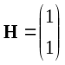.
For 2 port transmission the channel matrix is defined in the frequency domain by
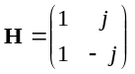.
For 4 port transmission the channel matrix is defined in the frequency domain by
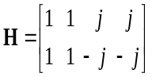
For 8 port transmission the channel matrix is defined in the frequency domain by
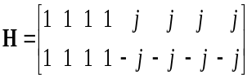

B.1.2 UE Receiver with 4Rx
For 1 port transmission the channel matrix is defined in the frequency domain by
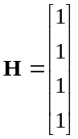.
For 2 port transmission the channel matrix is defined in the frequency domain by
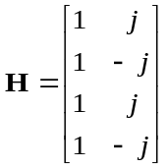.
For 4 port transmission the channel matrix is defined in the frequency domain by
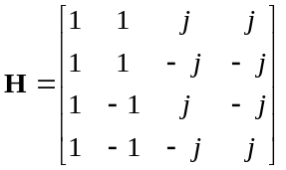.
For 8 port transmission the channel matrix is defined in the frequency domain by
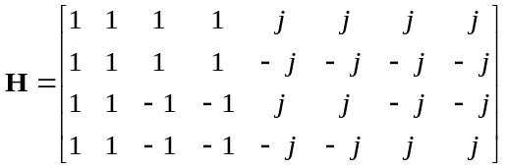

B.1.3 UE Receiver with 8Rx
For 1 port transmission the channel matrix is defined in the frequency domain by
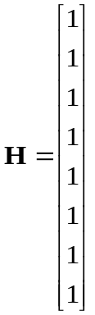
For 2 port transmission the channel matrix is defined in the frequency domain by

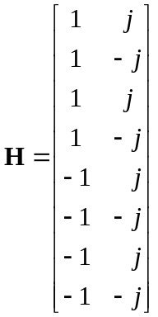
For 4 port transmission the channel matrix is defined in the frequency domain by

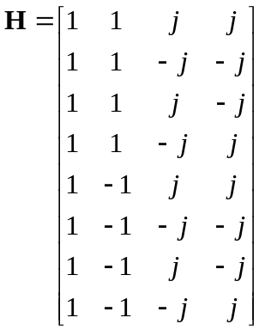
For 8 port transmission the channel matrix is defined in the frequency domain by

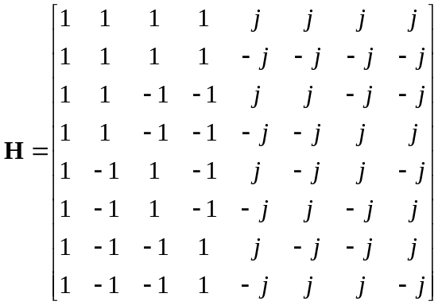

B.2 Multi-path fading propagation conditions
The multipath propagation conditions consist of several parts:
- A delay profile in the form of a "tapped delay-line", characterized by a number of taps at fixed positions on a sampling grid. The profile can be further characterized by the r.m.s. delay spread and the maximum delay spanned by the taps.
- A combination of channel model parameters that include the Delay profile and the Doppler spectrum that is characterized by a classical spectrum shape and a maximum Doppler frequency.
- Different models are used for FR1 (below 6 GHz) and FR2 (above 6 GHz).
Initial channel matrix for LOS component of TDL-D channel model is equal to channel matrix of Static propagation conditions in Clause B.1.

B.2.1 Delay profiles
The delay profiles are simplified from the TR 38.901 [5] TDL models. The simplification steps are shown below for information. These steps are only used when new delay profiles are created. Otherwise, the delay profiles specified in B.2.1.1 and B.2.1.2 can be used as such.
Step 1: Use the original TDL model from TR 38.901[5].
Step 2: Re-order the taps in ascending delays
Step 3: Perform delay scaling according to the procedure described in clause 7.7.3 in TR 38.901 [5].
Step 4: Apply the quantization to the delay resolution 5 ns or 2ns as described in Table B.2.1.2-1. This is done simply by rounding the tap delays to the nearest multiple of the delay resolution.
Step 5: If multiple taps are rounded to the same delay bin, merge them by calculating their linear power sum.
Step 6: If there are more than 12 taps for 5ns resolution or 16 taps for 2ns resolution as described in Table B.2.1.2-1 in the quantized model, merge the taps as follows
- Find the weakest tap from all taps (both merged and unmerged taps are considered)
- If there are two or more taps having the same value and are the weakest, select the tap with the smallest delay as the weakest tap.
- When the weakest tap is the first delay tap, merge taps as follows
- Update the power of the first delay tap as the linear power sum of the weakest tap and the second delay tap.
- Remove the second delay tap.
- When the weakest tap is the last delay tap, merge taps as follows
- Update the power of the last delay tap as the linear power sum of the second-to-last tap and the last tap.
- Remove the second-to-last tap.
- Otherwise
- For each side of the weakest tap, identify the neighbour tap that has the smaller delay difference to the weakest tap.
- When the delay difference between the weakest tap and the identified neighbour tap on one side equals the delay difference between the weakest tap and the identified neighbour tap on the other side.
- Select the neighbour tap that is weaker in power for merging.
- Otherwise, select the neighbour tap that has smaller delay difference for merging.
- To merge, the power of the merged tap is the linear sum of the power of the weakest tap and the selected tap.
- When the selected tap is the first tap, the location of the merged tap is the location of the first tap. The weakest tap is removed.
- When the selected tap is the last tap, the location of the merged tap is the location of the last tap. The weakest tap is removed.
- Otherwise, the location of the merged tap is based on the average delay of the weakest tap and selected tap. If the average delay is on the sampling grid, the location of the merged tap is the average delay. Merge two parallel taps with different delays (average delay, sum power) starting from the weakest ones. Otherwise, the location of the merged tap is rounded towards the direction of the selected tap (e.g. For 5ns resolution, 10 ns & 20 ns 15 ns, 10 ns & 25 ns 20 ns, if 25 ns had higher or equal power; 15 ns, if 10 ns had higher power). The weakest tap and the selected tap are removed.
- Repeat step 6 until the final number of taps is 12 or 16.
Step 7: Round the amplitudes of taps to one decimal (e.g. -8.78 dB -8.8 dB)
Step 8: If the delay spread has slightly changed due to the tap merge, adjust the final delay spread by increasing or decreasing the power of the last tap so that the delay spread is corrected.
Step 9: Re-normalize tap powers such that the strongest tap is at 0dB.
Note: Some values of the delay profile created by the simplification steps may differ from the values in tables B.2.1.1-2, B.2.1.1-3, B.2.1.1-4, B.2.1.2-2, and B.2.1.1-3 for the corresponding model.
Note: For Step 5 and Step 6, the power values are expressed in the linear domain using 6 digits of precision. The operations are in the linear domain.
Note: Delay profile for TDLD30 and TDLD10 is generated under assumption that Steps 1-8 are applied for taps with Rayleigh distribution.

B.2.1.1 Delay profiles for FR1
The delay profiles for FR1 are selected to be representative of low, medium and high delay spread environment. The resulting model parameters are specified in B.2.1.1-1 and the tapped delay line models are specified in Tables B.2.1.1-2 ~ Table B.2.1.1-4.
Table B.2.1.1-1: Delay profiles for NR channel models
Model | Number of  channel taps | Delay spread  (r.m.s.) | Maximum excess tap delay (span) | Delay resolution
TDLA30 | 12 | 30 ns | 290 ns | 5 ns
TDLB100 | 12 | 100 ns | 480 ns | 5 ns
TDLC300 | 12 | 300 ns | 2595 ns | 5 ns
TDLD30 | 10 | 30 ns | 375 ns | 5 ns

Table B.2.1.1-2: TDLA30 (DS = 30 ns)
Tap # | Delay [ns] | Power [dB] | Fading distribution
1 | 0 | -15.5 | Rayleigh
2 | 10 | 0 | Rayleigh
3 | 15 | -5.1 | Rayleigh
4 | 20 | -5.1 | Rayleigh
5 | 25 | -9.6 | Rayleigh
6 | 50 | -8.2 | Rayleigh
7 | 65 | -13.1 | Rayleigh
8 | 75 | -11.5 | Rayleigh
9 | 105 | -11.0 | Rayleigh
10 | 135 | -16.2 | Rayleigh
11 | 150 | -16.6 | Rayleigh
12 | 290 | -26.2 | Rayleigh

Table B.2.1.1-3: TDLB100 (DS = 100ns)
Tap # | Delay [ns] | Power [dB] | Fading distribution
1 | 0 | 0 | Rayleigh
2 | 10 | -2.2 | Rayleigh
3 | 20 | -0.6 | Rayleigh
4 | 30 | -0.6 | Rayleigh
5 | 35 | -0.3 | Rayleigh
6 | 45 | -1.2 | Rayleigh
7 | 55 | -5.9 | Rayleigh
8 | 120 | -2.2 | Rayleigh
9 | 170 | -0.8 | Rayleigh
10 | 245 | -6.3 | Rayleigh
11 | 330 | -7.5 | Rayleigh
12 | 480 | -7.1 | Rayleigh

Table B.2.1.1-4: TDLC300 (DS = 300 ns)
Tap # | Delay [ns] | Power [dB] | Fading distribution
1 | 0 | -6.9 | Rayleigh
2 | 65 | 0 | Rayleigh
3 | 70 | -7.7 | Rayleigh
4 | 190 | -2.5 | Rayleigh
5 | 195 | -2.4 | Rayleigh
6 | 200 | -9.9 | Rayleigh
7 | 240 | -8.0 | Rayleigh
8 | 325 | -6.6 | Rayleigh
9 | 520 | -7.1 | Rayleigh
10 | 1045 | -13.0 | Rayleigh
11 | 1510 | -14.2 | Rayleigh
12 | 2595 | -16.0 | Rayleigh

Table B.2.1.1-5 TDLD30 (DS = 30 ns)
Tap # | Delay [ns] | Power [dB] | Fading distribution
1 | 0 | -0.2 | LOS path
1 | 0 | -12.4 | Rayleigh
2 | 20 | -21 | Rayleigh
3 | 40 | -16.7 | Rayleigh
4 | 55 | -18.3 | Rayleigh
5 | 80 | -21.9 | Rayleigh
6 | 120 | -27.8 | Rayleigh
7 | 240 | -23.6 | Rayleigh
8 | 285 | -24.8 | Rayleigh
9 | 290 | -30.0 | Rayleigh
10 | 375 | -27.6 | Rayleigh
Note 1: Tap #1 follows a Ricean distribution.

B.2.1.2 Delay profiles for FR2
The delay profiles for FR2 are specified in B.2.1.2-1 and the tapped delay line models are specified in Tables B.2.1.2-2 to Table B.2.1.2-6.

Table B.2.1.2-1: Delay profiles for NR channel models
Model | Number of  channel taps | Delay spread  (r.m.s.) | Maximum excess tap delay (span) | Delay resolution
TDLA30 | 12 | 30 ns | 290 ns | 5 ns
TDLC60 | 12 | 60 ns | 520 ns | 5 ns
TDLD30 | 10 | 30 ns | 375 ns | 5 ns
TDLA10 (NOTE 1) | 16 | 10 ns | 96 ns | 2 ns
TDLD10 (NOTE 1) | 10 | 10 ns | 126 ns | 2 ns
NOTE 1: The delay profile is applicable only for channel bandwidths > 200 MHz.

Table B.2.1.2-2: TDLA30 (DS = 30 ns)
Tap # | Delay [ns] | Power [dB] | Fading distribution
1 | 0 | -15.5 | Rayleigh
2 | 10 | 0 | Rayleigh
3 | 15 | -5.1 | Rayleigh
4 | 20 | -5.1 | Rayleigh
5 | 25 | -9.6 | Rayleigh
6 | 50 | -8.2 | Rayleigh
7 | 65 | -13.1 | Rayleigh
8 | 75 | -11.5 | Rayleigh
9 | 105 | -11.0 | Rayleigh
10 | 135 | -16.2 | Rayleigh
11 | 150 | -16.6 | Rayleigh
12 | 290 | -26.2 | Rayleigh

Table B.2.1.2-3: TDLC60 (DS = 60 ns)
Tap # | Delay [ns] | Power [dB] | Fading distribution
1 | 0 | -7.8 | Rayleigh
2 | 15 | -0.3 | Rayleigh
3 | 40 | 0 | Rayleigh
4 | 50 | -8.9 | Rayleigh
5 | 55 | -14.5 | Rayleigh
6 | 75 | -8.5 | Rayleigh
7 | 80 | -10.2 | Rayleigh
8 | 130 | -12.1 | Rayleigh
9 | 210 | -13.9 | Rayleigh
10 | 300 | -15.2 | Rayleigh
11 | 360 | -16.9 | Rayleigh
12 | 520 | -19.4 | Rayleigh

Table B.2.1.2-4 TDLD30 (DS = 30 ns)
Tap # | Delay [ns] | Power [dB] | Fading distribution
1 | 0 | -0.2 | LOS path
1 | 0 | -12.4 | Rayleigh
2 | 20 | -21 | Rayleigh
3 | 40 | -16.7 | Rayleigh
4 | 55 | -18.3 | Rayleigh
5 | 80 | -21.9 | Rayleigh
6 | 120 | -27.8 | Rayleigh
7 | 240 | -23.6 | Rayleigh
8 | 285 | -24.8 | Rayleigh
9 | 290 | -30.0 | Rayleigh
10 | 375 | -27.6 | Rayleigh
Note 1: Tap #1 follows a Rician distribution.

Table B.2.1.2-5 TDLA10 (DS = 10 ns)
Tap # | Delay [ns] | Power [dB] | Fading distribution
1 | 0 | -16.1 | Rayleigh
2 | 4 | 0 | Rayleigh
3 | 6 | -4 | Rayleigh
4 | 8 | -10.2 | Rayleigh
5 | 16 | -18.6 | Rayleigh
6 | 18 | -9.3 | Rayleigh
7 | 22 | -13.7 | Rayleigh
8 | 24 | -17.9 | Rayleigh
9 | 26 | -13.5 | Rayleigh
10 | 30 | -14 | Rayleigh
11 | 40 | -15.4 | Rayleigh
12 | 44 | -18.9 | Rayleigh
13 | 46 | -21.0 | Rayleigh
14 | 48 | -21.6 | Rayleigh
15 | 50 | -19.3 | Rayleigh
16 | 96 | -25.9 | Rayleigh

Table B.2.1.2-6 TDLD10 (DS = 10 ns)
Tap # | Delay [ns] | Power [dB] | Fading distribution
1 | 0 | -0.2 | LOS
 | 0 | -12.4 | Rayleigh
2 | 6 | -21.1 | Rayleigh
3 | 14 | -16.7 | Rayleigh
4 | 18 | -18.3 | Rayleigh
5 | 26 | -22 | Rayleigh
6 | 40 | -27.9 | Rayleigh
7 | 80 | -23.7 | Rayleigh
8 | 94 | -24.9 | Rayleigh
9 | 98 | -30.0 | Rayleigh
10 | 126 | -27.7 | Rayleigh
Note 1: Tap #1 follows a Rician distribution.

B.2.2 Combinations of channel model parameters
The propagation conditions used for the performance measurements in multi-path fading environment are indicated as a combination of a channel model name and a maximum Doppler frequency, i.e., TDLA<DS>-<Doppler>, TDLB<DS>-<Doppler>, TDLC<DS>-<Doppler>or TDLD<DS>-<Doppler> where '<DS>' indicates the desired delay spread and '<Doppler>' indicates the maximum Doppler frequency (Hz).
Table B.2.2-1 and Table B.2.2-2 show the propagation conditions that are used for the performance measurements in multi-path fading environment for low, medium and high Doppler frequencies for FR1 and FR2, respectively.
Table B.2.2-1: Channel model parameters for FR1
Combination name | Model | Maximum Doppler frequency
TDLA30-5 | TDLA30 | 5 Hz
TDLA30-10 | TDLA30 | 10 Hz
TDLA30-20 | TDLA30 | 20 Hz
TDLA30-180 | TDLA30 | 180 Hz
TDLA30-195 | TDLA30 | 195 Hz
TDLA30-1400 | TDLA30 | 1400 Hz
TDLA30-2700 | TDLA30 | 2700 Hz
TDLB100-400 | TDLB100 | 400 Hz
TDLC300-100 | TDLC300 | 100 Hz
TDLC300-600 | TDLC300 | 600 Hz
TDLC300-1200 | TDLC300 | 1200 Hz
TDLD30-5 | TDLD30 | 5 Hz

Table B.2.2-2: Channel model parameters for FR2
Combination name | Model | Maximum Doppler frequency
TDLA30-35 | TDLA30 | 35 Hz
TDLA30-75 | TDLA30 | 75 Hz
TDLA30-300 | TDLA30 | 300 Hz
TDLC60-300 | TDLC60 | 300 Hz
TDLD30-75 | TDLD30 | 75 Hz

B.2.3 MIMO Channel Correlation Matrices
The MIMO channel correlation matrices defined in B.2.3 apply for the antenna configuration using uniform linear arrays at both gNB and UE and for the antenna configuration using cross polarized antennas.

B.2.3.1 MIMO Correlation Matrices using Uniform Linear Array (ULA)
The MIMO channel correlation matrices defined in B.2.3.1 apply for the antenna configuration using uniform linear array (ULA) at both gNB and UE.

B.2.3.1.1 Definition of MIMO Correlation Matrices
Table B.2.3.1.1-1 defines the correlation matrix for the gNB.

Table B.2.3.1.1-1: gNB correlation matrix
 | One antenna | Two antennas | Four antennas
gNB Correlation | 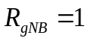 | 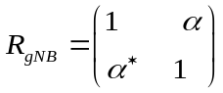 | 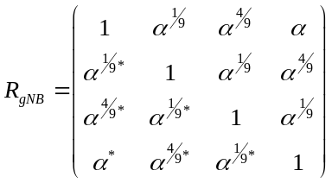

Table B.2.3.1.1-2 defines the correlation matrix for the UE:

Table B.2.3.1.1-2: UE correlation matrix
 | One antenna | Two antennas | Four antennas
UE Correlation | 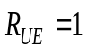 | 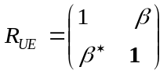 | 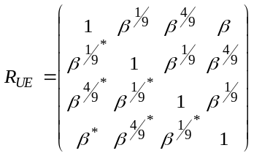

Table B.2.3.1.1-3 defines the channel spatial correlation matrix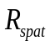. The parameters, α and β in Table B.2.3.1-3 defines the spatial correlation between the antennas at the gNB and UE.
Table B.2.3.1.1-3: correlation matrices
1x2 case | 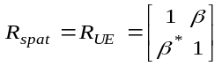
1x4 case | 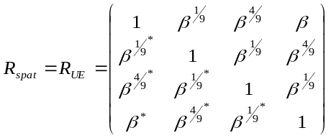
2x1 case | 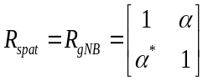
2x2 case | 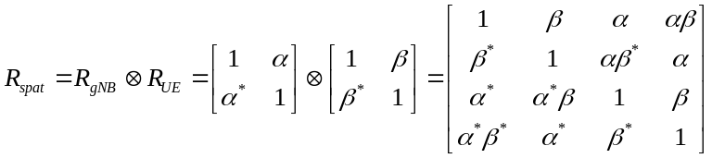
2x4 case | 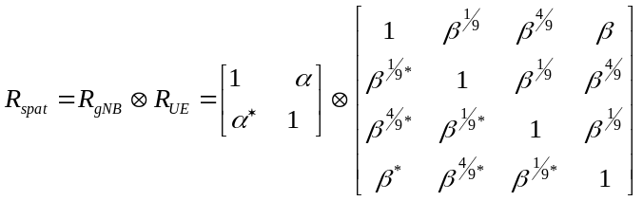
4x1 case | 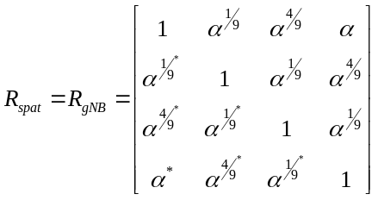
4x2 case | 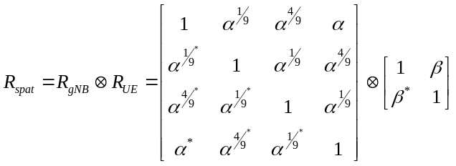
4x4 case | 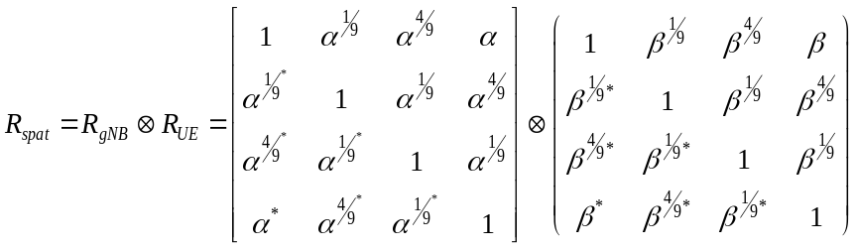
2x8 case | $$R_{spat}=R_{gNB}⊗R_{UE}=\left[\begin{aligned}&1 α \\ &α^{∗}\text{ 1}\end{aligned}\right]⊗\left(\begin{matrix}1 & β^{\frac{1}{49}} & β^{\frac{4}{49}} & β^{\frac{9}{49}} & β^{\frac{16}{49}} & β^{\frac{25}{49}} & β^{\frac{36}{49}} & β \\ {β^{\frac{1}{49}}}^{∗} & 1 & β^{\frac{1}{49}} & β^{\frac{4}{49}} & β^{\frac{9}{49}} & β^{\frac{16}{49}} & β^{\frac{25}{49}} & β^{\frac{36}{49}} \\ {β^{\frac{4}{9}}}^{∗} & {β^{\frac{1}{49}}}^{∗} & 1 & β^{\frac{1}{49}} & β^{\frac{4}{49}} & β^{\frac{9}{49}} & β^{\frac{16}{49}} & β^{\frac{25}{49}} \\ {β^{\frac{9}{49}}}^{∗} & {β^{\frac{4}{49}}}^{∗} & {β^{\frac{1}{49}}}^{∗} & 1 & β^{\frac{1}{49}} & β^{\frac{4}{49}} & β^{\frac{9}{49}} & β^{\frac{16}{49}} \\ {β^{\frac{16}{49}}}^{∗} & {β^{\frac{9}{49}}}^{∗} & {β^{\frac{4}{49}}}^{∗} & {β^{\frac{1}{49}}}^{∗} & 1 & β^{\frac{1}{49}} & β^{\frac{4}{49}}t & β^{\frac{9}{49}} \\ {β^{\frac{25}{49}}}^{∗} & {β^{\frac{16}{49}}}^{∗} & {β^{\frac{9}{49}}}^{∗} & {β^{\frac{4}{49}}}^{∗} & {β^{\frac{1}{49}}}^{∗} & 1 & β^{\frac{1}{49}} & β^{\frac{4}{49}} \\ {β^{\frac{36}{49}}}^{∗} & {β^{\frac{25}{49}}}^{∗} & {β^{\frac{16}{49}}}^{∗} & {β^{\frac{9}{49}}}^{∗} & {β^{\frac{4}{49}}}^{∗} & {β^{\frac{1}{49}}}^{∗} & 1 & β^{\frac{1}{49}} \\ β^{∗} & {β^{\frac{36}{49}}}^{∗} & {β^{\frac{25}{49}}}^{∗} & {β^{\frac{16}{49}}}^{∗} & {β^{\frac{9}{49}}}^{∗} & {β^{\frac{4}{49}}}^{∗} & {β^{\frac{1}{49}}}^{∗} & 1\end{matrix}\right)$$
4x8 case | $$R_{spat}=R_{gNB}⊗R_{UE}=\left[\begin{matrix}1 & α^{\frac{1}{9}} & α^{\frac{4}{9}} & α \\ α^{{\frac{1}{9}}^{∗}} & 1 & α^{\frac{1}{9}} & α^{\frac{4}{9}} \\ α^{{\frac{4}{9}}^{∗}} & α^{{\frac{1}{9}}^{∗}} & 1 & α^{\frac{1}{9}} \\ α^{∗} & α^{{\frac{4}{9}}^{∗}} & α^{{\frac{1}{9}}^{∗}} & 1\end{matrix}\right]⊗\left(\begin{matrix}1 & β^{\frac{1}{49}} & β^{\frac{4}{49}} & β^{\frac{9}{49}} & β^{\frac{16}{49}} & β^{\frac{25}{49}} & β^{\frac{36}{49}} & β \\ {β^{\frac{1}{49}}}^{∗} & 1 & β^{\frac{1}{49}} & β^{\frac{4}{49}} & β^{\frac{9}{49}} & β^{\frac{16}{49}} & β^{\frac{25}{49}} & β^{\frac{36}{49}} \\ {β^{\frac{4}{9}}}^{∗} & {β^{\frac{1}{49}}}^{∗} & 1 & β^{\frac{1}{49}} & β^{\frac{4}{49}} & β^{\frac{9}{49}} & β^{\frac{16}{49}} & β^{\frac{25}{49}} \\ {β^{\frac{9}{49}}}^{∗} & {β^{\frac{4}{49}}}^{∗} & {β^{\frac{1}{49}}}^{∗} & 1 & β^{\frac{1}{49}} & β^{\frac{4}{49}} & β^{\frac{9}{49}} & β^{\frac{16}{49}} \\ {β^{\frac{16}{49}}}^{∗} & {β^{\frac{9}{49}}}^{∗} & {β^{\frac{4}{49}}}^{∗} & {β^{\frac{1}{49}}}^{∗} & 1 & β^{\frac{1}{49}} & β^{\frac{4}{49}} & β^{\frac{9}{49}} \\ {β^{\frac{25}{49}}}^{∗} & {β^{\frac{16}{49}}}^{∗} & {β^{\frac{9}{49}}}^{∗} & {β^{\frac{4}{49}}}^{∗} & {β^{\frac{1}{49}}}^{∗} & 1 & β^{\frac{1}{49}} & β^{\frac{4}{49}} \\ {β^{\frac{36}{49}}}^{∗} & {β^{\frac{25}{49}}}^{∗} & {β^{\frac{16}{49}}}^{∗} & {β^{\frac{9}{49}}}^{∗} & {β^{\frac{4}{49}}}^{∗} & {β^{\frac{1}{49}}}^{∗} & 1 & β^{\frac{1}{49}} \\ β^{∗} & {β^{\frac{36}{49}}}^{∗} & {β^{\frac{25}{49}}}^{∗} & {β^{\frac{16}{49}}}^{∗} & {β^{\frac{9}{49}}}^{∗} & {β^{\frac{4}{49}}}^{∗} & {β^{\frac{1}{49}}}^{∗} & 1\end{matrix}\right)$$
8x8 case | $$R_{spat}=R_{gNB}⊗R_{UE}=\left(\begin{matrix}1 & α^{\frac{1}{49}} & α^{\frac{4}{49}} & α^{\frac{9}{49}} & α^{\frac{16}{49}} & α^{\frac{25}{49}} & α^{\frac{36}{49}} & α \\ {α^{\frac{1}{49}}}^{∗} & 1 & α^{\frac{1}{49}} & α^{\frac{4}{49}} & α^{\frac{9}{49}} & α^{\frac{16}{49}} & α^{\frac{25}{49}} & α^{\frac{36}{49}} \\ {α^{\frac{4}{49}}}^{∗} & {α^{\frac{1}{49}}}^{∗} & 1 & α^{\frac{1}{49}} & α^{\frac{4}{49}} & α^{\frac{9}{49}} & α^{\frac{16}{49}} & α^{\frac{25}{49}} \\ {α^{\frac{9}{49}}}^{∗} & {α^{\frac{4}{49}}}^{∗} & {α^{\frac{1}{49}}}^{∗} & 1 & α^{\frac{1}{49}} & α^{\frac{4}{49}} & α^{\frac{9}{49}} & α^{\frac{16}{49}} \\ {α^{\frac{16}{49}}}^{∗} & {α^{\frac{9}{49}}}^{∗} & {α^{\frac{4}{49}}}^{∗} & {α^{\frac{1}{49}}}^{∗} & 1 & α^{\frac{1}{49}} & α^{\frac{4}{49}} & α^{\frac{9}{49}} \\ {α^{\frac{25}{49}}}^{∗} & {α^{\frac{16}{49}}}^{∗} & {α^{\frac{9}{49}}}^{∗} & {α^{\frac{4}{49}}}^{∗} & {α^{\frac{1}{49}}}^{∗} & 1 & α^{\frac{1}{49}} & α^{\frac{4}{49}} \\ {α^{\frac{36}{49}}}^{∗} & {α^{\frac{25}{49}}}^{∗} & {α^{\frac{16}{49}}}^{∗} & {α^{\frac{9}{49}}}^{∗} & {α^{\frac{4}{49}}}^{∗} & {α^{\frac{1}{49}}}^{∗} & 1 & α^{\frac{1}{49}} \\ α^{∗} & {α^{\frac{36}{49}}}^{∗} & {α^{\frac{25}{49}}}^{∗} & {α^{\frac{16}{49}}}^{∗} & {α^{\frac{9}{49}}}^{∗} & {α^{\frac{4}{49}}}^{∗} & {α^{\frac{1}{49}}}^{∗} & 1\end{matrix}\right)⊗\left(\begin{matrix}1 & β^{\frac{1}{49}} & β^{\frac{4}{49}} & β^{\frac{9}{49}} & β^{\frac{16}{49}} & β^{\frac{25}{49}} & β^{\frac{36}{49}} & β \\ {β^{\frac{1}{49}}}^{∗} & 1 & β^{\frac{1}{49}} & β^{\frac{4}{49}} & β^{\frac{9}{49}} & β^{\frac{16}{49}} & β^{\frac{25}{49}} & β^{\frac{36}{49}} \\ {β^{\frac{4}{9}}}^{∗} & {β^{\frac{1}{49}}}^{∗} & 1 & β^{\frac{1}{49}} & β^{\frac{4}{49}} & β^{\frac{9}{49}} & β^{\frac{16}{49}} & β^{\frac{25}{49}} \\ {β^{\frac{9}{49}}}^{∗} & {β^{\frac{4}{49}}}^{∗} & {β^{\frac{1}{49}}}^{∗} & 1 & β^{\frac{1}{49}} & β^{\frac{4}{49}} & β^{\frac{9}{49}} & β^{\frac{16}{49}} \\ {β^{\frac{16}{49}}}^{∗} & {β^{\frac{9}{49}}}^{∗} & {β^{\frac{4}{49}}}^{∗} & {β^{\frac{1}{49}}}^{∗} & 1 & β^{\frac{1}{49}} & β^{\frac{4}{49}} & β^{\frac{9}{49}} \\ {β^{\frac{25}{49}}}^{∗} & {β^{\frac{16}{49}}}^{∗} & {β^{\frac{9}{49}}}^{∗} & {β^{\frac{4}{49}}}^{∗} & {β^{\frac{1}{49}}}^{∗} & 1 & β^{\frac{1}{49}} & β^{\frac{4}{49}} \\ {β^{\frac{36}{49}}}^{∗} & {β^{\frac{25}{49}}}^{∗} & {β^{\frac{16}{49}}}^{∗} & {β^{\frac{9}{49}}}^{∗} & {β^{\frac{4}{49}}}^{∗} & {β^{\frac{1}{49}}}^{∗} & 1 & β^{\frac{1}{49}} \\ β^{∗} & {β^{\frac{36}{49}}}^{∗} & {β^{\frac{25}{49}}}^{∗} & {β^{\frac{16}{49}}}^{∗} & {β^{\frac{9}{49}}}^{∗} & {β^{\frac{4}{49}}}^{∗} & {β^{\frac{1}{49}}}^{∗} & 1\end{matrix}\right)$$

For cases with more antennas at either gNB or UE or both, the channel spatial correlation matrix can still be expressed as the Kronecker product of 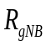 and 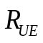 according to 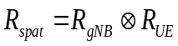.

B.2.3.1.2 MIMO Correlation Matrices at High, Medium and Low Level
The α and β for different correlation types are given in Table B.2.3.1.2-1.
Table B.2.3.1.2-1: The α and β parameters for ULA MIMO correlation matrices
Correlation Model | α | β
Low correlation | 0 | 0
Medium Correlation | 0.3 | 0.9
Medium Correlation A | 0.3 | 0.3874
Medium Correlation B | 0.3 | 0.005154
High Correlation | 0.9 | 0.9

The correlation matrices for high, medium, medium A and low correlation are defined in Table B.2.3.1.2-2, B.2.3.1.2-3, B.2.3.1.2-4 and B.2.3.1.2-5 as below.
The values in Table B.2.3.1.2-2 have been adjusted for the 4x2 and 4x4 high correlation cases to insure the correlation matrix is positive semi-definite after round-off to 4 digit precision. This is done using the equation:
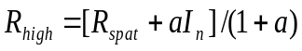
Where the value "a" is a scaling factor such that the smallest value is used to obtain a positive semi-definite result. For the 4x1 high correlation and 4x2 high correlation case, a=0.00010. For the 4x4 high correlation case, a=0.00012.
The same method is used to adjust the 2x4 and 4x4 medium correlation matrix in Table B.2.3.1.2-3 to insure the correlation matrix is positive semi-definite after round-off to 4 digit precision with a = 0.00010 and a = 0.00012.
Table B.2.3.1.2-2: MIMO correlation matrices for high correlation
1x2 case | 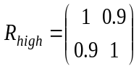
2x1 case
2x2 case | 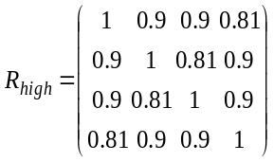
4x1  case | 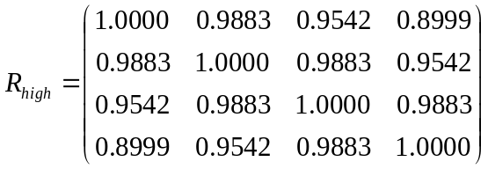
4x2 case | 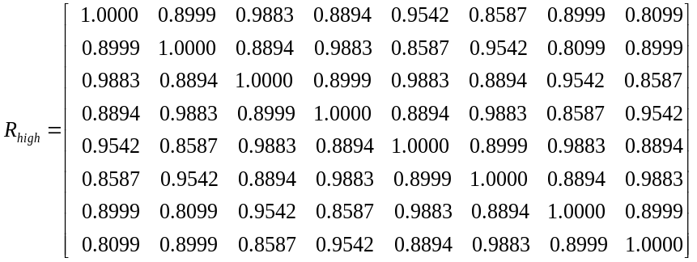
4x4 case | 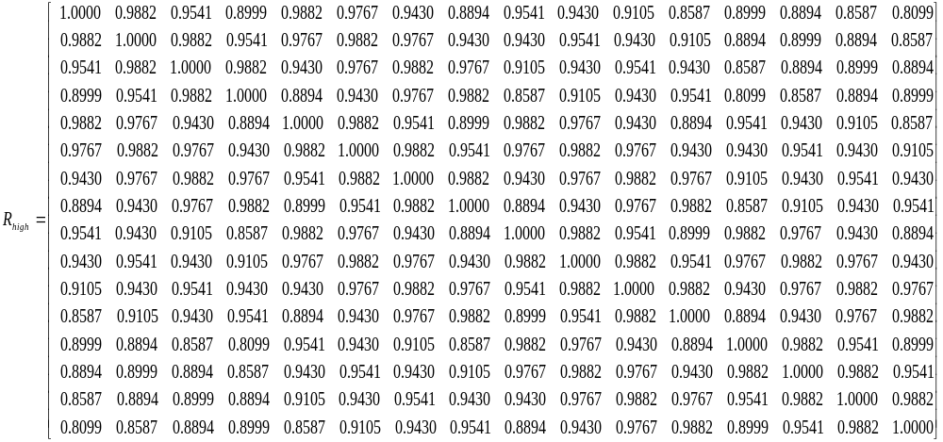

Table B.2.3.1.2-3: MIMO correlation matrices for medium correlation
1x2 case | N/A
2x1 case | N/A
2x2 case | 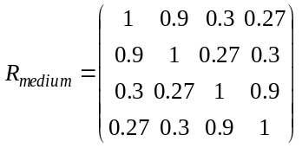
2x4 case | 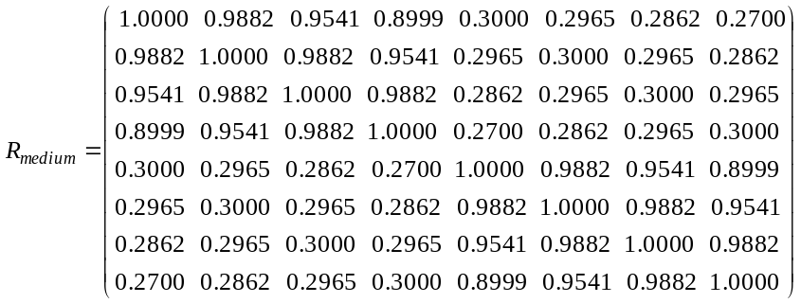
4x2 case | 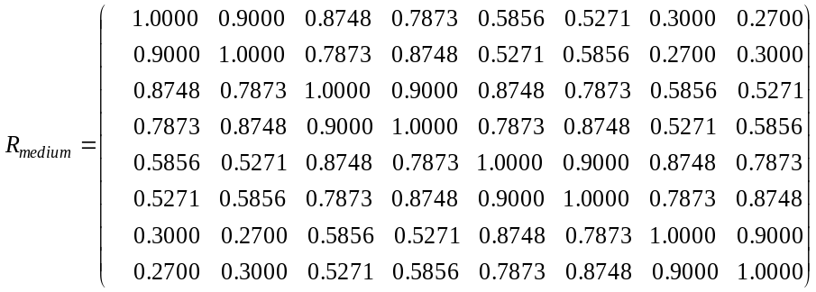
4x4 case | 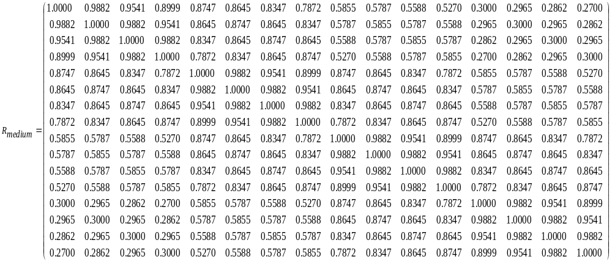

Table B.2.3.1.2-4: MIMO correlation matrices for medium correlation A
1x4 case | $$R_{medium A}=\left[\begin{matrix}\begin{matrix}1 & 0.9000 \\ 0.9000 & 1\end{matrix} & \begin{matrix}0.6561 & 0.3874 \\ 0.9000 & 0.6561\end{matrix} \\ \begin{matrix}0.6561 & 0.9000 \\ 0.3874 & 0.6561\end{matrix} & \begin{matrix}1 & 0.9000 \\ 0.9000 & 1\end{matrix}\end{matrix}\right]$$
2x4 case | 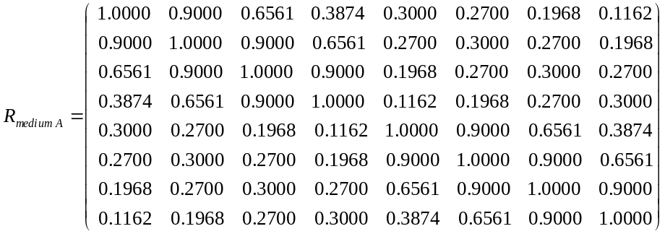
4x4 case | 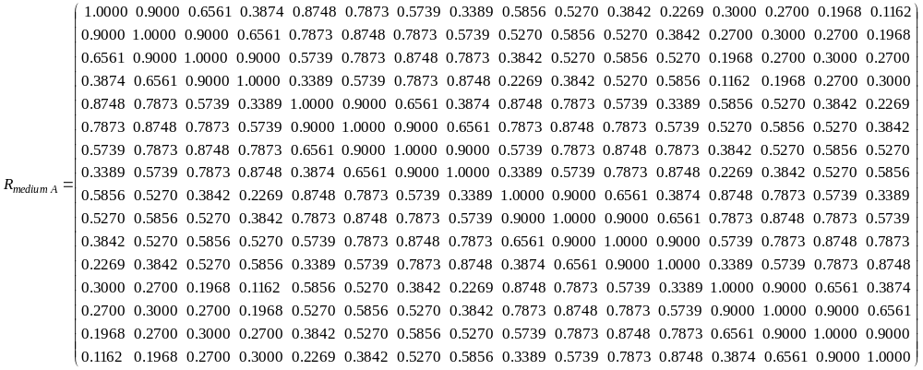

Table B.2.3.1.2-5: MIMO correlation matrices for low correlation
1x2 case | 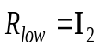
1x4 case | 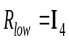
2x1 case
2x2 case
2x4 case | 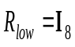
4x1 case
4x2 case
4x4 case | 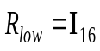
4x8 case | $$R_{low}=I_{32}$$
8x8 case | $$R_{low}=I_{64}$$

In Table B.2.3.1.2-5, I_{d} is the d×d identity matrix.

Table B.2.3.1.2-6: MIMO correlation matrices for medium correlation B
2x8 case | 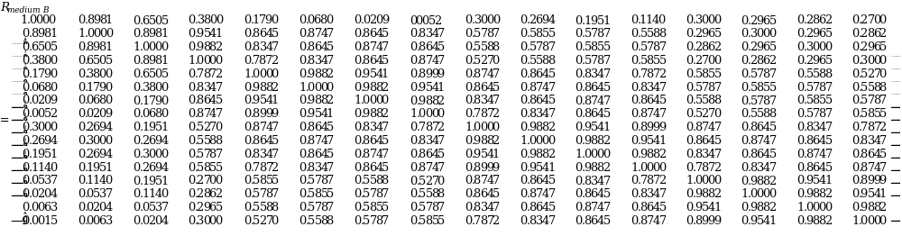

B.2.3.1.3 Beam steering approach
The beam steering approach defined in B.2.3.2.3 is applied, where the random channel matrix $H$ is calculated by letting $N_{2}=1$ and replacing $D_{θ_{k,1},θ_{k,2}}$ by:
$$D_{θ_{k,1},θ_{k,2}}=D_{θ_{k,1}}\left(N_{1}\right)$$

B.2.3.2 MIMO Correlation Matrices using Cross Polarized Antennas (X-pol)
The MIMO channel correlation matrices defined in B.2.3.2 apply for the antenna configuration using cross polarized (XP/X-pol) antennas at both gNB and UE. The cross-polarized antenna elements with +/-45 degrees polarization slant angles are deployed at gNB and cross-polarized antenna elements with +90/0 degrees polarization slant angles are deployed at UE.
For the 2D cross-polarized antenna array at eNodeB, the N antennas are indexed by 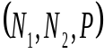, and total number of antennas is 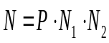, where
- 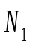 is the number of antenna elements in first dimension with same polarization,
- 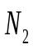 is the number of antenna elements in second dimension with same polarization, and
- is the number of polarization groups.
For the 2D cross-polarized antennas at gNB, the N antennas are labelled such that antennas shall be in increasing order of the second dimension firstly, then the first dimension, and finally the polarization group. For a specific antenna element at p-th polarization, n₁-th row, and n₂-th column within the 2D antenna array, the following index number is used for antenna labelling:
where N is the number of transmit antennas, p is the polarization group index, n₁ is the row index, and n₂ is the column index of the antenna element.
For the linear (single dimension, 1D) cross-polarized antenna, the N antennas are labelled following the above equations with N₂=1.

B.2.3.2.1 Definition of MIMO Correlation Matrices using cross polarized antennas
For the channel spatial correlation matrix, the following is used:
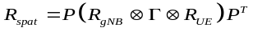
where
- is the spatial correlation matrix at the UE with same polarization,
- is the spatial correlation matrix at the gNB with same polarization,
- is a polarization correlation matrix, and
- 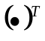denotes transpose.
The matrix is defined as
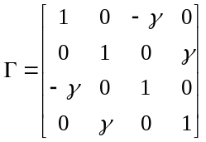
A permutation matrix P elements are defined as
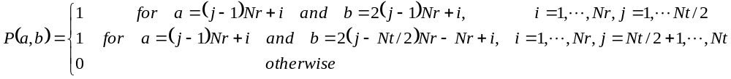.
where Nt and Nr is the number of transmitter and receiver respectively. This is used to map the spatial correlation coefficients in accordance with the antenna element labelling system described in B.2.3.2.
For the 2D cross-polarized antenna array at gNB, the spatial correlation matrix at the gNB is further expressed as following for 2D cross-polarized antenna array at gNB:
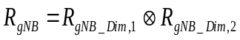
where
- - 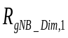 is the correlation matrix of antenna elements in first dimension with same polarization, and
- - 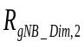 is the correlation matrix of antenna elements in second dimension with same polarization.
For the 2D cross polarized antenna array at gNB side, the spatial correlation matrices in one direction of antenna array are as follows:
- For 1 antenna element with the same polarization in one direction,
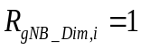.
- For 2 antenna elements with the same polarization in one direction,
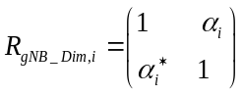.
- For 3 antenna elements with the same polarization in one direction,
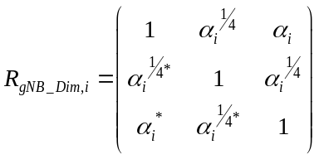.
- For 4 antenna elements with the same polarization in one direction,
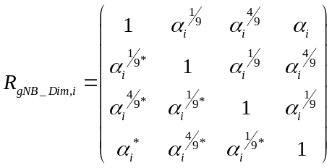.
where the index i = 1,2 stands for first dimension and second dimension respectively.
For the 1D cross-polarized antenna array at gNB, the matrix ofis determined by follow the equations for 2D cross-polarized antenna array and letting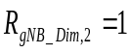, i.e.,
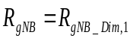
The spatial correlation matrices at UE side are as follows:
- For 1 antenna element with the same polarization,
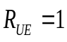.
- For 2 antenna elements with the same polarization,
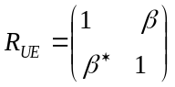.

B.2.3.2.2 MIMO Correlation Matrices using cross polarized antennas
The values for parameters α₁, α₂, β and γ for the cross polarized antenna models are given in Table B.2.3.2.2-1.
Table B.2.3.2.2-1: The α and β parameters for cross-polarized MIMO correlation matrices
Correlation Model | α₁ | α₂ | β | γ
Medium Correlation | 0.3 | 0.3 | 0.6 | 0.2
High Correlation | 0.9 | 0.9 | 0.9 | 0.3
Note 1: Value of α₁ applies when more than one pair of cross-polarized antenna elements in first dimension at gNB side.
Note 2: Value of α₂ applies when more than one pair of cross-polarized antenna elements in second dimension at gNB side.
Note 3: Value of β applies when more than one pair of cross-polarized antenna elements at UE side.

For the 1D cross polarized antenna array at gNB side, the correlation matrices for high spatial correlation and medium correlation are defined in Table B.2.3.2.2-2 and Table B.2.3.2.2-3 as below.
For the 2D cross polarized antenna array at gNB side, the correlation matrices for high spatial correlation are defined in Table B.2.3.2.2-4 as below.
The values in Table B.2.3.2.2-2, and Table B.2.3.2.2-4 have been adjusted to ensure the correlation matrix is positive semi-definite after round-off to 4 digit precision. This is done using the equation:
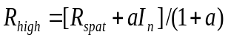 or 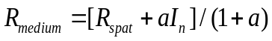
Where the value "a" is a scaling factor such that the smallest value is used to obtain a positive semi-definite result. For the 8(4,1,2)x2 high spatial correlation case, a=0.00010. For the 16 (4,2,2)x2 high spatial correlation case, a=0.00012.
The same method is used to adjust the the 16(4,2,2)x4, 32(4,4,2)x2 and 32(4,4,2)x4 high correlation matrix to insure the correlation matrix is positive semi-definite after round-off to 4 digit precision with a =0.00012, a =0.00022, and a=0.00022 resoectively.

Table B.2.3.2.2-2: MIMO correlation matrices for high spatial correlation (1D cross polarized antenna array at gNB side)
4(2,1,2)x2 case | 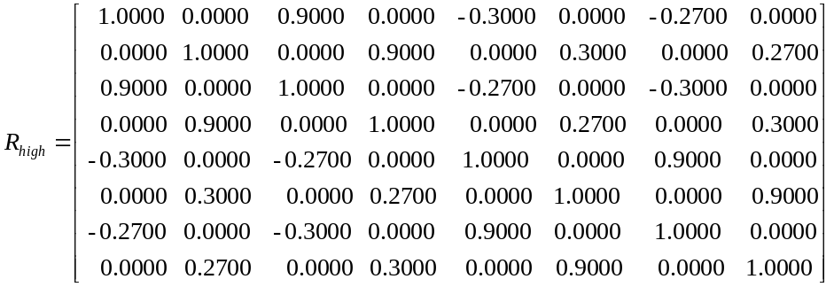
2(1,1,2)x4 case | 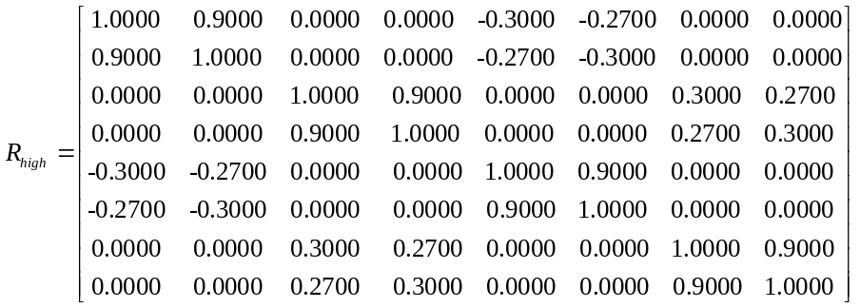
4(2,1,2)x4 case | 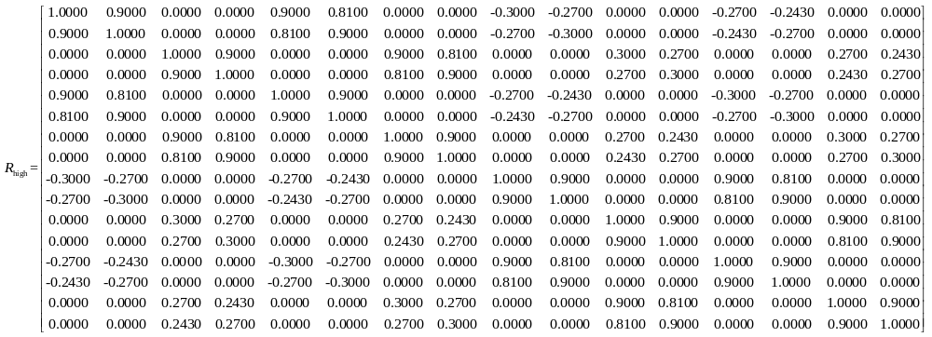
8(4,1,2)x2 case | 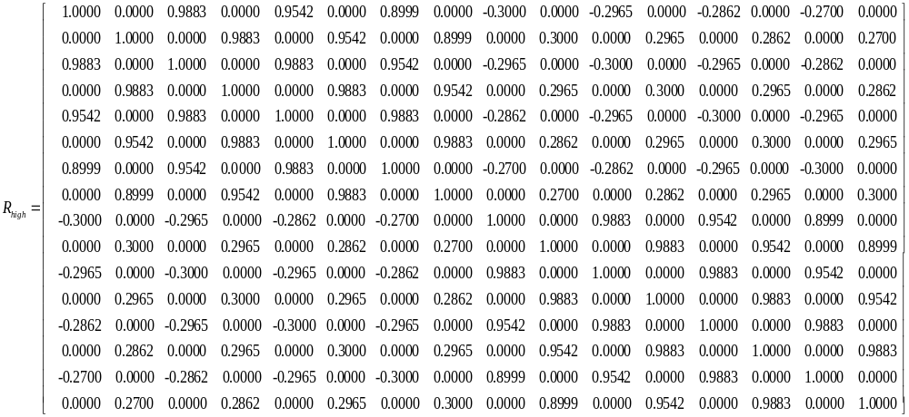

Table B.2.3.2.2-3: MIMO correlation matrices for medium spatial correlation (1D cross polarized antenna array at gNB side)
2(1,1,2)x2 case | $$R_{medium}=\left[\begin{aligned}\text{ 1.0000 0.0000 -0.2000 0.0000} \\ \text{ 0.0000 1.0000 0.0000 0.2000} \\ \text{ -0.2000 0.0000 1.0000 0.0000} \\ \text{ 0.0000 0.2000 0.0000 1.0000}\end{aligned}\right]$$

Table 1 B.2.3.2.2-4: MIMO correlation matices for high spatial correlation (2D cross polarized antenna array at gNB side)
16(4,2,2)x2  case | 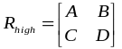, where  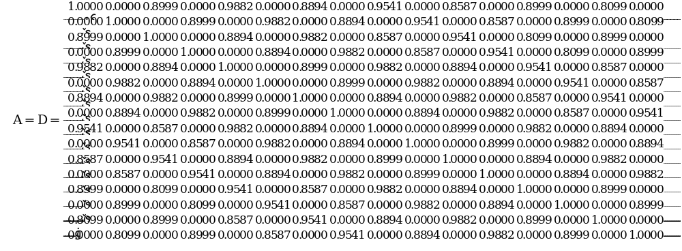  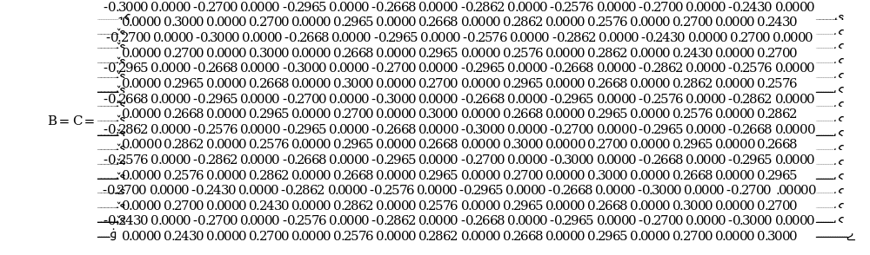

B.2.3.2.3 Beam steering approach
For the 2D cross-polarized antenna array at gNB, given the channel spatial correlation matrix in B.2.3.2.1 and B.2.3.2.2, the corresponding random channel matrix H can be calculated. The signal model for the k-th slot is denoted as
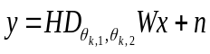
And the steering matrix is further expressed as following:
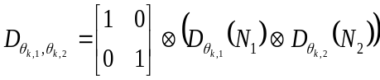
where
- H is the Nr×Nt channel matrix per subcarrier.
- 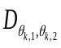 is the steering matrix,
- 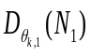 is the steering matrix in first dimension with same polarization,
- 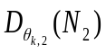 is the steering matrix in second dimension with same polarization,
- 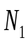 is the number of antenna elements in first dimension with same polarization,
- is the number of antenna elements in second dimension with same polarization,
- For antenna array with only one direction, number of antenna element in second direction equals 1.
For 1 antenna element with the same polarization in one direction,
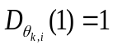.
For 2 antenna elements with the same polarization in one direction,
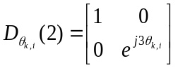.
For 3 antenna elements with the same polarization in one direction,
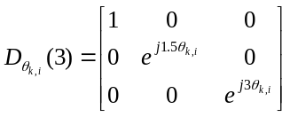.
For 4 antenna elements with the same polarization in one direction,
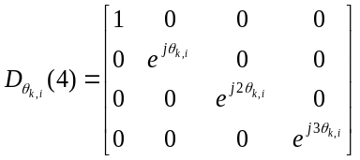.
where the index 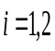 stands for first dimension and second dimension respectively.
- 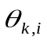 controls the phase variation in first dimension and second dimension respectively, and the phase for k-th subframe is denoted by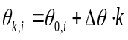, where 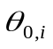is the random start value with the uniform distribution, i.e., 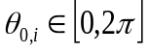, is the step of phase variation, which is defined in Table B.2.3.2.3-1, and k is the linear increment of 2^{-μ} for every slot throughout the simulation, the index stands for first dimension and second dimension respectively.
- is the precoding matrix for Nt transmission antennas,
- y is the received signal, x is the transmitted signal, and n is AWGN.
- corresponds to subcarrier spacing configuration, 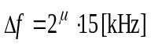
For the 1D cross-polarized antenna array at gNB, the corresponding random channel matrix H can be calculated by letting N₂=1, i.e.,
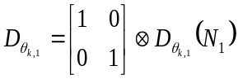
Table B.2.3.2.3-1: The step of phase variation
Variation Step | Value (rad/ms)
 | 1.2566×10⁻³

B.2.3.2.3A Beam steering approach with dual cluster beams
For the 2D cross-polarized antenna array at gNB, given the channel spatial correlation matrix in B.2.3.2.1 and B.2.3.2.2, the corresponding random channel matrix H can be calculated. The signal model for the k-th slot is denoted as
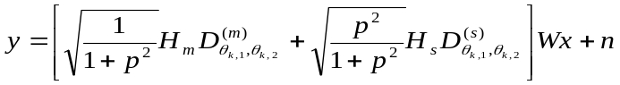
And the steering matrix is further expressed as following:
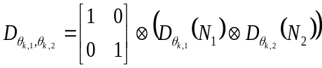
where
- 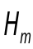,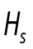are independent channels for the first beam and second beam with the Nr xNt channel matrix per subcarrier.
- 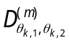, 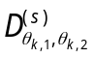are the steering matrix for first beam and second beam
- 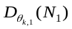 is the steering matrix in first dimension with same polarization,
- 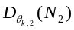 is the steering matrix in second dimension with same polarization,
- 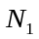 is the number of antenna elements infirst dimension with same polarization,
- 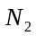 is the number of antenna elements in second dimension with same polarization,
- For antenna array with only one direction, number of antenna element in second direction equals 1，
- is the relative power ratio of the second beam to the first beam, the value of is specific to a test case,
For 1 antenna element of the same polarization in one direction, 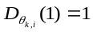.
For 2 antenna elements of the same polarization in one direction, 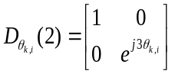.
For 3 antenna elements of the same polarization in one direction,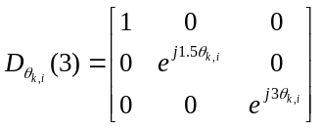.
For 4 antenna elements of the same polarization in one direction, 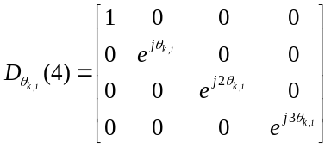.
where the index 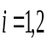 stands for first dimension and second dimension respectively.
- controls the phase variation in first dimension and second dimension respectively, and the phase for k-th subframe is denoted by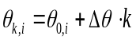, where is the random start value with the uniform distribution, i.e., , 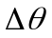 is the step of phase variation, which is defined in Table B.2.3.2.3A-1, and k is the linear increment of 2^{-μ} for every slot throughout the simulation, the index stands for first dimension and second dimension respectively.
- is the precoding matrix for Nt transmission antennas,
- y is the received signal, x is the transmitted signal, and n is AWGN.
- corresponds to subcarrier spacing configuration,
For the 1D cross-polarized antenna array at gNB, the corresponding random channel matrix H can be calculated by letting N₂=1, i.e.,
Table B.2.3.2.3A-1: The step of phase variation
Variation Step | Value (rad/subframe)
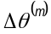 | 1.2566×10⁻³
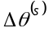 | 2.5132×10⁻³

B.2.3.3 MIMO Correlation Matrices for FR2 simultaneous reception
The correlation model for FR2 simultaneous reception in a two TRxP scenario with 1 antenna elecment with the same polarization in one direction at the gNB and UE side is defined as follows,
$R_{FR2−mTxRP−mRX}=E\left[h_{16×1}{h_{16×1}}^{H}\right]=\frac{1}{1+ρ}∙diag\left(\left[1 ρ ρ 1\right]\right)⊗R_{MIMO}=\frac{1}{1+ρ}\left[\begin{matrix}\begin{matrix}R_{MIMO} & 0 \\ 0 & ρR_{MIMO}\end{matrix} & 0 \\ 0 & \begin{matrix}ρR_{MIMO} & 0 \\ 0 & R_{MIMO}\end{matrix}\end{matrix}\right]$,

Where:
- $R_{MIMO}=$ $Γ$ is a $4×4$correlation matrix for each link between TRPs to receiver modules at the UE side generated with
- $R_{MIMO}$ is the $4×4$correlation matrix for each link between TRP to UE RX.
$R_{MIMO}=P\left(R_{TRP}⨂Γ⨂R_{UE−RX}\right)P^{T}$. With 2 RX per TRP and UE-RX, $R_{TRP}=1, R_{UE−RX}=1, R_{MIMO}=PΓP^{T}.$$Γ$ is the polarization coefficient matrix as defined in Annex B2.3.2 using parameter γ=0.0625;
- $⊗$ denotes the Kronecker product,
- $diag$ denotes the diagonal matrix,
- $h_{16×1}$is a vector of re-arranged channel values for 2 antenna elements at each TRP and receiver module, defined as follows:
$$h_{16×1}=\left[\begin{aligned}\begin{matrix}vec\left(H_{RX1,TRP1}\right) \\ vec\left(H_{RX2,TRP1}\right) \\ vec\left(H_{RX1,TRP2}\right)\end{matrix} \\ vec(H_{RX2,TRP2})\end{aligned}\right]$$

- vec( ) denotes vectorizing matrix column-by-column.

B.2.4 Two-tap propagation conditions for CQI tests
For Channel Quality Indication (CQI) tests, the following additional multi-path profile is used:
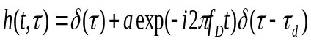
in continuous time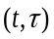 representation, with the delay, a constant value of a and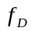the Doppler frequency. The same h(t,τ) is used to describe the fading channel between every pair of Tx and Rx.

B.3 High Speed Train Scenario

B.3.1 Single Tap Channel Profile
The high speed train condition for the test of the baseband performance is a non fading propagation channel with one tap. Doppler shift is given by
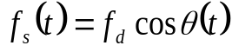 (B.3.1.1)
where 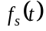 is the Doppler shift and 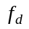 is the maximum Doppler frequency. The cosine of angle 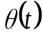is given by
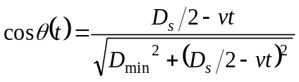, 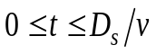 (B.3.1.2)
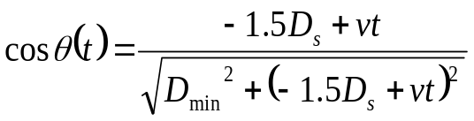, 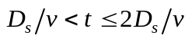 (B.3.1.3)
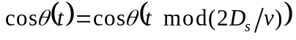, 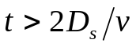 (B.3.1.4)
where 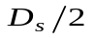 is the initial distance of the train from gNB, and 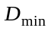 is gNB Railway track distance, both in meters; is the velocity of the train in m/s, is time in seconds.
Doppler shift and cosine angle are given by equation B.3.1.1 and B.3.1.2-B.3.1.4 respectively, where the required input parameters listed in Table B.3.1-1 and the resulting Doppler shift shown in Figures B.3.1-1, B.3.1-2, B.3.1-3, B.3.1-4 are applied for all frequency bands.
Table B.3.1-1: High speed train scenario
Parameter | Value
Parameter | HST-750 | HST-972 | HST-1000 | HST-1667
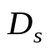 | 300 m | 300 m | 300 m | 300 m
 | 2 m | 2 m | 2 m | 2 m
 | 300 km/h | 500 km/h | 300 km/h | 500 km/h
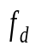 | 750 Hz for 15 kHz SCS test | 972 Hz for 15 kHz SCS test | 1000 Hz for 30 kHz SCS test | 1667 Hz for 30 kHz SCS test

Note 1: Parameters for HST conditions in Table B.3.1-1 including 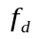 and Doppler shift trajectories presented on figures B.3.1-1 for 750 Hz and B.3.1-3 for 972 Hz for 15 kHz SCS and figures B.3.1-2 for 1000 Hz and B.3.1-4 for 1667 Hz for 30 kHz SCS are applied for performance verification in all frequency bands.
Note 2: The propagation conditions used for the performance requirements under high speed train condition are indicated as a combination of "HST" and Doppler shift, i.e. HST-<Doppler shift>, where '<Dopper shift>' indicates the maximum Doppler shift (Hz) .

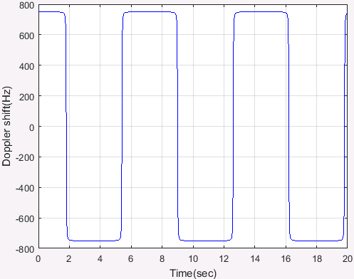
Figure B.3.1-1: Doppler shift trajectory (
= 750 Hz)
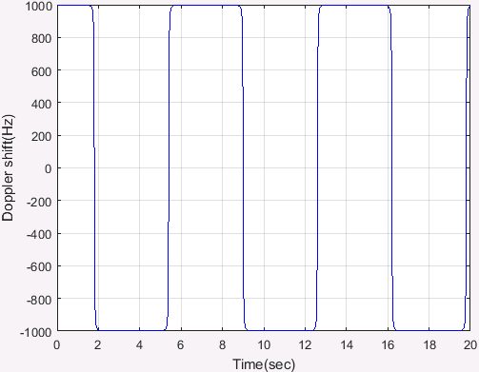
Figure B.3.1-2: Doppler shift trajectory (
= 1000 Hz)
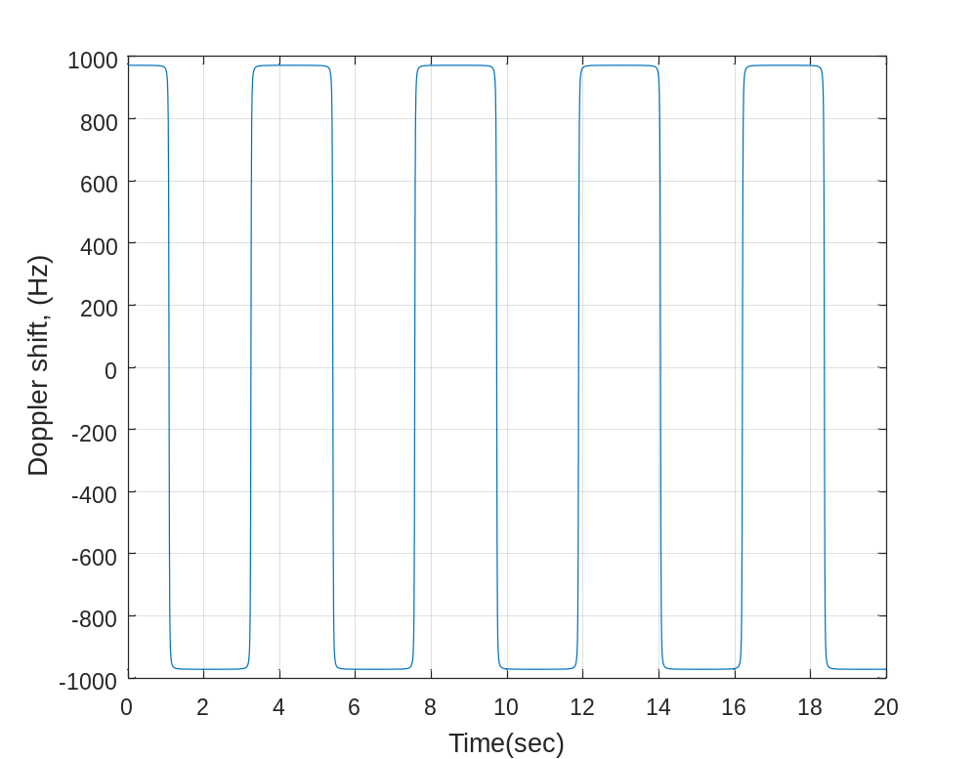
Figure B.3.1-3: Doppler shift trajectory (
= 972 Hz)
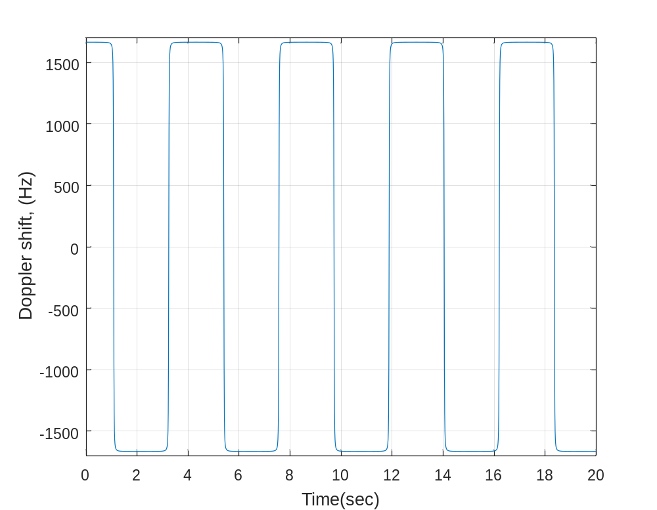
Figure B.3.1-4: Doppler shift trajectory (
= 1667 Hz)
For 1x2 antenna configuration, the same h(t,τ) is used to describe the channel between every pair of Tx and Rx.
For 1x4 antenna configuration, the same h(t,τ) is used to describe the channel between every pair of Tx and Rx.
Static channel matrix will be used as defined in Annex B.1.

B.3.2 HST-SFN Channel Profile
There is an infinite number of RRHs distributed equidistantly along the track with the same Cell ID as depicted in figure B.3.2-1.
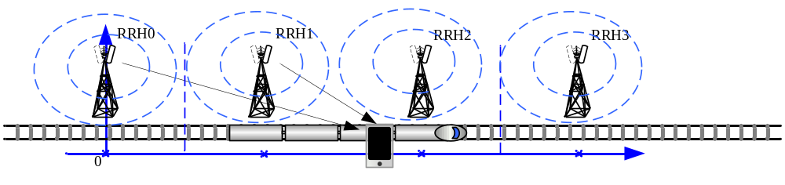
Figure B.3.2-1: Deployment of HST-SFN

The location of RRH k is given as:
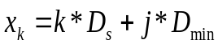 (B.3.2.1)
where: , 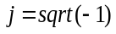 and 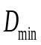is the distance between the RRHs and railway track, while 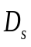 is the distance of two RRHs, both in meters.
The train location is denoted as:
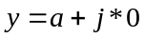 (B.3.2.2)
where: 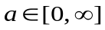 and a means distance in meters, which means the train is right on the track.
The HST-SFN scenario for the test of the baseband performance is a non fading propagation channel with four taps, namely the four nearest RRHs. Thus, RRH k is visible for the train only in the range:
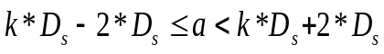 (B.3.2.3)
Power level 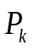 (dB) for the signal from k^{th} RRH, normalized to the total power received from all visible RRHs, is given by:
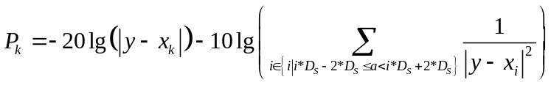 for (B.3.2.4)
Doppler shift 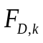(Hz) from k^{th} RRH is given by:
$F_{D,k}=f_{d}×real\left[−\frac{y−x_{k}}{\left|y−x_{k}\right|}\right] for kD_{s}−2D_{s}≤a< kD_{s}+2D_{s}$ (B.3.2.5)
The relative delay 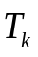 (s) for the signal from k^{th} RRH can be derived as:
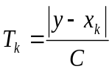 for (B.3.2.6)
In the abovef_{d} (Hz) is the maximum Doppler frequency as given in Table B.3.2-1, and C (m/s) is the velocity of light.
Power level, Doppler shift and relative delay are given by equations B.3.2.4 ~ B.3.2.6 respectively, where the required input parameters listed in table B.3.2-1 and the resulting Doppler shift shown in Figures B.3.2-3 and B.3.2-4 are applied for all frequency bands.
Table B.3.2-1: HST-SFN scenario
Parameter | Value
 | 700 m
 | 150 m
 | 500 km/h
870 Hz for 15 kHz SCS test;
1667 Hz for 30 kHz SCS test

NOTE 1: The trajectories of relative power, Doppler shifts and absolute delays presented in Figures B.3.2-2, B.3.2-3, B.3.2-4 and B.3.2-5 are derived from the equations B.3.2.4 ~ B.3.2.6 respectively, v is the velocity of the train.
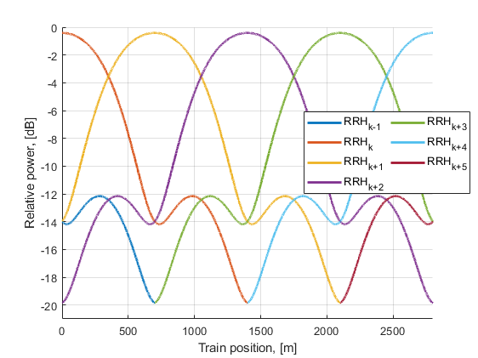
Figure B.3.2-2 Relative power level trajectories
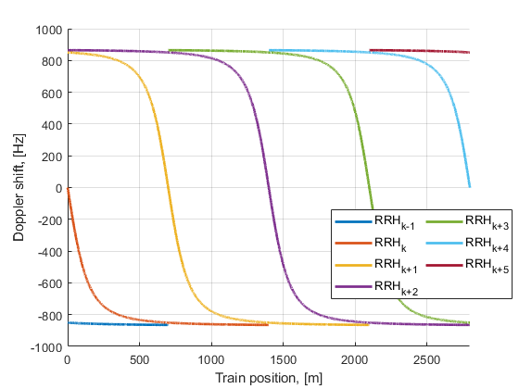
Figure B.3.2-3 Doppler shift trajectories (
= 870 Hz)
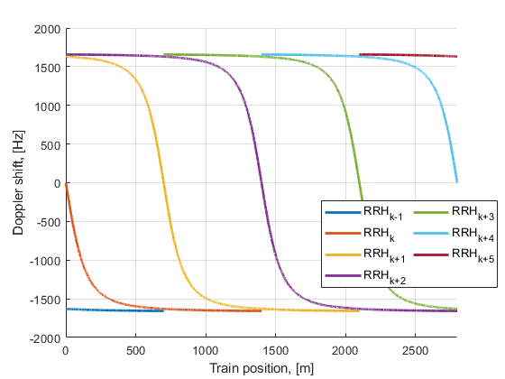
Figure B.3.2-4 Doppler shift trajectories (
= 1667 Hz)
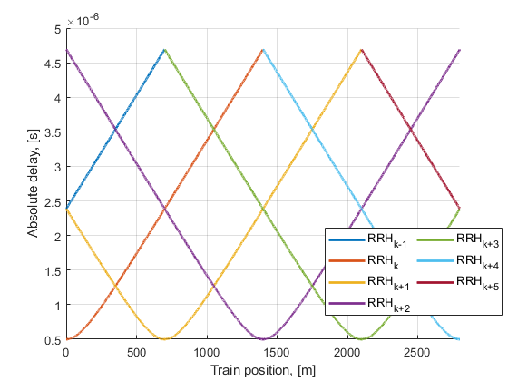
Figure B.3.2-5 Absolute delay trajectories
Static channel matrix will be used as defined in Annex B.1.

B.3.3 HST-DPS Channel Profile
There is an infinite number of RRHs distributed equidistantly along the railway track with the same Cell ID as illustrated in Figure B.3.3-1.
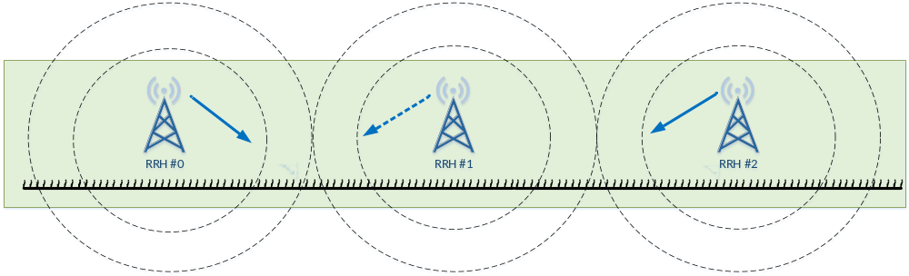
Figure B.3.3-1: Deployment of HST-DPS
The location of RRH k is given as:
(B.3.3.1)
where: , and is the distance between the RRHs and railway track, while is the distance of two RRHs, both in meters.
The train location is denoted as:
(B.3.3.2)
where: and a means distance in meters, which means the train is right on the track.
The HST DPS multi-RRH scenario for the test of the baseband performance is a single tap propagation channel at each time with switching of transmission point in the middle point between two RRHs. As shown in Figures B.3.3-2 and B.3.3-4, RRH k is visible for the train only in the range:
$k∗D_{s}−D_{s}≤a<k∗D_{s}+D_{s}$ (B.3.3.3)
However, as shown in Figures B.3.3-3 and B.3.3-5, RRH k is considered for PDSCH and PDCCH signal transmission only in the range:
$k∗D_{s}−\frac{D_{s}}{2}<a≤k∗D_{s}+\frac{D_{s}}{2}$ (B.3.3.4)
Propagation delay difference are not considered between signals from different RRHs.
Power level (dB) for the signal from each RRH equals to 0. Doppler shift (Hz) from k^{th} RRH is given by:
$F_{D,k}=f_{d}×real\left[−\frac{y−x_{k}}{\left|y−x_{k}\right|}\right] for k∗D_{s}−\frac{D_{s}}{2}<a≤k∗D_{s}+\frac{D_{s}}{2}$ (B.3.3. 5)

In the above f_{d} (Hz) is the maximum Doppler frequency as given in Table B.3.3-1, and C (m/s) is the velocity of light.
Doppler shift is given by equation B.3.3.5, where the required input parameters listed in table B.3.3-1 and the resulting Doppler shift shown in Figures B.3.3-2 ~ B.3.3-5 are applied for all frequency bands.
Table B.3.3-1: HST-DPS scenario
Parameter | Value
 | 700 m
 | 150 m
 | 500 km/h
870 Hz for 15 kHz SCS test;
1667 Hz for 30 kHz SCS test

NOTE 1: v is the velocity of the train.

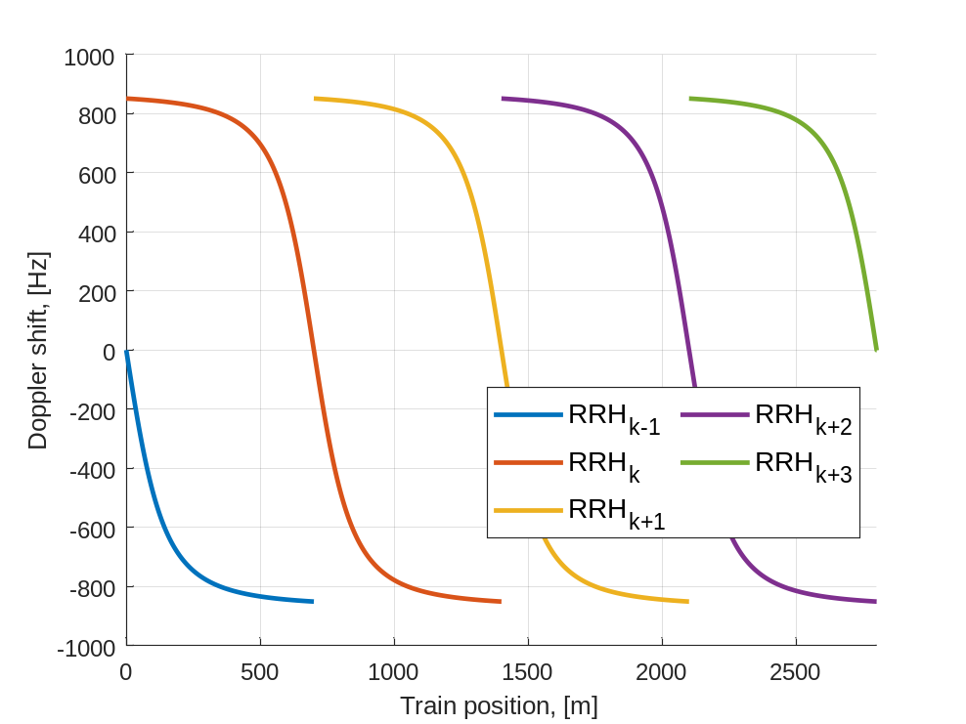
Figure B.3.3-2 Doppler shift trajectory (
= 870 Hz) showing visibility of each RRH

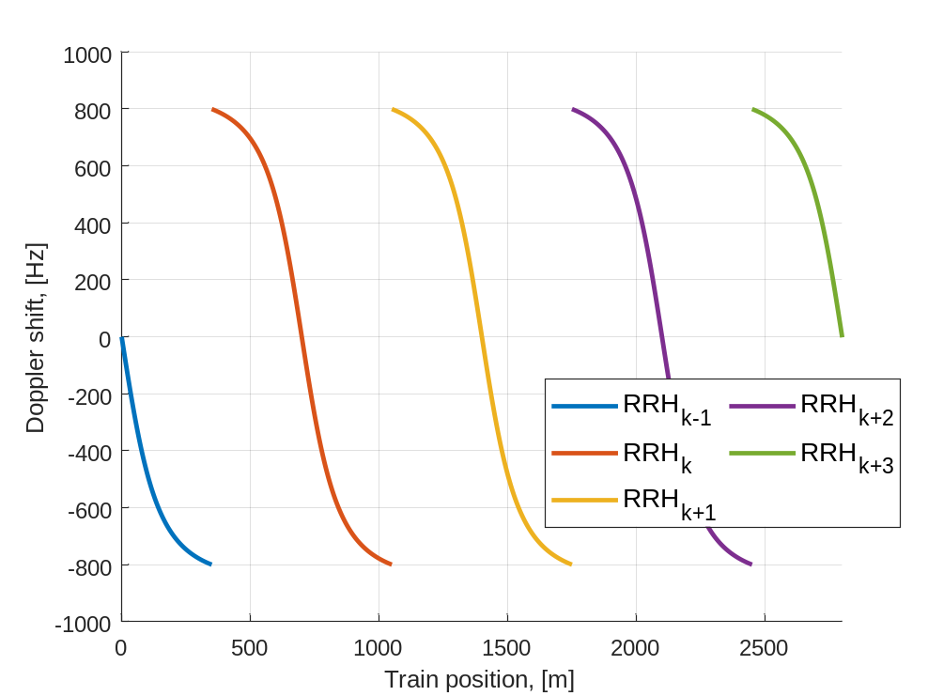
Figure B.3.3-3 Doppler shift trajectory (
= 870 Hz) as seen by PDCCH and PDSCH for each RRH

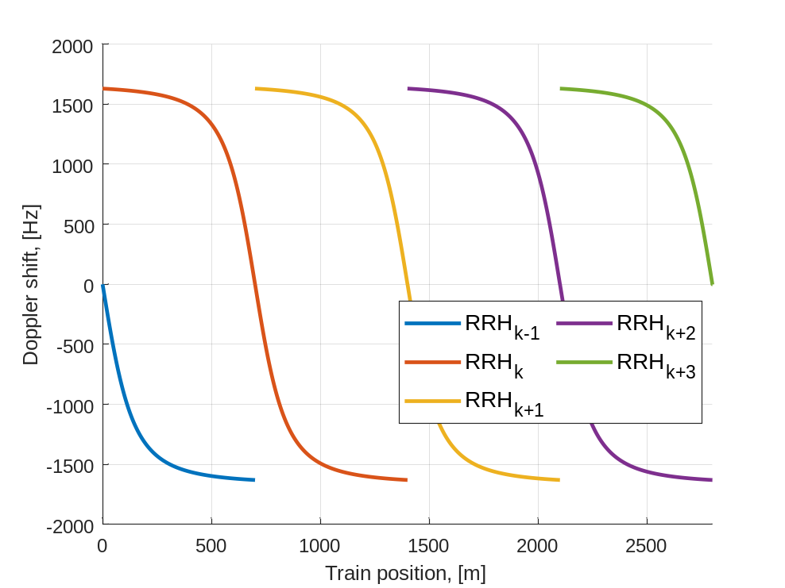
Figure B.3.3-4 Doppler shift trajectory (
= 1667 Hz) showing visibility of each RRH

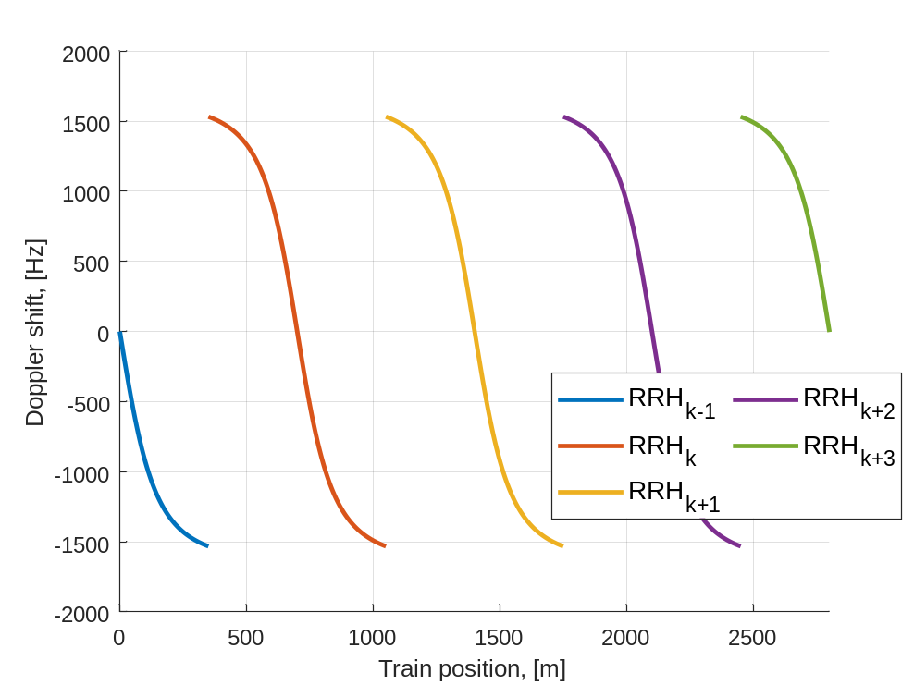
Figure B.3.3-5 Doppler shift trajectory (
= 1667 Hz) as seen by PDCCH and PDSCH for each RRH

Static channel matrix will be used as defined in Annex B.1.

B.3.4 FR2 HST-DPS Channel Profile
There is an infinite number of RRHs distributed equidistantly along the railway track with the same Cell ID as illustrated in Figure B.3.4.1-1 for Unidirectional, Figure B.3.4.2-1 for Bidirectional, and Figure 8.3.4.3-1 for Bidirectional with Multi-Rx chain reception
The location of RRH k is given as:
$x_{k}=k∗D_{s}+j∗D_{min}$ (B.3.4.1)
where: $k∈[−∞,∞]$, $j=sqrt(−1)$ and $D_{min}$is the distance between the RRHs and railway track, while $D_{s}$ is the distance of two RRHs, both in meters.
The train location is denoted as:
$y=a+j∗0$ (B.3.4.2)
where: $a∈[−D_{s_offset},∞]$ and a means distance in meters, which means the train is right on the track. $a=a_{0}+vt$ where v (m/s) is the moving speed of the train, $a_{0}={−D}_{s_offset}$ for B.3.4.1 Unidirectional Deployment Channel Profile and for B.3.4.3 Bidirectional Deployment Channel Profile with multi-Rx chain reception, and $a_{0}=0$ for B.3.4.2 Bidirectional Deployment Channel Profile.

B.3.4.1 Unidirectional Deployment Channel Profile
The FR2 HST DPS Unidirectional Deployment Channel Profile is a single tap propagation channel, switching transmission point between adjacent RRHs when the UE reaches a distance equal to D_{S_offset} from the serving RRH as illustrated in Figure B.3.4.1-1:
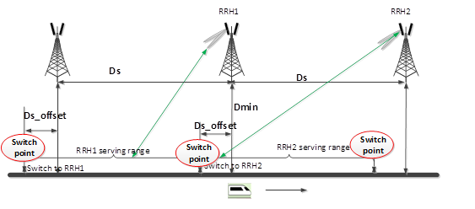
Figure B.3.4.1-1: Unidirectional deployment of FR2 HST-DPS
RRH k is visible for the train only in the range:
$(k−2)∗D_{s}− D_{s_offset}≤a<k∗D_{s}$ (B.3.4.1.1)
However, RRH k is considered for PDSCH and PDCCH signal transmission only in the range:
$(k − 1)∗D_{s}−D_{s_offset} <a≤k∗D_{s}− D_{s_offset}$ (B.3.4.1.2)
Propagation delay difference are not considered between signals from different RRHs.
Power level $P_{k}$ (dB) for the signal from each RRH equals to 0. Doppler shift $f_{s}\left(t\right)=f_{d} cos{θ\left(t\right)}$ (Hz) is given by:
$\cos{θ\left(t\right)}=\frac{D_{s_offset} +D_{s}−vt}{\sqrt{D_{min}^{2}+{\left(D_{s_offset}+D_{s}−vt\right)}^{2}}}, 0<t≤\frac{D_{s}}{v}$
$cosθ\left(t\right)=cosθ\left(t mod\left(\frac{D_{s}}{v}\right)\right), t>D_{s}/v$ (B.3.4.1.3)
Doppler shift is given by equation B.3.4.1.3, where the required input parameters listed in table B.3.4.1-1 and the resulting Doppler shift shown in Figures B.3.4.1-2 and B.3.4.1-3 are applied for all frequency bands.
Table B.3.4.1-1: FR2 HST-DPS Unidirectional scenario
Parameter | Value
Parameter | HST-DPS-FR2-UNI-A
$$D_{s}$$ | 700 m
$$D_{s_offset}$$ | 10 m
$$D_{min}$$ | 10 m
$$v$$ | 350 km/h
$$f_{d}$$ | 9722 Hz

Static channel matrix will be used as defined in Annex B.1.

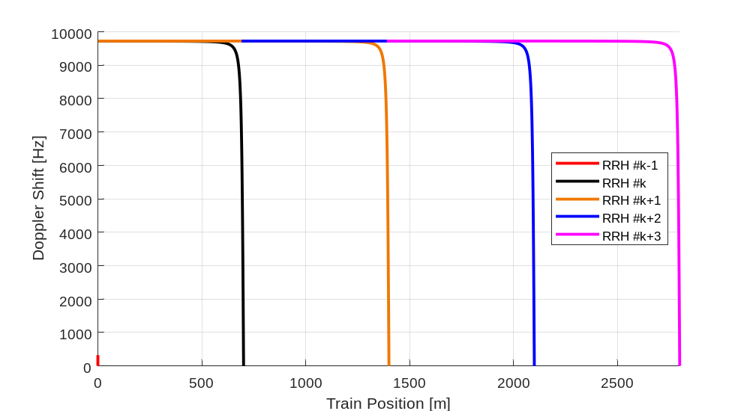
Figure B.3.4.1-2: Doppler shift trajectory (f_d = 9722 Hz) showing visibility
of each RRH for FR2 HST-DPS Unidirectional scenario

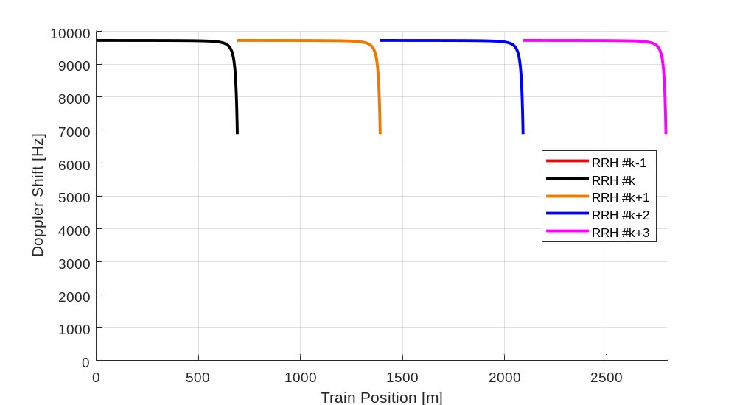
Figure B.3.4.1-3: Doppler shift trajectory (f_d = 9722 Hz) as seen by PDCCH and PDSCH
for each RRH for FR2 HST-DPS Unidirectional scenario

B.3.4.2 Bidirectional Deployment Channel Profile
The FR2 HST DPS Bidirectional Deployment Channel Profile is a single tap propagation channel, switching transmission point between adjacent RRHs as illustrated in Figure B.3.4.2-1:
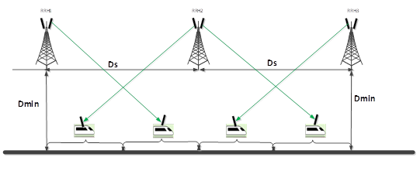
Figure B.3.4.2-1: Bidirectional deployment of FR2 HST-DPS
As shown in Figures B.3.4.2-1, RRH k is visible for the train only in the range:
$k∗D_{s}−D_{s}≤a<k∗D_{s}+D_{s}$ (B.3.4.2.1)
However, as shown in Figures B.3.3-3 and B.3.3-5, RRH k is considered for PDSCH and PDCCH signal transmission only in the range:
$\left(k−1\right)∗D_{s} <a≤k∗D_{s}−\frac{D_{s}}{2}; k∗D_{s}+\frac{D_{s}}{2} <a≤\left(k+1\right)∗D_{s}$ (B.3.4.2.2)
Note that UE is receiving PDSCH and PDCCH from the 2nd-nearest RRH. Propagation delay difference are not considered between signals from different RRHs.
Power level (dB) for the signal from each RRH equals to 0. Doppler shift $f_{s}\left(t\right)=f_{d} cos{θ\left(t\right)}$ (Hz) is given by:
$\cos{θ\left(t\right)}=\frac{D_{s}−vt}{\sqrt{D_{min}^{2}+{\left(D_{s}−vt\right)}^{2}}}, 0<t≤{(0.5∗D}_{s})/v$
$\cos{θ\left(t\right)}=−\frac{vt}{\sqrt{D_{min}^{2}+{\left(vt\right)}^{2}}}, {(0.5∗D}_{s})/v<t≤D_{s}/v$
$cosθ\left(t mod\left(\frac{D_{s}}{v}\right)\right), t>D_{s}/v$ (B.3.4.2.3)

Doppler shift is given by equation B.3.4.2.3, where the required input parameters listed in table B.3.4.2-1 and the resulting Doppler shift shown in Figures B.3.4.2-2 and B.3.4.2-3 are applied for all frequency bands.
Table B.3.4.2-1: FR2 HST-DPS Bidirectional scenario
Parameter | Value
Parameter | HST-DPS-FR2-BI-B
 | 700 m
 | 150 m
 | 350 km/h
 | 9722 Hz

Static channel matrix will be used as defined in Annex B.1.

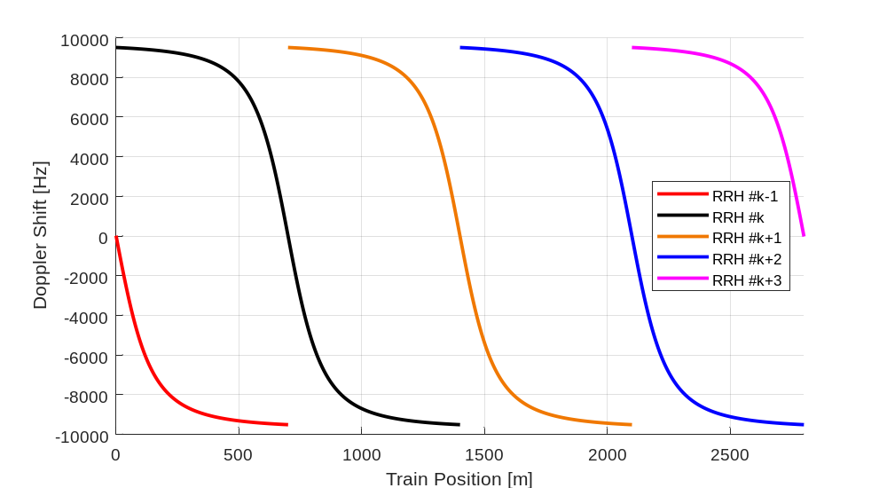
Figure B.3.4.2-2: Doppler shift trajectory (f_d = 9722 Hz) showing visibility
of each RRH for FR2 HST-DPS Bidirectional scenario

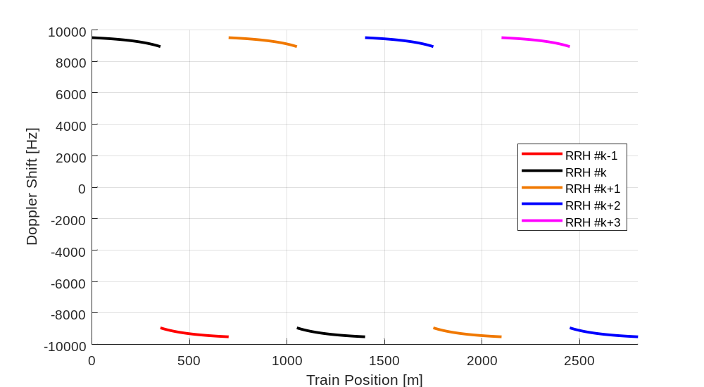
Figure B.3.4.2-3: Doppler shift trajectory (f_d = 9722 Hz) as seen by PDCCH and PDSCH
for each RRH for FR2 HST-DPS Bidirectional scenario

B.3.4.3 Bidirectional Deployment Channel Profile with Multi-Rx Chain Reception
The FR2 HST DPS Bidirectional Deployment Channel Profile with Multi-Rx Reception is a single tap propagation channel for each Rx chain, switching transmission point between adjacent RRHs for UE with each Rx Chain when the UE reaches a distance equal to D_{S_offset} from the serving RRH as illustrated in Figure B.3.4.3-1:
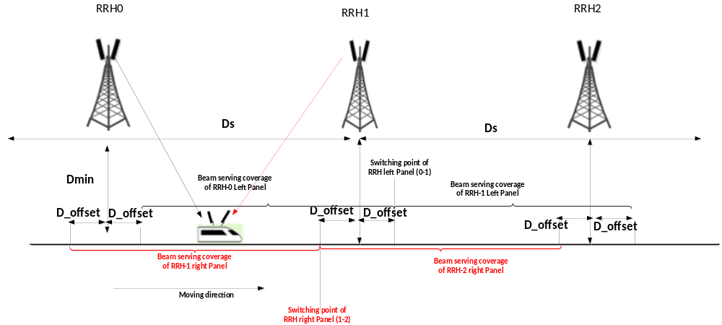
Figure B.3.4.3-1: Bidirectional deployment of FR2 HST-DPS with Multi-Rx Chain Reception
RRH k is visible for the train only in the range:
$(k−1)∗D_{s}−D_{s_{offset}}≤a<(k+1)∗D_{s}+D_{s_offset}$ (B.3.4.3.1)
However, as shown in Figures B.3.4.3-1, RRH k is considered for PDSCH and PDCCH signal transmission only received by UE with right Rx Chain in the range:
$(k − 1)∗D_{s}−D_{s_offset}≤a<k∗D_{s}− D_{s_offset}$ (B.3.4.3.2)
and RRH k is considered for PDSCH and PDCCH signal transmission only received by UE with left Rx Chain in the range:
$k∗D_{s}+D_{s_{offset}}≤a<\left(k+1\right)∗D_{s}+ D_{s_offset}$ (B.3.4.3.3)
Propagation delay difference are not considered between signals from different RRHs.
Power level $P_{k}$ (dB) for the signal from each RRH equals to 0.
Doppler shift $f_{s}\left(t\right)=f_{d} cos{θ\left(t\right)}$ (Hz) for PDSCH and PDCCH received by train with right Rx Chain is given by:
$$\cos{θ\left(t\right)=}\frac{D_{s_offset}+D_{s}−vt}{\sqrt{D_{min}^{2}+{\left(D_{s_offset}+D_{s}−vt\right)}^{2}}}, 0<t≤\frac{D_{s}}{v}$$
$\cos{θ(t)}=\cos\left(t mod\left(\frac{D_{s}}{v}\right)\right), t>\frac{D_{s}}{v}$ (B.3.4.3.4)
Doppler shift $f_{s}\left(t\right)=f_{d} cos{θ\left(t\right)}$ (Hz) for PDSCH and PDCCH received by train with left Rx Chain is given by:
$$\cos{θ\left(t\right)=}\left\{\begin{aligned}\frac{−\left(D_{s}−D_{s_offset}+vt\right)}{\sqrt{D_{min}^{2}+{\left(D_{s}−D_{s_offset}+vt\right)}^{2}}}, 0<t≤\frac{2D_{s_offset}}{v} \\ \frac{−\left({−D}_{s_offset}+vt\right)}{\sqrt{D_{min}^{2}+{\left(−D_{s_offset}+vt\right)}^{2}}}, \frac{2D_{s_offset}}{v}<t≤\frac{D_{s}}{v}\end{aligned}\right.$$
$\cos{θ(t)}=\cos\left(t mod\left(\frac{D_{s}}{v}\right)\right), t>\frac{D_{s}}{v}$ (B.3.4.3.5)
Doppler shift is given by equation B.3.4.3.4 and B.3.4.3.5, where the required input parameters listed in table B.3.4.3-1 and the resulting Doppler shift shown in Figures B.3.4.3-2 and B.3.4.3-3 are applied for all frequency bands.
Table B.3.4.3-1: FR2 HST-DPS Bidirectional scenario
Parameter | Value
Parameter | HST-DPS-FR2-BI-B1-MR
$$D_{s}$$ | 700 m
$$D_{s_offset}$$ | 100 m
$$D_{min}$$ | 150 m
$$v$$ | 350 km/h
$$f_{d}$$ | 9722 Hz

Static channel matrix will be used as defined in Annex B.1.

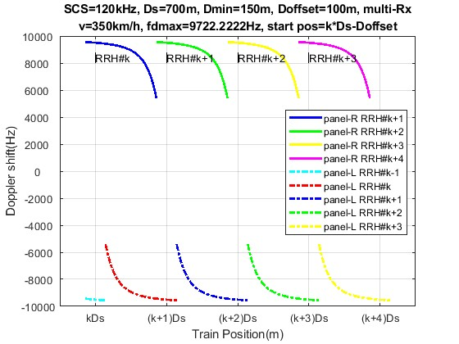
Figure B.3.4.3-2: Doppler shift trajectory (f_d = 9722 Hz) showing visibility
of each RRH for FR2 HST-DPS Bidirectional scenario with mutlit-Rx Chain Reception
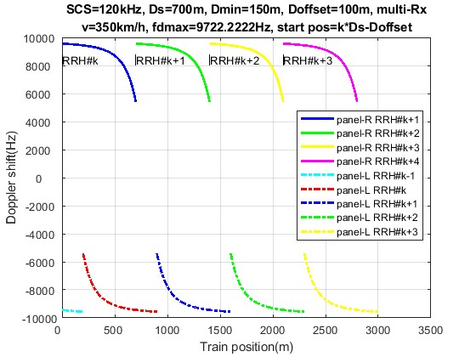
Figure B.3.4.3-3: Doppler shift trajectory (f_d = 9722 Hz) as seen by PDCCH and PDSCH
for each RRH for FR2 HST-DPS Bidirectional scenario with multi-Rx Chain Reception

B.3.5 HST-SFN Scheme A Channel Profile
There is an infinite number of RRHs distributed equidistantly along the railway track with the same Cell ID as illustrated in Figure B.3.5-1. The PDCCH/PDSCH are transmitted in SFN manner and TRS are transmitted in TRP specific manner as illustrated in Figure B.3.5-1.
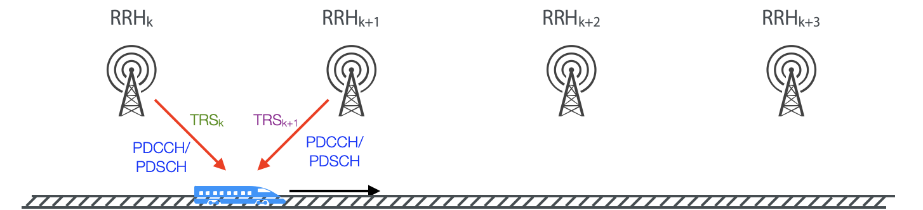
Figure B.3.5-1: Deployment of HST-SFN Scheme A
The location of RRH k is given as:
$x_{k}=k∗D_{s}+j∗D_{min}$ (B.3.5.1)
where: , and D_{min} is the distance between the RRHs and railway track, while D_{s} is the distance of two RRHs, both in meters.
The train location is denoted as:
$y=a+j∗0$ (B.3.5.2)
where: and a means distance in meters, which means the train is right on the track.
The HST Scheme A scenario for the test of the baseband performance is a non-fading propagation channel with two taps, namely the two nearest RRHs. Thus, RRH k is visible for the train only in the range:
$k∗D_{s}−D_{s}≤a<k∗D_{s}+D_{s}$ (B.3.5.3)
Power level P_{k} (dB) for the signal from k^{th} RRH, normalized to the total power received from all visible RRHs, is given by:

$P_{k}= −20\log\left(\left|y−x_{k}\right|\right)−10log\left(\sum_{i∈\left\{i | i∗D_{s}−D_{s}≤a<i∗D_{s}+D_{s}\right\}}{\frac{1}{{\left|y−x_{i}\right|}^{2}}}\right)$for $k∗D_{s}−D_{s}≤a<k∗D_{s}+D_{s}$ (B.3.5.4)
Doppler shift (Hz) from k^{th} RRH for TRS_{k}, PDCCH, PDSCH as shown in figure B.3.5-1 is given by:
$F_{D,k}= f_{c}∗real\left(−v∗\frac{\left(y−x_{k}\right)}{\left|y−x_{k}\right|∗C}\right) for k∗D_{s}−D_{s}≤a<k∗D_{s}+D_{s}$ (B.3.5.5)
The relative delay T_{k} (s) for the signal from k^{th} RRH can be derived as:
$T_{k}= \frac{|y−x_{k}|}{C} for k∗D_{s}−D_{s}≤a<k∗D_{s}+D_{s}$ (B.3.5.6)
In the above v (m/s) is the moving speed of the train, f_{C} (Hz) is the center frequency, and C (m/s) is the velocity of light.
Power level, Doppler shift and relative delay are given by equations B.3.5.4 ~ B.3.5.6 respectively, where the required input parameters listed in table B.3.5-1 and the resulting Doppler shift shown in Figures B.3.5-3 and B.3.5-4 are applied for all frequency bands.
Table B.3.5-1: HST-SFN scenario
Parameter | Value
 | 700 m
 | 150 m
 | 500 km/h
870 Hz for 15 kHz SCS test;
1667 Hz for 30 kHz SCS test

NOTE 1: Equation B.3.5.5 is a general formula for Doppler shift calculation. When defining the requirement for FR1 HST, max Doppler shifts f_{d} which corresponds to fc*v/C in equation B.3.5.5 are selected as defined in Table B.3.5-1 for HST-SFN Scheme A scenario.

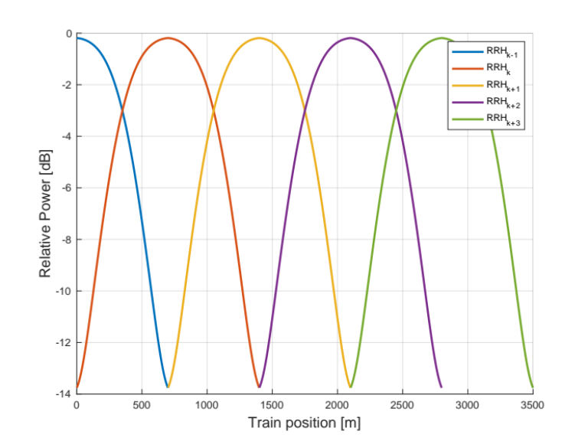
Figure B.3.5-2 Relative power level trajectories

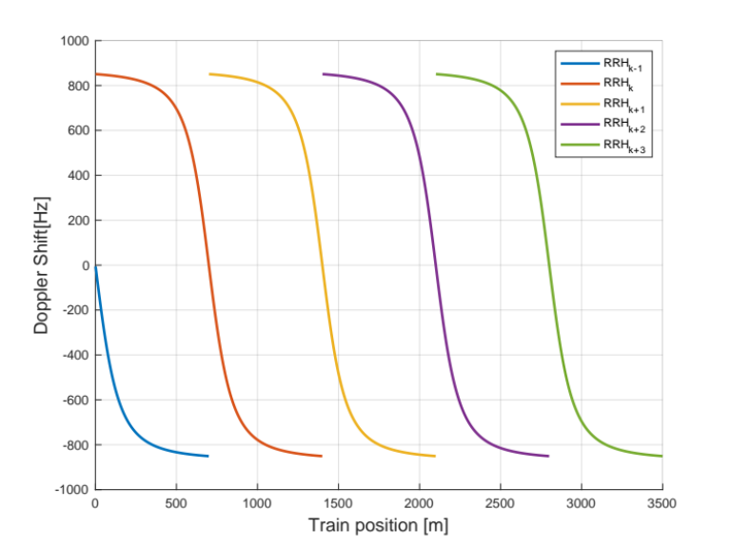
Figure B.3.5-3 Doppler shift trajectory (f_{d}= 870 Hz) showing visibility of each RRH
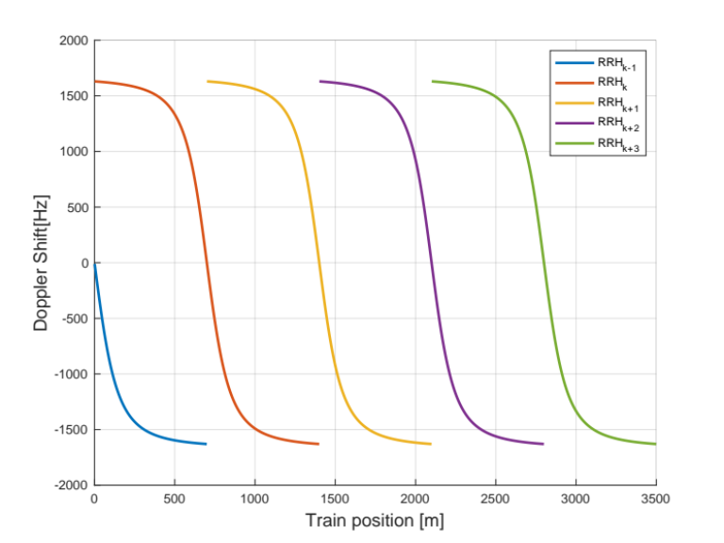
Figure B.3.5-4 Doppler shift trajectory (= 1667 Hz) showing visibility of each RRH
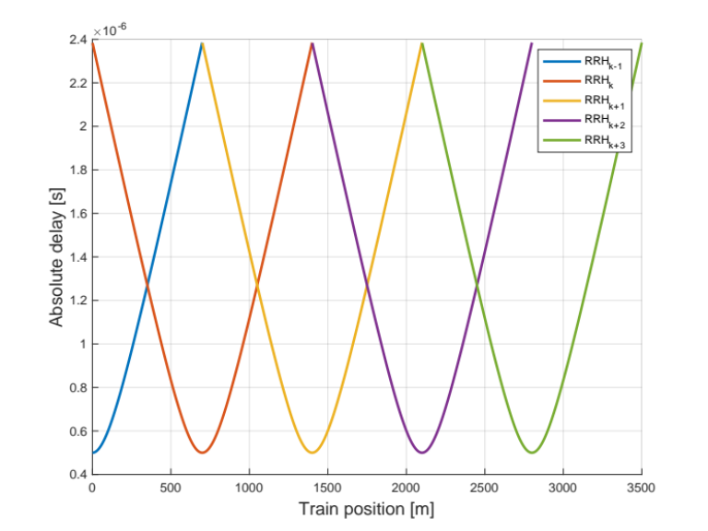
Figure B.3.5-5 Absolute delay trajectories

Static channel matrix will be used as defined in Annex B.1.

B.3.6 HST-SFN Scheme B Channel Profile
There is an infinite number of RRHs distributed equidistantly along the track with the same Cell ID as depicted in figure B.3.6-1. The PDCCH/PDSCH are transmitted in SFN manner from two RRHs and TRS are transmitted in RRH specific manner as illustrated in Figure B.3.6-1.

Figure B.3.6-1: Deployment of HST-SFN Scheme B
The location of RRH k is given as:
$x_{k}=k∗D_{s}+j∗D_{min}$ (B.3.6.1)
where:$k∈[−∞, +∞]$, $j=sqrt(−1)$ and D_{min} is the distance between the RRHs and railway track, while D_{s} is the distance of two RRHs, both in meters.
The train location is denoted as:
$y=a+j∗0$ (B.3.6.2)
where: $a∈[0, +∞]$ and a means distance in meters, which means the train is right on the track.
The HST-SFN Scheme B scenario for the test of the baseband performance is a non-fading propagation channel with two taps, namely the two nearest RRHs. Thus, RRH k is visible for the train only in the range:
$k∗D_{s}−D_{s}≤a<k∗D_{s}+D_{s}$ (B.3.6.3)
Power level P_{k} (dB) for the signal from k^{th} RRH, normalized to the total power received from all visible RRHs, is given by:
$P_{k}= −20\log\left(\left|y−x_{k}\right|\right)−10log\left(\sum_{i∈\left\{i | i∗D_{s}−D_{s}≤a<i∗D_{s}+D_{s}\right\}}{\frac{1}{{\left|y−x_{i}\right|}^{2}}}\right)for k∗D_{s}−D_{s}≤a<k∗D_{s}+D_{s}$ (B.3.6.4)
Doppler shift F_{D,k} (Hz) from k^{th} RRH for TRS_{k}, PDCCH and PDSCH transmission and Doppler shift F_{D,k+1} (Hz) from (k+1)^{th} RRH for PDCCH and PDSCH transmission as illustrated in Figure B.3.6-1 is given by:
$\left\{\begin{matrix}F_{D,k}=f_{c}×real\left[−v×\frac{y−x_{k}}{\left|y−x_{k}\right|×C}\right] \\ F_{D,k+1}=F_{D,k}\end{matrix}\right.$ for $k∗D_{s}≤a<k∗D_{s}+D_{s}$ (B.3.6.5)
The relative delay T_{k} (s) for the signal from k^{th} RRH can be derived as:
$T_{k}= \frac{|y−x_{k}|}{C} for k∗D_{s}−D_{s}≤a<k∗D_{s}+D_{s}$ (B.3.6.6)
In the above v (m/s) is the moving speed of the train, f_{C} (Hz) is the center frequency, and C (m/s) is the velocity of light.
Power level, Doppler shift and relative delay are given by equations B.3.6.4 ~ B.3.6.6 respectively, where the required input parameters listed in table B.3.6-1 and the resulting Doppler shift shown in Figures B.3.6-3 and B.3.6-4 are applied for all frequency bands.
Table B.3.6-1: HST-SFN Scheme B scenario
Parameter | Value
Parameter | HST-SFN-SchemeB
D_{s} | 700 m
D_{min} | 150 m
v | 500 km/h
f_{d} | 870 Hz for 15 kHz SCS test;  1667 Hz for 30 kHz SCS test

NOTE 1: The trajectories of ralative power, Doppler shifts and absolute delays presented in Figures B.3.6-2, B.3.6-3, B.3.6-4 and B.3.6-5 are derived from the equations B.3.6.4 ~ B.3.6.6 respectively.
NOTE 2: Equation B.3.6.5 is a general formula for Doppler shift calculation. When defining the requirement for FR1 HST, max Doppler shifts fd which corresponds to fc*v/C in equation B.3.6.5 are selected as defined in Table B.3.6-1 for HST-SFN scenario.
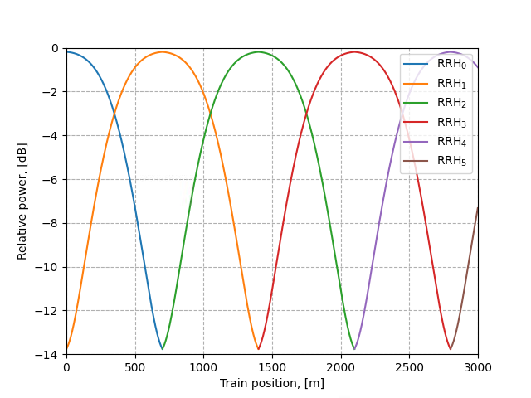
Figure B.3.6-2 Relative power level trajectories
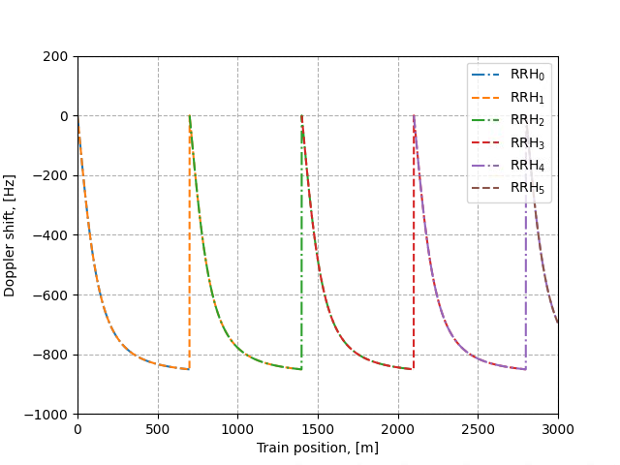
Figure B.3.6-3 Doppler shift trajectories (f_{d} = 870 Hz)
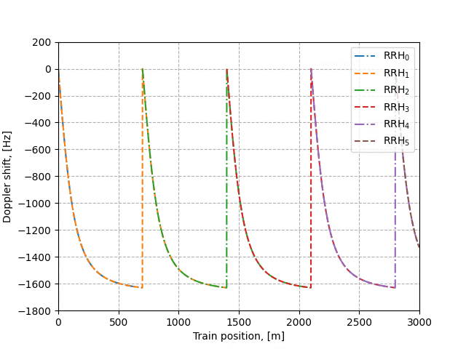
Figure B.3.6-4 Doppler shift trajectories (f_{d} = 1667 Hz)
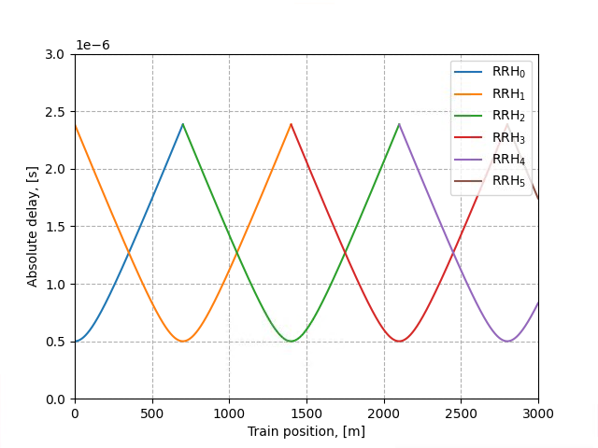
Figure B.3.6-5 Absolute delay trajectories
Static channel matrix will be used as defined in Annex B.1.

B.4 Physical signals, channels mapping and precoding

B.4.1 General
Unless otherwise stated, the transmission on antenna port(s) $p=p_{0}, p_{0}+1,..., p_{0}+N_{p}−1$ is defined by using a precoder matrix 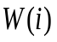 of size $N_{ANT}×N_{p}$, where $N_{ANT}$is the number of physical transmit antenna elements configured per test , $N_{p}$ is the number of ports for a reference signal or physical channel configured per test, and $p_{0}$ is the first port for that reference signal or physical channel as defined in clauses 7.3 and 7.4 in TS 38.211 [9]. This precoder takes as an input a block of signals for antenna port(s) $p=p_{0},p_{0}+1,...,p_{0}+N_{p}−1$, $y^{\left(p\right)}\left(i\right)={\left[y^{\left(p_{0}\right)}\left(i\right) y^{\left(p_{0}+1\right)}\left(i\right) … y^{\left(p_{0}+N_{p}−1\right)}\left(i\right)\right]}^{T}$, 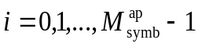, with 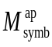 being the number of modulation symbols per antenna port including the reference signal symbols, and generates a block of signals $y_{bf}^{\left(q\right)}\left(i\right)={\left[y_{bf}^{\left(0\right)}\left(i\right) y_{bf}^{\left(1\right)}\left(i\right) … y_{bf}^{\left(N_{ANT}−1\right)}\left(i\right)\right]}^{T}$ the elements of which are to be mapped onto the frequency-time index pair 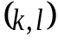as per the test configuration but transmitted on different physical antenna elements:
$$y_{bf}^{\left(q\right)}\left(i\right)=W\left(i\right)y^{\left(p\right)}(i)$$
For Clause 6 and 8, the transmission of PDCCH and PDCCH DMRS on antenna port $p=p_{0}$ is defined by using a precoder matrix of size 2x1. This precoder takes as an input a block of signals for antenna port(s) $p=p_{0}$, $y^{\left(p\right)}\left(i\right)=y^{\left(p_{0}\right)}\left(i\right)$ and generates a block of signals $y_{bf}^{\left(q\right)}\left(i\right)={\left[y_{bf}^{\left(0\right)}\left(i\right) y_{bf}^{\left(\frac{N_{ANT}}{2}\right)}\left(i\right)\right]}^{T}$ the elements of which are to be mapped onto the frequency-time index pair as per the test configuration but transmitted on different physical antenna elements:
$$y_{bf}^{\left(q\right)}\left(i\right)=W\left(i\right)y^{\left(p\right)}(i)$$
The precoder matrix is specific to the test case configuration. is defined in Clause 5.2.2.2 of TS 38.214 [12].
The transimison on PT-RS antenna port is associated (using same precoder) with the lowest indexed DM-RS antenna port among the DM-RS antenna ports assigned for the PDSCH.
The physical antenna elements are identified by indices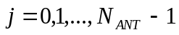, where 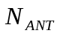 is the number of physical antenna elements configured per test.
Modulation symbols $y^{\left(p\right)}(i)$ with $p∈\left\{4000\right\}$ (i.e. PSS, SSS, PBCH and DM-RS for PBCH) are directly mapped to first physical antenna element.
Modulation symbols 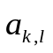 for CSI-RS resources which configured for tracking with one port are directly mapped to first physical antenna element.
Modulation symbols for CSI-RS resources which configured for beam refinement with one port are directly mapped to first physical antenna element.
Modulation symbols 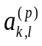 for NZP CSI-RS which configured for CSI acquisition with 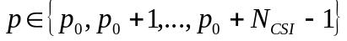 are mapped to the physical antenna index 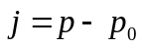 where 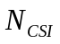is the number of NZP CSI-RS ports configured per test.

B.4.2 Beamforming for MU-MIMO
The transmission on antenna port(s) $p_{n}^{'}=p_{n}, p_{n}+1,..., p_{n}+N_{P}^{(n)}−1$, $n=0,1,…,N−1$ with $N$ being the number of co-scheduled UEs allocated for different antenna ports in one RE is defined by using a precoder matrix $W_{n}\left(i\right)$ of size $N_{ANT}×N_{p}^{(n)}$, where $N_{ANT}$is the number of physical transmit antenna elements configured per test , $N_{p}^{(n)}$is the number of ports for UE n for a reference signal or physical channel configured per test, $W_{n}\left(i\right)$ is the precoder matrix for UE n which is specific to the test case configuration, and $p_{n}$ is the first port for UE n for that reference signal or physical channel as defined in clauses 7.3 and 7.4 in TS 38.211 [9]. This precoder takes as an input a block of signals for antenna port(s) $p_{n}^{'}=p_{n}, p_{n}+1,..., p_{n}+N_{P}^{(n)}−1$, $y^{\left(p_{n}^{'}\right)}\left(i\right)={\left[y^{\left(p_{n}\right)}\left(i\right) y^{\left(p_{n}+1\right)}\left(i\right) … y^{\left(p_{n}+N_{p}^{(n)}−1\right)}\left(i\right)\right]}^{T}$, $i=0,1,…,M_{symb}^{ap}$, with $M_{symb}^{ap}$ being the number of modulation symbols per antenna port including the reference signal symbols, and generates a block of signals $y_{bf}^{\left(q\right)}\left(i\right)={\left[y_{bf}^{\left(0\right)}\left(i\right) y_{bf}^{\left(1\right)}\left(i\right) … y_{bf}^{\left(N_{ANT}−1\right)}\left(i\right)\right]}^{T}$ the elements of which are to be mapped onto the frequency-time index pair $(k,l)$as per the test configuration but transmitted on different physical antenna elements:
$$y_{bf}^{\left(q\right)}\left(i\right)=\sum_{n=0}^{N−1}{W_{n}\left(i\right)y^{\left(p_{n}^{'}\right)}\left(i\right)}$$
The $W_{n}\left(i\right)$ is specific to test case configuration and defined to maintain the average per UE signal power as $N_{P}^{(n)}/\sum_{n}^{N−1}{N_{P}^{(n)}}$

B.5 Transmission Model for requirements on bands with shared spectrum access
Clause B.5.1 provides a description of the Downlink Transmission Model to be used in PDSCH Demodulation and CQI reporting performance tests on bands with shared spectrum access. The model as designed in the clause B.5.1 applies to both configurations for channelAccessMode=’semiStatic’ or ‘dynamic’.

Clause B.5.2 provides a description of the Sidelink Transmission Model to be used in PSSCH performance tests on bands with shared spectrum access.

B.5.1 Downlink Transmission Model for bands with shared spectrum access
The Downlink Period for performance tests on bands with shared spectrum access is defined as the duration included in the Test Configuration Parameters.
For tests configured with the RRC Parameter channelAccessMode=’semiStatic’, the duration of the Fixed Frame Period (FFP) equals the duration of the Downlink Period.
For each Downlink Period, the downlink signal to be transmitted is allocated according to the steps listed below:
1. Select the Downlink Transmission Duration in number of slots, randomly and with equally distributed probability, from the set of possible Downlink Transmission Duration values as included in the Test Configuration Parameters;
a. This duration includes occupied OFDM symbols and non-occupied OFDM symbols within the Downlink Transmission;
2. Depending on the Downlink Transmission Duration chosen in the previous step:
b. If the Downlink Transmission Duration equals 2 slots, all the OFDM symbols in both slots are fully allocated to downlink transmission, else;
c. If the Downlink Transmission Duration is larger than 2 slots, the configuration of occupied symbols in the last slot included in the downlink duration is selected in number of symbols, randomly and with equally distributed probability, from the set of possible ‘Occupied OFDM symbols in the last slot of the downlink duration’ as included in the Test Configuration Parameters;
For each Downlink Period, the last Slot is not scheduled for downlink transmission. This is to comply with the Idle period requirement in case of channelAccessMode=’semiStatic’, and to align the test setup. In the case of channelAccessMode=’semiStatic’, it can be assumed that the Channel Occupancy Time (COT) covers the entire duration of the Downlink Period except for the last slot.
For each Downlink Period, a uniform random variable from [0, 1] is generated. If the random variable is less than the p_{LBT} value included in the Test Configuration Parameters, the entire Downlink Period duration is muted across the entire bandwidth. This applies to all the signals that were scheduled for transmission, including but not limited to PDSCH, PDCCH, SSB, TRS, CSI-RS, etc.

B.5.2 Sidelink Transmission Model for bands with shared spectrum access
The sidelink transmission model is defined with following steps:
1. Select the sidelink tranmisson duration randomly with equal distributed probability, from the set of possible Downlink Transmission Duration values as included in the Test Configuration Parameters.
2. Uniform random variable from [0, 1] is generated.
- If the random variable is higer than the LBT failure probability as defned in the Test Configuration Parameters:
- Start sidelink burst transmission with Sidelink Transmisson Duration selected in step1 at the end of last slot of previous transmission burst. For all slots within one transmission burst, not the first slot, CP of the first symbol with PSSCH/PSCCH is extended to make the gap located in last symbol of previous slot equal to 16us.
- Otherwise, the transmission is muted and the muting duration is the same as the number of slots for Sidelink Transmisson Duration selected in step1.

B.6 Interference model for PDSCH requirements with intercell interference

B.6.1 Interference to Noise ratio (INR)
Each interfering cell involved in PDSCH performance requirements with intercell interference is characterized by its associated interferer to noise ratio (INR) value:
$${INR}_{i}=\frac{\sum_{j=1}^{N_{RX}}{I_{or(i)}^{(j)}}}{\sum_{j=1}^{N_{RX}}{N_{oc}^{(j)}}}$$
where $I_{or(i)}^{(j)}$ is the average received power spectral density from the i-th strongest interfering cell involved in the requirement scenario on the j-th antenna connector and $N_{oc}$ is the average power spectral density of a white noise source consistent with definition provided in section [4.4.3/4.5.3].

B.6.2 Interference model for PDSCH and CSI Reporting requirements
This subclause provides synchronous network deployment interference model for each explicitly modelled interfering cell in the requirement scenario. In each subframe, each interfering cell shall transmit 16 QAM based randomly modulated data over the entire PDSCH region and over the full transmission bandwidth of the specified reference measurement channel. Transmitted physical channels shall include SSB and TRS/CSI-RS as specified in requirements section.
Transmission rank of the interfering cell shall be randomly determined with probabilities as specified in the requirements. The rank configuration will be independent for each interfering cell
For each slot a single precoding matrix for the number of layers υ associated to the selected rank shall be selected randomly from Table 5.2.2.2.1-1 of TS 38.214 [12] with PRB bundling size as given in the requirements.
The generic beamforming model in subclause B.4.1 shall be applied assuming number of antenna ports as specified in the requirement scenario.
Random precoding with selected rank and precoding matrices for each slot shall be applied to 16 QAM randomly modulated layer symbols including the demodulation reference symbols over antenna port 1000 when the rank is one and antenna ports 1000, 1001 when the rank is two. DMRS type 1 with front loaded single symbol and one additional DMRS position with FDM applied between DMRS and data (number of CDM groups without data is 1)
All REs in the control region, random precoding for the number of Tx antenna ports in the requirement scenario shall be applied to QPSK randomly modulated symbols. The EPRE ratio of these REs shall be as defined for PDCCH in Annex C.3.1

B.7 Interference model for PDSCH requirements with LTE-NR spectrum sharing
This clause provides interference modelling for each explicitly modelled LTE interfering cell. Each interfering cell involved in PDSCH performance requirements for LTE-NR spectrum sharing is characterized by its associated interferer to noise ratio (INR) value as defined in B.6.1.
In each subframe, each interfering cell shall transmit 16QAM randomly modulated data over the entire PDSCH region and over the full t7ransmission bandwidth according to the probabilities of occurrence. Transmitted physical channels shall include PSS, SSS and PBCH. Probabilities of occurrence of LTE PDSCH in each subframe are as specified in requirements.
For each subframe, a transmission rank shall be randomly determined independently from interfering cells. Probabilities of occurrence of each possible transmission rank are as specified in requirements.
For each subframe, a precoding matrix for the number of layers associated to the selected rank shall be selected randomly from Table 6.3.4.2.3-1 of TS 36.211 [15]. Note that codebook index 0 shall be excluded from random precoder selection when the number of layers is 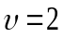.
Precoding for spatial multiplexing with CRS for the number of antenna ports shall be applied to 16QAM randomly modulated layer symbols, as specified in subclause 6.3.4.2.1 of TS 36.211 [15] with the selected precoding matrices for each subframe.
For unallocated REs in the control region, precoding for transmit diversity for the number of antenna ports in the simulation scenario shall be applied to QPSK randomly modulated layer symbols, as specified in subclause 6.3.4.3 of TS 36.211 [15]. The EPRE ratio for these REs shall be as defined for PDCCH in Annex C.3.2 of TS 36.101 [4].

Annex C (normative):
Downlink physical channels

C.1 General
This annex specifies the downlink physical channels that are needed for setting a connection and channels that are needed during a connection.

C.2 Setup (Conducted)
Table C.2-1 describes the downlink Physical Channels that are required for connection set up.
Table C.2-1: Downlink Physical Channels required for connection set-up
Physical Channel
PBCH
SSS
PSS
PDCCH
PDSCH
PBCH DMRS
PDCCH DMRS
PDSCH DMRS
CSI-RS

C.3 Connection (Conducted)
The following clauses, describes the downlink Physical Channels that are transmitted during a connection i.e., when measurements are done.

C.3.1 Measurement of Performance requirements
Table C.3.1-1 is applicable for measurements in which uniform RS-to-EPRE boosting for all downlink physical channels, unless otherwise stated.
Table C.3.1-1: Downlink Physical Channels transmitted during a connection (FDD and TDD)
Parameter | Unit | Value (Note 2)
SSS transmit power | W | Test specific
EPRE ratio of PSS to SSS | dB | 0
EPRE ratio of PBCH to SSS | dB | 0
EPRE ratio of PBCH to PBCH DMRS | dB | 0
EPRE ratio of PDCCH to SSS | dB | 0
EPRE ratio of PDCCH to PDCCH DMRS | dB | 0
EPRE ratio of PDSCH to SSS | dB | 0
EPRE ratio of PDSCH to PDSCH DMRS | dB | Test specific (Note 1)
EPRE ratio of CSI-RS to SSS | dB | -10*log10(L) (Note 3)
EPRE ratio of OCNG to SSS | dB | 0
EPRE ratio of PDCCH OCNG to SSS | dB | 0
EPRE ratio of LTE CRS to NR SSS | dB | 0 (Note 4)
Note 1: Value is derived from Table 4.1-1 in TS 38.214 [12] based on "Number of DM-RS CDM groups without data" and "DMRS Type" parameters specified for each test.
Note 2: The value is the energy of per RE for a single antenna port before pre-coding.
Note 3: 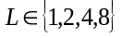 is the CDM group size of NZP CSI-RS specified for each test.
Note 4: It is only applicable to LTE-NR coexistence tests.

C.4 Setup (Radiated)
Table C.4-1 describes the downlink Physical Channels that are required for connection set up.
Table C.4-1: Downlink Physical Channels required for connection set-up
Physical Channel
PBCH
SSS
PSS
PDCCH
PDSCH
PBCH DMRS
PDCCH DMRS
PDSCH DMRS
CSI-RS
PTRS

C.5 Connection (Radiated)
The following clauses, describes the downlink Physical Channels that are transmitted during a connection i.e., when measurements are done.

C.5.1 Measurement of Receiver Characteristics
Table C.5.1-1 is applicable for measurements in which uniform RS-to-EPRE boosting for all downlink physical channels, unless otherwise stated.
Table C.5.1-1: Downlink Physical Channels transmitted during a connection (TDD)
Parameter | Unit | Value (Note 2)
SSS transmit power | W | Test specific
EPRE ratio of PSS to SSS | dB | 0
EPRE ratio of PBCH to SSS | dB | 0
EPRE ratio of PBCH to PBCH DMRS | dB | 0
EPRE ratio of PDCCH to SSS | dB | 0
EPRE ratio of PDCCH to PDCCH DMRS | dB | 0
EPRE ratio of PDSCH to SSS | dB | 0
EPRE ratio of PDSCH to PDSCH DMRS | dB | Test specific (Note 1)
EPRE ratio of CSI-RS to SSS | dB | -10*log10(L) (Note 3)
EPRE ratio of PTRS to PDSCH | dB | Test specific
EPRE ratio of OCNG to SSS | dB | 0
EPRE ratio of PDCCH OCNG to SSS | dB | 0
Note 1: Value is derived from Table 4.1-1 in TS 38.214 [12] based on "Number of DM-RS CDM groups without data" and "DMRS Type" parameters specified for each test.
Note 2: The value is the energy of per RE for a single antenna port before pre-coding.
Note 3: is the CDM group size of NZP CSI-RS specified for each test.
Note 4: Value is derived from Table 4.1-2 in TS 38.214 [12] based on “The number of PDSCH layers” and “epre-Ratio” parameters specified for each test.

Annex D (informative): Void

Annex E (normative):
Environmental conditions

E.1 General
This annex specifies the environmental requirements of the UE. Within these limits the requirements of the present documents shall be fulfilled.

E.2 Environmental (Conducted)
The requirements in this clause apply to all types of UE(s).

E.2.1 Temperature
The UE shall fulfil all the requirements in the temperature range defined in Table E.2.1-1.
Table E.2.1-1: Temperature conditions
+15°C to +35°C | For normal conditions (with relative humidity of 25 % to 75 %)

Outside this temperature range the UE, if powered on, shall not make ineffective use of the radio frequency spectrum. In no case shall the UE exceed the transmitted levels as defined in clause 6.2 of TS 38.101-1 [6] for extreme operation.

E.2.2 Voltage
The UE shall fulfil all the requirements in the voltage range defined in Table E.2.2-1.
Table E.2.2-1: Voltage conditions
Power source | Normal conditions  voltage
AC mains | nominal
Regulated lead acid battery | 1,1 * nominal
Non regulated batteries:  Leclanché  Lithium  Mercury/nickel & cadmium | Nominal  1,1 * Nominal  Nominal

Outside this voltage range the UE if powered on, shall not make ineffective use of the radio frequency spectrum. In no case shall the UE exceed the transmitted levels as defined in TS 38.101-1[6, Clause 6.2] for extreme operation. In particular, the UE shall inhibit all RF transmissions when the power supply voltage is below the manufacturer declared shutdown voltage.

E.2.3 Vibration
The UE shall fulfil all the requirements when vibrated at the following frequency/amplitudes.
Table E.2.3-1: Vibration conditions
Frequency | ASD (Acceleration Spectral Density) random vibration
5 Hz to 20 Hz | 0,96 m2/s3
20 Hz to 500 Hz | 0,96 m2/s3 at 20 Hz, thereafter –3 dB/Octave

Outside the specified frequency range the UE, if powered on, shall not make ineffective use of the radio frequency spectrum. In no case shall the UE exceed the transmitted levels as defined in TS 38.101-1[6] for extreme operation.

E.3 Environmental (Radiated)
The requirements in this clause apply to all types of UE(s).

E.3.1 Temperature
All requirements for UEs operating in FR2 are defined over the air and can only be tested in an OTA chamber.
The UE shall fulfil all the requirements in the temperature range defined in Table E.3.1-1.
Table E.3.1-1: Temperature conditions
+ 25 °C ± 10 °C | For normal (room temperature) conditions with relative humidity of 25% to 75%

Outside this temperature range the UE, if powered on, shall not make ineffective use of the radio frequency spectrum. In no case shall the UE exceed the transmitted levels as defined in clause 6.2 of TS 38.101-2 [7] for extreme operation.

E.3.2 Voltage
<Editor's note: This requirement is incomplete. The following aspects are either missing or not yet determined:
Methodology to control the voltage in a case which a power cable is not connected to DUT is FFS since it is not agreed whether we can connect the power cable to DUT at the OTA measurement situation yet.>
The UE shall fulfil all the requirements in the voltage range defined in Table E.3.2-1.
Table E.3.2-1: Voltage conditions
Power source | Normal conditions  voltage
AC mains | nominal
Regulated lead acid battery | 1,1 * nominal
Non regulated batteries:  Leclanché  Lithium  Mercury/nickel & cadmium | Nominal  1,1 * Nominal  Nominal

Outside this voltage range the UE if powered on, shall not make ineffective use of the radio frequency spectrum. In no case shall the UE exceed the transmitted levels as defined in clause 6.2 of TS 38.101-2 [7] for extreme operation. In particular, the UE shall inhibit all RF transmissions when the power supply voltage is below the manufacturer declared shutdown voltage.

E.3.3 Void

Annex F (informative): Void

Annex G (informative): Void

Annex H (informative): Void

Annex I (informative): Void

Annex J (informative): Void

Annex K (informative): Void

Annex L (informative):
Change history

Change history
Date | Meeting | tDoc | CR | Rev | Cat | Subject/Comment | New version
2018-07 | RAN4 AH18-07 | R4-1809554 |  |  |  | Draft skeleton | 0.0.1
2018-08 | RAN4#88 | R4-1811357 |  |  |  | Skeleton update | 0.0.2
2018-10 | RAN4#88bis | R4-1814237 |  |  |  | Approved Text Proposal in RAN4#88bis:  R4-1814053, "TP on performance specification 38.101-4 Chapter 4 general part"  R4-1814054, "TP to TS 38.101-4: FR1 PDSCH demodulation requirements (5.2)"  R4-1813924, "TP for introducing FR1 PDCCH requirements in TS 38.101-4 clause 5.3"  R4-1814058, "TP for 38.101-4 section 6.3 FR1 PMI test cases"  R4-1814060, "Draft TP on FR1 Rank Indication Reporting Performance Requirements"  R4-1814055, "Draft TP on FR2 PDSCH Demodulation Performance Requirements"  R4-1814022, "TP to TS38.101-4 Section 7.3: PDCCH demodulation requirements"  R4-1814059, "TP for 38.101-4 section 8.3 FR2 PMI test cases"  R4-1814061, "Draft TP on FR2 Rank Indication Reporting Performance Requirements"  R4-1813925, "TP for introducing demodulation performance requirements for interworking TS 38.101-4 section 9"  R4-1814052, "TP for 38.101-4 section 10 CSI test cases of interworking"  R4-1814066, "TP on channel models for TS38.101-4"  R4-1814023, "TP to TS38.101-4 Annex C: Downlink physical channels"  R4-1814024, "TP to TS38.101-4 Annex E: Environmental conditions" | 0.1.0
2018-11 | RAN4#89 | R4-1816559 |  |  |  | Approved Text Proposal in RAN4#89:  R4-1814053, "TP on performance specification 38.101-4 Chapter 4 general part"  R4-1814487, "TP for TS38.101-4 section 2 (Reference)"  R4-1814488, "TP for TS38.101-4 section 3 (Definitions, symbols and abbreviations)”  R4-1814579, "TP to TS 38.101-4: Annex A Measurement channels – PDSCH"  R4-1814580, "TP to TS 38.101-4: Annex A Measurement channels - DL Control"  R4-1814581, "TP to TS 38.101-4: Annex A Measurement channels – CSI"  R4-1816395, "FR2 demod: Noc, Band groups and Ref point - TP for TS 38.101-4"  R4-1816692, "TP to TS 38.101-4: Requirements applicability"  R4-1816693, "TP for performance requirements for interworking (9)"  R4-1816694, "TP to TS 38.101-4: FR1 PDSCH demodulation requirements (5.2)"  R4-1816695, "Draft TP on FR2 PDSCH Demodulation Performance Requirements"  R4-1816697, "TP for updating FR1 PDCCH requirements in TS 38.101-4 section 5.3"  R4-1816699, "TP to TS 38.101-4: 5.4 FR1 PBCH demodulation requirements"  R4-1816700, "TP to TS 38.101-4: 7.4 FR2 PBCH demodulation requirements"  R4-1816701, "TP of introduction of FR1 CQI requirement (6.2)"  R4-1816702, "TP to TS 38.101-4: FR2 CQI requirements (8.2)"  R4-1816703, "Draft TP on FR1 Rank Indication Reporting Performance Requirements"  R4-1816704, "Draft TP on FR2 Rank Indication Reporting Performance Requirements"  R4-1816705, "TP for TS 38.101-4 FR1 PMI test requirement"  R4-1816706, "TP to TS 38.101-4 FR2 PMI requirements"  R4-1816712, "TP to TS 38.101-4: FR1 SDR requirements (5.5) "  R4-1816713, "TP to TS38.101-4 Section 7.3: PDCCH demodulation requirements"  R4-1816714, "TP for propagation conditions in TS 38.104-4(Annex B)" | 0.2.0
2018-12 | RAN#82 | RP-182408 |  |  |  | V1.0.0 is submitted to RAN for 1-step approval | 1.0.0
2018-12 | RAN#82 | RP-182704 |  |  |  | V1.0.1 with editorial changes | 1.0.1
2018-12 | RAN#82 |  |  |  |  | Approved by plenary – Rel-15 spec under change control | 15.0.0
2019-03 | RAN#83 | RP-190403 | 0001 |  | B | CR on UE demodulation and CSI requirements for 38.101-4  This CR comboines all the endorsed draft CRs as list below:  General sections  R4-1902427, Draft CR on NR UE demodulation requirements applicability (Intel Corporation)  R4-1902576, Draft CR on General Applicability of Requirements (Qualcomm Incorporated)  R4-1902412, Editorial cleanup of FR2 Radiated Requirements General section (ANRITSU)  PDSCH  R4-1902414, Draft CR on FR1 normal PDSCH demodulation requirements (Intel Corporation)  R4-1902415, Draft CR on FR2 PDSCH Requirements (Qualcomm Incorporated)  R4-1902411, Draft CR on FR1 SDR requirements (Intel Corporation)  PDCCH  R4-1902416 Draft CR for updating FR1 PDCCH performance requirements in TS38.101-4 Huawei, HiSilicon  R4-1902423 Draft CR for updating FR2 PDCCH performance requirements in TS38.101-4 section 7.3 CATT  PBCH  R4-1902420, Draft CR on 2Rx PBCH demodulation requirement for FR1 (CMCC)  R4-1902421, Draft CR on 4Rx PBCH demodulation requirements for FR1 (CMCC)  R4-1902422, Draft CR on 2Rx PBCH demodulation requirement for FR2 (CMCC)  CSI  R4-1902418, Draft CR on FR2 CSI Reporting Tests (Qualcomm Incorporated)  R4-1902419, Draft CR on FR1 CSI Reporting Tests (Qualcomm Incorporated)  R4-1900105, Draft CR on NR CSI reporting (Intel Corporation)  R4-1902058, Draft CR for update of FR1 CQI reporting test (Huawei, HiSilicon)  R4-1902059, Draft CR for update of FR2 CQI reporting test (Intel)  R4-1902426, Draft CR for PMI test cases: 6.2, 8.2, A.3.2.2.2, A.3.2.2.5 (Samsung)  R4-1902425, Draft CR for FR1 and FR2 RI test cases (Qualcomm)  Annex  R4-1900369, Draft CR on PDSCH FRC (Intel Corporation)  R4-1900370, Draft CR on PDCCH FRC (Intel Corporation)  R4-1902424, Corrections to 38.101-4 clause B.2.1 Delay profile calculation (Huawei, HiSilicon)  R4-1902575, Draft CR on Beamforming Model (Qualcomm)  Additional modifications:  - Compared to endorsed CR R4-1902414, requirements for several FR1 PDSCH test cases were modified to correct stat error  - Correct the format for Annex A.x  - Correct table number under PDSCH section 5.2.3.1.3  - Some minor editorial changes  Editorial changes after RAN#83  To align the annex numbering with other specifications (TS 38.101-x series), annexes J and K were added and Change history was numbered as annex L. | 15.1.0
2019-06 | RAN#84 | RP-191240 | 0002 |  | B | CR to TS 38.101-4: Implementation of endorsed draft CRs from RAN4#90bis and RAN4#91  endorsed draft CRs from RAN4#90bis  R4-1902885, Draft CR on DL power allocation for TS 38.101-4  R4-1903387, Draft CR for adding applicable rules on CSI test cases: 6, 8, 10  R4-1903471, Draft CR on PBCH requirements  R4-1904750, draftCR on RMC for demod requirement for 38.101-4  R4-1904751, Clarification on step 5 and step 6 for delay profiles calculation in B.2.1  R4-1904756, Draft CR on FR1 normal PDSCH demodulation requirements  R4-1904757, Draft CR on FR2 PDSCH Demodulation Performance Tests  R4-1904758, Draft CR on EN-DC SDR requirements  R4-1904759, Addition of alternative TDD configuration for UE demodulation requirements  R4-1904765, Draft CR on FR2 PDCCH demodulation requirements  R4-1904766, draftCR: Updates to FR1 PDCCH demodulation requirements  R4-1904767, Draft CR for Beamforming model: Annex B.4.1  R4-1904768, Draft CR for modification on CSI test cases: 6, 8, 10  R4-1904776, Draft CR on FR1 SDR requirements  R4-1904777, Draft CR on FR2 SDR Requirements  R4-1904778, Draft CR on PDSCH DL RMC  R4-1904779, Draft CR to TS38.101-4: Correction to FR1 CSI test cases  R4-1904780, Draft CR to TS38.101-4: Correction to FR2 CSI test cases  R4-1904796, Draft CR to 38.101-4 on applicable SNR level for FR2  R4-1904833, Draft CR to TS 38.101-4 on SNR, Es and Noc setup  endorsed draft CRs from RAN4#91  R4-1906069, Draft CR on PBCH requirements  R4-1906706, Editorial corrections for 38.101-4 PBCH tables  R4-1907194, Draft CR on Noc and Es setup  R4-1907293, Draft CR to TS38.101-4 for FR2 SDR test cases  R4-1907294, draftCR: Introduce single-tap HST channel model in TS 38.101-4  R4-1907295, draftCR: updates to FR2 PDSCH test parameters  R4-1907296, draftCR: updates to FRC for demodulation performance  R4-1907297, draftCR: updates to FR1 CQI reporting test cases in section 6.2  R4-1907298, Draft CR to 38.101-4 on Applicability of requirements  R4-1907299, Draft CR to 38.101-4 on Demodulation requirements for interworking  R4-1907300, Draft CR to 38.101-4 on CSI requirements for interworking  R4-1907301, Draft CR on FR1 normal PDSCH demodulation requirements  R4-1907302, Draft CR on PDSCH FRC  R4-1907303, Draft CR on FR2 CSI Reporting tests  R4-1907304, Editorial corrections for 38.101-4 PDCCH tables  R4-1907307, draftCR: updates to FR1 PDSCH test parameters  R4-1907308, Draft CR on EN-DC SDR requirements  R4-1907309, Draft CR to TS38.101-4 on adding FRC for sub-band CQI test cases  R4-1907310, Draft CR to TS38.101-4: Environmental conditions (Annex E)  R4-1907315, Draft CR on SDR requirements for NR CA between FR1 and FR2 | 15.2.0
2019-09 | RAN#85 | RP-192022 | 0008 |  | F | CR to TS 38.101-4: Implementation of endorsed draft CRs from RAN4#92 (Rel-15)  R4-1907978, Update of Noc values for Power class 2 demodulation test  R4-1908202, Draft CR to TS 38.101-4: Environmental conditions  R4-1908215, Draft CR to TS 38.101-4: Clarification of PTRS configuration for FR2 tests  R4-1908217, Draft CR to TS 38.101-4: DL power configuration in radiated tests  R4-1908517, Draft CR to TS 38.101-4: Corrections of FRC for FR2 PMI tests  R4-1909250, Editorial change to correct TDD measurement channels  R4-1909252, Editorial correction to PBCH requirements  R4-1909253, Editorial correction to PDSCH reference channels  R4-1909862, draft CR: updates to FR2 PDSCH test parameters  R4-1909864, draftCR: Introduce single-tap HST channel model in TS 38.101-4  R4-1910020, Antenna configuration for LTE cell in EN-DC  R4-1910021, DraftCR to 38.101-4 : Corrections to Interworking requirements  R4-1910023, Draft CR to TS 38.101-4: Enhanced SU-MIMO receiver definition  R4-1910024, draftCR: addition of test applicability for features with UE capability  R4-1910053, Draft CR on corrections and missing parameters for PDSCH demodulation performance tests  R4-1910054, Draft CR to TS 38.101-4: NR FR1 PDSCH requirements finalization  R4-1910055, Draft CR to TS 38.101-4: Corrections for SDR requirements  R4-1910056, Editorial correction to formatting on SDR table  R4-1910057, draft CR: updates to FR1 PDSCH test parameters  R4-1910058, Draft CR on corrections for PDCCH demodulation performance tests  R4-1910060, Draft CR on corrections for CSI Reporting performance tests  R4-1910061, Draft CR on updates to FR1 CSI reporting test  R4-1910062, Draft CR on updates to FR2 CSI reporting test  R4-1910129, Draft CR to TS 38.101-4: Applicability of minimum requirements  R4-1910563, Updates to NR PDCCH test parameters | 15.3.0
2019-12 | RAN#86 | RP-192998 | 0009 | 2 | F | CR to TS 38.101-4: Corrections for applicability rules (R15) | 15.4.0
2019-12 | RAN#86 | RP-192998 | 0010 |  | F | CR to TS 38.101-4: Editorial corrections for PDSCH RMC (R15) | 15.4.0
2019-12 | RAN#86 | RP-192998 | 0011 |  | B | CR to TS 38.101-4: Introduction of NE-DC and NR-DC SDR requirements (R15) | 15.4.0
2019-12 | RAN#86 | RP-192998 | 0014 | 1 | F | CR on corrections for MIMO Correlation Matrices | 15.4.0
2019-12 | RAN#86 | RP-192998 | 0015 | 1 | F | CR on corrections for FR1 PDSCH demodulation performance tests | 15.4.0
2019-12 | RAN#86 | RP-192998 | 0016 | 1 | F | CR on corrections for FR2 PDSCH demodulation performance tests | 15.4.0
2019-12 | RAN#86 | RP-192998 | 0017 | 1 | F | CR on corrections for FR1 CSI Reporting performance tests | 15.4.0
2019-12 | RAN#86 | RP-192998 | 0018 | 1 | F | CR on corrections for FR2 CSI Reporting performance tests | 15.4.0
2019-12 | RAN#86 | RP-192998 | 0019 |  | F | Editorial change on reference PDCCH payload size | 15.4.0
2019-12 | RAN#86 | RP-192998 | 0021 | 1 | F | Editorial CR to correct PMI test cases | 15.4.0
2019-12 | RAN#86 | RP-192998 | 0023 | 1 | F | CR for TS38.101-4: Angle of arrival for radiated UE demodulation testing | 15.4.0
2019-12 | RAN#86 | RP-192998 | 0024 |  | F | CR on demodulation performance requirements for EN-DC including FR1 and FR2 CCs | 15.4.0
2019-12 | RAN#86 | RP-192998 | 0025 |  | F | CR: Correction on NR PDCCH demodulation performance requirements | 15.4.0
2019-12 | RAN#86 | RP-192998 | 0026 |  | F | CR on CSI reporting requirements for EN-DC including FR1 and FR2 CCs | 15.4.0
2019-12 | RAN#86 | RP-192998 | 0027 | 1 | B | CR on NE-DC and NGEN-DC performance requirements | 15.4.0
2019-12 | RAN#86 | RP-192998 | 0028 | 1 | B | CR on NR-DC performance requirements | 15.4.0
2019-12 | RAN#86 | RP-192998 | 0029 |  | F | CR: Updates to NR RMC for UE performance requirements | 15.4.0
2019-12 | RAN#86 | RP-192998 | 0030 | 1 | F | CR: Updates to NR EN-DC SDR tests | 15.4.0
2020-03 | RAN#87 | RP-200397 | 0031 | 1 | F | Clarification of Random PMI when testing | 15.5.0
2020-03 | RAN#87 | RP-200397 | 0032 | 1 | F | Correction to 5.3.3 4Rx PDCCH Demod Requirements | 15.5.0
2020-03 | RAN#87 | RP-200397 | 0033 | 1 | F | CR on corrections for FR1 PDSCH demodulation performance tests | 15.5.0
2020-03 | RAN#87 | RP-200397 | 0034 | 1 | F | CR to TS 38.101-4: Editorial corrections (R15) | 15.5.0
2020-03 | RAN#87 | RP-200397 | 0037 |  | F | CR on number of NZP CSI-RS ports for RI reporting test in a TDD 4Rx test case | 15.5.0
2020-03 | RAN#87 | RP-200397 | 0038 |  | F | CR: Updates to NR PDSCH test parameters (Rel-15) | 15.5.0
2020-03 | RAN#87 | RP-200379 | 0035 |  | B | CR to TS 38.101-4: LTE-NR coexistence requirements for TDD mode (R16) | 16.0.0
2020-06 | RAN#88 | RP-200985 | 0040 |  | A | CR to Aperiodic Report Slot Offset for CQI report | 16.1.0
2020-06 | RAN#88 | RP-200985 | 0044 |  | A | CR to TS 38.101-4: Beamforming clarification (R16) | 16.1.0
2020-06 | RAN#88 | RP-201043 | 0045 |  | F | CR to TS 38.101-4: CR on TDD LTE-NR coexistence requirements finalization | 16.1.0
2020-06 | RAN#88 | RP-200985 | 0047 |  | A | CR to TS 38.101-4: MIMO correlation matrices definition (R16) | 16.1.0
2020-06 | RAN#88 | RP-200985 | 0054 |  | A | CR for correction of Angle of Arrival for Radiated Requirements in section 4 | 16.1.0
2020-06 | RAN#88 | RP-200985 | 0055 |  | A | CR: updates to NR CSI test | 16.1.0
2020-06 | RAN#88 | RP-201048 | 0042 | 1 | F | CR on max MIMO layer assumption in TS38.101-4 | 16.1.0
2020-06 | RAN#88 | RP-200985 | 0056 |  | A | Update of DL physical channels definitions | 16.1.0
2020-06 | RAN#88 | RP-200985 | 0057 |  | A | CR: clarification on EPRE ratio definition | 16.1.0
2020-09 | RAN#89 | RP-201512 | 0059 |  | A | CR to ZP-CSI-RS configuration | 16.2.0
2020-09 | RAN#89 | RP-201512 | 0061 |  | A | CR to 2Rx PDSCH mapping type B | 16.2.0
2020-09 | RAN#89 | RP-201499 | 0074 |  | B | CR for TS 38.101-4: Applicability for NR PMI requirements with Tx ports larger than 8 and up to 32 | 16.2.0
2020-09 | RAN#89 | RP-201499 | 0075 |  | B | Addition of Rel-16 SP Type I PMI tests, FRCs, and spatial correlation matrices | 16.2.0
2020-09 | RAN#89 | RP-201512 | 0078 |  | A | CR on Corrections in 38.101-4 | 16.2.0
2020-12 | RAN#90 | RP-202489 | 0080 |  | A | Update of Noc for NR operating bands in FR2 | 16.3.0
2020-12 | RAN#90 | RP-202489 | 0082 |  | A | Correction to FR1 Aperiodic CSI Reporting | 16.3.0
2020-12 | RAN#90 | RP-202489 | 0084 |  | A | Correction to FR2 PMI Aperiodic CSI Reporting | 16.3.0
2020-12 | RAN#90 | RP-202416 | 0085 | 1 | B | CR on requirements with slot aggregation in FR2 | 16.3.0
2020-12 | RAN#90 | RP-202423 | 0088 |  | B | Draft CR on FRC for Normal NR CA demodulation requirements | 16.3.0
2020-12 | RAN#90 | RP-202422 | 0090 | 1 | B | CR to TS 38.101-4: HST-SFN FDD performance requirements | 16.3.0
2020-12 | RAN#90 | RP-202422 | 0091 | 1 | B | CR to TS 38.101-4: Propagation conditions for HST scenarios | 16.3.0
2020-12 | RAN#90 | RP-202422 | 0092 | 1 | B | CR on HST-SFN requirements for TDD | 16.3.0
2020-12 | RAN#90 | RP-202423 | 0093 | 1 | B | Introduction of NR PDSCH FR1 CA 2Rx performance requirements | 16.3.0
2020-12 | RAN#90 | RP-202423 | 0094 | 1 | B | CR: FR1 EN-DC power imbalance requirements | 16.3.0
2020-12 | RAN#90 | RP-202422 | 0097 | 1 | B | CR on HST DPS requirements | 16.3.0
2020-12 | RAN#90 | RP-202422 | 0098 | 1 | B | CR on HST single-tap and HST multi-path fading requirements | 16.3.0
2020-12 | RAN#90 | RP-202422 | 0099 | 1 | B | CR on applicability rules for HST scenarios | 16.3.0
2020-12 | RAN#90 | RP-202416 | 0100 | 1 | B | CR to TS 38.101-4: Addition of UE performance requirements for FR1 URLLC PDSCH repetitions over multiple slots | 16.3.0
2020-12 | RAN#90 | RP-202416 | 0102 | 1 | B | CR to TS 38.101-4: Applicability rules for URLLC UE demodulation requirements | 16.3.0
2020-12 | RAN#90 | RP-202423 | 0103 | 1 | B | CR: Introduction of performance requirements for NR FR1 PDSCH CA with 4Rx | 16.3.0
2020-12 | RAN#90 | RP-202423 | 0105 | 1 | B | CR: Addition of power imbalance requirements for intra-band contiguous CA and intra-band EN-DC | 16.3.0
2020-12 | RAN#90 | RP-202423 | 0108 | 1 | B | CR on Applicability rules for Normal NR CA demodulation requirements | 16.3.0
2020-12 | RAN#90 | RP-202416 | 0109 |  | B | CR on FRC for UE Ultra-low BLER requirements | 16.3.0
2020-12 | RAN#90 | RP-202416 | 0110 | 1 | B | CR on FRC for UE Higher BLER requirements | 16.3.0
2020-12 | RAN#90 | RP-202416 | 0111 | 1 | B | CR to TS 38.101-4: Performance requirements for URLLC High BLER feature tests | 16.3.0
2020-12 | RAN#90 | RP-202416 | 0112 | 1 | B | CR to TS 38.101-4: Performance requirements for URLLC PDSCH 0.001% BLER | 16.3.0
2020-12 | RAN#90 | RP-202422 | 0113 | 1 | B | CR to TS38.101-4: Addition of Rel-16 HST FRCs | 16.3.0
2020-12 | RAN#90 | RP-202489 | 0117 |  | A | CR: Updates OCNG pattern reference (Rel-16) | 16.3.0
2020-12 | RAN#90 | RP-202489 | 0119 | 1 | A | CR: Correction on OCNG pattern | 16.3.0
2020-12 | RAN#90 | RP-202422 | 0120 | 2 | B | CR on FDD HST Single-Tap and Multipath Fading Requirements | 16.3.0
2020-12 | RAN#90 | RP-202416 | 0121 | 2 | B | CR on FR1 PDSCH Mapping Type B and Processing Capability 2 Requirements | 16.3.0
2020-12 | RAN#90 | RP-202423 | 0122 |  | B | CR on FR2 PDSCH CA Requirements | 16.3.0
2020-12 | RAN#90 | RP-202423 | 0123 |  | F | CR to TS 38.101-4: on gamma values for SP Type I PMI requirements | 16.3.0
2021-03 | RAN#91 | RP-210078 | 0124 | 1 | F | CR on FDD HST Single-Tap and Multipath Fading Requirements | 16.4.0
2021-03 | RAN#91 | RP-210068 | 0126 | 1 | B | CR to 38-101-4 on CQI reporting requirements for URLLC | 16.4.0
2021-03 | RAN#91 | RP-210068 | 0127 | 1 | F | CR to 38.101-4 on requirements with slot aggreagation in FR2 | 16.4.0
2021-03 | RAN#91 | RP-210064 | 0128 | 1 | B | CR to 38.101-4 for eMIMO demod requirements - General and Applicability rule | 16.4.0
2021-03 | RAN#91 | RP-210066 | 0129 | 1 | B | CR for TS38.101-4, test for FR2 PDCCH DCI format 2_6 demodulation | 16.4.0
2021-03 | RAN#91 | RP-210065 | 0130 |  | F | CR for NR PDSCH FR1 CA 2Rx performance requirements | 16.4.0
2021-03 | RAN#91 | RP-210066 | 0131 | 1 | B | CR for TS38.101-4, test for FR1 TDD PDCCH DCI format 2_6 demodulation | 16.4.0
2021-03 | RAN#91 | RP-210067 | 0133 | 1 | B | CR on adding applicability, requirements and measurement channel for FR2 DL 256QAM CQI reporting test under fading condition | 16.4.0
2021-03 | RAN#91 | RP-210065 | 0134 |  | B | CR: Adding applicability and requirements for FR1 and FR2 CA CQI reporting test | 16.4.0
2021-03 | RAN#91 | RP-210064 | 0135 | 2 | B | Introduction of PMI test cases with Rel-16 eType II codebook | 16.4.0
2021-03 | RAN#91 | RP-210065 | 0136 | 2 | B | Introduction of PMI test cases with Rel-15 Type II codebook | 16.4.0
2021-03 | RAN#91 | RP-210068 | 0137 |  | F | CR to 38.101-4 on FRC table update for URLLC ultra low BLER requirements | 16.4.0
2021-03 | RAN#91 | RP-210067 | 0138 | 1 | F | CR on demodulation performance requirements for DL 256QAM for FR2 | 16.4.0
2021-03 | RAN#91 | RP-210068 | 0139 | 1 | B | CR on FRC for URLLC UE Higher BLER requirements | 16.4.0
2021-03 | RAN#91 | RP-210067 | 0140 | 1 | B | CR on simplified TDL-D channel model for FR2 DL 256QAM demodulation requirements | 16.4.0
2021-03 | RAN#91 | RP-210067 | 0141 | 1 | B | CR on applicability rules and FRC for FR2 DL 256QAM CQI requirements | 16.4.0
2021-03 | RAN#91 | RP-210065 | 0142 | 1 | B | CR on applicability rules for Normal NR CA requirements | 16.4.0
2021-03 | RAN#91 | RP-210064 | 0143 | 1 | B | CR to TS 38.101-4: Performance requirements single-DCI based multi-TRP Repetition Tx schemes | 16.4.0
2021-03 | RAN#91 | RP-210067 | 0144 |  | B | CR on applicability and FRC for PDSCH normal demodulation for DL 256QAM for FR2 | 16.4.0
2021-03 | RAN#91 | RP-210067 | 0145 | 1 | B | CR on SDR requirements for DL 256QAM for FR2 | 16.4.0
2021-03 | RAN#91 | RP-210078 | 0146 |  | F | CR on update TRS and CSI-RS transmission for HST DPS requirements | 16.4.0
2021-03 | RAN#91 | RP-210064 | 0147 | 1 | B | CR for 38.101-4 Introduction of PDSCH requirement with Single-DCI based SDM scheme | 16.4.0
2021-03 | RAN#91 | RP-210064 | 0148 | 2 | B | CR for 38.101-4 Introduction of PDSCH requirement with Multi-DCI based multi-TRP transmission schemes | 16.4.0
2021-03 | RAN#91 | RP-210065 | 0149 | 1 | B | CR for 38.101-4 Applicablity of PMI reporting test with Tx ports larger than 8 and up to 32 | 16.4.0
2021-03 | RAN#91 | RP-210065 | 0150 | 1 | B | CR for 38.101-4 Applicablity of PMI reporting test of eType II codebook | 16.4.0
2021-03 | RAN#91 | RP-210068 | 0151 | 1 | F | CR to TS 38.101-4 Correction of UE performance requirements for FR1 URLLC PDSCH repetitions over multiple slots. | 16.4.0
2021-03 | RAN#91 | RP-210068 | 0152 | 1 | B | CR to TS38.101-4 Applicability rules for URLLC CSI requirements | 16.4.0
2021-03 | RAN#91 | RP-210065 | 0153 |  | F | CR: Updates to power imbalance for CA | 16.4.0
2021-03 | RAN#91 | RP-210066 | 0154 | 1 | F | CR on Fixed reference channel for power saving performance | 16.4.0
2021-03 | RAN#91 | RP-210065 | 0156 |  | F | Correction of title on 16Tx port subband PMI reporting | 16.4.0
2021-03 | RAN#91 | RP-210116 | 0158 |  | A | Correction of CQI test parameters and FRC for UE demodulation test | 16.4.0
2021-03 | RAN#91 | RP-210064 | 0159 | 1 | B | CR: FRC for eMIMO sDCI/mDCI-based PDSCH transmission | 16.4.0
2021-03 | RAN#91 | RP-210068 | 0160 | 1 | B | CR on FRC for Ultra low BLER UE CQI requirements | 16.4.0
2021-03 | RAN#91 | RP-210116 | 0162 |  | A | CR on FRC for NR RI requirements (Rel-16) | 16.4.0
2021-03 | RAN#91 | RP-210068 | 0164 | 1 | F | CR to TS 38.101-4: Performance requirements for URLLC PDSCH 0.001% BLER | 16.4.0
2021-03 | RAN#91 | RP-210068 | 0165 | 1 | F | CR to TS 38.101-4: Performance requirements for URLLC High BLER feature tests | 16.4.0
2021-03 | RAN#91 | RP-210068 | 0166 | 1 | F | CR on FR1 PDSCH Mapping Type B and Processing Capability 2 Requirements | 16.4.0
2021-03 | RAN#91 | RP-210116 | 0168 |  | A | CR on corrections for LTE-NR Co-existence tests and OCNG pattern | 16.4.0
2021-03 | RAN#91 | RP-210116 | 0170 |  | A | CR to 38.101-4 on update to CSI reporting test parameters for Aperiodic reporting (R16) | 16.4.0
2021-03 | RAN#91 | RP-210066 | 0171 |  | F | CR for TS38.101-4, test for FR1 FDD PDCCH DCI format 2_6 demodulation | 16.4.0
2021-03 | RAN#91 | RP-210065 | 0172 |  | F | CR: Update on test applicability rule for EN-DC power imbalance | 16.4.0

Change history
Date | Meeting | tDoc | CR | Rev | Cat | Subject/Comment | New version
2021-03 | RAN#91 | RP-200379 | 0155 |  | B | Introduction of Noc for PC5 in n257/n258 | 17.0.0
2021-06 | RAN#92e | RP-211084 | 0179 |  | A | CR to the definition of explicitly HARQ feedback timing in DCI format 1_0 for PDCCH demodulation tests | 17.1.0
2021-06 | RAN#92e | RP-211084 | 0182 |  | A | Noc levels for FR2 demodulation test cases | 17.1.0
2021-06 | RAN#92e | RP-211100 | 0185 | 1 | A | CR on finalization on the FR2 256QAM CQI report test case | 17.1.0
2021-06 | RAN#92e | RP-211086 | 0188 |  | A | CR on NR UE demodulation performance requirements maintenance (R17) | 17.1.0
2021-06 | RAN#92e | RP-211104 | 0190 |  | A | CR to TS 38.101-4: Performance requirements for single-DCI based multi-TRP Repetition Tx schemes (R17) | 17.1.0
2021-06 | RAN#92e | RP-211104 | 0192 |  | A | CR to TS 38.101-4: HST-DPS channel model clarification (R17) | 17.1.0
2021-06 | RAN#92e | RP-211104 | 0194 |  | A | Corrections to align the description of PMI test cases with TS 38.214 | 17.1.0
2021-06 | RAN#92e | RP-211104 | 0202 |  | A | CR to 38.101-4 on URLLC requirements for PDSCH slot aggregation in FR2 - R17 | 17.1.0
2021-06 | RAN#92e | RP-211104 | 0204 |  | A | CR to 38.101-4 on CQI Reporting requirements with Table3 - R17 | 17.1.0
2021-06 | RAN#92e | RP-211104 | 0206 |  | A | CR to 38.101-4 on TRS config update for HST-DPS test cases- R17 | 17.1.0
2021-06 | RAN#92e | RP-211104 | 0209 |  | A | CR on HST-SFN requirements for TDD | 17.1.0
2021-06 | RAN#92e | RP-211101 | 0211 |  | A | Big CR: Introduction of Rel-16 NR V2X demodulation performance requirements | 17.1.0
2021-06 | RAN#92e | RP-211105 | 0214 |  | A | Clear up CR for Rel-16 eMIMO PMI test cases | 17.1.0
2021-06 | RAN#92e | RP-211105 | 0216 |  | A | Correction on PMI test cases with Rel-15 Type I, TypeII codebook | 17.1.0
2021-06 | RAN#92e | RP-211106 | 0218 |  | A | CR on corrections of PDCCH-WUS requirements | 17.1.0
2021-06 | RAN#92e | RP-211088 | 0221 |  | A | CR: Updates to PDSCH requirements and CSI requirements (Rel-17) | 17.1.0
2021-06 | RAN#92e | RP-211120 | 0223 | 1 | B | CR on UE demodulation and CSI repopting for 35MHz and 45MHz channel bandwidth for FR1 FDD (Rel-17) | 17.1.0
2021-06 | RAN#92e | RP-211108 | 0225 |  | A | CR on correction of FRC for HST (Rel-17) | 17.1.0
2021-06 | RAN#92e | RP-211108 | 0227 |  | A | CR on removal of square brackets for HST requirements (Rel-17) | 17.1.0
2021-06 | RAN#92e | RP-211100 | 0230 |  | A | CR on correction of FRC for DL 256QAM (Rel-17) | 17.1.0
2021-06 | RAN#92e | RP-211100 | 0232 |  | A | CR on correction of FR2 256QAM CQI applicability rules (Rel-17) | 17.1.0
2021-06 | RAN#92e | RP-211104 | 0234 | 1 | F | CR to TS 38.101-4: Cleanup of UE performance requirements for FR1 URLLC PDSCH repetitions over multiple slots | 17.1.0
2021-06 | RAN#92e | RP-211108 | 0237 |  | A | CR for 38.101-4: Updates on PDSCH requirement with Single-DCI based SDM scheme | 17.1.0
2021-06 | RAN#92e | RP-211108 | 0238 |  | A | CR for 38.101-4: Updates on PDSCH requirement with Multi-DCI based transmission scheme | 17.1.0
2021-06 | RAN#92e | RP-211088 | 0241 |  | A | Correction of variable name for PMI test metric | 17.1.0
2021-06 | RAN#92e | RP-211109 | 0244 |  | F | Removal of [] from Noc power level for n257/n258 PC5 | 17.1.0
2021-06 | RAN#92e | RP-211109 | 0246 |  | A | Finalization of URLLC pre-emption and mapping type B requirements | 17.1.0
2021-06 | RAN#92e | RP-211109 | 0248 |  | A | CR: Correction of the applicability of requirements | 17.1.0
2021-06 | RAN#92e | RP-211100 | 0253 |  | A | CR on clarification of TDL-D channel model (R17) | 17.1.0
2021-06 | RAN#92e | RP-211110 | 0254 |  | A |  | 17.1.0
2021-06 | RAN#92e | RP-211091 | 0260 |  | A | CR to TS 38.101-4: Editorial corrections (R17) | 17.1.0
2021-06 | RAN#92e | RP-211104 | 0261 | 1 | A | CR to TS 38.101-4: FRC index update and Editorial corrections (R17) | 17.1.0
2021-06 | RAN#92e | RP-211094 | 0266 | 1 | A | Big CR for the Introduction of NR-U UE Demodulation Requirements (PDSCH and CQI) | 17.1.0
2021-09 | RAN#93e | RP-211913 | 0267 |  | F | Correction of Noc power level for n257/n258 PC5 | 17.2.0
2021-09 | RAN#93e | RP-211909 | 0268 |  | F | CR on UE demodulation and CSI reporting for 35MHz and 45MHz channel bandwidth for FR1 FDD | 17.2.0
2021-09 | RAN#93e | RP-211898 | 0269 |  | B | CR: TS 38.101-4: n262 demodulation requirements | 17.2.0
2021-09 | RAN#93e | RP-211924 | 0272 |  | A | Big CR for TS 38.101-4 Maintenance (Rel-17, CAT A) | 17.2.0
2021-12 | RAN#94e | RP-212836 | 0273 | 1 | F | CR: Applicability of FR2 demodulation requirements to n262 | 17.3.0
2021-12 | RAN#94e | RP-212833 | 0274 | 1 | B | CR: Introduction of Noc power level for n259 PC5 | 17.3.0
2021-12 | RAN#94e | RP-212846 | 0277 |  | A | Big CR for TS 38.101-4 Maintenance (Rel-17, CAT A) | 17.3.0
2022-03 | RAN#95 | RP-220372 | 0278 |  | B | Big CR to 38.101-4: Introduction of FR1 HST demodulation requirements | 17.4.0
2022-03 | RAN#95 | RP-220337 | 0281 |  | F | Big CR for TS 38.101-4 Maintenance (Rel-17, CAT F) | 17.4.0
2022-06 | RAN#96 | RP-221680 | 0282 |  | B | Big CR on FR2 HST UE demodulation requirement for TS 38.101-4 | 17.5.0
2022-06 | RAN#96 | RP-221675 | 0287 |  | B | Big CR to 38.101-4: Introduction of FR1 1024QAM UE demodulation and CQI reporting requirements | 17.5.0
2022-06 | RAN#96 | RP-221665 | 0290 |  | A | Big CR for TS 38.101-4 Maintenance (Rel-17, CAT A) | 17.5.0
2022-06 | RAN#96 | RP-221680 | 0291 |  | F | Big CR to 38.101-4: Introduction of FR1 HST demodulation requirements | 17.5.0
2022-06 | RAN#96 | RP-221674 | 0292 |  | B | Big CR for inter-cell MMSE-IRC | 17.5.0
2022-09 | RAN#97 | RP-222041 | 0294 |  | F | Big CR on FR2 HST UE demodulation requirement for TS 38.101-4 | 17.6.0
2022-09 | RAN#97 | RP-222049 | 0295 |  | B | BigCR for IRC for intra cell inter user MMSE receiver requirements | 17.6.0
2022-09 | RAN#97 | RP-222034 | 0298 | 1 | F | Correction CR for 1024QAM UE Demod Requirements | 17.6.0
2022-09 | RAN#97 | RP-222049 | 0299 |  | B | Big CR for inter-cell MMSE-IRC | 17.6.0
2022-09 | RAN#97 | RP-222049 | 0300 |  | B | Big CR for CRS-IM | 17.6.0
2022-09 | RAN#97 | RP-222056 | 0301 |  | B | Big CR to 38.101-4: Introduction of RedCap UE demodulation and CSI reporting requirements | 17.6.0
2022-09 | RAN#97 | RP-222025 | 0304 |  | F | Big CR for TS 38.101-4 Maintenance (Rel-17, CAT F) | 17.6.0
2022-09 | RAN#97 | RP-222041 | 0305 |  | F | Big CR to 38.101-4 for Rel-17 FR1 HST maintenance (Rel-17, CAT F) | 17.6.0
2022-12 | RAN#98-e | RP-223308 | 0306 | 1 | F | CR on maintenance of PDSCH CRS-IM demod requirements | 17.7.0
2022-12 | RAN#98-e | RP-223308 | 0307 | 1 | F | CR on maintenance on PDSCH 4Rx demod requirements for MU-MIMO IRC | 17.7.0
2022-12 | RAN#98-e | RP-223297 | 0312 |  | A | Correction to LTE-NR coexistence requirements | 17.7.0
2022-12 | RAN#98-e | RP-223308 | 0313 | 1 | F | CR for Maintenance of PDSCH demod requirements with inter-cell interference | 17.7.0
2022-12 | RAN#98-e | RP-223297 | 0315 |  | A | CR to dl-DataToUL-ACK for PDSCH demod CA TCs | 17.7.0
2022-12 | RAN#98-e | RP-223297 | 0317 |  | A | CR to TS38.101-4, Corrections to NR-U (Rel-17) | 17.7.0
2022-12 | RAN#98-e | RP-223310 | 0319 |  | B | Big CR on UE demodulation and CSI requirement for FeMIMO | 17.7.0
2022-12 | RAN#98-e | RP-223301 | 0320 |  | F | Big CR to 38.101-4: Correction of RedCap UE demodulation and CSI reporting requirements | 17.7.0
2022-12 | RAN#98-e | RP-223308 | 0324 | 1 | F | CR on modification on Rel-17 CRS-IM performance requirements in TS 38.101-4 | 17.7.0
2022-12 | RAN#98-e | RP-223297 | 0326 |  | A | CR on corrections to parameters of Rel-17 V2X HARQ buffer test in TS 38.101-4 | 17.7.0
2022-12 | RAN#98-e | RP-223297 | 0328 |  | A | CR on corrections to parameters of Rel-17 NR-U test in TS 38.101-4 | 17.7.0
2022-12 | RAN#98-e | RP-223293 | 0332 |  | A | CR for 38.101-4 on correction of FR2 PBCH Test Parameters | 17.7.0
2023-03 | RAN#99 | RP-230513 | 0333 | 1 | F | Maintenance of R17 demodulation performance requirements for NR_demod_enh2-Perf | 17.8.0
2023-03 | RAN#99 | RP-230518 | 0334 |  | F | CR to TS38.101-4, Corrections to RedCap CSI requirements | 17.8.0
2023-03 | RAN#99 | RP-230514 | 0338 | 1 | F | correction CR on UE demodulation and CSI requirement for FeMIMO | 17.8.0
2023-03 | RAN#99 | RP-230514 | 0340 |  | A | FR1 HST demod test description correction R17 mirror | 17.8.0
2023-03 | RAN#99 | RP-230518 | 0341 |  | F | Miscellaneous corrections to RedCap requirements | 17.8.0
2023-03 | RAN#99 | RP-230505 | 0344 |  | A | CR: Updates to precoder configuration for PDSCH, PDCCH and SDR tests in TS 38.101-4 (Rel-17) | 17.8.0
2023-03 | RAN#99 | RP-230499 | 0347 |  | A | CR: Updates to V2X FRC in TS 38.101-4 (Rel-17) | 17.8.0
2023-03 | RAN#99 | RP-230510 | 0353 |  | B | BigCR on FR2-2 UE demodulation performance requirements in TS 38.101-4 | 17.8.0
2023-06 | RAN#100 | RP-231357 | 0355 |  | A | Cat.A - Correction CR for the Report Quantity for CQI Reporting Tests with 1TX | 17.9.0
2023-06 | RAN#100 | RP-231357 | 0359 |  | A | CR to Candidate CCEs of SDR SA DL-CA | 17.9.0
2023-06 | RAN#100 | RP-231343 | 0360 |  | F | Correction CR for 1024QAM Demod Requirements applicability | 17.9.0
2023-06 | RAN#100 | RP-231350 | 0361 |  | F | Clean up R17 RedCap Demod Requirements | 17.9.0
2023-06 | RAN#100 | RP-231347 | 0362 |  | F | CR for 38.101-4: PDCCH requirements for FR2-2 | 17.9.0
2023-06 | RAN#100 | RP-231347 | 0365 | 1 | F | CR for 38.101-4: Correction of wrongly placed section for FR2-2 | 17.9.0
2023-06 | RAN#100 | RP-231350 | 0366 |  | F | CR: Editorial correction of PDCCH demodulation requirements for RedCap | 17.9.0
2023-06 | RAN#100 | RP-231358 | 0369 |  | A | CR on 38.101-4: Update PDSCH and PDCCH codebook configurations in 4Tx tests (Rel-17) | 17.9.0
2023-06 | RAN#100 | RP-231351 | 0371 |  | A | CR on 38.101-4 Introduction of channel model paramters definition specified for V2X requirements (Rel-17) | 17.9.0
2023-06 | RAN#100 | RP-231347 | 0372 | 1 | F | CR on 38.101-4: Updates to FR2-2 UE performance requirements | 17.9.0
2023-06 | RAN#100 | RP-231354 | 0374 |  | A | Correction for HST test setup from Rel-16 (TS 38.101-4, Rel-17) | 17.9.0
2023-06 | RAN#100 | RP-231347 | 0378 | 1 | F | CR to 38.101-4 for brackets removal and fixing typos | 17.9.0
2023-06 | RAN#100 | RP-231347 | 0379 | 1 | F | Update to FR2 delay profiles | 17.9.0
2023-06 | RAN#100 | RP-231350 | 0381 |  | F | Correction for HST FR1 test setup from Rel-17 (TS 38.101-4, Rel-17) | 17.9.0
2023-06 | RAN#100 | RP-231354 | 0382 |  | F | Correction for HST FR2 test setup from Rel-17 (TS 38.101-4, Rel-17) | 17.9.0
2023-06 | RAN#100 | RP-231346 | 0383 |  | F | Correction for HST SFN scheme A and B test setup from Rel-17 (TS 38.101-4, Rel-17) | 17.9.0

Change history
Date | Meeting | tDoc | CR | Rev | Cat | Subject/Comment | New version
2023-06 | RAN#100 | RP-231367 | 0363 |  | B | Big CR on ATP requirements | 18.0.0
2023-09 | RAN#101 | RP-232489 | 0386 |  | A | [NR_DL1024QAM_FR1-Perf] CR to 38.101-4: Corrections to channel model parameters for FR1 (Rel-18) | 18.1.0
2023-09 | RAN#101 | RP-232489 | 0388 |  | A | [NR_demod_enh2-Perf, NR_redcap-Perf] CR to PDSCH requirements and RMCs for SCS 30kHz FR1 | 18.1.0
2023-09 | RAN#101 | RP-232491 | 0397 |  | A | Correction CR on Rel-17 FR2 HST test setup and FRC | 18.1.0
2023-09 | RAN#101 | RP-232499 | 0404 |  | A | [NR_unlic-Perf] Add clarification to simulation parameters for SSB Q Factor (Rel.18 - Cat. A) | 18.1.0
2023-09 | RAN#101 | RP-232497 | 0406 |  | A | [NR_redcap-Perf] Align Measurement channel to test rank in CQI Redcap tests (Rel.18 - Cat A) | 18.1.0
2023-09 | RAN#101 | RP-232490 | 0411 |  | A | [NR_ext_to_71GHz-Perf] CR on 38.101-4 Update TDD UL-DL configuration for FR2-2 480kHz SCS (Rel-18) | 18.1.0
2023-09 | RAN#101 | RP-232490 | 0414 |  | A | [NR_HST_FR1_enh-Perf] CR on HST-SFN CA UE capability (TS38.101-4, Rel-18) | 18.1.0
2023-09 | RAN#101 | RP-232516 | 0401 | 1 | F | [NR_demod_enh3-Perf] correction CR 38.101-4 on PDSCH absolute physical layer throughput requirements | 18.1.0
2023-09 | RAN#101 | RP-232502 | 0418 | 1 | F | [NR_newRAT-Perf] CR on correction of FRC definition (TS38.101-4, Rel-18) | 18.1.0
2023-12 | RAN#102 | RP-233333 | 0424 |  | A | [NR_newRAT-Perf] CR to TS38.101-4 Corrections to test parameters for CSI test cases (Rel-18) | 18.2.0
2023-12 | RAN#102 | RP-233364 | 0425 |  | B | BigCR for 38.101-4: Type 2 UE NonCol NR-CA PDSCH demodulation requirements | 18.2.0
2023-12 | RAN#102 | RP-233333 | 0432 |  | A | [NR_newRAT-Perf] CR for 38.101-4 on correction of wrong table number (Rel-18, Cat A) | 18.2.0
2023-12 | RAN#102 | RP-233346 | 0435 |  | A | [NR_HST] HST-SFN and HST-DPS model clarification-R18mirror | 18.2.0
2023-12 | RAN#102 | RP-233338 | 0438 |  | A | [NR_L1enh_URLLC-Perf] CR to Report quantity for CQI Reporting tests with 1Tx | 18.2.0
2023-12 | RAN#102 | RP-233350 | 0446 |  | A | Correction of CSI FR1 RMC table foramt for CQI table 1 | 18.2.0
2023-12 | RAN#102 | RP-233334 | 0450 |  | A | Corrections on test parameters for PDSCH test | 18.2.0
2023-12 | RAN#102 | RP-233345 | 0452 |  | A | CR on 38.101-4 Correction on test paramters for FR2-2 PDSCH test with 480kHz | 18.2.0
2023-12 | RAN#102 | RP-233338 | 0455 |  | A | CR on 38.101-4 Correcting applicability for FR2 multi-slot repetition test case (Rel-18) | 18.2.0
2023-12 | RAN#102 | RP-233350 | 0459 |  | A | CR to align Rank on TDD Redcap CQI Tests - [Rel.18 Cat.A] | 18.2.0
2023-12 | RAN#102 | RP-233346 | 0462 |  | A | [NR_HST_FR1_enh] HST-DPS model clarification (CA) | 18.2.0
2023-12 | RAN#102 | RP-233336 | 0465 |  | A | Sidelink demodulation typo fixed | 18.2.0
2023-12 | RAN#102 | RP-233335 | 0442 | 1 | A | [NR_newRAT-Perf, NR_redcap-Perf] CR on 38.101-4 general applicablity of requirements (Rel-18) | 18.2.0
2023-12 | RAN#102 | RP-233345 | 0444 | 1 | A | [NR_ext_to_71GHz-Perf] CR on 38.101-4 general applicablity of requirements (Rel-18) | 18.2.0
2023-12 | RAN#102 | RP-233364 | 0428 | 1 | F | CR for 38.101-4 on Demodulation and CSI requiremets for ATP | 18.2.0
2024-03 | RAN#103 | RP-240558 | 0476 |  | A | (NR_DL256QAM_FR2-Perf) Correction to 256QAM CQI reporting | 18.3.0
2024-03 | RAN#103 | RP-240558 | 0507 |  | A | (NR_DL1024QAM_FR1-Perf) Add New Es value for EVM=2.5% (R18)(Cat.A) | 18.3.0
2024-03 | RAN#103 | RP-240558 | 0509 |  | A | (NR_DL1024QAM_FR1-Perf) Include 1024QAM Table in ENDC Demod Requirements (R18)(Cat.A) | 18.3.0
2024-03 | RAN#103 | RP-240559 | 0490 |  | A | (NR_ext_to_71GHz-Perf) CR on 38.101-4 Correction on test paramters for FR2-2 PDSCH test with 480kHz | 18.3.0
2024-03 | RAN#103 | RP-240559 | 0510 |  | A | (NR_HST_FR2-Perf) FR2 HST DPS Model Clarification (R18)(Cat.A) | 18.3.0
2024-03 | RAN#103 | RP-240567 | 0470 |  | A | (NR_newRAT-Perf) Correction to FR2 SDR requirements | 18.3.0
2024-03 | RAN#103 | RP-240569 | 0504 | 1 | F | (NR_newRAT-Perf) CR to TS38.101-4: Corrections on FRC definition (Rel-18) | 18.3.0
2024-03 | RAN#103 | RP-240571 | 0508 |  | A | (NR_perf_enh-Perf) Correct FRC for R.PDSCH.1-18.1 FDD (R18)(Cat.A) | 18.3.0
2024-03 | RAN#103 | RP-240573 | 0488 |  | A | (NR_redcap-Perf) CR on 38.101-4 Correction on applicability rules for RedCap requirements | 18.3.0
2024-03 | RAN#103 | RP-240573 | 0506 |  | A | (NR_redcap-Perf) CR to TS38.101-4: Corrections on RedCap SDR test cases (Rel-18) | 18.3.0
2024-03 | RAN#103 | RP-240576 | 0494 |  | A | (NR_unlic-Perf) Correction of configuration for NR-U CQI reporting requirements (R18) | 18.3.0
2024-03 | RAN#103 | RP-240591 | 0485 |  | B | [NR_FR2_multiRX_DL-Perf] Big CR to TS38.101-4 UE demodulation and CSI performance requirements for FR2 multi-Rx | 18.3.0
2024-03 | RAN#103 | RP-240592 | 0480 |  | B | (NR_ATG-Perf) BigCR to TS 38.101-4 Introduction of demodulation performance requirements for NR ATG UE | 18.3.0
2024-03 | RAN#103 | RP-240593 | 0497 | 1 | F | BigCR for 38.101-4: Type 2 UE NonCol NR-CA PDSCH demodulation requirements | 18.3.0
2024-06 | s |  |  |  |  | Editorial change: wrong version on coversheet | 18.3.1
2024-06 | RAN#104 | RP-241439 | 0512 |  | 0512 | Big CR for UE advanced receiver performance requirements for MU-MIMO | 18.4.0
2024-06 | RAN#104 | RP-241483 | 0513 |  | 0513 | [NR_ATG-Perf] Corrections related to ATG Applicability [R18][Cat.F] | 18.4.0
2024-06 | RAN#104 | RP-241397 | 0516 |  | 0516 | (NR_HST-Perf) CR to FR1 HST-DPS on TCI state switching scheduling | 18.4.0
2024-06 | RAN#104 | RP-241399 | 0519 |  | 0519 | (NR_perf_enh-Perf) Editorial CR change to combine tables for requirements applicability for optional UE features | 18.4.0
2024-06 | RAN#104 | RP-241384 | 0523 |  | 0523 | (NR_newRAT-Perf) Editorial CR to Rename sub-clauses under PDCCH requirements | 18.4.0
2024-06 | RAN#104 | RP-241435 | 0524 |  | 0524 | CR to 38.101-4 on PDSCH demod requirements for mDCI fully-overlapping with multi-RX in FR2 | 18.4.0
2024-06 | RAN#104 | RP-241435 | 0529 |  | 0529 | CR for 38.101-4 on Minimum requirements for mDCI non-overlapping | 18.4.0
2024-06 | RAN#104 | RP-241435 | 0530 |  | 0530 | CR on applicability of requirements for FR2 multi-Rx | 18.4.0
2024-06 | RAN#104 | RP-241396 | 0534 |  | 0534 | (NR_demod_enh2-Perf ) CR to 38.101-4 Correction on FRC for CRS-IM requirement | 18.4.0
2024-06 | RAN#104 | RP-241483 | 0535 |  | 0535 | CR to 38.101-4: Correction on the reference measurement channel for ATG requirements | 18.4.0
2024-06 | RAN#104 | RP-241417 | 0536 |  | 0536 | BigCR to 38.101-4 Introduction of PDCCH requirement for DSS enhancement | 18.4.0
2024-06 | RAN#104 | RP-241423 | 0538 |  | 0538 | Big CR for 38.101-4: Introduction of eRedCap UE demodulation and CSI reporting requirements | 18.4.0
2024-06 | RAN#104 | RP-241483 | 0539 |  | 0539 | [NR_ATG-Perf] CR on ATG PDSCH demodulation performance requirements (TS38.101-4, Rel-18) | 18.4.0
2024-06 | RAN#104 | RP-241396 | 0549 |  | 0549 | [NR_DL1024QAM_FR1-Perf] CR on updates to CQI reporting under AWGN for 1024QAM | 18.4.0
2024-06 | RAN#104 | RP-241396 | 0552 |  | 0552 | [NR_demod_enh2-Perf] CR for 38.101-4 Introduction of applicability rules | 18.4.0
2024-06 | RAN#104 | RP-241396 | 0526 | 1 | 0526 | Corrections on the FRC for Table A.3.2.2.2-29 | 18.4.0
2024-06 | RAN#104 | RP-241433 | 0550 | 1 | 0550 | BigCR for 38.101-4 Introduction of 8Rx performance requirements | 18.4.0
2024-06 | RAN#104 | RP-241435 | 0540 | 1 | 0540 | CR on Minimum requirements and FRC definition for sDCI SDM (TS38.101-4, Rel-18) | 18.4.0
2024-06 | RAN#104 | RP-241435 | 0566 | 1 | 0566 | CR to 38.101-4 PMI requirements of FR2 multiRX DL | 18.4.0
2024-06 | RAN#104 | RP-241436 | 0565 | 1 | 0565 | Big CR for TS 38.101-4 on Rel-18 FR2 HST demodulation requirements | 18.4.0
2024-06 | RAN#104 | RP-241432 | 0528 | 1 | 0528 | BigCR for 38.101-4 on Lessthan5MHz UE demod perf and CSI requirements | 18.4.0
2024-06 | RAN#104 | RP-241421 | 0525 | 2 | 0525 | Big CR to TS38.101-4 on Sidelink enhancement demod performance | 18.4.0
2024-06 | RAN#104 | RP-241420 | 0531 | 1 | 0531 | Draft Big CR for UE demodulation and CSI requirements for Rel-18 MIMO in 38.101-4 | 18.4.0
2024-06 | RAN#104 | RP-241484 | 0537 | 1 | 0537 | (NonCol_intraB_ENDC_NR_CA-Perf) Correction of PDSCH demodulation requirements for Non-colocated CA | 18.4.0
2024-06 | RAN#104 | RP-241439 | 0553 | 1 | 0553 | [NR_demod_enh3-Perf] CR for 38.101-4: Add applicability of requirements for PDSCH requirements with link Adapation. | 18.4.0
2024-09 | RAN#105 | RP-242162 | 0567 | - | F | CR for TS38.101-4, corrections on UE 8Rx requirements | 18.5.0
2024-09 | RAN#105 | RP-242161 | 0569 | - | A | (NR_DL1024QAM_FR1-Perf) CR for TS38.101-4, corrections to CodebookSubsetRestriction on 1024QAM CQI requirements | 18.5.0
2024-09 | RAN#105 | RP-242162 | 0571 | - | F | Correction on the 8Rx CQI reporting requirements | 18.5.0
2024-09 | RAN#105 | RP-242166 | 0572 | 1 | F | CR to 38.101-4 on PDSCH demod requirements for mDCI fully-overlapping with multi-RX in FR2 | 18.5.0
2024-09 | RAN#105 | RP-242161 | 0573 | 1 | F | CR to 38.101-4 on FDD 4Rx requirements for advanced receiver for MU-MIMO | 18.5.0
2024-09 | RAN#105 | RP-242184 | 0576 | 1 | F | CR on PDSCH TDD Requirements for Enhanced Support of RedCap | 18.5.0
2024-09 | RAN#105 | RP-242161 | 0581 | - | F | CR for 38.101-4 on RMC corrections for MU-MIMO | 18.5.0
2024-09 | RAN#105 | RP-242161 | 0583 | - | F | (NR_demod_enh2) CR for 38.101-4 on corrections of RMC references | 18.5.0
2024-09 | RAN#105 | RP-242166 | 0584 | - | F | CR for 38.101-4 on RMC corrections for MultiRx requirements | 18.5.0
2024-09 | RAN#105 | RP-242156 | 0586 | 2 | F | (NR_ATG-Perf) CR to TS 38.101-4 corrections of PDSCH and corresponding HARQ-ACK relationship for 30D4S6U TDD pattern for ATG | 18.5.0
2024-09 | RAN#105 | RP-242161 | 0587 | 1 | F | CR to 38.101-4: Correction on FDD 2Rx PDSCH requirements for advanced receiver for MU-MIMO | 18.5.0
2024-09 | RAN#105 | RP-242161 | 0589 | 1 | F | CR to 38.101-4: Correction on PDCCH demodulation requirement for DSS enhancement | 18.5.0
2024-09 | RAN#105 | RP-242156 | 0590 | - | F | CR to 38.101-4: Correction on PDSCH demodulation requirement for ATG | 18.5.0
2024-09 | RAN#105 | RP-242176 | 0591 | 1 | A | (NR_newRAT-Perf) CR to Rel-18 38.101-4 Frequency domain granularity of random PMI for PMI requirements | 18.5.0
2024-09 | RAN#105 | RP-242161 | 0595 | 1 | F | CR on TDD 4Rx requirements for advanced receiver for MU-MIMO | 18.5.0
2024-09 | RAN#105 | RP-242185 | 0597 | - | A | (NR_redcap) Correction of applicability of RedCap UE demodulation requirements | 18.5.0
2024-09 | RAN#105 | RP-242184 | 0598 | 1 | F | (NR_redcap_enh-Perf) CR for 38.101-4: Correction of eRedCap demodulation and CSI reporting requirements | 18.5.0
2024-09 | RAN#105 | RP-242161 | 0600 | - | A | (NR_demod_enh2-Perf) Corrections on CQI requirements with inter-cell interference | 18.5.0
2024-09 | RAN#105 | RP-242167 | 0603 | - | A | (NR_HST-Perf) Corrections on NR HST test parameters | 18.5.0
2024-09 | RAN#105 | RP-242185 | 0609 | - | A | (NR_redcap-Perf) CR for 38.101-4: Corrections on RedCap PMI test setup | 18.5.0
2024-09 | RAN#105 | RP-242163 | 0610 | 1 | F | CR for 38.101-4 Corrections on less than 5MHz PDCCH demodulation requirements | 18.5.0
2024-09 | RAN#105 | RP-242161 | 0611 | 1 | F | CR for 38.101-4 Corrections on applicability rules for advanced receiver for MU-MIMO | 18.5.0
2024-09 | RAN#105 | RP-242188 | 0612 | - | F | CR for 38.101-4 Corrections on Rel-18 sidelink demod test | 18.5.0
2024-09 | RAN#105 | RP-242162 | 0614 | 1 | F | CR for 38.101-4 Corrections on 8Rx requirements | 18.5.0
2024-09 | RAN#105 | RP-242156 | 0615 | 1 | F | CR on ATG PDSCH demodulation performance requirements | 18.5.0
2024-09 | RAN#105 | RP-242176 | 0620 | - | F | (NR_newRAT-Perf) CR on PTRS configuration for UE demodulation requirements | 18.5.0
2024-09 | RAN#105 | RP-242183 | 0625 | 1 | F | (NR_perf_enh-Perf) Correction CR on applicability of FR1 demodulation requirements (Rel-18) | 18.5.0
2024-09 | RAN#105 | RP-242169 | 0630 | 1 | F | (NR_MIMO_evo_DL_UL-Perf) CR on applicability rules and demodulation requirements for Rel-18 MIMO | 18.5.0
2024-09 | RAN#105 | RP-242169 | 0631 | 1 | F | (NR_MIMO_evo_DL_UL-Perf) CR on applicability rules and CSI reporting requirements for Rel-18 MIMO | 18.5.0
2024-09 | RAN#105 | RP-242176 | 0638 | - | A | (NR_newRAT-Perf) Editorial CR to 38.101-4 on PBCH requirements to unify table numbering format | 18.5.0
2024-09 | RAN#105 | RP-242167 | 0639 | 1 | F | Correction CR for TS 38.101-4 on Rel-18 FR2 HST demodulation requirements | 18.5.0
2024-12 | RAN#106 | RP-243039 | 0647 |  | F | CR for TS38.101-4 corrections on Rel-18 MU-MIMO requirements | 18.6.0
2024-12 | RAN#106 | RP-243049 | 0648 |  | F | CR for TS38.101-4 corrections on MIMO evolution requirements | 18.6.0
2024-12 | RAN#106 | RP-243039 | 0650 |  | A | (NR_DL1024QAM_FR1-Perf) Correction of Es level for SDR tests | 18.6.0
2024-12 | RAN#106 | RP-243047 | 0657 |  | A | (NR_L1enh_URLLC-Perf) CR for 38.101-4 on missing MCS table name in FRC | 18.6.0
2024-12 | RAN#106 | RP-243060 | 0660 |  | A | (NR_newRAT-Perf) Clarify CSI-RS multiplexing for PMI Reporting Requirements | 18.6.0
2024-12 | RAN#106 | RP-243041 | 0665 | 1 | F | CR for Rel-18 TS38.101-4, alignments on the expression of CSI-RS conigurations for 8Rx CQI requirements | 18.6.0
2024-12 | RAN#106 | RP-243034 | 0666 | 1 | F | CR to TS 38.101-4 corrections of PDSCH and corresponding HARQ-ACK relationship for 30D4S6U TDD pattern for ATG | 18.6.0
2024-12 | RAN#106 | RP-243044 | 0667 | 1 | F | CR to 38.101-4 on PT-RS config update for PDSCH demod requirements with multi-RX in FR2 | 18.6.0
2024-12 | RAN#106 | RP-243055 | 0671 | 1 | A | (NR_newRAT-Perf) Editorial CR to 38.101-4 on PDCCH requirements to unify table numbering format | 18.6.0
2024-12 | RAN#106 | RP-243049 | 0672 |  | F | CR on applicability rules for Rel-18 enhanced DMRS | 18.6.0
2024-12 | RAN#106 | RP-243039 | 0673 | 1 | F | Updates to Enhanced Receiver Type 2 definition | 18.6.0
2024-12 | RAN#106 | RP-243049 | 0689 |  | F | (NR_MIMO_evo_DL_UL-Perf) CR on UE demodulation and CSI requirements | 18.6.0
2024-12 | RAN#106 | RP-243045 | 0693 | 1 | F | (NR_HST_FR2_enh-Perf) CR on UE CA demodulation requirements | 18.6.0
2024-12 | RAN#106 | RP-243062 | 0694 | 1 | F | CR to 38.101-4: Editorial correction of eRedCap UE demodulation and CSI reporting requirements | 18.6.0
2024-12 | RAN#106 | RP-243041 | 0695 | 1 | F | CR to 38101-4: Add MIMO correlation matrices for 8Rx cases | 18.6.0
2024-12 | RAN#106 | RP-243039 | 0696 |  | F | CR to 38.101-4: Clean up for the PDCCH requirements for DSS enhancement | 18.6.0
2024-12 | RAN#106 | RP-243045 | 0698 | 1 | F | CR on UE Capability for HST FR2 with multi-Rx | 18.6.0
2024-12 | RAN#106 | RP-243045 | 0701 | 1 | A | (NR_HST_FR1_enh-Perf) Update FrequencyOccupation for CSI-RS for tracking in HST-SFN CA (Rel-18) | 18.6.0
2024-12 | RAN#106 | RP-243062 | 0703 | 1 | F | CR for Rel-18 TS38.101-4, alignments on the expression of CSI-RS conigurations for RedCap enhancement requirements | 18.6.0
2024-12 | RAN#106 | RP-243055 | 0704 |  | A | CR for Rel-18 TS38.101-4, alignments on the expression of CSI-RS conigurations for CQI, PMI and RI requirements | 18.6.0
2025-03 | RAN#107 | RP-250589 | 0706 |  | A | (NR_demod_enh2-Perf) CR for TS38.101-4, corrections on configurations for CQI reporting with inter-cell interference | 18.7.0
2025-03 | RAN#107 | RP-250586 | 0711 |  | A | (NR_perf_enh-Perf) CR to CQI-PMI-RI Delay in 6.2A.3.1.1 Test1 | 18.7.0
2025-03 | RAN#107 | RP-250586 | 0715 |  | A | (NR_perf_enh-Perf) CR to 38.101-4 for PT-RS config-R18 | 18.7.0
2025-03 | RAN#107 | RP-250602 | 0716 |  | F | CR to 38.101-4 for PT-RS config for requirements with multi-RX in FR2 | 18.7.0
2025-03 | RAN#107 | RP-250589 | 0721 | 1 | F | (NR_demod_enh3-Perf) Correct Measurement Channel for Requirements in Section 5.6 | 18.7.0
2025-03 | RAN#107 | RP-250589 | 0723 |  | A | (NR_demod_enh2-Perf) CR to 38.101-4 on clarifying test specifications for CQI reporting with inter-cell interference | 18.7.0
2025-03 | RAN#107 | RP-250589 | 0726 |  | A | (NR_demod_enh2-Perf) CR for 38.101-4 on Correction to FRC tables | 18.7.0
2025-03 | RAN#107 | RP-250602 | 0728 | 1 | F | (NR_FR2_multiRX_DL-Perf) CR for 38.101-4 on Correcting FRC tables | 18.7.0
2025-03 | RAN#107 | RP-250590 | 0730 |  | A | (NR_ext_to_71GHz-Perf) CR for 38.101-4 on Correcting duplicate FRCs | 18.7.0
2025-03 | RAN#107 | RP-250601 | 0731 |  | F | CR on applicability rules for Rel-18 ATG | 18.7.0
2025-03 | RAN#107 | RP-250604 | 0732 |  | F | CR on applicability rules for Rel-18 less than 5MHz BW | 18.7.0
2025-03 | RAN#107 | RP-250603 | 0733 | 1 | F | CR on PDSCH Reference Channel for Rel-18 8Rx CA | 18.7.0
2025-03 | RAN#107 | RP-250603 | 0735 | 1 | F | CR on 38.101-4: Modification on applicability rules and test setup for 8Rx requirements | 18.7.0
2025-03 | RAN#107 | RP-250590 | 0737 |  | A | CR on 38.101-4: Modification on the general statement for FR2 CSI test | 18.7.0
2025-03 | RAN#107 | RP-250608 | 0738 | 1 | F | CR on 38.101-4 Modification on test setups for R18 sidelink requirements | 18.7.0
2025-03 | RAN#107 | RP-250580 | 0744 |  | A | (NR_newRAT-Perf) CR on UE CSI requirements | 18.7.0
2025-03 | RAN#107 | RP-250586 | 0747 |  | A | (NR_perf_enh-Perf) CR on UE CSI requirements | 18.7.0
2025-03 | RAN#107 | RP-250583 | 0750 |  | A | (NR_eMIMO-Perf) CR on UE CSI requirements | 18.7.0
2025-03 | RAN#107 | RP-250590 | 0752 |  | A | (NR_FeMIMO-Perf) CR on UE CSI requirements | 18.7.0
2025-03 | RAN#107 | RP-250596 | 0754 |  | A | (NR_redcap-Perf) CR on UE CSI requirements | 18.7.0
2025-03 | RAN#107 | RP-250608 | 0755 |  | F | (NR_redcap_enh-Perf) CR on UE CSI requirements | 18.7.0
2025-03 | RAN#107 | RP-250586 | 0757 |  | A | (NR_perf_enh-Perf) CR on UE CA demodulation requirements | 18.7.0
2025-03 | RAN#107 | RP-250580 | 0762 |  | A | (NR_newRAT-Perf) CR to TS38101-4 Correction on the test numbering of PDCCH requirements | 18.7.0
2025-06 | RAN#108 | RP-250913 | 0766 |  | A | (NR_eMIMO-Perf) Correction to ZP CSI configuration for PMI requirements | 18.8.0
2025-06 | RAN#108 | RP-250915 | 0769 |  | A | (NR_perf_enh-Perf) Correction to ZP CSI configuration for PMI requirements | 18.8.0
2025-06 | RAN#108 | RP-250924 | 0773 |  | F | (NR_ATG-Perf) CR to TS 38.101-4 Correction on missing applicability for CSI requirements for ATG UE | 18.8.0
2025-06 | RAN#108 | RP-250926 | 0777 | 1 | F | CR on PDSCH demodulation performance requirements and Reference Channel for Rel-18 8Rx CA | 18.8.0
2025-06 | RAN#108 | RP-250926 | 0778 |  | F | [NR_DSS_enh-Perf] Modification on test applicability rules for eDSS requirements | 18.8.0
2025-06 | RAN#108 | RP-250926 | 0779 |  | F | [NR_ENDC_RF_FR1_enh2-Perf] Modification on test setup of 8Rx CA requirements | 18.8.0
2025-06 | RAN#108 | RP-250926 | 0780 |  | F | (NR_HST_FR2-Perf) CR on 38.101-4 for correcting FRC Table | 18.8.0
2025-06 | RAN#108 | RP-250912 | 0784 |  | A | (NR_newRAT-Perf) Correction on aggregation level and number of candidates for SDR test parameters (Rel18) | 18.8.0
2025-06 | RAN#108 | RP-250912 | 0788 |  | A | (NR_newRAT-Perf) CR for TS38.101-4, correction to CSI-RS configurations for CQI requirements | 18.8.0

