# Booting the ISO file using Oracle VirtualBox

1. Insert the GENESIS DVD in the DVD ROM.
2. Press the “install GENESIS” button in the menu after running the autorun.
3. It will install the Oracle VirtualBox and the extension pack that is included in the DVD.
4. After the finishing the installation it will open the. vdi file using the newly installed Oracle VirtualBox.
5. Select Genesis -> go to settings -> storage -> select the empty disk icon under the Controller: IDE.
6. On the right side click the disc icon and choose Virtual Optical Disk File.
7. Windows file explorer will open. Navigate to the directory of the DVD and choose the genesis*.iso file. Click OK and then click Start button in the Oracle VirtualBox to start the virtual Genesis OS environment.
8. You cannot experience the real genesis unless you burn the .ISO file to a DVD and boot using it in a real computer machine.
9. Performance in the virtual machine is different in the real computer machine.

# Booting the live medium

1. Insert preferred installation medium such as USB Flash Drive or DVD and reboot the computer.
2. Enter BIOS setup and Configure the computer to boot using legacy/bios mode.
3. Save and exit the new configuration and restart the computer.
4. Press the corresponding key to enter boot menu while the computer restart. (it’s either ESC, F2, F12, DELETE depending on your computer)
5. Choose the preferred live installation medium in the boot menu option lists. (USB flash drive or DVD)
6. Choose “boot Genesis GNU/Linux (x86_64)” from the Genesis boot menu option to boot the graphical user interface of Genesis OS.

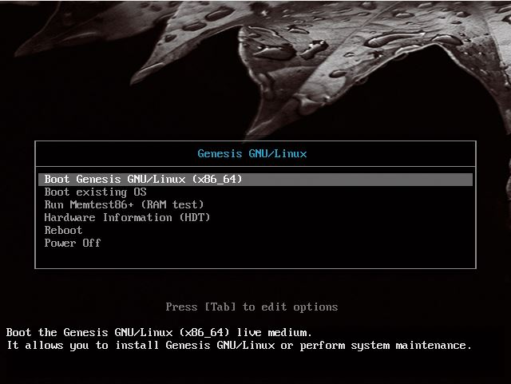

Figure 1: Genesis Boot Menu

This is the boot menu option that the users will see whenever they booted the Genesis live medium. Its option consists of

Boot Genesis GNU/Linux (x86_64) – boot the Genesis GNU/Linux live medium.

Boot Existing OS – boot an existing operating system.

Run Memtest86* (RAM test) – run memory test.

Hardware Information – view the hardware information of the computer.

Reboot – restart the computer.

Power Off – Shuts down the computer.

# Installation Instruction

There are two ways to launch the Genesis Installer.

## Using the whisker menu to launch the installer

1. Click Genesis icon or press windows key to launch whisker menu.
2. Choose Favorites -> Genesis installer to start the installer or
3. Choose Settings -> Genesis installer to start the installer.
4. There are two options for the installation, automatic and manual installation.
5. Choose 1 for automatic installation and 2 for manual installation. E is for exit if you want to exit the installer.
6. Just follow the instruction to proceed with the installation.
7. For manual installation, the developer presume that the user has enough Linux knowledge to proceed with the installation.
8. Some personal information will be asked after the initial installation such as username, root password and create regular user to use in default instead of the root account.
9. After everything, the user will be asked to reboot to the newly installed Genesis Operating System or the user can reboot manually.

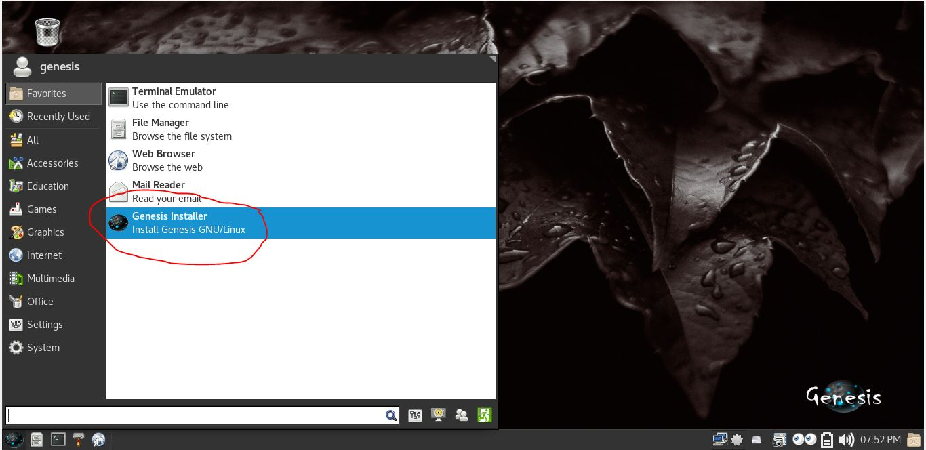

Figure 2: Menu -> Favorites -> Genesis installer

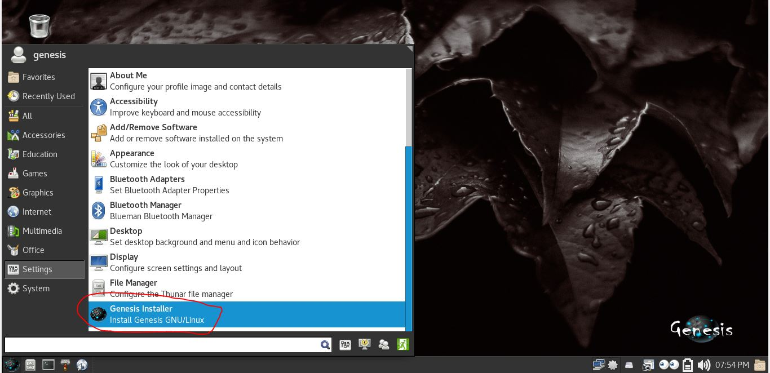

Figure 3: Menu -> Settings -> Genesis installer

The two figures above (Figure 10 - 11) shows how to access the Genesis installer by just clicking the Genesis installer icon in the Favorites category or in the settings category. This is one way of executing the Genesis installer.

## Launch the installer via terminal

1. Click Genesis icon -> Favorites -> Terminal emulator or
2. Genesis icon -> System -> xfce terminal or
3. press ctrl + alt + T simultaneously to launch terminal.
4. Type “sudo stringskip” in the terminal to launch the installer Main Menu with root privilege.
5. Or you can directly type “sudo lester” in the terminal to launch automatic installer with root privilege and follow the instruction to proceed with the installation.
6. Or for manual installation, just directly type “sudo konev” in the terminal and follow the installation instruction.

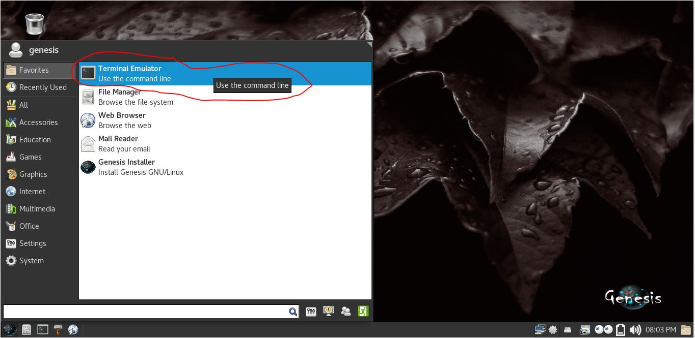

Figure 4: Launch Genesis installer via terminal emulator

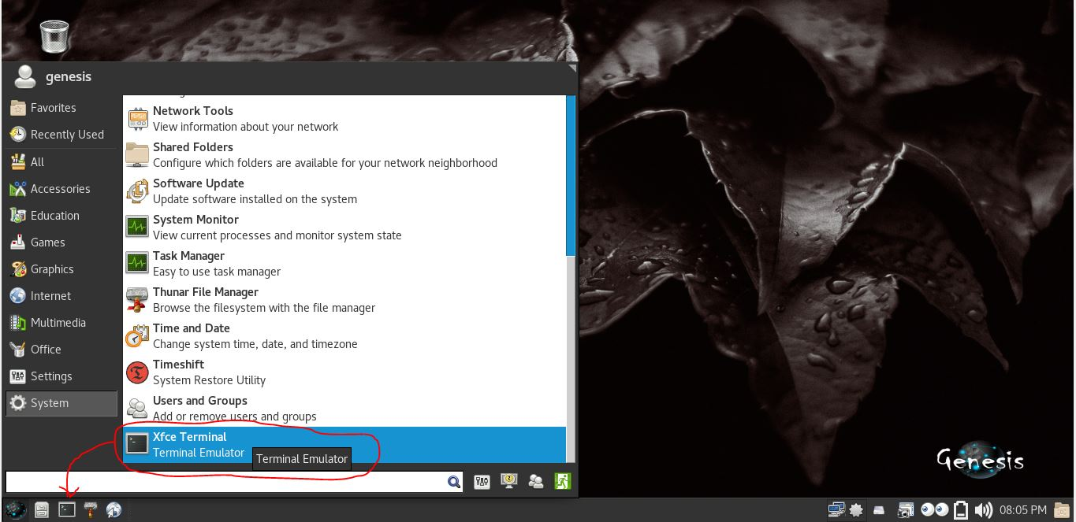

Figure 5: Launch Genesis installer via terminal emulator 2

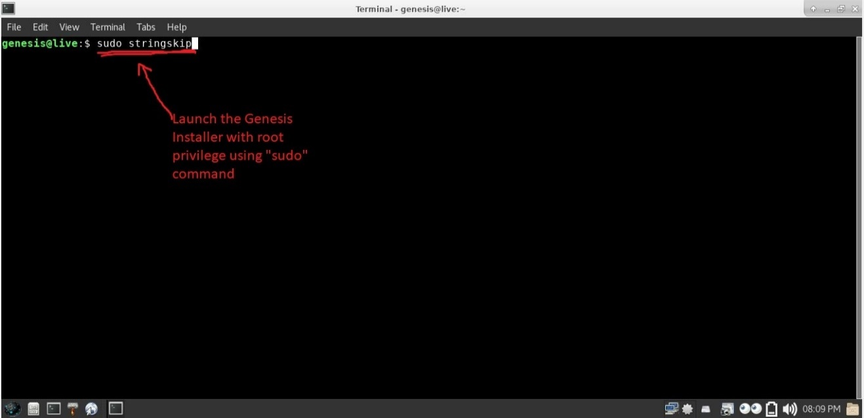

Figure 6: Launch Genesis installer via terminal emulator 3

The figure above shows the different ways of launching the Genesis Installer via terminal emulator. First, the users can just open a terminal emulator via the whisker menu -> Favorites -> Terminal emulator or secondly, via the Whiskermenu -> System -> xfce terminal or the users can click the default terminal icon at the bottom left of the panel or, simultaneously press Ctrl + Alt + T. Type “sudo stringskip” to launch the installer with root privilege using the sudo command in linux. “stringskip” is the name of the executable script that will launch the menu option of the Genesis installer. The user can directly type “sudo lester” to launch the automatic installer script or “sudo konev” for the manual installer script.

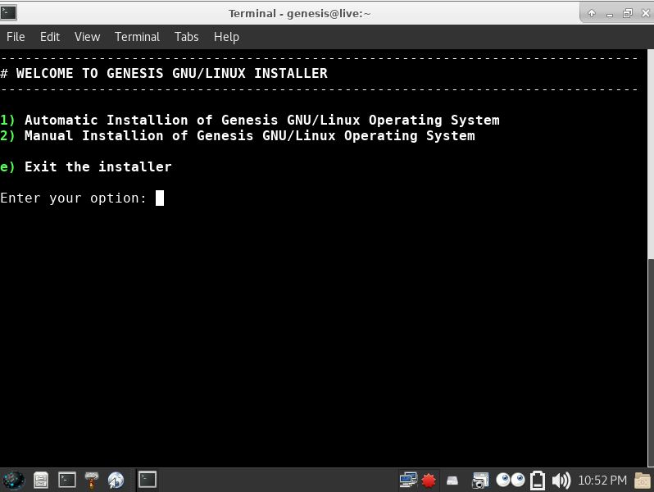

Figure 7: Genesis installer main menu

The figure above shows the main menu of the Genesis installer. There are two options to choose. The automatic and the manual installation. The user may choose automatic installation method for hustle free. This is the recommended method to use for users with new hard disk drive or computers with no installed operating system yet because this method will erase and format the first hard disk drive found in the computer. On the contrary, the users can choose the manual installation method if he/she has advance knowledge in Linux and knows exactly what he/she is doing and he/she absolutely knew the risks.

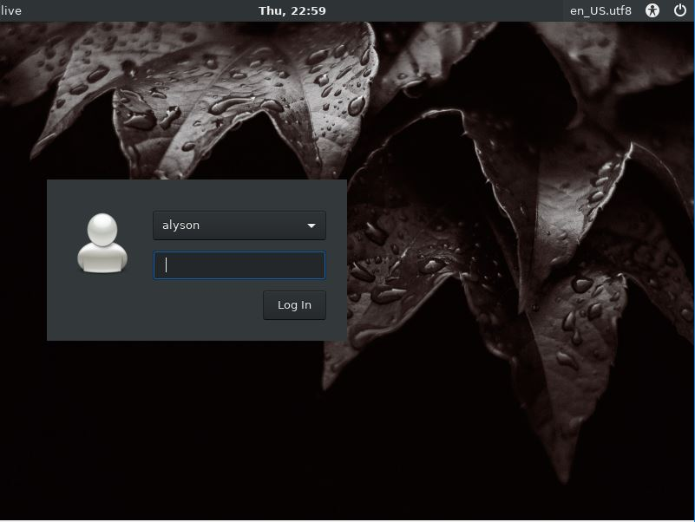

Figure 8: Genesis Login Manager

The figure above shows the Genesis Login Manager. This is the first GUI the users will see after successfully booted from the Genesis Operating System. in the username drop down menu, the users can choose which user to login. This is also where the switch users and the logout button in the whisker menu will lead the users when the users want to switch from one account to another without logging out the previous logged account or logout from previous account and login to another account.

There is also an option to shut down or restart the Genesis OS in the upper right corner of the login manager.

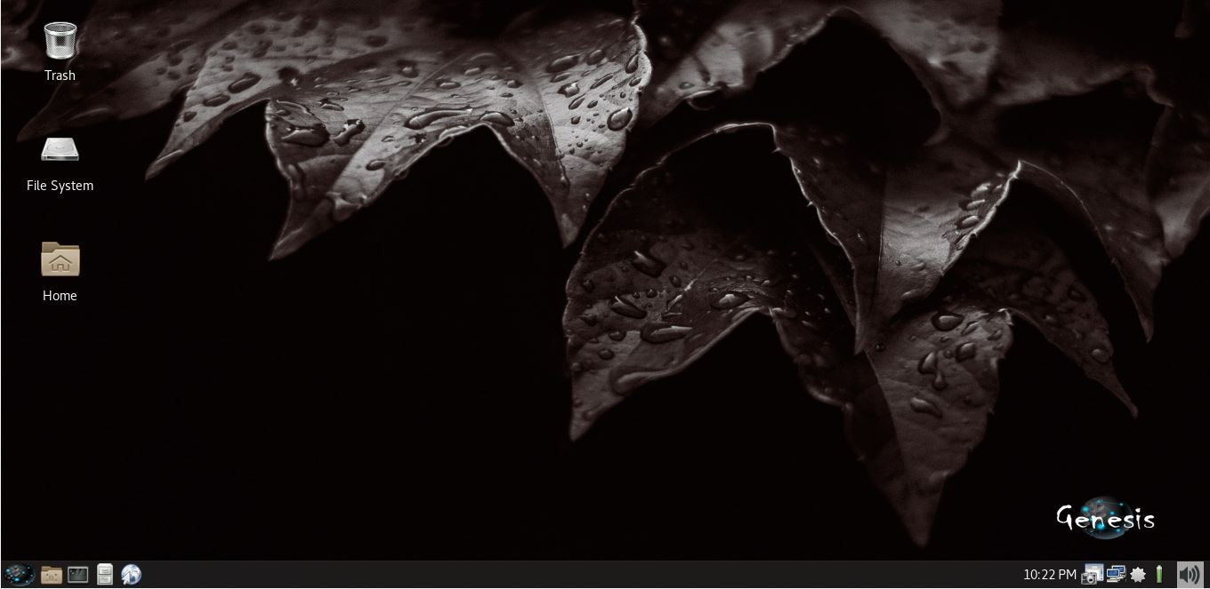

Figure 9: Genesis Desktop

The figure above shows the desktop environment of the Genesis Operating System. it shows the trash icon, file system and the home folder. The xfce4-panel is located at the bottom of the desktop. Items found at the bottom left of the panel are whisker menu, places option (shows the home folder directory, trash, desktop, root filesystem directory, recent documents and mounted volumes), Default terminal emulator (xfce-terminal), Default file manager (Thunar file manager) and the Default web browser (Mozilla Firefox). The bottom right of the panel is composed of network manager applet, system update notification, mount device option (option to safely remove mounted devices), screen shooter plugin, eyes plugin (to monitor the coordinates of the mouse cursor), power manager plugin (monitor battery), pulse audio plugin (volume adjustment), clock plugin and show desktop plugin (clear the desktop by minimizing all open windows).

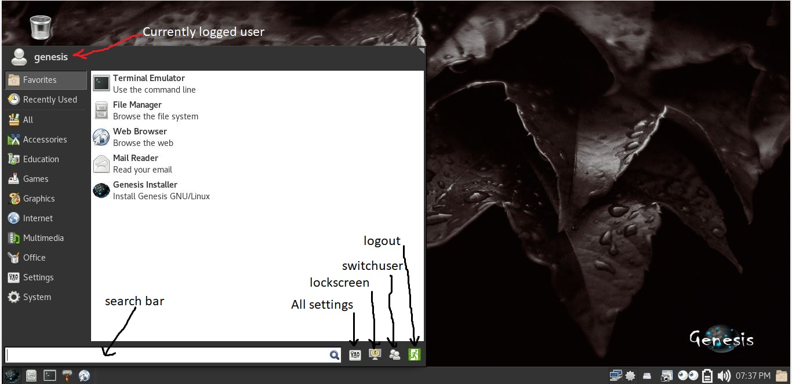

Figure 10: Whisker Menu

The figure above shows the whisker menu popped up whenever the users click the Genesis icon at the bottom left of the panel or by pressing the windows button in the keyboard. The menu option consists of different categories such as Favorites, recently used, Accessories, Education, Games, Graphics, Internet, Multimedia, Office, Settings and System. Applications that belong to each category is shown in the right side of the category menu when clicked. the bottom part of the menu is composed of the search bar, All Settings, Lock Screen, Switch users and the Logout button. The upper left with the user icon is where the information of the currently logged user is found.

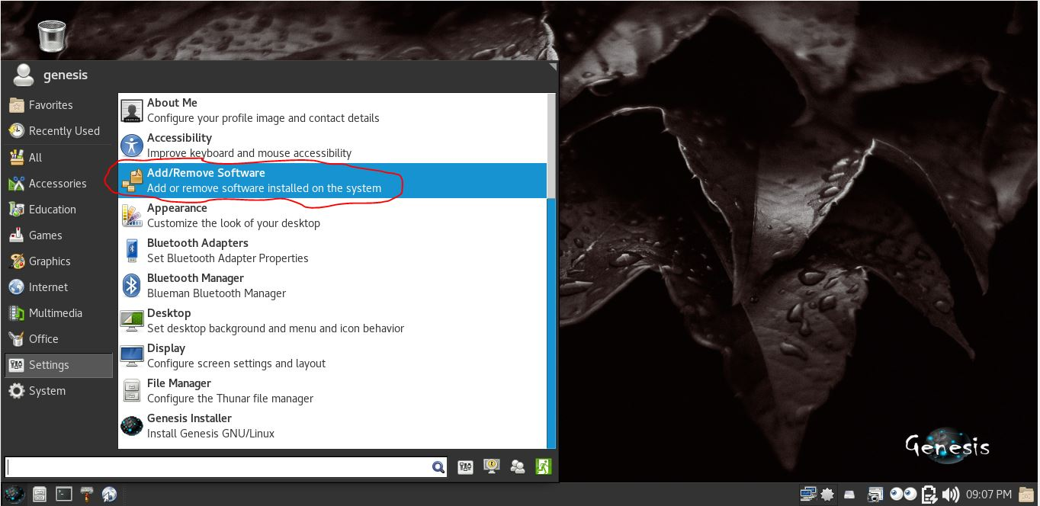

Figure 11: Menu -> Settings -> Add/Remove Software

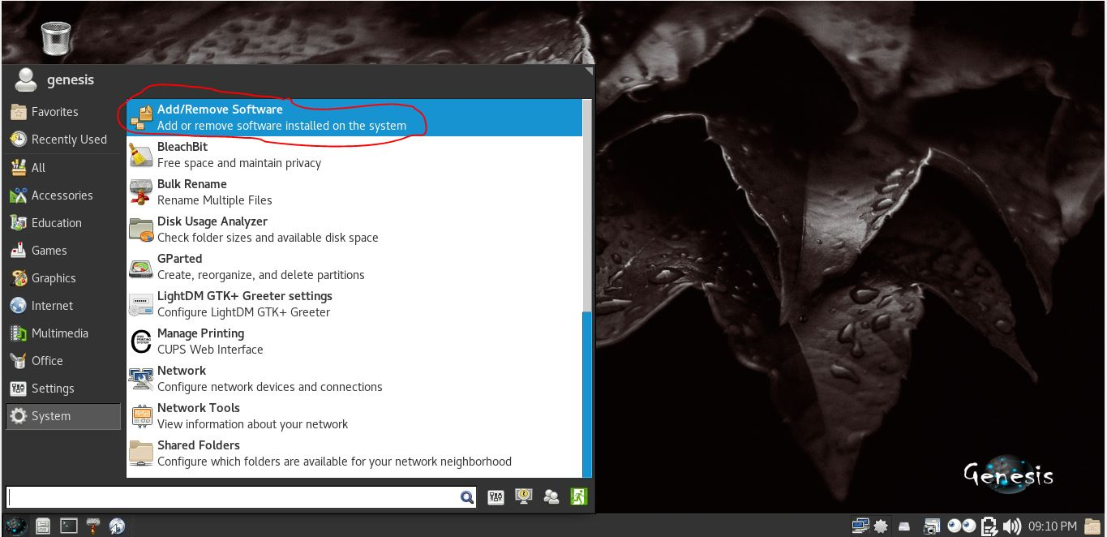

Figure 12: Menu -> System -> Add/Remove Software 2



Figure 13: Add/Remove Software

The figure above (Figure 16 - 18) shows the add/remove software option of the system. this is where the users can install/uninstall packages or applications. The users can install local packages via the dropdown option at the top right of the menu. It is recommended to have a working internet connection and synchronize the local database after a fresh install for best result. Only packages available in the official Archlinux repository and the Archlinux User Repository are listed in the graphical front-end of the package manager. The users can install packages outside the official repository granted that he/she has enough knowledge of dealing with it.

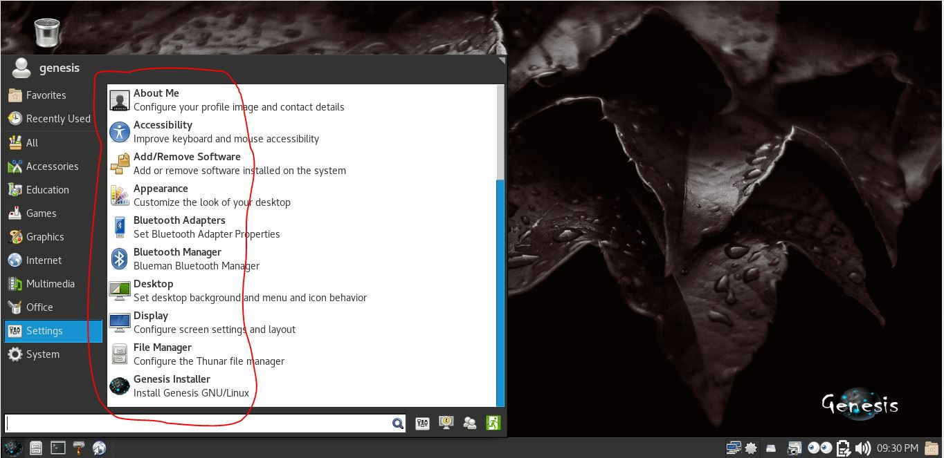

Figure 14: Settings Menu

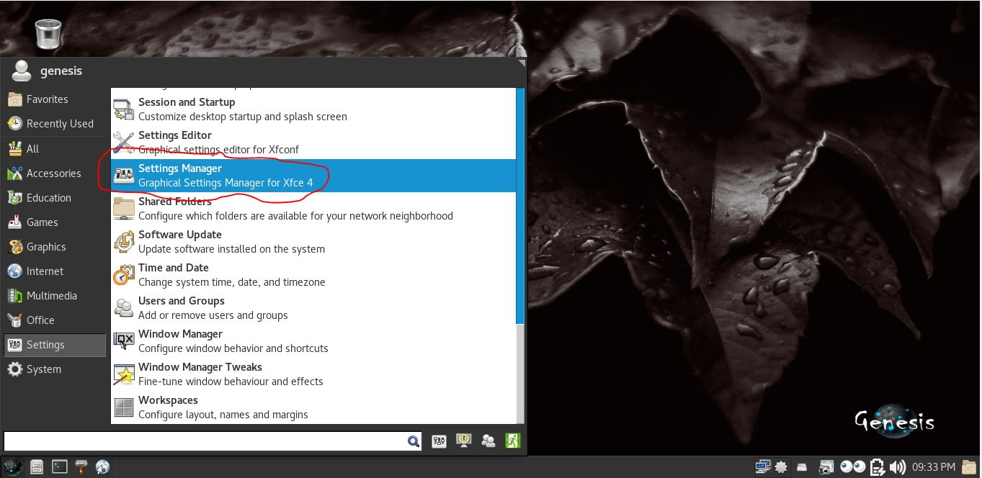

Figure 15: Graphical Settings Manager

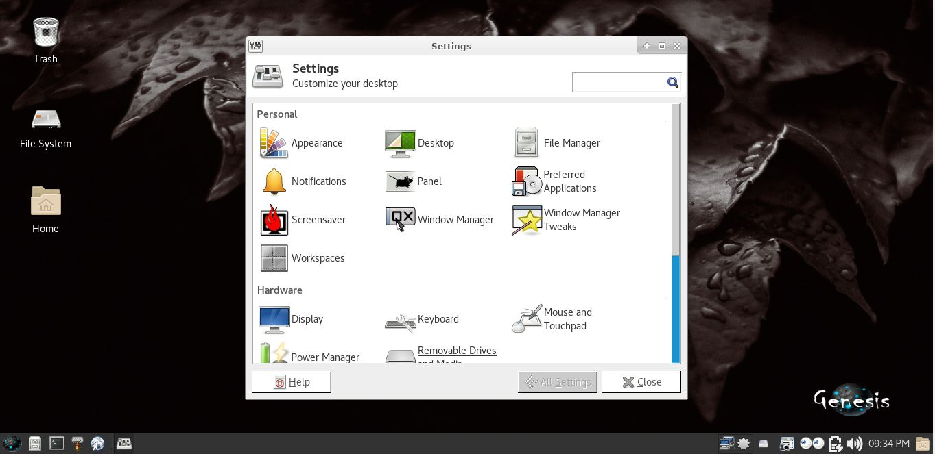

Figure 16: Graphical Settings Menu

The images above (Figure 19 - 21) shows the general settings of the system. here the users can find different options to tweak and customize the system such as, Appearance, Desktop, File Manager, Notifications, Panel, Preferred Applications, Screensaver, Window manager, Display, Keyboard, mouse and touchpad, power manager, removable drives and many others.

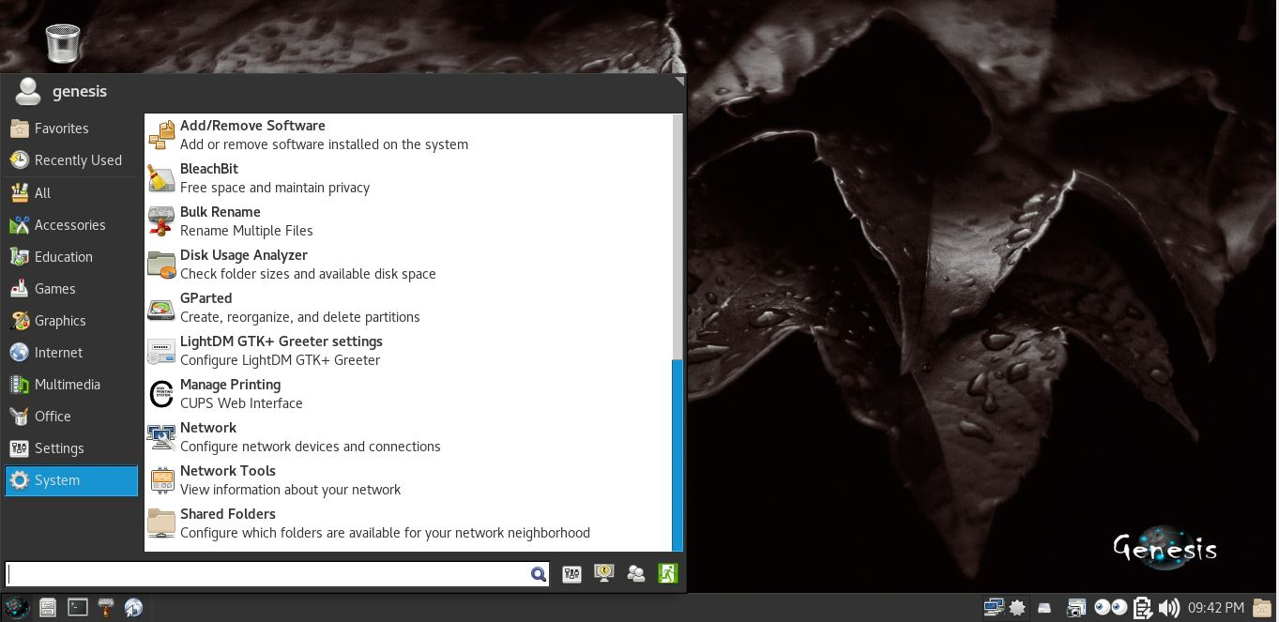

Figure 17: System Applications

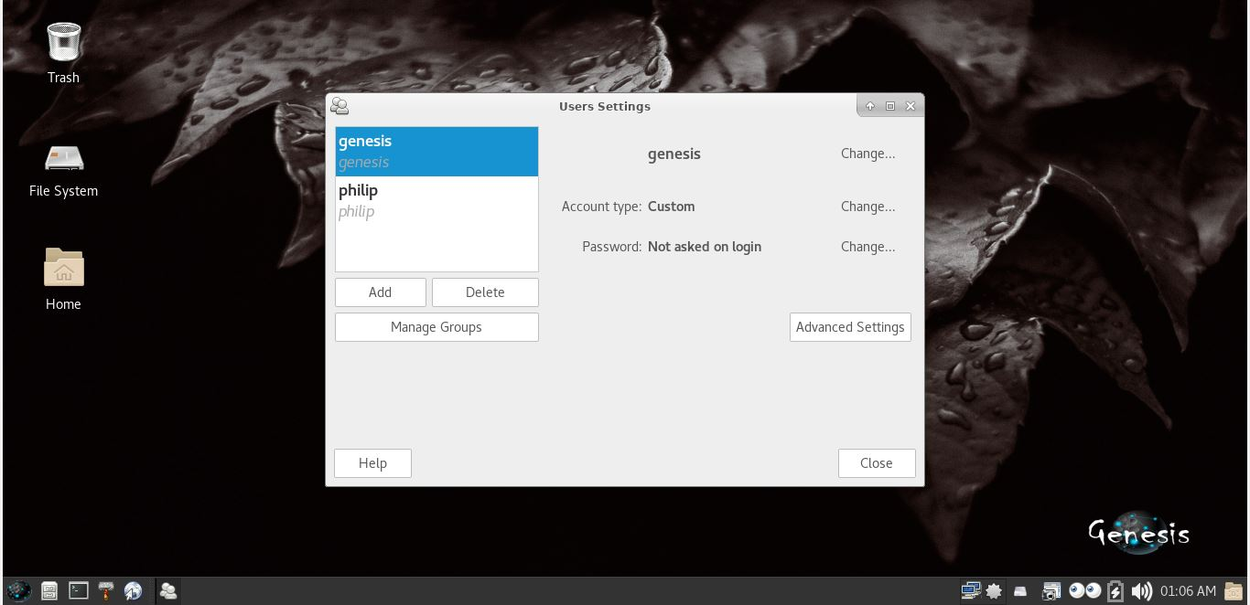

Figure 18: Add/Remove Users and groups

The figure (figure 22) above shows the different system applications. These applications are mostly used for administrative tasks. Application like add/remove users and groups (figure 23) is just one of the application that belongs to this category.

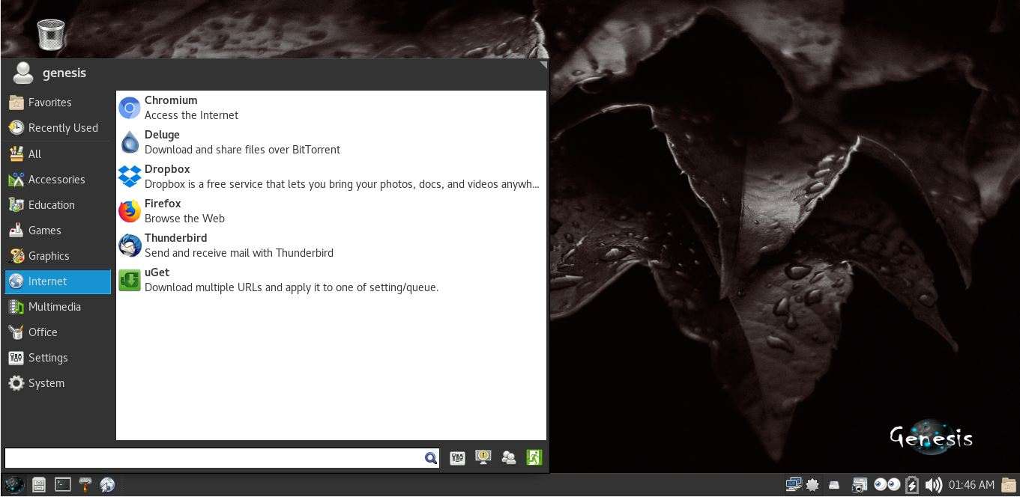

Figure 19: Internet capable applications

The figure above shows the different applications that uses active internet connection to run properly. Some of the applications that belong in this category are the web browsers.

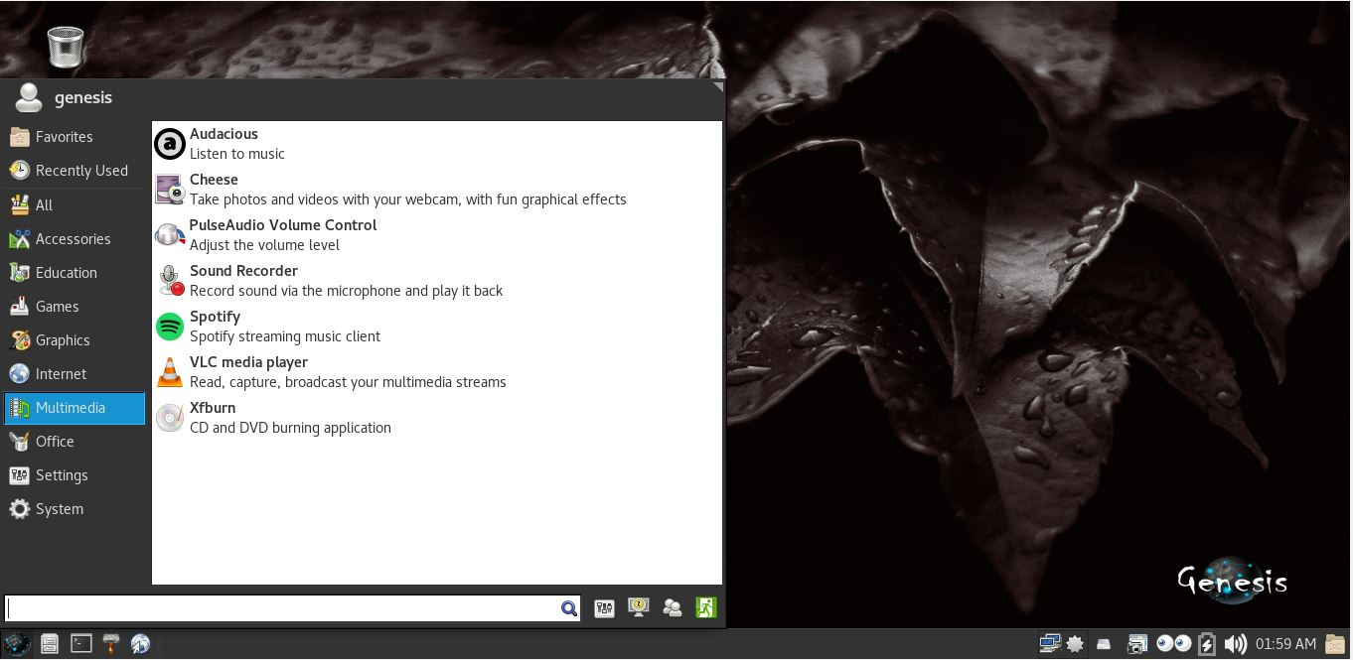

Figure 20: Multimedia Applications

The figure above shows the different applications the belongs in the multimedia category. The system’s default audio and video player belong here which are Audacious for audio player and VLC for video player.