连接MYSQL数据库的简单增删改查

项目框架如图所示：

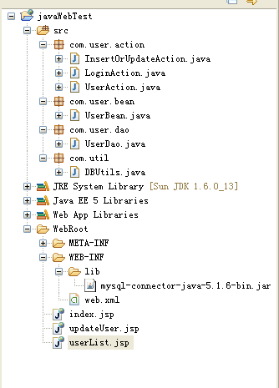

所需工具：

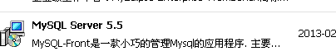

所需工具：



所需工具：



所需工具：



程序代码：**package** com.user.action;

**import** java.io.IOException;

**import** javax.servlet.ServletException;

**import** javax.servlet.http.HttpServlet;

**import** javax.servlet.http.HttpServletRequest;

**import** javax.servlet.http.HttpServletResponse;

**import** com.user.bean.UserBean;

**import** com.user.dao.UserDao;

**public** **class** InsertOrUpdateAction **extends** HttpServlet {

/**

*

*/

**private** **static** **final** **long** *serialVersionUID* = 1L;

**private** UserDao userDao ;

**public** **void** doGet(HttpServletRequest request, HttpServletResponse response)

**throws** ServletException, IOException {

doPost(request, response);

}

**public** **void** doPost(HttpServletRequest request, HttpServletResponse response)

**throws** ServletException, IOException {

request.setCharacterEncoding("utf-8");

response.setCharacterEncoding("utf-8");

userDao = **new** UserDao();

String str = request.getRequestURI();

str = str.substring(str.lastIndexOf("/")+1);

String yx = request.getParameter("yx");

String zy = request.getParameter("zy");

String age = request.getParameter("age");

String dh = request.getParameter("dh");

String qq = request.getParameter("qq");

String sex = request.getParameter("sex");

UserBean userBean = **new** UserBean();

userBean.setYx(yx);

userBean.setZy(zy);

**if**(!"".equals(age)&&age!=**null**)

{

userBean.setAge(Integer.*valueOf*(age));

}**else**{

userBean.setAge(0);

}

userBean.setDh(dh);

userBean.setQq(qq);

userBean.setSex(sex);

**if**("InsertUserAction".equals(str)){

**if**(userDao.insertUser(userBean)){

response.sendRedirect("SelectAllUser");

}**else**{

response.sendRedirect("SelectAllUser");

}

}**else** **if**("UpdateUserAction".equals(str)){

String strId = request.getParameter("id");

**if**(!"".equals(strId)&&strId!=**null**){

userBean.setId(Integer.*valueOf*(strId));

}**else**{

userBean.setId(-1);

}

**if**(userDao.updateUser(userBean)){

response.sendRedirect("SelectAllUser");

}**else**{

response.sendRedirect("SelectAllUser");

}

}

}

}

**package** com.user.action;

**import** java.io.IOException;

**import** javax.servlet.ServletException;

**import** javax.servlet.http.HttpServlet;

**import** javax.servlet.http.HttpServletRequest;

**import** javax.servlet.http.HttpServletResponse;

**public** **class** LoginAction **extends** HttpServlet {

/**

*

*/

**private** **static** **final** **long** *serialVersionUID* = 1L;

**public** **void** doGet(HttpServletRequest request, HttpServletResponse response)

**throws** ServletException, IOException {

doPost(request, response);

}

**public** **void** doPost(HttpServletRequest request, HttpServletResponse response)

**throws** ServletException, IOException {

String name= request.getParameter("name");

String password = request.getParameter("password");

**if**("".equals(name)||"".equals(password))

{

response.sendRedirect("/javaWebTest/index.jsp");

}**else**{

**if**("123".equals(name)&&"123".equals(password))

{

response.sendRedirect("SelectAllUser");

}**else**{

response.sendRedirect("/javaWebTest/index.jsp");

}

}

}

}

package com.user.action;

import java.io.IOException;

import java.util.List;

import javax.servlet.ServletException;

import javax.servlet.http.HttpServlet;

import javax.servlet.http.HttpServletRequest;

import javax.servlet.http.HttpServletResponse;

import com.user.bean.UserBean;

import com.user.dao.UserDao;

public class UserAction extends HttpServlet {

/**

*

*/

private static final long serialVersionUID = 1L;

private UserDao userDao ;

public void doGet(HttpServletRequest request, HttpServletResponse response)

throws ServletException, IOException {

doPost(request, response);

}

public void doPost(HttpServletRequest request, HttpServletResponse response)

throws ServletException, IOException {

request.setCharacterEncoding("utf-8");

response.setCharacterEncoding("utf-8");

userDao = new UserDao();

String str = request.getRequestURI();

str = str.substring(str.lastIndexOf("/")+1);

if("SelectAllUser".equals(str.trim()))

{

List<UserBean> list = userDao.getAllUser();

request.setAttribute("UserList", list);

request.getRequestDispatcher("/userList.jsp").forward(request, response);

}else if("SelectOneUser".equals(str))

{

String strId = request.getParameter("id");

int id = Integer.valueOf(strId);

UserBean userBean = userDao.selectUserById(id);

request.setAttribute("userBean", userBean);

request.getRequestDispatcher("/updateUser.jsp").forward(request, response);

}else if("DeleteUserById".equals(str)){

String strId = request.getParameter("id");

int id = Integer.valueOf(strId);

if(userDao.deleteUser(id)){

response.sendRedirect("SelectAllUser");

}else{

response.sendRedirect("SelectAllUser");

}

}

}

}

package com.user.dao;

import java.sql.ResultSet;

import java.sql.SQLException;

import java.util.ArrayList;

import java.util.List;

import com.user.bean.UserBean;

import com.util.DBUtils;

public class UserDao {

private DBUtils dbUtil;

/**

* 查询所有的user

* @return

*/

public List<UserBean> getAllUser()

{

dbUtil = new DBUtils();

List<UserBean> list = new ArrayList<UserBean>();

String sql = "select * from user";

ResultSet rs = dbUtil.exceteSQl(sql);

try {

while(rs.next())

{

int i =1;

UserBean userBean = new UserBean();

userBean.setId(rs.getInt(i++));

userBean.setName(rs.getString(i++));

userBean.setYx(rs.getString(i++));

userBean.setZy(rs.getString(i++));

userBean.setAge(rs.getInt(i++));

userBean.setDh(rs.getString(i++));

userBean.setQq(rs.getString(i++));

userBean.setSex(rs.getString(i++));

list.add(userBean);

}

} catch (SQLException e) {

e.printStackTrace();

}finally{

dbUtil.close();

}

return list;

}

/**

* 根据id查询user

* @param id

* @return

*/

public UserBean selectUserById(int id){

dbUtil = new DBUtils();

UserBean userBean = new UserBean();

String sql = "select * from user where id = '"+id+"'";

ResultSet rs = dbUtil.exceteSQl(sql);

try {

if(rs.next())

{

int i =1;

userBean.setId(rs.getInt(i++));

userBean.setYx(rs.getString(i++));

userBean.setZy(rs.getString(i++));

userBean.setAge(rs.getInt(i++));

userBean.setDh(rs.getString(i++));

userBean.setQq(rs.getString(i++));

userBean.setSex(rs.getString(i++));

}

} catch (SQLException e) {

e.printStackTrace();

}

return userBean;

}

/**

* 插入用户

* @param userBean

* @return

*/

public boolean insertUser(UserBean userBean){

dbUtil = new DBUtils();

String sql = "insert into user (yx,zy,age,dh,qq,sex) values(?,?,?,?,?,?)";

int row = dbUtil.excete(sql, new Object[]{userBean.getYx(),userBean.getZy(),userBean.getAge(),userBean.getDh(),userBean.getQq(),userBean.getSex()});

if(row>0){

return true;

}

return false;

}

/**

* 删除用户

* @param id

* @return

*/

public boolean deleteUser(int id){

dbUtil = new DBUtils();

String sql = "delete from user where id = '"+id+ "'";

int row = dbUtil.excete(sql);

if(row>0)

{

return true;

}

return false;

}

/**

* 修改user

* @param userBean

* @return

*/

public boolean updateUser(UserBean userBean){

dbUtil = new DBUtils();

String sql = "update user set yx =? ,zy=?,age=?,dh=?,qq=?,sex=? where id = ?";

int row = dbUtil.excete(sql, new Object[]{userBean.getYx(),userBean.getZy(),userBean.getAge(),userBean.getDh(),userBean.getQq(),userBean.getSex(),userBean.getId()});

if(row>0)

{

return true;

}

return false;

}

}

**package** com.user.bean;

**public** **class** UserBean {

**private** **int** id;

**private** String name;//电话

**private** String yx;//院系

**private** String zy;//专业

**private** **int** age;//年龄

**private** String dh;

**private** String qq;

**private** String sex;

**public** **int** getId() {

**return** id;

}

**public** **void** setId(**int** id) {

**this**.id = id;

}

**public** String getName() {

**return** name;

}

**public** **void** setName(String name) {

**this**.name = name;

}

**public** String getYx() {

**return** yx;

}

**public** **void** setYx(String yx) {

**this**.yx = yx;

}

**public** String getZy() {

**return** zy;

}

**public** **void** setZy(String zy) {

**this**.zy = zy;

}

**public** **int** getAge() {

**return** age;

}

**public** **void** setAge(**int** age) {

**this**.age = age;

}

**public** String getDh() {

**return** dh;

}

**public** **void** setDh(String dh) {

**this**.dh = dh;

}

**public** String getQq() {

**return** qq;

}

**public** **void** setQq(String qq) {

**this**.qq = qq;

}

**public** String getSex() {

**return** sex;

}

**public** **void** setSex(String sex) {

**this**.sex = sex;

}

}

package com.user.dao;

import java.sql.ResultSet;

import java.sql.SQLException;

import java.util.ArrayList;

import java.util.List;

import com.user.bean.UserBean;

import com.util.DBUtils;

public class UserDao {

private DBUtils dbUtil;

/**

* 查询所有的user

* @return

*/

public List<UserBean> getAllUser()

{

dbUtil = new DBUtils();

List<UserBean> list = new ArrayList<UserBean>();

String sql = "select * from user";

ResultSet rs = dbUtil.exceteSQl(sql);

try {

while(rs.next())

{

int i =1;

UserBean userBean = new UserBean();

userBean.setId(rs.getInt(i++));

userBean.setName(rs.getString(i++));

userBean.setYx(rs.getString(i++));

userBean.setZy(rs.getString(i++));

userBean.setAge(rs.getInt(i++));

userBean.setDh(rs.getString(i++));

userBean.setQq(rs.getString(i++));

userBean.setSex(rs.getString(i++));

list.add(userBean);

}

} catch (SQLException e) {

e.printStackTrace();

}finally{

dbUtil.close();

}

return list;

}

/**

* 根据id查询user

* @param id

* @return

*/

public UserBean selectUserById(int id){

dbUtil = new DBUtils();

UserBean userBean = new UserBean();

String sql = "select * from user where id = '"+id+"'";

ResultSet rs = dbUtil.exceteSQl(sql);

try {

if(rs.next())

{

int i =1;

userBean.setId(rs.getInt(i++));

userBean.setYx(rs.getString(i++));

userBean.setZy(rs.getString(i++));

userBean.setAge(rs.getInt(i++));

userBean.setDh(rs.getString(i++));

userBean.setQq(rs.getString(i++));

userBean.setSex(rs.getString(i++));

}

} catch (SQLException e) {

e.printStackTrace();

}

return userBean;

}

/**

* 插入用户

* @param userBean

* @return

*/

public boolean insertUser(UserBean userBean){

dbUtil = new DBUtils();

String sql = "insert into user (yx,zy,age,dh,qq,sex) values(?,?,?,?,?,?)";

int row = dbUtil.excete(sql, new Object[]{userBean.getYx(),userBean.getZy(),userBean.getAge(),userBean.getDh(),userBean.getQq(),userBean.getSex()});

if(row>0){

return true;

}

return false;

}

/**

* 删除用户

* @param id

* @return

*/

public boolean deleteUser(int id){

dbUtil = new DBUtils();

String sql = "delete from user where id = '"+id+ "'";

int row = dbUtil.excete(sql);

if(row>0)

{

return true;

}

return false;

}

/**

* 修改user

* @param userBean

* @return

*/

public boolean updateUser(UserBean userBean){

dbUtil = new DBUtils();

String sql = "update user set yx =? ,zy=?,age=?,dh=?,qq=?,sex=? where id = ?";

int row = dbUtil.excete(sql, new Object[]{userBean.getYx(),userBean.getZy(),userBean.getAge(),userBean.getDh(),userBean.getQq(),userBean.getSex(),userBean.getId()});

if(row>0)

{

return true;

}

return false;

}

}

package com.util;

import java.sql.Date;

import java.sql.DriverManager;

import java.sql.PreparedStatement;

import java.sql.ResultSet;

import java.sql.SQLException;

import com.mysql.jdbc.Connection;

import com.mysql.jdbc.Statement;

public class DBUtils {

private static Connection conn=null;

private Statement st=null;

private ResultSet rs = null;

private PreparedStatement ps;

static{

try {

Class.forName("com.mysql.jdbc.Driver");

conn = (Connection) DriverManager.getConnection("jdbc:mysql://localhost:3306/ygx?useUnicode=true&characterEncoding=UTF-8","root" ,"123456" );

} catch (ClassNotFoundException e) {

e.printStackTrace();

} catch (SQLException e) {

e.printStackTrace();

}

}

/**

*

* @Title: exceteSQl

* @Description: TODO(执行不带参数的sql语句)

* @param sql

* @return ResultSet

* @throws

*/

public ResultSet exceteSQl(String sql)

{

try {

st =(Statement) conn.createStatement();

rs = st.executeQuery(sql);

} catch (SQLException e) {

e.printStackTrace();

}

return rs;

}

/**

*

* @Title: exceteSQl

* @Description: TODO(执行带参数的sql语句)

* @param sql

* @param obj

* @return ResultSet

* @throws

*/

public ResultSet exceteSQl(String sql, Object[] obj)

{

int length = obj.length;

try {

ps = conn.prepareStatement(sql);

preparStateSql(obj, length);

rs = ps.executeQuery();

} catch (SQLException e) {

e.printStackTrace();

}

return rs;

}

/**

*

* @Title: excete

* @Description: TODO(此方法适用于不带参数的修改，删除，增加)

* @param sql

* @return int

* @throws

*/

public int excete(String sql){

int row =0;

try {

st = (Statement) conn.createStatement();

row = st.executeUpdate(sql);

} catch (SQLException e) {

e.printStackTrace();

}finally{

close();

}

return row;

}

/**

*

* @Title: excete

* @Description: TODO(此方法适用带参数的修改，删除，增加)

* @param sql

* @param obj

* @return int

* @throws

*/

public int excete(String sql, Object[] obj)

{

int row =0;

int length = obj.length;

try {

ps = conn.prepareStatement(sql);

preparStateSql(obj, length);

row = ps.executeUpdate();

} catch (SQLException e) {

e.printStackTrace();

}finally{

close();

}

return row;

}

/**

*

* @Title: preparStateSql

* @Description: TODO(参数赋值)

* @param obj

* @param length

* @throws SQLException void

* @throws

*/

private void preparStateSql(Object[] obj, int length) throws SQLException {

for(int i=0;i<length;i++)

{

if(obj[i].getClass()==String.class)

{

ps.setString(i+1, obj[i].toString());

}else if(obj[i].getClass()==Integer.class)

{

ps.setInt(i+1, (Integer)obj[i]);

}else if(obj[i].getClass()==Double.class)

{

ps.setDouble(i+1, (Double)obj[i]);

}else if(obj[i].getClass()==Date.class)//java.sql.Date

{

ps.setDate(i+1, (Date)obj[i]);

}

}

}

/**

*

* @Title: close

* @Description: TODO(数据库连接关闭) void

* @throws

*/

public void close()

{

if(rs!=null)

{

try {

rs.close();

} catch (SQLException e) {

e.printStackTrace();

}

}

if(st!=null)

{

try {

st.close();

} catch (SQLException e) {

e.printStackTrace();

}

}

if(ps!=null)

{

try {

ps.close();

} catch (SQLException e) {

e.printStackTrace();

}

}

}

public static void main(String[] args) {

DBUtils db = new DBUtils();

String sql = "select * from user ";

ResultSet rr = db.exceteSQl(sql);

try {

while(rr.next())

{

int i =1;

System.out.print(rr.getInt(i++)+" ");

System.out.print(rr.getString(i++)+" ");

System.out.print(rr.getString(i++)+" ");

System.out.print(rr.getInt(i++)+" ");

System.out.print(rr.getString(i++)+" ");

System.out.print(rr.getString(i++)+" ");

System.out.println(rr.getString(i++));

}

} catch (SQLException e) {

// TODO Auto-generated catch block

e.printStackTrace();

}finally{

db.close();

}

//String sql = "insert into user (yx,zy,age,dh,qq,sex) values(\"软件\",\"测试\",12,\"110\",\"123456789\",\"女\")";

/* String sql = "insert into user (yx,zy,age,dh,qq,sex) values(?,?,?,?,?,?)";

int row = db.excete(sql, new Object[]{"软件","测试",12,"110","123456789","女"});

//int row = db.excete(sql);

if(row>0)

{

System.out.println("增加成功");

}*/

/*String sql = "update user set yx=? where id =?";

int row = db.excete(sql, new Object[]{"计通",3});

if(row>0)

{

System.out.println("修改成功");

}*/

}

}

所需要的驱动包：

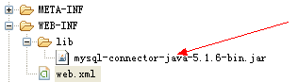

Web.xml配置：

<?xml version=*"1.0"* encoding=*"UTF-8"*?>

<web-app version=*"2.5"*

xmlns=*"http://java.sun.com/xml/ns/javaee"*

xmlns:xsi=*"http://www.w3.org/2001/XMLSchema-instance"*

xsi:schemaLocation=*"http://java.sun.com/xml/ns/javaee*

*http://java.sun.com/xml/ns/javaee/web-app_2_5.xsd"*>

<display-name></display-name>

<servlet>

<servlet-name>UserAction</servlet-name>

<servlet-class>com.user.action.UserAction</servlet-class>

</servlet>

<servlet>

<servlet-name>InsertOrUpdateAction</servlet-name>

<servlet-class>com.user.action.InsertOrUpdateAction</servlet-class>

</servlet>

<servlet>

<servlet-name>LoginAction</servlet-name>

<servlet-class>com.user.action.LoginAction</servlet-class>

</servlet>

<servlet-mapping>

<servlet-name>UserAction</servlet-name>

<url-pattern>/SelectAllUser</url-pattern>

<url-pattern>/SelectOneUser</url-pattern>

<url-pattern>/DeleteUserById</url-pattern>

</servlet-mapping>

<servlet-mapping>

<servlet-name>InsertOrUpdateAction</servlet-name>

<url-pattern>/InsertUserAction</url-pattern>

<url-pattern>/UpdateUserAction</url-pattern>

</servlet-mapping>

<servlet-mapping>

<servlet-name>LoginAction</servlet-name>

<url-pattern>/LoginAction</url-pattern>

</servlet-mapping>

<welcome-file-list>

<welcome-file>index.jsp</welcome-file>

</welcome-file-list>

</web-app>

Jsp:

<%@ page language=*"java"* import=*"java.util.*"* pageEncoding=*"UTF-8"*%>

<%

String path = request.getContextPath();

String basePath = request.getScheme()+"://"+request.getServerName()+":"+request.getServerPort()+path+"/";

%>

<!DOCTYPE HTML PUBLIC "-//W3C//DTD HTML 4.01 Transitional//EN">

<html>

<head>

<base href=*"*<%=basePath%>*"*>

<title>My JSP 'index.jsp' starting page</title>

<meta http-equiv=*"pragma"* content=*"no-cache"*>

<meta http-equiv=*"cache-control"* content=*"no-cache"*>

<meta http-equiv=*"expires"* content=*"0"*>

<meta http-equiv=*"keywords"* content=*"keyword1,keyword2,keyword3"*>

<meta http-equiv=*"description"* content=*"This is my page"*>

<style type=*"text/css"*>

*.table1*{

margin:*0 auto*;

border-collapse: *collapse*;

}

*.table1* **td**{

padding: *0px*;

height:*25px*;

border:*1px solid #6AB6B6*;

text-align:*center*;

font-family:*"微软雅黑"*;

font-size:*12px*;

background-color:*#EAFEFE*;

}

*.table1* **td***.title*{

height:*28px*;

color:*#fff*;

background-color:*#6AB6B6*;

font-weight:*bold*;

font-size:*20px*;

text-align: *center*;

}

*.table1* **tr***.colname*{

font-size: *14px*;

font-weight: *bold*;

}

* *.nobd_table* **td**{

border: *none*;

}

</style>

</head>

<body>

<div align=*"center"* style="padding-top: *30px*;" id = *"add"* >

<form action=*"LoginAction"* method=*"post"* >

<table class=*"table1"* width=*"50%"* >

<tr>

<td class=*"title"* colspan=*"2"* >欢迎你的登录!</td>

</tr>

<tr>

<td>帐号</td>

<td> <input type=*"text"* name=*"name"* > </td>

</tr>

<tr>

<td>密码</td>

<td> <input type=*"password"* name=*"password"* > </td>

</tr>

<tr>

<td colspan=*"2"* > <input type=*"submit"* value=*"登录"* > <input type=*"reset"* value=*"重置"* ></td>

</tr>

</table>

</form>

</div>

</body>

</html>

<%@ page language=*"java"* import=*"java.util.*,com.user.bean.UserBean"* pageEncoding=*"utf-8"*%>

<%@ taglib prefix=*"c"* uri=*"http://java.sun.com/jsp/jstl/core"* %>

<%

String path = request.getContextPath();

String basePath = request.getScheme()+"://"+request.getServerName()+":"+request.getServerPort()+path+"/";

%>

<!DOCTYPE HTML PUBLIC "-//W3C//DTD HTML 4.01 Transitional//EN">

<html>

<head>

<base href=*"*<%=basePath%>*"*>

<title>My JSP 'userList.jsp' starting page</title>

<meta http-equiv=*"pragma"* content=*"no-cache"*>

<meta http-equiv=*"cache-control"* content=*"no-cache"*>

<meta http-equiv=*"expires"* content=*"0"*>

<meta http-equiv=*"keywords"* content=*"keyword1,keyword2,keyword3"*>

<meta http-equiv=*"description"* content=*"This is my page"*>

<style type=*"text/css"*>

*.table1*{

margin:*0 auto*;

border-collapse: *collapse*;

}

*.table1* **td**{

padding: *0px*;

height:*25px*;

border:*1px solid #6AB6B6*;

text-align:*center*;

font-family:*"微软雅黑"*;

font-size:*12px*;

background-color:*#EAFEFE*;

}

*.table1* **td***.title*{

height:*28px*;

color:*#fff*;

background-color:*#6AB6B6*;

font-weight:*bold*;

font-size:*20px*;

text-align: *center*;

}

*.table1* **tr***.colname*{

font-size: *14px*;

font-weight: *bold*;

}

* *.nobd_table* **td**{

border: *none*;

}

</style>

<script type=*"text/javascript"*>

**function** goback()

{

}

</script>

</head>

<body>

<div align=*"center"* style="padding-top: *30px*;" id = *"add"* >

<form action=*"UpdateUserAction"* method=*"post"* >

<table class=*"table1"* width=*"50%"* >

<tr>

<td colspan=*"2"* class=*"title"* >user信息填写</td>

</tr>

<tr>

<td>院系</td>

<td> <input type=*"text"* name=*"yx"* id=*"yx"* value=*"*${userBean.yx }*"* ><input type=*"hidden"* name=*"id"* value=*"*${userBean.id }*"* > </td>

</tr>

<tr>

<td>专业</td>

<td> <input type=*"text"* name=*"zy"* id=*"zy"* value=*"*${userBean.zy }*"* > </td>

</tr>

<tr>

<td>年龄</td>

<td><input type=*"text"* name=*"age"* id=*"age"* value=*"*${userBean.age }*"* > </td>

</tr>

<tr>

<td>电话</td>

<td> <input type=*"text"* name=*"dh"* id=*"dh"* value=*"*${userBean.dh }*"* > </td>

</tr>

<tr>

<td>QQ</td>

<td> <input type=*"text"* name=*"qq"* id=*"qq"* value=*"*${userBean.qq }*"* > </td>

</tr>

<tr>

<td>行别</td>

<td>

<c:set value=*"男"* var=*"sexs"* ></c:set>

<c:if test="${userBean.sex **eq** sexs }">

<input type=*"radio"* name=*"sex"* value=*"男"* checked=*"checked"* >男<input type=*"radio"* name=*"sex"* value=*"女"*>女</c:if>

<c:if test="${userBean.sex **ne** sexs }">

<input type=*"radio"* name=*"sex"* value=*"男"* >男<input type=*"radio"* checked=*"checked"* name=*"sex"* value=*"女"*>女</c:if>

</td>

</tr>

<tr>

<td colspan=*"2"* > <input type=*"submit"* value=*"提交"* >&nbsp;&nbsp;&nbsp;&nbsp;<input type=*"reset"* value=*"重置"* > &nbsp;&nbsp;&nbsp;&nbsp;<input type=*"button"* value=*"返回"* onclick="Javascript:window.history.go(-1);" > </td>

</tr>

</table>

</form>

</div>

</body>

</html>

<%@ page language=*"java"* import=*"java.util.*,com.user.bean.UserBean"* pageEncoding=*"utf-8"*%>

<%@ taglib prefix=*"c"* uri=*"http://java.sun.com/jsp/jstl/core"* %>

<%

String path = request.getContextPath();

String basePath = request.getScheme()+"://"+request.getServerName()+":"+request.getServerPort()+path+"/";

%>

<!DOCTYPE HTML PUBLIC "-//W3C//DTD HTML 4.01 Transitional//EN">

<html>

<head>

<base href=*"*<%=basePath%>*"*>

<title>My JSP 'userList.jsp' starting page</title>

<meta http-equiv=*"pragma"* content=*"no-cache"*>

<meta http-equiv=*"cache-control"* content=*"no-cache"*>

<meta http-equiv=*"expires"* content=*"0"*>

<meta http-equiv=*"keywords"* content=*"keyword1,keyword2,keyword3"*>

<meta http-equiv=*"description"* content=*"This is my page"*>

<style type=*"text/css"*>

*.table1*{

margin:*0 auto*;

border-collapse: *collapse*;

}

*.table1* **td**{

padding: *0px*;

height:*25px*;

border:*1px solid #6AB6B6*;

text-align:*center*;

font-family:*"微软雅黑"*;

font-size:*12px*;

background-color:*#EAFEFE*;

}

*.table1* **td***.title*{

height:*28px*;

color:*#fff*;

background-color:*#6AB6B6*;

font-weight:*bold*;

font-size:*20px*;

text-align: *center*;

}

*.table1* **tr***.colname*{

font-size: *14px*;

font-weight: *bold*;

}

* *.nobd_table* **td**{

border: *none*;

}

</style>

<script type=*"text/javascript"*>

**function** viewList(){

document.getElementById('list').style.display= '';

document.getElementById('add').style.display= 'none';

}

**function** viewAdd(){

document.getElementById('list').style.display= 'none';

document.getElementById('add').style.display= '';

}

</script>

</head>

<body onload="viewList()" >

<div align=*"center"* style="padding-top: *30px*;" id = *"list"*>

<table width=*"70%"* class=*"table1"* >

<tr>

<td colspan=*"8"* class=*"title"* >user表列表信息 &nbsp;&nbsp;&nbsp;&nbsp;&nbsp;&nbsp;<input type=*"button"* value=*"增加"* onclick="viewAdd()" > </td>

</tr>

<tr>

<td>序号</td>

<td>姓名</td>

<td>院系</td>

<td>专业</td>

<td>年龄</td>

<td>电话</td>

<td>QQ</td>

<td>性别</td>

<td>操作</td>

</tr>

<c:forEach var=*"bean"* items="${UserList }" >

<tr>

<td>${bean.id }</td>

<td>${bean.name }</td>

<td>${bean.yx }</td>

<td>${bean.zy }</td>

<td>${bean.age }</td>

<td>${bean.dh }</td>

<td>${bean.qq }</td>

<td>${bean.sex }</td>

<td>

<a href=*"SelectOneUser?id=*${bean.id}*"* > 修改 </a>&nbsp;&nbsp;&nbsp;&nbsp;

<a href=*"DeleteUserById?id=*${bean.id}*"* > 删除</a>

</td>

</tr>

</c:forEach>

</table>

</div>

<div align=*"center"* style="padding-top: *30px*;" id = *"add"* >

<form action=*"InsertUserAction"* method=*"post"* >

<table class=*"table1"* width=*"50%"* >

<tr>

<td colspan=*"2"* class=*"title"* >user信息填写</td>

</tr>

<tr>

<td>院系</td>

<td> <input type=*"text"* name=*"yx"* id=*"yx"*> </td>

</tr>

<tr>

<td>姓名</td>

<td> <input type=*"text"* name=*"yx"* id=*"name"*> </td>

</tr>

<tr>

<td>专业</td>

<td> <input type=*"text"* name=*"zy"* id=*"zy"*> </td>

</tr>

<tr>

<td>年龄</td>

<td><input type=*"text"* name=*"age"* id=*"age"*> </td>

</tr>

<tr>

<td>电话</td>

<td> <input type=*"text"* name=*"dh"* id=*"dh"*> </td>

</tr>

<tr>

<td>QQ</td>

<td> <input type=*"text"* name=*"qq"* id=*"qq"*> </td>

</tr>

<tr>

<td>行别</td>

<td><input type=*"radio"* name=*"sex"* value=*"男"* checked=*"checked"* >男<input type=*"radio"* name=*"sex"* value=*"女"*>女 </td>

</tr>

<tr>

<td colspan=*"2"* > <input type=*"submit"* value=*"提交"* >&nbsp;&nbsp;&nbsp;&nbsp;<input type=*"reset"* value=*"重置"* > &nbsp;&nbsp;&nbsp;&nbsp;<input type=*"button"* value=*"返回"* onclick="viewList()" > </td>

</tr>

</table>

</form>

</div>

</body>

</html>

需要图形化操作数据库工具：



导出的表格user.sql

/*

Navicat MySQL Data Transfer

Source Host : localhost:3306

Source Database : test

Target Host : localhost:3306

Target Database : test

Date: 2013-11-02 09:34:58

*/

SET FOREIGN_KEY_CHECKS=0;

-- ----------------------------

-- Table structure for user

-- ----------------------------

DROP TABLE IF EXISTS `user`;

CREATE TABLE `user` (

`id` int(11) NOT NULL AUTO_INCREMENT,

`yx` varchar(20) DEFAULT NULL,

`zy` varchar(20) DEFAULT NULL,

`age` int(11) DEFAULT NULL,

`dh` varchar(12) DEFAULT NULL,

`qq` varchar(10) DEFAULT NULL,

`sex` varchar(2) DEFAULT NULL,

PRIMARY KEY (`id`)

) ENGINE=InnoDB AUTO_INCREMENT=9 DEFAULT CHARSET=utf8;

-- ----------------------------

-- Records of user

-- ----------------------------

INSERT INTO `user` VALUES ('1', '计通', '3G', '20', '18037178577', '973171702', '男');

INSERT INTO `user` VALUES ('3', '计通', '测试', '12', '110', '123456789', '女');

INSERT INTO `user` VALUES ('4', '软件', '测试', '12', '110', '123456789', '女');

INSERT INTO `user` VALUES ('5', '软件', '测试', '12', '110', '123456789', '女');

INSERT INTO `user` VALUES ('8', '计通', '软件', '23', '232323', '45454', '男');

运行图示：

登陆界面：

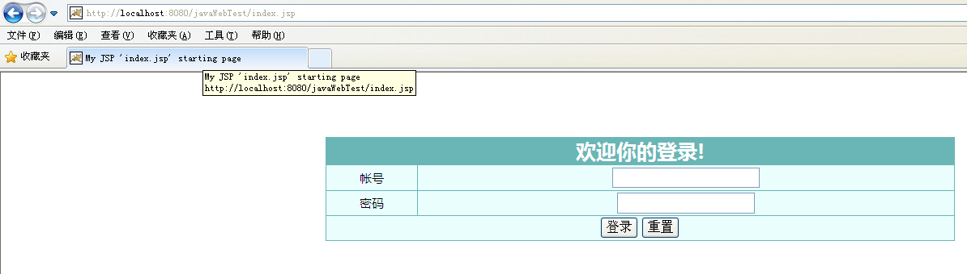

进入界面：

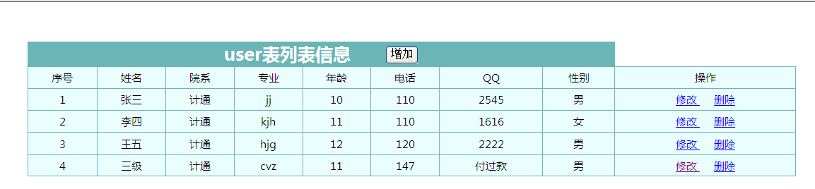

增加界面

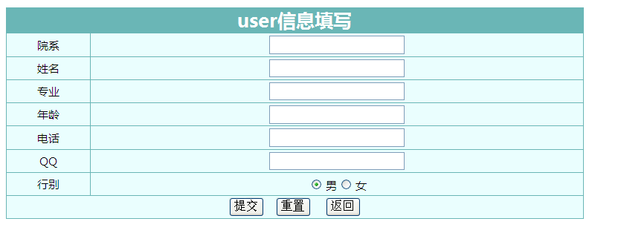

修改界面：

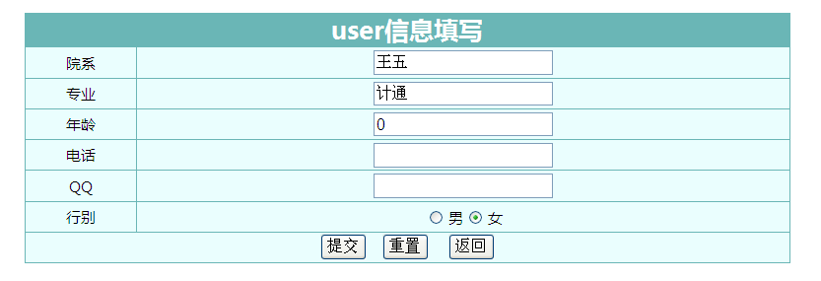

时间仓促 可能细节上 没有过多追求 还请勿喷粪…..