Brett Ferrante and Wenting Wang

Syracuse Parks and Recreation Department Registration Database

IST 659

**Section II: Project Summary**

The Syracuse Parks and Recreation Department offers a wide variety of classes for all ages. Classes range from arts and crafts to senior exercise programs to children’s swimming lessons. The Parks and Recreation Department also hosts a variety of sports leagues for both athletes and children. Any class or athletic team can meet up in one or more of the many community areas that are supervised by the Parks and Recreation Department, such as community centers, parks, and pools. The registration for these classes and teams is still paper based, with applicants either picking up registration forms from the Parks and Recreation Department or printing them from the website.

To better handle the registration and payments of community members, the Syracuse Parks and Recreation Department needs a database system to log the current and past classes, the locations, times, and beginning and end dates of classes, as well as all community members who have registered for said class. The database will also store the rosters of past and current athletic teams, as well as their schedules for the season. Finally, the database will store the invoices for the class and athletic registrations, allowing users to view who has paid, how much a class or athletic team has made, and the overall revenue for any period of time.

The users of this database will be the employees of the Parks and Recreation Department. Employees will easily be able to see what is happening in a park, pool, field, or community center on a given day. Additionally, they can track revenue of classes and compare this to past years. In addition to tracking revenue, employees can see when classes are full, and store contact information for those registered for said classes. Employees can also easily create and edit the schedule for athletic teams in this database, and can avoid conflicts by having an overview of free times in the parks as well as the scheduling preferences of the teams all in one place.

**Section III**: entity and attribute table

|  |  |
| --- | --- |
| Data object | Parks and Recreation Service Database |
| **Entity I** | **Community_Members** |
| Primary key | Community_ID ( Every community member has an unique ID) |
| Other attribute I | First_Name |
| Other attribute II | Last_Name |
| III | Gender |
| IV | Street_Address |
| VI | Apartment_# |
| VII | Home_Phone |
| VIII | City |
| XI | State |
| X | Zip |
| XI | Work_Phone |
| XII | Email_Address |
| XIII | Date_of_Birth (Some programs have requirement for ages) |
| XIV | Swim_Level (Aquatic program requires) |
| **Entity II** | **Registration** |
| Primary key | Registration_ID (Every registration has an unique ID, it’s a surrogate key for the combination of Community_ID, Registration_Time, Registration_Type and Class_ID/ Team_ID) |
| Foreign key | Community_ID (This is the primary key of the Community_Members Entity, a community member can have zero or many registration records, one registration record corresponds only to one community member. ) |
| I | Registration_Type (Whether the community member registers for classes or for Athletic teams, for example, if the member registers for a broomball league team, then the subtype is Athletic_Team, if the member registers for a fitness class, then the subtype is Class) |
| **Entity III** | **Class (This is one of the subtypes of the Registration Entity)** |
| Primary key, Foreign key | Registration_ID (This is unique ID of the Class Entity as well as the primary key of the Registration Entity, it correlate the Class subtype to the parent Registration Entity) |
| Foreign key | Class_ID (This is the primary key of the Classes Entity, it correlate the Class Subtype to the Classes Entity, one class can have zero or many registration records, one registration record corresponds only to one class) |
| **Entity IV** | **Athletic_Team (This is one of the subtypes of the Registration Entity)** |
| Primary key, Foreign key | Registration_ID (This is unique ID of the Athletic_Team Entity as well as the primary key of the Registration Entity, it correlate the Athletic_Team subtype to the parent Registration Entity) |
| Foreign key | Team_ID |
| Other attribute I | Jersey_Number (This is the athlete’s number in the specific team) |
| **Entity V** | **Classes** |
| Primary key | Class_ID (Every different class or the same class in different times have unique Class_IDs) |
| Foreign key | Instructor_ID (This is the primary key of the Instructors Entity, one instructor can instruct many classes, one class has and only has one instructor.) |
| Other attribute I | Class_Name |
| Other attribute II | Program |
| III | Start_Date |
| IV | End_Date |
| VI | Start_Time |
| VII | End_Time |
| VIII | Fee |
| XI | Age_Requirement (Some programs are only for children, some only for seniors, etc) |
| X | Class_Type |
| **Entity VI** | **Instructors** |
| Primary key | Instructor_ID (Every instructor has an unique Instructor_ID |
| Other attribute I | First_Name |
| Other attribute II | Last_Name |
| III | Address |
| IV | Primary_Phone |
| VI | Secondary_Phone |
| VII | Email_Address |
| **Entity VII** | **Aquatic (This is one of the three subtypes of the Classes Entity)** |
| Primary key, Foreign key | Class_ID (This is unique ID of the Aquatic Entity as well as the primary key of the Classes Entity, it correlate the Aquatic subtype to the parent Classes Entity) |
| Foreign key | Pool_Name (This is the primary key of the Pools Entity, one pool can have zero or many classes, one class corresponds to one and only one pool. ) |
| Other attribute I | Number_of_Lanes (This is the amount of lanes that need to be reserved for this specific class) |
| **Entity VIII** | **Pools** |
| Primary key | Pool_Name (Every pool has a unique name. ) |
| Other attribute I | Number_of_Lanes (This is the total number of lanes in the pool) |
| Other attribute II | Operating_Hours |
| III | Address |
| IV | Phone_Number |
| **Entity IX** | **Outdoors (This is one of the three subtypes of the Classes Entity)** |
| Primary key, Foreign key | Class_ID ( This is unique ID of the Outdoors Entity as well as the primary key of the Classes Entity, it correlate the Outdoors subtype to the parent Classes Entity) |
| Foreign key | Park_Name (This is the primary key of the Parks Entity, one park can have zero or many classes, one class corresponds to one and only one park. ) |
| Other attribute I | Area (This is the section of the park that the class will meet in, such as baseball diamond, NW gazebo, southern field) |
| **Entity X** | **Parks** |
| Primary key | Park_Name (Every park has a unique name. ) |
| Other attribute I | Operating_Hours |
| Other attribute II | Address |
| III | Phone_Number |
| **Entity XI** | **Indoors (This is one of the three subtypes of the Classes Entity)** |
| Primary key, Foreign key | Class_ID (This is unique ID of the Indoors Entity as well as the primary key of the Classes Entity, it correlate the Indoors subtype to the parent Classes Entity) |
| Foreign key | Community_Center (This is the primary key of the Community_Centers Entity, one community center can have zero or many classes, one class corresponds to one and only one community center. ) |
| Other attribute I | Room_Number |
| **Entity XII** | **Community_Centers** |
| Primary key | Center_Name (Every community center has a unique name. ) |
| Other attribute I | Operating_Hours |
| Other attribute II | Address |
| III | Phone_Number |
| **Entity XIII** | **Teams** |
| Primary key | Team_ID (Every team has a unique Team_ID) |
| Other attribute I | Team_Name |
| Other attribute II | League |
| III | Maximum_Members |
| IV | Manager |
| VI | Captain |
| VII | Nights_Unable_to_Play |
| **Entity XIX** | Athletics_Schedule |
| Primary key, Foreign key | Team_1 (This is one of the combined primary keys which comprise of two teams and their contest date and year. It’s also the primary key of the Teams Entity. One team can have zero or many schedule records, one schedule record corresponds to one and only one team. ) |
| Primary key, Foreign key | Team_2 (This is one of the combined primary keys which comprise of two teams and their contest date and year. It’s also the primary key of the Teams Entity. One team can have zero or many schedule records, one schedule record corresponds to one and only one team. ) |
| Primary key | Date (This is one of the combined primary keys which comprise of two teams and their contest date and year.) |
| Primary key | Year (This is one of the combined primary keys which comprise of two teams and their contest date and year.) |
| Other attribute I | Location |
| Other attribute II | Time |
| Other attribute III | Winning_Team |
| IV | Final_Score |

**Section IV: Relational Data Model**

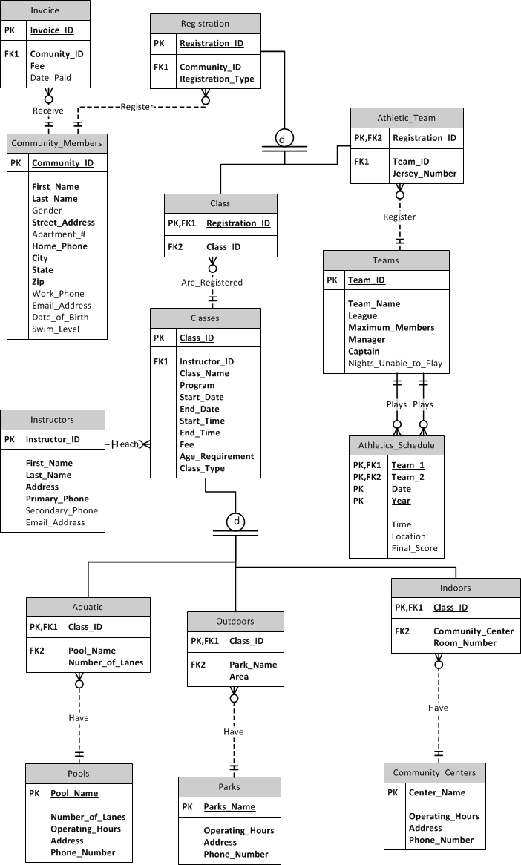

**Section V: Major Questions**

The major questions that a user of this database will want to know are:

1. What is happening in a park/pool/community center on a given date?
2. How much revenue are classes making compared to previous years?
3. What are the most popular types of classes?
4. Who has not paid for a class/athletic team?
5. What are the best athletic teams?
6. What athletic teams can play against each other?

The database will be able to answer all of these questions. Each class and sports game is recorded in the database, as well as its location. This way, employees can get an overview of what is happening in any area supervised by the Syracuse Parks and Recreation Department.

The database will be able to track revenue by recording the cost of each class and the number of people registered for the course, this allows an easy calculation as to the amount of money being brought in by a class. Classes from previous seasons and years are also stored in the database, allowing employees to compare one year’s revenue against another’s.

The ‘Program’ attribute in the ‘Classes’ table allows classes to be separated by what program they’re in, such as Arts & Crafts, Youth Recreation, Aquatics, etc. This allows employees to see what classes are most popular so that more can be offered in coming seasons.

The ‘Date_Paid’ attribute in the ‘Invoice’ entity is optional, and is filled in once a community member pays for their classes. This allows employees to track who has and who has not paid for their classes or athletic teams.

By tracking the scores of games throughout the years, as well as the winning teams, the best teams can be tracked. This information is used for creating the leagues in coming seasons. When registering for an athletic team, the teams can request a league to play in. Employees in charge of creating the leagues can see what teams are the best and worst, and may use this information to place a team in a more difficult or easy league in coming seasons.

Finally, the database will help with the scheduling of sports games by recording the preferences of each team. When registering, teams state if there are any nights that they cannot play. This information goes into the “Nights_Unable_to_Play’ attribute in the ‘Teams’ table. This information makes it easy for an employee to see what teams can play on what nights when creating a schedule.