3. Find some details about the following things about node:

a. Find some more details about callbacks

* A **callback** is a function passed as an argument to another function.
* It is called after the main function has finished its execution.
* Essentially, a callback allows one function to invoke another function once it completes its task.

Uses:

* Callbacks are particularly useful in scenarios where you need better control over when to execute a function.
* They are commonly used for handling asynchronous operations, event handling, and more.

Examples of Callbacks:

a. **Sequence Control:**

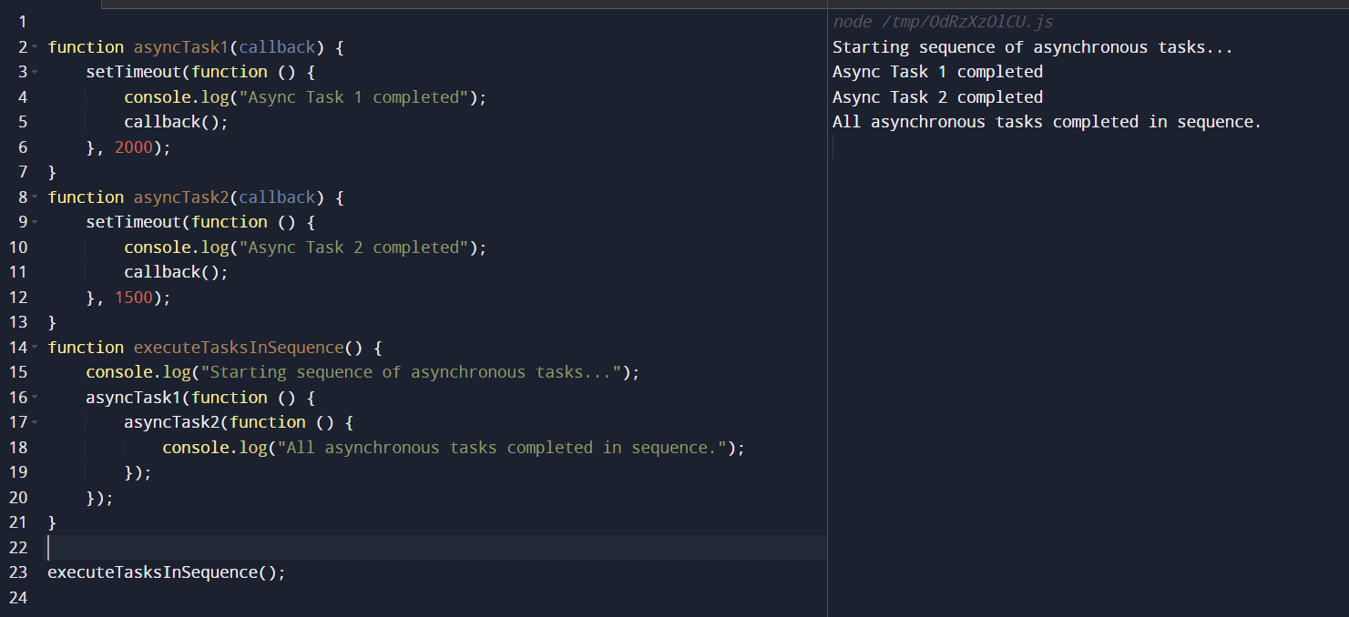

**b. Asynchronous Functions:  
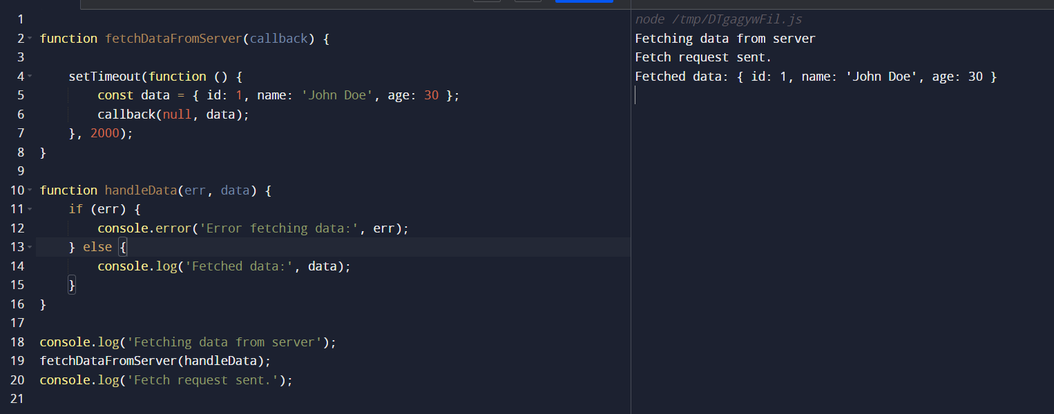**

c. **Array Operations:**

* Callbacks are commonly used with array methods like map, filter, and reduce.

Map:

The map method transforms each element of an array based on a provided callback function and returns a new array containing the results.

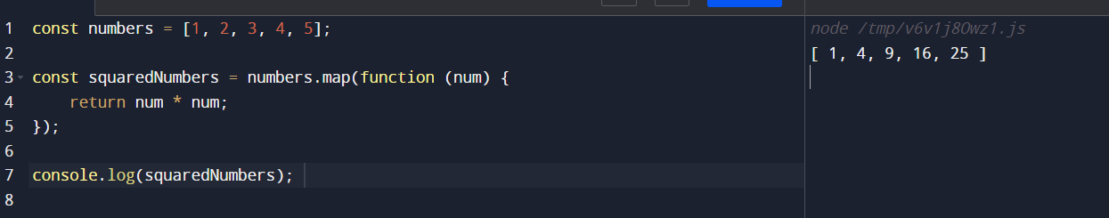

Filter:

The filter method creates a new array with all elements that pass a test implemented by the provided callback function.

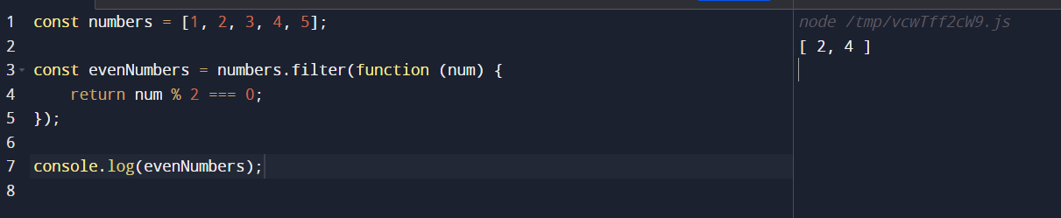

Reduce:

The reduce method applies a function against an accumulator and each element in the array (from left to right) to reduce it to a single value.

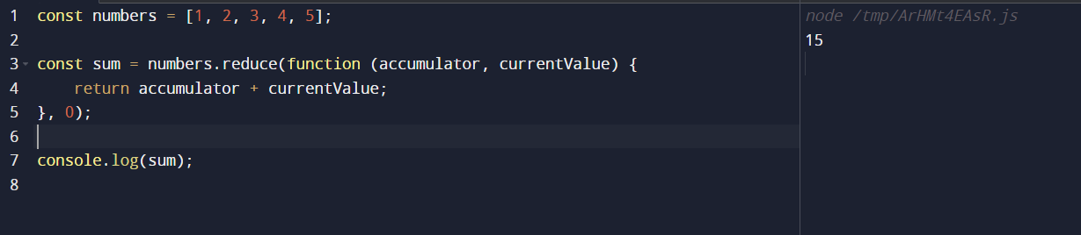 **Remember:**

* + When passing a function as an argument, avoid using parentheses.
  + Correct: myCalculator(5, 5, myDisplayer);
  + Incorrect: myCalculator(5, 5, myDisplayer());

b. Check the following methods in javascript where callbacks are involved:

a. map()

b. findIndex()

c. find()

d. filter():

map():

The map() method creates a new array populated with the results of calling a provided function on every element in the calling array.

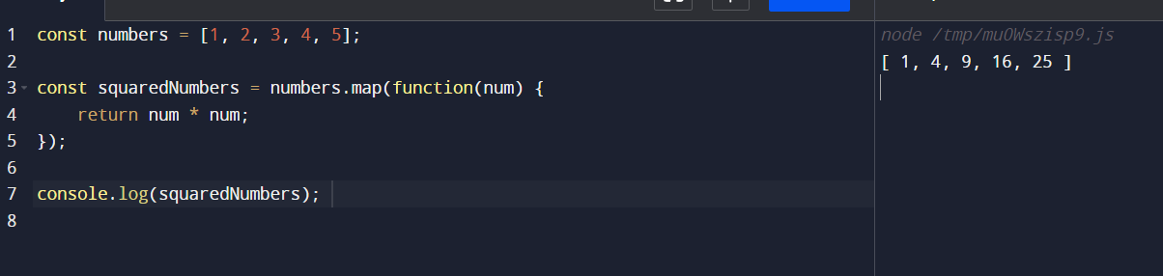

findIndex():

The findIndex() method returns the index of the first element in the array that satisfies the provided testing function. Otherwise, it returns -1.

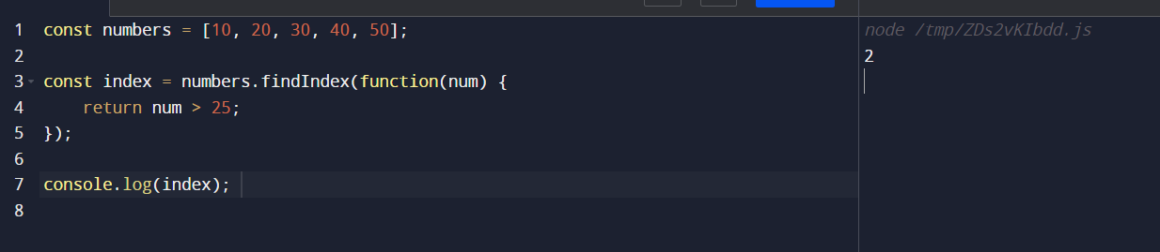

find():

The find() method returns the value of the first element in the array that satisfies the provided testing function. Otherwise, it returns undefined.

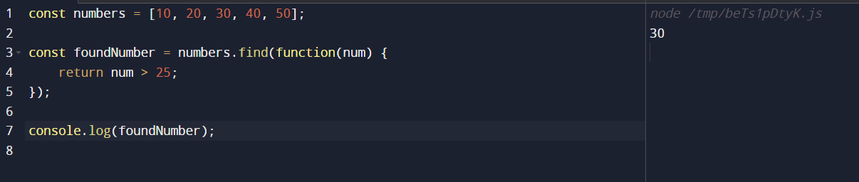

filter():

The filter() method creates a new array with all elements that pass the test implemented by the provided function.

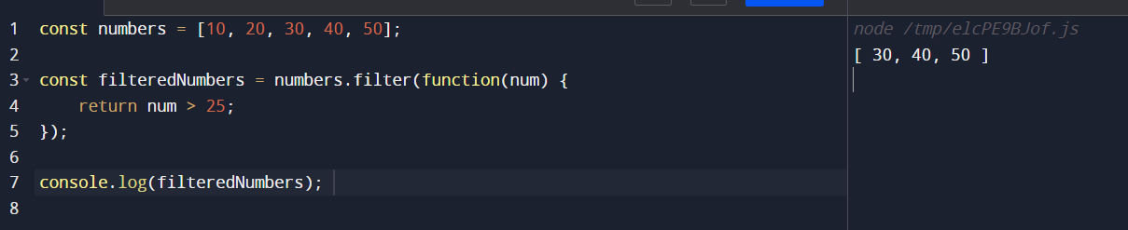

c. What kind of applications we can create using node js?

1. **Real-Time Chat Applications**:
   * Node.js is particularly well-suited for high-performance applications that involve significant I/O work, such as real-time chat servers.
   * Its primarily I/O model allows you to handle time-intensive operations outside the main JavaScript thread, ensuring smooth chat experiences without UI lags1.
2. **Social Media Platforms**:
   * You can create social media platforms using Node.js. These applications deliver content to subscribers while allowing them to submit new content and distribute it across the network.
3. **Internet of Things (IoT)**:
   * Node.js is perfect for IoT applications due to its event-driven nature.
   * It can handle connecting and communicating with IoT devices while leaving the main thread free for other events like UI updates.
4. **Streaming Apps**:
   * Node.js has excellent support for HTTP streaming, making it ideal for building live data streaming applications.
   * Examples include live sports tickers or news apps that need to push real-time updates.
5. **Online Payment Processors**:
   * Node.js is scalable, supports real-time communication, and handles high-traffic websites.
   * It’s commonly used to build online payment processors like PayPal or subscription services that bill users monthly.
6. **Remote Collaboration Tools**:
   * Real-time collaborative features, such as chat systems or remote desktop-style tools, can be built using Node.js.
   * You can even create web-based terminal emulators to remotely access systems worldwide.
7. **Customer Relationship Management (CRM) Tools**:
   * Node.js is great for scalable CRM tools that interact with large amounts of data and users simultaneously.
   * Its robustness ensures smooth user interactions without easily crashing.
8. **Single-Page Applications (SPAs)**:
   * Node.js is ideal for building fast and scalable front-end applications.
   * SPAs benefit from Node.js features that handle requests without requiring frequent web app refreshes.
9. **Advanced Fintech Applications**:
   * Node.js can handle both simple and complex fintech applications that involve real-time data processing and communication

d. Find out more details about "Event Loops" in node js

In Node.js, the event loop is a crucial part of its architecture, responsible for handling asynchronous operations efficiently.

1. **Single-threaded and Asynchronous**: Node.js is single-threaded, meaning it operates on a single thread (the event loop) to handle all I/O operations and callbacks. However, it is designed to be non-blocking and asynchronous, allowing it to handle multiple concurrent operations efficiently.
2. **Event-Driven Architecture**: Node.js uses an event-driven architecture, where actions or events trigger corresponding callbacks. These events can originate from various sources, such as I/O operations, timers, network requests, or user interactions.
3. **Event Loop Phases**: The event loop in Node.js consists of several phases, each responsible for specific tasks:
   * **Timers**: Executes setTimeout() and setInterval() callbacks.
   * **Pending Callbacks**: Executes I/O-related callbacks deferred from the previous loop iteration.
   * **Idle, Prepare**: Used internally for housekeeping tasks.
   * **Poll**: Retrieves new I/O events from the system and executes their callbacks. Also, it will execute callbacks registered with setImmediate().
   * **Check**: Executes setImmediate() callbacks.
   * **Close Callbacks**: Executes close event callbacks (e.g., socket.on('close', ...)).
4. **Non-Blocking I/O**: Node.js employs non-blocking I/O operations, meaning it doesn't wait for I/O operations to complete. Instead, it continues executing the next operation, and once the I/O operation finishes, it triggers the corresponding callback. This allows Node.js to handle many concurrent operations without getting blocked.
5. **Callback Queue**: Asynchronous operations in Node.js use callback functions to handle the results. These callbacks are placed in a callback queue by the event loop. When the event loop enters the appropriate phase, it dequeues the callbacks from the queue and executes them.
6. **Concurrency and Scalability**: Node.js' event-driven, non-blocking architecture makes it highly scalable and efficient for handling I/O-heavy applications, such as web servers. It can handle a large number of concurrent connections without consuming excessive system resources.

Understanding the event loop is essential for writing efficient Node.js applications, as it determines how asynchronous operations are managed and executed. By leveraging the event loop effectively, developers can build high-performance and scalable applications in Node.js.

**Timers Phase**:

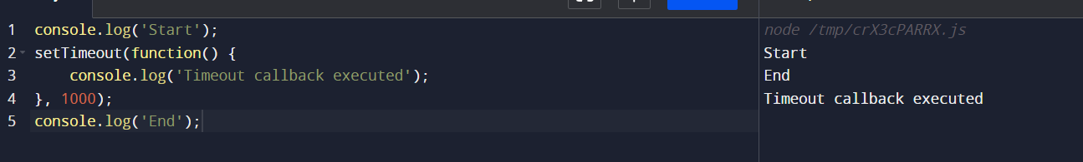

In this example, "Start" and "End" will be printed first, followed by "Timeout callback executed" after a delay of 1 second.

**Check Phase:**

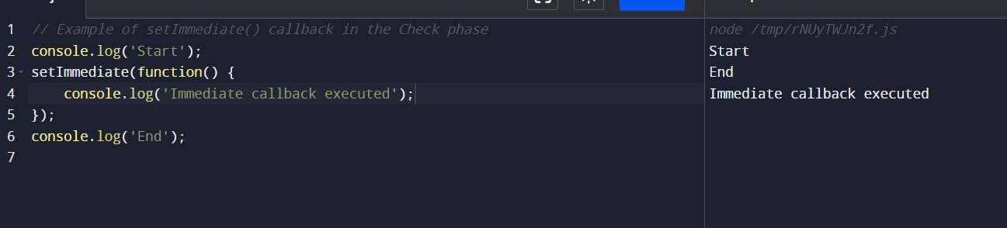

4. What are differences between MySql and MongoDb? in table format along give advanges and disadvantages too and where they should be used

|  |  |  |
| --- | --- | --- |
| Features | MySQL | MongoDB |
| **Data Model** | Relational (Tables, Rows, Columns) | NoSQL (Documents, Collections) |
| **Query Language** | SQL | MongoDB Query Language (JSON-like) |
| **Schema** | Fixed schema (requires predefined schema) | Dynamic schema (schema-less, flexible) |
| **Transactions** | Supports ACID transactions | Limited transaction support (Atomicity at document level) |
| **Scaling** | Vertical scaling (adding more powerful hardware) | Horizontal scaling (sharding) |
| **Complex Queries** | Better suited for complex joins and queries | Limited support for complex queries and joins |
| **Data Integrity** | Strong data integrity and consistency | Flexible data model may sacrifice some integrity |
| **Performance** | High performance for structured data | High performance for unstructured or semi-structured data |
| **Use Cases** | Traditional RDBMS applications, where data structure is well-defined and relationships are important | Agile development, Big Data, Real-time analytics, where flexibility and scalability are crucial |
| **Advantages** | - Well-established, widely used | - Flexible schema, easier scalability |
|  | - ACID compliance | - High performance for unstructured data |
|  | - Strong data integrity and consistency | - Horizontal scaling and sharding capabilities |
| **Disadvantages** | - Fixed schema can be limiting for evolving data models | - Limited support for complex queries and joins |
|  | - Vertical scaling can be costly and less flexible | - Eventual consistency model may lead to data inconsistency |
|  | - Not well-suited for handling unstructured data | - Requires careful schema design for data integrity |
| Use Cases | * Traditional relational database applications where data consistency, integrity, and structured queries are critical. * Applications with a well-defined schema and fixed data model. * Use cases where ACID transactions are required. | * Agile development projects where data structures evolve rapidly. * Big Data applications handling large volumes of unstructured or semi-structured data. * Real-time analytics and IoT applications requiring high scalability and flexibility. * Applications that benefit from horizontal scaling and sharding. |

5. What is let, var,const key words and their differences in the table formatt along with example codes

|  |  |  |  |
| --- | --- | --- | --- |
| Feature | var | let | const |
| Scope | Function scope | Block scope | Block scope |
| Re-assignable | Yes | Yes | No |
| Hoisting | Hoisted to the top of the function or global scope | Hoisted to the top of the block scope | Hoisted to the top of the block scope |
| Initialization | Can be declared without being initialized | Must be initialized before use | Must be initialized before use |
| Redeclaration | Can be re-declared within the same scope | Cannot be re-declared within the same scope | Cannot be re-declared within the same scope |

