1. What is Regular expression in JavaScript?

A regular expression, often abbreviated as "regex" or "regexp," is a sequence of characters that define a search pattern. In JavaScript, regular expressions are objects that allow you to perform pattern matching and search operations within strings.

Regular expressions can be used for various tasks such as:

* Searching for patterns within a string.
* Validating input to ensure it matches a desired format.
* Replacing parts of a string based on a pattern.
* Extracting specific information from strings.

In JavaScript, regular expressions can be created using the RegExp constructor or by using a literal syntax enclosed between slashes (/).

**test(string):** This method tests whether a string contains a match for the regular expression pattern. It returns **true** if a match is found, otherwise **false**.

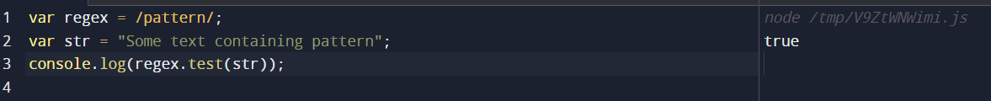

**exec(string):** This method searches for a match within a string and returns an array containing information about the match. If no match is found, it returns **null**.

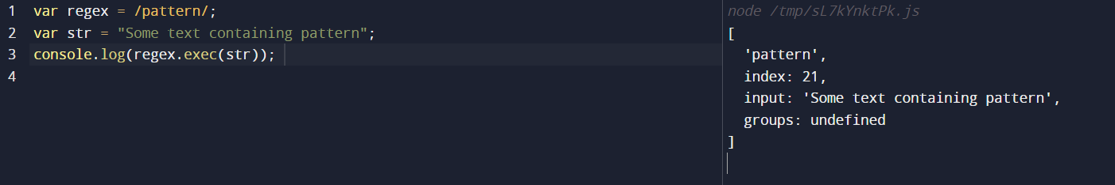

**match(string):** This method is available on strings and works similarly to **exec()**. It searches for a match within the string and returns an array containing information about the match, or **null** if no match is found.

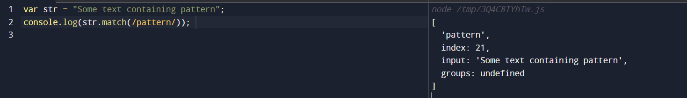

**search(string):** This method searches for a match within a string and returns the index of the first occurrence of the match, or **-1** if no match is found.

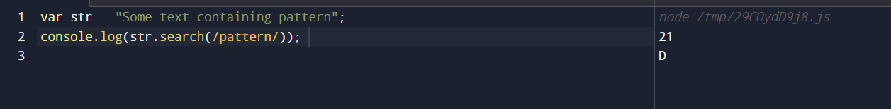

**replace(string, replacement):** This method searches a string for a specified pattern, and replaces matches with a replacement string.

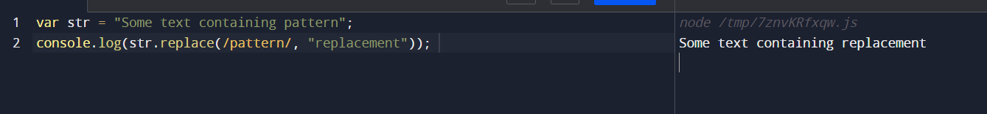

**split(string):** This method splits a string into an array of substrings using a regular expression pattern as a delimiter.

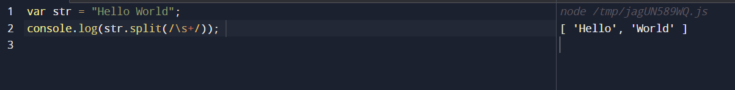

map():

The map() method creates a new array populated with the results of calling a provided function on every element in the calling array.

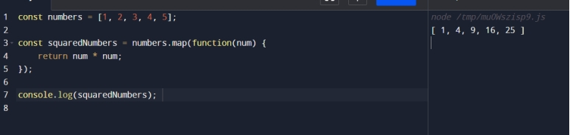

findIndex():

The findIndex() method returns the index of the first element in the array that satisfies the provided testing function. Otherwise, it returns -1.

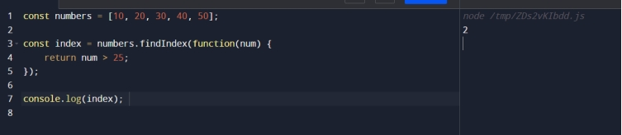

find():

The find() method returns the value of the first element in the array that satisfies the provided testing function. Otherwise, it returns undefined.

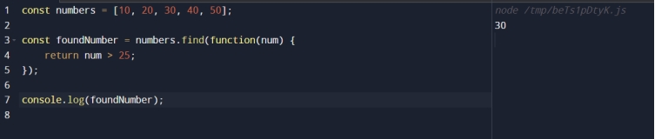

filter():

The filter() method creates a new array with all elements that pass the test implemented by the provided function.

