a. How to extract only values from the object?

To extract only values from an object in JavaScript, you can use the **Object.values()** method. This method returns an array containing the values of the properties of the object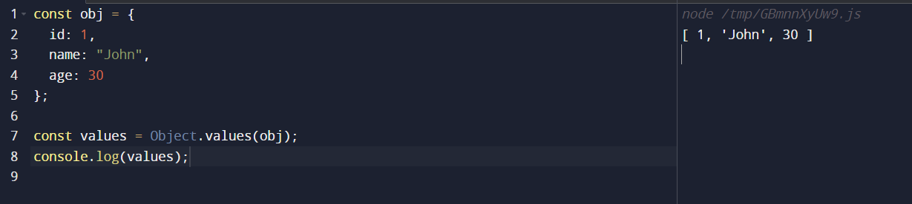

b. How to clone the object? in js with example

methods such as using the spread operator (**...**), **Object.assign()**, or **JSON.parse()** and **JSON.stringify()**. Here's an example of cloning an object using the spread operator:

