tidy_data

Autogenerated data summary from dataMaid

2018-09-03 12:16:59

# Data report overview

The dataset examined has the following dimensions:

|  |  |
| --- | --- |
| Feature | Result |
| Number of observations | 180 |
| Number of variables | 81 |

### Checks performed

The following variable checks were performed, depending on the data type of each variable:

|  |  |  |  |  |  |  |  |
| --- | --- | --- | --- | --- | --- | --- | --- |
|  | character | factor | labelled | numeric | integer | logical | Date |
| Identify miscoded missing values | × | × | × | × | × |  | × |
| Identify prefixed and suffixed whitespace | × | × | × |  |  |  |  |
| Identify levels with < 6 obs. | × | × | × |  |  |  |  |
| Identify case issues | × | × | × |  |  |  |  |
| Identify misclassified numeric or integer variables | × | × | × |  |  |  |  |
| Identify outliers |  |  |  | × | × |  | × |

Please note that all numerical values in the following have been rounded to 2 decimals.

# Summary table

|  |  |  |  |  |
| --- | --- | --- | --- | --- |
|  | Variable class | # unique values | Missing observations | Any problems? |
| subjectId | integer | 30 | 0.00 % |  |
| activityId | integer | 6 | 0.00 % |  |
| tBodyAcc-mean()-X | numeric | 180 | 0.00 % | × |
| tBodyAcc-mean()-Y | numeric | 180 | 0.00 % | × |
| tBodyAcc-mean()-Z | numeric | 180 | 0.00 % | × |
| tBodyAcc-std()-X | numeric | 180 | 0.00 % |  |
| tBodyAcc-std()-Y | numeric | 180 | 0.00 % |  |
| tBodyAcc-std()-Z | numeric | 180 | 0.00 % |  |
| tGravityAcc-mean()-X | numeric | 180 | 0.00 % | × |
| tGravityAcc-mean()-Y | numeric | 180 | 0.00 % | × |
| tGravityAcc-mean()-Z | numeric | 180 | 0.00 % | × |
| tGravityAcc-std()-X | numeric | 180 | 0.00 % | × |
| tGravityAcc-std()-Y | numeric | 180 | 0.00 % | × |
| tGravityAcc-std()-Z | numeric | 180 | 0.00 % | × |
| tBodyAccJerk-mean()-X | numeric | 180 | 0.00 % | × |
| tBodyAccJerk-mean()-Y | numeric | 180 | 0.00 % | × |
| tBodyAccJerk-mean()-Z | numeric | 180 | 0.00 % | × |
| tBodyAccJerk-std()-X | numeric | 180 | 0.00 % |  |
| tBodyAccJerk-std()-Y | numeric | 180 | 0.00 % |  |
| tBodyAccJerk-std()-Z | numeric | 180 | 0.00 % |  |
| tBodyGyro-mean()-X | numeric | 180 | 0.00 % | × |
| tBodyGyro-mean()-Y | numeric | 180 | 0.00 % | × |
| tBodyGyro-mean()-Z | numeric | 180 | 0.00 % | × |
| tBodyGyro-std()-X | numeric | 180 | 0.00 % |  |
| tBodyGyro-std()-Y | numeric | 180 | 0.00 % |  |
| tBodyGyro-std()-Z | numeric | 180 | 0.00 % |  |
| tBodyGyroJerk-mean()-X | numeric | 180 | 0.00 % | × |
| tBodyGyroJerk-mean()-Y | numeric | 180 | 0.00 % | × |
| tBodyGyroJerk-mean()-Z | numeric | 180 | 0.00 % | × |
| tBodyGyroJerk-std()-X | numeric | 180 | 0.00 % |  |
| tBodyGyroJerk-std()-Y | numeric | 180 | 0.00 % |  |
| tBodyGyroJerk-std()-Z | numeric | 180 | 0.00 % |  |
| tBodyAccMag-mean() | numeric | 180 | 0.00 % |  |
| tBodyAccMag-std() | numeric | 180 | 0.00 % |  |
| tGravityAccMag-mean() | numeric | 180 | 0.00 % |  |
| tGravityAccMag-std() | numeric | 180 | 0.00 % |  |
| tBodyAccJerkMag-mean() | numeric | 180 | 0.00 % |  |
| tBodyAccJerkMag-std() | numeric | 180 | 0.00 % |  |
| tBodyGyroMag-mean() | numeric | 180 | 0.00 % |  |
| tBodyGyroMag-std() | numeric | 180 | 0.00 % |  |
| tBodyGyroJerkMag-mean() | numeric | 180 | 0.00 % |  |
| tBodyGyroJerkMag-std() | numeric | 180 | 0.00 % |  |
| fBodyAcc-mean()-X | numeric | 180 | 0.00 % |  |
| fBodyAcc-mean()-Y | numeric | 180 | 0.00 % |  |
| fBodyAcc-mean()-Z | numeric | 180 | 0.00 % |  |
| fBodyAcc-std()-X | numeric | 180 | 0.00 % |  |
| fBodyAcc-std()-Y | numeric | 180 | 0.00 % |  |
| fBodyAcc-std()-Z | numeric | 180 | 0.00 % |  |
| fBodyAcc-meanFreq()-X | numeric | 180 | 0.00 % |  |
| fBodyAcc-meanFreq()-Y | numeric | 180 | 0.00 % | × |
| fBodyAcc-meanFreq()-Z | numeric | 180 | 0.00 % | × |
| fBodyAccJerk-mean()-X | numeric | 180 | 0.00 % |  |
| fBodyAccJerk-mean()-Y | numeric | 180 | 0.00 % |  |
| fBodyAccJerk-mean()-Z | numeric | 180 | 0.00 % |  |
| fBodyAccJerk-std()-X | numeric | 180 | 0.00 % |  |
| fBodyAccJerk-std()-Y | numeric | 180 | 0.00 % |  |
| fBodyAccJerk-std()-Z | numeric | 180 | 0.00 % |  |
| fBodyAccJerk-meanFreq()-X | numeric | 180 | 0.00 % |  |
| fBodyAccJerk-meanFreq()-Y | numeric | 180 | 0.00 % |  |
| fBodyAccJerk-meanFreq()-Z | numeric | 180 | 0.00 % | × |
| fBodyGyro-mean()-X | numeric | 180 | 0.00 % |  |
| fBodyGyro-mean()-Y | numeric | 180 | 0.00 % |  |
| fBodyGyro-mean()-Z | numeric | 180 | 0.00 % |  |
| fBodyGyro-std()-X | numeric | 180 | 0.00 % |  |
| fBodyGyro-std()-Y | numeric | 180 | 0.00 % |  |
| fBodyGyro-std()-Z | numeric | 180 | 0.00 % |  |
| fBodyGyro-meanFreq()-X | numeric | 180 | 0.00 % |  |
| fBodyGyro-meanFreq()-Y | numeric | 180 | 0.00 % | × |
| fBodyGyro-meanFreq()-Z | numeric | 180 | 0.00 % | × |
| fBodyAccMag-mean() | numeric | 180 | 0.00 % |  |
| fBodyAccMag-std() | numeric | 180 | 0.00 % |  |
| fBodyAccMag-meanFreq() | numeric | 180 | 0.00 % | × |
| fBodyBodyAccJerkMag-mean() | numeric | 180 | 0.00 % |  |
| fBodyBodyAccJerkMag-std() | numeric | 180 | 0.00 % |  |
| fBodyBodyAccJerkMag-meanFreq() | numeric | 180 | 0.00 % |  |
| fBodyBodyGyroMag-mean() | numeric | 180 | 0.00 % |  |
| fBodyBodyGyroMag-std() | numeric | 180 | 0.00 % |  |
| fBodyBodyGyroMag-meanFreq() | numeric | 180 | 0.00 % | × |
| fBodyBodyGyroJerkMag-mean() | numeric | 180 | 0.00 % |  |
| fBodyBodyGyroJerkMag-std() | numeric | 180 | 0.00 % |  |
| fBodyBodyGyroJerkMag-meanFreq() | numeric | 180 | 0.00 % | × |

# Variable list

## subjectId

|  |  |
| --- | --- |
| Feature | Result |
| Variable type | integer |
| Number of missing obs. | 0 (0 %) |
| Number of unique values | 30 |
| Median | 15.5 |
| 1st and 3rd quartiles | 8; 23 |
| Min. and max. | 1; 30 |

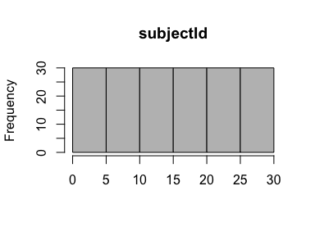

## activityId

|  |  |
| --- | --- |
| Feature | Result |
| Variable type | integer |
| Number of missing obs. | 0 (0 %) |
| Number of unique values | 6 |
| Median | 3.5 |
| 1st and 3rd quartiles | 2; 5 |
| Min. and max. | 1; 6 |

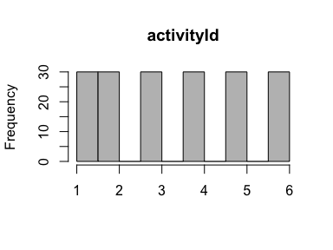

## tBodyAcc-mean()-X

|  |  |
| --- | --- |
| Feature | Result |
| Variable type | numeric |
| Number of missing obs. | 0 (0 %) |
| Number of unique values | 180 |
| Median | 0.28 |
| 1st and 3rd quartiles | 0.27; 0.28 |
| Min. and max. | 0.22; 0.3 |

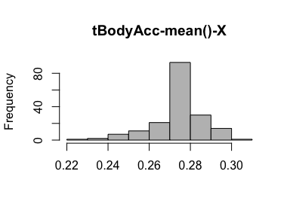

* Note that the following possible outlier values were detected: "0.22", "0.28", "0.28", "0.28", "0.28", "0.28", "0.28", "0.29", "0.29", "0.29" (18 additional values omitted).

## tBodyAcc-mean()-Y

|  |  |
| --- | --- |
| Feature | Result |
| Variable type | numeric |
| Number of missing obs. | 0 (0 %) |
| Number of unique values | 180 |
| Median | -0.02 |
| 1st and 3rd quartiles | -0.02; -0.01 |
| Min. and max. | -0.04; 0 |

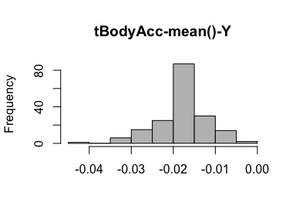

* Note that the following possible outlier values were detected: "-0.04", "-0.03", "-0.03", "-0.03", "-0.01", "-0.01", "-0.01", "-0.01", "-0.01", "-0.01" (12 additional values omitted).

## tBodyAcc-mean()-Z

|  |  |
| --- | --- |
| Feature | Result |
| Variable type | numeric |
| Number of missing obs. | 0 (0 %) |
| Number of unique values | 180 |
| Median | -0.11 |
| 1st and 3rd quartiles | -0.11; -0.1 |
| Min. and max. | -0.15; -0.08 |

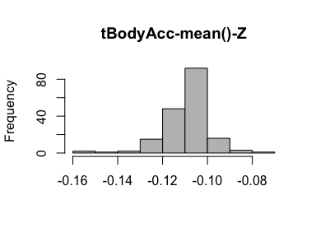

* Note that the following possible outlier values were detected: "-0.15", "-0.15", "-0.14", "-0.13", "-0.13", "-0.1", "-0.1", "-0.09", "-0.09", "-0.09" (3 additional values omitted).

## tBodyAcc-std()-X

|  |  |
| --- | --- |
| Feature | Result |
| Variable type | numeric |
| Number of missing obs. | 0 (0 %) |
| Number of unique values | 180 |
| Median | -0.75 |
| 1st and 3rd quartiles | -0.98; -0.2 |
| Min. and max. | -1; 0.63 |

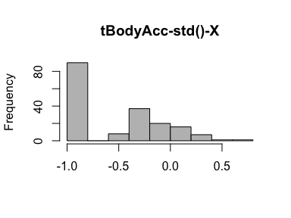

## tBodyAcc-std()-Y

|  |  |
| --- | --- |
| Feature | Result |
| Variable type | numeric |
| Number of missing obs. | 0 (0 %) |
| Number of unique values | 180 |
| Median | -0.51 |
| 1st and 3rd quartiles | -0.94; -0.03 |
| Min. and max. | -0.99; 0.62 |

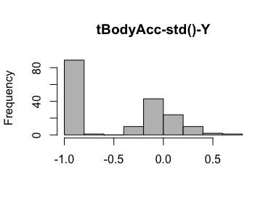

## tBodyAcc-std()-Z

|  |  |
| --- | --- |
| Feature | Result |
| Variable type | numeric |
| Number of missing obs. | 0 (0 %) |
| Number of unique values | 180 |
| Median | -0.65 |
| 1st and 3rd quartiles | -0.95; -0.23 |
| Min. and max. | -0.99; 0.61 |

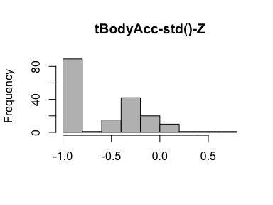

## tGravityAcc-mean()-X

|  |  |
| --- | --- |
| Feature | Result |
| Variable type | numeric |
| Number of missing obs. | 0 (0 %) |
| Number of unique values | 180 |
| Median | 0.92 |
| 1st and 3rd quartiles | 0.84; 0.94 |
| Min. and max. | -0.68; 0.97 |

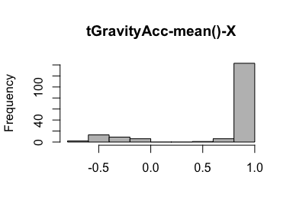

* Note that the following possible outlier values were detected: "-0.68", "-0.62", "-0.58", "-0.53", "-0.51", "-0.5", "-0.49", "-0.48", "-0.48", "-0.47" (37 additional values omitted).

## tGravityAcc-mean()-Y

|  |  |
| --- | --- |
| Feature | Result |
| Variable type | numeric |
| Number of missing obs. | 0 (0 %) |
| Number of unique values | 180 |
| Median | -0.13 |
| 1st and 3rd quartiles | -0.23; 0.09 |
| Min. and max. | -0.48; 0.96 |

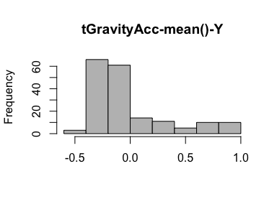

* Note that the following possible outlier values were detected: "-0.48", "-0.43", "-0.42", "-0.39", "-0.38", "-0.37", "-0.37", "-0.36".

## tGravityAcc-mean()-Z

|  |  |
| --- | --- |
| Feature | Result |
| Variable type | numeric |
| Number of missing obs. | 0 (0 %) |
| Number of unique values | 180 |
| Median | 0.02 |
| 1st and 3rd quartiles | -0.12; 0.15 |
| Min. and max. | -0.5; 0.96 |

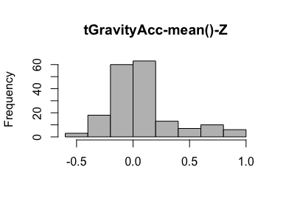

* Note that the following possible outlier values were detected: "-0.5", "-0.42", "-0.4", "-0.39", "-0.38", "0.72", "0.72", "0.77", "0.79", "0.84" (5 additional values omitted).

## tGravityAcc-std()-X

|  |  |
| --- | --- |
| Feature | Result |
| Variable type | numeric |
| Number of missing obs. | 0 (0 %) |
| Number of unique values | 180 |
| Median | -0.97 |
| 1st and 3rd quartiles | -0.98; -0.95 |
| Min. and max. | -1; -0.83 |

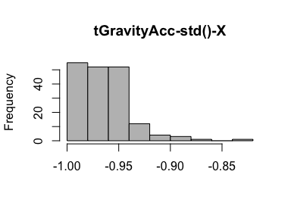

* Note that the following possible outlier values were detected: "-0.83".

## tGravityAcc-std()-Y

|  |  |
| --- | --- |
| Feature | Result |
| Variable type | numeric |
| Number of missing obs. | 0 (0 %) |
| Number of unique values | 180 |
| Median | -0.96 |
| 1st and 3rd quartiles | -0.97; -0.94 |
| Min. and max. | -0.99; -0.64 |

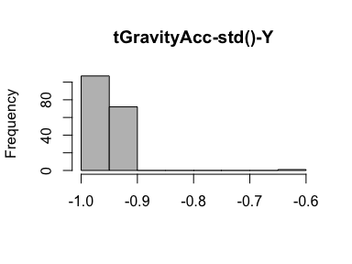

* Note that the following possible outlier values were detected: "-0.99", "-0.99", "-0.99", "-0.99", "-0.99", "-0.99", "-0.64".

## tGravityAcc-std()-Z

|  |  |
| --- | --- |
| Feature | Result |
| Variable type | numeric |
| Number of missing obs. | 0 (0 %) |
| Number of unique values | 180 |
| Median | -0.95 |
| 1st and 3rd quartiles | -0.96; -0.92 |
| Min. and max. | -0.99; -0.61 |

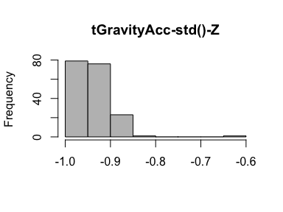

* Note that the following possible outlier values were detected: "-0.99", "-0.99", "-0.99", "-0.99", "-0.99", "-0.98", "-0.98", "-0.98", "-0.98", "-0.61".

## tBodyAccJerk-mean()-X

|  |  |
| --- | --- |
| Feature | Result |
| Variable type | numeric |
| Number of missing obs. | 0 (0 %) |
| Number of unique values | 180 |
| Median | 0.08 |
| 1st and 3rd quartiles | 0.07; 0.08 |
| Min. and max. | 0.04; 0.13 |

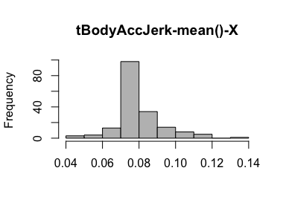

* Note that the following possible outlier values were detected: "0.04", "0.04", "0.05", "0.05", "0.06", "0.06", "0.06", "0.06", "0.06", "0.06" (14 additional values omitted).

## tBodyAccJerk-mean()-Y

|  |  |
| --- | --- |
| Feature | Result |
| Variable type | numeric |
| Number of missing obs. | 0 (0 %) |
| Number of unique values | 180 |
| Median | 0.01 |
| 1st and 3rd quartiles | 0; 0.01 |
| Min. and max. | -0.04; 0.06 |

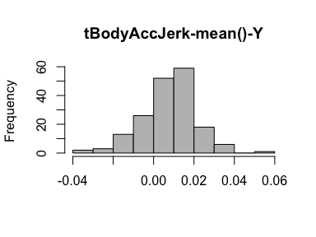

* Note that the following possible outlier values were detected: "0.02", "0.02", "0.02", "0.02", "0.02", "0.02", "0.02", "0.02", "0.02", "0.02" (16 additional values omitted).

## tBodyAccJerk-mean()-Z

|  |  |
| --- | --- |
| Feature | Result |
| Variable type | numeric |
| Number of missing obs. | 0 (0 %) |
| Number of unique values | 180 |
| Median | 0 |
| 1st and 3rd quartiles | -0.01; 0 |
| Min. and max. | -0.07; 0.04 |

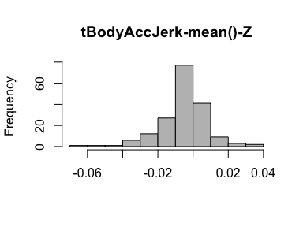

* Note that the following possible outlier values were detected: "-0.07", "-0.05", "-0.05", "-0.04", "-0.04", "-0.03", "0.02", "0.02", "0.02", "0.02" (3 additional values omitted).

## tBodyAccJerk-std()-X

|  |  |
| --- | --- |
| Feature | Result |
| Variable type | numeric |
| Number of missing obs. | 0 (0 %) |
| Number of unique values | 180 |
| Median | -0.81 |
| 1st and 3rd quartiles | -0.98; -0.22 |
| Min. and max. | -0.99; 0.54 |

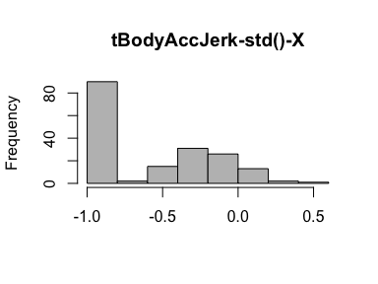

## tBodyAccJerk-std()-Y

|  |  |
| --- | --- |
| Feature | Result |
| Variable type | numeric |
| Number of missing obs. | 0 (0 %) |
| Number of unique values | 180 |
| Median | -0.78 |
| 1st and 3rd quartiles | -0.97; -0.15 |
| Min. and max. | -0.99; 0.36 |

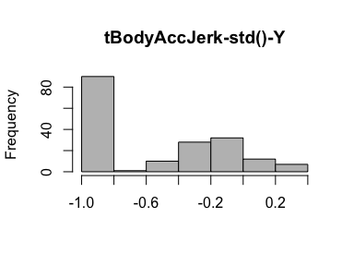

## tBodyAccJerk-std()-Z

|  |  |
| --- | --- |
| Feature | Result |
| Variable type | numeric |
| Number of missing obs. | 0 (0 %) |
| Number of unique values | 180 |
| Median | -0.88 |
| 1st and 3rd quartiles | -0.98; -0.51 |
| Min. and max. | -0.99; 0.03 |

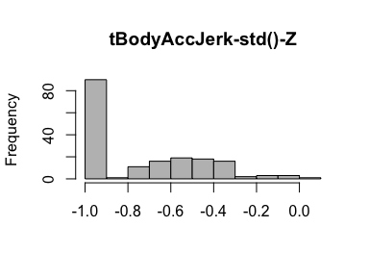

## tBodyGyro-mean()-X

|  |  |
| --- | --- |
| Feature | Result |
| Variable type | numeric |
| Number of missing obs. | 0 (0 %) |
| Number of unique values | 180 |
| Median | -0.03 |
| 1st and 3rd quartiles | -0.05; -0.02 |
| Min. and max. | -0.21; 0.19 |

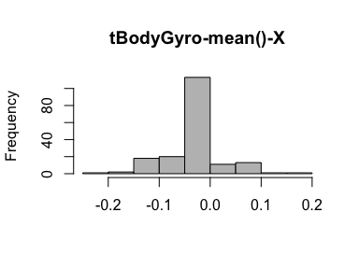

* Note that the following possible outlier values were detected: "-0.21", "-0.16", "-0.16", "-0.14", "-0.14", "-0.14", "-0.14", "0", "0", "0.01" (21 additional values omitted).

## tBodyGyro-mean()-Y

|  |  |
| --- | --- |
| Feature | Result |
| Variable type | numeric |
| Number of missing obs. | 0 (0 %) |
| Number of unique values | 180 |
| Median | -0.07 |
| 1st and 3rd quartiles | -0.09; -0.06 |
| Min. and max. | -0.2; 0.03 |

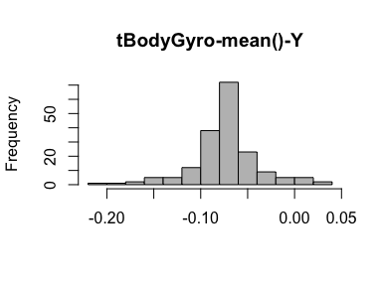

* Note that the following possible outlier values were detected: "-0.2", "-0.18", "-0.17", "-0.17", "-0.16", "-0.16", "-0.15", "-0.15", "-0.15", "-0.14" (13 additional values omitted).

## tBodyGyro-mean()-Z

|  |  |
| --- | --- |
| Feature | Result |
| Variable type | numeric |
| Number of missing obs. | 0 (0 %) |
| Number of unique values | 180 |
| Median | 0.09 |
| 1st and 3rd quartiles | 0.07; 0.1 |
| Min. and max. | -0.07; 0.18 |

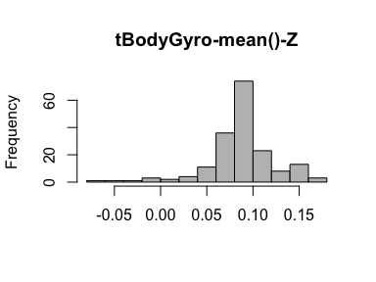

* Note that the following possible outlier values were detected: "-0.07", "-0.04", "-0.03", "-0.01", "-0.01", "0", "0.02", "0.02", "0.02", "0.02" (10 additional values omitted).

## tBodyGyro-std()-X

|  |  |
| --- | --- |
| Feature | Result |
| Variable type | numeric |
| Number of missing obs. | 0 (0 %) |
| Number of unique values | 180 |
| Median | -0.79 |
| 1st and 3rd quartiles | -0.97; -0.44 |
| Min. and max. | -0.99; 0.27 |

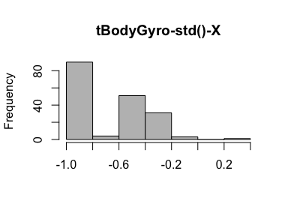

## tBodyGyro-std()-Y

|  |  |
| --- | --- |
| Feature | Result |
| Variable type | numeric |
| Number of missing obs. | 0 (0 %) |
| Number of unique values | 180 |
| Median | -0.8 |
| 1st and 3rd quartiles | -0.96; -0.42 |
| Min. and max. | -0.99; 0.48 |

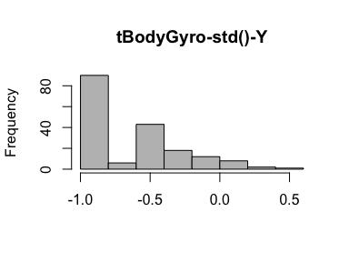

## tBodyGyro-std()-Z

|  |  |
| --- | --- |
| Feature | Result |
| Variable type | numeric |
| Number of missing obs. | 0 (0 %) |
| Number of unique values | 180 |
| Median | -0.8 |
| 1st and 3rd quartiles | -0.96; -0.31 |
| Min. and max. | -0.99; 0.56 |

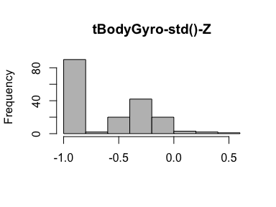

## tBodyGyroJerk-mean()-X

|  |  |
| --- | --- |
| Feature | Result |
| Variable type | numeric |
| Number of missing obs. | 0 (0 %) |
| Number of unique values | 180 |
| Median | -0.1 |
| 1st and 3rd quartiles | -0.1; -0.09 |
| Min. and max. | -0.16; -0.02 |

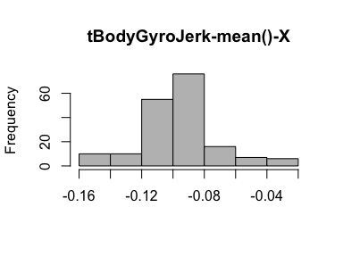

* Note that the following possible outlier values were detected: "-0.16", "-0.16", "-0.15", "-0.15", "-0.15", "-0.14", "-0.14", "-0.14", "-0.14", "-0.14" (26 additional values omitted).

## tBodyGyroJerk-mean()-Y

|  |  |
| --- | --- |
| Feature | Result |
| Variable type | numeric |
| Number of missing obs. | 0 (0 %) |
| Number of unique values | 180 |
| Median | -0.04 |
| 1st and 3rd quartiles | -0.05; -0.04 |
| Min. and max. | -0.08; -0.01 |

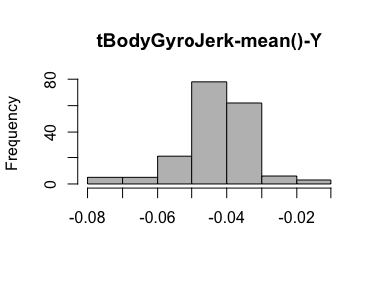

* Note that the following possible outlier values were detected: "-0.08", "-0.07", "-0.07", "-0.07", "-0.07", "-0.07", "-0.07", "-0.03", "-0.03", "-0.03" (14 additional values omitted).

## tBodyGyroJerk-mean()-Z

|  |  |
| --- | --- |
| Feature | Result |
| Variable type | numeric |
| Number of missing obs. | 0 (0 %) |
| Number of unique values | 180 |
| Median | -0.05 |
| 1st and 3rd quartiles | -0.06; -0.05 |
| Min. and max. | -0.09; -0.01 |

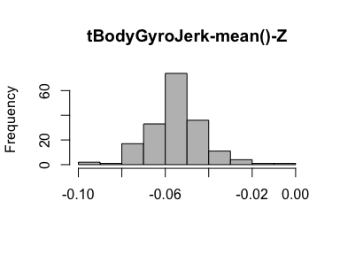

* Note that the following possible outlier values were detected: "-0.04", "-0.04", "-0.04", "-0.04", "-0.04", "-0.04", "-0.04", "-0.04", "-0.04", "-0.04" (12 additional values omitted).

## tBodyGyroJerk-std()-X

|  |  |
| --- | --- |
| Feature | Result |
| Variable type | numeric |
| Number of missing obs. | 0 (0 %) |
| Number of unique values | 180 |
| Median | -0.84 |
| 1st and 3rd quartiles | -0.98; -0.46 |
| Min. and max. | -1; 0.18 |

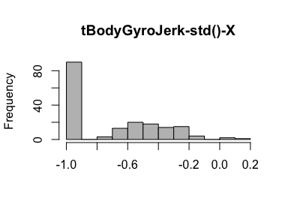

## tBodyGyroJerk-std()-Y

|  |  |
| --- | --- |
| Feature | Result |
| Variable type | numeric |
| Number of missing obs. | 0 (0 %) |
| Number of unique values | 180 |
| Median | -0.89 |
| 1st and 3rd quartiles | -0.98; -0.59 |
| Min. and max. | -1; 0.3 |

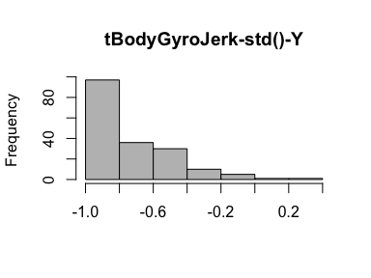

## tBodyGyroJerk-std()-Z

|  |  |
| --- | --- |
| Feature | Result |
| Variable type | numeric |
| Number of missing obs. | 0 (0 %) |
| Number of unique values | 180 |
| Median | -0.86 |
| 1st and 3rd quartiles | -0.98; -0.47 |
| Min. and max. | -1; 0.19 |

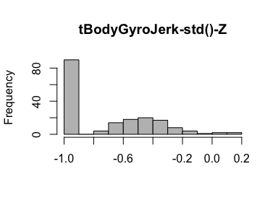

## tBodyAccMag-mean()

|  |  |
| --- | --- |
| Feature | Result |
| Variable type | numeric |
| Number of missing obs. | 0 (0 %) |
| Number of unique values | 180 |
| Median | -0.48 |
| 1st and 3rd quartiles | -0.96; -0.09 |
| Min. and max. | -0.99; 0.64 |

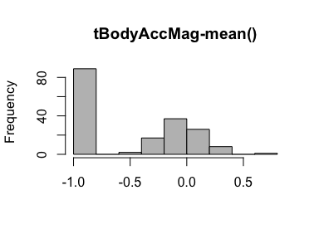

## tBodyAccMag-std()

|  |  |
| --- | --- |
| Feature | Result |
| Variable type | numeric |
| Number of missing obs. | 0 (0 %) |
| Number of unique values | 180 |
| Median | -0.61 |
| 1st and 3rd quartiles | -0.94; -0.21 |
| Min. and max. | -0.99; 0.43 |

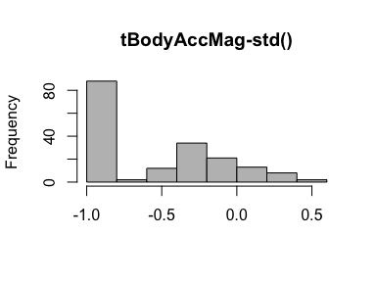

## tGravityAccMag-mean()

|  |  |
| --- | --- |
| Feature | Result |
| Variable type | numeric |
| Number of missing obs. | 0 (0 %) |
| Number of unique values | 180 |
| Median | -0.48 |
| 1st and 3rd quartiles | -0.96; -0.09 |
| Min. and max. | -0.99; 0.64 |

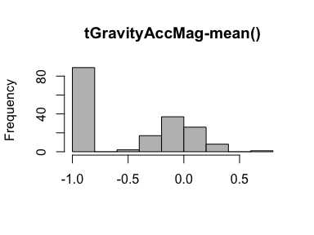

## tGravityAccMag-std()

|  |  |
| --- | --- |
| Feature | Result |
| Variable type | numeric |
| Number of missing obs. | 0 (0 %) |
| Number of unique values | 180 |
| Median | -0.61 |
| 1st and 3rd quartiles | -0.94; -0.21 |
| Min. and max. | -0.99; 0.43 |

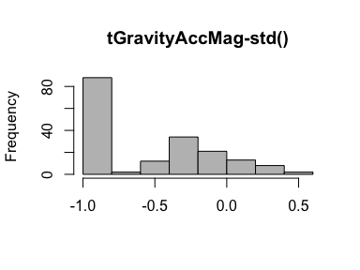

## tBodyAccJerkMag-mean()

|  |  |
| --- | --- |
| Feature | Result |
| Variable type | numeric |
| Number of missing obs. | 0 (0 %) |
| Number of unique values | 180 |
| Median | -0.82 |
| 1st and 3rd quartiles | -0.98; -0.25 |
| Min. and max. | -0.99; 0.43 |

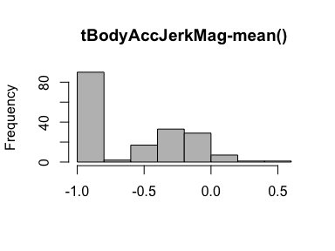

## tBodyAccJerkMag-std()

|  |  |
| --- | --- |
| Feature | Result |
| Variable type | numeric |
| Number of missing obs. | 0 (0 %) |
| Number of unique values | 180 |
| Median | -0.8 |
| 1st and 3rd quartiles | -0.98; -0.22 |
| Min. and max. | -0.99; 0.45 |

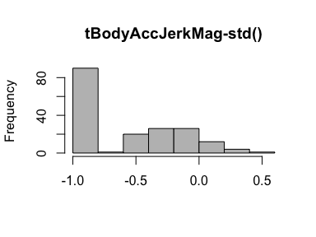

## tBodyGyroMag-mean()

|  |  |
| --- | --- |
| Feature | Result |
| Variable type | numeric |
| Number of missing obs. | 0 (0 %) |
| Number of unique values | 180 |
| Median | -0.66 |
| 1st and 3rd quartiles | -0.95; -0.22 |
| Min. and max. | -0.98; 0.42 |

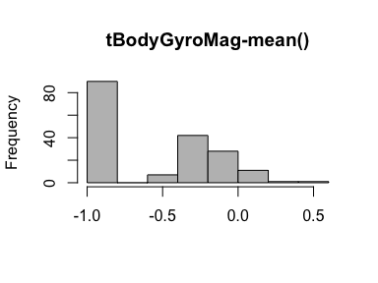

## tBodyGyroMag-std()

|  |  |
| --- | --- |
| Feature | Result |
| Variable type | numeric |
| Number of missing obs. | 0 (0 %) |
| Number of unique values | 180 |
| Median | -0.74 |
| 1st and 3rd quartiles | -0.95; -0.36 |
| Min. and max. | -0.98; 0.3 |

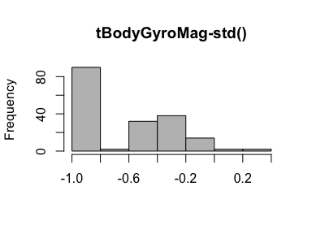

## tBodyGyroJerkMag-mean()

|  |  |
| --- | --- |
| Feature | Result |
| Variable type | numeric |
| Number of missing obs. | 0 (0 %) |
| Number of unique values | 180 |
| Median | -0.86 |
| 1st and 3rd quartiles | -0.99; -0.51 |
| Min. and max. | -1; 0.09 |

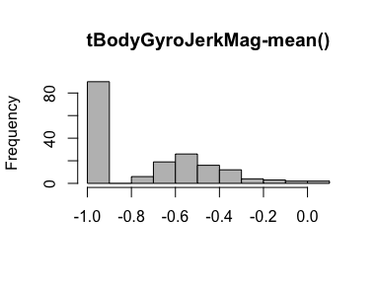

## tBodyGyroJerkMag-std()

|  |  |
| --- | --- |
| Feature | Result |
| Variable type | numeric |
| Number of missing obs. | 0 (0 %) |
| Number of unique values | 180 |
| Median | -0.88 |
| 1st and 3rd quartiles | -0.98; -0.58 |
| Min. and max. | -1; 0.25 |

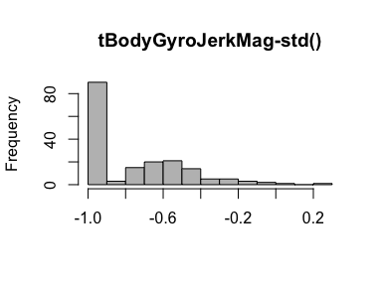

## fBodyAcc-mean()-X

|  |  |
| --- | --- |
| Feature | Result |
| Variable type | numeric |
| Number of missing obs. | 0 (0 %) |
| Number of unique values | 180 |
| Median | -0.77 |
| 1st and 3rd quartiles | -0.98; -0.22 |
| Min. and max. | -1; 0.54 |

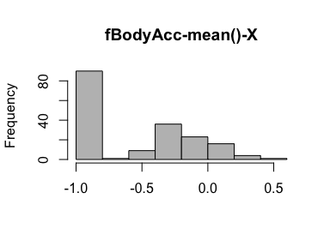

## fBodyAcc-mean()-Y

|  |  |
| --- | --- |
| Feature | Result |
| Variable type | numeric |
| Number of missing obs. | 0 (0 %) |
| Number of unique values | 180 |
| Median | -0.59 |
| 1st and 3rd quartiles | -0.95; -0.06 |
| Min. and max. | -0.99; 0.52 |

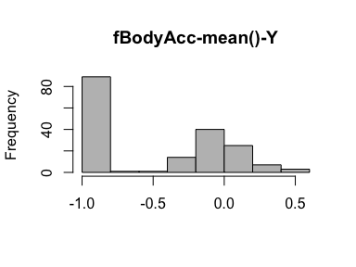

## fBodyAcc-mean()-Z

|  |  |
| --- | --- |
| Feature | Result |
| Variable type | numeric |
| Number of missing obs. | 0 (0 %) |
| Number of unique values | 180 |
| Median | -0.72 |
| 1st and 3rd quartiles | -0.96; -0.32 |
| Min. and max. | -0.99; 0.28 |

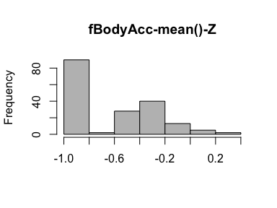

## fBodyAcc-std()-X

|  |  |
| --- | --- |
| Feature | Result |
| Variable type | numeric |
| Number of missing obs. | 0 (0 %) |
| Number of unique values | 180 |
| Median | -0.75 |
| 1st and 3rd quartiles | -0.98; -0.2 |
| Min. and max. | -1; 0.66 |

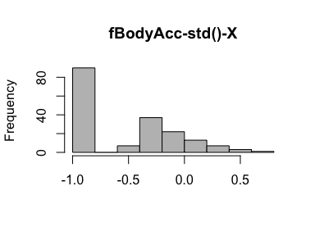

## fBodyAcc-std()-Y

|  |  |
| --- | --- |
| Feature | Result |
| Variable type | numeric |
| Number of missing obs. | 0 (0 %) |
| Number of unique values | 180 |
| Median | -0.51 |
| 1st and 3rd quartiles | -0.94; -0.08 |
| Min. and max. | -0.99; 0.56 |

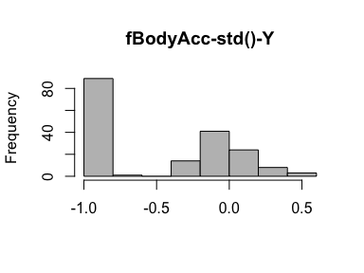

## fBodyAcc-std()-Z

|  |  |
| --- | --- |
| Feature | Result |
| Variable type | numeric |
| Number of missing obs. | 0 (0 %) |
| Number of unique values | 180 |
| Median | -0.64 |
| 1st and 3rd quartiles | -0.95; -0.27 |
| Min. and max. | -0.99; 0.69 |

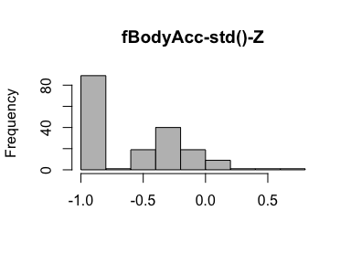

## fBodyAcc-meanFreq()-X

|  |  |
| --- | --- |
| Feature | Result |
| Variable type | numeric |
| Number of missing obs. | 0 (0 %) |
| Number of unique values | 180 |
| Median | -0.26 |
| 1st and 3rd quartiles | -0.39; -0.06 |
| Min. and max. | -0.64; 0.16 |

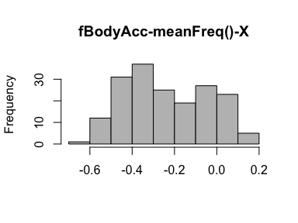

## fBodyAcc-meanFreq()-Y

|  |  |
| --- | --- |
| Feature | Result |
| Variable type | numeric |
| Number of missing obs. | 0 (0 %) |
| Number of unique values | 180 |
| Median | 0.01 |
| 1st and 3rd quartiles | -0.08; 0.09 |
| Min. and max. | -0.38; 0.47 |

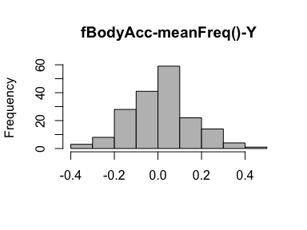

* Note that the following possible outlier values were detected: "-0.38", "-0.37", "-0.33", "0.37", "0.47".

## fBodyAcc-meanFreq()-Z

|  |  |
| --- | --- |
| Feature | Result |
| Variable type | numeric |
| Number of missing obs. | 0 (0 %) |
| Number of unique values | 180 |
| Median | 0.07 |
| 1st and 3rd quartiles | -0.04; 0.18 |
| Min. and max. | -0.52; 0.4 |

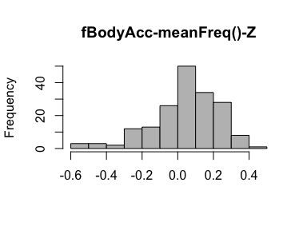

* Note that the following possible outlier values were detected: "-0.52", "-0.51", "-0.51", "-0.49", "-0.46", "0.4".

## fBodyAccJerk-mean()-X

|  |  |
| --- | --- |
| Feature | Result |
| Variable type | numeric |
| Number of missing obs. | 0 (0 %) |
| Number of unique values | 180 |
| Median | -0.81 |
| 1st and 3rd quartiles | -0.98; -0.28 |
| Min. and max. | -0.99; 0.47 |

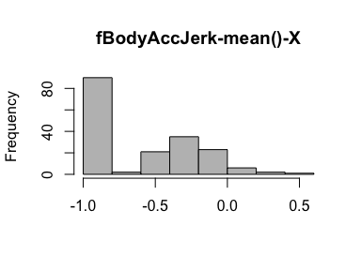

## fBodyAccJerk-mean()-Y

|  |  |
| --- | --- |
| Feature | Result |
| Variable type | numeric |
| Number of missing obs. | 0 (0 %) |
| Number of unique values | 180 |
| Median | -0.78 |
| 1st and 3rd quartiles | -0.97; -0.2 |
| Min. and max. | -0.99; 0.28 |

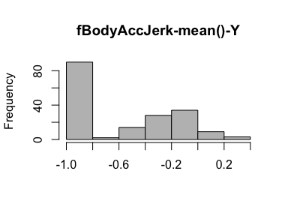

## fBodyAccJerk-mean()-Z

|  |  |
| --- | --- |
| Feature | Result |
| Variable type | numeric |
| Number of missing obs. | 0 (0 %) |
| Number of unique values | 180 |
| Median | -0.87 |
| 1st and 3rd quartiles | -0.98; -0.47 |
| Min. and max. | -0.99; 0.16 |

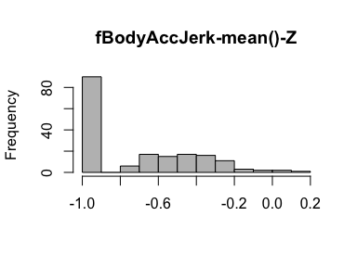

## fBodyAccJerk-std()-X

|  |  |
| --- | --- |
| Feature | Result |
| Variable type | numeric |
| Number of missing obs. | 0 (0 %) |
| Number of unique values | 180 |
| Median | -0.83 |
| 1st and 3rd quartiles | -0.98; -0.25 |
| Min. and max. | -1; 0.48 |

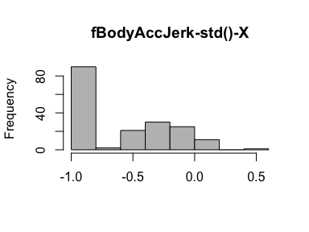

## fBodyAccJerk-std()-Y

|  |  |
| --- | --- |
| Feature | Result |
| Variable type | numeric |
| Number of missing obs. | 0 (0 %) |
| Number of unique values | 180 |
| Median | -0.79 |
| 1st and 3rd quartiles | -0.97; -0.17 |
| Min. and max. | -0.99; 0.35 |

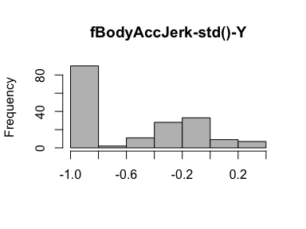

## fBodyAccJerk-std()-Z

|  |  |
| --- | --- |
| Feature | Result |
| Variable type | numeric |
| Number of missing obs. | 0 (0 %) |
| Number of unique values | 180 |
| Median | -0.9 |
| 1st and 3rd quartiles | -0.98; -0.54 |
| Min. and max. | -0.99; -0.01 |

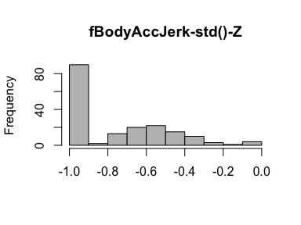

## fBodyAccJerk-meanFreq()-X

|  |  |
| --- | --- |
| Feature | Result |
| Variable type | numeric |
| Number of missing obs. | 0 (0 %) |
| Number of unique values | 180 |
| Median | -0.06 |
| 1st and 3rd quartiles | -0.29; 0.18 |
| Min. and max. | -0.58; 0.33 |

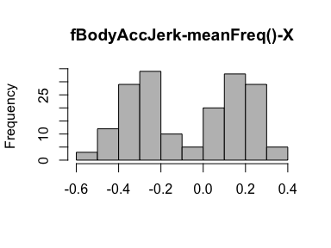

## fBodyAccJerk-meanFreq()-Y

|  |  |
| --- | --- |
| Feature | Result |
| Variable type | numeric |
| Number of missing obs. | 0 (0 %) |
| Number of unique values | 180 |
| Median | -0.23 |
| 1st and 3rd quartiles | -0.4; -0.05 |
| Min. and max. | -0.6; 0.2 |

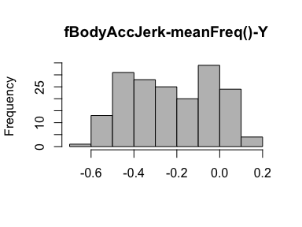

## fBodyAccJerk-meanFreq()-Z

|  |  |
| --- | --- |
| Feature | Result |
| Variable type | numeric |
| Number of missing obs. | 0 (0 %) |
| Number of unique values | 180 |
| Median | -0.09 |
| 1st and 3rd quartiles | -0.31; 0.04 |
| Min. and max. | -0.63; 0.23 |

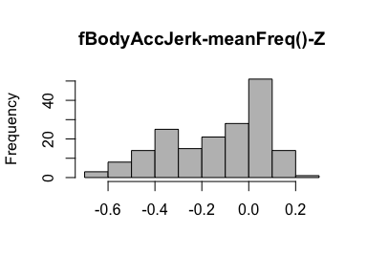

* Note that the following possible outlier values were detected: "0.23".

## fBodyGyro-mean()-X

|  |  |
| --- | --- |
| Feature | Result |
| Variable type | numeric |
| Number of missing obs. | 0 (0 %) |
| Number of unique values | 180 |
| Median | -0.73 |
| 1st and 3rd quartiles | -0.97; -0.34 |
| Min. and max. | -0.99; 0.47 |

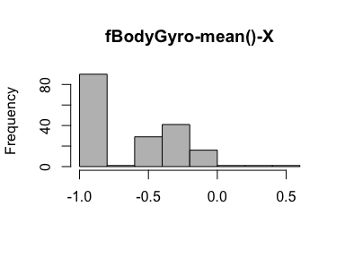

## fBodyGyro-mean()-Y

|  |  |
| --- | --- |
| Feature | Result |
| Variable type | numeric |
| Number of missing obs. | 0 (0 %) |
| Number of unique values | 180 |
| Median | -0.81 |
| 1st and 3rd quartiles | -0.97; -0.45 |
| Min. and max. | -0.99; 0.33 |

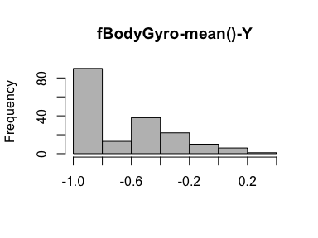

## fBodyGyro-mean()-Z

|  |  |
| --- | --- |
| Feature | Result |
| Variable type | numeric |
| Number of missing obs. | 0 (0 %) |
| Number of unique values | 180 |
| Median | -0.79 |
| 1st and 3rd quartiles | -0.96; -0.26 |
| Min. and max. | -0.99; 0.49 |

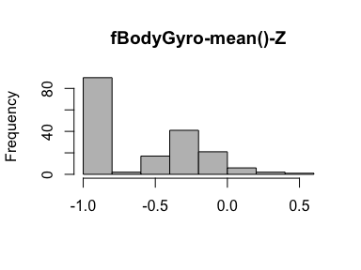

## fBodyGyro-std()-X

|  |  |
| --- | --- |
| Feature | Result |
| Variable type | numeric |
| Number of missing obs. | 0 (0 %) |
| Number of unique values | 180 |
| Median | -0.81 |
| 1st and 3rd quartiles | -0.98; -0.48 |
| Min. and max. | -0.99; 0.2 |

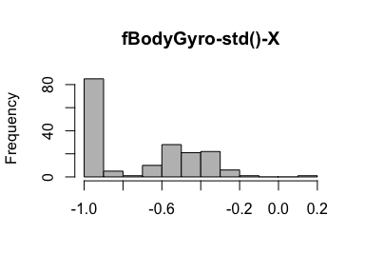

## fBodyGyro-std()-Y

|  |  |
| --- | --- |
| Feature | Result |
| Variable type | numeric |
| Number of missing obs. | 0 (0 %) |
| Number of unique values | 180 |
| Median | -0.8 |
| 1st and 3rd quartiles | -0.96; -0.42 |
| Min. and max. | -0.99; 0.65 |

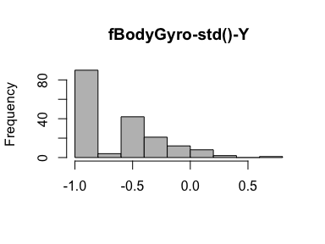

## fBodyGyro-std()-Z

|  |  |
| --- | --- |
| Feature | Result |
| Variable type | numeric |
| Number of missing obs. | 0 (0 %) |
| Number of unique values | 180 |
| Median | -0.82 |
| 1st and 3rd quartiles | -0.96; -0.39 |
| Min. and max. | -0.99; 0.52 |

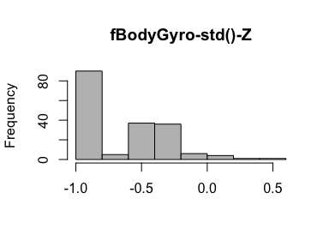

## fBodyGyro-meanFreq()-X

|  |  |
| --- | --- |
| Feature | Result |
| Variable type | numeric |
| Number of missing obs. | 0 (0 %) |
| Number of unique values | 180 |
| Median | -0.12 |
| 1st and 3rd quartiles | -0.21; 0 |
| Min. and max. | -0.4; 0.25 |

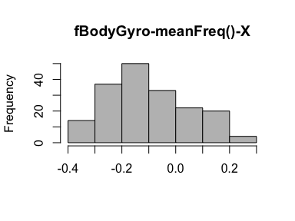

## fBodyGyro-meanFreq()-Y

|  |  |
| --- | --- |
| Feature | Result |
| Variable type | numeric |
| Number of missing obs. | 0 (0 %) |
| Number of unique values | 180 |
| Median | -0.16 |
| 1st and 3rd quartiles | -0.29; -0.04 |
| Min. and max. | -0.67; 0.27 |

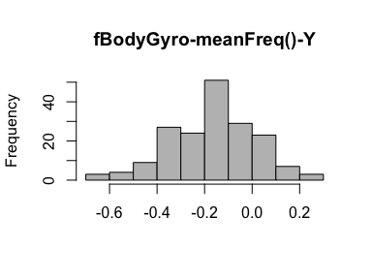

* Note that the following possible outlier values were detected: "0.27".

## fBodyGyro-meanFreq()-Z

|  |  |
| --- | --- |
| Feature | Result |
| Variable type | numeric |
| Number of missing obs. | 0 (0 %) |
| Number of unique values | 180 |
| Median | -0.05 |
| 1st and 3rd quartiles | -0.15; 0.04 |
| Min. and max. | -0.51; 0.38 |

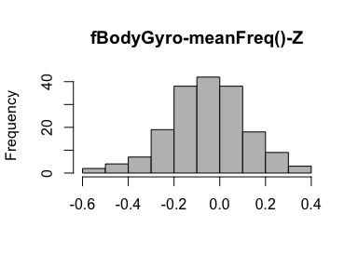

* Note that the following possible outlier values were detected: "-0.51", "-0.5", "0.29", "0.3", "0.3", "0.38".

## fBodyAccMag-mean()

|  |  |
| --- | --- |
| Feature | Result |
| Variable type | numeric |
| Number of missing obs. | 0 (0 %) |
| Number of unique values | 180 |
| Median | -0.67 |
| 1st and 3rd quartiles | -0.96; -0.16 |
| Min. and max. | -0.99; 0.59 |

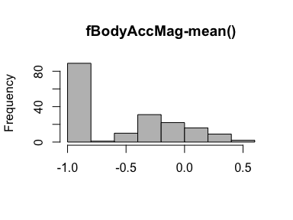

## fBodyAccMag-std()

|  |  |
| --- | --- |
| Feature | Result |
| Variable type | numeric |
| Number of missing obs. | 0 (0 %) |
| Number of unique values | 180 |
| Median | -0.65 |
| 1st and 3rd quartiles | -0.95; -0.37 |
| Min. and max. | -0.99; 0.18 |

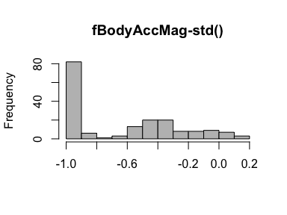

## fBodyAccMag-meanFreq()

|  |  |
| --- | --- |
| Feature | Result |
| Variable type | numeric |
| Number of missing obs. | 0 (0 %) |
| Number of unique values | 180 |
| Median | 0.08 |
| 1st and 3rd quartiles | -0.01; 0.17 |
| Min. and max. | -0.31; 0.44 |

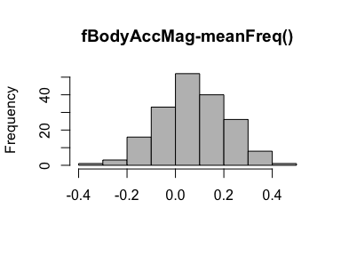

* Note that the following possible outlier values were detected: "0.44".

## fBodyBodyAccJerkMag-mean()

|  |  |
| --- | --- |
| Feature | Result |
| Variable type | numeric |
| Number of missing obs. | 0 (0 %) |
| Number of unique values | 180 |
| Median | -0.79 |
| 1st and 3rd quartiles | -0.98; -0.19 |
| Min. and max. | -0.99; 0.54 |

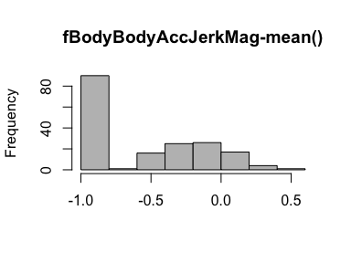

## fBodyBodyAccJerkMag-std()

|  |  |
| --- | --- |
| Feature | Result |
| Variable type | numeric |
| Number of missing obs. | 0 (0 %) |
| Number of unique values | 180 |
| Median | -0.81 |
| 1st and 3rd quartiles | -0.98; -0.27 |
| Min. and max. | -0.99; 0.32 |

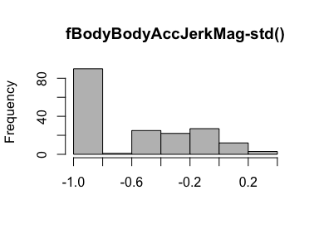

## fBodyBodyAccJerkMag-meanFreq()

|  |  |
| --- | --- |
| Feature | Result |
| Variable type | numeric |
| Number of missing obs. | 0 (0 %) |
| Number of unique values | 180 |
| Median | 0.17 |
| 1st and 3rd quartiles | 0.05; 0.28 |
| Min. and max. | -0.13; 0.49 |

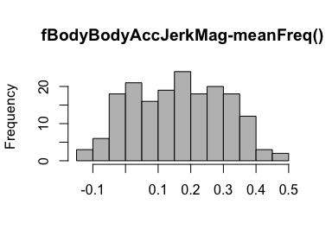

## fBodyBodyGyroMag-mean()

|  |  |
| --- | --- |
| Feature | Result |
| Variable type | numeric |
| Number of missing obs. | 0 (0 %) |
| Number of unique values | 180 |
| Median | -0.77 |
| 1st and 3rd quartiles | -0.96; -0.41 |
| Min. and max. | -0.99; 0.2 |

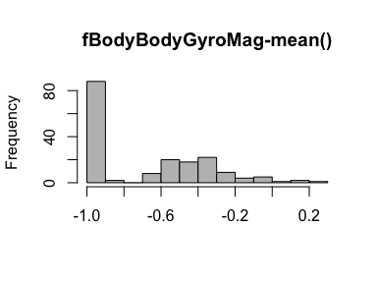

## fBodyBodyGyroMag-std()

|  |  |
| --- | --- |
| Feature | Result |
| Variable type | numeric |
| Number of missing obs. | 0 (0 %) |
| Number of unique values | 180 |
| Median | -0.77 |
| 1st and 3rd quartiles | -0.95; -0.43 |
| Min. and max. | -0.98; 0.24 |

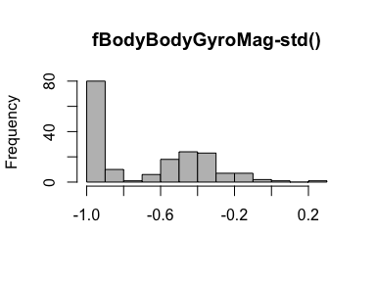

## fBodyBodyGyroMag-meanFreq()

|  |  |
| --- | --- |
| Feature | Result |
| Variable type | numeric |
| Number of missing obs. | 0 (0 %) |
| Number of unique values | 180 |
| Median | -0.05 |
| 1st and 3rd quartiles | -0.17; 0.08 |
| Min. and max. | -0.46; 0.41 |

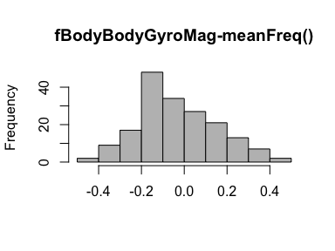

* Note that the following possible outlier values were detected: "-0.46".

## fBodyBodyGyroJerkMag-mean()

|  |  |
| --- | --- |
| Feature | Result |
| Variable type | numeric |
| Number of missing obs. | 0 (0 %) |
| Number of unique values | 180 |
| Median | -0.88 |
| 1st and 3rd quartiles | -0.98; -0.58 |
| Min. and max. | -1; 0.15 |

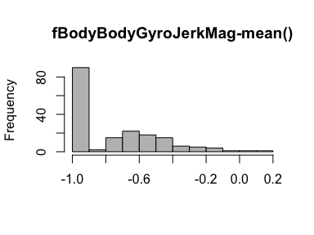

## fBodyBodyGyroJerkMag-std()

|  |  |
| --- | --- |
| Feature | Result |
| Variable type | numeric |
| Number of missing obs. | 0 (0 %) |
| Number of unique values | 180 |
| Median | -0.89 |
| 1st and 3rd quartiles | -0.98; -0.61 |
| Min. and max. | -1; 0.29 |

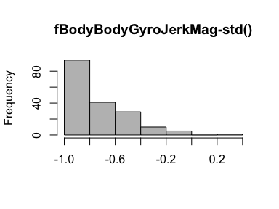

## fBodyBodyGyroJerkMag-meanFreq()

|  |  |
| --- | --- |
| Feature | Result |
| Variable type | numeric |
| Number of missing obs. | 0 (0 %) |
| Number of unique values | 180 |
| Median | 0.11 |
| 1st and 3rd quartiles | 0.05; 0.21 |
| Min. and max. | -0.18; 0.43 |

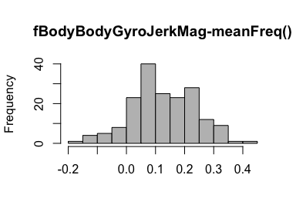

* Note that the following possible outlier values were detected: "-0.18", "-0.13", "-0.13", "-0.11", "-0.1", "-0.08", "-0.07", "-0.05", "-0.05", "-0.05" (1 additional values omitted).

Report generation information:

* Created by Scott Robertson (username: scottrobertson).
* Report creation time: Mon Sep 03 2018 12:17:00
* Report Was run from directory: /Users/scottrobertson/R Programming/Coursera
* dataMaid v1.1.2 [Pkg: 2018-05-03 from CRAN (R 3.5.1)]
* R version 3.5.1 (2018-07-02).
* Platform: x86_64-apple-darwin17.7.0 (64-bit)(macOS High Sierra 10.13.6).
* Function call: makeDataReport(data = tidy_data, replace = TRUE, visuals = setVisuals(all = "basicVisual"))