Impact of Transmission Type on Automobile Fuel Consumption

Scott Robertson

January 9, 2019

## Synopsis

The purpose of this paper is to answer two specific questions:

* Is an automatic or manual transmission better for MPG?; and
* Quantify the MPG difference between automatic and manual transmissions?

This has been achieved through a combination of exploratory analysis and regression models.

## Executive summary

## Data Source

For the purpose of this analysis we will be using the mtcars datatset which is included in the datasets package.

This data set contains fuel consumption, design specifications and performance measures for 32 automobiles from 1974-74.

## Exploratory Analysis

As a start point a piece of exploratory analysis was undertaken to determine if there is a relationship between transmission and MPG. The output of this analysis is in Figure 1 in Appendix A. This box plot shows a clear relationship between the two with manual transmission having a higher average MPG.

In order to understand and quantify this relationship we will use regression models. As part of the exploratory analysis a correlation matrix was produced to look at any existing relationships between variables in the data set. This matrix is included in Figure 2 in Appendix B.

Based on this analysis there are a number of highly correlated predictor variables that appear to have a greater impact

## Regression Analysis

To begin with we create a liner model with mpg as the dependent variable and use all remaining variables as predictors. As we have already identified correlated variables this will require additional work to improve the model.

summ(fit_all)

Observations

32

Dependent variable

mpg

Type

OLS linear regression

F(16,15)

7.83

R²

0.89

Adj. R²

0.78

Est.

S.E.

t val.

p

(Intercept)

23.88

20.07

1.19

0.25

cyl6

-2.65

3.04

-0.87

0.40

cyl8

-0.34

7.16

-0.05

0.96

disp

0.04

0.03

1.11

0.28

hp

-0.07

0.04

-1.79

0.09

.

drat

1.18

2.48

0.48

0.64

wt

-4.53

2.54

-1.78

0.09

.

qsec

0.37

0.94

0.39

0.70

vs1

1.93

2.87

0.67

0.51

amManual

1.21

3.21

0.38

0.71

gear4

1.11

3.80

0.29

0.77

gear5

2.53

3.74

0.68

0.51

carb2

-0.98

2.32

-0.42

0.68

carb3

3.00

4.29

0.70

0.50

carb4

1.09

4.45

0.25

0.81

carb6

4.48

6.38

0.70

0.49

carb8

7.25

8.36

0.87

0.40

Standard errors: OLS

Since none of the coefficients have a p-value less than 0.05 we cannot conclude which variables are more statistically significant.

In order to identify which variables are most significant in determining mpg we will use backward selection to identify the best combination of predictor variables to use in our model.

Observations

32

Dependent variable

mpg

Type

OLS linear regression

F(5,26)

33.57

R²

0.87

Adj. R²

0.84

Est.

S.E.

t val.

p

(Intercept)

33.71

2.60

12.94

0.00

***

cyl6

-3.03

1.41

-2.15

0.04

*

cyl8

-2.16

2.28

-0.95

0.35

hp

-0.03

0.01

-2.35

0.03

*

wt

-2.50

0.89

-2.82

0.01

**

amManual

1.81

1.40

1.30

0.21

Standard errors: OLS

The new model has 4 variables (cylinders, horsepower, weight, transmission). The R-squared value of 0.8659 confirms that this model explains about 87% of the variance in MPG. The p-values also are statistically significantly because they have a p-value less than 0.05. The coefficients conclude that increasing the number of cylinders from 4 to 6 with decrease the MPG by 3.03. Further increasing the cylinders to 8 with decrease the MPG by 2.16. Increasing the horsepower is decreases MPG 3.21 for every 100 horsepower. Weight decreases the MPG by 2.5 for each 1000 lbs increase. A Manual transmission improves the MPG by 1.81.

## Appendix A - Figures

### Figure 1

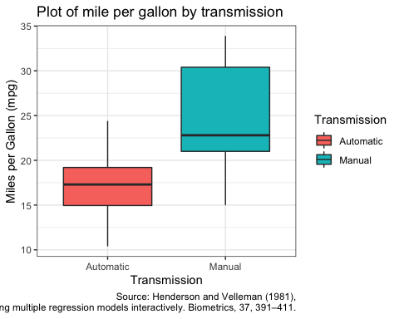

### Figure 2

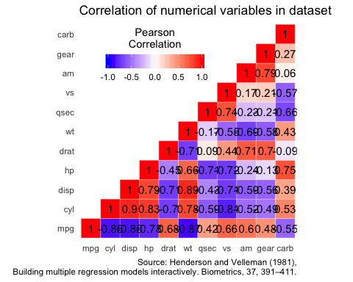

### Figure 3 - All Variable Model Diagnostics

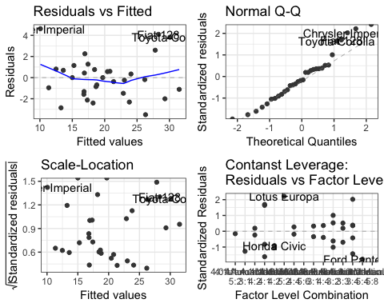

### Figure 4 - Stepwise Algorithm Model Diagnostics

