4.2 Normalisation

4.2.1 Database Design

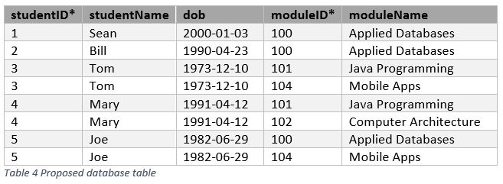

Firstly, this database is not well designed, in the sense that there are two primary keys, in order to maintain the minimum data redundancy possible, the best solution would be to make use of normalisation.

Normalisation is the technique of organizing data into multiple related tables as to minimize data repetition on the table.

I can point out a few examples of problems with the current database:

1 – Data redundancy increases the size of the Database

2 – When adding a new student, it will be necessary to repeat the data for moduleID and for moduleName for every row, which causes insertion anomaly.

3 – When removing students from the Database, the moduleName along with all other attributes will be deleted as well, causing deletion anomaly.

4 – Let’s say a moduleName changes and gets update from ‘Mobile Apps’ to ‘Mobile Application Development’, this change will need to be made on every single row that has the ‘Mobile app’ as a module, and if during the update, one row is missed, it will lead to inconsistent data.

**How to fix it:**

As previously mentioned, the right approach would be to use Normalisation, which would break down the current databases into multiple tables, in this case 2 would suffice, being 1 table for Students and the second for Modules, as such:

1st Table containing: studentID*, studentName and dob

2nd Table containing: moduleID*, moduleName and studentID (being a foreign key that references to the 1st table(studentID))