Build your own object detection system using YOLO
2026-03-11
Group members: Leila Strömberg, Pernilla Jacobsen
Objective: Make an own model that detect three object types: a red cup, a blue bottle, and a phone.
Creating a dataset.
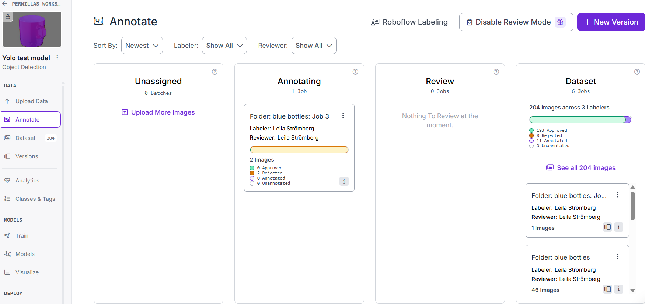
We used Roboflow to create a dataset. First we collected around 160 pictures. We took some pictures ourselves, we used a set of pictures found on Roboflow and we used google picture search to find some more. All these pictures were uploaded to Roboflow were we annotated them with class labels:
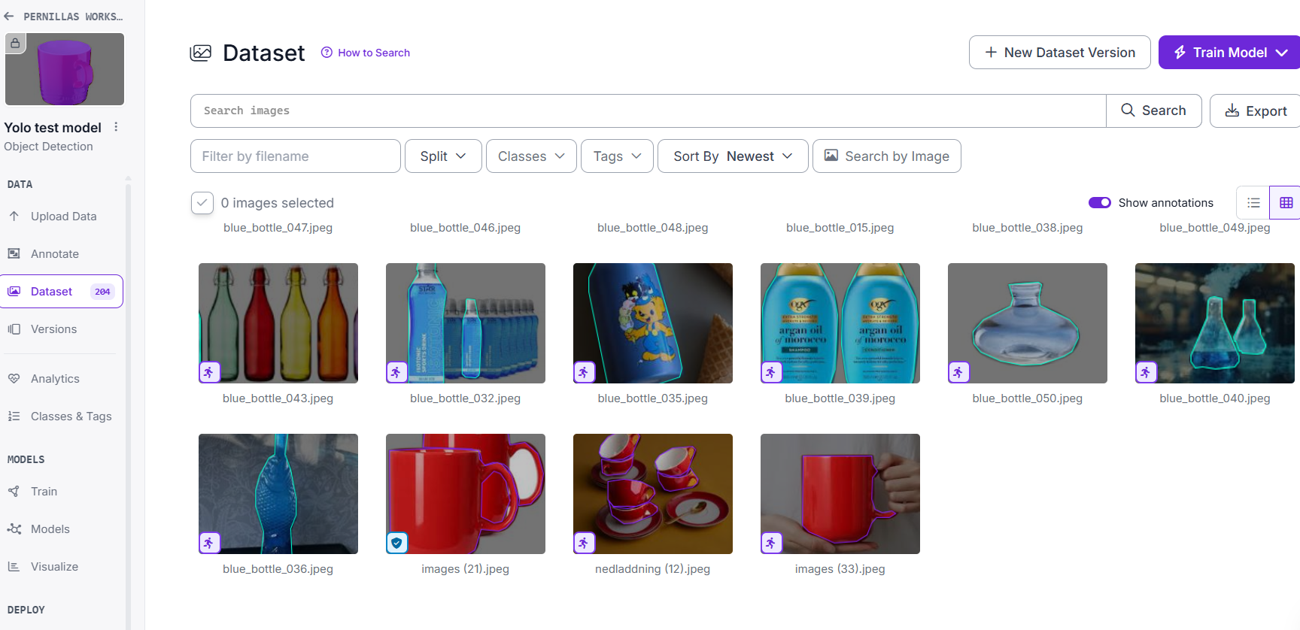

From roboflow we could create a dataset with some augmented versions (flipped, rotaded) of the pictures to expand the dataset. The advantage with roboflow is that the dataset is available online and we could use it in colab.
Models created.
We used colab since our computers are too slow for big modelling. Both of us are new to colab so the notebook ended up in Leilas titanic Git repository:
titanic-capstone-project/notebooks/train-yolov8-object-detection-on-custom-dataset.ipynb at main · hashtag-squirrel/titanic-capstone-project
https://github.com/strombergleila-source/object_detection

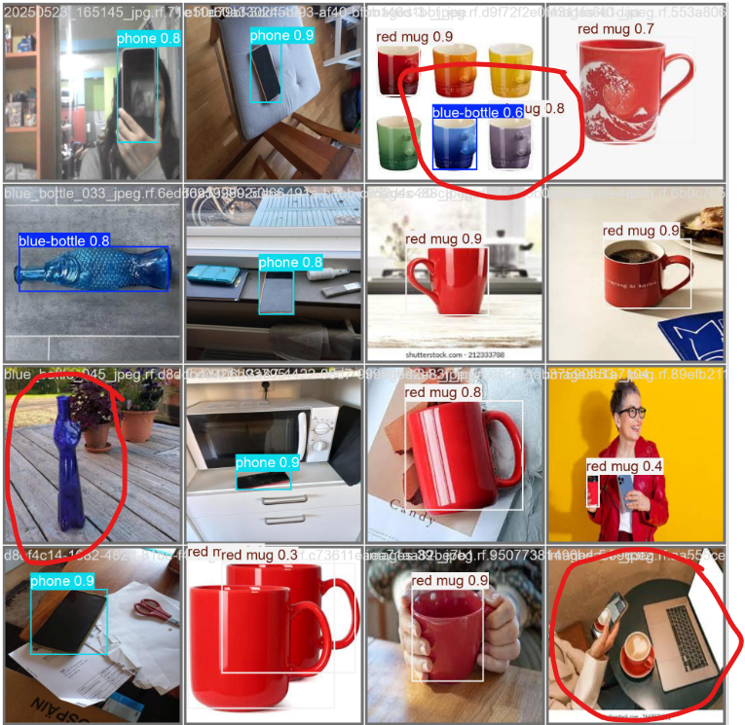
We started with 25 epochs. This model was fairly good at predicting pictures but makes some mistakes:

If we look at the loss curves we see that it probably still can improve:
We doubled the epochs to 50 to see if we could improve the model…

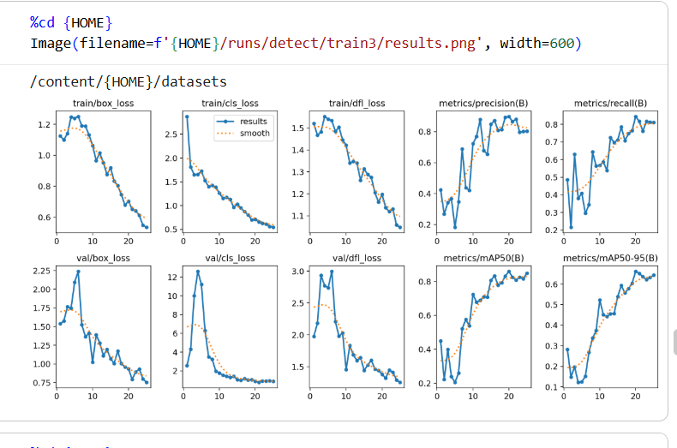
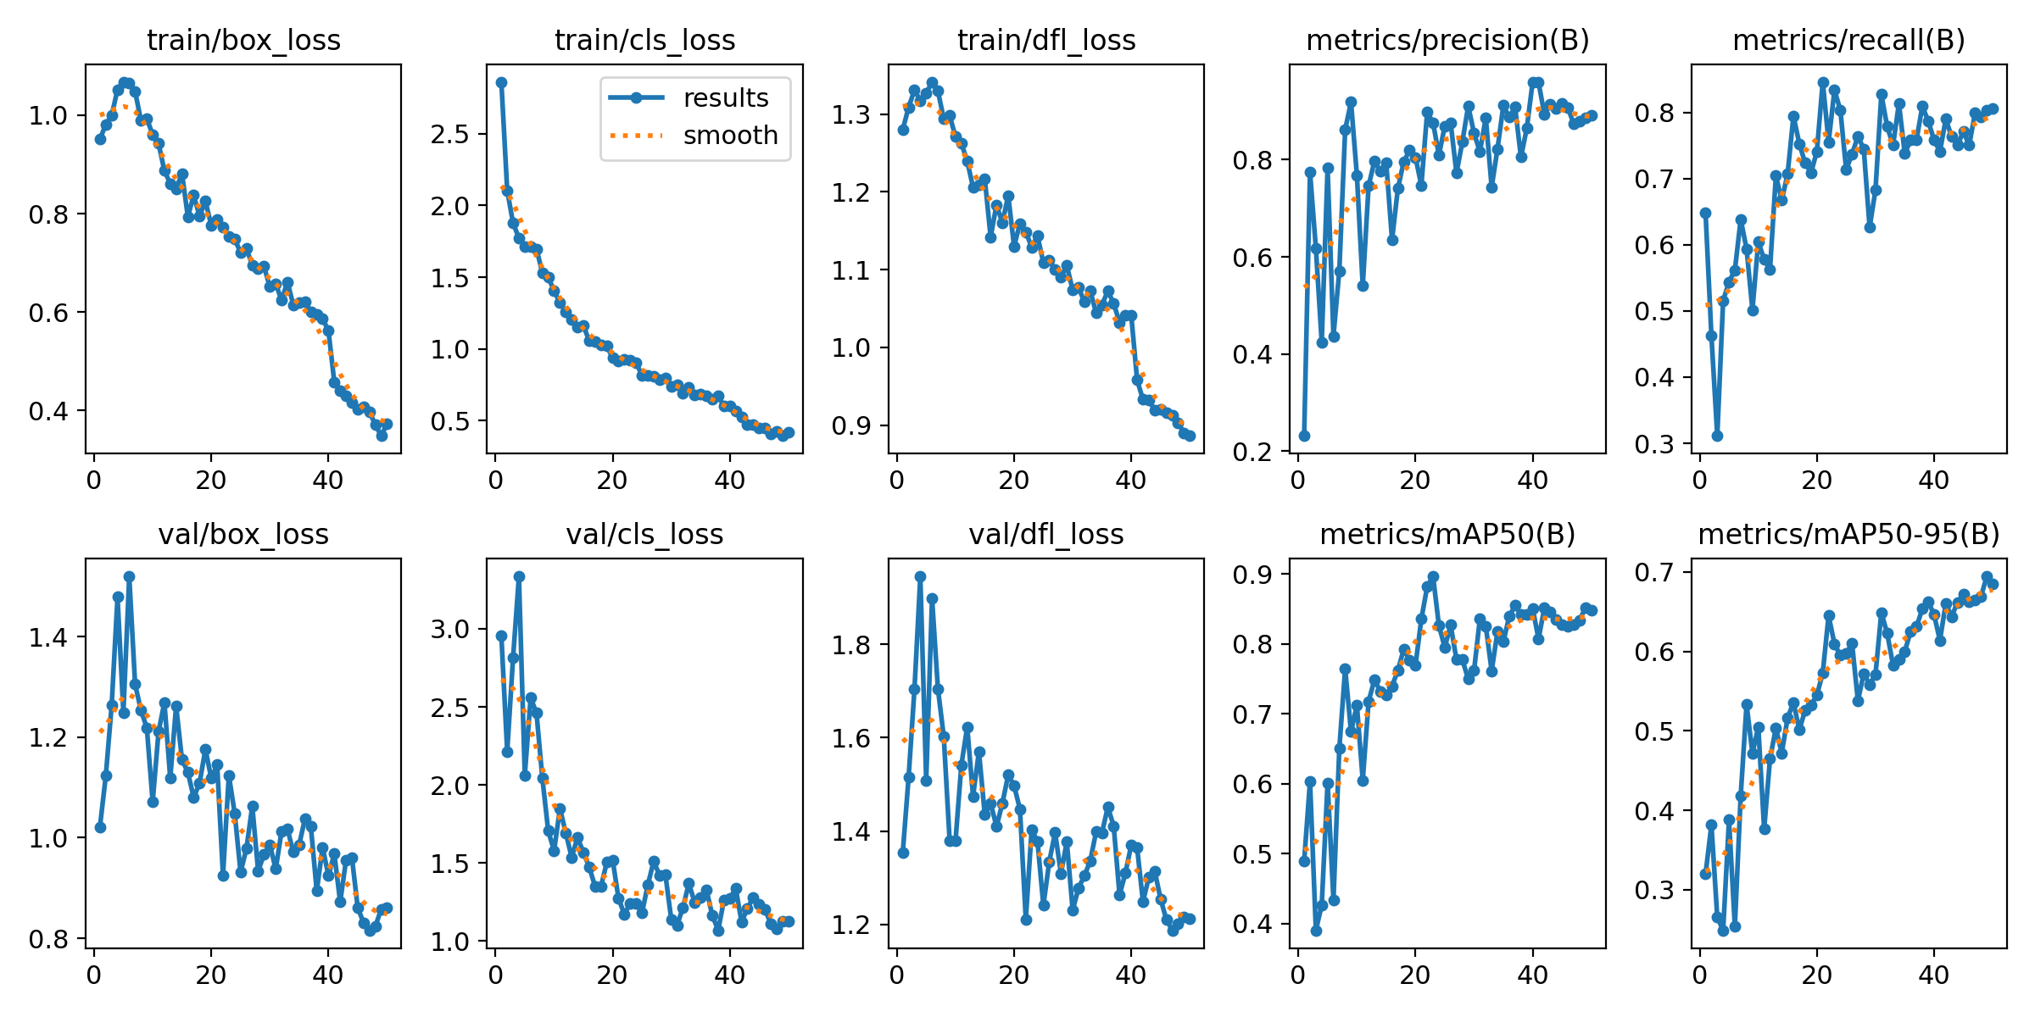

We ran our trained detector on a webcam feed and observed real-time predictions. You can find the code in video_cam.py at:
https://github.com/strombergleila-source/object_detection
The images are stored in the folder results_video_cam in GitHub.

References:
How to Train YOLOv8 Object Detection on a Custom Dataset

