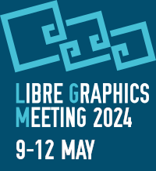
Call for Papers
Libre Graphics Meeting
9 – 12 May 2024, Rennes, France
Ending Call for paper : 26th january 2024.
Send back this completed sheet to contact.afgral@gmail.com

Talk
Title
Short description of the talk
Full description of the talk
Images (please provide at least one)
Duration | Lightning talk (5min)  30 minutes  1 hour  more : …………
Type | Conference  Demo  Workshop

Speaker(s)
First name
Last name
e-mail
Preferred day | 9 May  10 May  11 May  12 May (morning only)
Do you need a financial contribution for your travel?
Yes
No
If yes, how much (approx.) : €
The LGM will take place in Rennes, France. The financial contribution will be available according to the grant and the expenses. The organization cannot know, for now, how much it will be possible to refund for each of you.
Thanks, local Rennes team

