The Journey to the VWAP Trend Strategy
The complete story of one research project — from an academic paper to a final trading strategy
Strong Chicken Journal project • NQ futures • 2018–2026
Written for complete beginners — every term explained, no step left out

1. Introduction — what this document is
This document tells the entire journey of one quantitative research project: how we took an idea from an academic paper, verified it, broke it, repaired it, stress-tested it from every angle, ran into several walls — and finally distilled it into a trading strategy that was profitable in every single one of eight years of historical data, with a worst drawdown of only −6.4%.
It is written so that a complete beginner can follow it. Every technical term is explained the first time it appears, and chapter 3 is a glossary. Nothing is hidden — we describe every dead end, every failed test, the technical problems that slowed us down, and even the decisions we chose NOT to make. That is what separates honest research from marketing: marketing shows you only the winner; research also shows you the graveyard of ideas the winner is standing on.

2. How the research was actually done (behind the scenes)
Before the content, the "workshop" — because the workflow is part of the story and shaped what was possible.
- QuantConnect (QC) — an online platform with minute-by-minute historical market data and the LEAN simulation engine; strategies are written in Python. We used a free account, which imposed three important constraints: (1) backtests could not be launched programmatically — every run had to be clicked manually in the browser; (2) only one compute node was available — one running backtest at a time; (3) outputs (logs, charts) were read back through an API with limits (log pagination in 200-line pages, ~10 kB log cap). We therefore designed every experiment so that one click answered as many questions as possible — instead of twenty runs, one run with twenty variants inside (the "compute-engine" pattern: strategies are simulated internally and results exported via chart series and tagged log lines).
- Local analysis — statistics (bootstrap, percentiles, heatmaps, charts) were computed with our own Python scripts (pandas, numpy, matplotlib) on data pulled from QC. Every figure in this document was produced this way.
- TradingView — a web charting app; in its Pine Script language we progressively built an indicator for live monitoring (its full evolution is chapter 15).
- Git repository — every piece of code, result, figure, and write-up is version-controlled; every conclusion has a traceable commit. The playbooks (technical journals) hold the full numbers of every test.
- Costs in simulations — everywhere we charge per-trade costs (fee + slippage). Two scenarios: optimistic 0.4 bps and conservative 1.2 bps per round trip. Unless stated otherwise, every number in this document is after conservative costs.
- Data — NQ futures as a "continuous contract" (individual expirations stitched together), minute candles, main session. In-sample window: Jan 2, 2018 – Sep 30, 2025.

3. Glossary for complete beginners
- Futures (futures contract) — an exchange contract for betting on the future price of something. We trade NQ = futures on the Nasdaq-100 index. NQ moves in points; one point = $20 per contract.
- Long / Short — long = betting on a rise; short = betting on a fall. Futures make both equally easy.
- RTH (Regular Trading Hours) — the main US session: 9:30–16:00 New York time.
- VWAP (Volume-Weighted Average Price) — the day's average price weighted by traded volume; "the average price everyone actually paid today." The most watched intraday "fair price."
- Bps (basis point) — one hundredth of a percent. 20 bps = 0.20%.
- Backtest — a simulation of a strategy on historical data. It never proves the future, only describes the past.
- In-sample (IS) / Out-of-sample (OOS) — IS = data you develop and tune on. OOS = data locked away, never looked at during development. Only OOS is a real test — on IS you are always "taking the exam with the answer sheet in your pocket."
- Overfitting — trap #1: try enough variants and one will look great on the past by pure chance. Telltale sign: only one exact parameter value works (an isolated "spike"), its neighbors don't.
- Equity curve — a chart of account value over time.
- CAGR — compound annual growth rate.
- Max drawdown (MDD) — the largest peak-to-trough drop of the account. For prop traders THE number — a big drawdown gets you fired.
- Sharpe ratio — return divided by volatility; "return per unit of bumpiness." 1.0 decent, 1.4 very good, 2+ suspicious.
- Win rate — percentage of profitable trades. A high win rate does NOT mean a profitable strategy — you will see this twice.
- Stop-loss (SL) / Take-profit (TP) — SL = the level where you cut a loss; TP = the level where you take profit.
- Stop-and-reverse — an exit that simultaneously opens a position in the opposite direction.
- Whipsaw — a quick false move: you enter, the market immediately reverses, you exit with a loss.
- Overnight gap — the difference between today's open (9:30) and yesterday's close (16:00).
- Vol-targeting (VT) — sizing positions by current volatility (calm market = bigger position, wild = smaller) to target constant risk. "VT15" = 15% annual volatility target.
- Monte Carlo / bootstrap — resampling historical returns (with replacement) into thousands of alternative "how it could have gone" scenarios.
- Percentile — position in a distribution: "30th percentile" = 30% of scenarios did worse.
- Quintiles — splitting data into fifths (Q1 = bottom 20%, Q5 = top 20%).
- t-statistic — a measure of statistical significance; |t| above ~2 is considered signal, not noise.
- Pre-registration — writing down the success criteria BEFORE running a test, so the result cannot be bent afterwards.
- Prop firm — a company that gives a trader its capital for a profit share, with a strict drawdown limit.

4. The starting point: the academic paper
Everything began with Zarattini & Aziz: "VWAP: The Holy Grail for Day Trading Systems" (SSRN 4631351). The authors claim a simple intraday trend-following strategy around VWAP achieved over 40% per year on the QQQ ETF (a Nasdaq-100 tracker) with a Sharpe around 2.
The paper's rules: every minute, check whether the candle closed above or below VWAP. Close above → be long; close below → be short (an immediate flip, stop-and-reverse). Entries fill at the next candle's open. Close everything at end of day. Pure trend-following: no guessing turns, just riding the current.
"Holy Grail" is marketing. Our question: is anything real in it, and does it survive contact with reality (costs, slippage, other markets)?

5. Step R1: Replication — checking the paper isn't lying
Replication = programming the rules exactly as written and verifying the numbers match. Half the internet's "miracle" strategies die right here. We tested QQQ and the leveraged TQQQ, 2018 – Sep 2023, with the paper's own cost model:
metric | QQQ ours | QQQ paper | TQQQ ours | TQQQ paper
total return | 611.6% | 671% | 1,484% | 8,242%
CAGR | 40.8% | 43% | 61.9% | 116%
volatility p.a. | 17.7% | 18% | 52.9% | 54%
Sharpe | 2.0 | 2.1 | 1.2 | 1.7
max drawdown | 8.8% | 9.4% | 40.9% | 36.1%
win rate | 17.4% | ~17% | 18.1% | ~17%
win:loss ratio | 5.5 | ~5.7 | 5.2 | ~5.5
trades | 23,360 | ~21,967 | 23,504 | ~22,399

QQQ: PASS, an almost exact match. Notice: a 17% win rate — the strategy loses 5 trades out of 6, yet earns, because the average win is 5.5× the average loss. That is the DNA of trend-following: many small losses, an occasional huge win.
TQQQ: trade structure matches, headline number doesn't. We traced the 0.71 bps/trade gap exactly: the paper computes per-share fees on pre-split prices, where the share price is high and the fee relatively tiny; on split-adjusted data the same fee is several times larger relatively. A data artifact, not a rules error — which is why QQQ (high share price) matched.

6. Step R2: Translating to the S&P 500 — dead end #1
We don't want to trade a fund, we want futures. Before the test we wrote down explicit decisions (no silent defaults): ES anchored to RTH 9:30–16:00; continuous contract; position 1× account value, no leverage; costs 0.4/1.2 bps per trade; window ending Sep 30, 2025 (the reserved OOS untouched). Results (2018 – 2025/09, ~17.5 trades/day):
scenario | SPY CAGR | SPY Sharpe | ES CAGR | ES Sharpe
gross (no costs) | +9.8% | 0.76 | +12.0% | 0.91
optimistic costs | −8.0% | −0.54 | −6.1% | −0.39
conservative costs | −35.5% | −2.91 | −34.1% | −2.78
simply holding SPY | +14.3% | 0.65 | — | —

Two crushing findings. First: the gross edge on the S&P is 4× weaker than on the Nasdaq — intraday trendiness is a property of the tech index, not of markets in general. Gross return is even BELOW buy-and-hold. Second: ~17.5 trades/day × cost × 250 days = an enormous bleed. For completeness: even the flagship QQQ with realistic costs is sobering — optimistic +19.4% (Sharpe 1.07, still interesting), conservative −14.0% (dead). The paper effectively assumes trading for free.
Lesson #1: Costs are not a detail. For high-frequency strategies they decide life and death. Any backtest without realistic costs is a fairy tale.

7. Step R4: The rescue on NQ — the hysteresis band
We moved the strategy to NQ (Nasdaq futures — where the edge lives) and attacked the costs. Starting point: 16.2 trades/day, conservative-cost CAGR −17.8%. The fix: a hysteresis band — draw a ±20 bps band around VWAP and act only when price closes BEYOND it. "Hysteresis" is a physics term: ignore small stimuli, respond only to large ones.
configuration | trades/day | CAGR (conserv. costs) | Sharpe | MDD
no band (raw replica) | 16.2 | −17.8% | — | —
20 bps band | 2.5 | +9.5% | 0.59 | −22.4%
20 bps band + VT15 | 2.5 | +9.6% | 0.74 | −12.2%

The anatomy of why it works: 77% of the original trades were whipsaws under 15 minutes, collectively losing hundreds of percent — the band filtered them out. And the other side of the coin: the top 1% of trades carried 2–3.6× the total profit — without the rare big winners the strategy does not exist. The VT15 layer doesn't raise the return but smooths the risk (drawdown −22% → −12%). This configuration (20 bps band + VT15) was frozen for the live test.

8. Step R3: The one-shot test on unseen data
From the start we kept a locked OOS window: data from Oct 1, 2025 onward, forbidden to touch. Before the test came the frozen spec ceremony: we wrote to a file the exact configuration, the exact evaluation bands (e.g. a result between −5% and 0% = "inconclusive"), and the promise the test runs only once. Only then the click.
A complication: the platform's continuous NQ data ended Apr 16, 2026, so of the planned 197 trading days only 140 materialized. The result: gross +1.87%, optimistic costs +1.11%, conservative −1.33% → per the pre-registered bands, INCONCLUSIVE. Important: the mechanics matched (2.3 trades/day, win rate 35.8% ≈ history) — the strategy behaved correctly; the edge was simply weak in that period. The window was thereby consumed.
Lesson #2: A short OOS window is a coin flip — statistically it cannot tell "works" from "doesn't." Monte Carlo will prove exactly this shortly.

9. Diagnosis D1: When does the strategy make money?
Instead of more tuning, we decomposed the edge by year and looked for the conditions it lives in:
year | NQ volatility | raw gross edge | band-20 net | band+VT15 net
2018 | 20.1% | +49.4% | +23.9% | +17.0%
2019 | 11.9% | +10.9% | −3.8% | −3.8%
2020 | 23.3% | +89.2% | +13.7% | +18.9%
2021 | 14.5% | +49.4% | +22.9% | +21.4%
2022 | 26.8% | +66.4% | +14.4% | +13.0%
2023 | 15.2% | +13.0% | +0.7% | +1.3%
2024 | 13.9% | +23.6% | +19.2% | +19.1%
2025 (Jan–Sep) | 21.4% | +5.1% | −11.4% | −7.8%

The pattern: the edge correlates with volatility (correlation +0.62; with time −0.44). Calm 2019 = weakest, wild 2020/2022 = strongest. Trend-following needs movement. But the last row is a warning: 2025 had volatility comparable to 2018 (21 vs 20%), yet an edge of only +5% instead of +49%. The last ~2 years deliver less edge than their volatility would predict — a possible fingerprint of "crowding" (too many people trading the same thing). Filed as something to watch.

10. Diagnosis D2: Monte Carlo and the parameter map
Two questions: (1) How much of the −1.33% OOS result is noise? (2) Is the configuration overfitted to one lucky value?
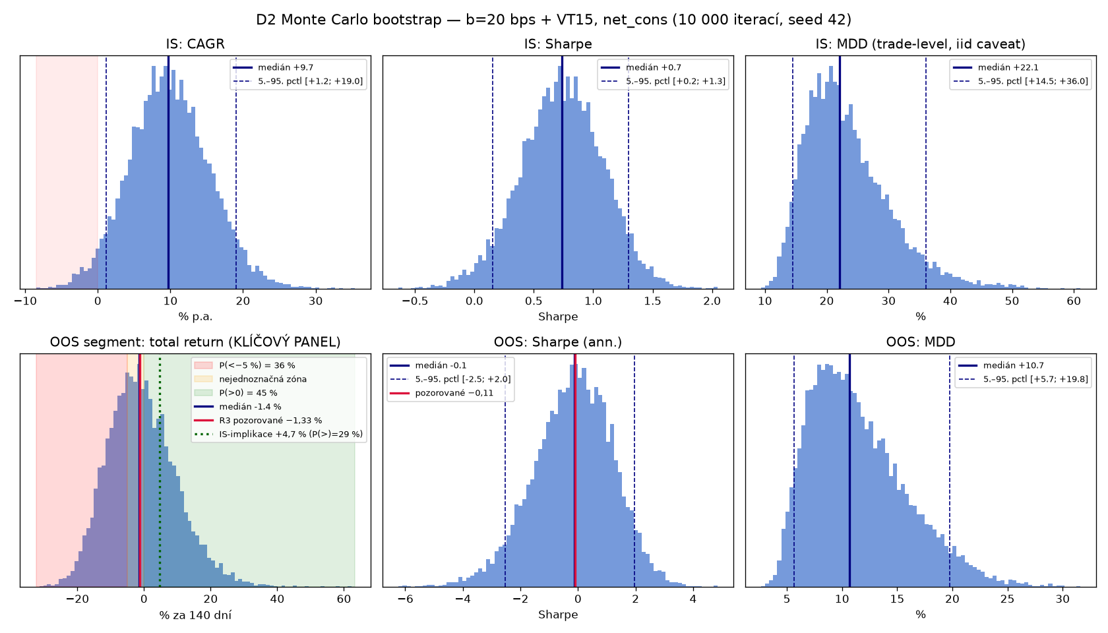
Monte Carlo: the distribution of possible outcomes (10,000 replayed scenarios from 5,372 historical trades).
In-sample bootstrap: median CAGR +9.7% (5th–95th percentile: +1.2 to +19.0%), probability of a negative CAGR only 3.2%. But the bootstrap of the OOS segment (325 trades): median −1.4%, range −16 to +18%, and crucially P(positive) = 44.8% — a coin flip. The −1.33% result is therefore almost entirely noise; the window had no power to decide anything. The "inconclusive" verdict of R3 was thus empirically confirmed.
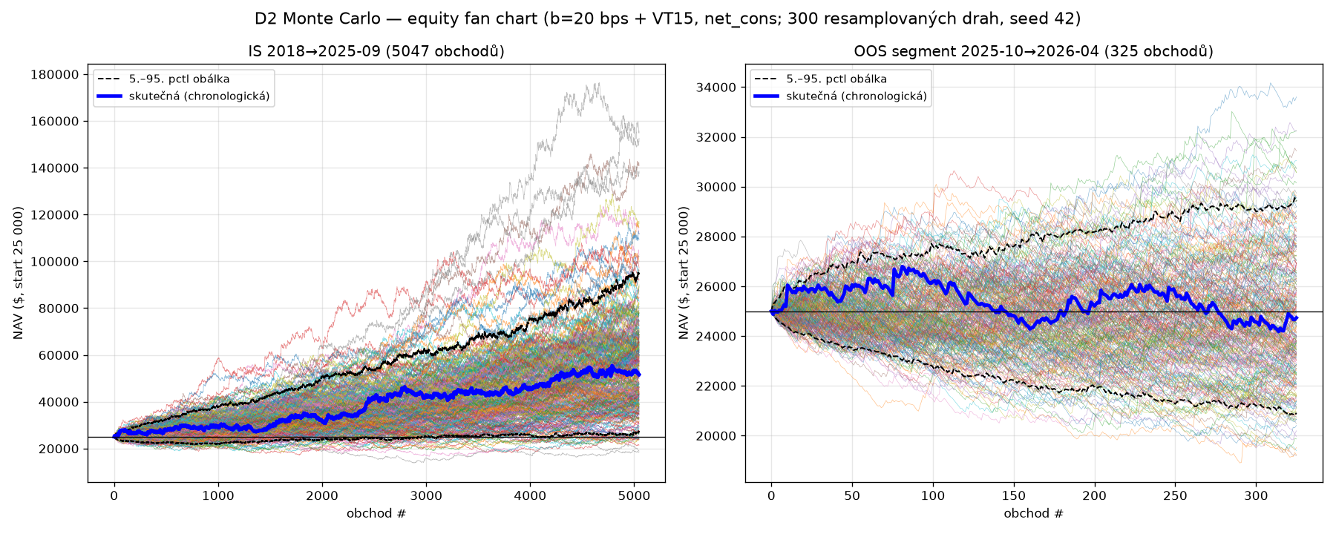
The fan of equity curves from Monte Carlo — this is how wide the spread of possible fates of the same strategy is.
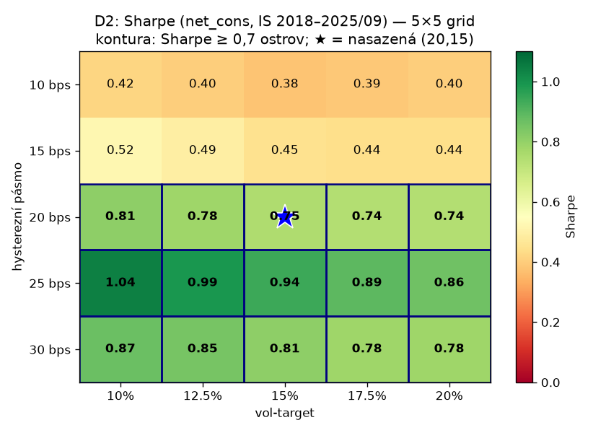
The parameter map (band × VT): one connected island of good values = a healthy sign.
The 5×5 grid (band 10–30 bps × VT 10–20%) by Sharpe: our cell (20, 15) = 0.75; the entire band rows 20/25/30 above 0.7; the best ridge at band 25 (Sharpe up to 1.04). Formal cluster analysis: at a Sharpe ≥ 0.5 threshold the good cells form one connected island of 16 of 25 — no isolate. Our configuration sits inside it (at the edge toward smaller bands). Conclusion: parametrically healthy.

11. Dead end #2: the fixed take-profit (the TP grid)
A tempting idea arrived: "add a fixed profit target for a higher win rate and less variance." Before the test we wrote down a prediction: "a fixed TP will significantly hurt expectancy." We tested TP at 0.25×, 0.5× and 1× the trade's risk (risk = distance from entry to the opposite band):
variant | win rate | trades | CAGR (conserv.) | MDD
TP = 0.25× risk | 79.6% | 11,115 | −11.3% | −62.9%
TP = 0.5× risk | 66.3% | 8,513 | −6.8% | −47.5%
TP = 1× risk | 51.3% | 6,656 | −1.2% | −37.5%
no TP (original) | 36.4% | 5,051 | +9.5% | −22.4%

The prediction was confirmed harder than expected — and the relationship is perfectly monotonic: the tighter the TP, the worse. A TP with an 80% win rate loses 11% a year! The mechanism: trend-following profit comes from a few huge winners; a fixed TP systematically cuts them off ("picks the flowers, waters the weeds") and lets only the losses run.
Lesson #3: Win rate is a marketing number. An 80% win rate can reliably go broke while a 36% win rate reliably earns.

12. A new variant: one trade per day
For real (discretionary) trading, stop-and-reverse with 2–3 trades/day is impractical. So we reshaped the strategy: one trade per day. Rules: from 9:31, wait for a 1-minute candle to close beyond the VWAP ±20 bps band → enter in the break's direction at the next candle's open, first signal of the day only. Exit: a close beyond the opposite band (no reversing!), or 16:00. We ran a verification with two branches — no TP, and a real TP of 74.375 points (half the originally considered 148.75):
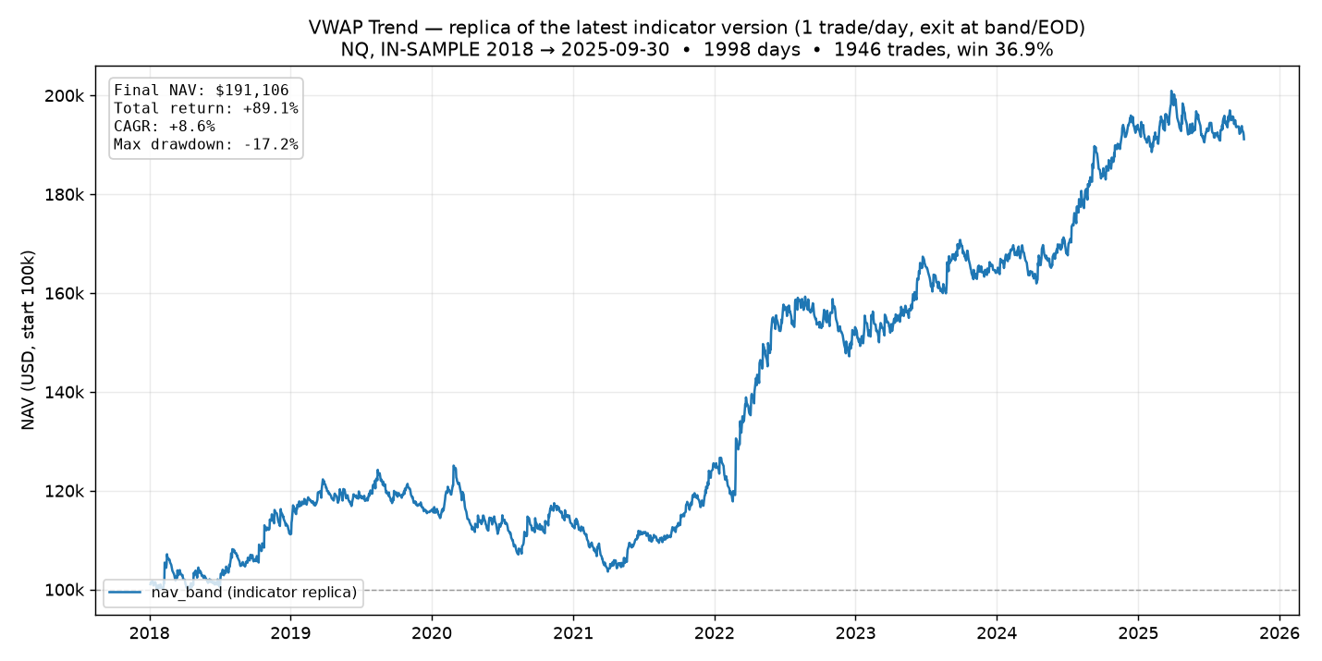
Equity curve of the one-trade-per-day variant (no TP): +89% over 7.7 years.
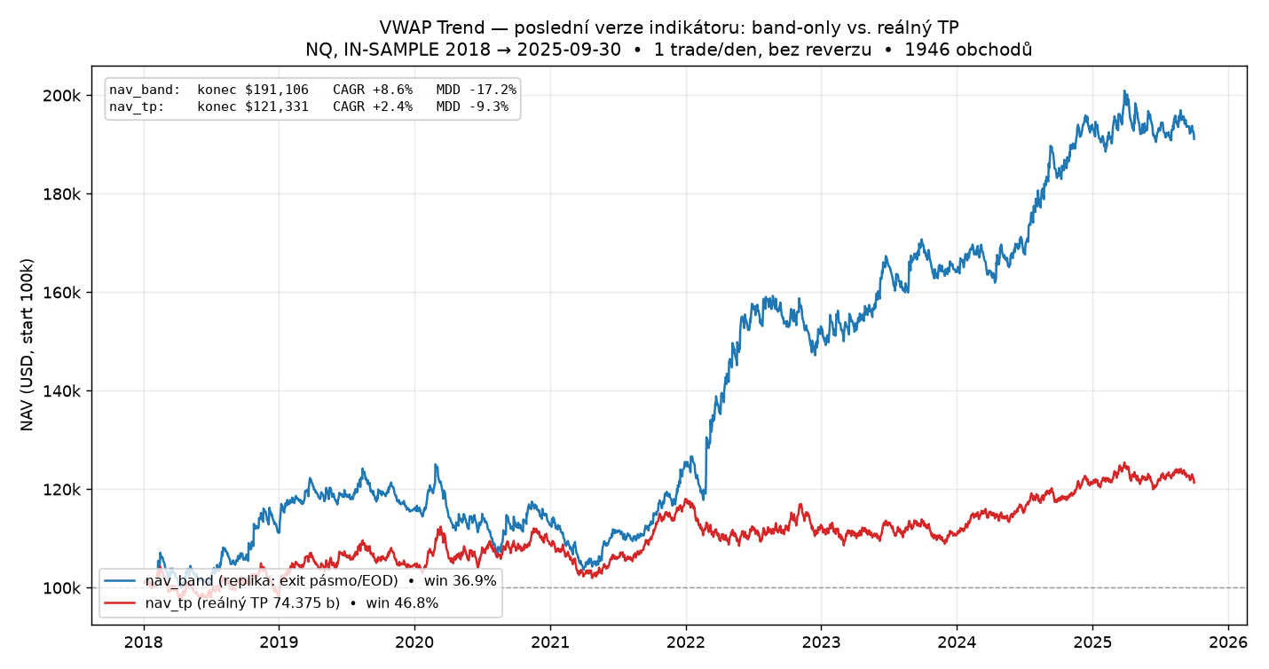
Both branches compared: no TP (blue) vs. TP 74.4 points (red).
variant | total | CAGR | MDD | win rate
no TP (band exit) | +89.1% | +8.6% | −17.2% | 36.9%
with TP 74.375 pts | +21.3% | +2.4% | −9.3% | 46.8%

The same lesson in a new disguise: the TP raised the win rate to 47% and softened the drawdown, but cut the return to a quarter. An important question also came up here: "wouldn't this beat the index?" The honest answer: no — simply holding the Nasdaq earned several times more over the same period. The strategy's added value is not raw return but half the drawdown, zero overnight risk, and the short side (it earns in declines too). This needs saying out loud.

13. The robustness test: fan chart, cloud, and heatmaps
The request was: "let's do our classic robustness test — the OOS window, a spaghetti fan chart, a cluster analysis, and a parameter-stability heatmap." One QC run supplied everything: the frozen band-20 run extended over the whole 2018–2026/04 range (for the fan chart and the OOS line) + a band grid 8–30 bps on IS only (for the heatmap).

13.1 The spaghetti fan chart — reality vs. expectations
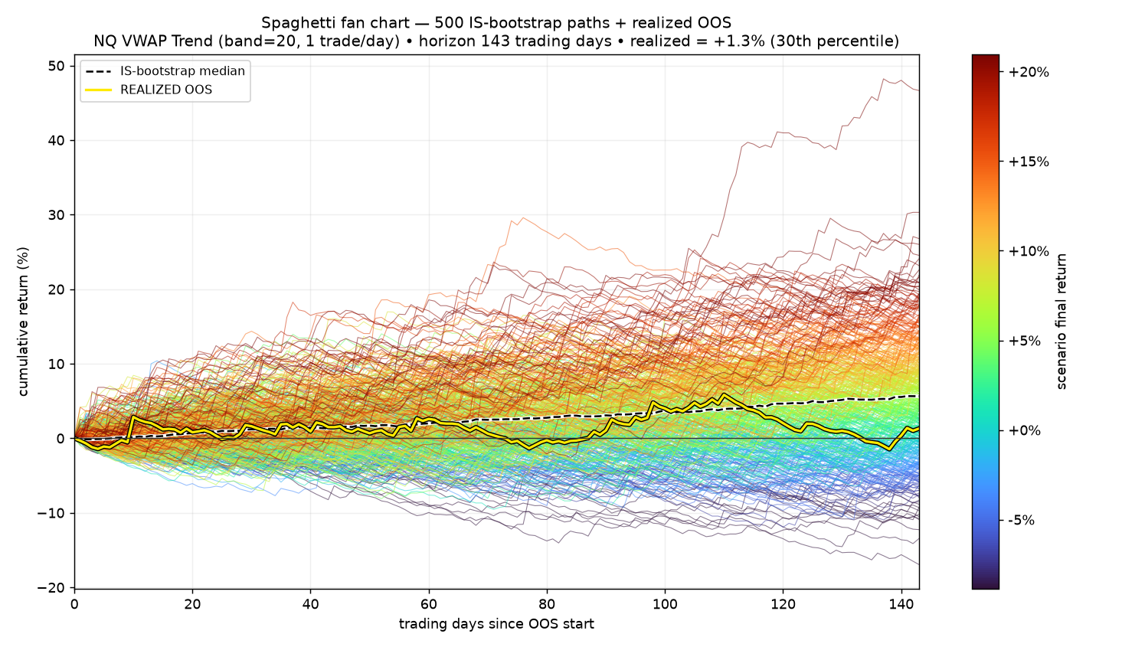
500 randomly replayed scenarios (colored paths) and the actual result on the newest data (yellow path).
From the IS daily returns we generated 500 alternative futures and drew the actual October 2025 – April 2026 result on top: +1.29% over 143 days = the 30th percentile. Reality stays inside the fan but below its middle — the edge exists, just weaker than the historical average. (Honesty note: this window had already been seen by R3, so for this variant it is "semi-OOS.")

13.2 The outcome cloud (cluster analysis)
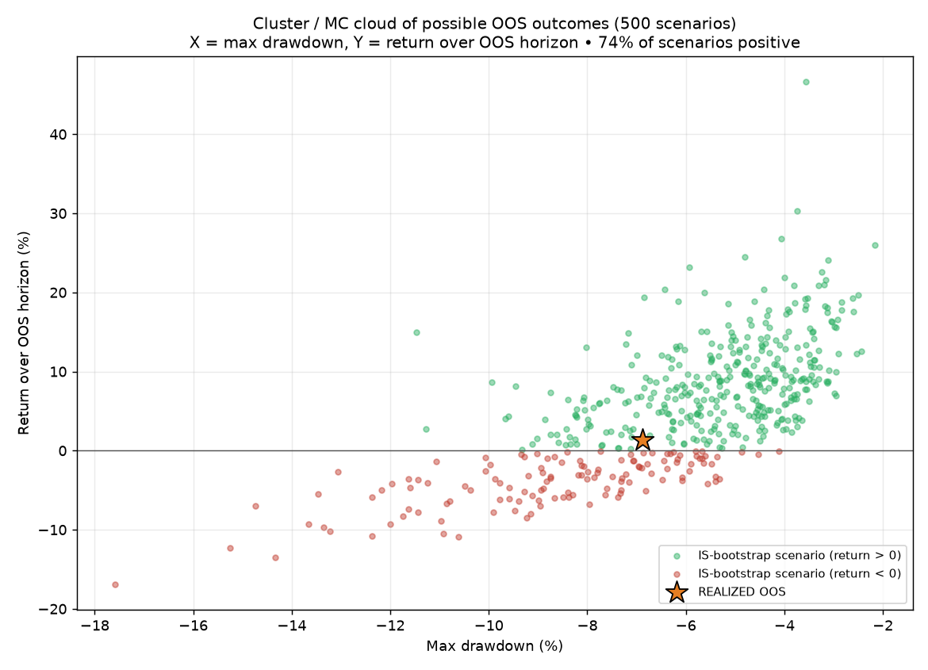
Each dot = one scenario (return × worst drawdown). The star = reality. 74% of scenarios positive.

13.3 Band stability across years
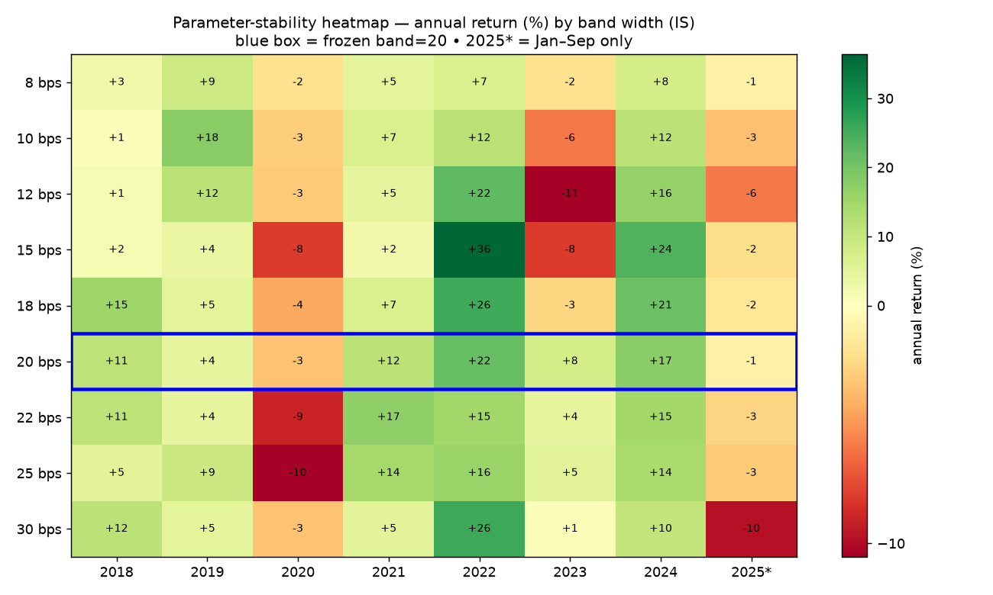
Annual returns by band width 8–30 bps. Blue box = our band 20.
band (bps) | 8 | 10 | 12 | 15 | 18 | 20 | 22 | 25 | 30
IS total return | +29% | +39% | +38% | +51% | +80% | +91% | +66% | +58% | +50%

The entire band family is profitable → the concept is not a one-value fluke. BUT: band 20 sits exactly at the peak of the curve (18 → +80, 20 → +91, 22 → +66). A peak is always partly luck — the realistic expectation is the neighborhood average (+50–80%), not the peak. This "peak warning" proved useful twice later.

13.4 The big 2D map: the overfitting check from the reference images
The user brought two textbook pictures: overfit = one bright pixel in noise; robust = a broad bright plateau. We built the same for our strategy: 12 band widths × 8 TP distances = 96 combinations in one run.
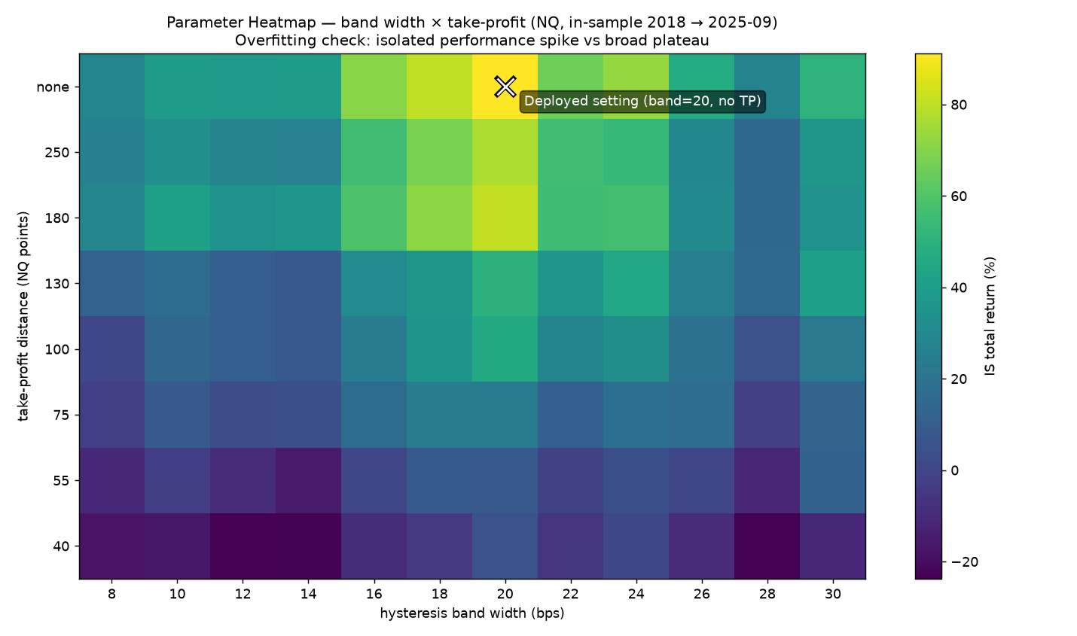
96 combinations (band × TP). Bright zone = profit. The cross = the deployed configuration (band 20, no TP).
The result: all 96 cells profitable (weakest +5%), a connected bright zone of bands 16–24 with loose/no TP (+66 to +91%). Along the TP axis a perfectly smooth gradient (TP 40 pts → +5%, TP 250 → +77%, no TP → +91%) — yet another independent confirmation that TP hurts. Verdict: plateau, not spike — but the deployed cell is again the global maximum, so the peak warning applies.

14. Why the strategy stagnated in 2019–2020
The equity curve shows a two-year dead zone (the user circled it directly on the chart). The breakdown revealed two different causes: 2019 = the lowest volatility of the sample, the market crawling up millimeter by millimeter, no intraday trends, whipsaws everywhere (+4.5%). 2020 = a paradox: enormous volatility (COVID), but the "one trade per day" cap meant the first signal often fired in the insane open, got stopped immediately — day over; we watched the afternoon trend from the bench (−3.3%). Proof: the uncapped variant made +13.7% that year — the cap caused the loss, not the signal. This insight launched the improvement phases.

15. Interlude: the TradingView indicator's evolution (v1 → v3)
Alongside the research we built the live-monitoring tool. Each version answered a specific request or bug — this too is part of the journey:
- v1 — the basic version: VWAP, ±20 bps band, BUY/SELL arrows; in an open trade the SL side of the band turned red.
- v2, step 1 — request: don't draw the SL as a moving band but as a fixed line, + a green TP line at 148.75 points.
- v2, step 2 — request: make the trade lines short (entry to exit), not infinite — so the chart keeps a readable history of all trades. Implementing it we caught a sneaky bug: the lines of old trades kept "stretching" toward new entries; the fix was a live-trade flag (trActive).
- v2, step 3 — TP halved to 74.375 and a one-trade-per-day limit introduced (stop-and-reverse removed) — the indicator caught up with the new strategy variant.
- v2, step 4 — a user bug report: "the history never shows a TP exit, only EOD or SL." Exact diagnosis: the TP line was only drawn, the position logic never evaluated it. Fix: a TP touch = a real exit + a green "TP" diamond.
- v3 — two switchable modes: "TP (fixed target)" vs. "Band (no TP)" — in Band mode no lines; instead the SL side of the band turns red and the trade-direction side green. Along the way we caught a Pine Script compile error (line width cannot be dynamic) — fixed with a constant width.
An English copy was made for the user's friend, plus a local Python backtester (vwap_trend_backtest.py) — a script that replays the same strategy on any CSV of minute data, with TP/fill/cost switches, so anyone can verify it independently.

16. Improvement — the rules of the game and Phase A
Before improving anything we wrote the rules (pre-registration): everything on IS data only; an improvement must raise CAGR by ≥2 points OR sharply cut the drawdown; must hold in most years (≥5/8); neighboring parameters must agree (no new spike). Two hypotheses from chapter 14: H1 — skip the chaotic open (enter from 9:45/10:00/10:30); H2 — allow another attempt after a morning stop-out (max 2/4 trades per day). One run: a grid of 4 entry times × 3 caps = 12 variants + an export of five daily conditions for the follow-up analysis.
A technical aside (honesty): the first run hit an undocumented limit of 10 chart series per backtest — we wanted 17, and the platform silently dropped seven. The fix: move the yearly sub-totals of all variants into logs, keep only essential series in charts — and one extra click.
variant (entry / max trades) | total | CAGR | MDD | Sharpe | win | years +
9:31 / 1 (baseline) | +91.1% | +8.7% | −17.2% | 0.85 | 36.9% | 6/8
9:31 / 2 | +76.7% | +7.6% | −16.1% | 0.60 | 36.9% | 6/8
9:31 / 4 | +109.4% | +10.0% | −17.7% | 0.67 | 37.2% | 5/8
9:45 / 1 | +65.7% | +6.7% | −15.5% | 0.65 | 36.9% | 6/8
9:45 / 2 | +122.7% | +10.9% | −16.7% | 0.82 | 37.9% | 7/8
9:45 / 4 | +135.2% | +11.7% | −17.1% | 0.78 | 38.0% | 6/8
10:00 / 1 | +100.7% | +9.4% | −11.9% | 0.89 | 39.2% | 7/8
10:00 / 2 | +112.4% | +10.2% | −20.5% | 0.78 | 39.1% | 6/8
10:00 / 4 | +113.8% | +10.3% | −20.4% | 0.71 | 39.1% | 6/8
10:30 / 1 | +42.4% | +4.7% | −18.4% | 0.49 | 40.5% | 6/8
10:30 / 2 | +102.1% | +9.5% | −18.7% | 0.76 | 41.1% | 6/8
10:30 / 4 | +125.9% | +11.1% | −18.8% | 0.81 | 41.1% | 6/8

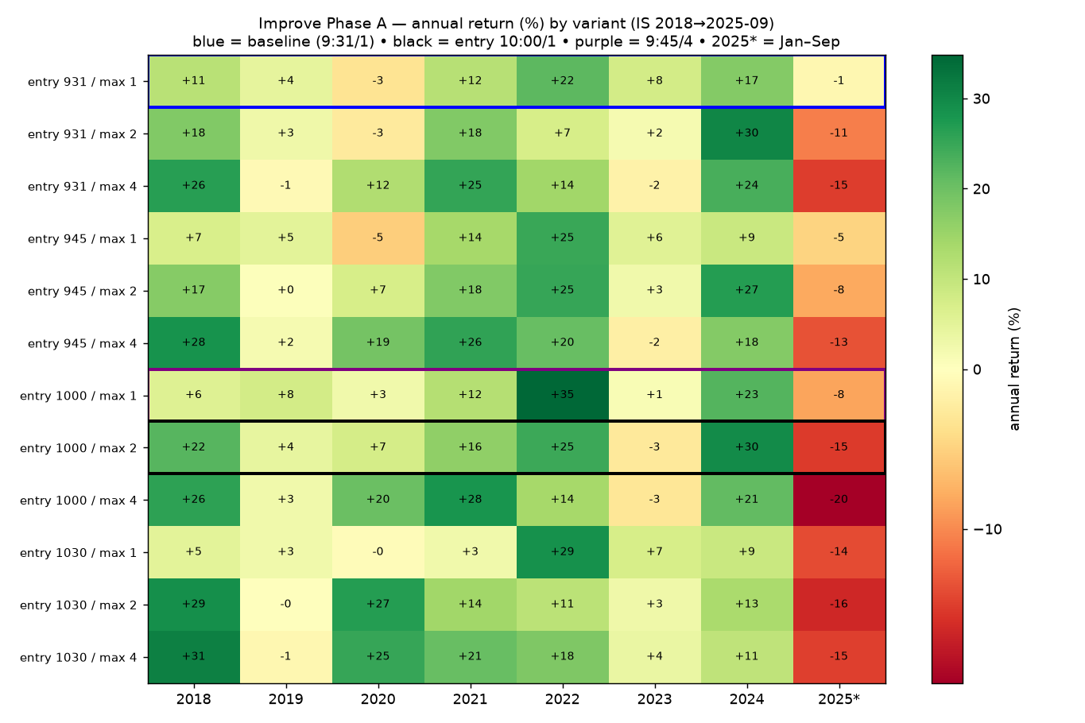
The 12-variant grid broken down by year — each variant's (in)consistency is visible here.
Verdict on H2 (re-entry): totals up, but head-to-head against the baseline it wins in only 4 of 8 years, the Sharpe drops (0.85 → 0.67–0.81), and crucially: the gains come from 2018/2020 while 2023 and 2025 get worse. Fails the criteria. Verdict on H1 (entry shift): the "max 1" column jumps 191 → 166 → 201 → 142 thousand with no logic = noise. The 10:00 entry looks good (Sharpe 0.89, MDD −11.9), but both its neighbors are bad → a suspicious spike; we don't trust it.
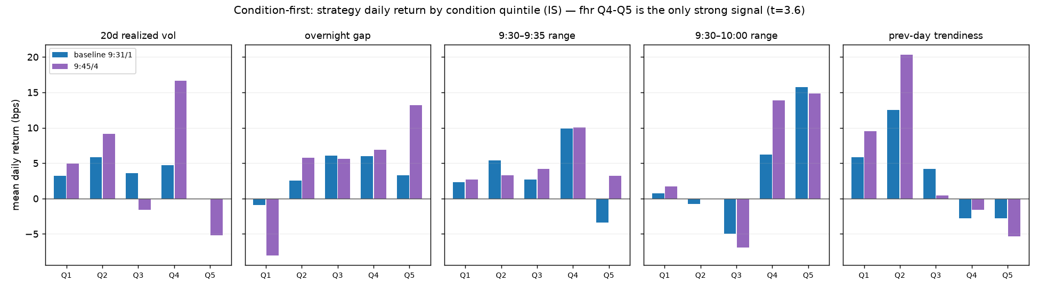
The condition analysis: strategy return by quintile of five morning variables (rv20, gap, or5r, fhr, ptrend).
condition (quintiles Q1→Q5, bps/day) | Q1 | Q2 | Q3 | Q4 | Q5 | note
fhr (9:30–10:00 range) | +0.7 | −0.8 | −5.0 | +6.2 | +15.7 | t = +3.6 — strong!
gap (overnight) | −0.9 | +2.6 | +6.0 | +6.0 | +3.3 | Q1 negative — a hint
ptrend (yesterday's trendiness) | +5.8 | +12.5 | +4.2 | −2.8 | −2.8 | inverse — weak
rv20 (20-day volatility) | +3.2 | +5.8 | +3.6 | +4.7 | −0.0 | nothing
or5r (9:30–9:35 range) | +2.3 | +5.4 | +2.7 | +9.9 | −3.4 | noise

The condition-first analysis (measure first, then test) struck gold: days with a wide first-30-minutes range gave +16 bps/day (t = 3.6). A weaker hint: the overnight gap (smallest gaps = a negative quintile). The logic: trend-following needs days with morning energy.

17. Phase B: gates — dead end #3 and an unexpected winner
We built "gates" (a gate = a condition without which the day is not traded at all). A crucial detail: the thresholds are not fixed numbers from the whole history (that would peek into the future) but a rolling percentile of the last 250 days computed from past days only — exactly as it would be computed live. Base: 10:00 entry, 1 trade/day. Results:
gate | total | CAGR | MDD | Sharpe | years vs. base | days in market
no filter (base) | +100.7% | +9.4% | −11.9% | 0.89 | — | 1944
fhr ≥ 40th pct | +91.4% | +8.7% | −11.3% | 0.95 | 5/8 | 1112
fhr ≥ 50th pct | +71.7% | +7.2% | −11.3% | 0.84 | 3/8 | 931
fhr ≥ 60th pct | +62.1% | +6.4% | −12.0% | 0.80 | 2/8 | 781
gap ≥ 20th pct | +140.7% | +12.0% | −11.3% | 1.21 | 6/8 | 1502
ptrend ≤ 60th pct | +101.1% | +9.4% | −7.5% | 1.13 | 3/8 | 1145
fhr50 + pt60 | +71.9% | +7.2% | −6.2% | 1.07 | 3/8 | 540
fhr50 + gap20 | +85.5% | +8.3% | −11.3% | 1.01 | 3/8 | 802

- The fhr gate — our favorite, from the strong signal — FAILED. Monotonically: the stricter the threshold, the worse. The beautiful quintile signal did not transfer into a trading rule. Dead end #3.
- The gap gate — the outsider — WON. Skipping the bottom 20% of days by overnight gap: +141%, Sharpe 1.21, 6/8 years, and above all it improved precisely the suspicious recent years 2023 (+6.7 vs +1.2) and 2025 (−2.4 vs −8.3).
- The pt gate left the return unchanged but cut the drawdown to −7.5% — filed as a risk damper.
Lesson #4: The strength of a statistical signal does not equal the usefulness of a rule — and an inconspicuous signal can make a great rule. Test, don't believe.

18. Phase C: is the gap gate luck? The plateau test
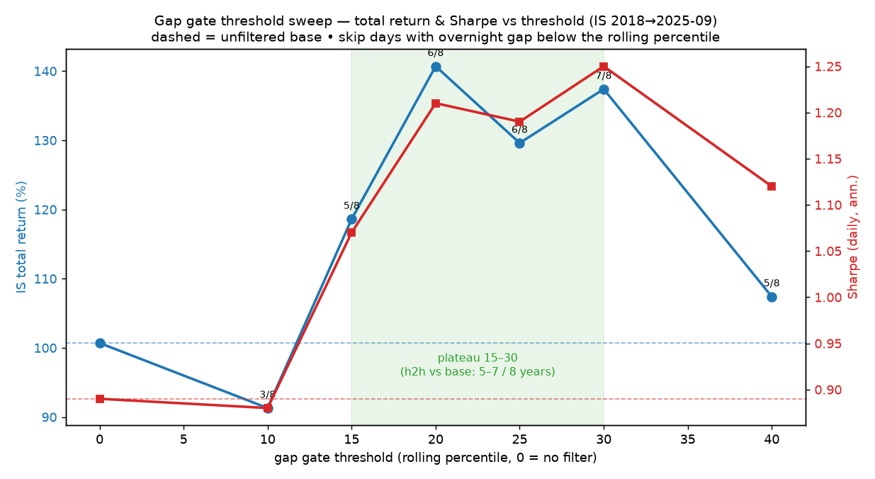
The gap-gate threshold sweep: return (blue) and Sharpe (red). Green zone = the 15–30 plateau.
gap threshold (percentile) | total | Sharpe | years vs. base
no filter | +100.7% | 0.89 | —
10 | +91.3% | 0.88 | 3/8
15 | +118.6% | 1.07 | 5/8
20 | +140.7% | 1.21 | 6/8
25 | +129.6% | 1.19 | 6/8
30 | +137.4% | 1.25 | 7/8
40 | +107.4% | 1.12 | 5/8
20 + ptrend60 | +109.1% | 1.27 | 4/8 (MDD −7.6%)

One winning threshold can be luck, so we swept the whole neighborhood. The result: a plateau at 15–30 with logical edges (10 barely filters → like base; 40 already cuts good days). Exactly the shape of a robust strategy. Following the peak lesson, we deploy the middle of the plateau (25), not the peak (20).

19. Phase D: the independence test
One uncomfortable question remained: phases B/C ran on the 10:00-entry base — which we ourselves had flagged as a suspicious spike. Is the credit in the gate, or in the entry? The gap is known at 9:30, so the gate can be applied to the fully original 9:31 entry. Sanity anchors: both base variants had to replicate their earlier numbers to the decimal — they did.
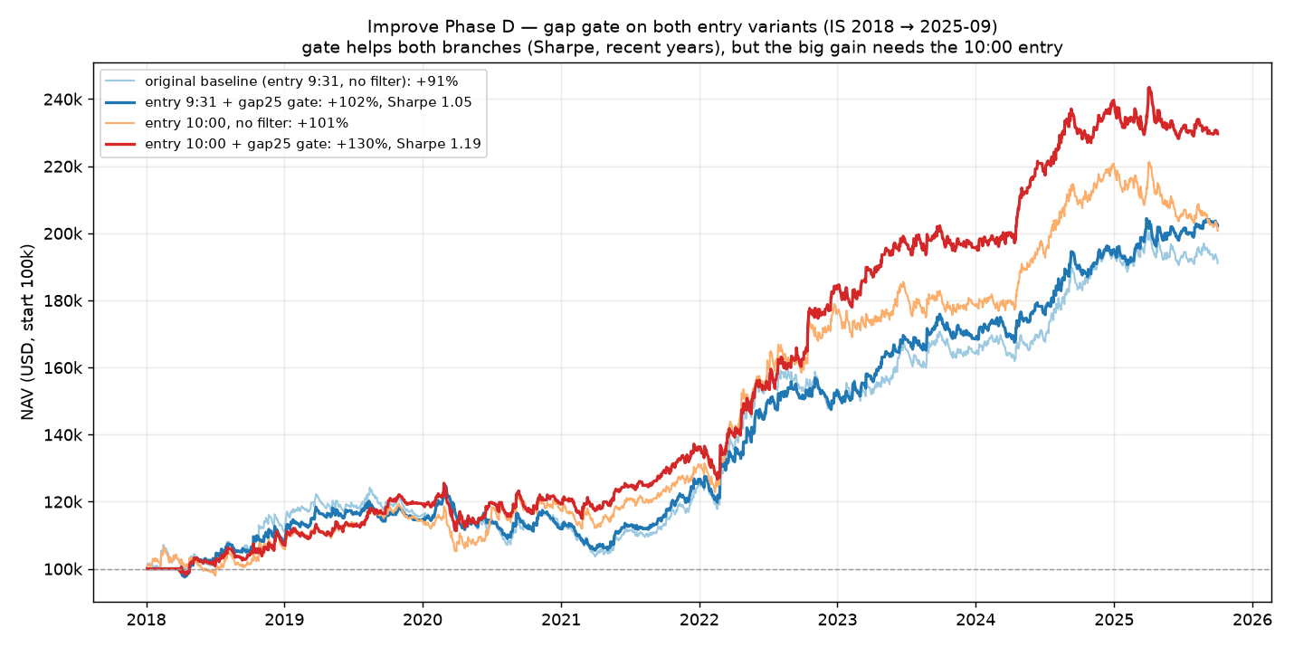
The gap gate on both entries: it helps both, but the big gain requires the suspicious 10:00 entry.
variant | total | CAGR | MDD | Sharpe | years vs. own base | 2025
9:31 no gate | +91.1% | +8.7% | −17.2% | 0.85 | — | −1.0%
9:31 + gap15 | +89.7% | +8.6% | −16.0% | 0.92 | 2/8 | +2.7%
9:31 + gap25 | +102.2% | +9.5% | −15.7% | 1.05 | 5/8 | +4.1%
10:00 no gate | +100.7% | +9.4% | −11.9% | 0.89 | — | −8.3%
10:00 + gap15 | +118.6% | +10.6% | −11.3% | 1.07 | 5/8 | −5.5%
10:00 + gap25 | +129.6% | +11.3% | −11.3% | 1.19 | 6/8 | −3.4%

The answer: the gate helps the original entry too (Sharpe 0.85 → 1.05; the year 2025 flipped positive on both branches!), but more mildly — CAGR only +0.8 points, below our pre-registered 2-point bar. The honest conclusion: the gap gate = a real but modest improvement of the risk profile. The big return numbers (+141%) require the shaky 10:00 entry and we do not promise them.

20. Phase E: the closing run and the final configuration
The last, pre-registered run — then tuning ends: (a) add the pt gate on top of the gap gate (acceptance criterion: MDD down by at least 3 points, return no worse than −10% relative); (b) decompose into the long and short halves (descriptive only, no decision).
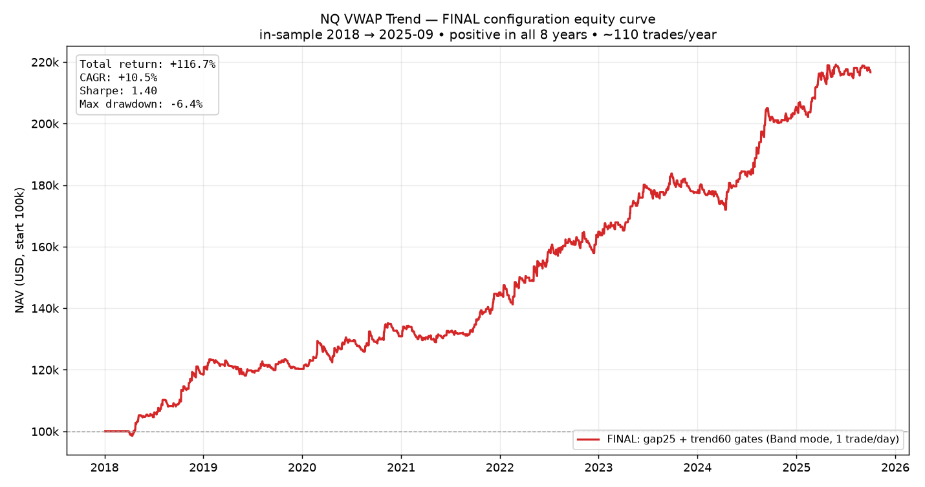
The final configuration: +117%, CAGR 10.5%, Sharpe 1.40, max drawdown −6.4%.
variant | total | CAGR | MDD | Sharpe | win | days in market
base 9:31 no gates | +91.1% | +8.7% | −17.2% | 0.85 | 36.9% | 1946
+ gap25 | +102.2% | +9.5% | −15.7% | 1.05 | 37.8% | 1410
+ gap25 + trend60 (FINAL) | +116.7% | +10.5% | −6.4% | 1.40 | 39.8% | 861
gap25, long only | +65.8% | +6.7% | −6.8% | 0.84 | — | 1204
gap25, short only | +25.0% | +2.9% | −18.3% | 0.39 | — | 1155

The combination of both gates beat the criteria with a huge margin: the drawdown −15.7 → −6.4% (we asked for 3 points, got 9.3), while the return rose. A bonus we hadn't even prescribed: positive in all 8 years (+18.5 / +1.5 / +8.8 / +10.9 / +13.6 / +7.7 / +15.1 / +6.0) — the only one of ~35 tested variants, including the repaired years 2020 and 2025. The price: it gives up part of the upside in strong years (2022: +13.6 vs +20.4) and trades only ~61% of days (~110 trades/year).
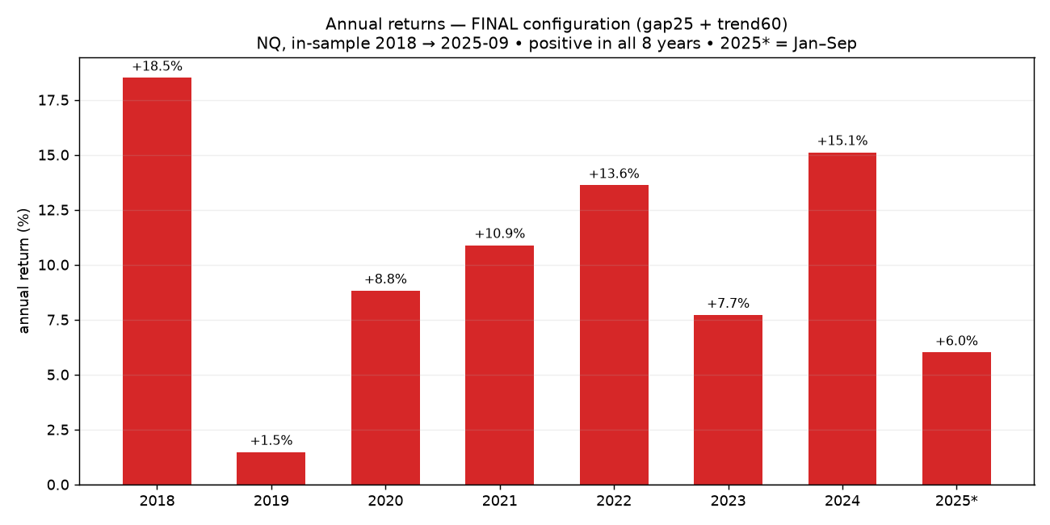
Annual returns of the final configuration — all eight years positive.
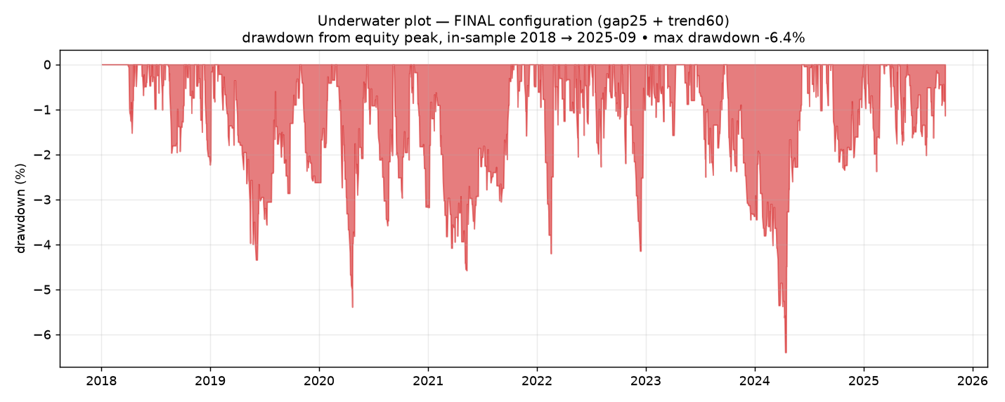
The underwater plot: how far below its peak the account ever was. Worst: −6.4%.
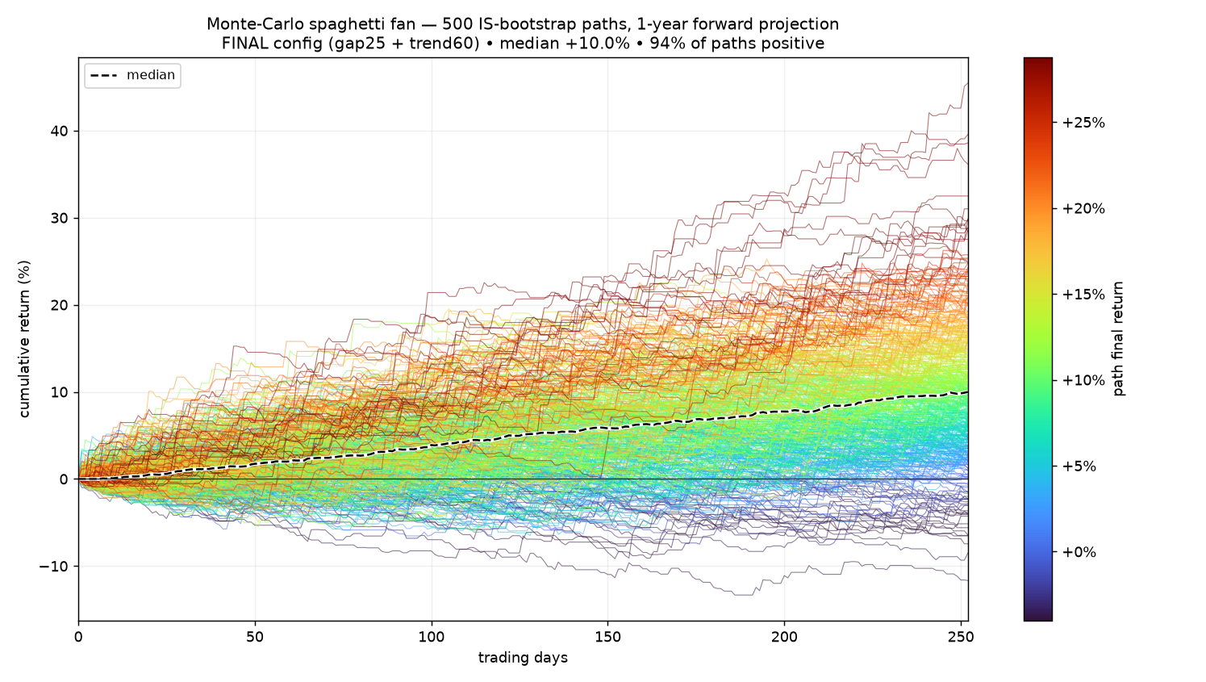
Monte Carlo projection one year ahead: 500 scenarios, 87% positive, median +11%.
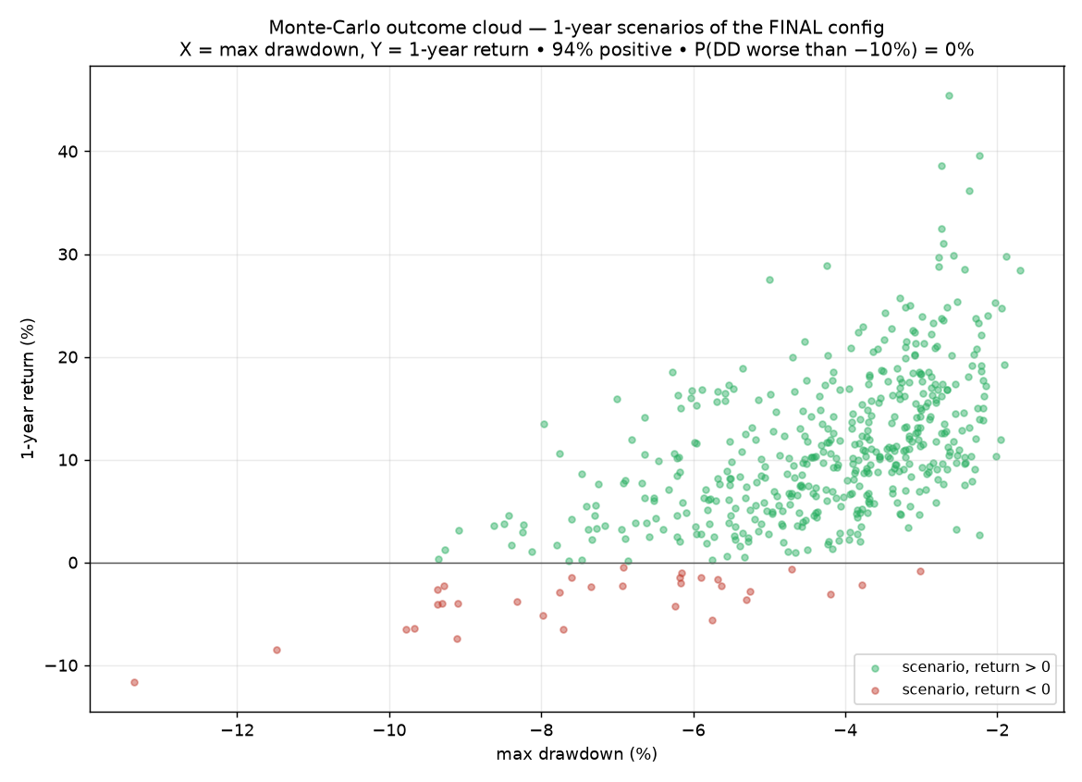
The cloud of one-year scenarios: return × drawdown.
The long/short decomposition (descriptive): long +66%, short +25% — both sides earn, and the short helps exactly in the years the long suffers (2018: short +13.6% while long −2.4%; 2020 short positive). Both sides stay.

The final rules (complete, ready to trade)
- Market: NQ futures, a 1-minute chart, the 9:30–16:00 New York session.
- At 9:30 each morning, two gates: (1) |overnight gap| ≥ the 25th percentile of the last 250 days; (2) yesterday's trendiness |close−open|/(high−low) ≤ the 60th percentile. If either fails → NO TRADING today.
- From 9:31: a 1-minute candle closes above VWAP +0.2% → long; below VWAP −0.2% → short. Enter at the next candle's open. First signal of the day only.
- Exit: a candle closes beyond the opposite band, or 16:00 — whichever comes first. No take-profit, no reversing.
Realistic expectations: the historical numbers (Sharpe 1.40) are inflated after ~35 tests on the same data. A sober estimate: Sharpe around 1.0, CAGR in the high single digits, drawdowns in the single digits.

21. The indicator v4–v5: the gates on a live chart
The final configuration flowed into the indicator in two steps. v4 added the gap gate: a forbidden day shows a red NO TRADE DAY banner in the corner; historical forbidden days get a red label at their 9:30 candle — drawn retroactively (the next morning), so it never clutters the current day; the gate activates after 60 days of chart history. v5 added the trend gate, the reason in the banner (gap / trend / gap+trend), a gate-status row in the info panel, an alert for forbidden days — and the default mode switched to "Band" (the final configuration has no TP). Both language versions (CZ/EN) live in the repository.

22. The OOS question — and the decision we did NOT make
At the end came the natural question: "can't we run the final version through the OOS data that is available?" The honest analysis: the October 2025 – April 2026 window had already been seen by this strategy family (R3 + robustness), so for the gates it would be "semi-dirty" OOS — weaker evidence, though not worthless. We prepared a complete pre-registration (exactly what would run and how the result would be read: below −8% = red flag; positive and ≥ base = mild support; otherwise uninformative) — and the user decided not to run the test. A legitimate, recorded decision: the dirty window would not have settled anything anyway, and clean alternatives exist: (1) paper trading with the indicator — every new day is a clean test; (2) the newest ~3 months of data the platform lacks (April–July 2026), replayed with the local backtester; (3) waiting for time to accumulate. Path 1 plus patience was chosen. The improvement chapter was formally closed.

23. Lessons of the whole journey (a summary for our future selves)
- Costs decide. The paper's 40% CAGR becomes −35% after realistic costs on another market. Test with conservative costs.
- Win rate deceives. 80% win rate lost; 37% earned. What matters is frequency × size of wins vs. losses.
- Let winners run. Three independent tests (the TP grid, the TP variant, the TP axis of the 2D map) confirmed: cutting the big wins kills trend-following.
- Plateau > peak. Trust parameters whose neighbors also work. Deploy the middle of the plateau (hence gap 25, not 20) — a peak is partly luck.
- A strong signal ≠ a good rule. The strongest signal (fhr, t=3.6) failed as a filter; the inconspicuous gap won. Test everything.
- A short OOS proves nothing. The bootstrap: a half-year window = a 45/55 coin flip. No strong conclusions, not even positive ones.
- Pre-register your criteria. Write down "what counts as success" BEFORE the test — the only protection against self-deception. We used it for R3, the TP grid, phases A–E, and the un-run semi-OOS.
- Audit the chain of dependencies. Phase D existed only because we remembered the 10:00 base was suspicious. An improvement is only as good as its weakest assumption.
- Admit the technical constraints. One node, manual clicks, the series limit, data ending April 2026 — all shaped the experiments and belong in the record.
- Close your chapters. Every additional test on the same data raises the overfitting risk. At some point say enough and let reality decide.

Appendix A: all the QuantConnect runs
project (ID) | purpose | key result
vwap_trend (34170904) | R1 replication, R2 translation, TP grid | QQQ PASS; SPY/ES FAIL; TP monotonically hurts
vwap_trend_1td (34240773) | one trade/day, band vs TP | +89% vs +21%
vwap_trend_robust (34242424) | fan + cloud + yearly heatmap + OOS line | OOS +1.29% (30th pct); band 20 = peak
vwap_trend_grid2d (34243168) | 2D map band × TP, 96 cells | plateau, all positive, TP gradient
vwap_trend_improve (34266528) | Phase A: 12 variants + conditions (2 runs due to series limit) | H1 noise, H2 inconsistent; fhr t=3.6
vwap_trend_improveB (34266984) | Phase B: fhr/gap/pt gates | fhr FAIL; gap20 +141%; pt60 MDD −7.5%
vwap_trend_improveC (34267097) | Phase C: gap threshold sweep | plateau 15–30
vwap_trend_improveD (34267284) | Phase D: entry independence | gate modest on 9:31 (+0.8 CAGR, Sharpe 1.05)
vwap_trend_improveE (34267822) | Phase E: closing run + L/S | FINAL: Sharpe 1.40, MDD −6.4%, 8/8 years

All the code, the playbooks, the figures, and this document live in the Strong-Chicken-Journal git repository. The VWAP Trend research chapter is closed; paper trading continues.

