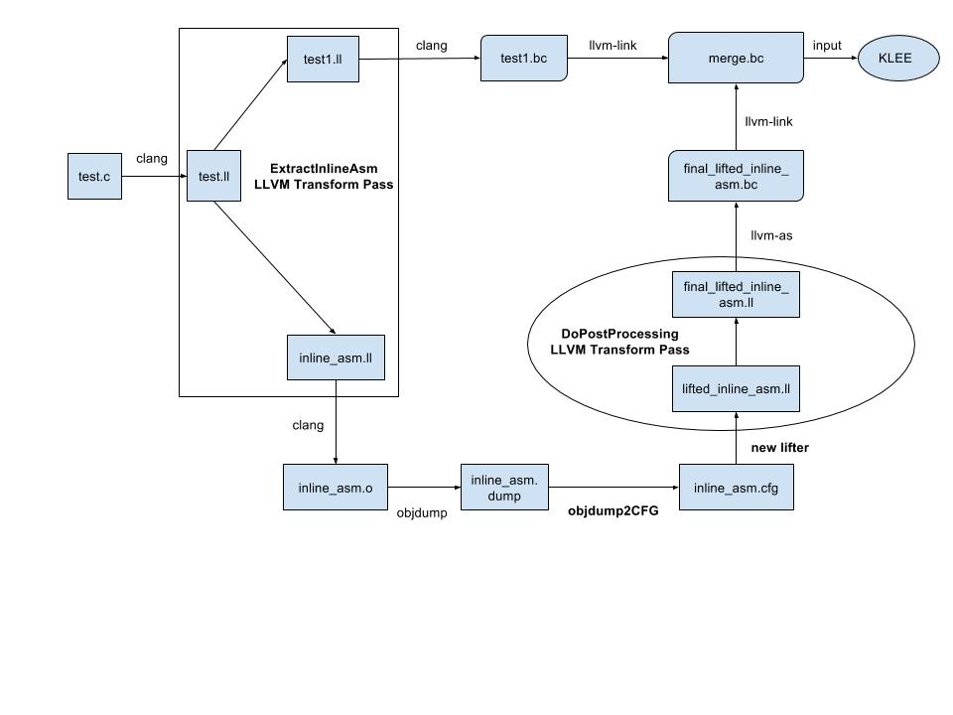
test_asm.c
long int func7(long int p1, long int p2)
{
long int out;
long int sum = p1 + p2;
long int minus = p1 - p2;
asm ("add %%rsi, %%rdi\n\t"
"mov %%rdi, %%rax\n\t"
: "=r" (out) : "r" (sum), "r" (minus) : "cc");
return out;
}

test_asm.ll (clang-3.5 -O2)
; ModuleID = 'test_asm.c'
target datalayout = "e-m:e-i64:64-f80:128-n8:16:32:64-S128"
target triple = "x86_64-pc-linux-gnu"

; Function Attrs: nounwind uwtable
define i64 @func7(i64 %p1, i64 %p2) #0 {
%1 = add nsw i64 %p2, %p1
%2 = sub nsw i64 %p1, %p2
%3 = tail call i64 asm "add %rsi, %rdi\0A\09mov %rdi, %rax\0A\09", "=r,r,r,~{cc},~{dirflag},~{fpsr},~{flags}"(i64 %1, i64 %2) #1, !srcloc !1
ret i64 %3
}
test1_asm.ll (ExtractInlineAsm LLVM Pass)
; ModuleID = 'test1_asm.bc'
target datalayout = "e-m:e-i64:64-f80:128-n8:16:32:64-S128"
target triple = "x86_64-pc-linux-gnu"

; Function Attrs: nounwind uwtable
define i64 @func7(i64 %p1, i64 %p2) #0 {
%1 = add nsw i64 %p2, %p1
%2 = sub nsw i64 %p1, %p2
%a = call i64 @lifted_inline_asm(i64 %1, i64 %2, i64 %1, i64 %1, i64 %1, i64 %1)
ret i64 %a
}

declare i64 @lifted_inline_asm(i64, i64, i64, i64, i64, i64)

inline_asm.ll (ExtractInlineAsm LLVM Pass)
; ModuleID = 'lifted_inline_asm.bc'

define i64 @lifted_inline_asm(i64, i64, i64, i64, i64, i64) {
entry:
%6 = call i64 asm "add %rsi, %rdi\0A\09mov %rdi, %rax\0A\09", "=r,r,r,~{cc},~{dirflag},~{fpsr},~{flags}"(i64 %0, i64 %1)
ret i64 %6
}

inline_asm.dump (objdump)
lifted_inline_asm.o: file format elf64-x86-64

Disassembly of section .text:

0000000000000000 <lifted_inline_asm>:
0: 55 push %rbp
1: 48 89 e5 mov %rsp,%rbp
4: 48 01 f7 add %rsi,%rdi
7: 48 89 f8 mov %rdi,%rax
a: 48 89 f0 mov %rsi,%rax
d: 4c 89 45 f8 mov %r8,-0x8(%rbp)
11: 48 89 4d f0 mov %rcx,-0x10(%rbp)
15: 48 89 55 e8 mov %rdx,-0x18(%rbp)
19: 4c 89 4d e0 mov %r9,-0x20(%rbp)
1d: 5d pop %rbp
1e: c3 retq

inline_asm.cfg (objdump2CFG)
fun 0: entry=true
blk 0:
ins 0: 55
ins 1: 48 89 e5
ins 4: 48 01 f7
ins 7: 48 89 f8
ins a: 48 89 f0
ins d: 4c 89 45 f8
ins 11: 48 89 4d f0
ins 15: 48 89 55 e8
ins 19: 4c 89 4d e0
ins 1d: 5d
ins 1e: c3

lifted_inline_asm.ll (new lifter, opt-3.5 -O2)
; Function Attrs: nounwind
define i64 @_x86_64_lifted_function_0(i64 %RDI_, i64 %RSI_, i64 %RDX_, i64 %RCX_, i64 %R8_, i64 %R9_) #8 {
%RAX_ = tail call i64 @_x86_64_UNDEFINED_64()
%RBP_ = tail call i64 @_x86_64_UNKNOWN_64()
%1 = load i64* @_x64_64_stackptr, align 8, !tbaa !1
%2 = add i64 %1, -8
%3 = inttoptr i64 %2 to i64*
store i64 %RBP_, i64* %3, align 8, !tbaa !1
%4 = inttoptr i64 %2 to i8*
%5 = getelementptr inbounds i8* %4, i64 -8
%6 = bitcast i8* %5 to i64*
store i64 %R8_, i64* %6, align 8, !tbaa !1
%7 = getelementptr inbounds i8* %4, i64 -16
%8 = bitcast i8* %7 to i64*
store i64 %RCX_, i64* %8, align 8, !tbaa !1
%9 = getelementptr inbounds i8* %4, i64 -24
%10 = bitcast i8* %9 to i64*
store i64 %RAX_, i64* %10, align 8, !tbaa !1
%11 = getelementptr inbounds i8* %4, i64 -32
%12 = bitcast i8* %11 to i64*
store i64 %R9_, i64* %12, align 8, !tbaa !1
ret i64 %RSI_
}

merge.ll (llvm-link)
; Function Attrs: nounwind uwtable
define i64 @func7(i64 %p1, i64 %p2) #9 {
%1 = add nsw i64 %p2, %p1
%2 = sub nsw i64 %p1, %p2
%a = call i64 @lifted_inline_asm(i64 %1, i64 %2, i64 %1, i64 %1, i64 %1, i64 %1)
ret i64 %a
}

declare i64 @lifted_inline_asm(i64, i64, i64, i64, i64, i64)

; Function Attrs: nounwind
define i64 @_x86_64_lifted_function_0(i64 %RDI_, i64 %RSI_, i64 %RDX_, i64 %RCX_, i64 %R8_, i64 %R9_) #8 {
%RAX_ = tail call i64 @_x86_64_UNDEFINED_64()
%RBP_ = tail call i64 @_x86_64_UNKNOWN_64()
%1 = load i64* @_x64_64_stackptr, align 8, !tbaa !1
%2 = add i64 %1, -8
%3 = inttoptr i64 %2 to i64*
store i64 %RBP_, i64* %3, align 8, !tbaa !1
%4 = inttoptr i64 %2 to i8*
%5 = getelementptr inbounds i8* %4, i64 -8
%6 = bitcast i8* %5 to i64*
store i64 %R8_, i64* %6, align 8, !tbaa !1
%7 = getelementptr inbounds i8* %4, i64 -16
%8 = bitcast i8* %7 to i64*
store i64 %RCX_, i64* %8, align 8, !tbaa !1
%9 = getelementptr inbounds i8* %4, i64 -24
%10 = bitcast i8* %9 to i64*
store i64 %RAX_, i64* %10, align 8, !tbaa !1
%11 = getelementptr inbounds i8* %4, i64 -32
%12 = bitcast i8* %11 to i64*
store i64 %R9_, i64* %12, align 8, !tbaa !1
ret i64 %RSI_
}

merge1.ll (DoPostProcessing LLVM Pass)
; declare i64 @_x86_64_lifted_function_0(i64, i64, i64, i64, i64, i64)

; Function Attrs: nounwind
define i64 @_x86_64_lifted_function_0(i64 %RDI_, i64 %RSI_, i64 %RDX_, i64 %RCX_, i64 %R8_, i64 %R9_) #8 {
%RAX_ = tail call i64 @_x86_64_UNDEFINED_64()
%RBP_ = tail call i64 @_x86_64_UNKNOWN_64()
%1 = load i64* @_x64_64_stackptr, align 8, !tbaa !1
%2 = add i64 %1, -8
%3 = inttoptr i64 %2 to i64*
store i64 %RBP_, i64* %3, align 8, !tbaa !1
%4 = inttoptr i64 %2 to i8*
%5 = getelementptr inbounds i8* %4, i64 -8
%6 = bitcast i8* %5 to i64*
store i64 %R8_, i64* %6, align 8, !tbaa !1
%7 = getelementptr inbounds i8* %4, i64 -16
%8 = bitcast i8* %7 to i64*
store i64 %RCX_, i64* %8, align 8, !tbaa !1
%9 = getelementptr inbounds i8* %4, i64 -24
%10 = bitcast i8* %9 to i64*
store i64 %RAX_, i64* %10, align 8, !tbaa !1
%11 = getelementptr inbounds i8* %4, i64 -32
%12 = bitcast i8* %11 to i64*
store i64 %R9_, i64* %12, align 8, !tbaa !1
ret i64 %RSI_
}

; Function Attrs: nounwind uwtable
define i64 @func7(i64 %p1, i64 %p2) #9 {
%1 = add nsw i64 %p2, %p1
%2 = sub nsw i64 %p1, %p2
%a = call i64 @_x86_64_lifted_function_0(i64 %1, i64 %2, i64 %1, i64 %1, i64 %1, i64 %1)
ret i64 %a
}

