Chapter 3

METHODOLOGY

This chapter explains how the study is conducted and how the proposed system is designed, developed, secured, and evaluated. It translates the objectives and theoretical foundations discussed in earlier chapters into a structured and verifiable research process. Specifically, this chapter presents the research design, requirements analysis, project development model, system architecture and design, cybersecurity measures, tools and technologies, testing and evaluation plan, data gathering procedures, statistical treatment of data, and ethical and legal considerations.

Research Design
This study adopts a Developmental Research design. The study is centered on the systematic designing, developing, and evaluating of RecruitGuard-CHD, a secure-by-design web-based recruitment workflow system intended to digitize and enforce the official DOH–CHD CALABARZON recruitment process. A developmental research approach is appropriate because the primary output of the study is a functional system prototype, and the study objectives require both the creation of the system and the verification that it achieves intended security- and accountability-related outcomes.
The developmental research design fits the study’s objectives in three ways. First, it supports translating the documented recruitment workflow into a structured system that enforces stage-based progression, prevents process bypass, and preserves finalized outputs. Second, it supports embedding cybersecurity principles into the system’s core functionality, particularly in access control, traceability, and evidence integrity mechanisms that strengthen accountability and defensibility. Third, it supports a structured evaluation of the developed system using defined criteria, including functional validation, controlled security testing, and user-based usability assessment, to determine whether the system meets the study’s intended goals.
The study is conducted in a controlled prototype setting using non-sensitive or synthetic data, and evaluation is performed through role-appropriate interaction with the system and test-based verification activities. Findings in later sections are based on descriptive assessment aligned with the research objectives and evaluation criteria, consistent with the developmental research focus on producing and evaluating a secure functional solution.

3.2 Requirements Analysis
This section defines the requirements for RecruitGuard-CHD in terms of what the proposed system must provide to satisfy the study objectives. Requirements are derived from the documented recruitment workflow to be enforced, the system’s accountability and evidence integrity goals, and the cybersecurity risks associated with unauthorized access, process bypass, and evidence tampering in a regulated public-sector recruitment environment. The requirements are stated as clear, testable conditions describing expected system behavior and quality attributes. This section establishes the basis for later system validation, security testing, and user-based evaluation.
To ensure traceability, requirements are grouped into: functional requirements (what the system must do), non-functional requirements (how well it must perform), and security requirements (what protections must exist to support confidentiality, integrity, and accountability).
3.2.1 Functional Requirements
This subsection defines the functional requirements of RecruitGuard-CHD. Functional requirements specify what the system must do to support the end-to-end recruitment workflow, enforce policy-aligned stage progression, preserve evidence integrity, and produce defensible recruitment outputs. The requirements are written as clear, testable statements using neutral language and are organized by functional area.

Table 3.1A Summary of Functional Requirements (by Functional Area)
Functional Area | Requirement Description (Summary) | Supported Objective Area
Identity and Role Management | Create/manage internal accounts, assign one role, enforce role permissions | Access Control, Accountability
Vacancy and QS Management | Create vacancies, encode and validate QS, publish with validity controls | Workflow Integrity, Compliance Support
Applicant Intake (OTP) | Accountless submission with OTP verification, checklist completeness, application ID | Intake Integrity, Accountability

Table 3.1B Summary of Functional Requirements (by Functional Area)
Recruitment Case Workflow | Create case per application, enforce stage order and prerequisites, stage-lock outputs | Workflow Integrity, Defensibility
Screening / Document Review | Record completeness + QS compliance + screening decision; lock outputs | Workflow Integrity, Defensibility
Interview (PSPT) | Session setup, HRMPSB rating entry, justification thresholds, lock ratings | Accountability, Defensibility
Deliberation and CAR | Consolidate locked inputs, generate CAR, rank list, lock CAR/minutes | Defensibility, Integrity
Appointing Authority | Submission packet, decision logging, reopen vacancy action, preserve history | Accountability, Defensibility
Appointment Preparation | Requirements checklist, uploads, assume-office tracking, announcement record | Workflow Integrity, Record-keeping
Evidence Vault | Store files with metadata, SHA-256 hashing, version preservation, exports | Evidence Integrity, Defensibility
Audit Logging | Log actor/role/action/time/stage/case; log access and exports | Accountability, Non-repudiation

Detailed Functional Requirements

A. Identity and Role Management
FR-01. The system shall allow the System Administrator (IT) to create, disable, and manage internal user accounts.
FR-02. The system shall assign exactly one primary role to each internal user account (Secretariat, HRMPSB Member, Appointing Authority, or System Administrator).
FR-03. The system shall enforce role-based access control such that only authorized roles can access role-restricted pages and actions.
FR-04. The system shall record account creation, disabling, and role assignment changes as audit events.

B. Vacancy and Qualification Standards (QS) Management
FR-05. The system shall allow the Secretariat to create vacancy records containing position details and recruitment metadata.
FR-06. The system shall require structured encoding of Qualification Standards (Education, Training, Experience, Eligibility) prior to vacancy publication.
FR-07. The system shall validate QS entries against an internal reference table before allowing vacancy publication.
FR-08. The system shall record vacancy publication channels, dates, and validity periods as part of the vacancy record.
FR-09. The system shall prevent applicant intake unless the vacancy is in “Published” status and within the validity period.
FR-10. The system shall lock QS fields after publication and permit changes only through a controlled amendment action recorded in the audit log.

C. Applicant Intake (Accountless + OTP)
FR-11. The system shall support accountless applicant submission per vacancy.
FR-12. The system shall require email OTP verification prior to accepting final submission.
FR-13. The system shall require completion of a document checklist prior to final submission and store the completeness status.
FR-14. The system shall generate a unique Application ID for each final submission and bind the submission to the corresponding vacancy and recruitment case.
FR-15. The system shall prevent editing after final submission unless a resubmission window is explicitly enabled and recorded as a case event.
FR-16. The system shall support tagging of submissions as “Next-in-Rank” and record intent submission status as part of the case history.

D. Recruitment Case Workflow and Stage Enforcement
FR-17. The system shall create a recruitment case for each application and enforce workflow stage progression according to the defined lifecycle.
FR-18. The system shall prevent stage skipping and require defined prerequisites before allowing stage advancement.
FR-19. The system shall stage-lock finalized outputs to prevent modification without a controlled re-open action recorded in the audit log.
FR-20. The system shall provide a case timeline view displaying stage events, status changes, and key case actions.

E. Document Review and Initial Screening
FR-21. The system shall allow the Secretariat to record document completeness and QS compliance decisions per applicant.
FR-22. The system shall support screening scoring consistent with position-level weighting rules (as applicable).
FR-23. The system shall require finalization and stage-locking of screening outputs (qualified/disqualified) before proceeding to the examination stage.

F. Examination Management
FR-24. The system shall allow the Secretariat to create and encode examination results by type (general, technical, or psychometric).
FR-25. The system shall record examination validity periods and prevent use of expired results in ranking decisions.
FR-26. The system shall record retake decisions and absence/waiver events as case events with justification fields.

G. Interview (PSPT) Management
FR-27. The system shall allow the Secretariat to create interview sessions per vacancy and record attendance and quorum information.
FR-28. The system shall allow HRMPSB Members to encode interview ratings directly in the system.
FR-29. The system shall require justification when interview ratings meet defined extreme thresholds.
FR-30. The system shall stage-lock interview ratings after finalization.
FR-31. The system shall support a fallback mechanism where scanned paper rating sheets are uploaded and linked before Secretariat encoding is permitted (when applicable).

H. Deliberation, Consolidation, and CAR Generation
FR-32. The system shall consolidate finalized screening, examination, and interview outputs into a unified scoring summary.
FR-33. The system shall generate the Comparative Assessment Report (CAR) as a system-derived artifact based on locked inputs.
FR-34. The system shall allow recording of deliberation minutes and attachment of supporting documents.
FR-35. The system shall produce a ranked list output and stage-lock the CAR and minutes after finalization.

I. Submission to Appointing Authority and Decision Logging
FR-36. The system shall create a submission packet view containing the CAR, ranking, and evidence references for the Appointing Authority.
FR-37. The system shall allow the Appointing Authority to record selection decisions and reopen-vacancy decisions as auditable actions.
FR-38. The system shall preserve a read-only historical record of pre-decision artifacts once a decision is recorded.

J. Appointment Preparation and Announcement
FR-39. The system shall support a requirements checklist and allow upload of post-selection requirements.
FR-40. The system shall track the “assume office within 30 days” requirement as a status field.
FR-41. The system shall store an announcement record as a case artifact with posting metadata.

K. Evidence Vault, Export, and Audit Logging
FR-42. The system shall store uploaded documents with metadata binding (case ID, stage, uploader, timestamp).
FR-43. The system shall generate a SHA-256 hash per uploaded file and preserve hash records for verification.
FR-44. The system shall preserve document versions without silent overwrite.
FR-45. The system shall generate evidence export bundles containing CAR, minutes, scoring breakdown (as applicable), document inventory, and hash verification output.
FR-46. The system shall restrict export permissions by role and log export actions as audit events.
FR-47. The system shall maintain audit logs capturing actor identity, role, action, timestamp, case ID, and workflow stage for critical actions and access-sensitive activities.
3.2.2 Non Functional Requirements
This subsection defines the non-functional requirements of RecruitGuard-CHD. Non-functional requirements describe the quality attributes the system must exhibit to be effective and usable in a regulated recruitment setting. These requirements focus on system performance, usability, reliability and availability, scalability considerations (within prototype scope), and maintainability. The evaluation of these attributes will be conducted using the testing and evaluation criteria described in Section 3.7.

Table 3.2A Summary of Non-Functional Requirements (Quality Attributes)
Quality Attribute | Non-Functional Requirement (Concise) | Evaluation Consideration (Section 3.7)
Performance | Timely dashboard/case views under evaluation conditions | Response time timing observations
Performance | Timely CAR/export generation for medium case (5–10 applicants) | Export generation time observations
Usability | Role-appropriate views and clear workflow stage visibility | SUS + Likert (workflow clarity)
Reliability | No data loss under normal evaluation use; stable operation | Defect log + session observation
Reliability | Stage-locked artifacts preserved unless controlled re-open | Stage-lock enforcement test cases
Table 3.2B Summary of Non-Functional Requirements (Quality Attributes)
Availability | Acceptable uptime during scheduled evaluation sessions | Uptime monitoring during sessions
Scalability | Handles growth in cases/files within prototype constraints | Observed stability under representative case volume
Maintainability | Workflow rules configurable without changing historical records | Review of configuration approach + consistency checks

A. Performance Requirements
NFR-P01. The system shall return standard dashboard and recruitment case views within acceptable response time under evaluation conditions.
NFR-P02. The system shall generate the Comparative Assessment Report (CAR) and a medium-sized evidence export bundle (representative case size: 5–10 applicants) within an acceptable time frame during evaluation.
NFR-P03. The system shall remain responsive during normal, simultaneous use by multiple internal users during evaluation activities (non-destructive concurrency conditions).

B. Usability Requirements
NFR-U01. The system shall provide role-appropriate interfaces such that each role (Secretariat, HRMPSB Member, Appointing Authority, System Administrator IT) sees only functions and views relevant to their responsibilities.
NFR-U02. The system shall present clear workflow stage status visibility (current stage, completed stages, pending prerequisites) to support correct stage progression.
NFR-U03. The system shall minimize user effort for routine workflow actions by providing structured forms, clear validation messages, and predictable navigation.
NFR-U04. The system shall provide understandable feedback for blocked actions (e.g., missing prerequisites, stage-locked artifacts, insufficient permission) to reduce user error.

C. Reliability and Availability Requirements
NFR-R01. The system shall operate reliably during scheduled evaluation sessions without data loss under normal use.
NFR-R02. The system shall preserve finalized records by preventing accidental overwriting of stage-locked artifacts unless a controlled re-open action is recorded.
NFR-R03. The system shall maintain acceptable availability during evaluation sessions to support uninterrupted workflow execution.
NFR-R04. The system shall support recovery from failures through backup and restore capability appropriate to the prototype environment to reduce risk of data loss.

D. Scalability Requirements (Prototype-Appropriate)
NFR-S01. The system shall support handling an increased number of recruitment cases and evidence files without requiring redesign of the core workflow model.
NFR-S02. The system shall support conceptual expansion of users and cases by maintaining structured data organization, consistent workflow rules, and bounded access control, while remaining within prototype constraints.

E. Maintainability and Configurability Requirements
NFR-M01. The system shall keep workflow stages, prerequisites, and policy-aligned rules configurable at the policy-rule level without altering historical records.
NFR-M02. The system shall maintain consistent naming, structured data fields, and standardized outputs (e.g., CAR, export bundle contents) to support maintainability and review.
NFR-M03. The system shall preserve audit and evidence records in a way that supports future inspection, export, and validation activities.
3.2.3 Security Requirements
This subsection defines the security requirements of RecruitGuard-CHD. Security requirements specify what security must be achieved to protect recruitment assets—such as applicant personally identifiable information (PII), submitted documents, screening outputs, examination results, interview ratings, CAR artifacts, deliberation minutes, appointment decision trails, and audit records—against unauthorized access, modification, disclosure, and repudiation. These requirements are derived from validated risks and the system’s secure-by-design objectives, and they focus on enforceable outcomes rather than implementation details.

Table 3.3 Summary of Security Requirements
Security Aspect | Requirement Description (Summary) | Security Objective Supported
Authentication | OTP-verified applicant intake; authenticated internal access | Integrity, Accountability
Authorization (RBAC/Stage-bound) | Role- and stage-bound permissions; least privilege | Confidentiality, Integrity
Workflow Protection | Block stage skipping; stage-lock finalized outputs | Integrity, Defensibility
Evidence Integrity | SHA-256 hashing; metadata binding; version preservation | Integrity, Non-repudiation
Audit Logging | Actor-attributed audit events; log access/export actions | Accountability, Non-repudiation
Export Controls | Role-restricted exports; export bundle includes hash report | Confidentiality, Defensibility
Session/Abuse Safeguards | Session controls; basic intake safeguards (non-destructive scope) | Confidentiality, Availability

3.2.4 Policy-to-Control Traceability Matrix
This subsection presents the Policy-to-Control Traceability Matrix for RecruitGuard-CHD. The purpose of this matrix is to demonstrate that RecruitGuard-CHD does not introduce new recruitment rules, but rather operationalizes the official CHD recruitment policy requirements into enforceable system controls. Each policy requirement is mapped to (1) the system control that enforces the requirement and (2) the evidence outputs that support accountability, auditability, and grievance defensibility. This traceability supports the study’s objectives by ensuring that workflow enforcement, evidence integrity, and decision accountability are structurally embedded in the system.

Table 3.4A Summary Policy-to-Control Mapping Matrix (Condensed)
Key Policy Requirement (CHD Personnel Order) | RecruitGuard-CHD Enforceable Control | Evidence/Output Produced
Vacancies must be properly posted/published before filling and intake must only occur for published vacancies | Enforce “Published” status gate; record publication channels and timestamps; block intake if not published | Published vacancy record + publication audit event
Posting period and validity rules must be followed; expired postings require republication | Publication validity tracker; automatic expiry blocking; controlled republication action with audit logging | Validity/expiry record + republication  event log
Qualification Standards (QS) must be encoded correctly  and differentiated by level | Structured QS encoding per position level; QS validation  before publication; QS locked after publication with  controlled amendment logging | QS snapshot + QS lock/amendment  logs
Secretariat accepts only timely submissions and required  documents per vacancy | Intake window enforcement; submission timestamping;  required document checklist prior to final submission | Submission receipt + application ID +  completeness inventory

Table 3.4B Summary Policy-to-Control Mapping Matrix (Condensed)
Next-in-rank rules must be handled consistently when  applicable | Next-in-rank tagging and intent recording;  inclusion/exclusion as auditable case event | Next-in-rank flag + intent record +  audit trail
Document review and initial screening must follow  prescribed criteria and produce defensible outputs | Structured screening form and decision capture; stage  prerequisites enforced; screening outputs stage-locked | Locked screening result + scoring  breakdown + audit log
Examination rules include recording results, validity  periods, and handling absence/waiver with justification | Exam module with type and validity metadata; enforce  expiry; record waiver/absence/retake events with justification | Exam record + validity status +  justification event logs
Interview must be documented; quorum/attendance  observed; extreme ratings justified; ratings finalized and  locked | Interview session scheduling + quorum/attendance  capture; extreme rating justification thresholds; stage-  lock interview ratings | Quorum/attendance record + locked  interview ratings + justifications

Table 3.4C Summary Policy-to-Control Mapping Matrix (Condensed)
Deliberation requires minutes; CAR must reflect  consolidated finalized inputs and ranked outcomes | CAR generated only from locked stage outputs;  deliberation minutes captured and stage-locked; ranked list system-derived | CAR artifact + minutes artifact + rank  output + lock events
Submission to Appointing Authority must be traceable  and evidence-backed | Generate submission packet view with CAR, ranking, and  evidence references; packet creation logged | Submission packet artifact + audit  events
Appointing Authority decisions must be recorded;  reopening vacancy must be traceable; prior outputs  preserved | Decision logging with optional justification; reopen-  vacancy action as controlled event; preserve read-only  history | Decision record + reopen event +  preserved historical outputs
Records must support audit/grievance review;  deliberation minutes and documents must be producible  on request | Evidence Vault with SHA-256 hashing, version  preservation, role-restricted export; export bundles  include inventory + hash verification report; exportlogs | Export bundle ZIP + inventory + hash  report + export audit logs

To maintain readability in the main manuscript, this section provides a condensed mapping table focusing on the most policy-critical requirements and their corresponding controls. The complete Policy-to-Control Mapping Matrix, including extended mappings and detailed traceability, is provided in the Appendix as a supporting artifact for audit and defensibility documentation.
3.2.5 Feasibility of the Study
This section evaluates whether the development and evaluation of RecruitGuard-CHD is practical, achievable, and sustainable within the constraints of the study. Feasibility is assessed in terms of the availability of required technologies and technical resources, suitability to the operational workflow, affordability within an academic setting, schedule viability within the project timeline, security feasibility given the defined testing boundaries, and alignment with legal and ethical requirements. This feasibility assessment focuses on the viability of conducting the study and delivering a working prototype, rather than commercial deployment or large-scale production readiness.
3.2.5.1 Technical Feasibility
Technical feasibility assesses whether RecruitGuard-CHD can be developed, deployed, and evaluated using available and compatible technologies required by the proposed system scope. This includes the availability of the development stack, compatibility of server and database components, feasibility of hosting the prototype on a cloud VPS, and the availability of security testing utilities required to validate secure-by-design controls in a controlled environment. The system is designed as a monolithic, server-rendered web application to reduce implementation complexity while maintaining enforceable workflow control, evidence integrity handling, and audit logging capabilities aligned with the recruitment process.
RecruitGuard-CHD is technically feasible because the required application framework, database platform, and web serving components are widely supported and compatible within a standard Linux VPS environment. The hosting environment supports the full application runtime and database requirements for prototype deployment, while also allowing a controlled staging copy to be deployed on the same VPS for security validation using dummy or synthetic data. Additionally, the security validation utilities selected for the study are compatible with the proposed technology stack and can be executed in a controlled, non-destructive posture consistent with the study’s ethical testing scope.

Table 3.5 Technical Capability Availability Summary
Requirement Type | Technical Capability Availability | Feasibility
Functional | Supported by a widely adopted web framework and relational database stack suitable for workflow systems | Feasible
Security | Supported by built-in authentication frameworks, role enforcement patterns, audit logging capability, and integrity hashing support | Feasible
Performance | Supported by production-grade web serving components appropriate for prototype-scale deployment | Feasible

Table 3.6 Core Technology Stack Availability (Prototype Deployment)
System Component | Selected Technology / Platform | Availability and Compatibility Basis
Server OS | Ubuntu 22.04 LTS | Stable Linux environment compatible with modern web stacks
Application Language | Python 3 | Widely supported runtime for web application development
Web Framework | Django (server-rendered) | Suitable for structured workflows, role-based access patterns, and form-driven processes
UI Layer | Django Templates + Bootstrap | Supports consistent UI without heavy frontend complexity
Database | PostgreSQL (same VPS for prototype) | Strong relational model suitable for recruitment records and audit logging
Web Server / Reverse Proxy | Nginx | Standard reverse proxy for routing and static file serving
Application Server | Gunicorn | Standard WSGI app server for Django behind Nginx
Evidence Storage | VPS filesystem (MEDIA_ROOT) | Supports structured file paths and controlled access within prototype scope
Integrity Mechanism | SHA-256 hashing | Supported via standard cryptographic hashing library
Staging for Security Testing | Staging copy on same VPS | Enables controlled testing without impacting the main prototype instance

Table 3.7 Development Hardware Requirements (Suggested)
Hardware Area | Minimum (Usable for Development) | Recommended (Smoother Development & Testing)
CPU | Dual-core (or equivalent) | Quad-core (or equivalent)
Memory (RAM) | 8 GB | 16 GB
Storage | 256 GB SSD | 512 GB SSD (or higher)
Display | 1366×768 | 1920×1080
Purpose | Enables basic development, local testing, and documentation work | Improves responsiveness during local testing, database use, and running security tools

These hardware requirements are presented to demonstrate that the development and evaluation activities can be conducted using commonly available computing resources in an academic setting. They are not presented as enterprise requirements, but as realistic development and testing conditions appropriate for a prototype workflow system.
3.2.5.2 Operational Feasibility
Operational feasibility evaluates whether RecruitGuard-CHD can be realistically used by its intended users within the existing recruitment workflow environment and whether the system’s adoption is practical within the scope of the study. RecruitGuard-CHD is designed around the official recruitment lifecycle and uses role-based views to align system functions with real operational responsibilities. The system’s design emphasizes workflow clarity, stage enforcement, and evidence handling without requiring specialized user behavior beyond standard form entry, document review actions, and role-appropriate approvals.
RecruitGuard-CHD is operationally feasible because the system mirrors the established HRMPSB process, reducing the learning curve associated with adopting a new workflow structure. Secretariat users function as process administrators who encode vacancies, manage intake, and finalize stage outputs; HRMPSB Members primarily enter interview ratings and view role-limited evaluation information; the Appointing Authority records decisions based on system-generated submission packets; and the System Administrator IT performs account and security configuration without accessing recruitment case content. This division of responsibilities supports real-world adoption by minimizing role confusion and preventing unauthorized actions through role and stage constraints.
Operational feasibility is further supported by the system’s use of clear stage dashboards, case timelines, and prerequisite-based blocking. These features help prevent common operational errors such as missing required steps, overlooking validity periods, or modifying finalized outputs without documentation. Because the applicant side is accountless and OTP-verified, applicant interaction remains limited to controlled intake tasks, reducing operational burden on both applicants and internal users. Within the study scope, adoption is feasible for evaluation activities because training requirements are limited to basic role navigation and form completion, and system tasks remain aligned with existing recruitment responsibilities.

Table 3.8 Operational Feasibility Assessment
Operational Aspect | Consideration | Assessment
User Roles | Role responsibilities in the system align with Secretariat, HRMPSB Members, Appointing Authority, and System Administrator IT | Feasible
Workflow Impact | The system mirrors the official recruitment lifecycle, reducing process disruption | Feasible
Usability Fit | Role-based views, stage dashboards, and case timelines support learnability during academic evaluation | Feasible
Error Prevention | Stage enforcement and prerequisite checks reduce missed steps and inconsistent handling | Feasible
Practical Adoption Scope | Applicant interaction is limited to OTP-based intake; internal workflow tasks are form-driven and structured | Feasible

3.2.5.3 Economic Feasibility
Economic feasibility assesses whether RecruitGuard-CHD can be developed, deployed, and evaluated within reasonable academic cost constraints. This study focuses on producing a working secure-by-design prototype and conducting controlled functional, security, and usability evaluation activities. The economic feasibility discussion is limited to required resources and operational cost viability and does not include return-on-investment (ROI) analysis or commercial financial projections.
RecruitGuard-CHD is economically feasible because the selected software stack is based on widely available open-source technologies suitable for academic development, and the prototype can be hosted on a low-cost cloud VPS. The finalized hosting baseline uses a DigitalOcean droplet with weekly backups enabled, resulting in a fixed monthly hosting cost of $14.40/month for the prototype environment. No managed database services or droplet add-ons are required within the scope of this study, which helps maintain predictable operational costs. Applicant intake email OTP is supported using an SMTP-based approach aligned with academic constraints, and the security testing utilities selected for the study are accessible without requiring enterprise licensing.
The cost structure is therefore aligned with the project’s scope and evaluation requirements, supporting deployment, controlled testing, and documentation within an academic timeframe without requiring specialized or enterprise-grade infrastructure.

Table 3.9A Resource and Cost Feasibility Summary
Resource Category | Description | Intended Use in the Study | Cost Context / Availability
Cloud VPS Hosting | DigitalOcean droplet (prototype hosting) | Host RecruitGuard-CHD web application and database | Low-cost monthly VPS

Table 3.9B Resource and Cost Feasibility Summary
Backups | DigitalOcean weekly backups | Support recovery and data protection during evaluation | Included in monthly baseline
Development Tools | Standard IDE/editor and local tooling | Development and local testing | Typically free or already available
Database | PostgreSQL on same VPS | Store recruitment cases, audit logs, and OTP metadata | Open-source
Web Serving | Nginx + Gunicorn | Serve the deployed Django application | Open-source
Email OTP | SMTP email sending for OTP | OTP delivery for accountless intake | SMTP-based, low-cost approach
Security Testing Tools | OWASP ZAP, Burp Suite Community, Bandit, pip-audit | Controlled security validation in staging | Free/community tools
Documentation Tools | Word processor + diagram tools | Manuscript preparation and diagram creation | Typically available in academic setting

Table 3.10 Frozen Monthly Hosting Baseline (Prototype)
Cost Item | Description | Monthly
VPS Droplet | DigitalOcean Basic (1 vCPU, 2 GB RAM, 50 GB SSD) | $12.00
Backups | Weekly Backups Enabled | $2.40
Total Monthly Hosting Cost |  | $14.40
This economic feasibility baseline demonstrates that RecruitGuard-CHD can be hosted and evaluated within a fixed, predictable monthly budget appropriate for an academic capstone prototype.
3.2.5.4 Schedule Feasibility
Schedule feasibility evaluates whether the study can realistically complete the design, development, deployment, and evaluation of RecruitGuard-CHD within the academic timeline. This feasibility assessment focuses on whether the scope is manageable and whether the work can be completed through structured phases without requiring excessive time, specialized resources, or extended organizational dependencies beyond the study’s control.
RecruitGuard-CHD is considered schedule-feasible because its scope is defined around a single, policy-aligned recruitment workflow implemented as a monolithic, server-rendered web system, which reduces integration complexity compared to multi-platform or distributed architectures. The workflow is implemented through stage-based progression with defined prerequisites, allowing development to be structured into incremental modules aligned with recruitment stages (vacancy publication, intake, screening, examination, interview, deliberation/CAR, submission/decision, and evidence export). This staged approach supports iterative development and early validation, enabling the team to implement core functions first and then proceed to security enforcement mechanisms, evidence handling, and reporting outputs.
Evaluation activities are also schedule-feasible because testing is planned in a controlled environment using dummy or synthetic data, and security validation is bounded by a non-destructive testing scope. User-based evaluation is limited to relevant internal roles (e.g., Secretariat and HRMPSB Members), which reduces scheduling complexity while still supporting usability and workflow clarity assessment. Documentation can proceed in parallel with development by maintaining consistent artifacts (requirements tables, workflow diagrams, audit log definitions, and export specifications) throughout the build cycle.
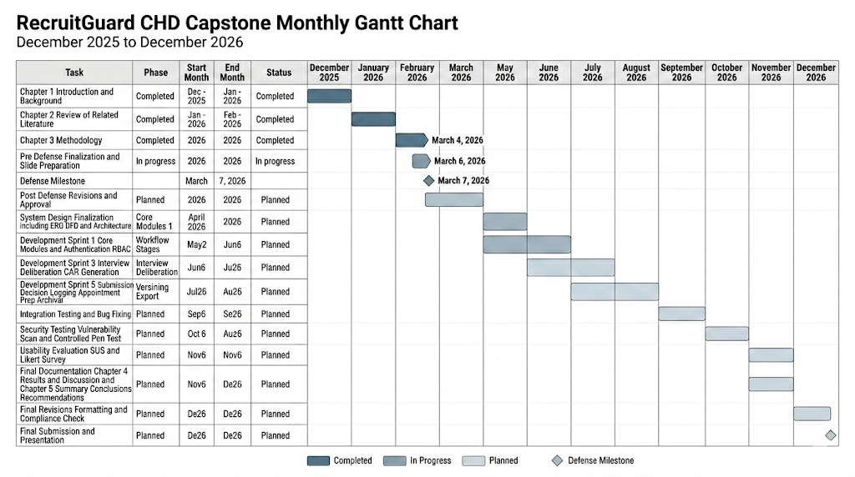
Figure 3.1 Gantt Chart of RecruitGuard-CHD

Table 3.11A High-Level Project Phases and Schedule Feasibility Assessment
Project Phase | Scope Description | Feasibility Assessment
Requirements and Policy  Traceability | Finalize FR/NFR/SR and policy-to-control mapping; confirm  workflow stages and outputs | Feasible
Table 3.11B High-Level Project Phases and Schedule Feasibility Assessment
System Development (Core  Workflow) | Implement stage flow, role views, intake, and case  management aligned with lifecycle | Feasible
Security and Integrity  Controls | Implement RBAC/stage-locking, audit logging, evidence  hashing/versioning, export controls | Feasible
Testing and Evaluation | Functional testing, controlled security testing on staging, usability evaluation (SUS + Likert add-on) | Feasible
Documentation and Finalization | Compile Chapter 3-4 outputs, finalize diagrams/tables,  consolidate evidence of testing activities | Feasible

A detailed project timeline and task-level schedule (Gantt chart) is provided as a supporting planning artifact in the Appendix to document schedule organization without turning this feasibility section into a task plan.
3.2.5.5 Security Feasibility
Security feasibility evaluates whether the security objectives of RecruitGuard-CHD can be realistically implemented and validated within the study’s scope, environment, and ethical constraints. This assessment focuses on whether the system can enforce workflow-level security controls (e.g., role-based access control, stage enforcement, and evidence integrity) and whether these controls can be evaluated using controlled, non-destructive testing in an approved environment.
RecruitGuard-CHD is security-feasible because its architecture is designed around enforceable workflow boundaries and evidence-grade record handling. The system’s core security controls—OTP verification for accountless intake, authenticated access for internal users, role- and stage-bound authorization, audit logging, stage-locking of finalized artifacts, and evidence hashing with version preservation—are achievable within the selected web stack and hosting environment. These controls are also measurable and verifiable through controlled testing scenarios that attempt unauthorized access, invalid workflow transitions, and export misuse.
Security validation is feasible because testing will be performed on a staging copy of the system deployed on the same VPS hosting environment using dummy or synthetic data only. The study’s frozen security testing plan uses accessible tools aligned with prototype constraints: automated DAST scanning (OWASP ZAP), controlled manual testing (Burp Suite Community), and SAST-lite and dependency auditing (Bandit and pip-audit). Importantly, security testing is bounded by non-destructive rules—no denial-of-service testing, no brute force attacks, no destructive payloads, and no testing outside the approved staging environment—ensuring the study remains ethical and controlled while still producing defensible security evidence.

Table 3.12 Security Feasibility Assessment
Security Area | Feasibility Basis (Why it is Achievable in this Study) | Assessment
Authentication (OTP + internal login) | OTP intake and authenticated internal access are supported within the selected web framework and can be validated through controlled test cases | Feasible
Authorization (RBAC + stage-bound rules) | Role and stage restrictions can be enforced at application level and verified through role-inappropriate access attempts | Feasible
Workflow Integrity (stage progression + stage locking) | Stage prerequisites and lock controls are implementable and testable through invalid transition attempts | Feasible
Evidence Integrity (SHA-256 + version preservation) | Hashing and versioning are achievable using standard libraries; integrity can be verified through export bundle hash reports | Feasible
Auditability (actor-attributed logging) | Audit event capture and review are supported via structured database logging and can be checked against “expected event” lists | Feasible
Security Testing Validation | Frozen plan uses accessible tools in a controlled staging environment with non-destructive boundaries | Feasible

3.2.5.6 Legal and Ethical Feasibility
Legal and ethical feasibility evaluates whether the study can be conducted in a manner that respects applicable data privacy principles, institutional research requirements, and ethical handling of sensitive information. This feasibility assessment focuses on responsible data handling during development and evaluation of RecruitGuard-CHD and does not provide legal interpretation or policy adjudication.
RecruitGuard-CHD is legally and ethically feasible because system testing and evaluation will be performed using dummy or synthetic data, minimizing exposure to real applicant personal information. Where user-based evaluation is conducted, participation is limited to relevant internal roles and is handled through informed participation procedures appropriate to the academic context. Data collected during evaluation (e.g., survey responses, usability ratings, and testing outcomes) will be used strictly for academic research purposes and will be processed and presented in an aggregated manner.
In terms of data handling, the system’s design supports secure access control, controlled evidence handling, and audit logging. Role-based restrictions limit access to sensitive records, while evidence handling preserves integrity through controlled storage and verifiable hashing. These measures support responsible research conduct by reducing unnecessary access to sensitive information and ensuring that system outputs remain traceable and defensible within the study scope.

Table 3.13 Legal and Ethical Feasibility Summary
Compliance Area | Consideration | Status
Data Privacy | Use of dummy/synthetic data; minimize handling of real PII | Compliant
User Participation | Participation limited to relevant roles; no unnecessary identifiers | Compliant
Data Handling | Secure access control and audit logging for accountability | Compliant
Research Ethics | Evaluation outputs used for academic purposes only | Compliant

3.3 Project Development Model
This section describes the structured development process used to design, build, and evaluate RecruitGuard-CHD in a disciplined and security-aware manner. The development model provides a clear, repeatable flow for progressing from requirements definition to implementation and verification, while ensuring that security considerations remain integrated throughout the project lifecycle. This discussion focuses on the model and phase relationships, not on code-level implementation or tool configurations.

3.3.1 Name of the Development Model
RecruitGuard-CHD adopts a Risk-Driven Iterative Secure SDLC model. The model is iterative to support incremental development and refinement of a regulated recruitment workflow system, and it is risk-driven to ensure that validated workflow, integrity, and accountability concerns remain continuously addressed as the system evolves. This model is appropriate for RecruitGuard-CHD because the project must consistently maintain alignment with a policy-bound workflow while producing defensible and testable outputs for evaluation.

3.3.2 Conceptual Overview of the Model
The Risk-Driven Iterative Secure SDLC is organized into four repeating phases that form a continuous cycle. Each iteration covers a manageable scope of system capability (e.g., a workflow segment or a set of required outputs), allowing controlled refinement while preserving methodological consistency.
Phase 1: Requirements and Risk Analysis
This phase defines the functional expectations and security expectations of the system based on study objectives and validated risks. It establishes what the system must enforce (e.g., workflow correctness, accountability, and evidence integrity expectations) and identifies constraints that guide secure development and evaluation.
Phase 2: Secure Design and Implementation
This phase converts the defined requirements into system behavior and system outputs. The focus is ensuring that the system’s design supports workflow enforcement, controlled access boundaries, and integrity-preserving handling of recruitment artifacts in a manner consistent with the defined requirements.

Phase 3: Verification and Security Testing
This phase verifies that implemented features and controls operate as intended under controlled conditions. Verification focuses on demonstrating that the system is testable and measurable in terms of required workflow behavior, security expectations, and output correctness. (Detailed tools and testing instruments are documented separately in the Tools and Testing sections.)
Phase 4: Review, Refinement, and Hardening
This phase consolidates verification feedback to refine system behavior, strengthen consistency of controls, and improve clarity of outputs and documentation. The cycle then repeats until the full required scope of RecruitGuard-CHD is completed within the academic timeframe.
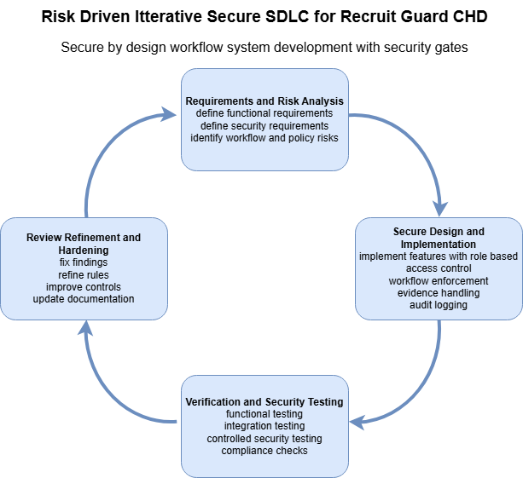
Figure 3.2 Risk-Driven Iterative Secure SDLC for RecruitGuard-CHD.
The figure illustrates the iterative relationship among requirements and risk analysis, secure design and implementation, verification and security testing, and review refinement and hardening.

3.3.3 Integration of Cybersecurity Considerations Across Phases
Cybersecurity considerations are integrated across all phases of the model rather than treated as a final, isolated step. Security is incorporated during requirements definition by establishing security expectations that are directly tied to the system’s regulated context and study objectives. Security is carried into design and implementation by ensuring that system behavior supports enforceable workflow progression, controlled access boundaries, and integrity-preserving handling of recruitment artifacts. Security is then verified through controlled validation and testing activities to confirm that the system remains measurable and defensible under evaluation conditions. Finally, refinement and hardening ensure that improvements identified during verification are integrated back into the system in a controlled and traceable manner.

3.3.4 Alignment with Study Objectives
The Risk-Driven Iterative Secure SDLC supports the study objectives by ensuring that development remains structured and evaluation-ready throughout the project timeline. The iterative cycle helps maintain continuous alignment with (1) workflow enforcement requirements, (2) evidence integrity and controlled document handling expectations, and (3) accountability and traceability requirements through consistent refinement and verification. This model also supports systematic evaluation by ensuring that each cycle produces outputs that can be assessed against the study’s testing and evaluation criteria, without requiring the entire system to be completed before verification can begin.

3.4 System Architecture and Design
This section presents a high-level structural view of RecruitGuard-CHD, describing how major components interact and how security is integrated into system operation. The discussion focuses on architectural roles and interactions to support recruitment workflow enforcement, evidence integrity, and accountability, without detailing code-level implementation.
3.4.1 Architecture Overview
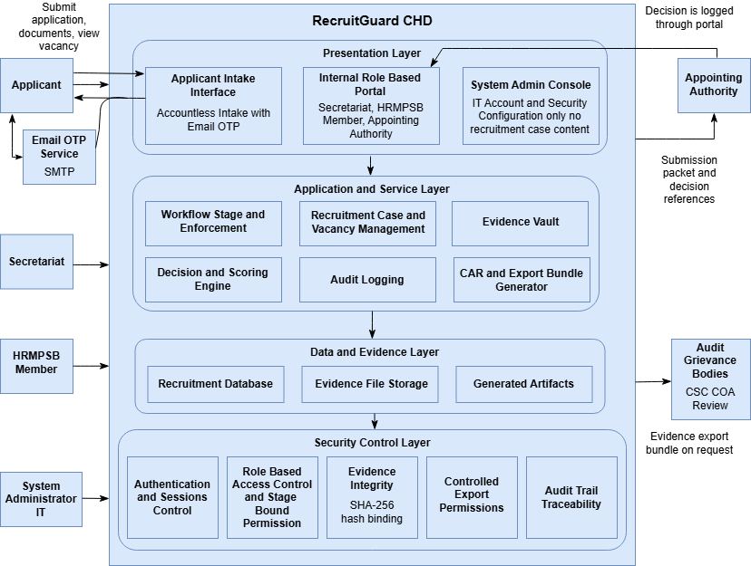
RecruitGuard-CHD is structured as a layered web-based recruitment workflow system that separates user interaction, workflow services, data and evidence storage, and security enforcement. This layered organization supports controlled recruitment processing by ensuring that recruitment actions are performed through role-appropriate interfaces, routed through stage-enforced workflow services, and preserved as attributable and integrity-verifiable records.
Figure 3.2 High-Level Layered Architecture of RecruitGuard-CHD

At the Presentation Layer, RecruitGuard-CHD provides two primary interaction surfaces. First, an applicant-facing intake interface allows vacancy viewing and accountless application submission, where final submission is gated by email OTP verification. Second, an internal role-based portal supports stage-specific tasks for the Secretariat, HRMPSB Members, and the Appointing Authority, ensuring that each role only interacts with functions relevant to its authority and the current workflow stage. Administrative functions are separated for the System Administrator (IT), whose access is limited to system and account administration rather than recruitment case content.
At the Application and Service Layer, the system operationalizes the recruitment lifecycle through workflow-centered components. The Workflow and Stage Enforcement component governs case creation, prerequisite checks, stage progression, and controlled re-open actions to prevent stage skipping and post-finalization edits. The Recruitment Case Management and Vacancy Management components support vacancy publishing metadata, applicant case tracking, and stage-bound processing from screening through deliberation and decision logging. The Evidence Vault component manages document intake and lifecycle handling, including evidence metadata binding and version preservation. Evidence integrity is supported through SHA-256 hashing tied to case and stage context to reduce the risk of silent tampering. The Audit Logging component records recruitment-grade events (actor identity, role, timestamp, case reference, and stage) to support non-repudiation and defensible decision trails. The Decision and Scoring Engine consolidates finalized stage outputs into structured scoring summaries and generates the Comparative Assessment Report (CAR) from locked inputs. Finally, the CAR and Export Bundle Generator produces controlled evidence packages containing required artifacts, inventories, and integrity verification outputs for audit or grievance needs.
At the Data and Evidence Layer, RecruitGuard-CHD stores structured recruitment records (e.g., vacancies, cases, stage outputs, scoring breakdowns, and audit events) and preserves uploaded documentary evidence as case-bound artifacts. System-generated outputs such as the CAR and export bundles are stored as controlled artifacts linked to their originating case and workflow stage, supporting traceability from decision outputs back to source inputs and recorded actions.
Security is treated as an integrated concern across layers through a Security Control Layer that ensures confidentiality, integrity, availability, and accountability in workflow execution. Role-based access control and stage-bound permissions restrict access to applicant data, ratings, and decision outputs. OTP verification reduces identity and submission risks for accountless intake. Evidence integrity controls (hash-bound storage and version preservation) support defensible evidence handling. Audit logging ensures attributable action trails for key recruitment events, including publication actions, screening finalization, interview rating submission, CAR finalization, decision logging, export generation, and archival or retention actions. For evaluation, security and functional testing are conducted on a staging copy deployed in the same VPS hosting environment using dummy or synthetic data only, ensuring controlled validation without affecting production-style records.

3.4.2 Context Diagram
Figure 3.3 Context Diagram of RecruitGuard-CHD
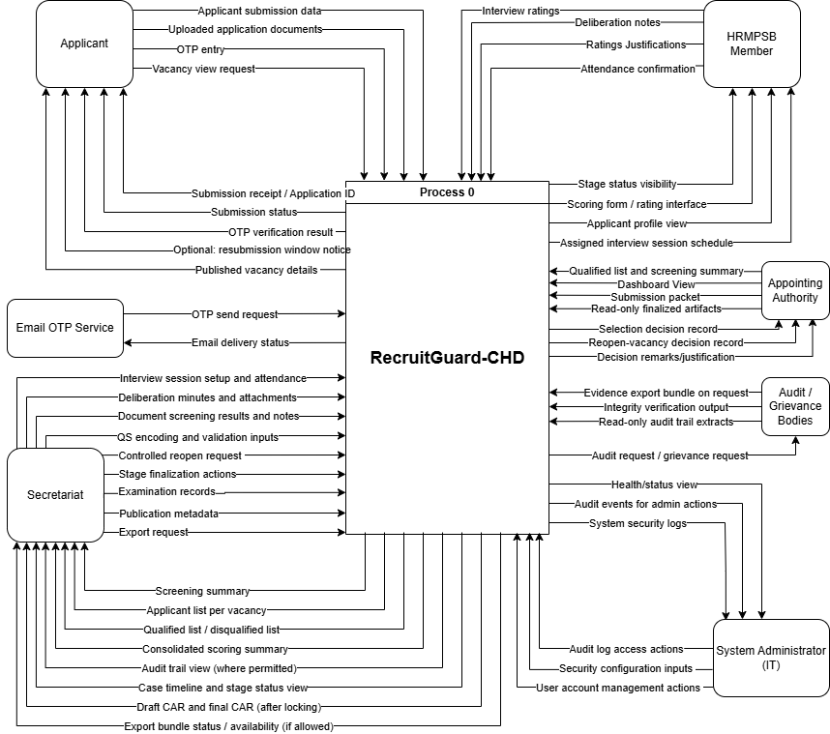
Figure 3.3 presents the context diagram of RecruitGuard-CHD, showing the system boundary and how the platform exchanges information with its external actors. The central process labeled “Process 0 – RecruitGuard-CHD” represents the entire secure-by-design recruitment workflow system. All users and external services are positioned outside the system boundary, and the arrows illustrate the high-level inputs and outputs exchanged during recruitment operations. The diagram emphasizes that recruitment activities are coordinated through a single controlled system that enforces workflow stages, supports evidence handling, and produces accountable outputs for decision-making and review.
Applicant (Accountless, OTP-Verified). The Applicant interacts with RecruitGuard-CHD through an accountless intake process. The Applicant submits a vacancy view request, provides application submission data, uploads application documents, and performs OTP entry to confirm identity for submission. In return, the system provides published vacancy details, OTP verification result, submission status, and a submission receipt with Application ID. Where applicable, the system may also provide an optional resubmission window notice when controlled resubmission is allowed.
Email OTP Service (Gmail SMTP). The Email OTP Service is treated as an external messaging service used only for OTP delivery. RecruitGuard-CHD sends an OTP send request to the OTP service, and the service returns email delivery status (delivery result/feedback) to support verification and traceability of intake communication.
Secretariat. The Secretariat is the primary process administrator for recruitment cases. Inputs to the system include vacancy record data, publication metadata, QS encoding and validation inputs, document screening results and notes, examination records, interview session setup and attendance, deliberation minutes and attachments, stage finalization actions, controlled reopen request, and export request (when authorized). In return, RecruitGuard-CHD provides operational outputs such as screening summary, applicant list per vacancy, qualified/disqualified list, consolidated scoring summary, case timeline and stage status view, draft CAR and final CAR (after locking), audit trail view (where permitted), and export bundle status/availability when export generation is allowed.
HRMPSB Member. HRMPSB Members contribute rating inputs required by the policy-defined workflow. They provide interview ratings, ratings justifications, attendance confirmation, and where applicable deliberation notes. The system returns stage status visibility, access to the scoring form/rating interface, applicant profile view, and the assigned interview session schedule, enabling role-limited participation without exposing unauthorized functions.
Appointing Authority. The Appointing Authority receives decision-support outputs produced from finalized workflow stages, including the dashboard view, qualified list and screening summary, and the submission packet. The system also provides read-only finalized artifacts to preserve integrity of finalized records. The Appointing Authority provides decision actions back to the system, including selection decision record, reopen-vacancy decision record, and associated decision remarks/justification, which the system records as part of the accountable decision trail.
Audit / Grievance Bodies (CSC, COA Review). External audit or grievance reviewers interact through controlled requests and controlled outputs. The system can provide evidence export bundle (on request/authorization), integrity verification output, and read-only audit trail extracts to support defensibility and review. These bodies may initiate an audit request / grievance request, which the system treats as an external trigger for review-oriented outputs without allowing modification of finalized recruitment records.
System Administrator (IT). The System Administrator supports platform administration and security operations. Administrative inputs include user account management actions, security configuration inputs, and audit log access actions (as permitted by role). The system returns system security logs, audit events for admin actions, and health/status view, supporting operational oversight while maintaining separation from recruitment case content.
Overall, the context diagram clarifies that RecruitGuard-CHD serves as the single controlled hub for recruitment workflow execution, where external actors provide required inputs and receive role-appropriate outputs, while review bodies and administrative functions are handled through controlled, auditable interactions.

3.4.3 Data Flow Diagram Level 1-A Intake Vacancy and Screening
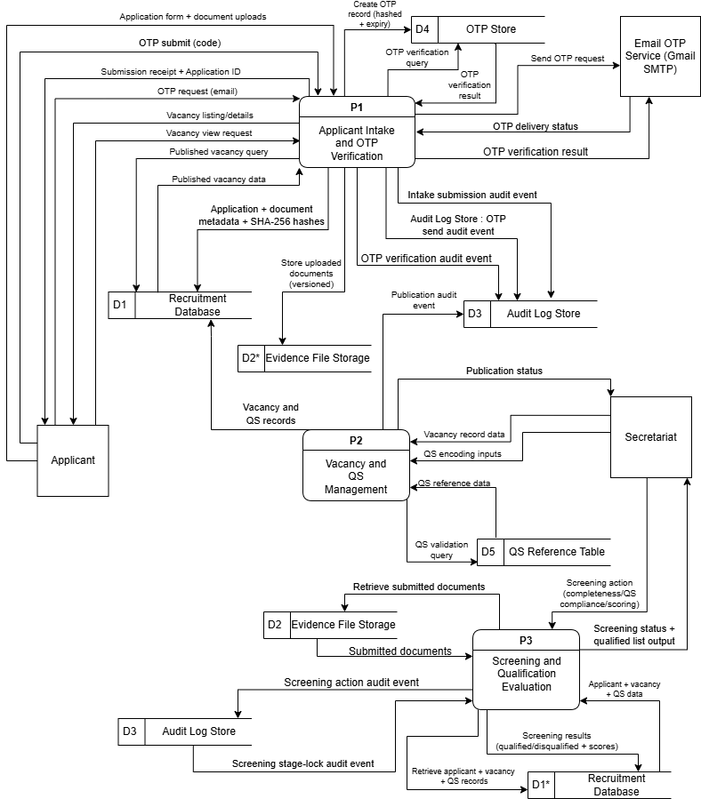
Figure 3.4 Data Flow Diagram Level 1-A Intake Vacancy and Screening
DFD Level 1A models the early phase of the recruitment lifecycle covering vacancy creation and publication, applicant vacancy viewing, accountless OTP verified intake, evidence capture, and initial screening. The Secretariat initiates vacancy setup by encoding vacancy record data and structured Qualification Standards through the Vacancy and QS Management process. Prior to allowing publication, the process performs QS validation by querying the QS Reference Table and using the reference results to confirm that the encoded QS is aligned to allowed standards. Upon successful validation, vacancy and QS records are stored in the Recruitment Database and a publication audit event is written to the Audit Log Store. Publication status is then returned to the Secretariat as confirmation that intake may proceed only when the vacancy is in Published status and within its validity period.
For applicant interaction, the Applicant Intake and OTP Verification process serves published vacancy information by querying the Recruitment Database and returning vacancy listings and details to the Applicant. When the Applicant requests OTP verification, the system creates an OTP record in the OTP Store using a hashed representation with an expiry control and requests delivery through the Email OTP Service. OTP delivery status is returned to the system, and an OTP send audit event is recorded in the Audit Log Store. The Applicant then submits the OTP code for verification, which is checked against the OTP Store, and the verification outcome is logged as an OTP verification audit event before a verification result is returned to the Applicant.
Once OTP verification is satisfied, the Applicant submits the application form together with required documents. Uploaded documents are written to the Evidence File Storage as versioned artifacts, while the Recruitment Database stores the structured application record together with document metadata and SHA-256 hashes. An intake submission audit event is recorded, and a submission receipt with a unique Application ID is returned to the Applicant. For initial screening, the Secretariat triggers the Screening and Qualification Evaluation process to assess completeness, QS compliance, and scoring. The process retrieves applicant records and vacancy QS details from the Recruitment Database and retrieves submitted documents from the Evidence File Storage. Screening results including qualified or disqualified status and scores are stored in the Recruitment Database. The screening action and the screening stage lock are both logged to the Audit Log Store, after which screening status and a qualified list output are returned to the Secretariat. This design ensures that decisions at the screening stage are traceable, and that evidentiary materials used for screening are preserved under integrity controls.

3.4.3 Data Flow Diagram Level 1-B Interview and Deliberation CAR
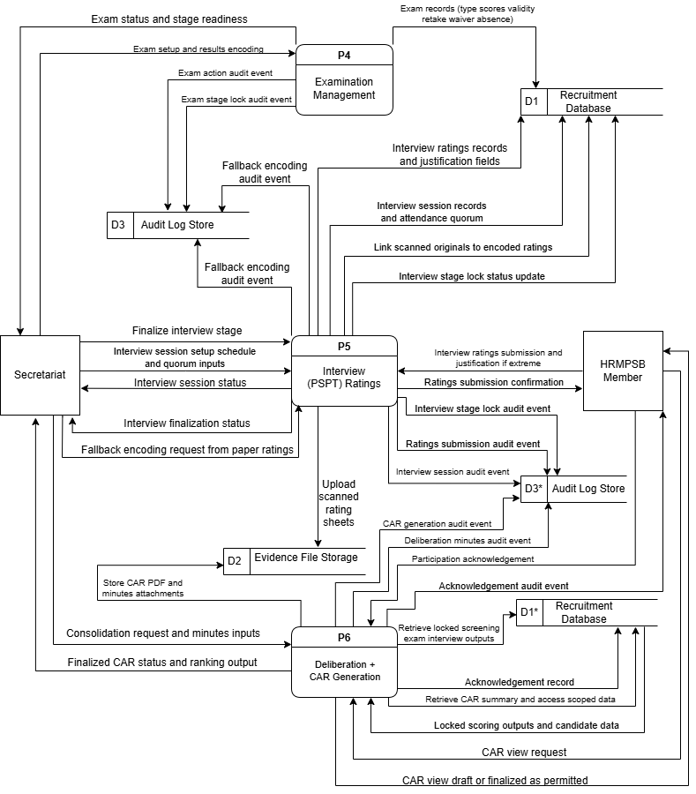
Figure 3.5 Data Flow Diagram Level 1-B Interview and Deliberation CAR
DFD Level 1B models the mid stage evaluation phase of the recruitment lifecycle where examination results are recorded, interview sessions and PSPT ratings are managed, and deliberation outputs are consolidated into the Comparative Assessment Report. The Secretariat initiates the Examination Management process by encoding exam setup details and results. Exam records including exam type, scores, validity tracking, retake recording, waiver handling, and absence recording are stored in the Recruitment Database. The system records an exam action audit event and an exam stage lock audit event in the Audit Log Store, then returns an exam status and stage readiness indicator to the Secretariat. This ensures that examinations become a controlled workflow input to later ranking and cannot be silently altered after locking.
For interviews, the Secretariat establishes the interview session schedule and quorum requirements through the Interview Ratings process, which stores session and attendance quorum records in the Recruitment Database and logs a session audit event. HRMPSB Members then submit interview ratings directly through the same process, including justification when ratings meet extreme thresholds. Interview ratings and justifications are stored in the Recruitment Database, and a ratings submission audit event is recorded. The system returns a ratings submission confirmation to the HRMPSB Member to provide a clear non repudiation trail. When paper based scoring is required as a fallback, the Secretariat initiates a fallback encoding request, uploads scanned rating sheets into Evidence File Storage, and links the scanned originals to encoded ratings in the Recruitment Database. A fallback encoding audit event is recorded to ensure that the encoded values remain traceable to the uploaded evidence.
Once interview encoding is complete, the Secretariat finalizes the interview stage, which updates the interview stage lock status in the Recruitment Database and records an interview stage lock audit event. The system returns an interview finalization status to confirm that interview ratings are now locked as an input to deliberation.
For deliberation, the Secretariat triggers Deliberation and CAR Generation with a consolidation request and minutes inputs. The process retrieves locked screening, examination, and interview outputs from the Recruitment Database and uses them to compute a consolidated scoring summary. The generated CAR PDF and minutes attachments are stored in Evidence File Storage, while CAR metadata, ranking summary, and evidence references are stored in the Recruitment Database. The system records separate audit events for CAR generation, deliberation minutes handling, and deliberation stage lock. The final output returned to the Secretariat is the finalized CAR status and ranking output.
In support of governance and transparency within HRMPSB operations, the HRMPSB Member may request to view the CAR through the deliberation process. The system retrieves CAR summary information and access scoped data from the Recruitment Database and returns the CAR view as draft or finalized depending on workflow permissions. Participation acknowledgement is captured and stored in the Recruitment Database and logged in the Audit Log Store to preserve accountability for deliberation participation.

3.4.3 Data Flow Diagram Level 1-C Submission Appointment Archival and Export
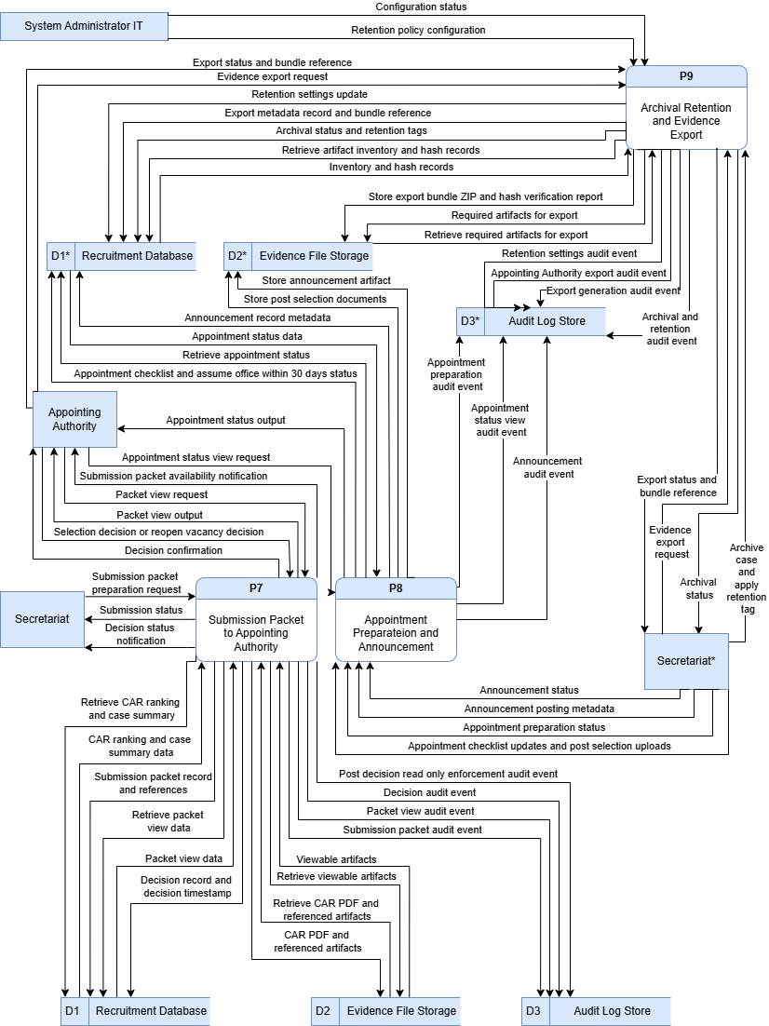
Figure 3.6 Data Flow Diagram Level 1-C Submission Appointment Archival and Export
DFD Level 1C models the final stages of the recruitment lifecycle including submission to the Appointing Authority, decision logging, appointment preparation and announcement recording, archival and retention tagging, and evidence export bundle generation. The Secretariat initiates the submission packet preparation process to compile a submission packet based on the finalized CAR and ranking outputs. The process retrieves CAR ranking and case summary data from the Recruitment Database and retrieves the CAR PDF and referenced artifacts from Evidence File Storage. It stores a submission packet record and references in the Recruitment Database, logs a submission packet audit event in the Audit Log Store, returns submission status to the Secretariat, and notifies the Appointing Authority that the submission packet is available for review.
The Appointing Authority may request to view the packet, which triggers retrieval of packet view data from the Recruitment Database and viewable artifacts from Evidence File Storage. A packet view audit event is recorded before the packet view output is returned. The Appointing Authority then records either a selection decision or a reopen vacancy decision. The system stores the decision record and timestamp in the Recruitment Database and records a decision audit event together with a post decision read only enforcement audit event to preserve the immutability of pre decision artifacts. Decision confirmation is returned to the Appointing Authority and decision status notification is returned to the Secretariat, ensuring that the system maintains lawful discretion while preserving defensible records.
For appointment preparation, the Secretariat updates appointment checklist items and uploads post selection requirements. Post selection documents are stored in Evidence File Storage, while appointment checklist status and the assume office within 30 days tracking status are stored in the Recruitment Database. An appointment preparation audit event is recorded, and appointment preparation status is returned to the Secretariat. The Appointing Authority may request to view appointment status, which triggers retrieval from the Recruitment Database and logs an appointment status view audit event before returning appointment status output.
Announcement recording is handled through the same appointment process. The Secretariat provides announcement posting metadata, which is stored in the Recruitment Database. The announcement artifact itself is stored in Evidence File Storage, and an announcement audit event is recorded. Announcement status is returned to the Secretariat as confirmation that the artifact is now preserved.
For archival and retention, the Secretariat triggers the archival process to archive a case and apply retention tags. The system stores archival status and retention tags in the Recruitment Database, logs an archival and retention audit event, and returns archival status. Evidence export is performed through the same process. When the Secretariat requests an evidence export, the system retrieves the artifact inventory and hash records from the Recruitment Database and retrieves required artifacts from Evidence File Storage. It generates the export bundle and hash verification report, stores them in Evidence File Storage, and records export metadata and bundle references in the Recruitment Database. An export generation audit event is recorded, and export status and bundle reference are returned. The Appointing Authority may also request an evidence export, which is logged as an Appointing Authority export audit event before returning the export status and bundle reference. Finally, system wide retention configuration is represented through the System Administrator IT, who submits retention policy configuration to the archival retention and export process. The system writes retention settings updates to the Recruitment Database, logs a retention settings audit event, and returns configuration status, while maintaining the requirement that the System Administrator does not access recruitment case content by default.
Overall, the three DFD levels collectively demonstrate that RecruitGuard-CHD enforces a controlled data lifecycle where each workflow stage consumes verified inputs, generates stage bound outputs, preserves evidentiary artifacts with integrity controls, and records attributable audit events to support accountability and grievance defensibility.

3.4.4 Use Case Diagram
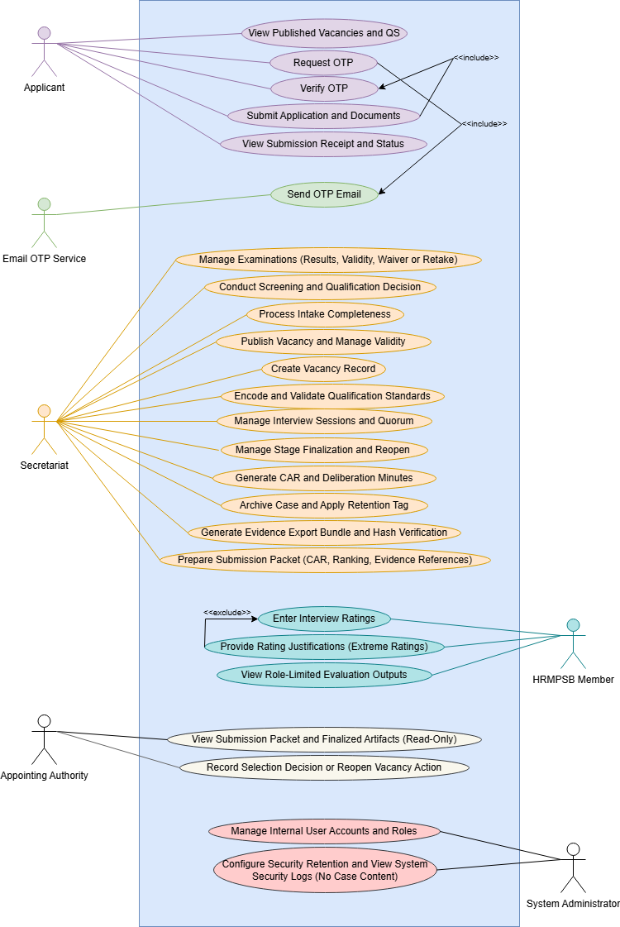
Figure 3.7 Use Case Diagram of RecruitGuard-CHD
Figure presents the Use Case Diagram of RecruitGuard-CHD, showing the system boundary and the major functions performed by the system in relation to the six primary actors involved in the DOH–CHD CALABARZON recruitment workflow. The diagram summarizes how RecruitGuard-CHD supports the recruitment lifecycle from vacancy publication and accountless applicant intake, through screening, examination, interview rating, deliberation and CAR generation, up to submission to the Appointing Authority, evidence export, and archival/retention handling.
The purpose of the use case diagram is to present what the system allows each actor to do, at a functional level, without exposing internal implementation details.

Actors (6)
- Applicant (Accountless, OTP-Verified): views published vacancies/QS, requests OTP, verifies OTP, submits application and documents, and views submission receipt/status.
- Email OTP Service (Gmail SMTP): external email service used only for delivering OTP emails and returning delivery status.
- Secretariat: primary process administrator who encodes vacancy and QS, performs screening, manages examinations and interview sessions, generates CAR/minutes, prepares submission packets, generates evidence exports, and archives cases.
- HRMPSB Member: enters interview ratings, provides justifications when required (extreme ratings), and views role-limited evaluation outputs.
- Appointing Authority: reviews the submission packet and finalized artifacts (read-only) and records the selection decision or vacancy reopening action.
- System Administrator (IT): manages internal user accounts and roles, and configures security/retention settings while viewing system security logs (without recruitment case content).

Use Case Relationships (Include / Extend)
- Request OTP includes Send OTP Email (OTP delivery is required to complete OTP request).
- Submit Application and Documents includes Verify OTP (final submission is only allowed after OTP verification).
- Provide Rating Justifications (Extreme Ratings) extends Enter Interview Ratings (justification is required only when ratings exceed defined extreme thresholds).

Table 3.4.4-A Applicant Use Case Specifications
UC ID | Use Case | Preconditions | Main Interaction Summary | Outputs / Postconditions | Alternate / Exceptions
UC-01 | View Published Vacancies and QS | Vacancy is published and within validity period | Applicant views vacancy listing and QS snapshot | Applicant can proceed to OTP request for a chosen vacancy | Expired/unpublished vacancy is not available for intake

Table 3.4.4-B Applicant Use Case Specifications
UC-02 | Request OTP | Applicant is on a published vacancy intake page | Applicant requests OTP; system creates OTP record and triggers OTP email sending | OTP request exists with expiry; OTP event is recorded for traceability | Email delivery failure is recorded; user may retry OTP request
UC-03 | Verify OTP | OTP request exists and is not expired | Applicant submits OTP; system validates OTP and returns result | Applicant is marked OTP-verified for the submission attempt | Invalid/expired OTP results in denial and prompts re-request
UC-04 | Submit Application and Documents | Applicant is OTP-verified | Applicant submits form + uploads documents; system stores submission artifacts and creates application record | Application ID and submission receipt generated; case bound to vacancy | Incomplete checklist blocks final submission until completed
UC-05 | View Submission Receipt and Status | Application exists | Applicant views receipt and current submission status | Proof of submission is available (Application ID); status visibility provided | If resubmission window is enabled, status shows resubmission instruction

Table 3.4.5-A Email OTP Service Use Case Specifications
UC ID | Use Case | Preconditions | Main Interaction Summary | Outputs / Postconditions | Alternate / Exceptions
UC-06 | Send OTP Email | System has created an OTP request (UC-02) | System sends OTP email request via SMTP; service returns delivery status | Delivery status is returned to the system for logging and user feedback | Delivery fails due to SMTP issues; failure status is captured

Table 3.4.6-A Secretariat Use Case Specifications
UC ID | Use Case | Preconditions | Main Interaction Summary | Outputs / Postconditions | Alternate / Exceptions
UC-07 | Create Vacancy Record | Secretariat authenticated and authorized | Encode vacancy details and recruitment metadata as a draft record | Vacancy draft exists; action is audit-recorded | None (draft remains editable until publication lock)
UC-08 | Encode and Validate Qualification Standards | Vacancy draft exists and is not yet locked | Encode QS (Education/Training/Experience/Eligibility); system validates against QS reference | Validated QS stored; QS validation evidence is recorded | QS mismatch blocks progression until corrected

Table 3.4.6-B Secretariat Use Case Specifications
UC-09 | Publish Vacancy and Manage Validity | Vacancy + QS are validated | Publish vacancy and record validity window; system locks QS fields after publication | Vacancy becomes available for intake; publication event is audit-logged | If validity expires, republication/amendment requires controlled logged action
UC-10 | Process Intake Completeness | Applicant submissions exist | Check completeness; record deficiencies; optionally enable resubmission window as a case event | Completeness status recorded; supporting notes stored | Missing required documents keeps status incomplete
UC-11 | Conduct Screening and Qualification Decision | Intake stage is satisfied/allowed to proceed | Record QS compliance, screening scores/decision; finalize screening to stage-lock outputs | Qualified/disqualified status produced; screening outputs locked; audit event recorded | Missing prerequisites prevents screening finalization
UC-12 | Manage Examinations (Results, Validity, Waiver or Retake) | Applicant is eligible for exam stage | Encode exam results by type; record validity; record waiver/absence; record retake decision with justification | Exam records stored with validity metadata; stage outputs can be finalized | Expired results are flagged and cannot be used for ranking decisions
UC-13 | Manage Interview Sessions and Quorum | Interview stage is opened | Create interview sessions; record attendance and quorum | Session/quorum record stored as stage evidence | Incomplete quorum/attendance record prevents proper session finalization

Table 3.4.6-C Secretariat Use Case Specifications
UC-14 | Manage Stage Finalization and Reopen | Stage outputs exist | Finalize stage outputs to lock; if correction is needed, reopen via controlled, logged action with justification | Lock prevents silent edits; reopen actions are traceable | Unauthorized reopen attempt is denied
UC-15 | Generate CAR and Deliberation Minutes | Screening, exams, interviews are finalized/locked | Consolidate locked outputs; generate CAR, minutes, and ranking list; finalize and lock artifacts | Final CAR + minutes produced as system artifacts; audit event recorded | Missing locked inputs prevents CAR generation/finalization
UC-16 | Prepare Submission Packet (CAR, Ranking, Evidence References) | CAR and ranking exist and are finalized | Assemble submission packet view for Appointing Authority including evidence references | Submission packet becomes available for review (read-only view) | None (packet remains dependent on finalized CAR inputs)
UC-17 | Generate Evidence Export Bundle and Hash Verification | Export permission granted; required artifacts exist | Generate export bundle (CAR, minutes, scoring breakdown where applicable, inventory, hash verification report) | Export bundle produced; export event is audit-logged | Unauthorized export request is denied

Table 3.4.6-D Secretariat Use Case Specifications
UC-18 | Archive Case and Apply Retention Tag | Recruitment case is completed/closed | Mark case archived; apply retention tag/settings; restrict access appropriately | Case transitions to archived status; retention tag stored | Unauthorized archival/retention action is denied

Table 3.4.7-A HRMPSB Member Use Case Specifications
UC ID | Use Case | Preconditions | Main Interaction Summary | Outputs / Postconditions | Alternate / Exceptions
UC-19 | Enter Interview Ratings | HRMPSB authenticated; interview session exists; quorum recorded | Member encodes PSPT interview ratings for applicants | Ratings stored and attributable; may be stage-finalized/locked | If fallback path is used, paper rating sheet is uploaded first and linked to encoded values
UC-20 | Provide Rating Justifications (Extreme Ratings) | Triggered only when rating meets extreme threshold | Member provides justification text supporting extreme rating | Justification is bound to rating entry; supports defensibility | If justification missing when required, rating submission is blocked
UC-21 | View Role-Limited Evaluation Outputs | HRMPSB authenticated and authorized | Member views permitted outputs (role-limited) | Read-only visibility consistent with RBAC | Attempt to access restricted artifacts is denied

Table 3.4.8-A Appointing Authority Use Case Specifications
UC ID | Use Case | Preconditions | Main Interaction Summary | Outputs / Postconditions | Alternate / Exceptions
UC-22 | View Submission Packet and Finalized Artifacts (Read-Only) | Submission packet exists; Appointing Authority authenticated | Reviews CAR, ranking, and evidence references in read-only mode | Decision-ready view based on preserved artifacts | Access to non-permitted views is denied
UC-22 | Record Selection Decision or Reopen Vacancy Action | Packet reviewed; decision stage open | Records selection decision (and justification where applicable) or records reopen-vacancy action | Decision/reopen event is logged; prior artifacts remain preserved/read-only | Unauthorized decision action is denied

Table 3.4.9-A System Administrator (IT) Use Case Specifications
UC ID | Use Case | Preconditions | Main Interaction Summary | Outputs / Postconditions | Alternate / Exceptions
UC-22 | Manage Internal User Accounts and Roles | IT admin authenticated and authorized | Create/disable users; assign roles; record actions as audit events | Account lifecycle is controlled and traceable | Unauthorized changes are denied

Table 3.4.9-B System Administrator (IT) Use Case Specifications
UC-22 | Configure Security Retention and View System Security Logs (No Case Content) | IT admin authenticated and authorized | Configure retention/security settings; view system security logs without recruitment case content | Security configuration changes recorded; logs support oversight | Attempt to access recruitment case content is blocked by role controls

3.4.5 Entity Relationship Diagram
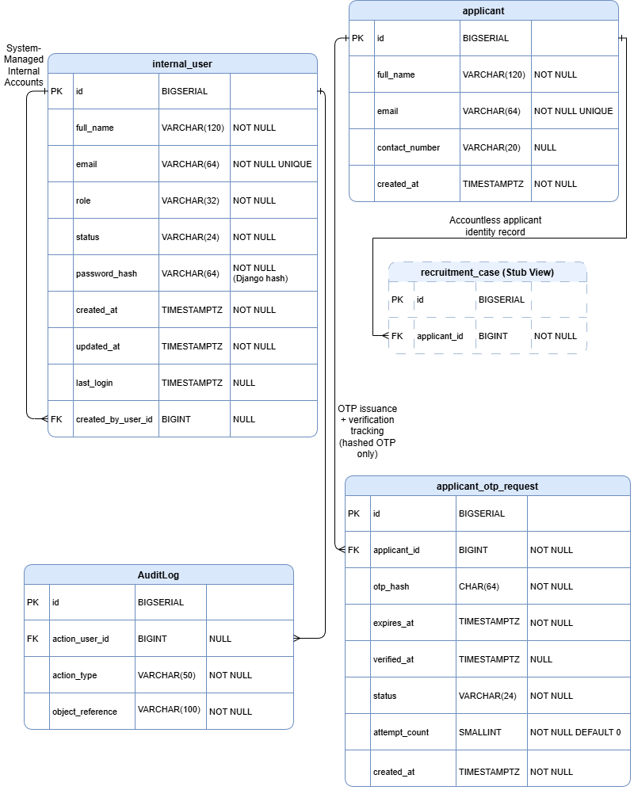
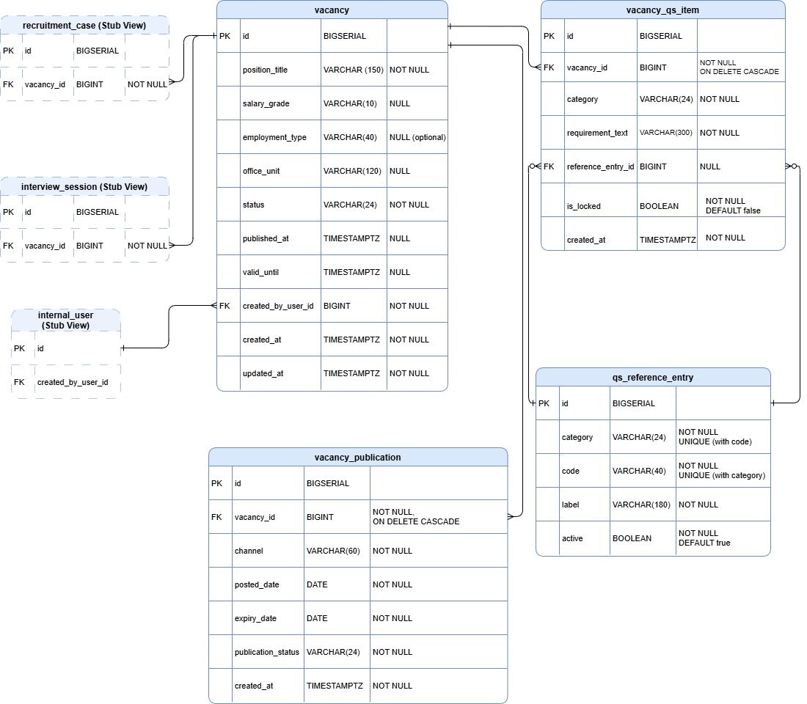
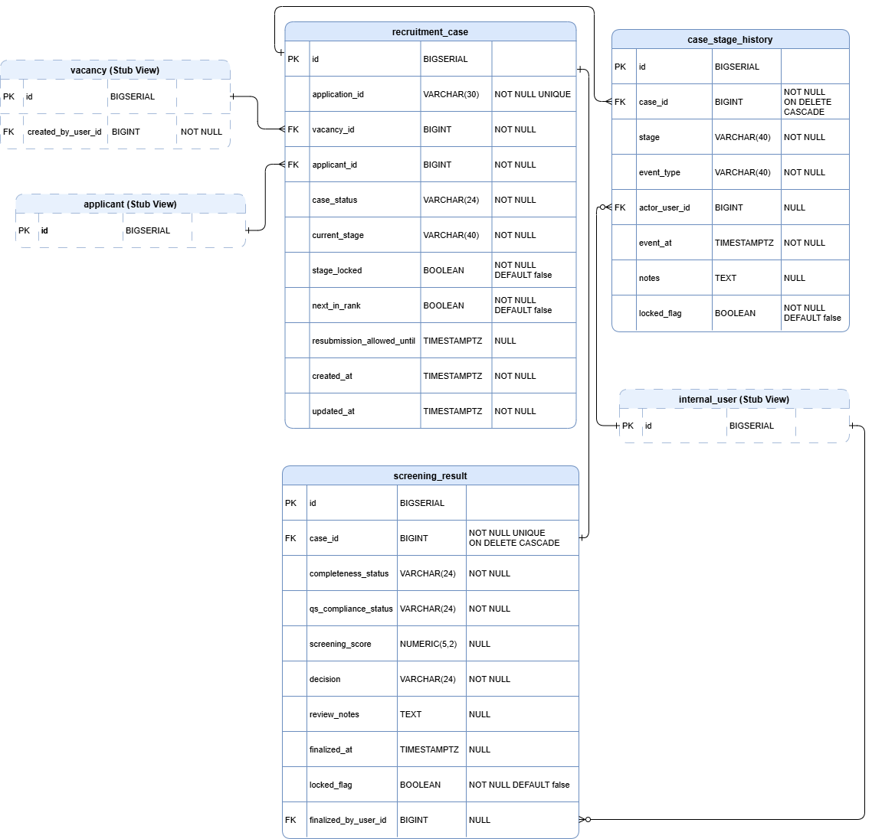
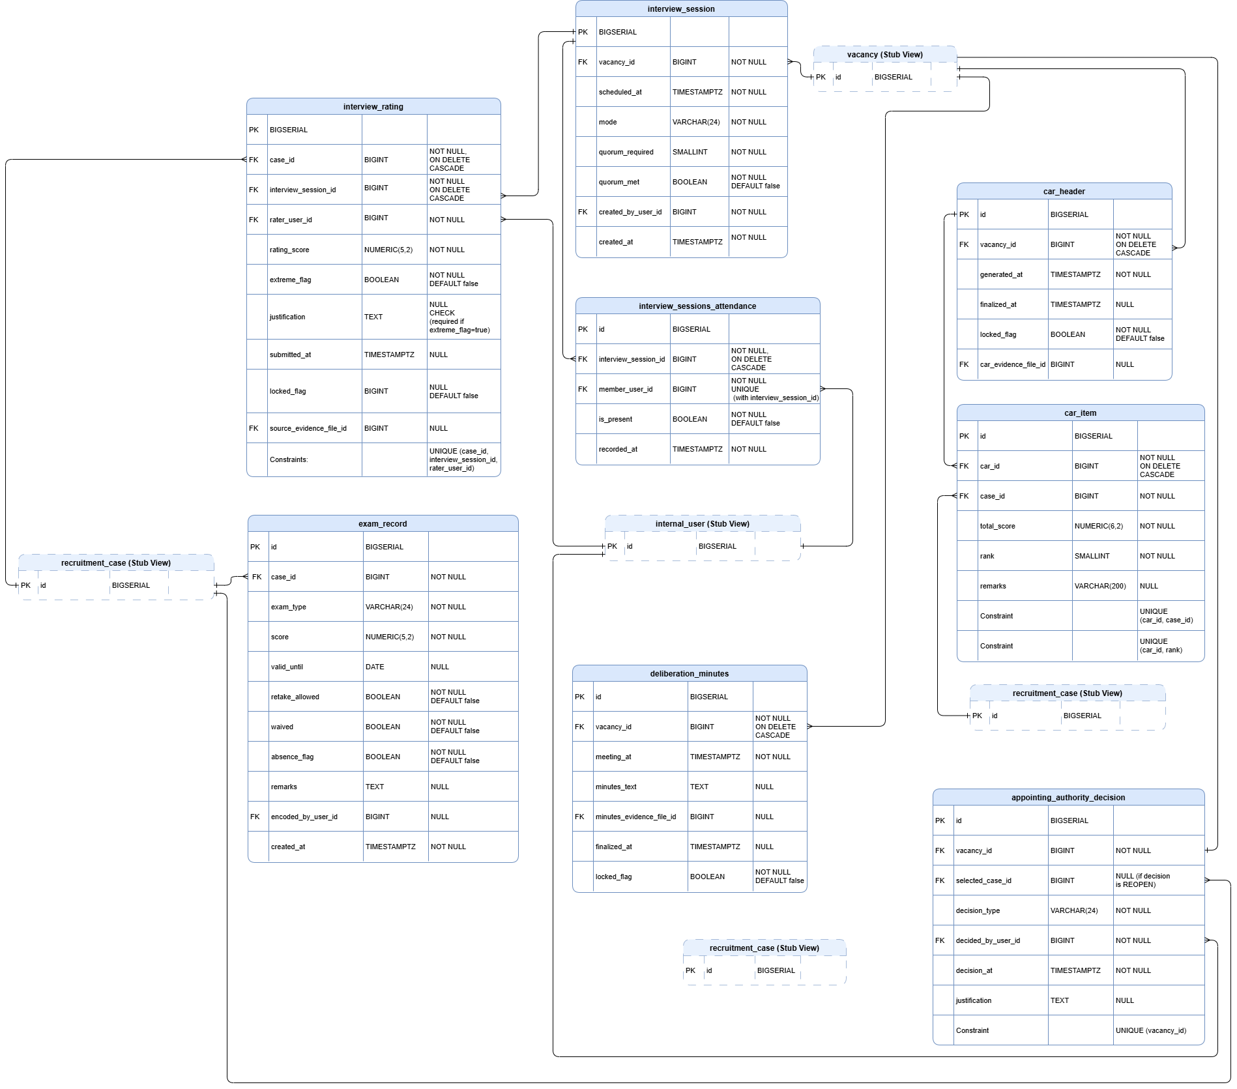
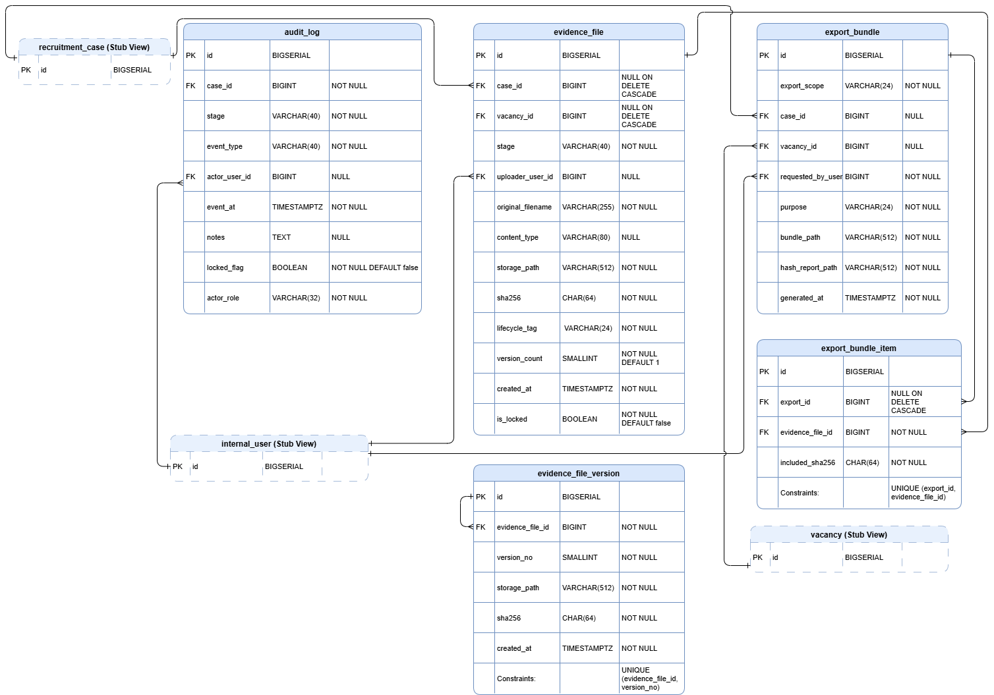
Figure 3.8 Entity Relationship Diagram
3.4.6 Network/Deployment Diagram
RecruitGuard-CHD is deployed as a single-server web application hosted on a cloud VPS. End users access the system using standard web browsers over the public internet through the VPS public IP address. Incoming web requests are received by the Nginx reverse proxy over HTTPS (public IP, self-signed certificate for prototype use) and are forwarded to the Gunicorn application server that hosts the Django web application. The Django application performs read and write operations to a PostgreSQL database for structured recruitment records and audit events, and stores uploaded evidence files in a local file storage directory within the VPS (MEDIA_ROOT). For accountless applicant intake, the Django application sends one-time password (OTP) emails through an external email service using SMTP (Gmail SMTP), supporting OTP delivery for submission verification. Administrative access to the VPS is performed by the System Administrator through SSH key authentication from an IT workstation under a restricted SSH posture. DigitalOcean weekly backups are enabled for the VPS to support recovery and continuity within the prototype environment.
Security testing is performed using a staging copy of RecruitGuard-CHD deployed on the same VPS. This staging instance uses dummy or synthetic data only and is utilized exclusively for controlled vulnerability scanning and controlled manual security testing to ensure that evaluation activities do not affect operational records or outputs.
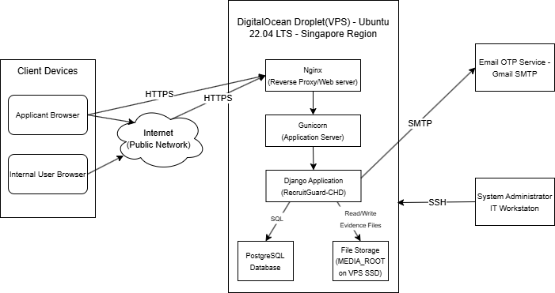Figure 3.9 Deployment Diagram of RecruitGuard-CHD (VPS-based deployment)

3.5 Cybersecurity Measures
This section describes how cybersecurity measures are applied within RecruitGuard-CHD to address validated risks and security requirements identified in earlier chapters. The purpose of this section is to explain how protection is integrated into system operations and workflow-level design decisions, ensuring that security mechanisms are systematically applied rather than added as isolated features. This section focuses on the categories of protection used and their purpose in the system context, without discussing tool configurations or security testing outcomes (which are discussed in later sections).
3.5.1 Security Practices
RecruitGuard-CHD applies security practices that protect recruitment data, evidence artifacts, and decision accountability throughout the recruitment lifecycle. These security practices are selected to match the system’s workflow-driven nature and the sensitivity of recruitment assets, including applicant personally identifiable information

3.5.1.1 Authentication and Access Control
RecruitGuard-CHD applies authentication and access control to ensure that only legitimate actors can interact with system functions appropriate to their role. Applicant intake is protected through OTP verification prior to final submission, which reduces impersonation risk for the accountless intake flow. Internal users are required to authenticate before accessing recruitment case content. Access is then restricted through role-based access control (RBAC) and stage-bound permissions to enforce least privilege and prevent unauthorized viewing or modification of sensitive recruitment records.

3.5.1.2 Workflow Integrity and Stage Enforcement
Because RecruitGuard-CHD digitizes a policy-defined recruitment lifecycle, workflow integrity is treated as a security requirement rather than only a usability feature. Stage enforcement prevents skipping required steps and blocks progression unless prerequisites are satisfied. Finalized outputs are protected through stage-locking so that sensitive artifacts—such as screening decisions, interview ratings, and CAR outputs—cannot be modified without a controlled re-open action that is itself recorded as an auditable event. This supports tamper resistance and improves defensibility of decisions.

3.5.1.3 Data Protection and Evidence Integrity Measures
RecruitGuard-CHD protects recruitment evidence by binding uploaded documents to integrity metadata and verifiable hashing. Evidence files are stored with case identifiers and workflow stage metadata and are hash-bound using SHA-256 to support later verification. Evidence version preservation prevents silent overwrite, ensuring that any replacement or resubmission results in a traceable version record rather than an unlogged modification. These controls support confidentiality and integrity while ensuring that evidence remains defensible during review or export.

3.5.1.4 Audit Logging and Accountability Measures
RecruitGuard-CHD applies audit logging to support non-repudiation and decision accountability. Security-relevant and workflow-critical actions are recorded with actor identity, role, timestamp, case context, and workflow stage. Audit logging is applied not only to primary recruitment actions (e.g., finalizing screening outputs or generating the CAR), but also to sensitive access activities (e.g., exporting evidence bundles or viewing audit logs). This creates attributable decision trails that support administrative review, grievance handling, and audit defensibility.

3.5.1.5 Controlled Export and Disclosure Controls
RecruitGuard-CHD treats export as a controlled disclosure surface. Evidence export is restricted by role and logged as an auditable event. Export bundles are structured to include required artifacts and an integrity verification output (hash verification report) so that exported evidence can be validated independently. This supports controlled information disclosure and minimizes the risk of unauthorized distribution of sensitive recruitment records.

Table 3.14-A Summary of Security Practices in RecruitGuard-CHD
Security Practice Category | Purpose (What it protects) | Where it is applied in RecruitGuard-CHD
Authentication and Access Control | Prevent unauthorized entry and restrict access by role | OTP-based applicant intake; authenticated internal access; RBAC and stage-bound permissions
Workflow Integrity Enforcement | Prevent stage skipping and unauthorized post-hoc edits | Stage prerequisites; stage-locking of finalized outputs; controlled re-open events
Evidence Integrity and Data Protection | Prevent silent document tampering and ensure integrity verification | Evidence Vault storage; SHA-256 hashing; metadata binding; version preservation

Table 3.14-B Summary of Security Practices in RecruitGuard-CHD
Audit Logging and Accountability | Ensure traceability and non-repudiation for decisions and actions | Actor-attributed audit events for key workflow actions and sensitive access events
Export Controls | Prevent unauthorized disclosure and preserve evidentiary defensibility | Role-restricted export generation; export logs; bundles include inventory + hash report

3.5.2 Application of Cybersecurity Measures
This subsection explains how RecruitGuard-CHD applies the identified cybersecurity measures within the system context to address the validated risks and STRIDE-based threats discussed in Chapter 1, without restating the threat analysis. Because RecruitGuard-CHD is a workflow-enforced recruitment system, security is applied primarily through (1) controlled identity and access boundaries, (2) workflow integrity enforcement that prevents process bypass, (3) evidence integrity mechanisms that preserve defensible records, and (4) audit logging that enables accountability and non-repudiation. These measures are embedded directly into the system’s recruitment stages and role-based interactions so that protection is consistently enforced at the points where recruitment evidence is collected, evaluated, finalized, and exported.

3.5.2.1 Applicant Intake (Accountless, OTP-Verified)
Security measures are applied at intake to protect identity and submission integrity for accountless applicants. OTP verification is required prior to accepting final submission, reducing spoofing and fraudulent submissions. Intake is also constrained by vacancy publication status and validity periods, which prevents unintended or out-of-window submissions that could create disputes or weaken defensibility. The system generates a submission receipt and application identifier to support traceability of what was submitted and when, which contributes to accountability and reduces repudiation risk in later stages.

3.5.2.2 Internal User Access (RBAC + Stage-Bound Permissions)
RecruitGuard-CHD applies role-based access control and stage-bound permission enforcement across internal portals to prevent unauthorized access and privilege escalation. Secretariat, HRMPSB Members, Appointing Authority, and System Administrator IT are each restricted to role-appropriate actions. Stage-bound access ensures that sensitive artifacts—such as screening outputs, interview ratings, and CAR drafts/final CAR—are only accessible when role and workflow stage conditions are satisfied. This application of access control directly addresses information disclosure and elevation of privilege risks while supporting confidentiality of applicant PII and integrity of evaluation outputs.

3.5.2.3 Workflow Integrity Enforcement (Stage Progression + Stage Locking)
Workflow integrity measures are applied to prevent stage skipping, post-hoc modification, and silent changes to decision-relevant records. RecruitGuard-CHD enforces prerequisites for stage advancement and prevents finalization when required artifacts are missing. Once stage outputs are finalized (e.g., screening decisions, exam results, interview ratings, CAR outputs), stage-locking prevents edits unless a controlled re-open action is performed and recorded. This ensures that any changes are attributable and defensible, addressing tampering and repudiation risks while strengthening the integrity of rankings and decision trails.

3.5.2.4 Evidence Vault Controls (Integrity, Version Preservation, Metadata Binding)
Evidence integrity measures are applied at the point of document handling to ensure recruitment documents remain verifiable. Uploaded evidence is stored with case and stage metadata and is bound to a SHA-256 hash for integrity verification. Version preservation prevents silent overwrite by maintaining traceable versions instead of replacing prior files without record. These measures directly address tampering risks for uploaded documents and improve defensibility in audits or grievances by enabling independent integrity checks during evidence export.

3.5.2.5 Audit Logging and Accountability (Recruitment-Grade Traceability)
Audit logging measures are applied across workflow actions and sensitive access activities to support non-repudiation and accountability. Key actions—such as publication, screening finalization, interview rating submission, CAR generation/finalization, decision logging, export generation, and archival/retention actions—are recorded with actor identity, role, timestamp, case context, and workflow stage. Audit log access and export actions are also recorded to prevent repudiation and strengthen accountability. This ensures the system can demonstrate who performed what action, when, and under which workflow stage context.

3.5.2.6 Controlled Export and Disclosure (Export Permissions + Integrity Outputs)
RecruitGuard-CHD applies export controls to treat evidence export as a controlled disclosure surface. Export permissions are restricted by role, and each export is recorded as an auditable event. Export bundles are structured to include required artifacts along with an evidence inventory and hash verification report, ensuring that exported evidence remains verifiable and defensible. This approach addresses information disclosure risks by preventing unauthorized export and supports integrity by enabling verification of evidence content outside the system.

3.5.2.7 Availability and Non-Destructive Security Posture (Study Scope)
Within the prototype scope, availability-related measures focus on maintaining stable operation during evaluation and reducing intake disruption risk using basic safeguards appropriate to a non-destructive academic study. The testing posture explicitly excludes denial-of-service testing and brute force attempts, ensuring that security validation remains controlled while still verifying enforcement of authentication, authorization, workflow integrity, evidence handling, and audit logging controls.

Table 3.15-A Traceability of Threats to Applied Cybersecurity Measures (Summary)
Validated Threat / Risk Category (Chapter 1) | Applied Measure in RecruitGuard-CHD | Where the Measure Appears in the System | Objective Supported
Spoofing (identity misuse at intake or internal access) | OTP verification for accountless intake; authenticated internal access | Applicant intake; internal portals | Integrity, Accountability

Table 3.15-B Traceability of Threats to Applied Cybersecurity Measures (Summary)
Tampering (scores/documents/records altered post-hoc) | Stage-locking; controlled re-open actions; evidence hashing and version preservation | Screening, exams, interviews, CAR; Evidence Vault | Integrity, Accountability
Repudiation (denial of actions/decisions) | Actor-attributed audit logging; logging of export and sensitive access | All critical workflow actions; audit log access/export | Accountability, Non-repudiation
Information Disclosure (PII/ratings/CAR exposure) | RBAC + stage-bound access; controlled export permissions | Internal portals; export module | Confidentiality
Denial of Service (workflow disruption) | Basic intake safeguards; controlled operational posture during evaluation | Intake endpoint; evaluation environment | Availability (prototype scope)
Elevation of Privilege (unauthorized role escalation) | Strict RBAC and role separation; restricted admin capabilities | Role enforcement layer; admin role boundaries | Confidentiality, Integrity

3.6 Tools and Technologies
This section documents the tools, technologies, and platforms used to support the development, deployment, and security evaluation of RecruitGuard-CHD. It provides transparency and reproducibility by identifying what tools were used, without discussing tool configurations, operational procedures, or evaluation results.

3.6.1 Development Tools
Table 3.16A Development Tools
Category | Tool / Technology | Purpose
Programming Language | Python 3 | Implements application logic and system functions
Web Framework | Django | Develops the web-based workflow system, including role-based views and server-side validation
Frontend/UI | Django Templates, Bootstrap | Provides server-rendered user interface with consistent layout and styling
Database Management System | PostgreSQL | Stores recruitment cases, workflow stages, evidence metadata, scoring outputs, and audit logs
Cloud Hosting (VPS) | DigitalOcean Droplet | Hosts the deployed prototype for evaluation access
Server Operating System | Ubuntu 22.04 LTS | Operating system environment for hosting the deployed system
Web Serving | Nginx, Gunicorn | Serves the Django application on the VPS using a reverse proxy and application server setup
Administrative Access | SSH key authentication | Provides secured administrative access to the VPS

Table 3.16B Development Tools
Backup Service | DigitalOcean Weekly Backups | Supports recoverability of the hosted prototype during the study period
Email OTP Delivery | Gmail SMTP (via Django email backend) | Sends OTP emails for accountless applicant verification
Evidence Integrity | SHA-256 hashing (Python hashlib) | Generates cryptographic hashes for uploaded evidence files for integrity verification
Document and Export Generation | ReportLab, Python zipfile | Generates PDF artifacts (e.g., CAR) and packages export bundles as ZIP files

RecruitGuard-CHD is implemented using Python and Django with PostgreSQL as the primary data store. The prototype is deployed on a DigitalOcean Droplet running Ubuntu 22.04 LTS and is served through Nginx and Gunicorn. OTP delivery for applicant verification is supported through Gmail SMTP. Evidence integrity is supported through SHA-256 hashing using Python libraries, while PDF artifact generation and export bundle packaging are produced using ReportLab and ZIP packaging utilities.
3.6.2 Security Testing Tools
Only tools that are actually used or formally planned for controlled security validation are listed in this subsection. Tools are applied strictly within the approved staging environment and are used for assessment and documentation purposes only.
Table 3.17 Security Tools
Tool | Purpose
OWASP ZAP | Controlled automated vulnerability scanning of the deployed web application (DAST)
Burp Suite Community | Controlled manual security testing through request/response inspection to validate access control and workflow protections
Bandit | SAST-lite static security checks for Python code
pip-audit | Dependency vulnerability auditing for Python packages
These tools support the study’s controlled security validation activities by enabling structured scanning, manual verification of security controls (such as RBAC and workflow enforcement), and code/dependency-level checks. Results and findings from these tools are reported in the evaluation section and not within this tools documentation subsection.
3.7 Testing and Evaluation
This section explains how RecruitGuard-CHD will be tested and how its effectiveness will be evaluated. It describes the planned testing methodologies that will be used to verify correct workflow behavior, role-based access enforcement, evidence integrity handling, and auditability mechanisms, and it outlines how evaluation will be conducted in a controlled setting using non-production data. This section presents how success is measured and validated, not the results of testing.

3.7.1 Testing Methodologies
RecruitGuard-CHD will undergo structured testing to verify that its functional workflow enforcement and security-driven controls operate as intended. Testing will be conducted in a controlled environment using dummy or synthetic data to avoid exposure of real applicant records. The testing methodology includes unit testing, integration testing, system testing, and controlled security testing, ensuring that both workflow correctness and security enforcement can be validated without reporting outcomes in this chapter.

Unit Testing
Unit testing will validate the correctness of individual modules and rule checks in isolation before full workflow integration. This includes verifying core logic such as OTP-related intake validation, role and permission checks, workflow stage prerequisites, stage-lock behavior, audit event creation, evidence hash generation, and export bundle assembly logic. Unit testing supports early identification of defects in workflow-critical and security-relevant components.

Integration Testing
Integration testing will verify that modules interact correctly across workflow stages and that data and state transitions remain consistent when components are combined. This includes validating end-to-end interactions such as intake submission to screening, screening outputs to examination and interview recording, interview ratings to CAR generation, CAR outputs to submission packets, and submission packets to decision logging and evidence export. Integration testing ensures that workflow enforcement remains effective across stage boundaries and that finalized outputs reflect locked upstream inputs.

System Testing
System testing will validate the overall behavior of RecruitGuard-CHD as a complete system under normal operating conditions. This includes executing representative recruitment cases from vacancy publication through intake, screening, evaluation, deliberation/CAR generation, submission to the appointing authority, decision recording, and archival or export activities. System testing verifies correct role-based views and actions, consistency of case timelines and dashboards, and preservation of finalized artifacts throughout the lifecycle.

Controlled Security Testing
Controlled security testing will validate that RecruitGuard-CHD’s security controls resist common misuse patterns relevant to the system scope. This includes testing authentication and session handling behavior, attempting role-inappropriate access to restricted pages and actions to validate RBAC enforcement, attempting invalid workflow actions such as skipping stages or editing after stage-lock, and validating that export and evidence access are restricted to authorized roles. Security testing will remain non-destructive and bounded to the approved staging environment to ensure ethical and controlled validation.
Collectively, these methodologies provide structured coverage for verifying that RecruitGuard-CHD is functionally correct, workflow-consistent, and security-enforced across its recruitment lifecycle, while maintaining the controlled, non-production conditions required for academic evaluation.
3.7.2 Evaluation Criteria
This subsection defines how the effectiveness of RecruitGuard-CHD will be measured based on the study objectives. Evaluation criteria are presented as measurable indicators and target acceptance criteria, covering system quality and cybersecurity effectiveness. This section specifies what will be evaluated and how success will be judged, without presenting outcomes, computed values, or interpretations (results belong to Chapter 4).

3.7.2.1 Evaluation Dimensions and Measures
RecruitGuard-CHD will be evaluated using a quality-based structure aligned with FURPS (Functionality, Usability, Reliability, Performance, Security), complemented by security-specific measures focused on workflow enforcement, access control, auditability, and evidence integrity. The evaluation combines (1) technical measurements generated during controlled testing and (2) user-based evaluation collected from intended internal users during the evaluation sessions.

Table 3.19-A Evaluation Dimensions, KPIs, Measurement, and Target Acceptance Criteria (FURPS-Aligned)
Evaluation Dimension | KPI / Metric | Measurement / Indicator (How Measured) | Target / Acceptance Criteria (Planned) | Evidence Source
Functionality | Workflow enforcement success rate | Percentage of attempted invalid workflow actions blocked (e.g., stage skipping, finalize w/o prerequisites, edit after lock) | $\geq 95\%$ invalid actions blocked | Test case logs, stage transition attempts, audit events
Functionality | CAR generation success rate | Percentage of cases where CAR is generated using locked inputs without errors | 100% successful for test cases used in evaluation | Generated CAR output, error logs
Functionality | Export bundle completeness rate | Percentage of exports containing all required artifacts (CAR, minutes, inventory, hash report, required references) | 100% required artifacts present (pass/fail per export) | Export bundle contents checklist
Usability | SUS score | Standard System Usability Scale scoring from evaluators | SUS $\geq 68$ (baseline acceptable usability) | SUS questionnaire responses

Table 3.19-B Evaluation Dimensions, KPIs, Measurement, and Target Acceptance Criteria (FURPS-Aligned)
Usability | Workflow clarity (Likert add-on) | Weighted mean of workflow clarity items (e.g., stage clarity, step enforcement) | Weighted mean $\geq 3.50$ ("Agree" range) | Likert add-on responses
Usability | Perceived defensibility (Likert add-on) | Weighted mean for perceived traceability and evidence integrity confidence items | Weighted mean $\geq 3.50$ | Likert add-on responses
Reliability | Uptime during evaluation sessions | Percent availability during scheduled evaluation sessions | $\geq 95\%$ availability during sessions | Session logs / uptime monitoring summary
Reliability | Critical error incidence | Count of critical failures preventing completion of core workflows during evaluation | 0 critical failures that block completion | Error logs, evaluator notes
Performance | Typical page responsiveness | Average response time for common pages (dashboard, case view) under evaluation load | Average $\leq 5$ seconds for typical views | Timing logs / observation timing sheet

Table 3.19-C Evaluation Dimensions, KPIs, Measurement, and Target Acceptance Criteria (FURPS-Aligned)
Performance | Export generation time | Time to generate CAR PDF and evidence export bundle for representative case sizes | $\leq 2$ minutes for representative export | Export generation timestamps
Security | Vulnerability count by severity | Number of findings categorized into Critical/High/Medium/Low | No unresolved Critical/High before final evaluation; Medium/Low documented and justified | Scan reports + remediation log
Security | Unauthorized access attempt block rate | Percentage of simulated unauthorized role actions denied (RBAC/session tests) | 100% denied in controlled tests | Access test logs, HTTP status outcomes
Security | Audit log completeness rate | Percentage of required critical events that generate audit entries | $\geq 95\%$ required events recorded | Audit log checklist vs. actual entries
Security | Export integrity verification pass rate | Percentage of exports where hash verification report validates evidence hashes | 100% integrity validation pass for exported bundles | Hash verification report in export

3.7.2.2 Alignment with Study Objectives and Security Models
The evaluation criteria are structured to ensure traceability to the study’s objectives—particularly those focused on workflow enforcement, accountability, evidence integrity, and audit/grievance defensibility. Security-related criteria are aligned with the study’s CIA-oriented protection goals (confidentiality, integrity, availability) and the workflow-level threats identified in earlier analysis (e.g., unauthorized access, evidence tampering, and action repudiation), without restating the threat model content in this section.

Table 3.20-A Testing + KPI + Objective Mapping Matrix
Testing / Evaluation Activity | Primary KPI(s) Supported | Objective Supported (Summary)
Unit and module testing (core  workflow functions) | Functional correctness rate; CAR  generation success rate | Ensure correct workflow outputs and  system-derived artifacts
Integration testing (intake -  screening - interview - CAR - export) | End-to-end workflow completion  rate; export completeness rate | Validate complete lifecycle enforcement  and defensible outputs
Workflow integrity enforcement tests  (invalid actions) | Workflow enforcement success rate | Prevent stage skipping and post-lock modification
RBAC and session authorization  checks | Unauthorized access attempt block rate | Enforce least privilege and role-bound  access
Audit log completeness checks | Audit log completeness rate | Ensure accountability and attributable  decision trails
Evidence integrity validation (hash verification in exports) | Export integrity verification pass rate | Preserve evidence integrity and support  defensible audits

Table 3.20-B Testing + KPI + Objective Mapping Matrix
Vulnerability scanning + controlled manual security testing | Vulnerability count by severity; | Identify and reduce exploitable  weaknesses pre-evaluation
Post-test user-based evaluation (SUS + Likert add-on) | SUS score; workflow clarity mean; defensibility perception mean | Measure usability and perceived defensibility by intended users

3.7.2.3 Acceptance Rules (Decision Thresholds)
For consistency in evaluation decisions, RecruitGuard-CHD will be considered acceptable for final evaluation when: (1) functional and workflow enforcement targets are met for the defined test cases, (2) export bundles meet completeness and integrity validation targets, (3) no unresolved Critical/High security findings remain, and (4) user-based evaluation meets the minimum usability and clarity thresholds defined above.
3.5.2 Statistical Treatment of Data
This section presents the statistical and analytical methods that will be used to process and summarize the data gathered during the testing and evaluation of RecruitGuard-CHD. Consistent with the study’s developmental research design, the statistical treatment focuses on descriptive analysis to summarize system evaluation outcomes and user-based feedback, without reporting results or drawing inferential conclusions.

3.5.2 Descriptive Statistical Methods for User-Based Evaluation Data
For quantitative responses gathered from the System Usability Scale (SUS) and the custom Likert-scale add-on, the study will use descriptive statistical methods to summarize participant responses. These include frequency counts and percentage distributions to show how responses are distributed across rating categories, and mean or weighted mean computations to summarize overall central tendency for each item and for grouped dimensions (e.g., workflow clarity, auditability/traceability, and evidence integrity/defensibility). The SUS will be scored using its standard scoring approach, and item-level summaries will be presented descriptively to support interpretation in Chapter 4.

3.5.3 Descriptive Summarization of Functional and Security Validation Outputs
For functional and security validation activities, results will be summarized using descriptive reporting focused on counts, rates, and categorical distributions. Functional testing outcomes will be presented as pass/fail counts and completion rates per test set, supporting statements about whether workflow rules and constraints are enforced as designed. Security testing outcomes will be summarized through vulnerability counts categorized by severity and through descriptive rates aligned with the frozen security testing metrics, such as the remediation rate, unauthorized access attempt block rate (RBAC/session tests), audit log completeness rate (expected events recorded), workflow enforcement success rate (invalid stage transitions blocked), and export integrity verification pass rate (valid hash verification outputs). These metrics will be reported descriptively in Chapter 4 without implying statistical causality.

3.5.4 Qualitative Treatment for Open-Ended Responses
For optional open-ended feedback collected during the user-based evaluation, qualitative responses will undergo thematic categorization through brief coding. Responses will be grouped into recurring themes relevant to the study objectives, such as workflow clarity, perceived accountability, audit trail usefulness, evidence integrity confidence, usability concerns, and perceived error-prevention support. The output of this treatment will be a descriptive theme summary, supported by representative paraphrased insights as appropriate in Chapter 4.

3.5.5 Alignment and Reporting Boundary
All analysis methods described in this section are selected to align with the data gathering instruments, evaluation criteria, and study objectives. This section defines how data will be processed and summarized; results, computed values, and interpretations are presented in Chapter 4, not in this chapter.
3.8 Data Gathering Procedure
The data gathering instruments define what will be used to record and capture evaluation data for RecruitGuard-CHD. These instruments are selected to support both system-focused validation (e.g., test case checklists and system-generated logs) and user-based evaluation (e.g., SUS and a custom Likert-scale add-on). Instrument descriptions in this section focus on the purpose and the type of data captured, while full instrument contents (e.g., questionnaire forms, checklists, and test case documents) are placed in the appendices where applicable.
3.8.1 Data Source
This study collects data from multiple controlled sources to support the requirements validation and evaluation of RecruitGuard-CHD. Data sources are selected to ensure that (1) the system’s workflow enforcement and outputs can be verified through objective system artifacts, and (2) user-based feedback can be captured from intended internal roles. To avoid privacy risks and ensure ethical handling of information, all records used for development and testing are dummy/synthetic data only, and no real applicant personally identifiable information (PII) is collected or processed.
3.8.1.1 Policy and Workflow Reference Sources
The study uses the official DOH–CHD recruitment policy document(s) and related CSC-aligned guidelines as reference inputs for defining system requirements, validating workflow stages, and constructing the policy-to-control traceability matrix. These references serve as the authoritative basis for what the system must enforce (e.g., stage progression constraints, required outputs, and evidence handling expectations), ensuring that RecruitGuard-CHD operationalizes policy requirements rather than introducing new rules.
3.8.1.2 Stakeholder and User-role Input Sources
Role-based inputs are obtained from intended internal users of the recruitment workflow, limited to what is necessary for requirements validation and usability evaluation. Inputs include structured feedback on clarity of workflow stages, usability of role-specific screens, and perceived support for accountability and defensibility. Participant identification is recorded only by role grouping (e.g., Secretariat, HRMPSB Member) to avoid collecting unnecessary personal information.
3.8.1.3 System-generated Operational Sources (during controlled use)
RecruitGuard-CHD produces system artifacts that function as primary evidence for evaluating workflow enforcement and accountability features. These include: system audit logs (actor-role-action-time-stage references), case timeline events, stage-lock indicators, evidence vault metadata (including SHA-256 hash records and version history), and system-generated outputs such as CAR PDFs and export bundle contents. These system-generated records provide verifiable traces linking actions to outputs without relying on subjective reporting.
3.8.1.4 Testing and Evaluation Artifact Sources
Data is also collected from controlled testing activities performed on the staging deployment. This includes functional test artifacts (pass/fail execution records for workflow constraints and prerequisites), security assessment outputs (vulnerability scan results, manual validation notes, SAST-lite and dependency audit findings), and integrity verification outputs (hash verification reports included in export bundles). These artifacts support measurement of security posture, enforcement strength, and evidence integrity under a non-production setup.
3.8.1.5 Survey and Instrument Response Sources
User-based evaluation data includes System Usability Scale (SUS) responses, the custom Likert-scale add-on aligned with workflow clarity, traceability, and evidence defensibility, and optional brief open-ended responses. These responses are collected solely for evaluation purposes and are analyzed using descriptive statistics and thematic categorization (as defined in the Statistical Treatment section).

Table 3.21-A Data Sources Summary
Data Source Category | Specific Data Collected | Primary Source | Purpose in the Study | Notes / Constraints
Policy & workflow references | Personnel Order rules, workflow stages, required outputs | DOH–CHD policy document(s) | Basis for requirements + policy-to-control traceability | Reference-only; no operational data
Stakeholder role inputs | Role-based feedback on workflow clarity & enforceability | Secretariat, HRMPSB Members (role grouping only) | Requirements validation + usability/perception inputs | No names; minimal identifiers
System-generated records | Audit logs, stage events, case timelines | RecruitGuard-CHD staging environment | Verify accountability, traceability, enforcement | Dummy/synthetic cases only
Evidence integrity artifacts | SHA-256 hash records, version history, export hash verification report | Evidence Vault + export bundles | Verify evidence integrity & controlled lifecycle | No real applicant docs
Functional testing artifacts | Pass/fail logs for prerequisites, stage-lock, invalid transitions | Controlled test execution | Validate workflow enforcement correctness | Non-production testing only

Table 3.21-B Data Sources Summary
Security testing outputs | DAST scan results, manual validation notes, SAST/dependency findings | ZAP, Burp, Bandit, pip-audit outputs | Measure security issues by severity + remediation tracking | Non-destructive scope
Survey responses | SUS + custom Likert + optional open-ended | Evaluation participants | Usability + perceived defensibility measures | Role grouping only

3.8.2 Participants of the Study
The participants of the study consist of selected individuals representing the intended internal user roles of RecruitGuard-CHD. Participation is limited to roles directly involved in recruitment workflow administration and rating activities to ensure that feedback is relevant to the system’s objectives of workflow clarity, accountability, evidence integrity, and defensibility. No personally identifying demographic information will be collected; participants will be categorized only by role grouping (e.g., Secretariat or HRMPSB Member).
3.8.2.1 Participant Groups
The study involves (1) HRMPSB Secretariat users, who serve as process administrators responsible for encoding and managing vacancy records, screening outputs, case progression, and documentation/evidence handling; and (2) HRMPSB Members, who serve as rating-input users responsible for encoding interview ratings (PSPT) and reviewing role-appropriate outputs such as qualified lists, examination results, and limited CAR views. These roles are selected because they directly interact with the workflow stages and artifacts that RecruitGuard-CHD is designed to enforce and protect.
3.8.2.2 Sample Size and Selection Approach
The study targets approximately 6–10 participants in total, distributed across the two role groups depending on availability. Participants are selected through purposive/convenience selection based on relevance to the workflow (i.e., they can reasonably perform the evaluation tasks or simulate the intended role actions). If the Secretariat role is represented by a limited number of individuals in practice, the study will include at least one Secretariat process administrator and balance the remaining participants through HRMPSB Member evaluators.
3.8.2.3 Inclusion and Exclusion Criteria
Participants must (a) represent an intended internal role (Secretariat or HRMPSB Member), and (b) be able to perform or simulate the role-relevant tasks used during controlled evaluation (e.g., navigating workflow dashboards, reviewing case timelines, encoding ratings where applicable). The study excludes applicants and the general public, and no real applicant records are used. All evaluation activities are performed using dummy/synthetic data in the staging environment to avoid handling real PII.

Table 3.22 Participant Group Summary
Participant Group | Role in Recruitment Workflow | Role in System Evaluation | Data/Feedback Collected | Instruments Used
HRMPSB Secretariat (Process Admin) | Administers workflow stages; manages cases and evidence handling | Completes workflow/  admin task scenarios; assesses clarity and enforceability | SUS + Likert ratings; optional open-ended comments | SUS, custom Likert add-on, task checklist
HRMPSB Member (Rater) | Encodes PSPT ratings; reviews role-appropriate lists/results | Completes rater task scenarios; assesses usability and defensibility features | SUS + Likert ratings; optional open-ended comments | SUS, custom Likert add-on, task checklist
Note: If the Appointing Authority will participate in evaluation tasks, they may be included as an additional role group strictly for decision-recording workflow validation; otherwise, this role is excluded from participant sampling.

3.8.3 Data Gathering Instruments
This subsection identifies the tools, documents, and system artifacts used to capture or record the data required for requirements validation and system evaluation of RecruitGuard-CHD. These instruments define what is used to record data, and do not describe testing results or interpretations. Full instrument templates (e.g., survey forms, checklists, and test case sheets) are provided in the appendices, where applicable.

3.8.3.1 Questionnaires and Survey Forms
RecruitGuard-CHD will use structured questionnaires to capture user-perceived evaluation data after controlled interaction with the system. The instruments consist of the System Usability Scale (SUS) and a short custom Likert-scale add-on aligned with the study’s workflow clarity, auditability, and perceived defensibility objectives. Responses are recorded using a standardized 5-point scale, enabling consistent summarization of perceived usability and trust-related perceptions across role-based participant groups.

3.8.3.2 Evaluation Checklists and Assessment Forms
To ensure consistent evaluation of system behavior against the defined requirements, the study will use structured checklists that document whether expected controls and workflow constraints are present and observable during evaluation. These include: (1) a workflow enforcement checklist (e.g., stage prerequisites, stage-lock behavior), (2) an RBAC verification checklist (role-appropriate access expectations), (3) an audit log completeness checklist (critical event presence), and (4) an export bundle completeness checklist (required artifacts included). These instruments support traceability by linking recorded observations to specific requirement categories and evaluation criteria.

3.8.3.3 Test Case and Validation Documents
Functional validation will be recorded using test case documents that define expected system behavior per major module and workflow stage. These documents serve as the structured record of test execution outcomes (e.g., whether a control condition is met, or whether an invalid action is blocked), and are aligned with the system’s functional requirements and workflow enforcement objectives. Test cases cover key recruitment workflow actions such as vacancy publication gating, applicant intake verification, stage progression, scoring consolidation, CAR generation, evidence export, and stage re-open controls (where applicable).

3.8.3.4 System-Generated Reports and Logs
System-generated artifacts will be treated as evaluation evidence and will be collected as part of the study instruments where relevant. These include: audit log records produced by the system for attributable actions (actor role, timestamp, action, case, and stage references), export bundle outputs (ZIP packages containing required artifacts), the hash verification report included in exports for evidence integrity validation, and other relevant system outputs (e.g., generated CAR documents and evidence inventory listings). These outputs provide objective records supporting auditability, integrity, and defensibility evaluation.
3.8.4 Data Collection Techniques
This subsection describes how study data will be obtained using the identified data sources and instruments. The techniques focus on data acquisition only and do not include interpretation, analysis, or reporting of results. Data collection is conducted in a controlled setting using dummy or synthetic records to ensure that no real applicant personal information is processed during evaluation activities.

3.8.4.1 Requirements Elicitation Techniques
To validate that RecruitGuard-CHD aligns with the intended recruitment workflow and policy-driven constraints, requirements-related data will be gathered through structured review and role-based feedback. Inputs are collected from intended internal users in the form of questionnaire responses and role-relevant observations of system behavior during controlled interaction. These techniques support the study by capturing whether the system requirements are understandable, complete, and aligned with the operational workflow, without collecting personally identifying participant data beyond role grouping.

3.8.4.2 System-Based Data Collection Methods
System-generated data will be collected through controlled execution of core workflow scenarios in the staging environment. These scenarios are designed to exercise key process enforcement behaviors, including stage progression constraints, role-based access restrictions, evidence handling, audit log generation, and export bundle generation. During controlled execution, evaluation checklists and test case logs will be used to record whether expected system behaviors occur (e.g., whether invalid actions are blocked, whether required artifacts are produced, and whether audit events are created for critical actions). The resulting data consists of pass/fail test case outcomes, recorded observations from the checklist, and system-produced artifacts (e.g., generated outputs and logs) relevant to evaluation.

3.8.4.3 Security Assessment Activities (Controlled Environment)
Security-related data will be collected through controlled security assessment activities performed against a staging copy of RecruitGuard-CHD deployed on the same VPS used for hosting. These activities are limited to non-destructive validation of authentication/session protections, RBAC enforcement, workflow integrity enforcement, evidence handling integrity, export controls, and audit log completeness. Security test outputs include identified findings (categorized by severity), counts of blocked unauthorized attempts (where applicable), evidence hash verification outcomes in export bundles, and remediation tracking records. Testing remains strictly within the approved staging environment using dummy/synthetic data, and excludes denial-of-service testing, brute-force attacks, destructive payloads, or any activity outside the authorized scope.

Table 3.23-A Summary of Data Collection Techniques
Data Collection Technique | Instrument Used | Data Captured (Type) | Intended Purpose
Role-based questionnaire (post-use) | SUS + custom Likert add-on | Quantitative ratings + optional short comments | Capture perceived usability, workflow clarity, and perceived defensibility
Controlled workflow scenario execution | Functional test cases + checklist | Pass/fail outcomes, observations, generated outputs | Verify workflow enforcement system behavior

Table 3.23-B Summary of Data Collection Techniques
Auditability verification | Audit log completeness checklist | Expected-event presence/absence per critical action | Confirm traceability and completeness of audit records
Evidence integrity verification | Export checklist + hash verification report review | Presence of required artifacts; hash verification outcome | Confirm evidence bundle completeness and integrity outputs
Controlled security assessment | Security test plan logs (DAST/manual/SAST-lite outputs) | Findings and severity categorization; remediation tracking | Identify and document security weaknesses under controlled scope

3.9 Ethical and Legal Considerations
This section describes the ethical safeguards and legal compliance considerations observed in conducting the study and in handling any study-related data produced during requirements validation, system testing, and user-based evaluation. The study is conducted for academic purposes and limits data collection to what is necessary to evaluate RecruitGuard-CHD, while applying responsible handling practices to prevent unauthorized access, disclosure, or misuse of collected information.

3.9.1 Ethical Conduct of the Study
The study follows responsible research practices by ensuring that evaluation activities are conducted in a controlled setting and are limited to tasks relevant to the study objectives. Participation in user-based evaluation is voluntary, and participants are informed of the purpose of the study, the type of activities involved, and the expected use of their responses for academic analysis. Participants are not required to provide personally identifying information beyond role-based grouping, and they may decline to answer any item that they consider sensitive.

3.9.2 Data Privacy and Legal Compliance Considerations
RecruitGuard-CHD is designed to process recruitment-related information, which may include personally identifiable information (PII) in a real operational environment. However, for this academic prototype evaluation, the study will avoid collecting or processing real applicant records. Testing and demonstration will use dummy or synthetic data only to minimize privacy risk. Where user-based evaluation is conducted, the study collects only role-based evaluation data (e.g., Secretariat, HRMPSB Member) and does not collect identifying demographic profiles, consistent with the principle of data minimization.

3.9.3 Data Handling, Storage, and Access Control
All study-related artifacts (e.g., completed evaluation checklists, test case results sheets, and exported system artifacts) are handled as restricted research materials. Access to stored data is limited to the research team and is used strictly for documentation and evaluation required by the study. Digital files are stored in controlled locations with access restrictions appropriate to an academic research context. System-generated artifacts used as evaluation evidence (e.g., audit logs, export bundles, and integrity verification outputs) are collected only as needed to demonstrate traceability and integrity properties of the system.

3.9.4 Participant Privacy and Confidentiality
If participants provide usability or perception-based feedback (e.g., SUS and custom Likert items), responses are recorded without attaching personal identifiers. Reporting of results will be aggregated and summarized by role group only. Any qualitative feedback is reviewed to ensure that no identifying details are included in the final documentation. Names of individuals are not included in the methodology, instruments, or reporting sections unless formally required and explicitly permitted under institutional rules.

3.9.5 Security Testing Ethics and Non-Destructive Boundaries
Security testing for RecruitGuard-CHD is conducted under strict safety boundaries to avoid harm, disruption, or unauthorized testing. All security testing is performed on a staging copy deployed on the same VPS used for hosting the system, using dummy/synthetic data only. Testing is non-destructive: it excludes denial-of-service testing, brute-force attempts, destructive payloads, and any testing outside the approved staging environment. These constraints ensure the evaluation remains ethical, controlled, and aligned with academic study scope.

3.9.6 Retention and Disposal of Study Data
Study data is retained only for the duration necessary to complete documentation, evaluation, and academic review requirements. After completion of the study and submission of required outputs, collected evaluation files and supporting artifacts will be archived in a controlled manner or disposed of according to applicable institutional guidance, ensuring that sensitive materials are not retained longer than necessary.

Table 3.22 Ethical and Legal Data Handling Summary
Compliance Area | Consideration | Study Practice
Informed consent | Participants must understand purpose and voluntariness | Consent is obtained prior to participation; participation is voluntary
Data minimization | Collect only what is necessary | Role-based grouping only; no personal identifiers beyond role
Privacy protection | Avoid exposing real personal data | Dummy/synthetic data used for all testing and demos
Confidentiality | Prevent unauthorized access | Restricted access to study artifacts; controlled storage
Secure evaluation | Avoid harmful testing | Non-destructive security testing; no DoS, no brute force
Controlled environment | Testing should be scoped and authorized | Staging copy on same VPS; testing limited to approved environment

