**Project Title:**Smart Parking

**Project Steps**

**Phase 1: Project Definition and Design Thinking**

**Project Definition:**

The project involves integrating IoT sensors into public transportation vehicles to monitor ridership, track locations, and predict arrival times. The goal is to provide real time transit information to the public through a public platform, enhancing the efficiency and quality of public transportation services. This project includes defining objectives, designing the IoT sensor system, developing the real time transit information platform, and integrating them using IoT technology and Python.

In urban areas, the increasing number of vehicles and limited parking spaces pose significant challenges for both drivers and city planners. Traditional parking systems often lead to inefficiencies, frustration, and environmental concerns. The goal of implementing a smart parking solution is to address these challenges and create a more seamless and sustainable parking experience.

**Design Thinking:**

A smart parking system is an intelligent solution that leverages technology to optimize the parking experience for drivers and improve overall efficiency in managing parking spaces.

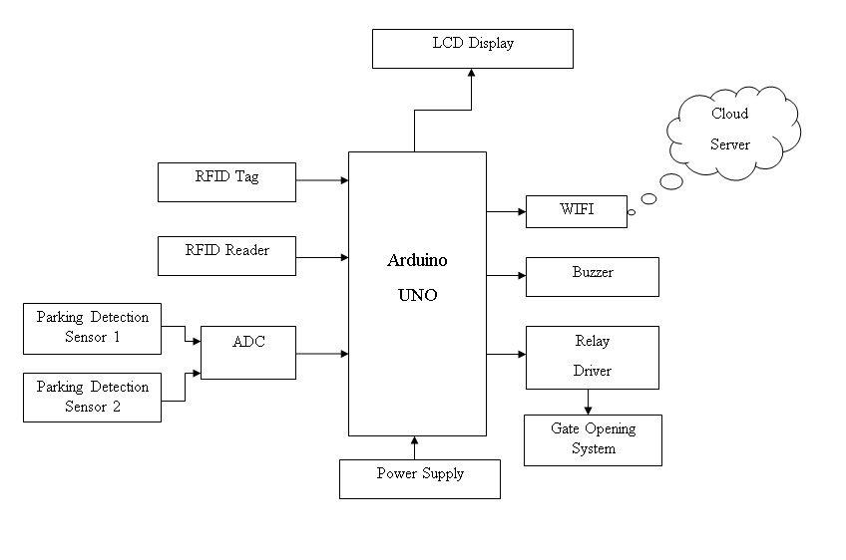

* **Project Objectives:**

**1. Real-Time Parking Space Monitoring:**

**Objective:** Implement a real-time parking space monitoring system to enhance efficiency and reduce search times for drivers.

**Key Results:**

* Achieve a minimum accuracy of 95% in detecting real-time parking space occupancy.
* Update parking space availability every 30 seconds to ensure up-to-date information.
* Implement a reliable sensor infrastructure with a mean time between failures (MTBF) of at least 10,000 hours.

**2. Mobile App Integration:**

**Objective:** Develop a user-friendly mobile application that seamlessly integrates with the smart parking system, offering a convenient experience for users.

**Key Results:**

* Launch a mobile app compatible with major platforms (iOS and Android) within three months.
* Attain a user satisfaction rating of at least 4.5 out of 5 based on app store reviews.
* Enable features such as real-time parking updates, reservation capabilities, and secure payment processing.

**3. Efficient Parking Guidance:**

**Objective:** Provide efficient parking guidance through the mobile app to optimize traffic flow and reduce search times.

**Key Results:**

* Reduce the average time drivers spend searching for parking by at least 30%.
* Implement dynamic routing within the app to guide users to the nearest available parking spaces.
* Achieve a user feedback rating of 80% or above for the effectiveness of parking guidance features.

**4. Automated Payment System:**

**Objective:** Implement an automated payment system within the mobile app to streamline transactions and enhance user convenience.

**Key Results:**

* Enable secure and seamless payment processing with transaction completion times under 30 seconds.
* Achieve a user adoption rate of at least 70% for in-app payments within the first six months.
* Integrate with major payment gateways to provide diverse payment options.

**5. Parking Space Reservation Feature:**

**Objective:** Allow users to reserve parking spaces in advance, ensuring a guaranteed spot upon arrival.

**Key Results:**

* Achieve a reservation success rate of 90% or higher.
* Implement a user-friendly reservation process within the app with clear instructions and confirmations.
* Introduce incentives for users to encourage the adoption of parking space reservations.

**6. Integration with Navigation Systems:**

**Objective:** Seamlessly integrate the smart parking system with popular navigation apps to provide turn-by-turn directions.

**Key Results:**

* Establish partnerships and integrations with at least three major navigation platforms within six months.
* Ensure accurate and real-time synchronization between the parking app and navigation systems.
* Attain positive user feedback regarding the effectiveness of integrated navigation
* **IoT Sensor Design:**

**1. Define the Objectives:**

* The primary objective is to accurately detect the occupancy status and availability of parking spaces in real time.
* Enable efficient parking space utilization and prevent unnecessary congestion or wastage of parking resources.
* Provide users with a user friendly interface to view the real time occupancy status and available parking spaces.
* Optimize parking operations and management by analyzing historical occupancy data.

**2. Determine Sensor Requirements:**

* Select appropriate sensors: Ultrasonic or infrared sensors are commonly used for occupancy detection. They should have a wide detection range and a fast response time.
* Sensors should be weatherproof and durable to withstand outdoor conditions.
* Evaluate power requirements and select sensors with long battery life or power efficient designs.
* Connectivity: Choose sensors with wireless connectivity options such as Wi Fi, Bluetooth, or LoRaWAN to transmit data to a central server.

**3. Sensor Placement and Coverage:**

* Identify the parking spaces where sensors will be deployed. Consider both on street and off street parking areas.
* Place sensors strategically to cover each parking space. Ensure that sensor detection ranges overlap slightly to avoid any blind spots.
* Sensors should be mounted securely and appropriately to ensure accurate occupancy detection.

**4. Data Transmission and Collection:**

* Configure the sensors to transmit occupancy data to a central server. This can be done via Wi Fi, Bluetooth, or LoRaWAN gateways placed within the sensor network's range.
* Ensure proper security measures are in place for data transmission to protect the privacy of users and the system itself.

**5. Centralized Data Processing and Analysis:**

* Develop a centralized server or cloud based platform to receive and process the sensor data.
* Use algorithms to analyze the occupancy data and determine the availability of parking spaces in real time.
* Implement data visualization tools or a user friendly interface to display the occupancy status and available spaces to users.

**6. Maintenance and Upgrades:**

* Regularly monitor and maintain the sensor network to ensure accurate occupancy detection.
* Periodically test and calibrate sensors to maintain their performance and accuracy.
* Upgrade the system as required with new features or enhancements based on user feedback or evolving technology.

**7. Monitoring and Reporting:**

* Implement a monitoring system to track sensor malfunctions or communication failures.
* Generate regular reports and analytics to analyze parking usage patterns,peak hours, or any other relevant data.
* Utilize the collected data for future planning and optimization of parking space
* **Real Time Transit Information Platform:**

Designing a mobile app interface for real-time parking availability involves creating an intuitive and user-friendly experience.

**1. Home Screen:**

* Welcome screen with the app logo and a search bar.
* A prominent "Find Parking" button to initiate the search process.
* Option for users to log in or sign up for an account.

**2. Search and Map View:**

* After tapping "Find Parking," users are directed to a map view.
* Map displays the city layout with color-coded markers indicating the availability of parking spaces: green for available, red for occupied.
* Clear icons for user location and destination.

**3. Filter and Sort Options:**

* Filters for users to specify preferences such as covered parking, accessible spaces, or proximity to specific landmarks.
* Sorting options based on distance, price, or user ratings.

**4. Real-Time Updates:**

* As the user explores the map, parking space markers dynamically update in real-time based on current availability.
* An indicator at the top showing the total number of available parking spaces.

**5. Parking Space Details:**

* Tapping on a parking space marker reveals details: distance from current location, pricing, available amenities, and user ratings.
* Option to view photos or additional information about the parking facility.

**6. Reserve and Pay:**

* Users can reserve a parking space directly from the map view by tapping on an available space.
* Seamless integration with a payment gateway for quick and secure transactions.

**7. User Profile:**

* User profiles with personal details, saved payment methods, and a history of past parking transactions.
* Option to set preferences and favorite parking locations.

**8. Notifications:**

* Push notifications for real-time alerts on parking space availability, reservation confirmations, and reminders for upcoming reservations.

**9. Navigation Integration:**

* Integration with popular navigation apps for turn-by-turn directions to the selected parking space.

**10. Accessibility Features:**

* Accessibility settings for users with disabilities, including options for voice navigation and high-contrast displays.

**11. Feedback and Ratings:**

* Users can provide feedback and ratings for parking spaces, helping others make informed decisions.
* A section for users to report issues or provide suggestions.

**12. Settings:**

* General app settings, including language preferences, notification settings, and privacy controls.

**13. Emergency Assistance:**

* Quick access to emergency assistance or support for users facing issues in the parking facility.

**14. Logout/Sign Out:**

* Easy access to log out or sign out for users who have finished using the app.
* **Integration Approach:**

**1. Sensor Data Collection:**

* Connect Sensors to Raspberry Pi:
* Connect parking sensors to the GPIO pins of the Raspberry Pi.
* Read Sensor Data:
* Use programming languages like Python to read data from the sensors at regular intervals.
* Occupancy Status:
* Determine the occupancy status of parking spaces based on the sensor readings.

**2. Processing and Decision Making:**

* Local Processing:
* Implement local processing on the Raspberry Pi to interpret sensor data and make decisions.
* Decision Logic:
* Apply decision logic to determine parking space availability, updating the status as either "occupied" or "available."

**3. Wireless Communication:**

* Connectivity Module:
* Utilize the wireless module on the Raspberry Pi to establish a connection with the central server or cloud-based platform.
* Data Transmission:
* Transmit the processed sensor data, including parking space availability, to the central server.

**4. Server-Side Processing:**

* Cloud-Based Server:
* Have a cloud-based server or central platform to receive and process data from multiple Raspberry Pi devices.
* Update Database:
* Update the central database with real-time parking space status information.

**5. Mobile App Integration:**

* API Integration:
* Develop APIs (Application Programming Interfaces) on the server side to facilitate communication between the mobile app and the central server.
* App Request Handling:
* When the mobile app requests real-time parking information or initiates actions (such as reservations), the server responds accordingly.
* Push Notifications:
* Implement push notifications to update the mobile app instantly when there are changes in parking space availability or when reservations are made.

**6. Security Considerations:**

* Secure Communication:
* Implement secure communication protocols to protect data transmitted between the Raspberry Pi devices and the central server.