MWPTools
Tools for MultiWii NAV on free OS (and CF mission logging)
“Sweet dreams and flying machines”

Overview
The MultiWii flight controller, since early 2014, has supported way point navigation. This impressive development has somewhat transformed the previously cross platform (albeit ugly Java) MultiWii experience, into effectively, a proprietary (Microsoft) operating system experience. Whilst I prefer cross platform solutions, I have some sympathy for the NAV author's choice, given the unpalatable alternative of updating the Java MultiWiiConf.
This project attempts to address the Windows dependency by providing tools for MultiWii-NAV mission planning on free operating systems. The principal application, mwp is a mission planner and flight logger for MW compatible flight contoller firmware (Multiwii and Cleanflight at least). Whilst it is unlikely that mwp can approach the functionality of WinGui, the aim is to at least enable users on free platforms to:
- Plan a mission using a geographic display;
- Edit missions, way point and actions;
- Upload the mission to a capable MultiWii-NAV flight controller;
- Download a mission from a capable MultiWii-NAV flight controller;
- Load and save missions to a file, in a format compatible with WinGui;
- Track the mission in real time on open source Multiwii compatible platforms, where suitable telemetry devices are available;
- Mission logging and log conversion to at least KML and GPX.
Other tools in the mwptools suite include:
- pidedit : A simple PID editor;
- switchedit; A simple switch editor;
- mspsim : A simulator for MSP (MultiWii Serial Protocol). mspsim provides enough of the MSP to facilitate the development of applications such as mwp and pidedit.

Caveat
There is not, to the best of the author's knowledge (as of early 2014), any protocol documentation for the changes to MSP to support MultiWii-NAV; the applications in this suite have been developed from knowledge gleaned from postings in the MultiWii forum, GPS NAV thread <http://www.multiwii.com/forum/viewtopic.php?f=8&t=3989>, and by reverse engineering of WinGui source code. Neither is an entirely satisfactory basis for development, compared to a proper specification, but it's the best available to date.
The author has flown his GPS capable multi-rotor using MultiWii-NAV and mwp; it appears to work well, however there is NO WARRANTY. You have been warned.
In addition, the applications support the functions of the Naze32 Cleanflight FC (mission logging (not planning), PID and switch configuration). On Cleanflight, mavlink telemetry is also supported, if your cleanflight firmware supports the mavlink implementation on PR 806.
Note also that this document frequently lags behind the source code. You are advised to check the applications (--help) for additional options not listed in this document, and note that the source code is the ultimate documentation.

Flight Controller variant
In MultiWii r1717, the MSP “capabilities” has been implemented in a somewhat unfortunate way, in that it overwrites capabilities previously defined for Naze32 Cleanflight flight controllers. As of 2014-10-17, it is almost impossible for mwptools to detect whether it is running on a nav capable Multiwii FC, or another FC that may offer other functions. Whilst there is some hope that common sense will later prevail (and the Cleanflight MSP_API_VERSION is a not a great help along this road), in order to protect the user from this, mwptools is cautious in detecting FC capabilities, and allows the user to define which FC is being used, as follows:
- A symbolic link may be made to the mwp and switchedit applications suffixing the FC model, thusly:
  - mwp-mw -> mwp # non-nav multiwill;
  - mwp-mwnav -> mwp # multiwii-nav;
  - mwp-cf -> mwp # cleanflight;
  - mwp-auto -> mwp # auto-dectect for mw and cleanflight (MSP_API_VERSION, post 2014-10-24);
  - and likewise for switchedit (swithedit-cf etc.).
- mwp may be invoked with –flight-controller=(mw|mwnav|cf|auto)
- There is a gsettings key, 'fctype', which can be set to mw/mwnav/cf/auto;
  - Otherwise, you get the FC type chooser dialogue:
  - Selecting Cancel (at startup) causes the application to terminate instantly.
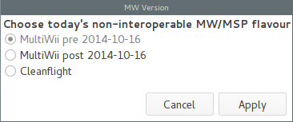Illustration 1: Choose the flight controller variant
- The author will be delighted to remove this inconvenience should the various FC authors see sense and restores interoperability, or a more general agreement on FC identification is agreed by the responsible parties.
- In most cases, setting the gsettings key 'fctype' to 'auto' just works.

mwp – “A mission planner for the rest of us”
mwp is the mission planner component of mwptools. It provides a graphic user interface for creating, editing and managing MultiWii NAV missions.
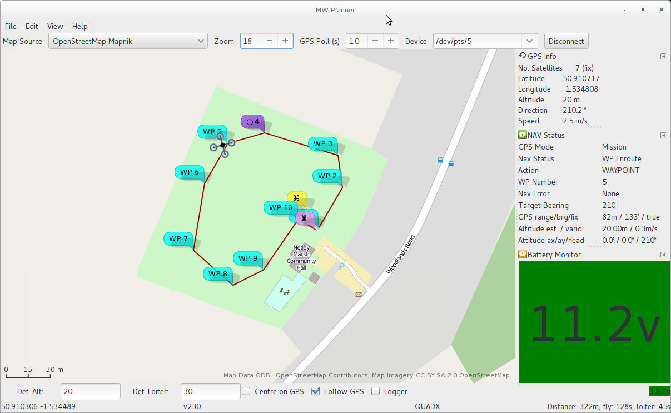Illustration 2: mwp window showing a mission and mission tracking
Illustration 2 Shows the mwp main window and the main user interface elements.
- A menu bar. The menu options are described below;
- A setting bar, allowing the selection of the map source, zoom level, GPS update and the serial device used to connect to the flight controller. In this example, a pseudo-terminal is used with mspsim (the mwptools MSP simulator) providing the GPS and navigation status;
- The main body of the application window it divided into a number of panes:
  - The map pane shows the map view and the current mission. If GPS following is enabled, the aerial vehicle is also shown;
  - A dock area. This can display a variety of information, include the mission (in tabular form), the current NAV status, the current GPS data and the battery status. In the screen shot, the mission tote is hidden, but can be enabled from the View menu. The dock is further described in the section “Using the Dock“. Note that many of the screen shots following were taken before the dock was implemented;
- An options bar, where default values of altitude and loiter time may be set, and toggles control whether the map is centred on the GPS, whether the vehicle icon follows the GPS, whether logging is enabled and whether audio prompts are made (see Illustration 17);
- A status bar shows the current map centre position, the MultiWii version, the MultiWii vehicle type and mission statistics (distance, flight time and loiter times). Jumps are taken into account when calculating these values, unless the jumps have infinite repeats.
Existing missions can be loaded from the File / Open menu item. A standard file chooser, with filters of 'Mission' (*.xml, *.mission) will load existing mission files, including those created with WinGui. Where the mission was previously saved by mwp, the mission file will include map centre and zoom information, so loading a mission will zoom to the mission location.
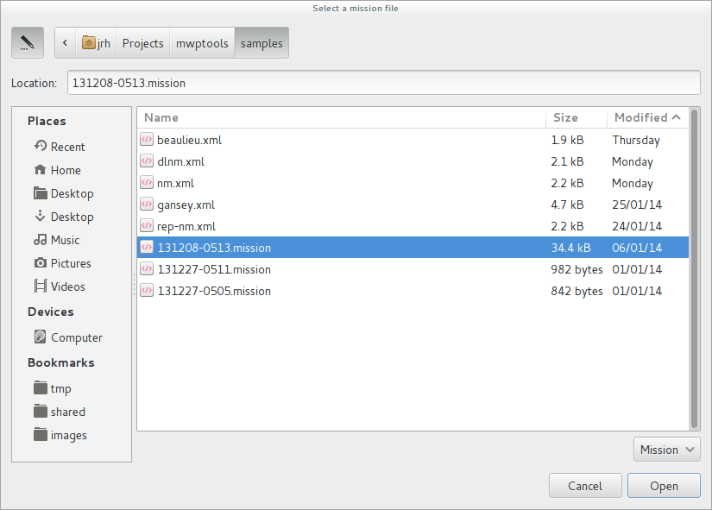Illustration 3: Opening a mission file (EOSBandi / WinGui sample file)
Opening the selected file loads the mission and displays the mission data on the map, and in the tote, replacing any previous mission data (note this example WinGui mission would not load on a real FC, due to the excessive number of way points):
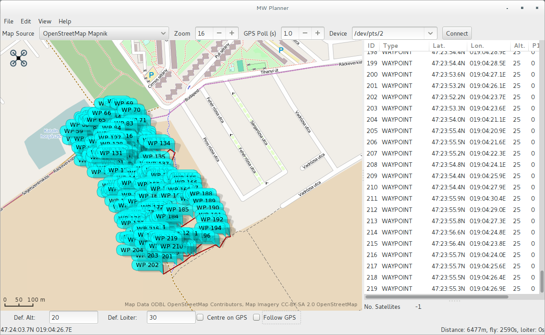Illustration 4: Import of EOSBandi / WinGui sample file (don't fly this one)
New way points and actions may be created in two ways:
- Right mouse click on the map;
- From the right mouse button pop-up menu in the mission tote.
- A defaults and settings bar. Here the default altitude and loiter times used for way point definition are shown / edited. There are also display options to follow the GPS, and centre on the GPS. The current battery voltage is also shown, colour-coded according to the battery status setting from the FC;

Opening Missions
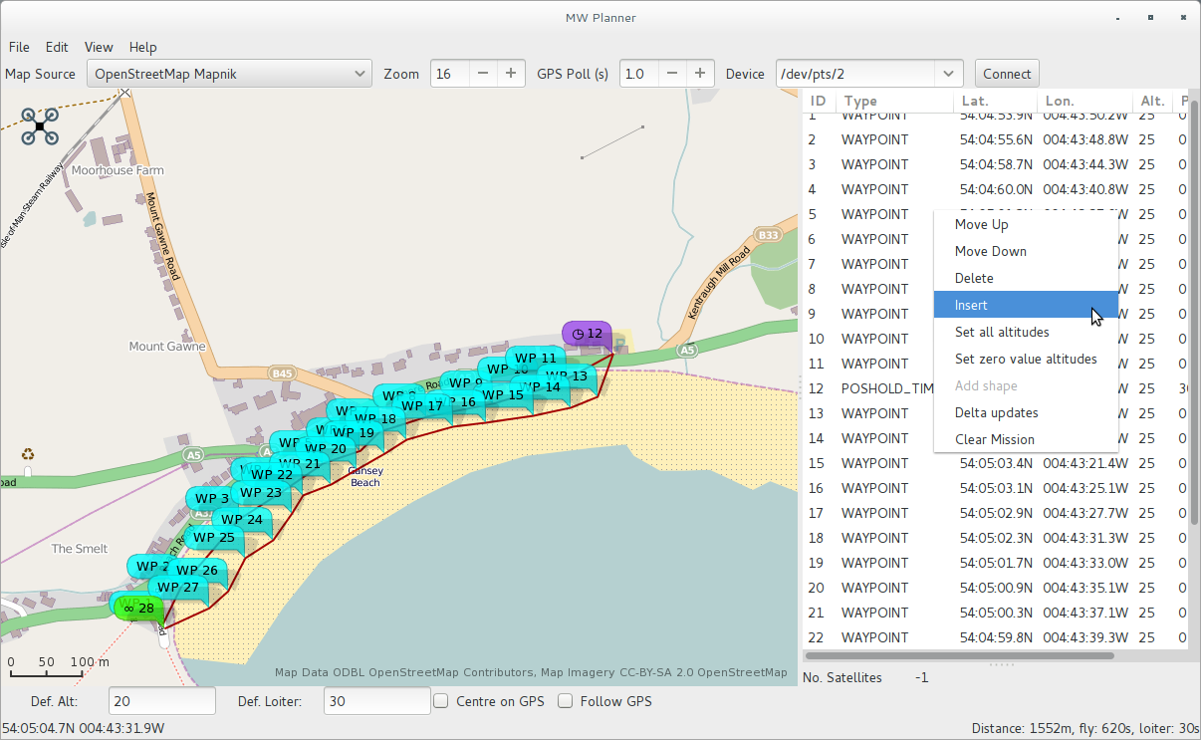Illustration 5: Mission pop-up menu (let's go for a [quick] pint at "The Shore" hotel)

In Illustration 5, the mission pop-up menu has been invoked, and the “Insert” action selected.

Creating and editing missions
Way points and actions may be created for new missions, or modified in existing (loaded) missions.
Mission points are created either by a right click on the map, or by the mission pop-up menu, “Insert” action (see Illustration 5). Depending on how the point is created, it will be displayed in a slightly different way. This distinction is somewhat artificial, but seemed logical at the time --- it may be changed in the future. This is shown in Illustration 6, and explained further below.
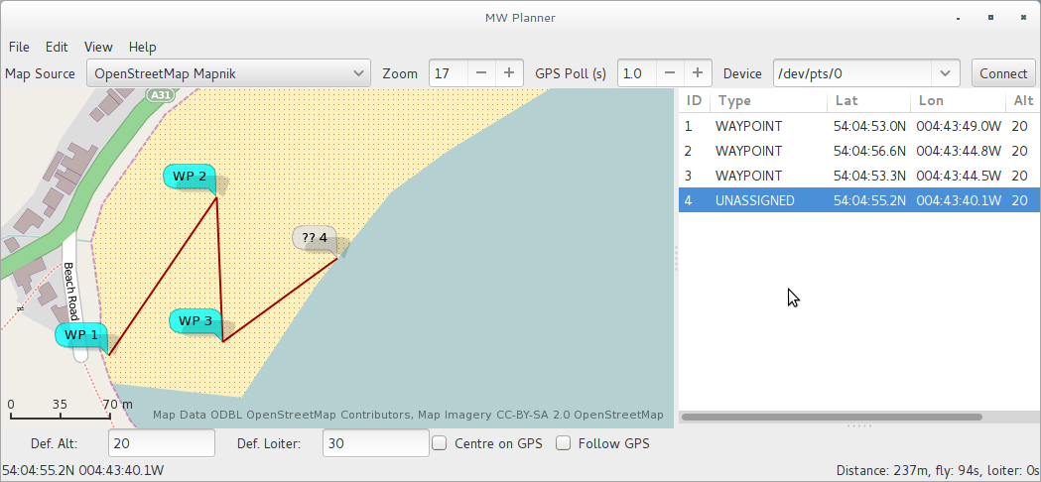Illustration 6: Entering way points in mwp

In Illustration 6, way points 1,2, and 3 have been entered by right click on the map (as this is the most common way point type, this is the default), way point 4 (??4) has been entered from the mission pop-up menu, and thus has type of UNASSIGNED. UNASSIGNED way points are not saved or uploaded as part of a mission; they must be converted to a 'real' mission way point or action (see Type below).

Editing way points
Way points are edited in the tote. When a row is selected, the tote column headers will change to indicate the data fields appropriate to the point type (in particular the “parameters” P1,P2,P3 those interpretation is dependent on the point type.
- Position. The position of a way point may be changed by dragging the way point icon on the map. If the display mode is decimal degrees (see Preferences and Settings), then the position may also be edited in the tote. Where the position is DMS.s, then the position cannot currently be edited in the tote;
- Order. The order of way points may be changed by either:
  - Using the “Move Up” and “Move Down” entries from the mission pop-up menu; or
  - Dragging the tote item to the desired position. In order to drag, the entry must be 'grabbed' on the ID column (Illustration 7). In that screen-shot (below), way point 7 is being dropped between way points 3 and 4.
  - At the end of the drop, the list and markers on the map will be re-ordered.
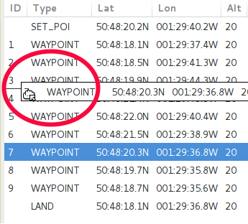Illustration 7: Dragging a way point to re-order. Note the 'grab' by the ID column
- Type. The way point type may be selected from a drop down menu embedded in the “Type” column of the tote:
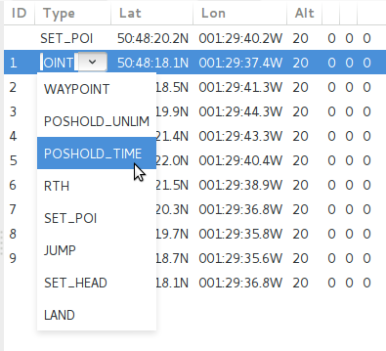Illustration 8: Changing a way point type
Once the type has been changed, default parameters for that way point type or action will be set. The defaults are discussed in the section “Preferences and Settings“, and may be edited in the tote.
- Altitude. New points are created with the default altitude (from the “defaults and settings bar”, and as pre-defined in preferences). Some basic validation is performed;
- Parameters P1, P2 and P3. The parameters P1,P2 and P3 are integer values that have a meaning specific to the way-point type or action. For example, for action type of JUMP, P1 is the point to which to jump, and P2 is the number of repeats. The author's understanding of the parameters associated with each way point type or action is given in the reverse engineered protocol documentation (e&oe);
- Multiple points may be added using the pop-up “Add shapes” option (see below).

Other mission popup menu actions
- Delete. The delete action will delete the selected (highlighted) way point(s). If no way point is selected, this option has no affect;
- Set all altitudes. Sets all selected way point (but not LAND) altitude values to the current “Def Alt” value;
- Set zero value altitudes. As for “Set all altitudes”, but only affects points with an altitude of zero;
- Add shape. Where the mission consists of exactly one SET POI point as the first point in a mission (there may also be other extant way-points), this option will display a dialogue to enter the number of points in a shape, the radial distance (from the SET POI to a point), an offset angle and the direction of rotation:
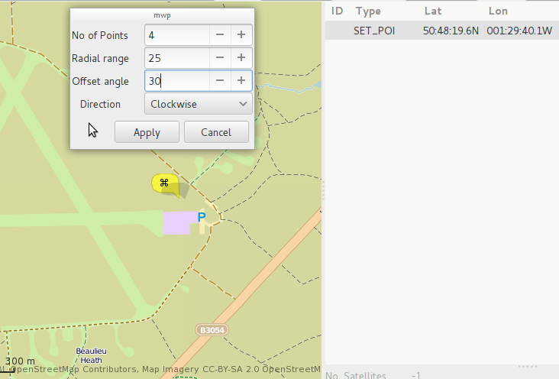Illustration 9: Defining a shape around a single POI

Apply, with the result:
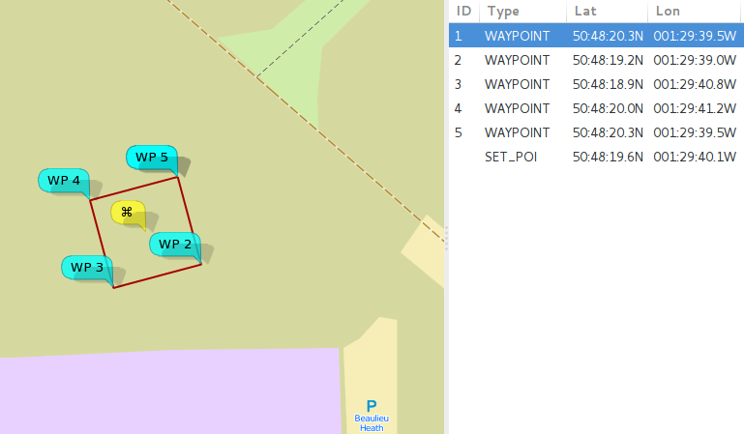Illustration 10: Inserted shape points
Noting that points 1 and 5 (start and end) are coincident, If you didn't expect to see this, consider what happens with no offset:
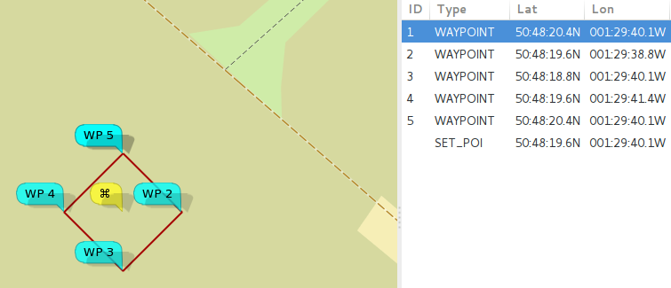Illustration 11: Square with no offset

Here we start with the first (and last) points immediately North of the POI; thus, in Illustration 10 we have the same shape rotated by 30°, as specified. If you wanted the lines to be horizontal / vertical, specify an offset of 45° for a square. Shape points are appended to any extant mission points, and the shape tool may be invoked multiple times, for example to create 'concentric' circles;
- Delta updates. This option allows you to make bulk (delta, positive or negative) changes to all positions and / or altitudes:
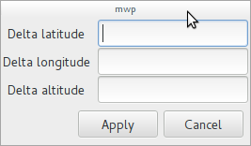Illustration 12: Delta changes dialogue
- Clear Mission. The Clear Mission option clears the mission. There is no confirmation and no reversion, so be sure you want to do this.

Preferences and Settings
Preferences and default settings are stored using GTK+3 gsettings / dconf (on Linux / other free Unix like platforms, and whatever OS mechanism this maps onto for other operating systems). The gsettings schema is org.mwptools.planner. The following settings are stored.
Key | Usage | Default | Prefs
atexit | A command run on exit (e.g. to restore screensaver or powersaving settings). | (none) | No
atstart | A command run on start (e.g. to override screensaver or powersaving settings). | (none) | No
audio-bearing-is-reciprocal | Whether the audio reported bearing is the reciprocal (i.e. bearing from home to quad, rather than from quad to home. | false | No
audio-on-arm | Whether audio messages are automatically enabled on arm and disabled on disarm. | false | No
baudrate | The default baud rate for serial devices. | 115200 | No
compat-version | The WinGui version stored in mission files. Note that no validation is done dependent on the compat-version value, as any WinGui version specific variations are not known. | 2.3-pre8 | No
default-altitude | The default altitude for way points | 20 (metres) | Yes
default-latitude | The default latitude for the map | 50.909528 | Yes
default-loiter | The default loiter time for POSWAIT_TIME way points | 30 (seconds) | Yes
default-longitude | The default longitude for the map | -1.532936 | Yes
default-map | The default map to be used. If not defined, the default from the underlying toolkit (libchamplain, OSM Mapnik) will be used. | (none) | Yes
default-nav-speed | The default navigation speed (used for timings only, does not affect FC settings) | 2.5 (m/s) | Yes
default-zoom | Default zoom level | 15 | Yes
device-names | A list of serial devices that will be presented in the Connect combo box. | '/dev/3dr', '/dev/rfcomm1', '/dev/mega2560', '/dev/ttyACM0@115200', '/dev/pts/0' | Yes
display-dms | Display positions as degree:minute:seconds (vice decimal degrees). | false | Yes
espeak-voice | Default espeak voice (see espeak documentation). | default | No
heartbeat | A command that is invoked every minute, e.g. to defeat an over zealous screen saver ('xset -display :0 s reset'). | (none) | No
log-on-arm | Whether logging is automatically enabled on arm and disabled on disarm. | false | No
map-sources | User defined map sources. You can add additional map sources beyond the default sources in libchamplain. The value is the name of file defining such sources. This is further explained in the Map Sources section of this document. | (none) | No
media-player | The media player used to play the low battery alert. If you don't want an audible alert, set this to 'false'. The default is paplay, but any media player capable of playing vorbis files (bleet.ogg) may be used (e.g. mplayer). | paplay | No
set-head-is-b0rken | Whether you consider mw-nav set head to work properly or not (i.e. as reciprocal, (the author has this set to true)). This may be fixed post MW pre 2.4 r1729, as a patch has been submitted. | false | No
show-scary-warning | Defines whether a scary warning concerning the dangers of flying an undocumented protocol is displayed when you upload way points to the flight controller.  This option is no longer used. As mwp has now been flight tested, there is no longer a “scary warning”. | true | No
speak-interval | The interval between audio messages. A value of 0 disables audio messages, if non-zero, must be 15 or greater (seconds). | 0 | Yes
fctype | Flight controller type (mw,mwnav,cf,auto) | (none) | No
update-interval | Update rate for telemetry polling | 1 (second) | No
vlevels | The cell voltages at which colour transitions occur. A ';' separated list. An empty list uses the defaults “3.7;3.57;3.47;3.0”. | '' | No
quaduri | A URI for a Quadkey map proxy. See the section Quadkey Proxy. | (none) | No
default-layout | The default dock layout loaded at startup, unless modified by the -l option. If undefined, .layout is used. See the section “Using the Dock“ for more details. | (none) | No
display-distance | Index into display distance units (0=metres, 1=feet, 2=yards) | 0 | Yes
display-speed | Index into display speed units (0=metres/sec, 1=kilometer/hour, 2=miles/hour, 3=knots) | 0 | Yes
mavph, mavrth | As mavlink does not report status changes, it is necessary to define the rc channel and min / max values for PH and RTH, if you wish to have cute icons displayed for these events. The values are channel, min, max, separated by a colon, e..g. 8:1300:1700. | (none) | No
Table 1: gsettings used by mwp
The preferences dialogue is invoked from the menu Edit/Preferences item, and appears as Illustration 13:

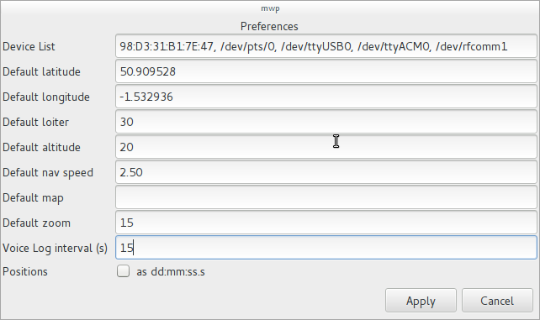Illustration 13: mwp preferences dialogue
The screen shot shows using a Bluetooth address; this option was supported for Linux (only) in earlier versions; it is no longer supported. Use a proper device node (e.g. /dev/rfcomm1 on Linux) on all operating systems.

Other menu options
- File / Save. Saves the current mission to an XML fiile.
- File / Upload. Uploads the current mission to the flight controller (where connected and the FC supports sufficient capability). Once uploaded, the mission is then downloaded and compared to the source mission. You are warned if there is a mismatch, and the state of the FC is undefined if a mismatch occurs;
- File / Download. Downloads the mission from the flight controller, replacing (without warning, you selected to do this), the mission in the application;
- File / Replay Log File. Replays a log file at 'wall clock' speed;
- File / Load log File. Loads a log file, disregarding 'wall clock' time (i.e. as quickly as reasonably possible);
- File / Quit. Quits the application (without warning .... you get the modus operandi here);
- Edit / Nav Config. Where connected to a suitably capable flight controller, displays a nav config window (the values are now editable and may be applied to the flight controller by clicking 'Apply');
- Edit / Set FC Mode. Allows you to set the flight controller type, if auto detection failed or you selected the wrong one;
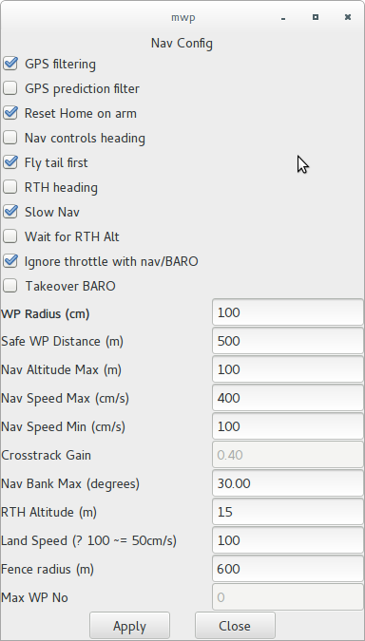Illustration 14: Nav Config dialogue
- View / Centre on Position. Centre the map on a user defined location;
- View / Mission Tote. Forces display of the mission tote in a dockable window;
- View / Nav Status. Where connected to a suitably capable flight controller, displays a nav status dock window;
- View / GPS Status. Forces display of the GPS status a dockable window;
- View / Voltage in dock. Forces display of the battery voltage (where monitored) in a dockable window;
- View / 3DR Radio Status. If you have a 3DR radio for telemetry, this option enables the display of 3DR statistics;
- Help / About. Displays a somewhat uninformative 'about' dialogue (however, my wife likes pink, and I like MW multi-rotors).
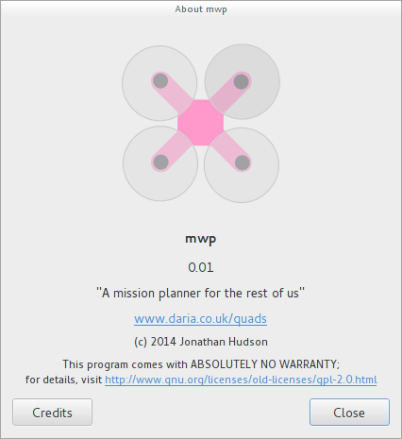Illustration 15: Uninformative "About” dialogue
The screen shot below shows a (once) fully loaded dock, with all display options enabled:
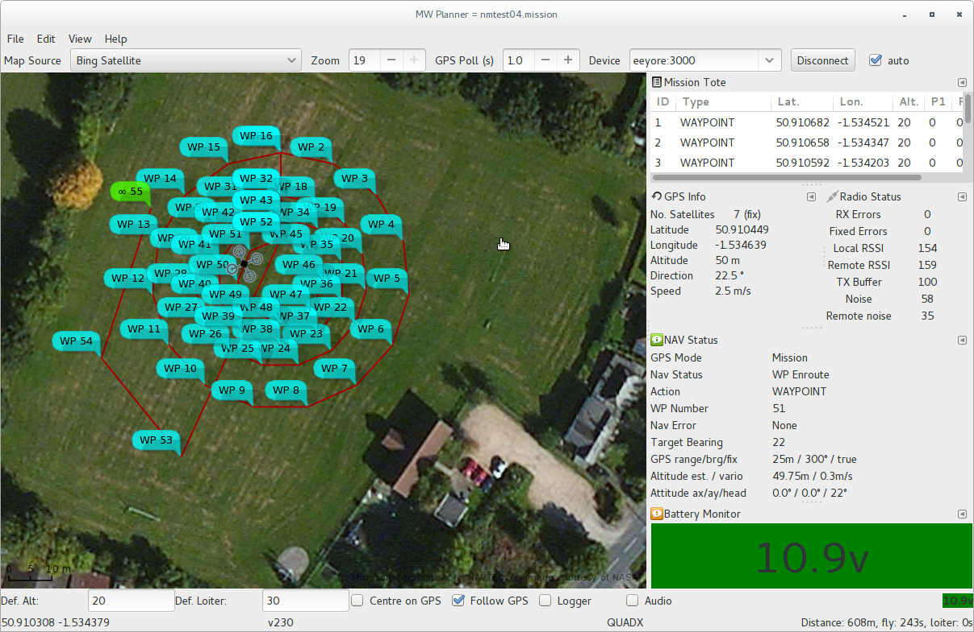Illustration 16: Fully configured dock showing flight status

Logging
The screen-shots so far have been taken prior to the addition of the logging capability. As of v0.01, mwp supports logging. Logging is started / stopped by the Logger checkbox:
When logging is invoked, a log file is created in the current working directory:
Illustration 17: Logging option
mwp_YYYY-MM-DD_HHmmSS.log
where YYYY is the year, MM month, DD day, HH hour, mm minutes SS seconds in the local time zone.
The file format is “streamed json”, i.e. a json document for each logged event, for example (in this example, the vehicle is sitting on a window sill in my house, at the time there was no voltage monitoring on the vehicle, nor any mission loaded):
{"type":"status","utime":1391973539,"gps_mode":0,"nav_mode":0,"action":0,
"wp_number":0,"nav_error":10,"target_bearing":0}
{"type":"comp_gps","utime":1391973539,"bearing":0,"range":0,"update":1}
{"type":"altitude","utime":1391973539,"estalt":1.03,"vario":0}
{"type":"attitude","utime":1391973539,"angx":-0.4,"angy":-1.3,"heading":273}
{"type":"analog","utime":1391973539,"voltage":0,"power":0,"rssi":0,"amps":0}
{"type":"raw_gps","utime":1391973539,"lat":50.9150417,"lon":-1.5304901,
"cse":21.1,"spd":0.13,"alt":21,"fix":1,"numsat":7}
For each entry, there is a type field describing the data that follows, and “Unix” timestamp (utime, time_t), followed by type specific data.
The script (in the samples) mwp-log2gpx.rb is a Ruby language script that converts the log to a GPX file. mwp-log2kml.rb converts the log file to KML. Other scripts are provided to import the data into an SQL database (making it easy to find the maximum range, altitude etc), and to export from an SQL database to gpx and kml, using an 'armed' filter. SQL support is provided using the Sequel ORM, and databases should be defined using Sequel URIs.

Audio Prompts
Audio prompts are enabled from the options bar (Illustration 17). In order for audio prompts to be made, it is necessary that the flight controller is connected, and the preferences' “Voice Log Interval” value is 15 or more (seconds).

Using the Dock
mwp uses the GNOME Docking Library (gdl) to provide a dock capability. Items in the dock may be hidden, iconified or torn off into a separate window (that may then be returned to the dock). The section explains how use gdl in mwp.
If you exit the application using the File / Quit menu option, dock setting are saved. If you exit by closing the window, dock settings are not saved.
Note that when mwp is updated and the dock is expanded by adding new dock items, any previously saved dock layouts are invalidated, and you will have to manually recreate them.
When mwp is first started, the dock contains the mission tote and two iconified items (the GPS Status and Nav Status windows [highlighted in red]).
In Illustration 18, three areas of the dock are highlighted:
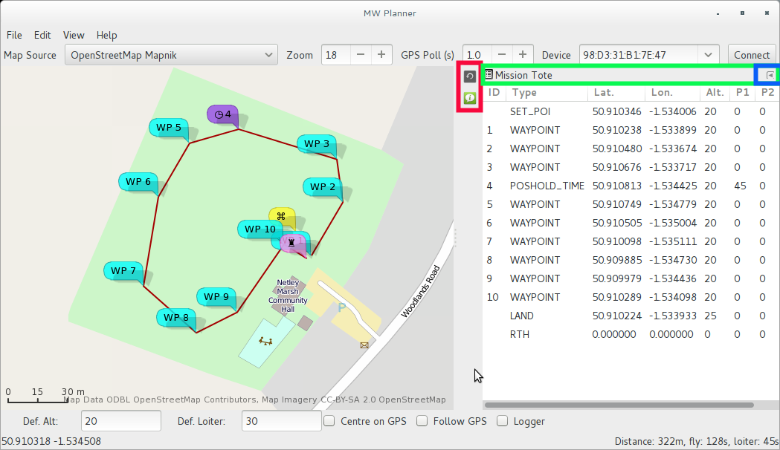Illustration 18: Inital Dock display
- In red, the dock icons. Clicking on these will restore the window (either to the dock, or as a separate window);
- In green, the dock tab bar. Where multiple items are in the dock, the tab icon may be dragged to reposition the docked window. In also has a pop-up menu, that allows the item to be completely hidden (but recoverable from the View menu), and;
- In blue, a iconify widget that will add the item to dock icon bar (the bit in red).
If the item tab bar icon (left-most in the green area) is dragged from the dock, the item will appear as a separate window.
By default, the battery monitor does not appear in the dock (but may be added from the View menu). In Illustration 19, the battery monitor has been added to the dock, and the mission tote has been moved to the dock icon bar.
The battery monitor window will resize the text to provide as visible as possible a voltage window. As for the all the dock windows, this window may be dragged on the desktop (and resized). In figure Illustration 20, the battery monitor window has been dragged from the dock and may be resized as an ordinary window. The detached window may be added to the dock by dragging the window's “tab bar” back into the dock, or added back to the dock icon bar using the iconify button (the left facing arrow to the right of the window's “tab bar”. If the detached window is closed, then it becomes hidden, and may be reattached to the dock (as an iconifed dock item) from the View menu.
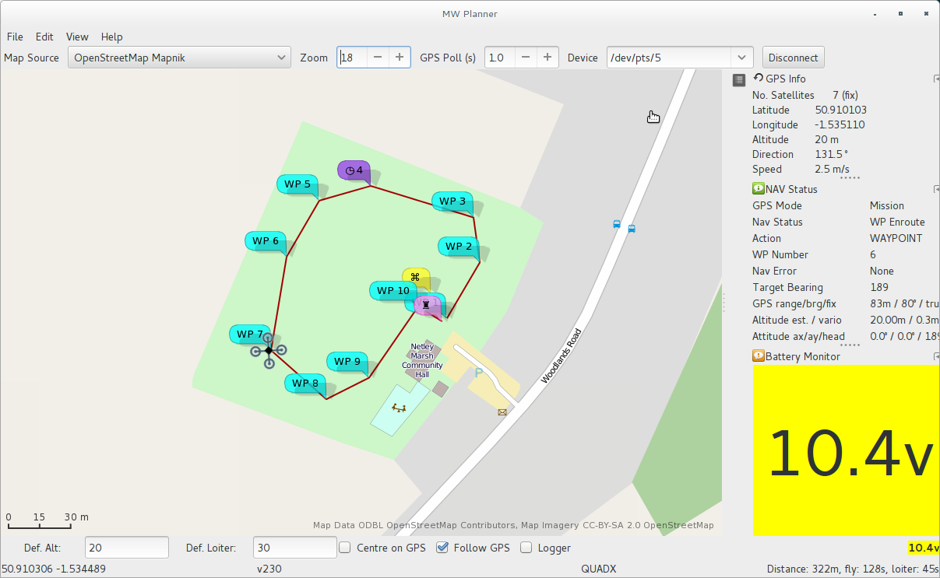Illustration 19: Dock with battery monitor
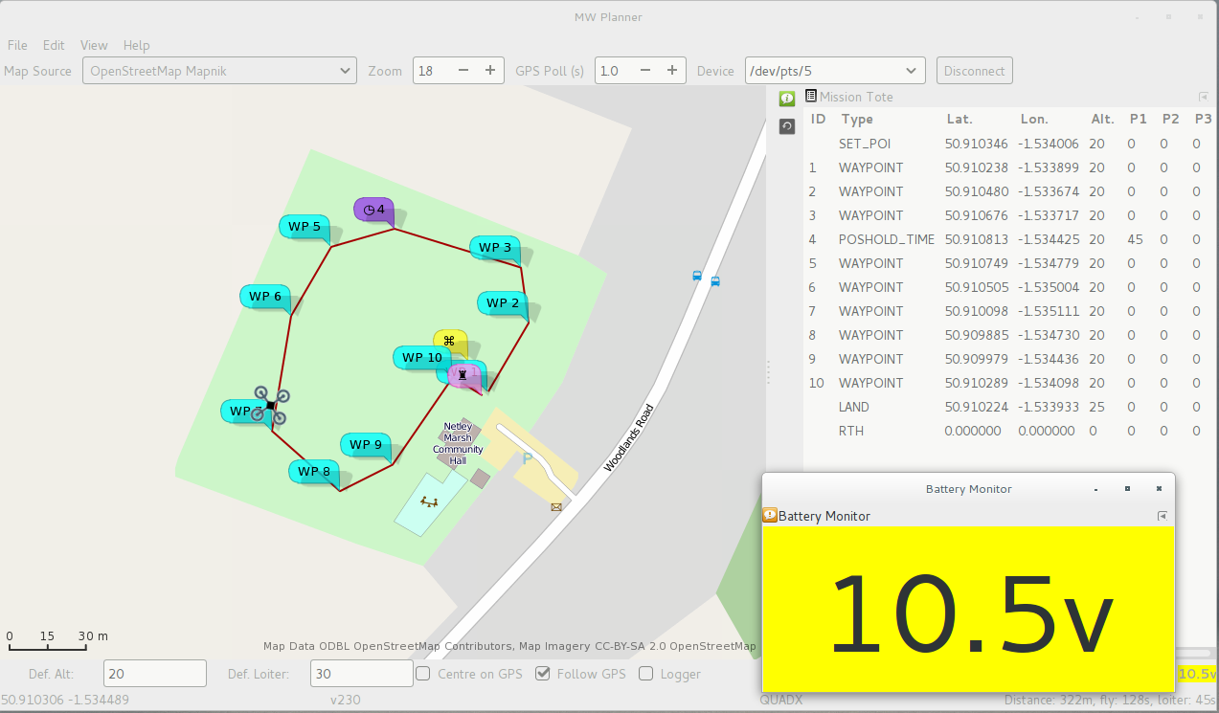Illustration 20: Battery window detached from the dock
The View menu contains items that can be added to the dock, and a Layouts menu. The Layouts menu offers options of 'Save' and 'Restore' in order to manage multiple dock arrangements.
- Save provides a text entry where you may enter a name for the saved layout. If the name exists, the contents are replaced, otherwise a new layout is saved. All layouts are saved under ~/.config/mwp as <NAME>.xml. There is a default of .layout (i.e. ~/.config/mwp/.layout.xml). It is deliberately difficult to remove this, but its content may be easily replaced.
- Restore provides a check-box list of existing layouts. Selecting one and clicking OK will cause that layout to be loaded into the dock.

Available Dock Items
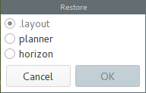Illustration 21: Layout "Restore" dialogue
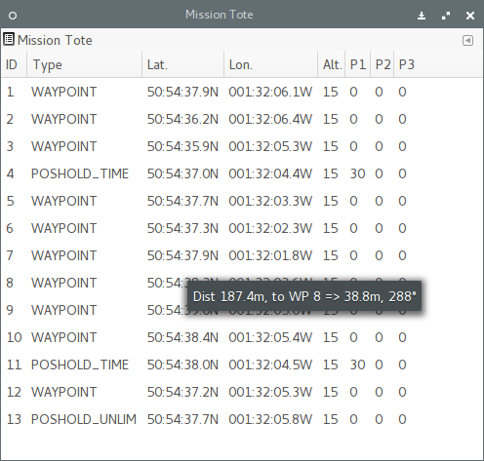Illustration 22: Mission Tote | 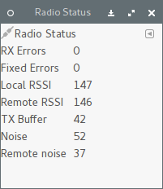Illustration 23: Radio Status
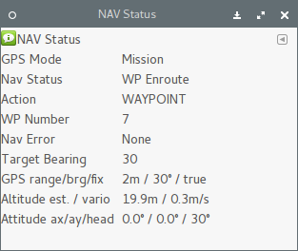Illustration 24: Navigation Status | 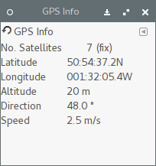Illustration 25: GPS Information
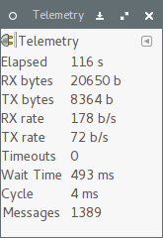Illustration 26: Telemetry Status | 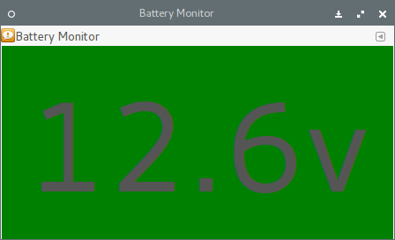Illustration 27: Battery Status
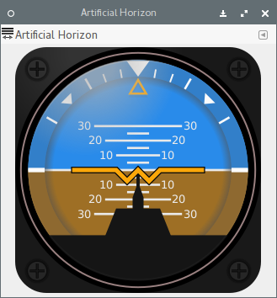Illustration 28: Artificial Horizon | 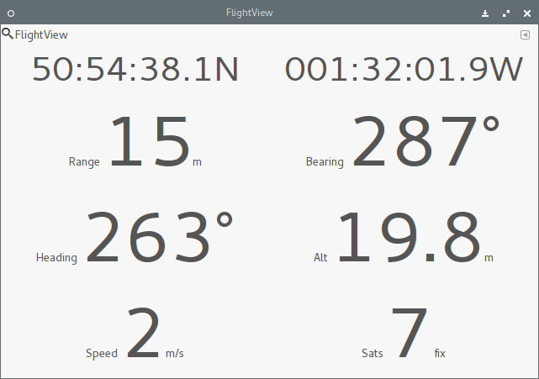Illustration 29: Flight Information (large font)

Map Sources
As may have been mentioned in passing, mwp uses libchamplain for the map display. libchamplain, by default provides a set of free, unencumbered, open source map resources. The libchamplain developers take the terms and conditions of commercial mapping sources very (some might say, over) seriously and no commercial sources (Google, Bing etc.) are, by default, included, for fear of the user violating their somewhat ambiguous terms of service.
There are, however, other map sources that can be legitimately added to libchamplain (and hence mwp). A mechanism is therefore provided to add such sources. By default, this will not permit you to abuse the terms of service of commercial providers, as only 'fixed URI' is ever supported. There is a 'quadkeys' patch for libchamplain floating around that enables Bing maps to be supported, apply at your own risk; this will not support other sources that require rewritten URIs based on scale (such as Ovi, Yahoo, Yandex etc).
To use an additional map source in mwp:
- Define the “map-sources” key in the settings, this is the name of a JSON file in ~/.config/mwp defining the map sources (or rather XDG_CONFIG_HOME on Unix like systems, and perhaps something to do with CSIDL_LOCAL_APPDATA on Microsoft OS).
A JSON file, samples/sources.json provides an example:

{
"sources": [
{
"id": "historic-gb",
"name": "GB Historic",
"license": "(c) National Library of Scotland",
"license_uri": "http://maps.nls.uk/projects/api/index.html",
"min_zoom": 5,
"max_zoom": 16,
"tile_size": 256,
"projection": "MERCATOR",
"uri_format": "http://geo.nls.uk/mapdata2/os/seventh/#Z#/#X#/#TMSY#.png"
},
{
"id": "localcache",
"name": "Private cache",
"license": "(c) OSM",
"license_uri": "http://localhost/",
"min_zoom": 0,
"max_zoom": 17,
"tile_size": 256,
"projection": "MERCATOR",
"uri_format": "http://localhost/mapcache/tms/1.0.0/nsites@GoogleMapsCompatible/#Z#/#X#/#TMSY#.png"
}
]
}

The latter only works (probably) chez-author. See the libchamplain documentation for map sources definitions (this documentation really exists).

Quadkey proxy
As applying the quadkeys patch is onerous, a second mechanism exists whereby mwp will provide a proxy that translates the TMS keys that libchamplain understands into quadkey notation that Bing needs, and fetches the tiles for you from a user defined quadkeys source. This allows the use of Bing imagery without patching libchamplain.
In order to enable the quadkeys proxy, you need to do a couple of configuration activities:
- Copy the sample quadkeys_proxy.json file to ~/.config/mwp/sources.json (or append it if you have other custom sources);
- Review ~/.config/mwp/sources.json and verify that the default proxy port does not clash with anything else you might be using. Do not change anything other than port number (unless you really understand what you're doing);
- Ensure that the gsettings key 'map-sources' is set to allow user defined map sources;
- Ensure that the gsettings key 'quaduri' that defines the real quadkeys source is also set (there is no default) is shown below, #Q# indicates where the per tile quadkey value goes).
$ gsettings set org.mwptools.planner map-sources 'sources.json'
$ # This sets aerial imagery only
$ gsettings set org.mwptools.planner quaduri 'http://a0.ortho.tiles.virtualearth.net/tiles/a#Q#.png?g=131'
$ # whereas, this will use aerial imagery with roads overlayed.
$ gsettings set org.mwptools.planner quaduri 'http://h0.ortho.tiles.virtualearth.net/tiles/h#Q#.png?g=131'
$ # Your choice ...
- Convince yourself you are content with the Bing Terms of Service;
- Enable “Bing Proxy” as the map source, set it as default if you wish.
If you are running an old version of libsoup (e.g. Ubuntu 14.10 or earlier), the make process will build an external proxy (as legacy libsoup cannot run within a threaded X application). The external process (qproxy) will be killed when you exit mwp. It is not necessary to make any configuration changes other than those documented above.

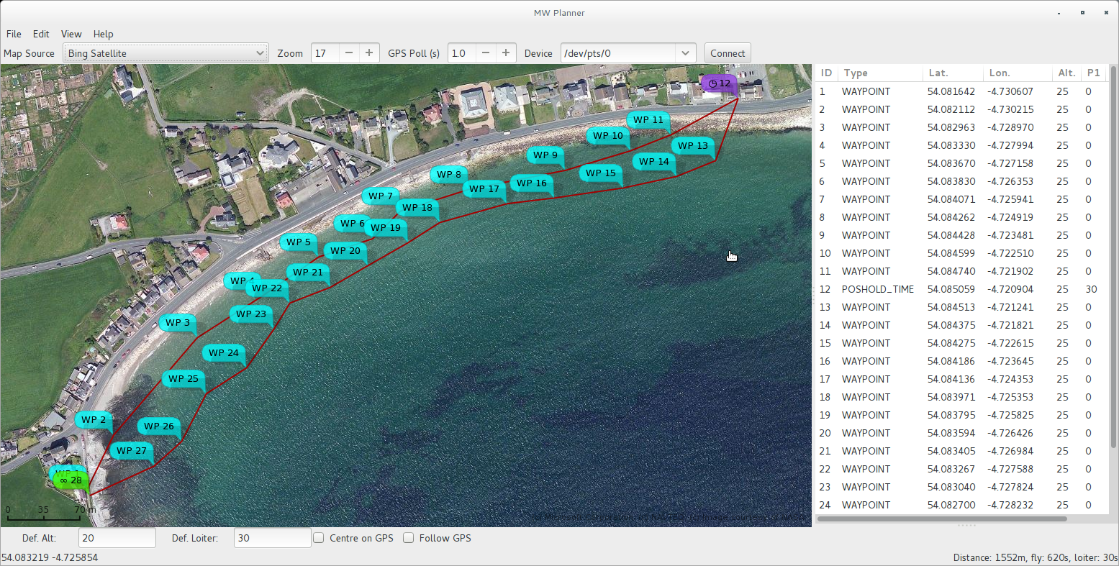Illustration 30: Don't fly this when the tide is in (Bing maps)
Flash backs to the 1950s work too (the map data, note the Xfce UI, Arch Linux on a Samsung ARM Chromebook):
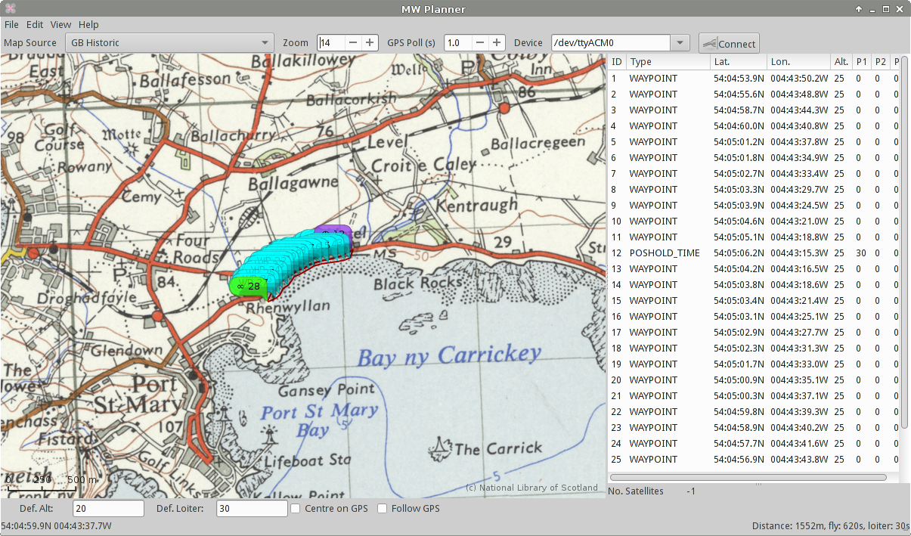Illustration 31: “You can take the boy out of the island, but you can't take the island out of the boy”

Installation
The mwptools applications have a number of installation targets:
- make install-system: Requires root. Installs under /usr;
- make install-local: Installs under $HOME, XDG directories. Applications in $HOME/bin. Directories are created as needed.
Default for make install is install-local.
Note that for the .desktop files to be found for install-local, it is necessary that $HOME/bin is in the path when the desktop environment is started; note also that ~/.profile is sourced by the desktop environment. It is also necessary for XDG_DATA_DIRS to contain $HOME/.local/share.
For non-free / non-Unix like OS, you will have to work out your own installation, as the author is not familiar with such systems.

Short Cut keys
In the map window, the following keys may be used:
Key | Affect
Control + | Zoom map in
Control - | Zoom map out
F11 | Toggle full screen
Control f | Toggle full screen
Control c | Clear tracking information
Control t | Reset mission timer
Table 2: Short-cut keys

Building
In order to build mwp (and mwptools) on any platform a number of infrastructure open source components are required, at least:
- vala (0.20 or later recommended, may work with earlier), and gcc (or clang);
- GTK+-3.0 (and normal dependencies, 3.8 or later tested, 3.10+ preferred);
- libchamplain (0.12 or later);
- libchamplain dependencies (Clutter mainly);
- gdl (GNOME Docking library);
- libespeak.
For free OS, these dependencies should be easily satisfied; for propriety platforms, Clutter, gdl and libchampain may (or not, I don't know) be available. For Ubuntu, you will the “-dev” versions of the libraries. For Ubuntu and Fedora, the dependencies are listed in text files in the docs directory.
Specifically on Ubuntu, the version of libchamplain (as of Ubuntu 13.10) does not support bounding boxes, you should use the mwpu target, rather than mwp. In Ubuntu 14.04, the default libchamplain is sufficient.
In order to address specific OS quirks (particularly for Ubuntu), you should build using the makeall.sh script.
$ ./makeall.sh
By default, this script installs in a local directory (~/bin, and uses ~/.local for settings).
For a local install, binaries are in $HOME/bin. You should ensure you have set the following environment variable (add to one $HOME/.profile, / $HOME/.bash_profile or equivalent for your shell)
[ -z "$XDG_DATA_DIRS" ] && XDG_DATA_DIRS=/usr/share:~/.local/share || XDG_DATA_DIRS=$XDG_DATA_DIRS:~/.local/share
export XDG_DATA_DIRS
mwptools is developed and tested on Arch Linux (ARM, x86_64, ia32); it is also tested on Ubuntu.
In particular, for Ubuntu 13.10 (or earlier), and platforms using versions of libchamplain c. 0.12.3, rotation of the vehicle is disabled, as this causes the vehicle to be incorrectly geo-located on the map. Libchamplain 0.12.6 (at least) have no such issues.

Protocol Documentation
In order to attempt to understand the new NAV protocol, a reverse engineered understanding is published as https://docs.google.com/document/d/16ZfS_qwc-rJeA7N5Tx0DA6wtgxl6HdGgaz-jE3lHBWs/edit?usp=sharing. I hope this is useful. Corrections appreciated.

pidedit
pidedit is a PID editor.
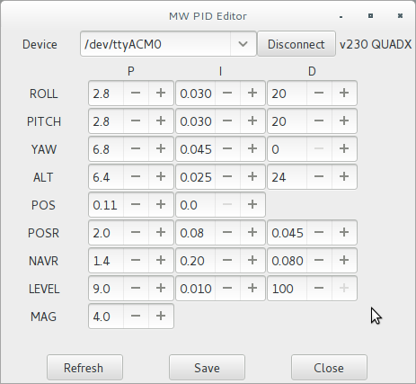Illustration 32: pidedit - trivial PID editor
The application should be somewhat self-explanatory:
- Each PID parameter can be edited;
- Refresh: Refreshes the user interface from the flight controller;
- Save: Saves the values to the FC EEPROM;
- Close: Quits the application.
As for mwp, there is a gsettings entry for pidedit, the schema is also “org.mwptools.planner”, and the only items used are "device-names”, a comma separated list and baudrate.

switchedit – switch editor
switchedit offers the editing of switch settings. The screen-shot below shows the current user interface; pidedit now also offers the capability to save and restore settings.
Illustration 33 also shows how to specify a baud rate as part of the device name (otherwise defaults to 115200 baud, or the baudrate preference settings).
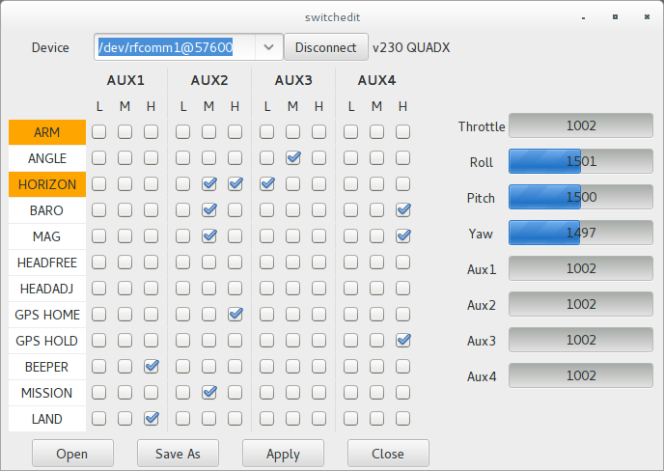Illustration 33: Editing switch settings
Switchedit supports the cleanflight switch range mode by translating the range modes into discrete MultiWii compatible switch boxes, as above. If you use more than 4 switches or 3 settings, this will not work and you must use the cleanflight configurator.

mspsim – MSP simulator
mspsim is a simple simulator for the MSP protocol (including the undocumented NAV extensions). Its sole purpose has been to allow the author to develop mwp without a NAV capable MultiWii platform. Unlike the other tools in the mwptools suite, it is unashamedly POSIX dependent, using POSIX pseudo-terminals for communications (it would however be simple to use e.g.com2com on Microsoft OS). It also supports UDP (as do the other tools).
The concept is simple. On start-up mspsim allocates a master pseudo-terminal (pty) for its use and displays the slave pty device name that can be used in the application under test (e.g. mwp or pidedit).
In Illustration 34, mspsim is being used to test mwp. mspsim is invoked with the same mission file as is loaded into mwp. The slave pty advertised by mspsim is used as the serial device by mwp. mspsim responds to MSP commands issued by mwp, so the simulated FC configuration, status, GPS location and nav status is played into mwp. When the “Play” button is mspsim is activated, mspsim “flys” the mission, providing simulated GPS and “nav status” to mwp.
mspsim is a very simple simulation; it does not honour POSHOLD_TIME loiter time, nor does it honour JUMP; its sole purpose is to simulate the MSP communications. Thus a number of states are hard coded into the simulation (e.g. vehicle type is always QUADX).
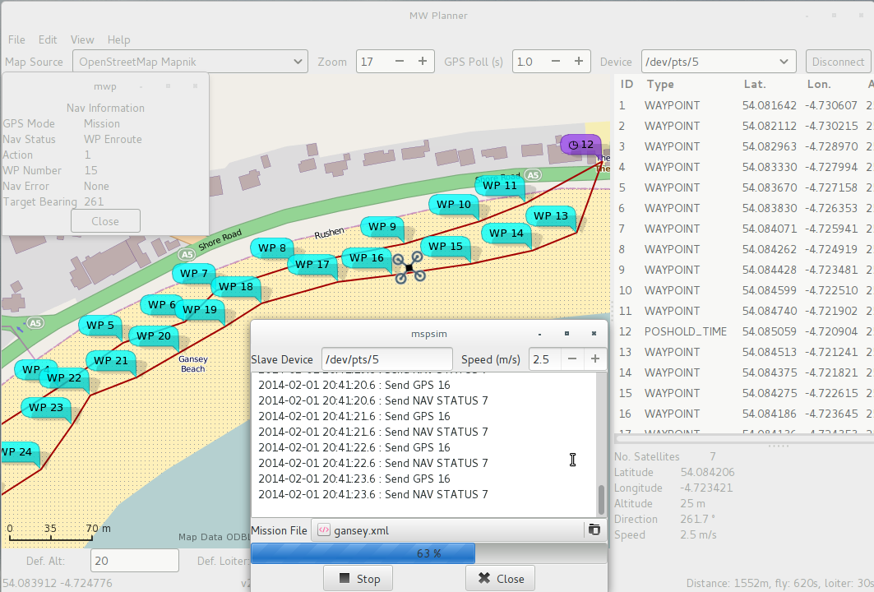Illustration 34: mspsim being used to test mwp (pre-dock UI)
The numbers after the command mnemonics in the status list represent the (assumed) message payload size.
The following messages are supported (to some degree) by mspsim:
- The Connect / Disconnect buttons connect / disconnect the serial device.;

MSP Messages simulated
Mnemonic | Description, usage
IDENT | Version identity (230).
STATUS | FC status. mspsim supplies sensor (0x1f) and cycle time (2345).
MISC | FC settings. mspsim supplies minthrottle, maxthrottle, mincommand.
PID | PID settings. mspsim supplies values appropriate to an extremely lightweight, somewhat over-powered 250mm MTM QUADX.
ALTITUDE | Returns appropriate data from the simulated mission.
EEPROM_WRITE | Recognised, no response necessary.
SET_PID | Recognised, response sent. mspsim does not retain values supplied.
RAW_GPS | mspsim supplies values based on the mission file supplied (or 1 satellite, no fix if no file).
SET_HEAD | Recognised, no response necessary.
WP | mspsim supplies any values previously received via SET_WP.
SET_WP | Values are stored, and will be returned via a WP query.
NAV_STATUS | mspsim supplies values based on the mission file supplied and the state of “Play” through the mission file.
NAV_CONFIG | Recognised, with a default filled response.
RADIO | Recognised, with a random filled response.
ATTITUDE | Recognised, response based on simulated mission.
COMP_GPS | Returns appropriate data from the simulated mission.

It must be reiterated that the purpose of mspsim is not to supply a realistic flight simulator, rather it is to provide responses to test the extended MSP protocol.
mspsim has the following options:
$ mspsim –help
Usage:
mspsim [OPTION…]

Help Options:
-h, --help Show help options

Application Options:
-m, --mission Mission file
-x, --exhaust-battery exhaust the battery (else warn1)
-u, --udp-port udp port for comms

$ mspsim -m nmtest04.mission -u 6666 # Use UDP port 6666, set device to localhost:6666 in mwp

Mission File extensions
mwp writes a single extension to the WinGui XML mission file format, representing the zoom level and centre coordinates appropriate to the mission, for example:
<mwp zoom="18" cx="-1.5347760915756226" cy="50.910293849231742"></mwp>
These extensions should be ignored by WinGui.

Command line options
mwp and mspsim may be supplied with the name of a mission file. If one is using mspsim to test mwp, it is advisable to use the same file.
$ mwp --help
Usage:
mwp [OPTION…]

Help Options:
-h, --help Show help options

Application Options:
-m, --mission Mission file
-s, --serial-device Serial device
-c, --connect connect to first device
--ignore-sizing ignore minimum size constraint
--ignore-rotation ignore vehicle icon rotation on old libchamplain
$ # thusly ...
$ mspsim ../samples/gansey.xml &
$ # see which slave PTY we're offered ... in this case /dev/pts/5
$ mwp -m ../samples/gansey.xml -s /dev/pts/5 -c
The --ignore-rotation option may be necessary on older versions of libchamplain (though the code attempts to avoid it being necessary for recent Ubuntu (e.g. 13.10).

Platform Caveats
The application is untested on big endian CPUs.

Other Configuration Items
It is not currently my intention to address all the elements of MultiWii configuration. The cross-platform tools MultiWiiConf or Cleanflight Configurator may be used for configuration of items not addressed by mwptools.

Naze 32
The application also works with Naze 32, at least with the cleanflight <https://github.com/hydra/cleanflight> firmware. It may also work with baseflight, but it not tested, due to the latter's GPL abuse.

LTM Light (Telemetry)
mwp supports the ltm <http://www.wedontneednasa.com/2014/02/lighttelemetry-v2-en-route-to-ground-osd.html> protocol, as far as is reasonably possible.

Cf-cli
cf-cli is a command line tool to backup and restore Cleanflight settings. See README.md in the common/ directory, or <http://www.daria.co.uk/cf-cli/>, where you will also find a Windows binary.

Author, copyright and licence
mwptools is written by Jonathan Hudson <jh+mwptools@daria.co.uk> (aka stronnag on the MW forum, rcgroups, #cleanflight etc., but the NSA already knew that). It is licensed under the GPL 2.0 (or later, your choice).
This document describes the 0.01 pre-alpha software version.
Marko S aka marksev1 aka msev reported that localisation of decimal points was not handled correctly (now fixed). He has also bugged me tirelessly on ltm support :).

Annexe A – MultiWii Configuration
In order to use the full capability of mwptools, it is necessary to configure multiwii to have full GPS and navigation support. The following extract from multiwii's config.h illustrates the settings required. In particular, the highlighted item is essential; most of the others can be set in the Nav Config dialogue.
//Enables the MSP_WP command set , which is used by WinGUI for displaying an setting up navigation
#define USE_MSP_WP

// HOME position is reset at every arm, uncomment it to prohibit it (you can set home position with GyroCalibration)
//#define DONT_RESET_HOME_AT_ARM

/* GPS navigation can control the heading */

// copter faces toward the navigation point, maghold must be enabled for it
#define NAV_CONTROLS_HEADING 1 //(**)
// true - copter comes in with tail first
#define NAV_TAIL_FIRST 0 //(**)
// true - when copter arrives to home position it rotates it's head to takeoff direction
#define NAV_SET_TAKEOFF_HEADING 1 //(**)

/* Get your magnetic declination from here : http://magnetic-declination.com/
Convert the degree+minutes into decimal degree by ==> degree+minutes*(1/60)
Note the sign on declination it could be negative or positive (WEST or EAST)
Also note, that maqgnetic declination changes with time, so recheck your value every 3-6 months */
#define MAG_DECLINATION -1.53f //(**)

// Adds a forward predictive filterig to compensate gps lag. Code based on Jason Short's lead filter implementation
#define GPS_LEAD_FILTER //(**)

// add a 5 element moving average filter to GPS coordinates, helps eliminate gps noise but adds latency comment out to disable
// use it with NMEA gps only
//#define GPS_FILTERING //(**)

// if we are within this distance to a waypoint then we consider it reached (distance is in cm)
#define GPS_WP_RADIUS 100 //(**)

// Safe WP distance, do not start mission if the first wp distance is larger than this number (in meters)
// Also aborts mission if the next waypoint distance is more than this number
#define SAFE_WP_DISTANCE 500 //(**)

//Maximu allowable navigation altitude (in meters) automatic altitude control will not go above this height
#define MAX_NAV_ALTITUDE 100 //(**)

// minimum speed when approach waypoint
#define NAV_SPEED_MIN 100 // cm/sec //(**)
// maximum speed to reach between waypoints
#define NAV_SPEED_MAX 400 // cm/sec //(**)
// Slow down to zero when reaching waypoint (same as NAV_SPEED_MIN = 0)
#define NAV_SLOW_NAV 0 //(**)
// Weight factor of the crosstrack error in navigation calculations (do not touch)
#define CROSSTRACK_GAIN .4 //(**)
// Maximum allowable banking than navigation outputs
#define NAV_BANK_MAX 3000 //(**)

//Defines the RTH altitude. 0 means keep current alt during RTH (in meters)
#define RTH_ALTITUDE 15 //(**)
//Wait to reach RTH alt before start moving to home (0-no, 1-yes)
#define WAIT_FOR_RTH_ALT 1 //(**)

//Navigation engine will takeover BARO mode control
#define NAV_TAKEOVER_BARO 1 //(**)

//Throttle stick input will be ignored (only in BARO)
#define IGNORE_THROTTLE 1 //(**)

//If FENCE DISTANCE is larger than 0 then copter will switch to RTH when it farther from home
//than the defined number in meters
#define FENCE_DISTANCE 600

//This governs the descent speed during landing. 100 is equals approc 50cm/sec
#define LAND_SPEED 100

James Taylor, Fire and Rain. Full line is 'sweet dreams and flying machines in pieces on the ground', so let's skip the final part.
WinGui is an open source MultiWii management program on Microsoft proprietary operating systems by András Schäffer (EOSBandi). It may be downloaded from https://code.google.com/p/mw-wingui/. András also authored the NAV support in MultiWii (for which I and many other were extremely grateful, at least until r1717).

