
SYSTEM PROCESS GUIDE

Data Gathering and
Cloud Upload Flow
  - Project Access Alaminos

Purpose | Document the verified data-gathering sources and the different routes used to upload or import data into the cloud-hosted Project Access system.
System basis | Current repository implementation reviewed on August 5, 2026.

1. Executive Summary
Project Access does have multiple ways to gather and upload data to the cloud server. The methods are designed for different volumes, sources and levels of trust. Some routes save a validated record directly, while batch imports first stage or preview the data and require confirmation before they update the canonical database.
Key conclusion: All channels ultimately converge on the same cloud application controls: authentication or role permissions, server-side validation, duplicate/conflict checks, database transactions or approval gates, managed file storage, and audit/error logging.

- Manual staff encoding and authorized API calls are direct, record-by-record submission paths.
- Standard resident CSV and legacy BHWIS CSV are batch paths with preview, staging or explicit confirmation controls.
- Live BHWIS access is an on-demand identity check and one-resident import during registration; it is not a continuous bulk synchronization.
- Resident mobile/PWA channels submit profile updates, service requests, grievances, SOS alerts and complaints through authenticated cloud endpoints.
- Specialized uploads handle scholar PIN workbooks and photo/signature batches that can be attached immediately or staged until the resident exists.

2. High-Level Flowchart
The diagram below shows how different data sources converge on the cloud server while retaining different validation and approval paths.
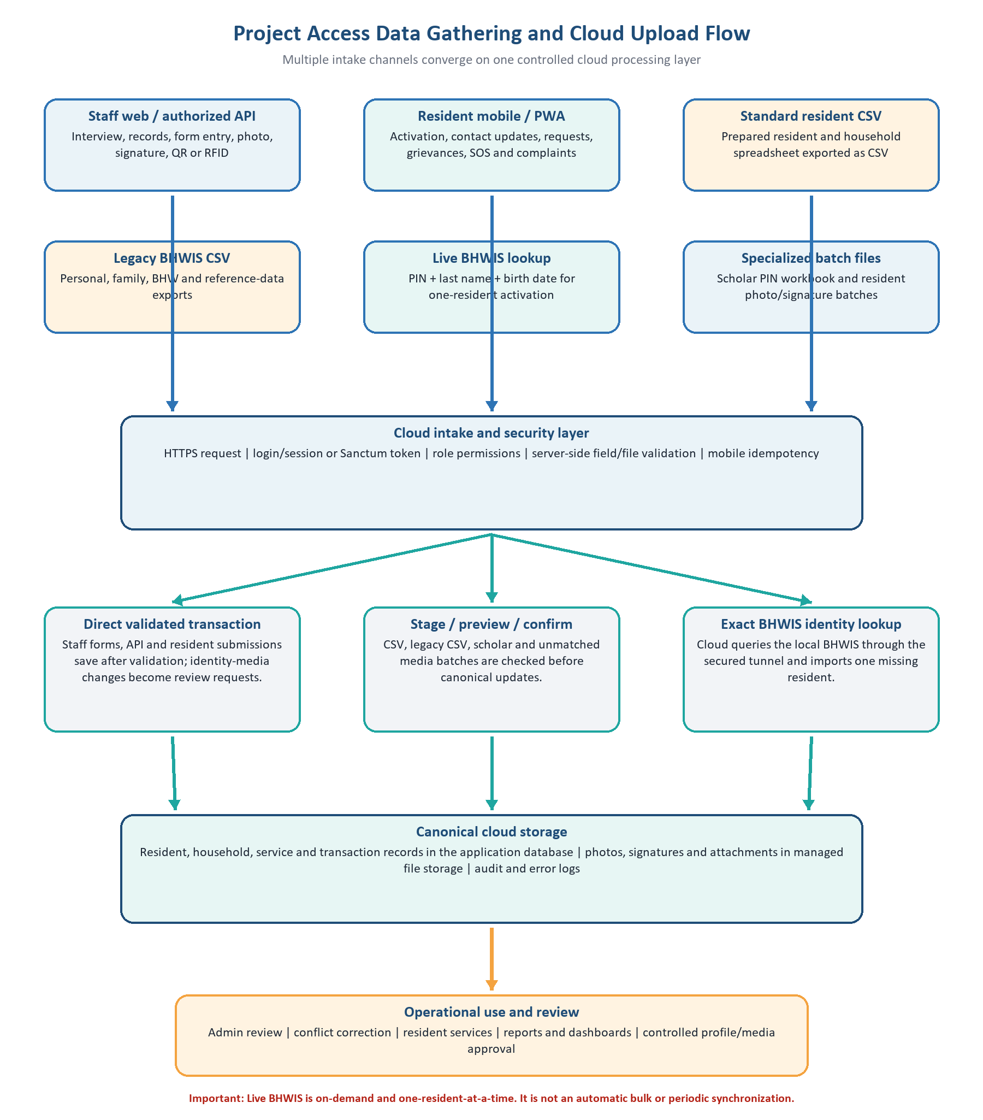
Figure 1. Verified Project Access data-gathering and cloud-upload channels.

3. Main Data Categories Collected
Category | Typical content | Primary source
Identity | PIN/resident ID, name, birth date, gender, civil status | Staff form, BHWIS, approved CSV
Household/address | Address, barangay, household membership and relationships | Interview, staff verification, BHWIS family export
Contact and livelihood | Phone, email, occupation, income source and emergency contact | Resident or staff-assisted collection
Program/sector flags | Voter, PWD, senior, solo parent, 4Ps, scholar, BHW and other sector markers | Approved office records and controlled imports
Identity media | Photo and signature | Staff camera/tablet/file upload or verified resident change request
Service activity | Applications, grievances, SOS, complaints, posts, comments and attachments | Resident portal/mobile/PWA or authorized staff
Technical audit data | Submission channel, time, IP/user agent, consent outcome and error logs | Generated by the cloud application

01 Manual Staff Web Registration
Best used for: One resident or household at a time, especially assisted registration and corrections.

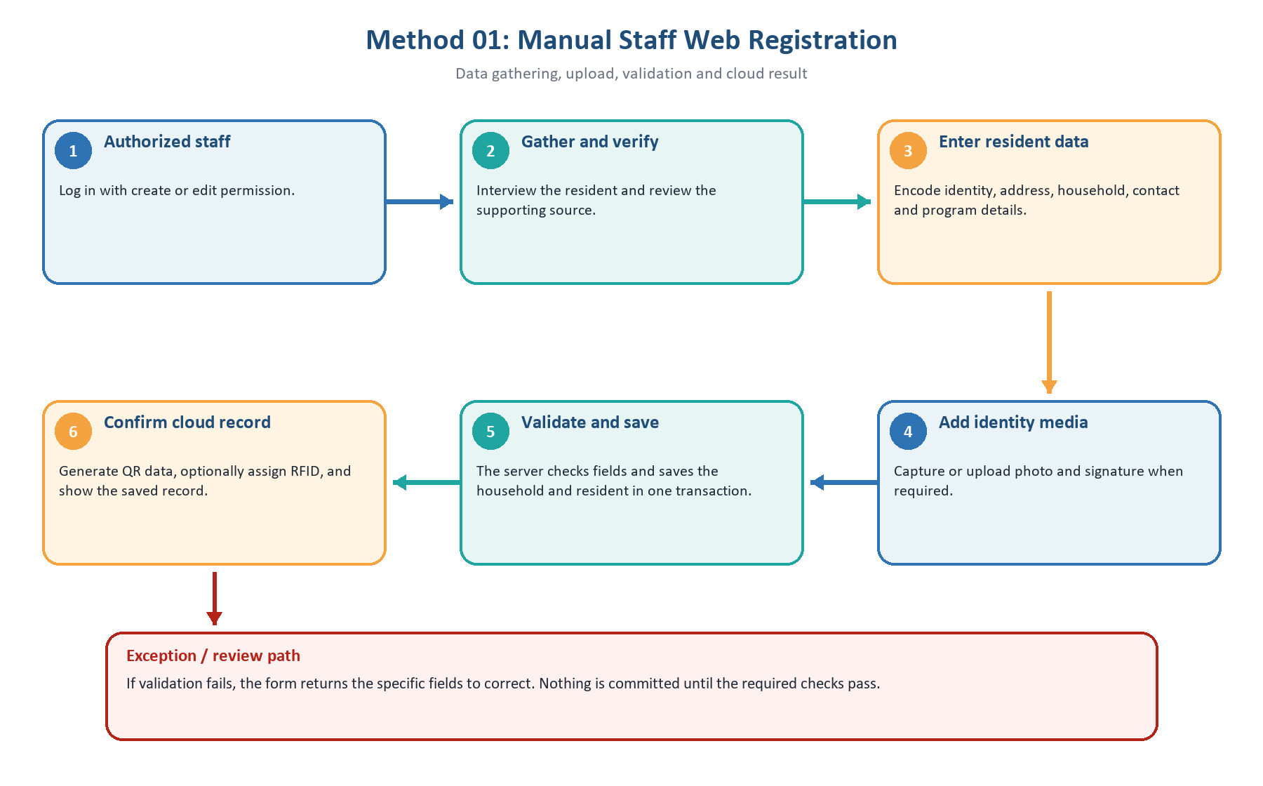
Figure 2. Detailed workflow for Manual Staff Web Registration.
Key controls | Login and create/edit permissions; required field and format checks; database transaction; server-generated IDs.
Cloud result | Canonical resident and household records are saved directly after successful validation.

02 Authorized Staff or System API
Best used for: Controlled system-to-system integration or an authorized client submitting an individual record.

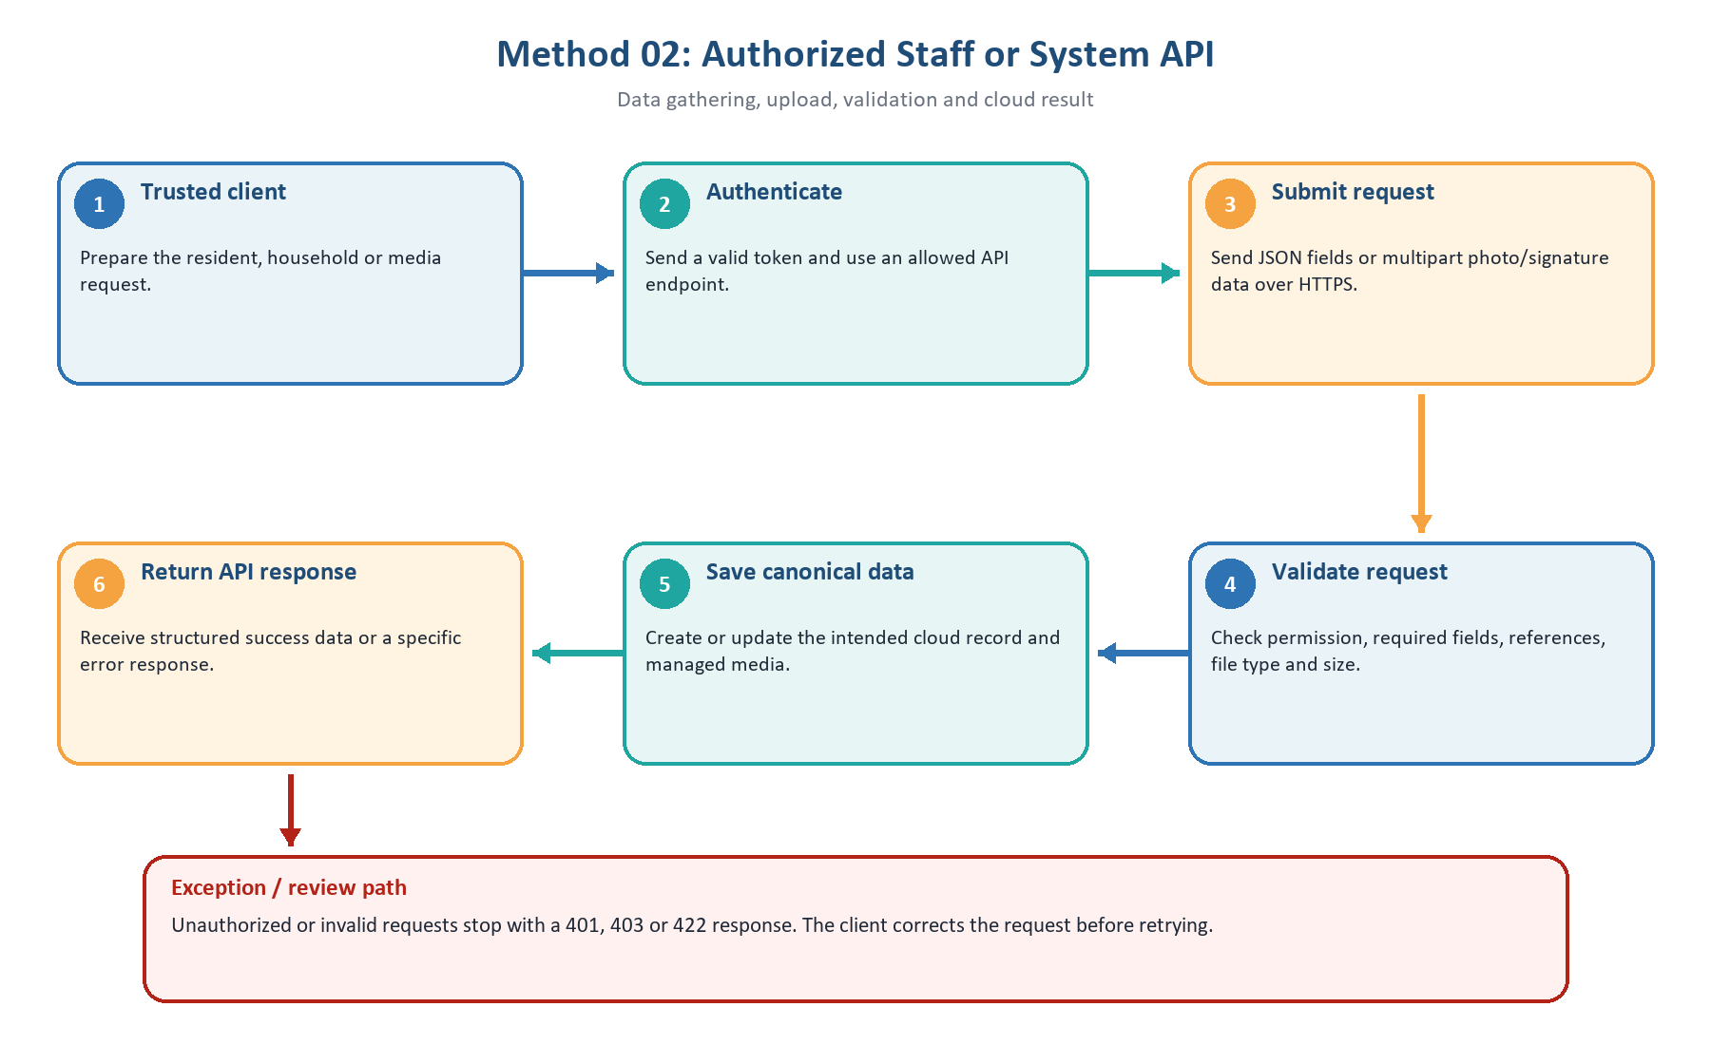
Figure 3. Detailed workflow for Authorized Staff or System API.
Key controls | Token authentication; role/permission middleware; server-side validation; media type and size limits.
Cloud result | A direct canonical update or a structured authorization/validation response; no CSV staging step.

03 Standard Resident CSV Import
Best used for: A prepared batch that follows the Project Access resident CSV template.

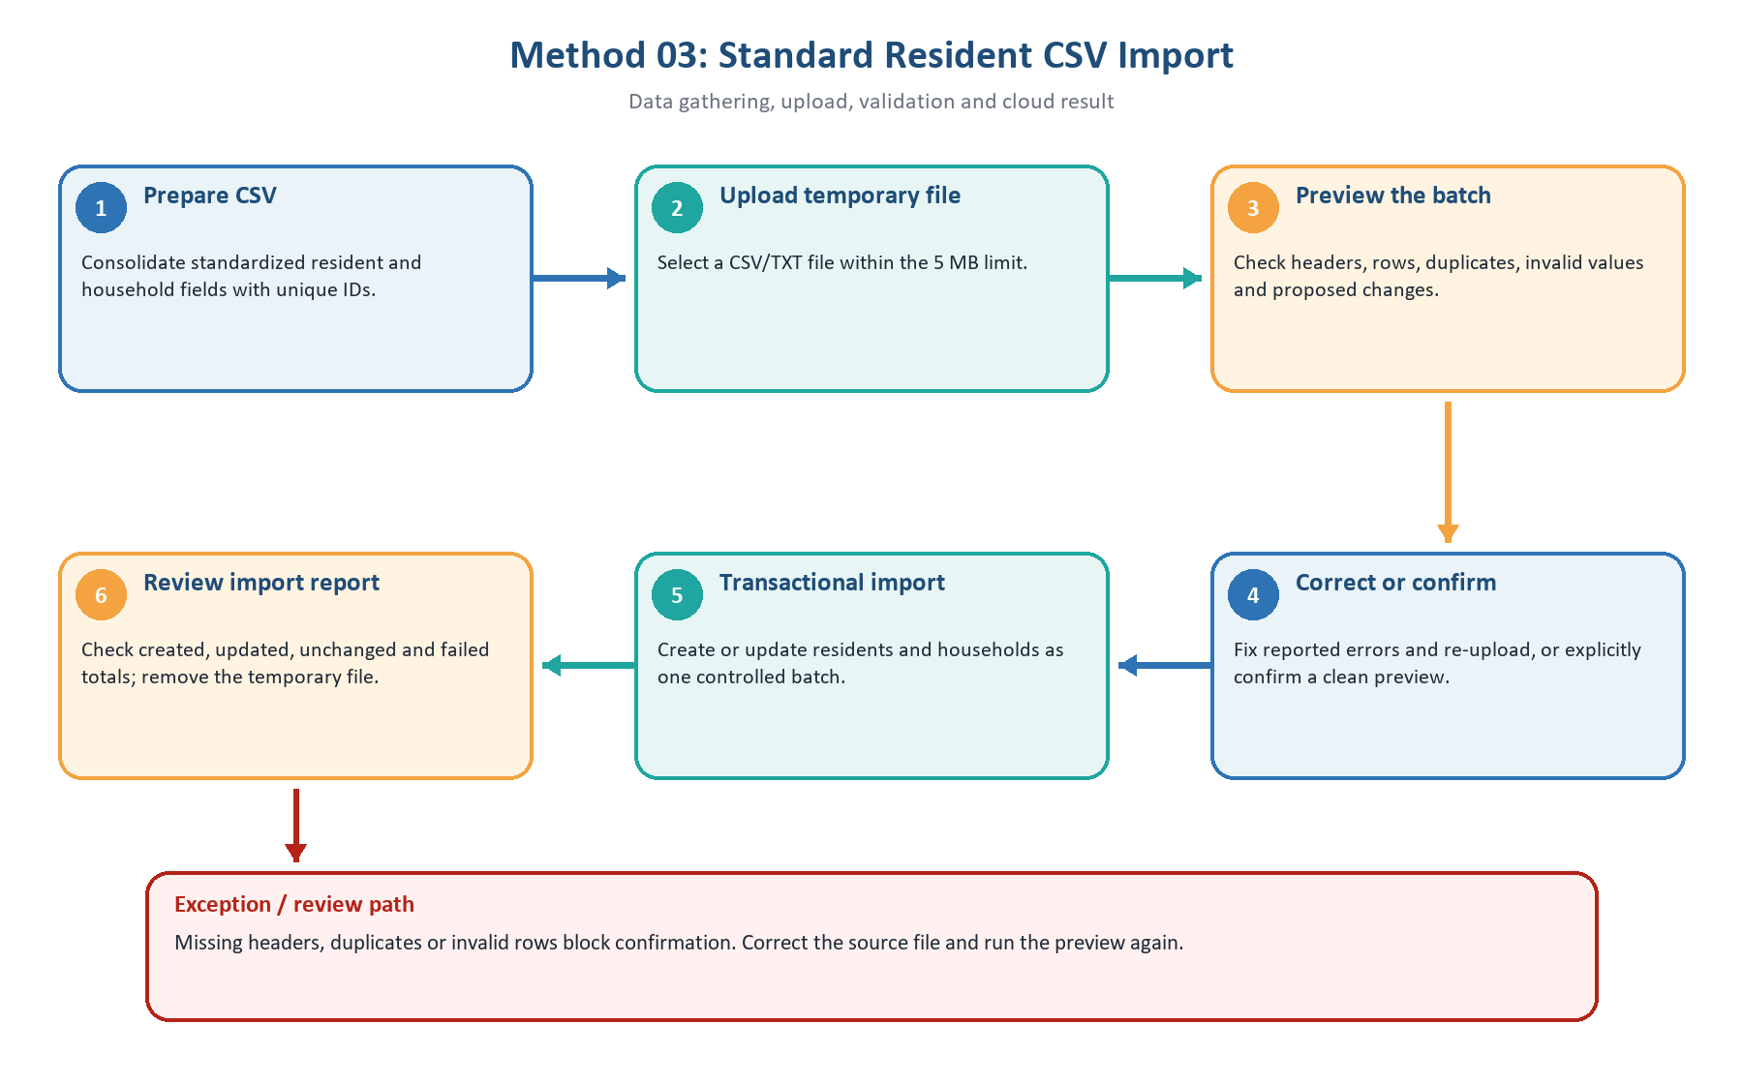
Figure 4. Detailed workflow for Standard Resident CSV Import.
Key controls | Import permission; CSV/TXT and 5 MB limit; preview gate; duplicate checks; transaction; temporary-file cleanup.
Cloud result | A controlled batch update with a clear reconciliation report.

04 Legacy BHWIS CSV Import
Best used for: Initial migration, historical load or fallback when live BHWIS access is unavailable.

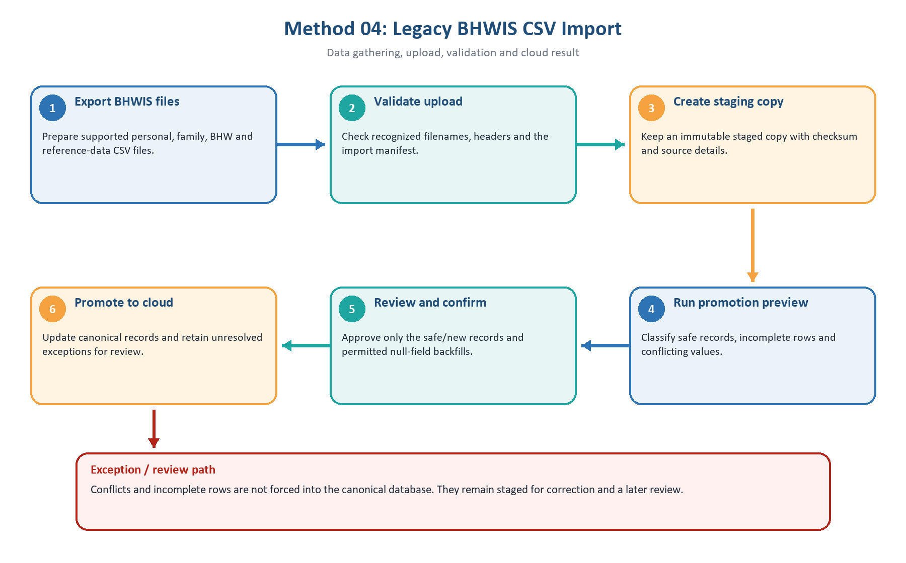
Figure 5. Detailed workflow for Legacy BHWIS CSV Import.
Key controls | Import permission; manifest/checksum; staging; dry-run preview; explicit confirmation; conflict protection.
Cloud result | Safe data is promoted without overwriting different populated canonical values.

05 Live BHWIS On-Demand Registration
Best used for: Resident activation when the person is not yet available in the cloud database.

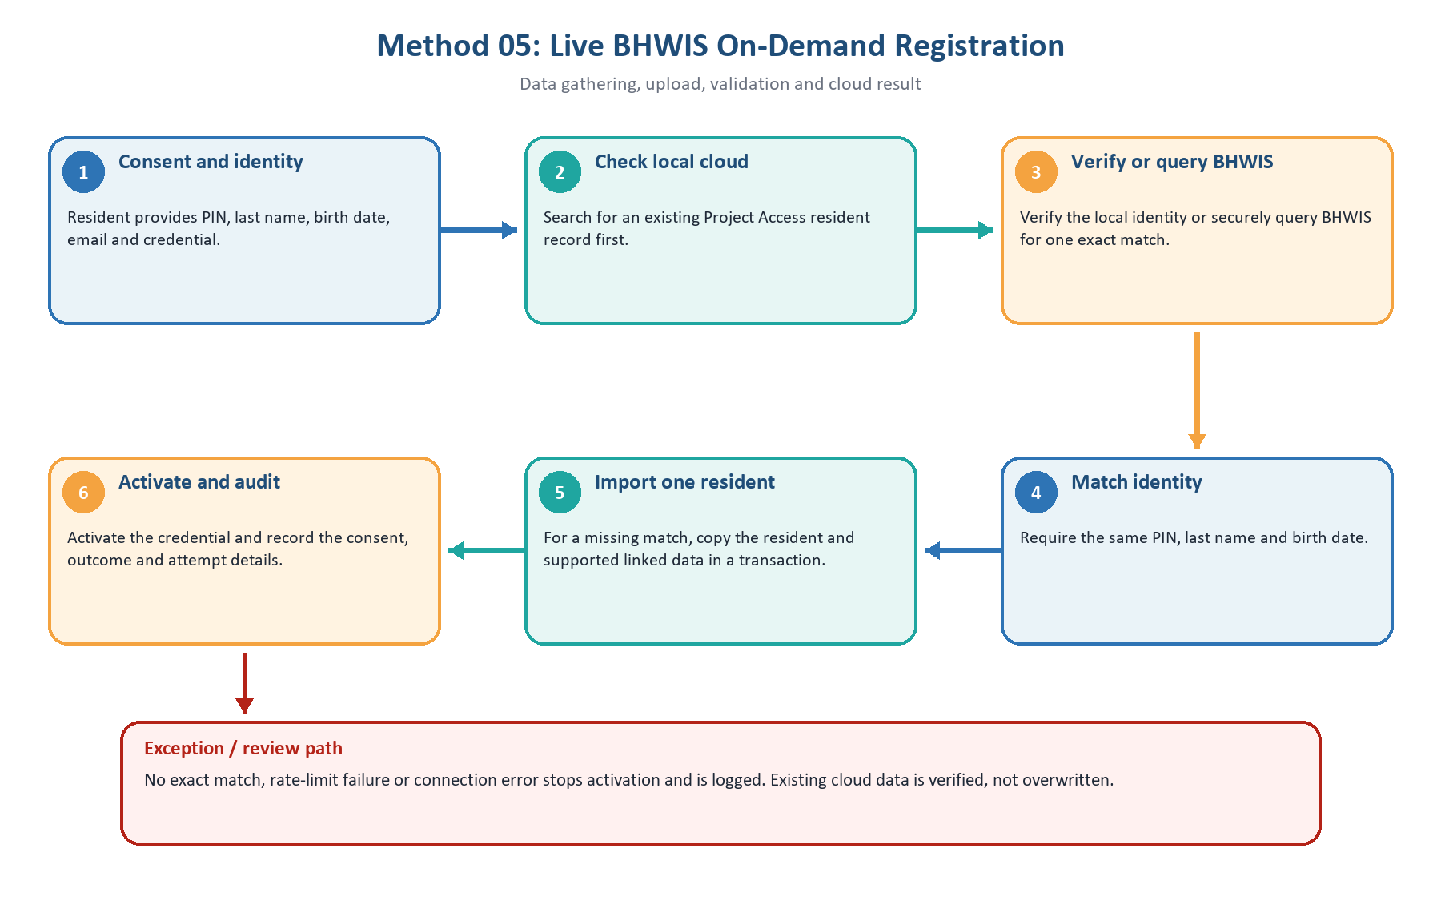
Figure 6. Detailed workflow for Live BHWIS On-Demand Registration.
Key controls | Consent audit; exact identity match; PIN/IP rate limits; secured read-only connection; lock and transaction.
Cloud result | One resident is activated or imported and activated. This is not bulk or scheduled synchronization.

06 Resident Mobile App and PWA Submissions
Best used for: Self-service profile data, requests, grievances, SOS alerts, complaints and attachments.

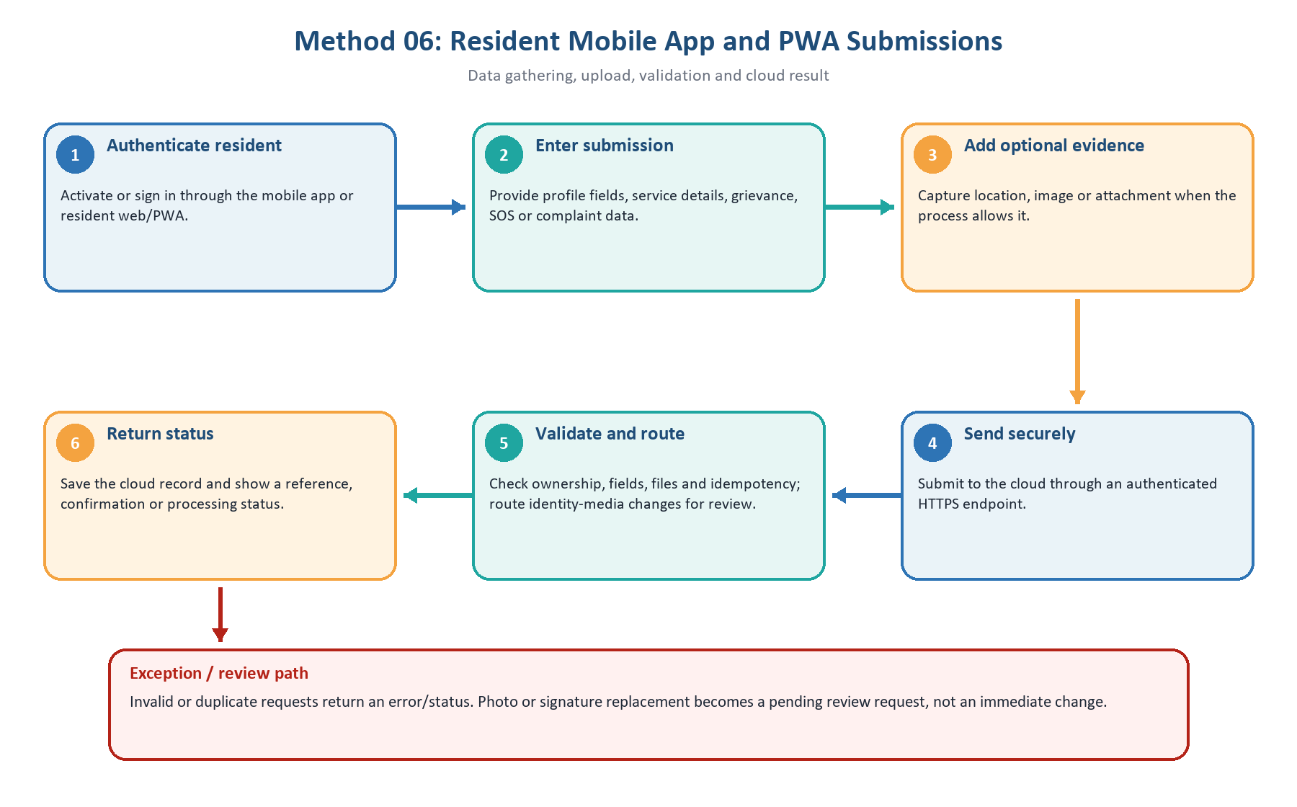
Figure 7. Detailed workflow for Resident Mobile App and PWA Submissions.
Key controls | Resident session/token; ownership checks; field/file validation; mobile idempotency; identity-media approval gate.
Cloud result | A traceable cloud submission that administrators can review and process.

07 Specialized Workbook and Media Batch Uploads
Best used for: Scholar PIN updates and batches of resident photos or signatures.

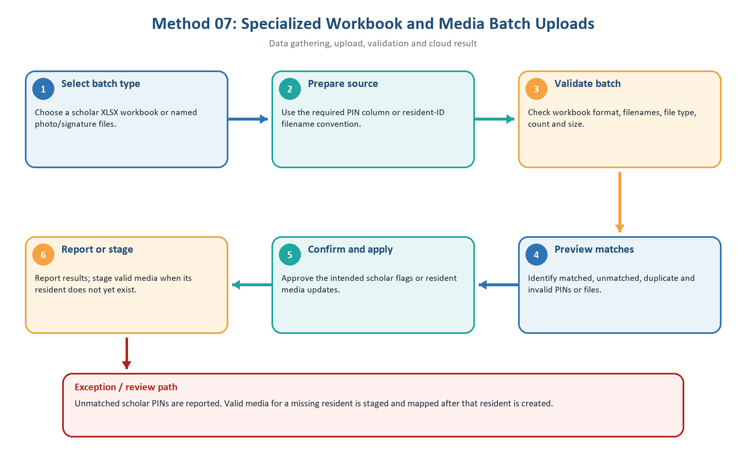
Figure 8. Detailed workflow for Specialized Workbook and Media Batch Uploads.
Key controls | Import permission; workbook/filename conventions; preview; confirmation; batch/file limits; duplicate checks.
Cloud result | Only the targeted scholar flag or identity media is updated; this is not a full resident import.

5. How to Choose the Correct Method
Situation | Recommended method | Reason
New walk-in resident with supporting information | Manual staff web registration | Supports full assisted data capture, photo/signature and immediate verification.
Trusted client submits one record | Authorized API | Provides structured responses and permission-controlled direct updates.
Clean resident spreadsheet using Project Access fields | Standard resident CSV | Preview-and-confirm batch import with row statistics.
Historical BHWIS exports or live connection outage | Legacy BHWIS CSV | Preserves source rows and requires safe promotion review.
Resident activates an account and is missing in cloud | Live BHWIS lookup | Verifies identity and imports exactly one matching record.
Resident submits service or incident information | Mobile app / PWA | Uses the resident's authenticated self-service channel.
Scholar list or many identity images | Specialized workbook/media batch | Updates only the intended flag or media and supports staging.

6. Validation, Security and Review Controls
- Access control: staff routes require the relevant create, edit or import permission; resident routes require an authenticated resident session or token.
- Transport and request control: cloud submissions should use HTTPS; protected mobile writes include idempotency handling to reduce duplicate processing when a request is retried.
- Server-side validation: required fields, formats, date ranges, database references, image types and file-size limits are checked again on the server.
- Batch protection: standard CSV uses a preview-and-confirm gate; legacy CSV uses staging, dry-run promotion and explicit commit; scholar import requires preview and acceptance.
- Identity protection: live BHWIS activation requires an exact PIN, last-name and birth-date match, creates a consent/audit record and rate-limits attempts.
- Conflict protection: legacy promotion does not overwrite populated canonical values with a different legacy value; differences remain conflicts for review.
- Media protection: resident-initiated photo/signature replacements are submitted as review requests and do not immediately replace the verified identity media.
- Operational traceability: the application records outcomes, errors and selected channel/audit details so failures and exceptions can be investigated.

7. Recommended Standard Operating Flow
- Assign an owner. Identify the office and authorized person responsible for the source data and its correction.
- Prepare and verify. Check consent, identity, required fields, source documents, duplicate PINs and attachment quality.
- Use the least complex valid channel. Direct entry for a single assisted record; standard CSV for a clean batch; legacy CSV only for BHWIS exports; live lookup only for activation.
- Upload through the authenticated production site. Avoid sending personal data through personal email, messaging apps or unapproved file-sharing links.
- Review before commit. For batch uploads, review created, matched, updated, incomplete and conflict counts before confirmation.
- Reconcile after commit. Compare the import report with the source control total and record unresolved exceptions by PIN or row.
- Protect and retain. Apply the approved backup, access, retention and deletion policy to database records, uploaded files and temporary source files.

