SmartCity ACCESS · Module Guide
Alaminos City Scholarship Program
How a resident applies online and how city staff review, conditionally approve, and award ACSP scholarships — with the full process flow for both sides.

Resident portal + Admin console · Program code ACSP · Reference format ACSP-YYYYMMDD-XXXXXX
The whole process at a glance
Two-stage approval
ACSP uses two-stage approval. In the first stage the resident uploads scanned requirements and staff review them online. When everything checks out, the application becomes Conditionally Approved — which is not yet a scholarship. In the second stage the resident appears at the office in person with the original hard copies. Only then does the application become Awarded and the resident get marked as a scholar.

In other words, no scholarship is approved purely online. The online portion screens applicants and shortens the queue; final verification is always in person.
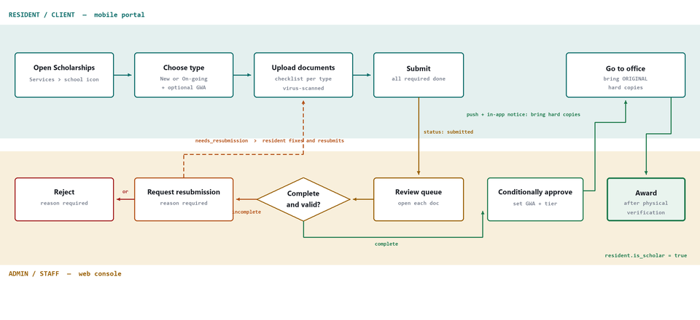
Fig. 1 — Swimlane flow. Teal = resident actions in the mobile portal. Ochre = staff actions in the admin console. The dashed loop is the correction cycle.

Part 1 — For the Resident (Client)
The resident needs an active resident-portal account. Every step works in a mobile phone browser; there is nothing to install.
01 | Open the Scholarships screen  Log in to the resident portal. On the home screen there is a Scholarships icon (school) in the services rail at the top — or go through Services → Scholarships.  Where: /resident-portal/scholarships

02 | Tap "Apply for Scholarships"  This button only appears while a program is open. When the application period is closed, the screen says "No scholarship programs are open for applications right now." — no application can be started until an admin opens one.

03 | Pick the program and scholar type  - Scholarship program — for example, Alaminos City Scholarship Program (ACSP) · 2026-2027.  - Scholar type — New Applicant for first-time applicants; On-going (Old Scholar) for renewals. This matters: the two types have different requirement lists.  - GWA — optional, but worth filling in. It determines the award tier.  Submitting the form creates a draft with a reference number (e.g. ACSP-20260813-A1B2C3). Only one active application is allowed per program — if one is already in progress, a second cannot be started.

04 | Upload the requirements  The detail screen shows a Document checklist. An amber upload icon means nothing has been uploaded yet; a green check means that item is done. Below the checklist, pick a Document type, choose a file, and tap Upload.  - Accepted formats: JPG · JPEG · PNG · WEBP · PDF, up to 10 MB per file.  - Images are resized and compressed automatically (max 2000px), so large phone photos are fine.  - Every file goes through a virus scan. If it fails, the file is not saved.  - Uploading again to the same document type replaces the previous file rather than adding to it. This is how to swap out a wrong file.  - A Remove control sits next to each uploaded file while the status is still draft or needs-resubmission.

05 | Tap "Submit application"  Submission is only allowed once every required document is uploaded. If something is missing, the message names exactly which items. After submitting, the status becomes Submitted and the files are locked — the application is now waiting for staff review.

06 | Wait for the result — everything appears in the Timeline  Every change sends a push and in-app notification and is recorded in the application's Timeline. Staff can respond in three ways:  - Needs Resubmission — comes with a written reason. Go back to the checklist, replace the files named in the reason, and tap Resubmit application. There is no limit on how many times this can happen.  - Rejected — comes with a reason; that application is finished.  - Conditionally Approved — the digital review passed. The screen then shows the award tier and benefits, the office address and hours, and the list of original documents to bring.

07 | Go to the office with the hard copies  This is the final step, and it has to be done in person. Bring the original or certified documents listed on the screen. Once staff verify them, the application becomes Awarded and a congratulatory notification arrives.

Reminder for residents
Conditionally Approved is not yet a scholarship. No grant is approved until the originals are presented at the office. The online steps only handle screening, so the queue moves faster.

Part 2 — For the Admin (Staff)
The manage-scholarship-applications permission is required. It is already granted to system-administrator, Super Admin, and program-manager. If Scholarships is missing from the sidebar, the cause is a missing permission — not a bug.
Where: sidebar → Scholarships · route /scholarships
Tab | What it is for
Review queue | Where applications are reviewed. Stat cards across the top show Submitted, Under review, Conditional, and Awarded counts. There is a search box (name, resident ID, or reference number) and filters for status, applicant type, and program.
Programs & walk-in | Where the application period is opened and closed, and where the office address, office hours, and the list of originals the resident must bring are set.

2.1 — Opening an application period
01 | Open the "Programs & walk-in" tab  Click Edit on a program card to change an existing program, or fill in the blank form to create a new one.

02 | Fill in the fields  - Program name and Academic year — e.g. 2026-2027.  - Open at / Close at — these open and close the application window. Outside it, residents cannot apply.  - Office address and Office hours — these appear verbatim in the notification and on the screen of a conditionally-approved resident.  - Required originals — one item per line. This is the exact list the resident will bring to the office.  - Program is active — must be checked. Even with correct dates, an inactive program stays closed.

03 | Click "Save program"  Changes take effect immediately. Verify on the program card: it should read Active and Open.

2.2 — Reviewing an application
01 | Select an application in the queue  The default filter is Submitted — these are the new arrivals. Click a card and the detail panel opens on the right.

02 | Click "Mark under review"  Optional, but recommended when several staff share the queue — it shows others that someone has picked it up. It sends no notification to the resident.

03 | Inspect each document  The Documents section gives three controls per file:  - Download — opens the file in a new tab for inspection.  - Verify — marks the document as correct.  - Reject doc — requires a reason in the "Reason for document rejection / resubmission" box below. Type the reason before clicking.  Also check the scan status next to the filename. Rejected documents are automatically queued for resubmission.

04 | Choose an action  Every action opens a confirmation modal. Request resubmission and Reject require a reason (minimum 5 characters) — the resident reads what is written verbatim, so be specific.  - Conditionally approve — the digital review passed. Fill in the GWA and Award tier first, or leave the tier on "Auto from GWA" to derive it (≥95 = Academic Excellence, 90–94.9 = Academic Achievement). Every document not explicitly rejected is marked verified.  - Request resubmission — lets the resident edit the files again.  - Reject — closes the application.

05 | When the resident arrives at the office  Search by reference number or name — filtering by Conditionally approved is faster. Compare the hard copies against the Required originals list, then:  - Physical verify & award — the originals are complete. The status becomes Awarded and the resident record is marked is_scholar.  - Hard copies incomplete — something is missing. Sends the application back to needs-resubmission with a reason.  - Final reject — for problems discovered during verification.

Reminder for staff
There is no shortcut from Submitted to Awarded. Applications must pass through Conditionally Approved — this is deliberate, so no scholarship can be approved without someone inspecting the originals. Every action is logged with the staff member's name and a timestamp in the Timeline.

The statuses and what they mean
Status | Meaning | Resident can | Staff can
Draft | Application created but not yet submitted. | Upload, remove, submit | Nothing yet — not in the active queue
Submitted | Required documents complete, waiting for staff. | View only | Under review · Conditionally approve · Resubmission · Reject
Under Review | A staff member is currently handling it. | View only | Conditionally approve · Resubmission · Reject
Needs Resubmission | A document is missing or wrong; the reason is written out. | Replace files, resubmit | Wait for the new submission
Conditionally Approved | Digital review passed. Waiting for the in-person visit. | Go to the office with originals | Physical verify & award · Hard copies incomplete · Final reject
Awarded | Originals verified. Complete and approved. | View only | View only
Rejected | Not approved; the reason is written out. | View only | View only

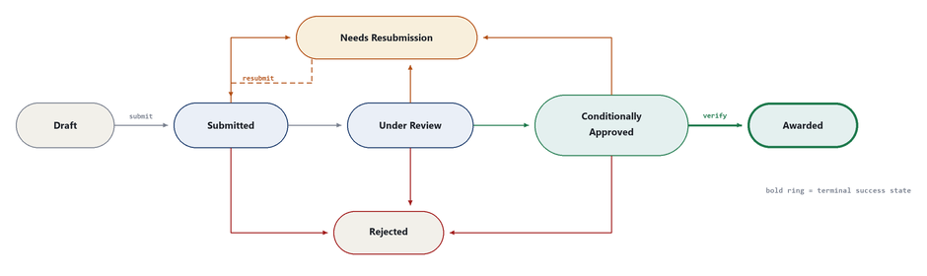
Fig. 2 — Status machine. Ochre arrows are correction paths, red are rejections, green is the approval spine. Awarded is reachable only from Conditionally Approved.
Requirements per scholar type
The checklist changes automatically based on the scholar type selected. Everything below is required — the list must be complete before the application can be submitted.
New Applicant | On-going (Old Scholar)
Accomplished form | Accomplished form
2x2 photo with name tag | 2x2 photo with name tag
Legal parent's I.D. | Legal parent's I.D.
Form 137A (Certified) | Registration form (Certified x2)
Birth certificate | True copy of grades
Certified Form 137 or registration form | Latest certificate
Indigent Certificate | Photocopies of all requirements
Photocopies of all requirements | —

Award tiers
Tier | GWA | Benefits
Academic Excellence | ≥ 95 | Full tuition, monthly stipend, and book allowance
Academic Achievement | 90 – 94.9 | 75% tuition and monthly stipend

The tier is suggested automatically from the GWA, but staff can override it in the detail panel. Below a GWA of 90 there is no automatic tier — staff decide manually whether the application passes.
Common questions
Question | Answer
The "Apply" button is missing in the resident portal | The program is closed. In admin → Programs & walk-in, check Program is active and confirm today's date falls between Open at and Close at.
Scholarships is missing from the admin sidebar | The manage-scholarship-applications permission is missing. Add it to the role through Role Management.
A resident cannot submit | A required document is missing, and the error message names which one. Note that a rejected document counts as not uploaded — it has to be replaced.
Why can't a resident apply again? | Only one active application is allowed per program. The current one has to finish (Awarded or Rejected) before a new one can be created.
An upload failed | Three possible causes: the file is over 10 MB, the format is not accepted, or it failed the virus scan. Each gives a different message.
What if the wrong file was uploaded? | Upload again to the same document type — it replaces the previous file. It can also be removed first, as long as the status is still draft or needs-resubmission.

ACSP module · SmartCity ACCESS · Resident portal and Admin console
The steps here follow the system's actual behavior: two-stage approval with mandatory physical verification before awarding.

