AIRS Frequency Calibration Model for L1c

L. Larrabee Strow

Introduction
This packages contains codes to compute the AIRS channel frequencies over time. See test_freqcal.m for an example of how to use these codes. The ab.mat file contains the channel AB states versus time, there is an entry for every channel property file. I can provide the code to read these files if desired.
This package is located on my JPL account in /home/strow/Work/JPL_nucal. You can also get updates from github at \url(https://github.com/strow/JPL_nucal).

Example Run
Run test_freqcal.m to test. It will create two plots. One shows the change in wavenumber of the center of channel 600 versus time. The second plot shows the variation in AB state of that channel versus time. This channel was chosen since it's AB state changed three times.

Status of AIRS Frequency Calibration
I recently measured the AIRS frequency calibration for the M3 module over time using daily averaged clear-scenes in a narrow latitude band at the equator, descending node, ocean only.
The result is shown in the following figure. This figure basically confirms that the exponential decay determine from the first 10 years of orbit is still good enough to use for later times.
This is preliminary, since I have modified the mean level of the M3 measured frequency calibration to match the output of get_yoff.m. I am working to understand why I had to do this, but I suspect it is just a programming issue.
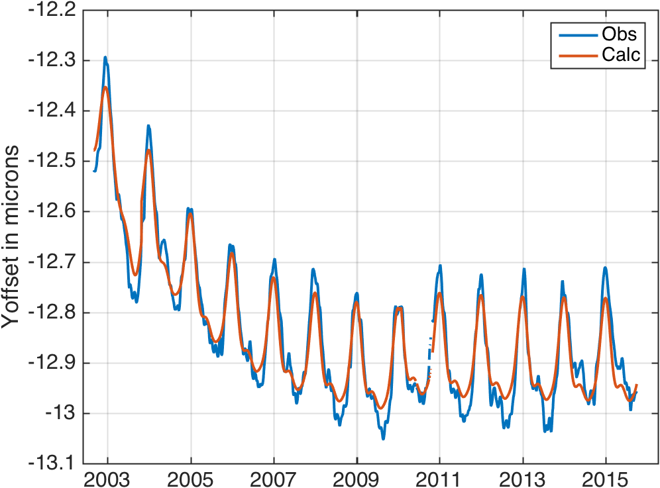 Figure 3.1: Relative variation in module M3 from clear-ocean spectra compared to output of get_yoff.m

