Assignment 1

CSSE490: Bio-Inspired Artificial Intelligence

Prepared and submitted by:

_Austin Strozier________

Collaboration and resources:

I worked (alone)

Resources I used to complete this assignment (websites, textbook, friends, etc.):

____Python Documentation_______

____Stack Overflow_____________

________________________

Sample Experiment

1. **An explanation of the experiment (including parameters used)**

|  |  |
| --- | --- |
| *population size:* | *100* |
| *mutation rate:* | *1/N* |
| *crossover:* | *None* |
| *elitism rate:* | *None* |
| *chromosome length:* | *100* |
| *selection method:* | *Truncation* |
| *max generations:* | *200* |

*I ran the simulator for the first time while crossing my fingers!*

1. **A hypothesis (might just be a guess)**

*I expect to see all the curves go up at roughly the same rate and never cross each other.*

1. **Description of the results including plots**

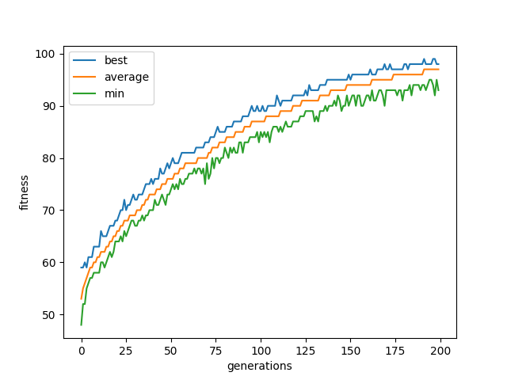

The best never quite reaches the max but comes close to 10. The min seemed to fluctuate more than the best and the average steadily increased.

1. **What if anything you can conclude and anything you learned or affirmed by doing so?**

The truncation selection causes the steady increase in the graphs shown. The deletion of the bottom fifty causes the gene pool to increase and keep increasing. The minimum was more volatile than the other curves because the results were thrown out when moving to the next generation. Even after 200 generations the best was not met, this occurs because the mutation process is random. The variation is less in the best than I thought, but this must be due to truncations method.

Assignment 2

CSSE490: Bio-Inspired Artificial Intelligence

Prepared and submitted by:

_Austin Strozier________

Collaboration and resources:

I worked (alone)

Resources I used to complete this assignment (websites, textbook, friends, etc.):

____Python Documentation_______

____Stack Overflow_____________

________________________

Sample Experiment

1. **An explanation of the experiment (including parameters used)**

|  |  |
| --- | --- |
| *population size:* | *100* |
| *mutation rate:* | *1/N* |
| *crossover:* | *None* |
| *elitism rate:* | *1/N* |
| *chromosome length:* | *100* |
| *selection method:* | *Truncation* |
| *max generations:* | *200* |

*I ran the simulator for the first time while crossing my fingers!*

1. **A hypothesis (might just be a guess)**

*I expect to see all the curves go up at roughly the same rate and never cross each other.*

1. **Description of the results including plots**

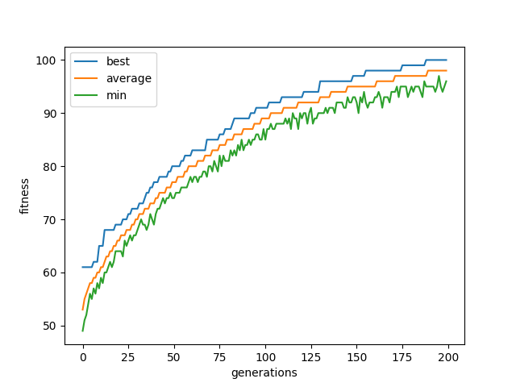

The solution does converge to the best possible solution of 100 at generation 188.The curves all show an increasing trend, but only the minimum shows a cycle with the upward trend. The minimum curve has low spikes, and the other curves only increase.

1. **What if anything you can conclude and anything you learned or affirmed by doing so?**

The best curve can only increase because of the elitism modifier. The best is always preserved, so the next generation’s best must be as great as the previous generation. The inclusion of the elitism rate also allowed the genes to converge to the best solution.

Assignment 3

CSSE490: Bio-Inspired Artificial Intelligence

Prepared and submitted by:

_Austin Strozier________

Collaboration and resources:

I worked (alone)

Resources I used to complete this assignment (websites, textbook, friends, etc.):

____Python Documentation_______

____Stack Overflow_____________

________________________

Sample Experiment

1. **An explanation of the experiment (including parameters used)**

|  |  |
| --- | --- |
| *population size:* | *100* |
| *mutation rate:* | *1/N* |
| *crossover:* | *Yes* |
| *elitism rate:* | *None* |
| *chromosome length:* | *100* |
| *selection method:* | *Truncation* |
| *max generations:* | *200* |

*I ran the simulator for the first time while crossing my fingers!*

1. **A hypothesis (might just be a guess)**

*I expect to see all the curves go up at roughly the same rate and never cross each other.*

1. **Description of the results including plots**

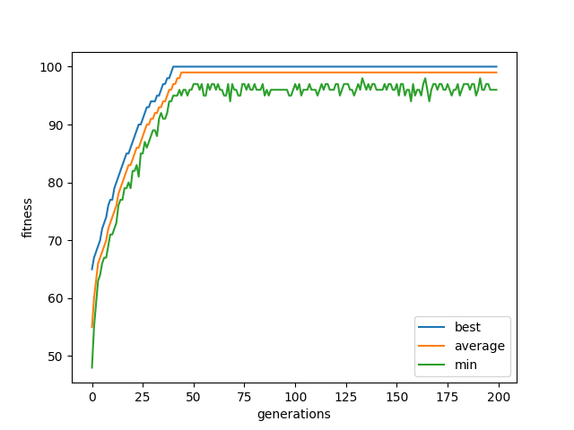

The best solution was found rather quickly at around 35 generations. The best never decreased and neither did the average. The minimum was the only volatile curve that dipped below its previous values

1. **What if anything you can conclude and anything you learned or affirmed by doing so?**

The truncation combined with the crossover made the system converge at a quicker rate than the previous experiments. The truncation keeps the top 50 and then the children come from the top 50. The way that I handled the crossover made it converge much more quickly. The elite of each top 50 would breed with the other top 50 and then the 2nd and 3rd place would breed. I did not think the elite could breed with itself. The minimum could decrease between generations because the minimum was not kept between generations

Assignment 4

CSSE490: Bio-Inspired Artificial Intelligence

Prepared and submitted by:

_Austin Strozier________

Collaboration and resources:

I worked (alone)

Resources I used to complete this assignment (websites, textbook, friends, etc.):

____Python Documentation_______

____Stack Overflow_____________

________________________

Sample Experiment

1. **An explanation of the experiment (including parameters used)**

|  |  |
| --- | --- |
| *population size:* | *100* |
| *mutation rate:* | *None* |
| *crossover:* | *Yes* |
| *elitism rate:* | *None* |
| *chromosome length:* | *100* |
| *selection method:* | *Truncation* |
| *max generations:* | *200* |

*I ran the simulator for the first time while crossing my fingers!*

1. **A hypothesis (might just be a guess)**

*I expect to see all the curves go up at roughly the same rate and never cross each other.*

1. **Description of the results including plots**

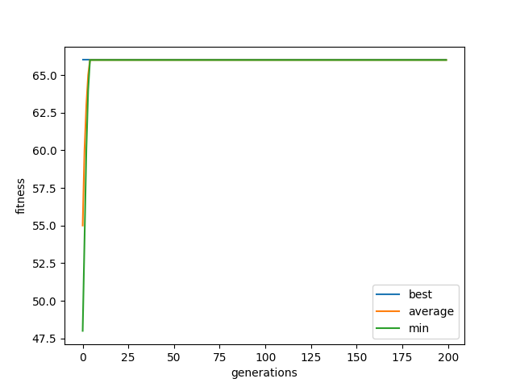

The solution is not found in 200 generations and in fact stagnates at a constant value. This occurs for every curve and has a sharp increase to the constant value.

1. **What if anything you can conclude and anything you learned or affirmed by doing so?**

Crossover by itself may converge to the optimal solution. The issue is finding the right switch point that could accomplish this. I only have one switch point that causes the genes of the child to switch to the other parent. The issue here is that without mutations the genetic code stagnates. The same code eventually copies to every child especially because I have the elite breed with the top 50 and so the code cannot change from the initial best. Crossover may be able to do the job, but not the way I do it.

Assignment 5

CSSE490: Bio-Inspired Artificial Intelligence

Prepared and submitted by:

_Austin Strozier________

Collaboration and resources:

I worked (alone)

Resources I used to complete this assignment (websites, textbook, friends, etc.):

____Python Documentation_______

____Stack Overflow_____________

________________________

Sample Experiment

1. **An explanation of the experiment (including parameters used)**

|  |  |
| --- | --- |
| *population size:* | *100* |
| *mutation rate:* | *1/5,1/10,1/2* |
| *crossover:* | *None* |
| *elitism rate:* | *None* |
| *chromosome length:* | *100* |
| *selection method:* | *Truncation* |
| *max generations:* | *200* |

*I ran the simulator for the first time while crossing my fingers!*

1. **A hypothesis (might just be a guess)**

*I expect to see all the curves go up at roughly the same rate and never cross each other.*

1. **Description of the results including plots**

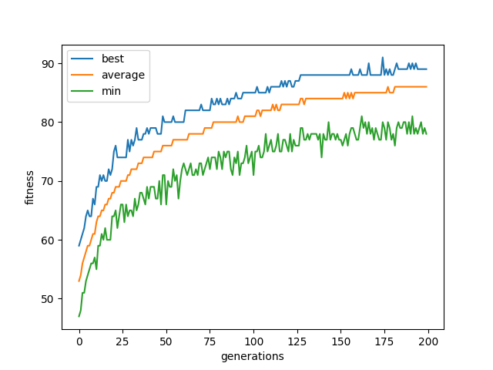

Mutation Rate: 5%

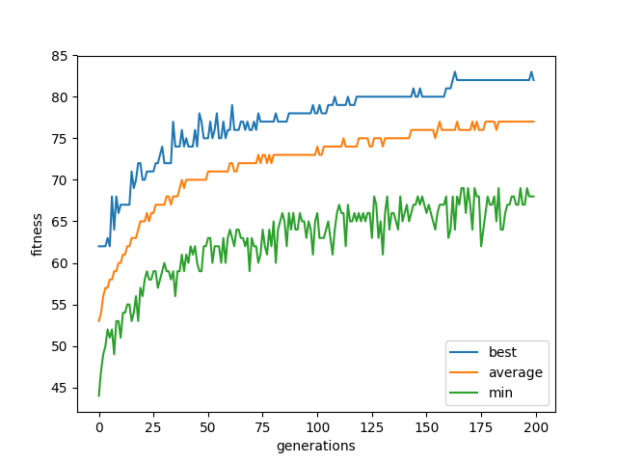

Mutation Rate: 10%

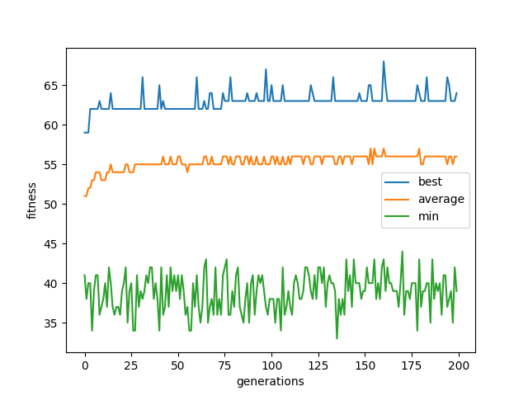

Mutation Rate 50%

The first two graphs show a convergence to a max number but does not reach the best solution. The third graph does not come close to the max solution but show a lot of oscillation for the minimum values and the best values.

1. **What if anything you can conclude and anything you learned or affirmed by doing so?**

The truncation method keeps the best curve from dipping below the previous generation. The higher the mutation rate causes more variation between generations as expected and shown in the third graph’s minimum curve. The highest mutation rate causes the gene pool to stagnate because the genes mutate too randomly to allow truncation to force the fitness score to improve. The smaller mutation rates allow just enough variation that the good will stay good for a while, and truncation will allow the good to prosper and eliminate the bad.