1. 两台机器都要安装docker23.0.1

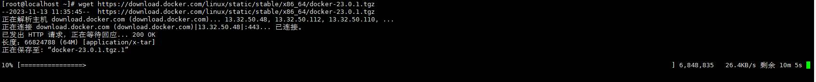

1. 在两台机器中创建**macvlan网络**

docker network create -d macvlan --subnet=192.168.139.0/24 --gateway=192.168.139.2 -o parent=ens33 macvlan-master



拉取mysql8并分别在两台中创建容器并启动该容器

docker pull mysql:8

Master：

mkdir -p /home/data/mysql/data/master

mkdir -p /home/data/mysql/master

cd /home/data/mysql/master

vi master.cnf

Slave：

mkdir -p /home/data/mysql/data/slave

mkdir -p /home/data/mysql/slave

cd /home/data/mysql/slave

vi slave.cnf

创建容器

Master：

docker create -p 3308:3306 --name mysqlmaster --privileged=true \

-v /home/data/mysql/data/master:/var/lib/mysql \

-v /home/data/mysql/master:/etc/mysql/conf.d \

-e MYSQL_ROOT_PASSWORD=123456 \

--net macvlan-master--ip 192.168.139.3 \

mysql:8

Slave:

docker create -p 3309:3306 --name mysqlslave --privileged=true \

-v /home/data/mysql/data/slave:/var/lib/mysql \

-v /home/data/mysql/slave:/etc/mysql/conf.d \

-e MYSQL_ROOT_PASSWORD=123456 \

--net macvlan-master --ip 192.168.139.4 \

mysql:8

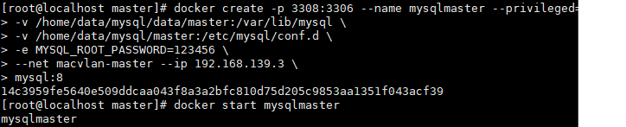

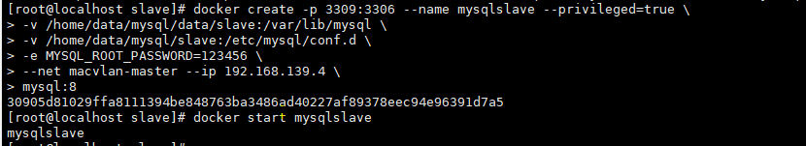

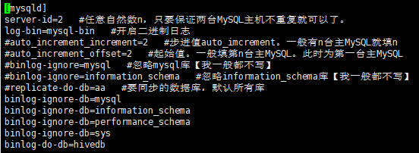



1. 配置远程访问

Master：

docker exec -it mysqlmaster /bin/bash

mysql -uroot -p123456 -h 192.168.139.3

alter user ‘root’@’%’ identified with mysql_native_password by ‘123456’;

Slave：

docker exec -it mysqlslave /bin/bash

mysql -uroot -p123456 -h 192.168.110.4

alter user ‘root’@’%’ identified with mysql_native_password by ‘123456’;



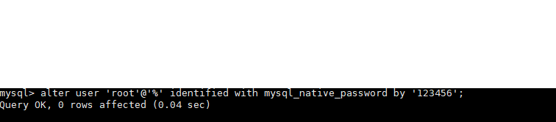

1. 配置主从

set sql_mode=(select replace(@@sql_mode,’ONLY_FULL_GROUP_BY’,’’));

grant replication slave on *.* to ‘root’@’%’ identified by ‘123456’;

flush privileges;

show master status \G;

Slave：

stop slave;

CHANGE MASTER TO MASTER_HOST='192.168.110.3',MASTER_PORT=3306,MASTER_USER='root',MASTER_PASSWORD='123456',MASTER_LOG_FILE='mysql-bin.000003',MASTER_LOG_POS=1100;

start slave;

show slave status \G;

需要严重注意一下master中file和Position这两个的值，一会在从机会用到注意不要填错

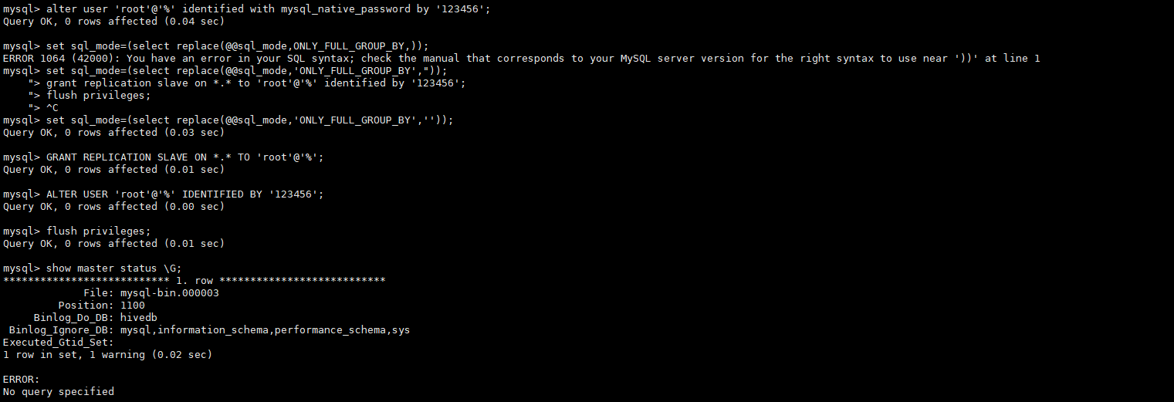

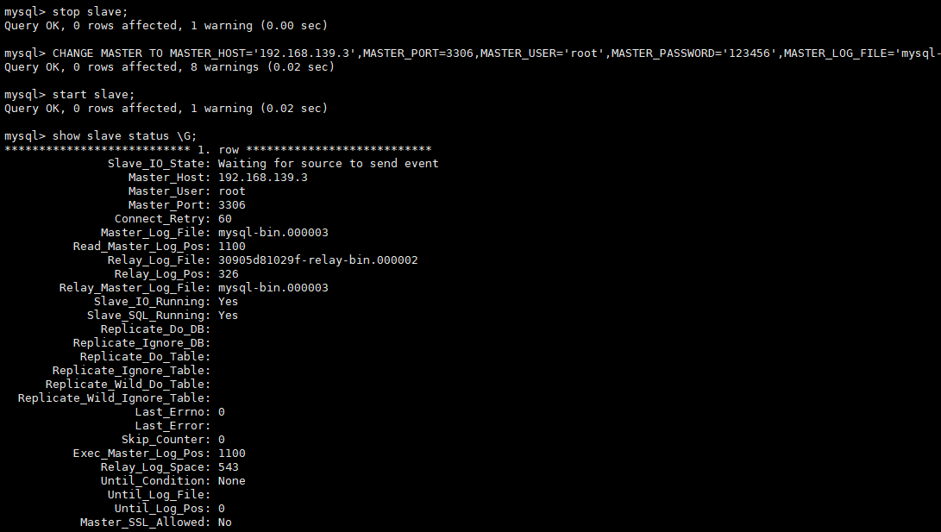

create database hivedb;

use hivedb;

create table stu(id int,name varchar(20));

show tables;

insert into stu values(1,'tom');