提前将black_exporter下载到本地或者使用wget直接下载
在根目录下创建个一个文件夹用于存放black_exporter压缩包
wget https://github.com/prometheus/blackbox_exporter/releases/download/v0.23.0/blackbox_exporter-0.24.0.linux-amd64.tar.gz
解压
[root@centos7-node1 black_exporter_p]# tar -zxvf blackbox_exporter-0.24.0.linux-amd64.tar.gz
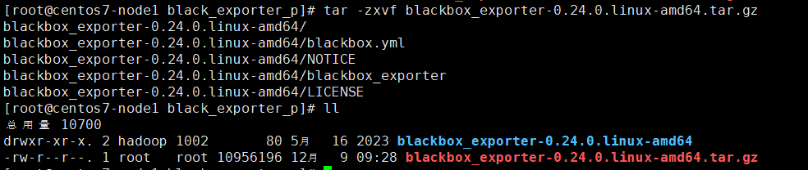
改名
[root@centos7-node1 black_exporter_p]# mv blackbox_exporter-0.24.0.linux-amd64 blackbox_exporter-0.24.0
准备service文件
[root@centos7-node1 black_exporter_p]# vim /lib/systemd/system/blackbox-exporter.service

[Unit]
Description=Prometheus Blackbox Exporter
After=network.target

[Service]
Type=simple
User=root
Group=root
ExecStart=/black_exporter_p/blackbox_exporter-0.24.0/blackbox_exporter --config.file=/black_exporter_p/blackbox_exporter-0.24.0/blackbox.yml --web.listen-address=:9115
Restart=on-failure

[Install]
WantedBy=multi-user.target

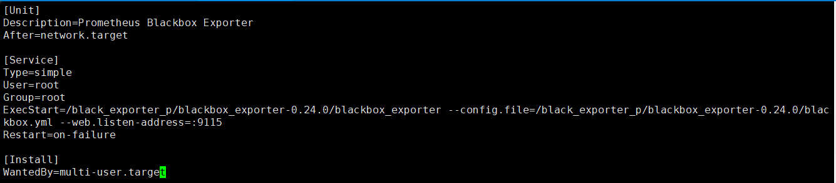
启动blackbox-exporter
重新加载systemd守护进程配置
[root@centos7-node1 black_exporter_p]# systemctl daemon-reload
启动blackbox_exporter服务
[root@centos7-node1 black_exporter_p]# systemctl start blackbox-exporter.service
查看blackbox_exporter服务
[root@centos7-node1 black_exporter_p]# systemctl status blackbox-exporter.service
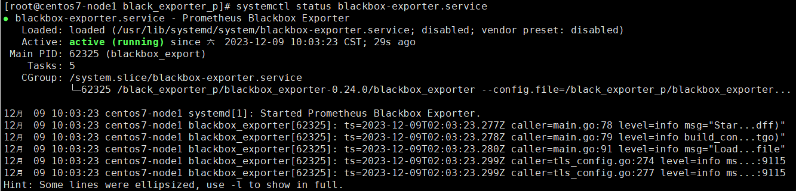
设置开机自启
[root@centos7-node1 black_exporter_p]# systemctl enable blackbox-exporter.service

访问blackbox-exporter web界面验证
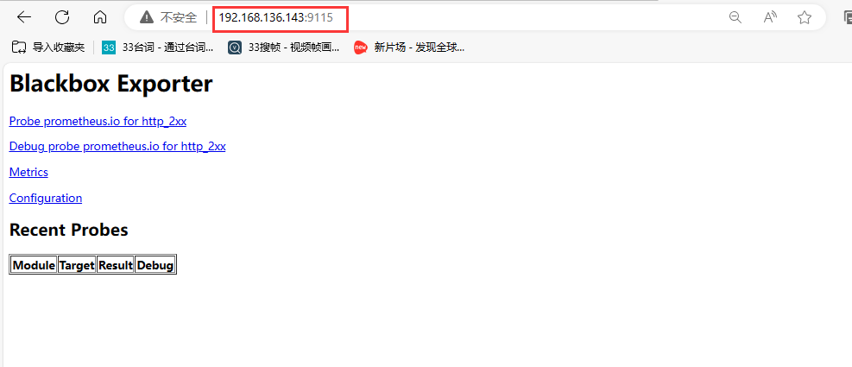

blackbox-exporter实现url监控
修改Prometheus配置，添加Job
配置完成记得重新启动Prometheus

- job_name: http-status
metrics_path: /probe #指定指标接口
params: #指定查询参数，在Prometheus向target发送Get请求获取指标数据时，会传递到url上
module: [http_2xx]
static_configs:
- targets:
- http://www.baidu.com
labels: #自定义标签，附加在target上
group: web
relabel_configs:
#将标签__address__的值赋值给__param_target标签，以__param开头的标签也会作为查询参数传递Prometheus的Get请求，作用和上面的params配
置类似
- source_labels: [__address__]
target_label: __param_target
#将标签__param_target的值赋值给instance标签
- source_labels: [__param_target]
target_label: instance
#将标签__address__的值修改给balckbox-expoter的地址
- target_label: __address__
replacement: 192.168.136.143:9115
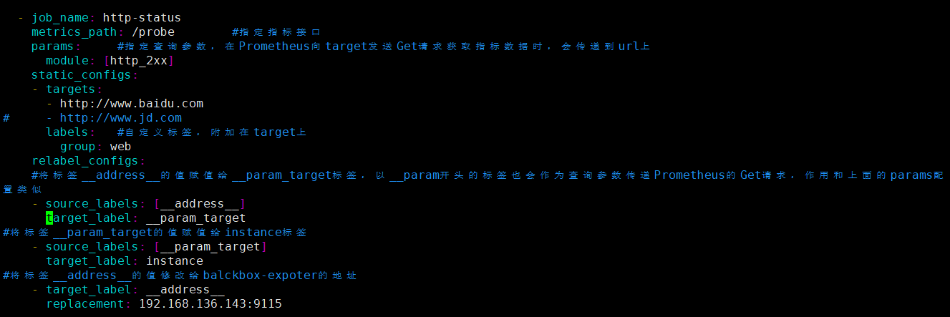

重启prometheus服务：
systemctl reload prometheus.service

在界面查看target状态
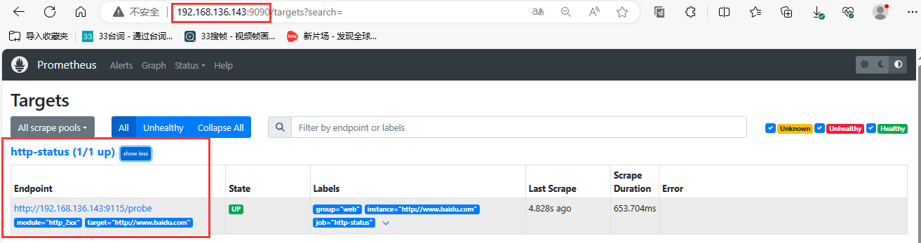
访问blackbox-exporter界面查看数据
