MDMPI Mobile App
Collection Process Flow and System Narrative
Process Documentation (Quality Management System)
Document No.
Revision | 0
Effective Date
Application Version | 1.1.104
Platforms | Android
Department | Collection
Prepared by | Jay Bryan C. Abaoag
Reviewed by
Approved by
Controlled document. Printed copies are uncontrolled unless stamped.

Table of Contents
1. Purpose 3
2. Scope 3
3. Definitions 3
4. The Collection User 4
5. System Overview 4
6. Common Steps 5
6.1 Signing in and onboarding 5
6.2 Collection navigation 5
6.3 The Home dashboard 6
6.4 Finding accounts: search and filters 6
7. Process Flows 6
7.1 Acquiring accounts from the Collection Bucket 6
7.2 Recording a field engagement 7
7.3 Recording a batch engagement 7
7.4 Releasing an account 8
7.5 Office activities 8
7.6 Calendar 9
7.7 Monthly summaries and target 9
8. Outcome and Activity Reference 10
9. Current Implementation Status 10
10. Related Documents 11
11. Revision History 11

1. Purpose
This document describes how the Collection Department uses the MDMPI Mobile App to work the list of unpaid invoices, visit clients, and record the outcome of each collection. It presents the process flow of the Collection feature and a narrative of how a collector works through it, from signing in to settling or deferring an invoice.
It is intended for inclusion in the Quality Management System documentation as the process description for the Collection feature of the mobile application. It is written as a plain user walkthrough.

2. Scope
The document covers the Collection workflows of the MDMPI Mobile App:
- Signing in, first-time onboarding and the Collection navigation.
- The Home dashboard: Actual Collection, Total Collected, the Collection Bucket, and the Settled / Due Date / Reconciliation / Advanced Payment summaries.
- Acquiring accounts from the Collection Bucket into Field Engagement.
- Recording a field engagement, single or batch, and the outcome of each invoice.
- Releasing an account back to the bucket (Clear Engagement and Deferred Engagement).
- Office activities: Deposit, CWT Pick-up, Reconciliation and Advanced Payment.
- The Calendar view and the monthly collection summaries.
Out of scope: the Logistics, Service and InHouse department workflows, which are documented separately; and the technical architecture of the application.
Implementation note. The Collection feature is at the design and field-testing stage. It runs on the device and, in the current build, works from on-device data; it is not yet connected to a central collection server. See Section 9, Current Implementation Status, before relying on this document for a live-system audit.

3. Definitions
Term | Meaning in the MDMPI Mobile App
Account | A client with one or more unpaid invoices. Accounts are shown as cards with the client name, address and totals.
Invoice | A single amount due for a client, with an invoice number, invoice date and due date. The unit the collector works on and records against.
Collection Bucket | The pool of invoices still to be collected. Accounts here are not yet being worked; the collector picks accounts from the bucket.
Acquire (claim) an account | Moving an account's invoices from the Collection Bucket into Field Engagement so the collector can work and record against them.
Field Engagement | The collector's active worklist: the accounts and invoices the collector has acquired and is visiting or following up.
Engagement / engagement outcome | A recorded visit or contact for an invoice, with the amount collected and an outcome (Collected, Partially Collected, Pre-Collection or Others).
Deferred Engagement | Releasing an account back to the bucket with a reason (Follow Up, Customer Unavailable, Refused to Pay, or Others), for example when the client cannot pay today.
Clear Engagement | Releasing an account back to the bucket without recording a reason or history, for example when it was acquired by mistake.
Office activity | A recorded office-side action that is not a client visit: Deposit, CWT Pick-up, Reconciliation or Advanced Payment.
Advanced Payment | A payment received without an invoice yet; recorded first, then assigned to an invoice later.
CWT | Creditable Withholding Tax. A CWT Pick-up records the collection of a client's withholding-tax certificate.
Reconciliation | Marking an account's invoices for reconciliation so they are tracked separately while balances are checked with the client.
Engagement history | The record of each save against an invoice or account: date, collector, outcome, amount, bank / cheque details and remarks.
Target | The monthly collection target the collector sets, shown against the Actual Collection total.

4. The Collection User
Collection is a single-user workflow. A user whose department is Collection signs in and works the whole process alone: picking accounts, visiting clients, recording outcomes and releasing accounts. There are no separate roles or hand-offs within Collection, unlike the Logistics workflow. Office activities (Deposit, CWT Pick-up, Reconciliation, Advanced Payment) are recorded by the same user.

5. System Overview
Figure 1 shows the collection cycle. Invoices start in the Collection Bucket. The collector acquires an account, which moves its invoices into Field Engagement. The collector visits or contacts the client and records the engagement: an invoice paid in full is marked Collected and returns to the bucket under Settled; a part payment leaves the balance in Field Engagement as Partially Collected. An account that cannot be worked is released back to the bucket, either cleared or deferred with a reason.
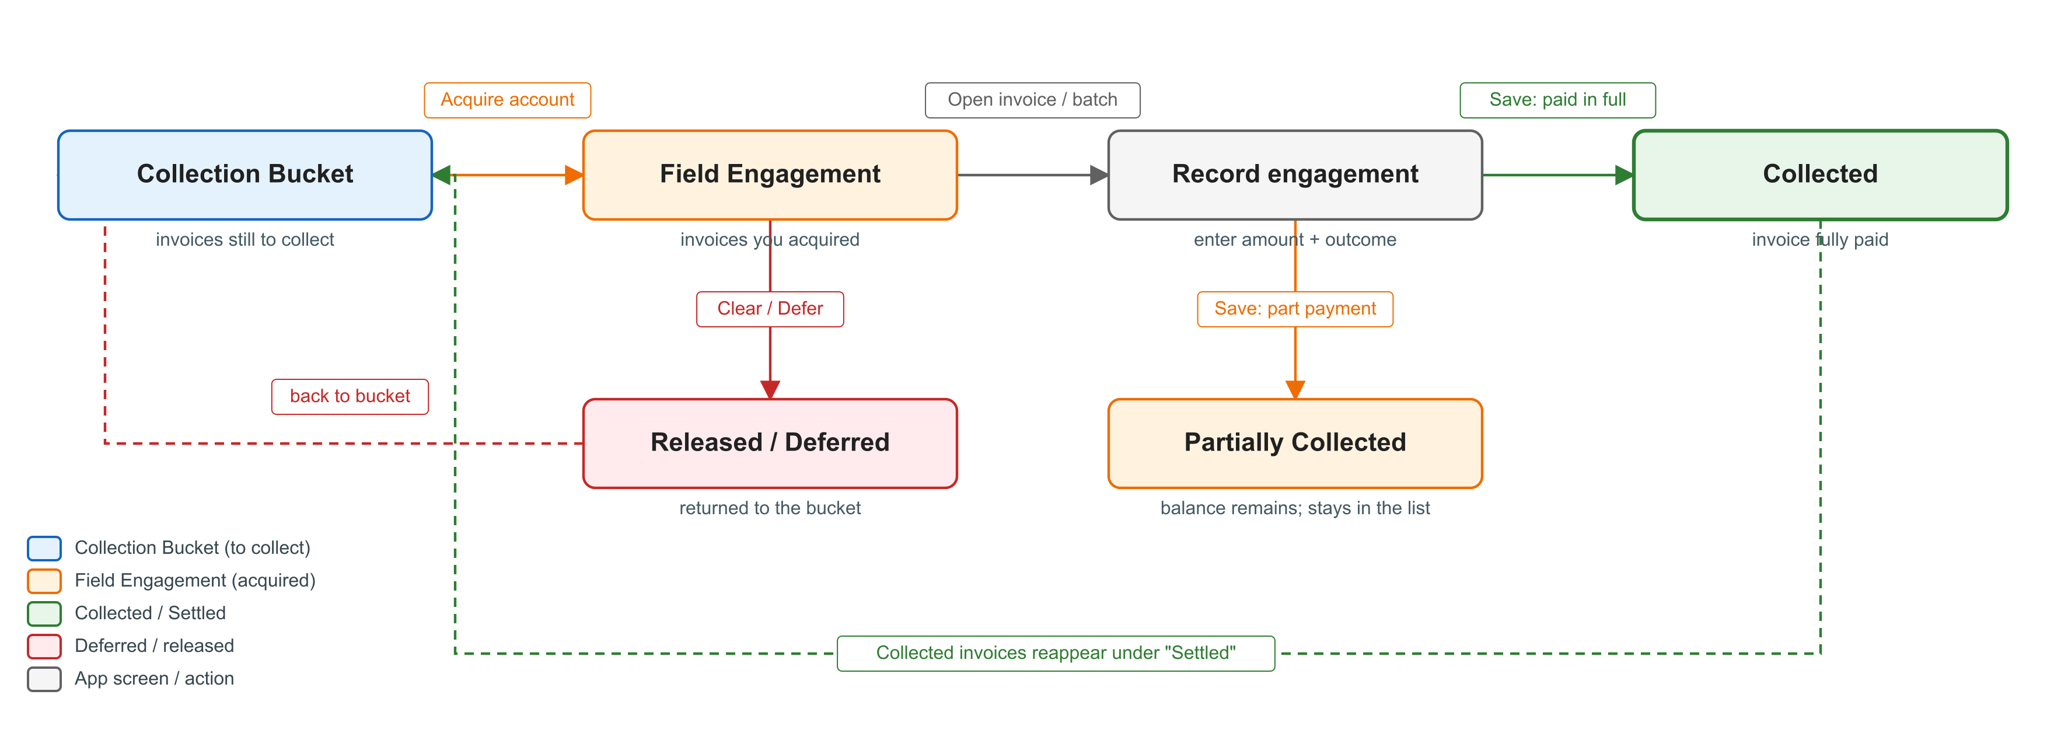
Figure 1. The MDMPI Mobile App collection cycle

6. Common Steps

6.1 Signing in and onboarding
- Open the MDMPI Mobile App. The splash screen shows the MDMPI logo for a few seconds.
- On first run the app asks for the device permissions it needs. Allow them.
- On the Log In screen enter your e-mail and password and tap Log In. Use Forget Password? to receive a password-reset e-mail; use Create Account only when instructed by IMS.
- If your e-mail address has not been verified, verify it from the e-mail you received and return to the app.
- On your first sign-in the Collection onboarding shows three slides: "Welcome to MDMPI APP!", "Add Your Collections" and "Track Your Collections". Tap the arrow to move on, or Skip. The onboarding does not appear again on that device.
- The Collection navigation opens on the Home tab.

6.2 Collection navigation
The bottom bar has four tabs (icons only):
Tab | What the user does there
Home | Dashboard: Actual Collection and Total Collected totals, the Collection Bucket button, the Settled / Due Date / Reconciliation / Advanced Payment summaries, and the recent engagement history.
Field Engagement | The active worklist of acquired accounts and invoices; where engagements are recorded and accounts are released.
Calendar | Engagements shown by date, and the button to add an office activity.
Settings | Account and profile, and the shared app settings and logout.

6.3 The Home dashboard
Item | What it shows / does
Actual Collection | The month's deposited total against the Target. Tapping it opens the Actual Collection summary (deposits for the month), where the Target can be set.
Total Collected this Month | The total collected across all invoices for the month. Tapping it opens the Total Collected summary.
COLLECTION BUCKET | Shows how many invoices are still to collect ("No items in bucket" or "N item(s) to collect"). Tapping it opens the Collection Bucket (Section 7.1).
Settled / Due Date / Reconciliation / Advanced Payment | Four summary tiles. Each opens a filtered list: settled invoices, invoices past due, invoices marked for reconciliation, and advanced payments waiting to be assigned to an invoice.
Engagement History | The most recent saved engagements, with Show All to open the full history.

6.4 Finding accounts: search and filters
In the Collection Bucket and in Field Engagement the collector narrows the list with the search box (by account name), the amount-due range filter, and Filter by Area. The area filter chooses a main region (Luzon, Visayas, Mindanao or Medical Imaging) and, for Luzon, a sub-region (North, South or Central Luzon), and shows only the accounts in that area.

7. Process Flows

7.1 Acquiring accounts from the Collection Bucket
The collector plans the day by moving accounts from the bucket into Field Engagement.
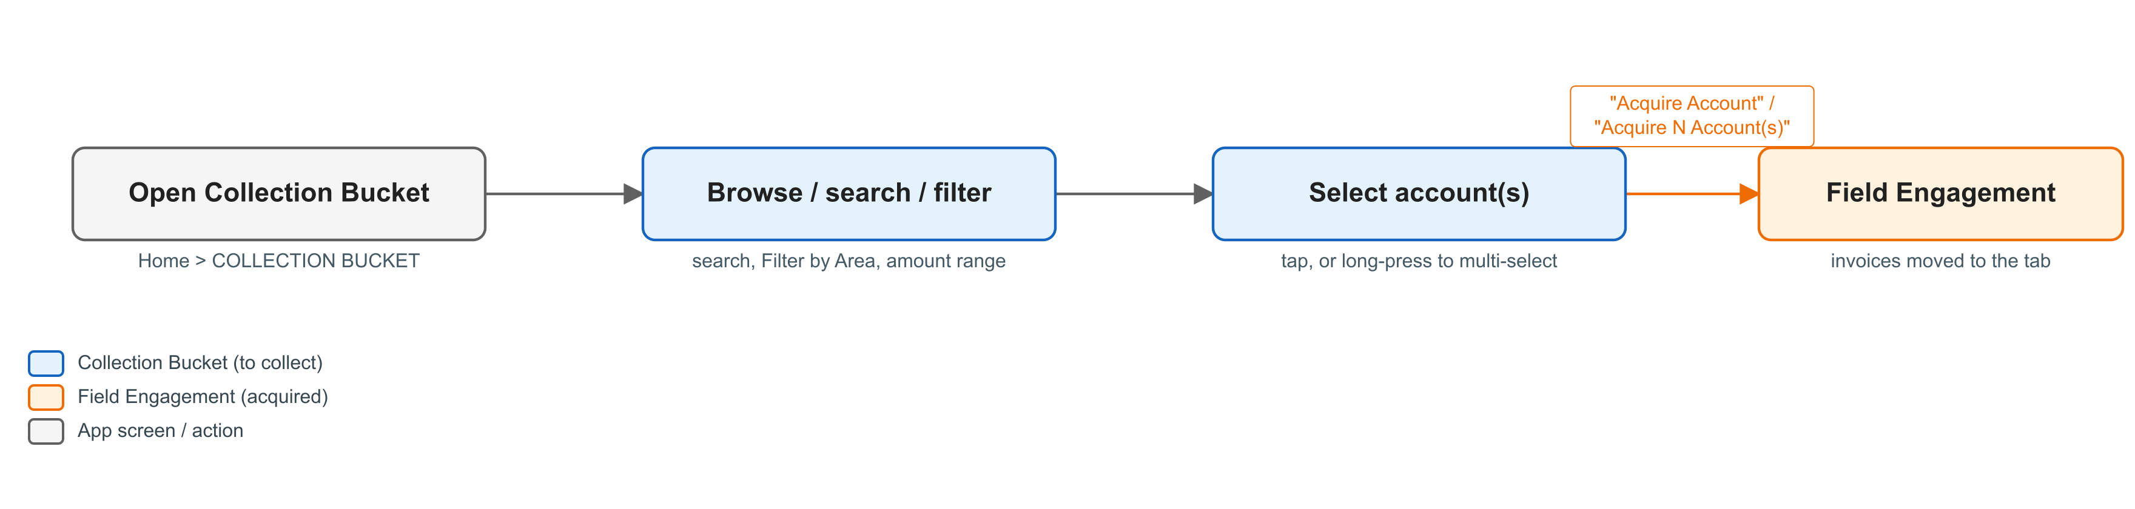
Figure 2. Acquiring accounts from the Collection Bucket
Step | Action | What the user does / what happens
1 | Open the bucket | On Home, tap COLLECTION BUCKET. The bucket lists accounts with unpaid invoices.
2 | Find accounts | Use the search box, the amount-due range filter, or Filter by Area to narrow the list.
3 | Select | Tap a single account, or long-press to start multi-select and tick several accounts.
4 | Acquire | Tap "Acquire Account" on a card, or "Acquire N Account(s)" for a multi-select. The account's invoices move to Field Engagement, and the app confirms with "Account Acquired" / "Accounts Acquired".

Narrative. At the start of the day the collector opens the Collection Bucket and reviews the accounts that still owe. Using the area and amount filters, the collector picks the accounts to visit and taps Acquire. Those invoices move into the Field Engagement tab, which becomes the worklist for the day. Invoices that were marked for reconciliation are taken first when an account is acquired.

7.2 Recording a field engagement
When the collector visits or contacts a client, the outcome for an invoice is recorded on the Engagement Details screen.
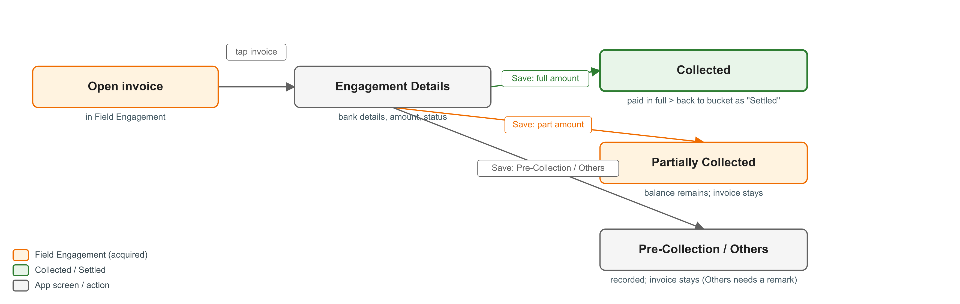
Figure 3. Recording a field engagement outcome
Step | Action | What the user does / what happens
1 | Open the invoice | In Field Engagement, open the account and tap the invoice to open Engagement Details.
2 | Enter bank details | Optionally enter the Bank Name, Check Number and Check Date for a cheque payment.
3 | Enter the amount | In "Paid to invoice", enter the amount collected for this invoice.
4 | Choose the outcome | In "Update Status / Outcome" pick Collected, Partially Collected, Pre-Collection or Others. Others requires a remark.
5 | Save | Tap Save. If the amount clears the balance, the invoice becomes Collected and returns to the bucket under Settled. If a balance remains, the invoice stays in Field Engagement as Partially Collected. Every save adds an entry to the engagement history (date, collector, outcome, amount, bank / cheque details, remarks).

Narrative. The collector arrives at the client, agrees the payment and opens the invoice in Field Engagement. If the client pays by cheque, the collector records the bank name, cheque number and cheque date, then enters the amount received and the outcome. A full payment settles the invoice; a part payment keeps the remaining balance on the worklist for a follow-up. When the reason is not a payment, for example a scheduled return visit, the collector records Pre-Collection or Others with a note. Every entry is written to the engagement history so the visit is traceable.

7.3 Recording a batch engagement
When a client settles several invoices with one cheque, the collector records them together instead of one by one.
- In the account, long-press to multi-select two or more invoices and tap "Batch Record N Invoices".
- On Batch Engagement Recording, enter the visit and bank details (Bank Name, Check #, Check Date) and the Total Amount Received.
- Distribute the total across the invoices: for each invoice set the amount, an outcome and any remarks. The screen shows whether the distribution is balanced ("Balanced! Ready to save.") or how much is left or over.
- When the amounts match the total, tap "Save Batch Engagement". Each invoice is recorded and its history updated, the same as a single engagement.

7.4 Releasing an account
An account that cannot be worked is returned to the bucket in one of two ways.
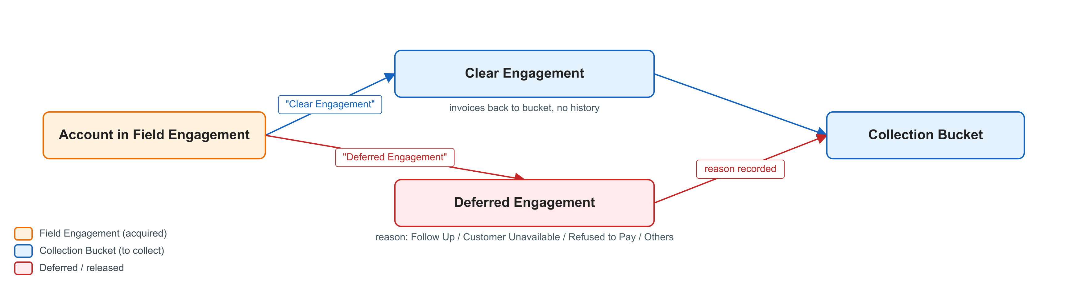
Figure 4. Releasing an account back to the bucket
Step | Action | What the user does / what happens
A | Clear Engagement | In the account, tap "Clear Engagement". The invoices move back to the bucket with no reason recorded. Used when the account was acquired by mistake or is no longer being worked today.
B | Deferred Engagement | Tap "Deferred Engagement", choose the reason (Follow Up, Customer Unavailable, Refused to Pay, or Others, with a note for Others) and Confirm. The invoices move back to the bucket and the reason is written to the account history.

Narrative. If the client is out or asks for a later visit, the collector uses Deferred Engagement and records why, so the reason is on file and the account can be picked up again another day. Clear Engagement is the quiet version, used only to undo an acquisition without leaving a reason.

7.5 Office activities
Besides client visits, the collector records office-side activities. These are opened from the "Add Field Engagement" button on the Calendar (or from Home) which shows Select Activity Type.
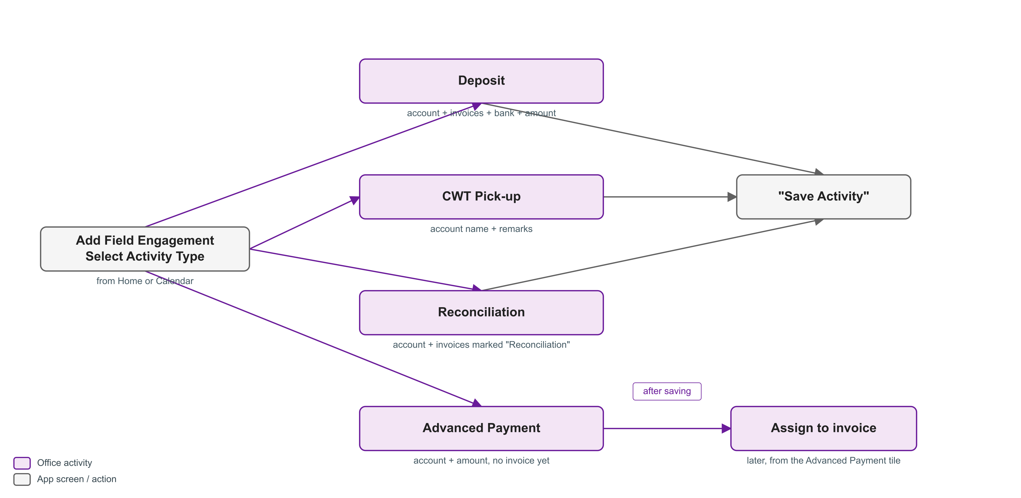
Figure 5. Office activities
Activity | What the user records
Deposit | On Record Deposit: the Account, the invoices being deposited, the Bank Name, the Amount and the Check Number, with remarks. Tap Save Activity. Deposits feed the Actual Collection total on Home.
CWT Pick-up | On Record CWT Pick-up: the Account Name and remarks. Tap Save Activity. Records the collection of a client's creditable-withholding-tax certificate.
Reconciliation | On Record Reconciliation: the Account and the invoices to reconcile, with remarks. Tap Save Activity. The chosen invoices are marked Reconciliation and appear under the Reconciliation summary.
Advanced Payment | On Record Advanced Payment: the Account and the Amount Paid, with remarks. Tap Save Activity. The payment waits under Advanced Payment on Home until it is assigned to an invoice.

Assigning an advanced payment. Later, from the Advanced Payment summary on Home, the collector taps Assign on an unassigned payment, enters the invoice number, amount due and due date, and confirms. The app creates the invoice with the balance after the advance, and marks it Collected if the advance covers it in full.

7.6 Calendar
The Calendar tab marks the days that have engagements. The collector selects a day to see its engagements, and can filter them by account with "Select Account to view engagements". The "Add Field Engagement" button opens Select Activity Type for a new office activity (Section 7.5).

7.7 Monthly summaries and target
Summary | What it shows
Actual Collection | The month's Deposit activities, totalled, against the Target. Opened from the Actual Collection card; the Target is set here with Set Target Collection.
Total Collected this Month | Every amount collected against invoices for the month, totalled, with the account, invoice, collector and date on each row. Opened from the Total Collected card.

Both summaries have a month selector for the last twelve months.

8. Outcome and Activity Reference
Outcome / activity | When it is used | Where it is set
Collected | The invoice is paid in full. | Engagement Details / Batch
Partially Collected | A part payment is received; a balance remains. | Engagement Details / Batch
Pre-Collection | A pre-collection visit or arrangement, no payment yet. | Engagement Details / Batch
Others | Any other recorded outcome; a remark is required. | Engagement Details / Batch
Follow Up / Customer Unavailable / Refused to Pay / Others | Reason for deferring and releasing an account to the bucket. | Deferred Engagement dialog
Deposit | A bank deposit of collected amounts. | Record Deposit
CWT Pick-up | Collection of a withholding-tax certificate. | Record CWT Pick-up
Reconciliation | Invoices set aside for balance checking. | Record Reconciliation
Advanced Payment | A payment received before an invoice exists. | Record Advanced Payment

9. Current Implementation Status
The Collection feature is at the design and field-testing stage. The following points describe how it behaves in the current build and should be read alongside the process above, so the document is not taken to describe a fully live, server-backed system.
- On-device operation. Collection runs on the device. Acquiring, recording and releasing update the copy of the data held on that device.
- No central server yet. Saved engagements and activities are not yet synchronized to a central collection server; the design provides for this, but it is not active in the current build.
- Sample data. Where no data has been loaded onto the device, the bucket is populated with sample accounts and invoices for demonstration and training.
- Receipt photos. A "Receipts & Documentation" area with an Add Photo control is designed but not yet enabled for capturing receipt or deposit-slip images.
These items are the remaining work to move Collection from designed workflow to a fully connected system. The user-facing steps in Sections 6 and 7 reflect the intended process and the current on-device behaviour.

10. Related Documents
- Logistics Process Flow and System Narrative (docs/application/LOGISTICS_PROCESS_FLOW_AND_NARRATIVE.docx)
- Collection Module documentation (docs/modules/collection/README.md)
- Application documentation index (docs/application/README.md)

11. Revision History
Revision | Date | Description | Prepared by
0 | 2026-09-10 | Initial issue, based on application version 1.1.104 (Collection at design / field-testing stage).

